# WEEK 2

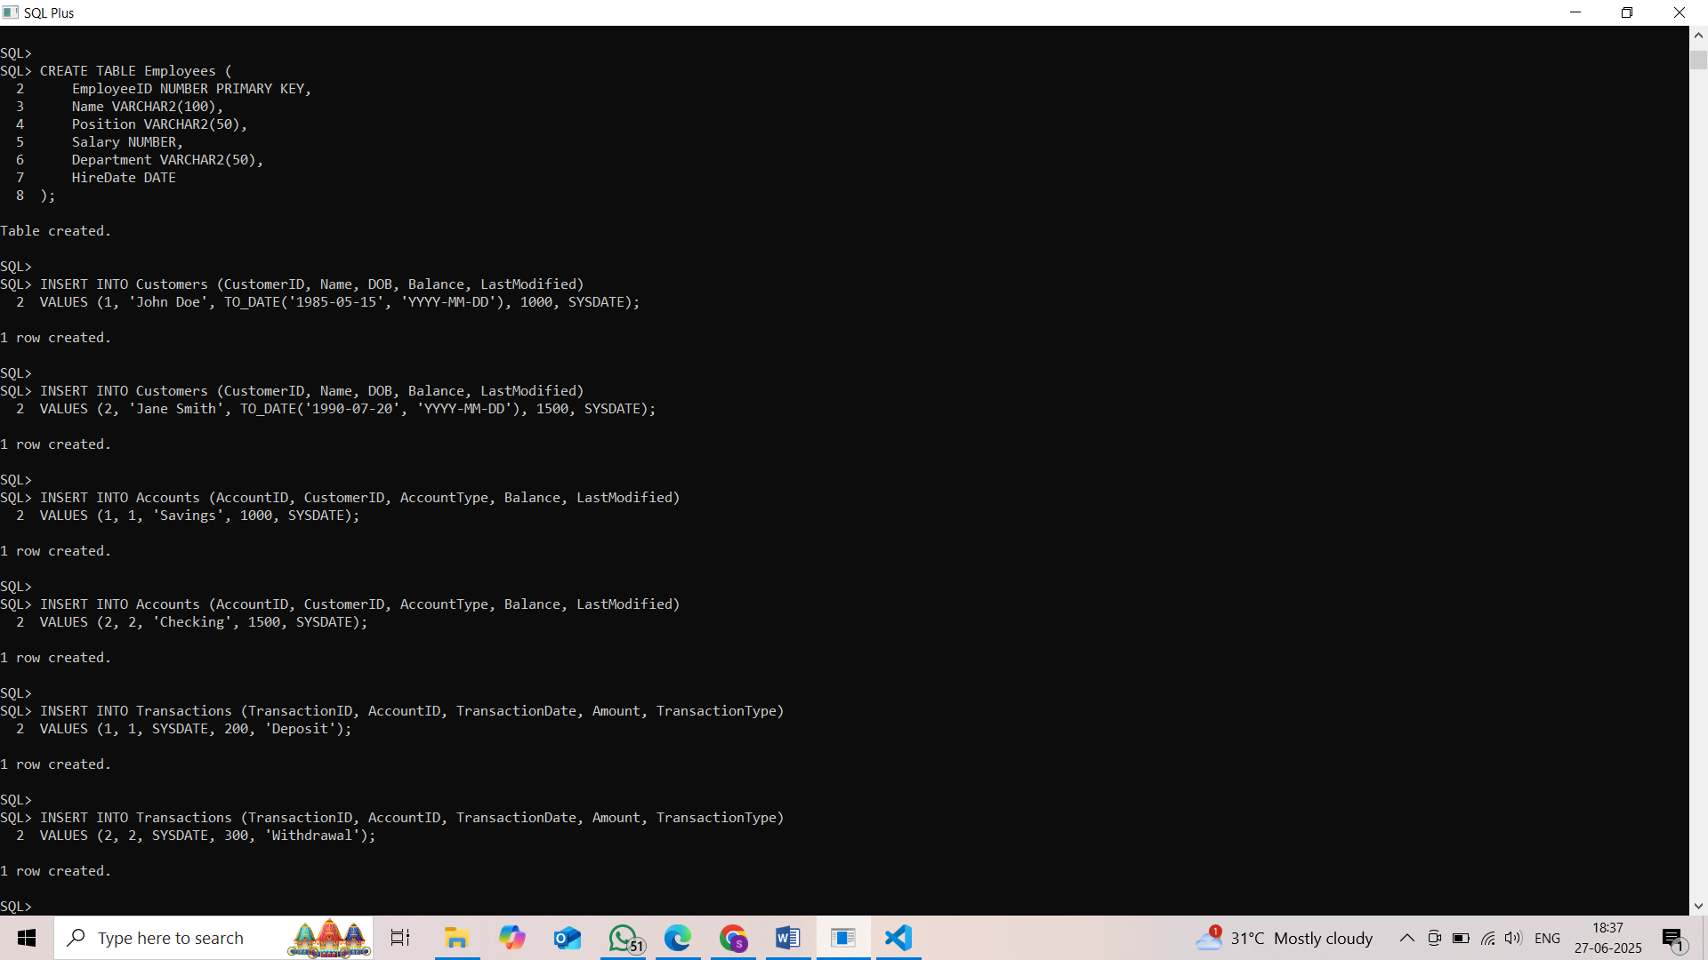

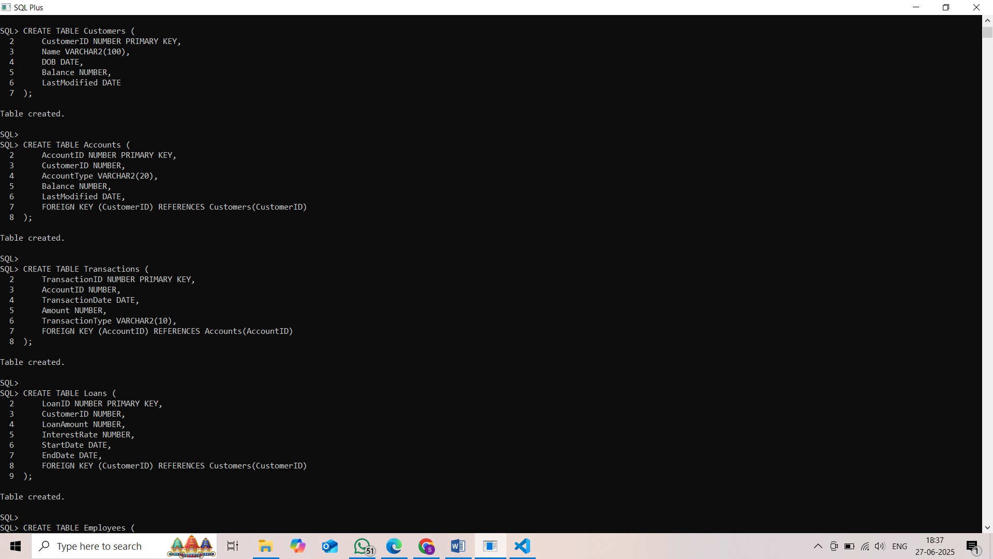

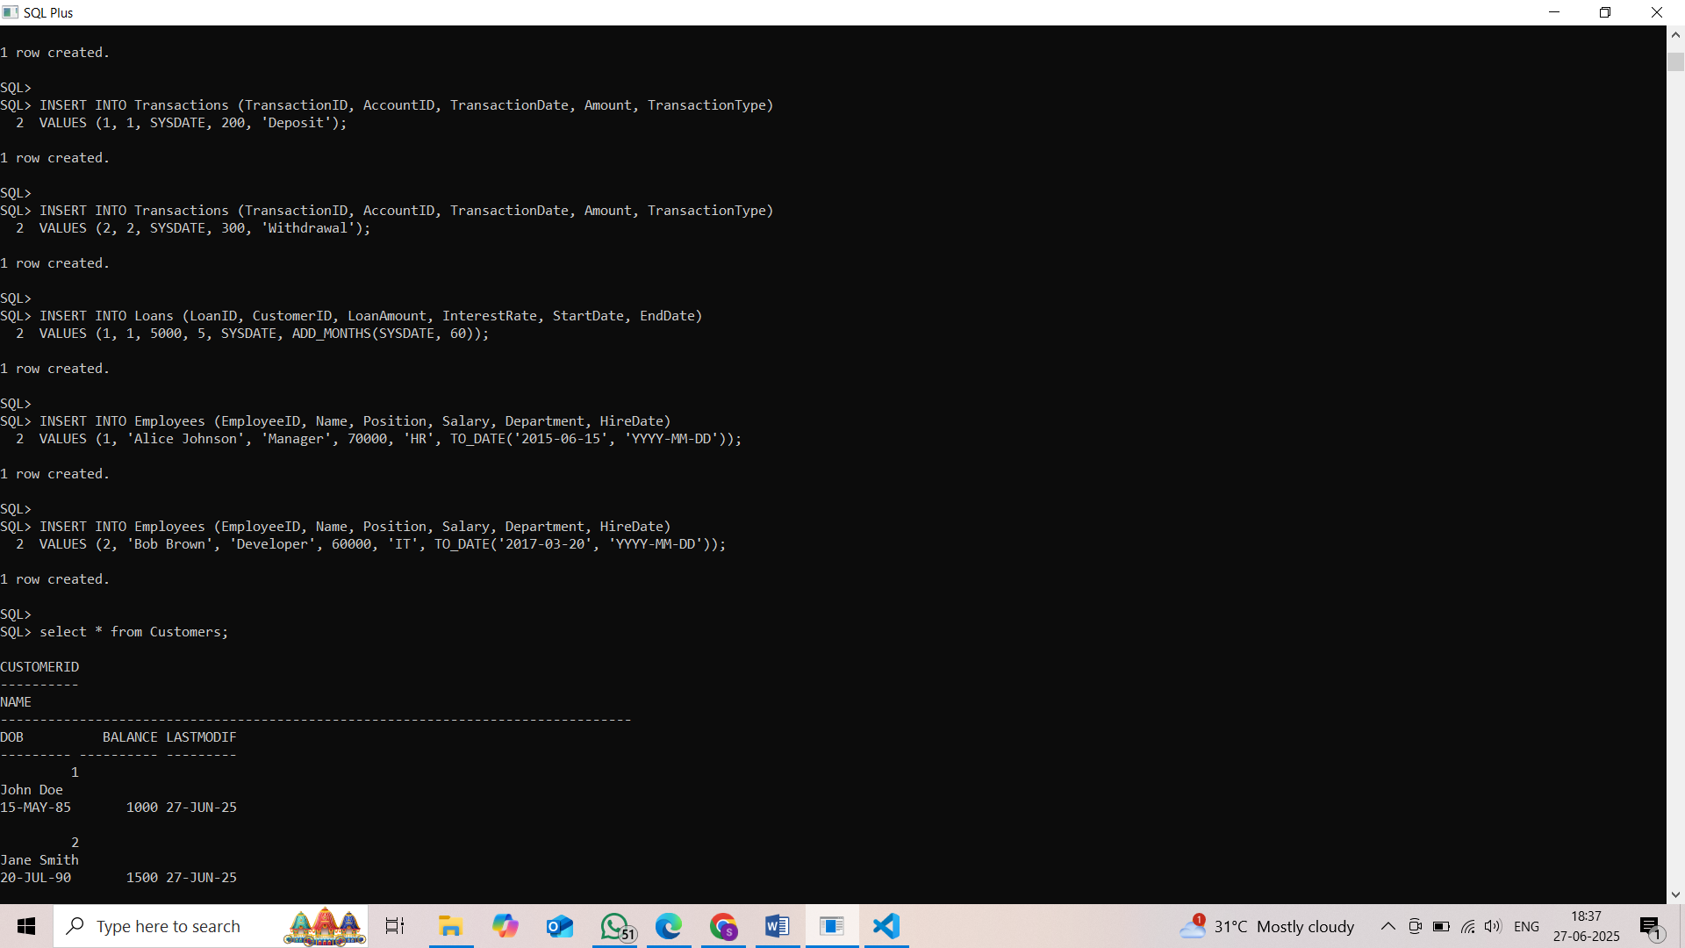

Exercise 1: Control Structures

Scenario 1: The bank wants to apply a 1% discount to the loan interest rate for all customers who are above 60 years old.  
Question: Write a PL/SQL block that loops through all customers, calculates their age from DOB, and if the age is over 60, reduce the interest rate by 1% for their loans.

Scenario 2: The bank promotes customers to VIP status if they maintain high balances.  
Question: Write a PL/SQL block that iterates through all customers and, if the balance is over $10,000, sets a column IsVIP to 'Y' or TRUE.

Scenario 3: The bank needs to send reminders for loans that are due in the next 30 days.  
Question: Write a PL/SQL block that fetches all loans where the end date is within the next 30 days and prints a message: "Reminder: Loan for Customer <ID> is due soon".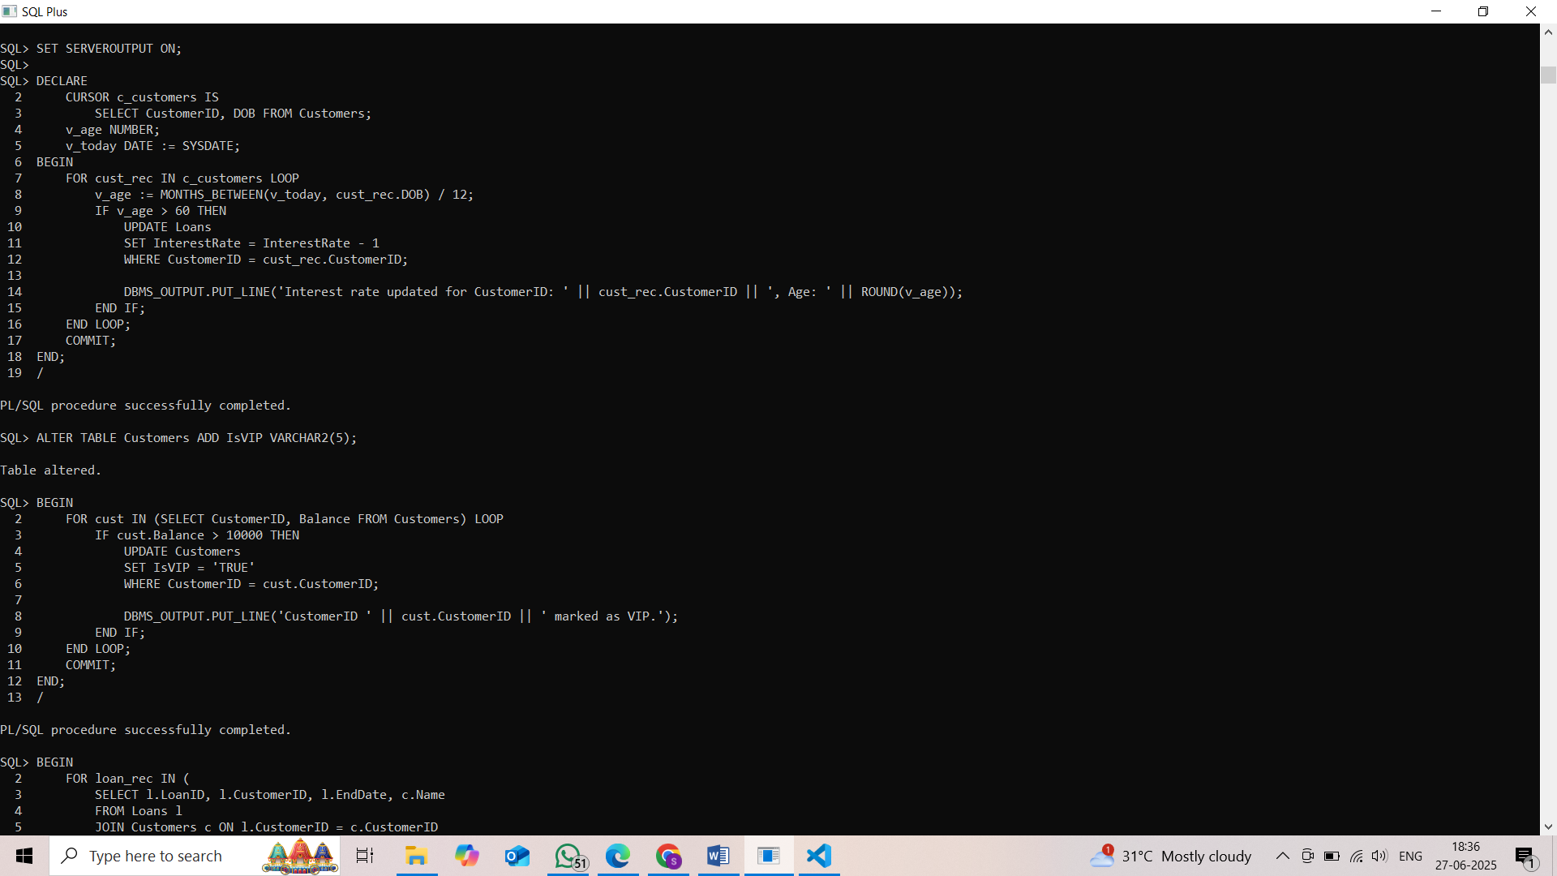

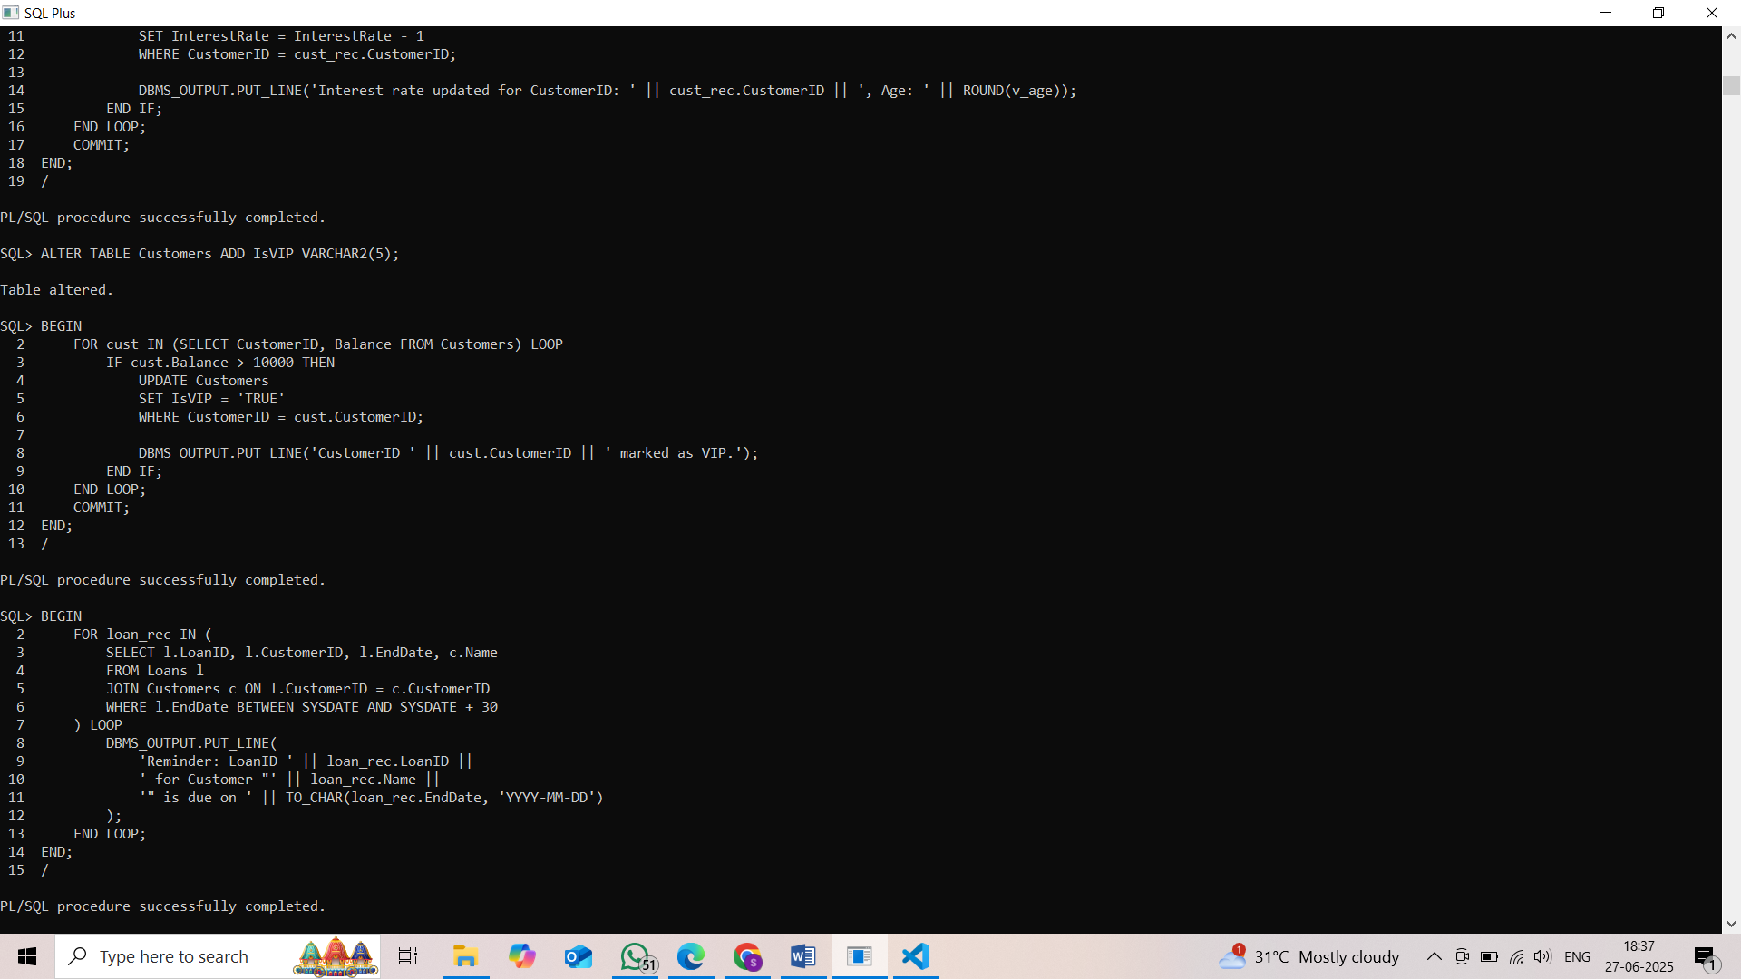

Exercise 3: Stored Procedures

Scenario 1: Each month, the bank applies 1% interest to all savings accounts.  
Question: Write a stored procedure named ProcessMonthlyInterest that finds all savings accounts and adds 1% of their current balance to the balance.

Scenario 2: Based on performance, employees in a department get a salary bonus.  
Question: Write a stored procedure named UpdateEmployeeBonus that accepts a department name and a bonus percentage, and updates the salary of all employees in that department.

Scenario 3: Customers want to transfer funds between their own accounts.  
Question: Write a stored procedure named TransferFunds that accepts from_account, to_account, and amount. It checks if from_account has sufficient balance, and if yes, deducts the amount from from_account and adds it to to_account. If not, it should print "Insufficient Balance".

# C:\Users\Nikitha\Pictures\Screenshots\Screenshot (83).pngC:\Users\Nikitha\Pictures\Screenshots\Screenshot (82).png