**ServiceNow Platform and Development Fundamentals**

ServiceNow is a cloud-based platform designed to streamline and automate various business processes across an organization. It offers a wide range of services, including IT service management (ITSM), human resources, customer service, and operations management. The platform enables businesses to manage tasks, tickets, and workflows efficiently by providing tools for automation, customization, and integration. With features like Global Search, Application Navigator, and a user-friendly interface, ServiceNow simplifies the management of complex tasks while supporting data integration, reporting, and low-code development to meet the needs of both technical and non-technical users.

**Architecture of ServiceNow Platform**

ServiceNow is a cloud-based enterprise platform that follows a multi-instance architecture, which means each customer gets their own dedicated instance of the platform, allowing for greater customization and control.

The ServiceNow platform consists of several layers, including:

**User Interface Layer**: This layer is responsible for rendering the user interface that end-users interact with. It includes various UI components like forms, lists, and pop-ups.

**Application Layer**: This layer contains the core applications of the ServiceNow platform, such as Incident Management, Change Management, and Service Catalog. These applications are built using the ServiceNow application development framework.

**Database Layer**: This layer is where all the data is stored. ServiceNow uses a proprietary database called the Common Service Data Model (CSDM) that allows customers to manage their IT services and infrastructure in a standardised way.

**Integration Layer**: This layer is responsible for integrating ServiceNow with other third-party systems and applications. ServiceNow supports various integration methods like REST, SOAP, and MID Server.

**Workflow Layer**: This layer provides a graphical interface for creating complex workflows that automate business processes.

**Orchestration Layer:** This layer is responsible for automating tasks across multiple systems and applications. ServiceNow's Orchestration module allows users to create workflows that automate tasks like provisioning virtual machines or executing scripts on remote servers.

Overall, the architecture of ServiceNow is designed to be flexible and scalable, allowing customers to easily customise the platform to meet their unique business needs.

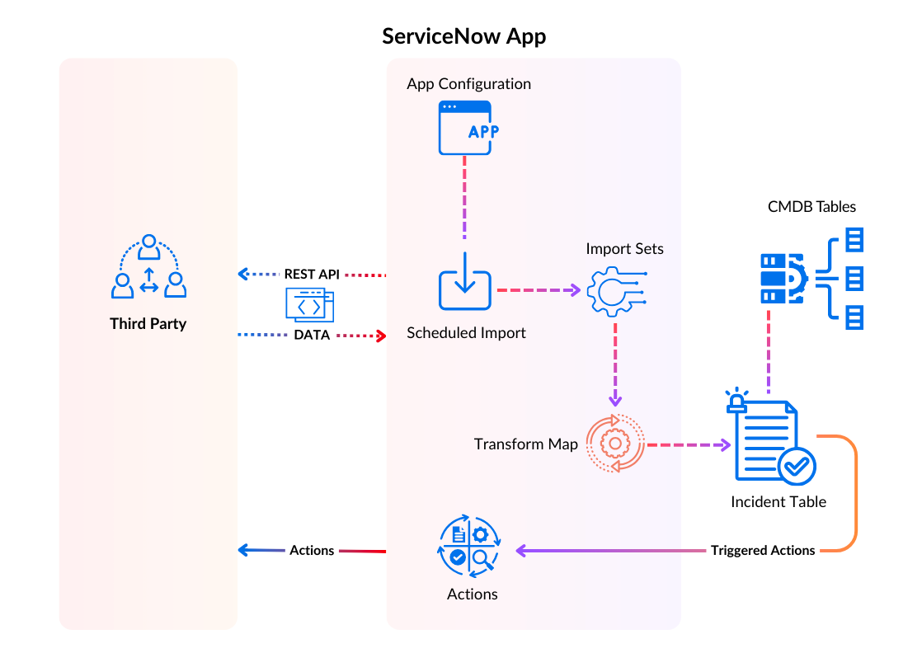

**Infrastructure for deploying and utilizing ServiceNow services.**

1. **Setting Up**: Create and configure your ServiceNow instance in the cloud.

2. **Customizing**: Customize the platform to fit your needs with workflows, forms, and reports.

3. **Integrating**: Connect with other systems via APIs or connectors.

4. **Managing Users**: Set roles and permissions for access control.

5.**Deploying**: Move changes from test to live environments.

6. **Maintaining**: Monitor performance and apply updates as needed.

**Navigating the ServiceNow Platform and Mastering ServiceNow User Interfaces**

Navigating the ServiceNow Platform involves **Dashboard Access**, **Application Navigator**, **Search Functionality**, **Forms and Lists**, **Reports and Analytics**

Mastering ServiceNow User Interfaces involves **Understanding Layouts**, **Using Widgets**, **Customizing Views**, **Navigating Menus**, **Utilizing Help**

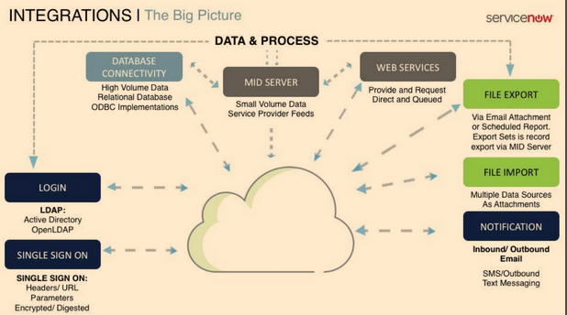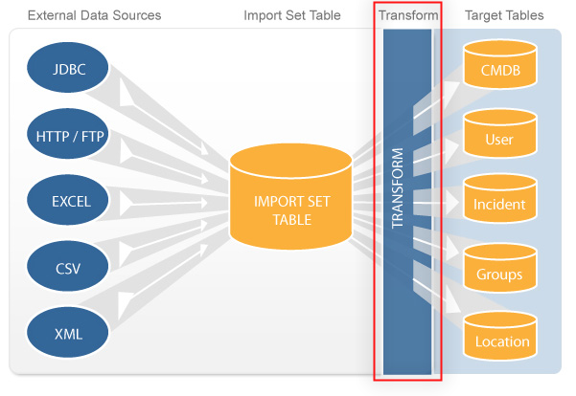**Data Imports and Integrations, Report Creation and Management**

To import data, we upload external files in formats like CSV or Excel, or use APIs, then map the fields and utilize import sets to process the data efficiently.

Integrations allow us to connect with external systems through APIs, connectors, or web services, enabling seamless data exchange and process automation.

Reports are created by selecting relevant data sources, applying filters, and choosing chart types to visualize the data.

Management involves organizing, scheduling, and sharing reports with stakeholders, as well as setting up automated reporting for efficient data distribution.

We should use reporting tools to perform real-time data analysis and gain actionable insights for informed decision-making.

**ServiceNow Data Model for Reporting**

The ServiceNow platform data model for reporting is built around tables, which store records, and fields, which hold specific data. Reports are generated by querying these tables and fields, usingfilters andgroupings to analyze and visualize the data. The model also supports relationships between tables for more complex reporting.

**Creating, Managing, and Sharing Reports in ServiceNow**

To create, manage, and share reports in ServiceNow:

1. **Creating Reports**:
   * Go to **Reports** > **Create New**.
   * Select a **data source** (table) and choose a **report type** (e.g., bar chart, list, pie chart).
   * Apply **filters** and **grouping** options to refine the data.
   * Customize **visual elements** like chart colors, labels, and titles.
2. **Managing Reports**:
   * Go to **Reports** > **View/Run** to view a list of all reports.
   * **Edit, clone, or delete** reports from the list.
   * Use the **report designer** to adjust fields, filters, and layout.
3. **Sharing Reports**:
   * Click on **Share** to share reports via email or generate a public link.
   * Schedule **automated reports** to send at regular intervals.
   * Share reports with specific users or groups by setting **permissions** for viewing or editing.

**Data visualization in Decision making**

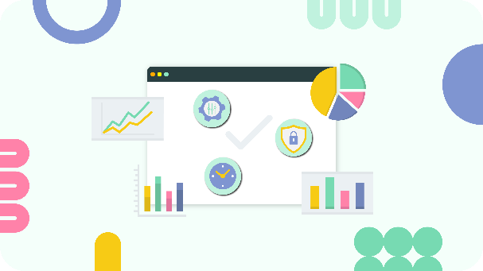Data visualization in ServiceNow is crucial for decision-making as it transforms complex data into intuitive charts and graphs, making trends and insights easily accessible and understandable. This enables quicker, more informed decisions by highlighting key metrics and patterns at a glance.

**Branding and Customization**

It involves tailoring the platform’s appearance and functionality to align with your organization's identity and needs. This includes customizing logos, color schemes, and user interfaces, as well as modifying workflows and forms to better fit business processes.

**Customizing the ServiceNow user interface through branding tools**

* Navigate to **System Properties** > **Basic Configuration UI16**.

We can modify the appearance by adjusting colors, uploading logos, and changing the overall theme to align with our organization's brand. We should use the **Service Portal** to further customize widget layouts and styles for a personalized user experience. Additionally, we need to update the application navigator and form layouts to better fit our business processes. After making these adjustments, preview the changes to ensure they meet our branding requirements and then save them to apply the new look and feel across the platform.

**Applying Corporate Identity to ServiceNow Portal Using Guided Setup and UI Builder**

To apply a corporate identity to the ServiceNow portal using Company Guided Setup and UI Builder, start with the Company Guided Setup to configure basic branding elements such as logos, color schemes, and theme settings. Next, use the UI Builder to customize the portal layout by adjusting widgets, adding company-specific branding elements, and modifying page styles to match your corporate identity. This process ensures a cohesive and personalized look that reflects your organization's brand across the ServiceNow portal.

**Low Code No Code Development and Digital Transformation**

Low Code No Code Development refers to creating applications with minimal coding (low code) or without any coding (no code), using visual interfaces and drag-and-drop tools. In the context of digital transformation in ServiceNow, it allows users to rapidly develop and deploy custom applications, automate processes, and integrate systems without requiring extensive programming expertise. This accelerates innovation, reduces development costs, and empowers business users to address their needs quickly, aligning with the broader goals of digital 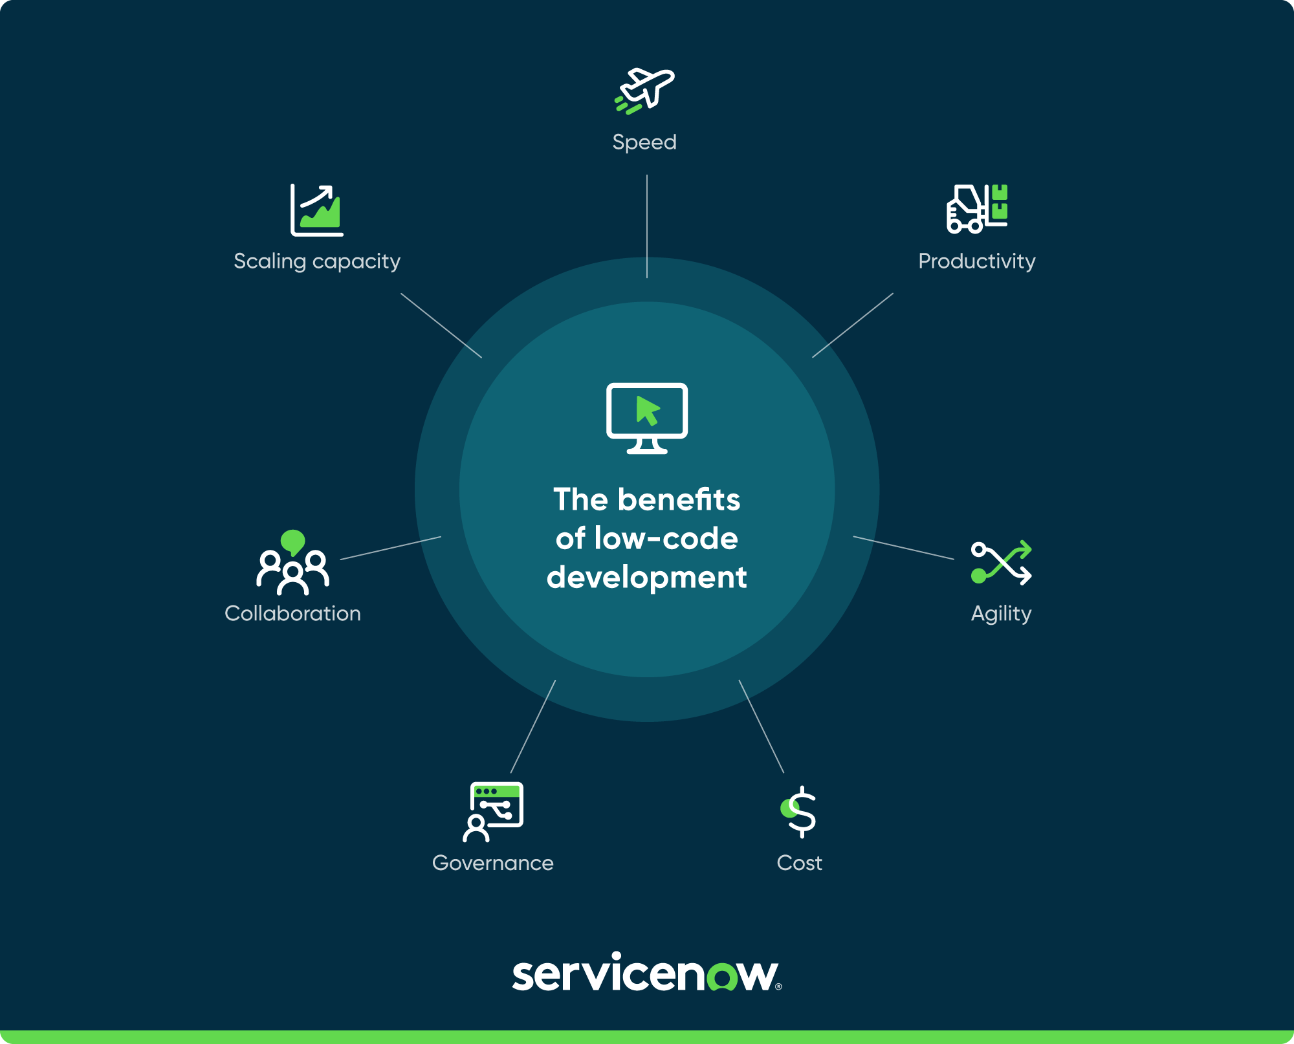transformation.

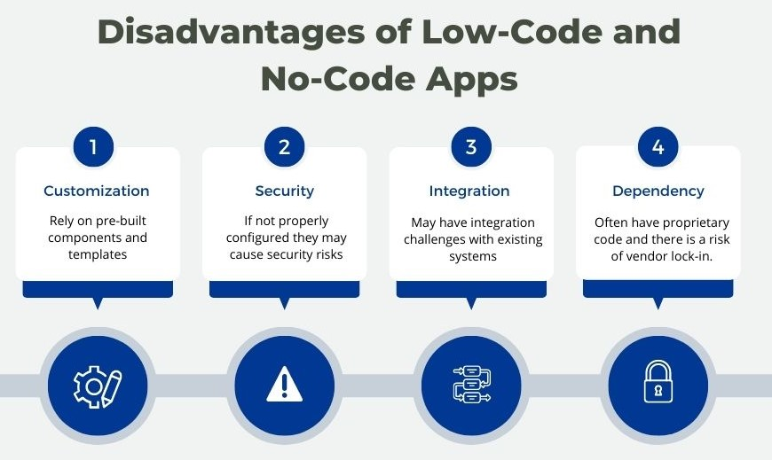

**Career Opportunities in Low Code No Code Development**

They include:

1. **ServiceNow Application Developer 4.Consultant**
2. **Platform Administrator 5. Business Analyst**
3. **Solution Architect 6. Technical Support Specialist**