Front-End UI/UX Mini Project

## 1. Title Page

Project Title: Multi cause NGO Portal

Submitted By: Vadapalli Lakshmi Kalyani Sahithi(2462370)

Sacchit Kallara Viju(2462356)

Aadithya Vimal(2462302)

College Email ID: [vadapalli.lakshmi@btech.christuniversity.in](mailto:vadapalli.lakshmi@btech.christuniversity.in)

sacchit.kallara[@btech.christuniversity.in](mailto:vadapalli.lakshmi@btech.christuniversity.in)

aadithya.vimal@btech.christuniversity.in

Course: UI/UX Design Fundamentals

Instructor Name: Ms.Nagaveena

Institution: Christ University

Date of Submission: 26/09/2025

## 2. Abstract

## This project presents an interactive NGO portal that supports multiple social causes, including education, healthcare access, women empowerment, environmental protection, and disaster relief. The portal provides a user-friendly interface where visitors can explore causes, contribute through donations, volunteer for initiatives, and stay updated with ongoing events and campaigns. It features cause listings with search and filter options, detailed pages highlighting objectives and impact stories, and integrated forms for donations and volunteer registrations. Animated counters and smooth visual effects enhance engagement, while a responsive design built with HTML, CSS, JavaScript, Bootstrap, and jQuery ensures accessibility across all devices. By combining transparency, interactivity, and visual appeal, the portal strengthens community participation and promotes collective action toward sustainable development.

## 3. Objectives

## Raise Awareness: Provide an interactive platform to inform users about various social causes and their importance.

## Promote Participation: Encourage users to actively contribute through donations and volunteer registrations.

## Showcase Impact: Display measurable outcomes and achievements using animated counters and visual metrics.

## Facilitate Exploration: Allow users to search, filter, and explore causes easily based on category, urgency, or location.

## Provide Updates: Keep users informed about upcoming events, campaigns, and NGO news.

## Enhance Accessibility: Ensure a responsive and visually appealing design compatible across different devices.

## Strengthen Community Engagement: Foster transparency and trust, encouraging users to collaborate in social initiatives.

## 4. Scope of the Project

## The scope of this project is to design and develop a fully functional interactive NGO portal that serves as a bridge between the organization and society. The portal will cover multiple social causes such as education, healthcare, women empowerment, environmental protection, and disaster relief. It will allow users to explore causes through listings, detailed descriptions, and impact stories, while also enabling them to donate funds or register as volunteers. The system will provide search and filter functionality for easy navigation and showcase events, campaigns, and news updates to keep users engaged. Additionally, the project scope includes implementing animated counters, smooth visual effects, and responsive design to ensure accessibility across devices. This portal is intended to increase transparency, improve outreach, and strengthen community participation by making the NGO’s initiatives more visible and engaging to a wide audience.

## 5. Tools & Technologies Used

|  |  |
| --- | --- |
| **Tool / Technology** | **Purpose** |
| **HTML5** | Provides markup and structures the content of the website. |
| **CSS3** | Handles styling, animations, color themes, and layout management. |
| **JavaScript (ES6)** | Adds interactivity, dynamic behaviors, and animated features such as counters. |
| **Bootstrap 5** | Ensures responsive design and consistent UI components across devices. |

## 6. HTML Structure Overview

## Semantic Tags Used: The portal makes use of semantic HTML5 tags such as <header>, <nav>, <main>, <section>, and <footer> to ensure proper content organization and accessibility.

## Structured Sections: The website is divided into reusable and well-defined sections, including Hero Section, About Us, Causes, Donation Form, Volunteer Form, Events & Updates, and Impact (Animated Counters).

## Navigation Menu: A responsive navigation bar is implemented using <ul> lists and anchor <a> links, enabling smooth scrolling between different sections of the portal.

## Cause Details Pages: Individual causes are linked from the main listing to detailed pages providing objectives, activities, and engagement options.

## Forms Integration: The structure includes separate sections for Donation and Volunteer Registration forms, each organized within <form> tags for user input.

## Footer: The footer contains essential NGO contact details, quick links, and social media icons for extended connectivity.

## 7. CSS Styling Strategy

## Color Theme: A warm and safe color palette (shades of orange, gold, beige, and soft brown) has been applied throughout the website to reflect trust, positivity, and community support.

## Typography: Clean and readable fonts with varied sizes are used to differentiate between headings, subheadings, and body text, ensuring visual hierarchy and accessibility.

## Layout Management: CSS Flexbox and Grid are utilized for aligning content sections, making the design responsive and well-structured across devices.

## Navigation Styling: The navigation bar is styled with hover effects, smooth transitions, and sticky behavior to improve usability and user experience.

## Animations & Transitions: Keyframe animations, fade-ins, glow effects, and scrolling animations are used to create a lively and engaging experience. Counters and call-to-action buttons are animated to grab user attention.

## Buttons & Forms: Buttons such as Donate Now and Volunteer are styled with consistent colors, rounded corners, hover glow effects, and clear visibility. Forms are aligned properly with spacing, input highlights, and responsive designs.

## Responsive Design: Media queries are applied to ensure that all sections (text, counters, images, and forms) adapt seamlessly to desktops, tablets, and mobile devices.

## Reusable Classes: Common styling (like shadows, glow, padding, and animations) is defined in reusable CSS classes for consistency and easier maintenance.

## 8. Key Features

## While the NGO portal fulfills its primary objectives, there is significant scope for future improvements to make it more impactful and efficient. Integration of a secure online payment gateway can simplify the donation process and build trust among donors. A multilingual interface could expand accessibility to diverse communities worldwide, ensuring inclusivity. Adding a real-time chatbot assistant would enhance user engagement by addressing queries instantly. Furthermore, implementing user accounts with dashboards for donors and volunteers could allow personalized experiences, tracking contributions, and managing participation. Incorporating social media integration and automated newsletters would further boost outreach and awareness. In addition, advanced analytics and reporting tools could help the NGO measure performance and impact more effectively. These enhancements would transform the portal into a more robust, transparent, and interactive platform, supporting long-term sustainability and growth.

## 9. Challenges Faced & Solutions

## During the development of the NGO portal, several challenges were encountered and addressed effectively. One major challenge was designing the portal to be engaging while maintaining simplicity, which was solved by using a warm and consistent color theme with subtle animations and clear layouts. Ensuring responsiveness across different devices posed another difficulty, overcome by applying Bootstrap’s grid system, Flexbox, and custom media queries. Implementing smooth animations and rolling number effects was also a challenge, which was resolved through CSS keyframes and lightweight JavaScript functions. Additionally, organizing multiple causes with detailed descriptions required a structured approach, achieved by creating separate listings, filtering options, and detailed pages. Finally, collecting donations and volunteer data in a user-friendly manner was addressed by integrating simple, validated forms for seamless user interaction.

## 10. Outcome

## The development of the NGO portal resulted in a fully functional, interactive, and user-friendly platform that effectively showcases multiple social causes such as education, healthcare, women empowerment, environment, and disaster relief. The portal successfully provides users with the ability to explore causes, view detailed information, and participate through donations and volunteer registrations. Features such as animated counters, smooth transitions, and a warm, consistent design theme enhanced engagement and visual appeal. The integration of events and updates ensures that users remain informed about ongoing campaigns and initiatives, while responsive design guarantees accessibility across desktops, tablets, and mobile devices. Overall, the project outcome is a dynamic and transparent platform that strengthens community involvement, increases outreach, and supports the NGO’s mission of driving collective action toward sustainable development.

## 11. Future Enhancements

## While the NGO portal fulfills its primary objectives, there is significant scope for future improvements to make it more impactful and efficient. Integration of a secure online payment gateway can simplify the donation process and build trust among donors. A multilingual interface could expand accessibility to diverse communities worldwide, ensuring inclusivity. Adding a real-time chatbot assistant would enhance user engagement by addressing queries instantly. Furthermore, implementing user accounts with dashboards for donors and volunteers could allow personalized experiences, tracking contributions, and managing participation. Incorporating social media integration and automated newsletters would further boost outreach and awareness. In addition, advanced analytics and reporting tools could help the NGO measure performance and impact more effectively. These enhancements would transform the portal into a more robust, transparent, and interactive platform, supporting long-term sustainability and growth.

## 12. Sample Code

HTML:

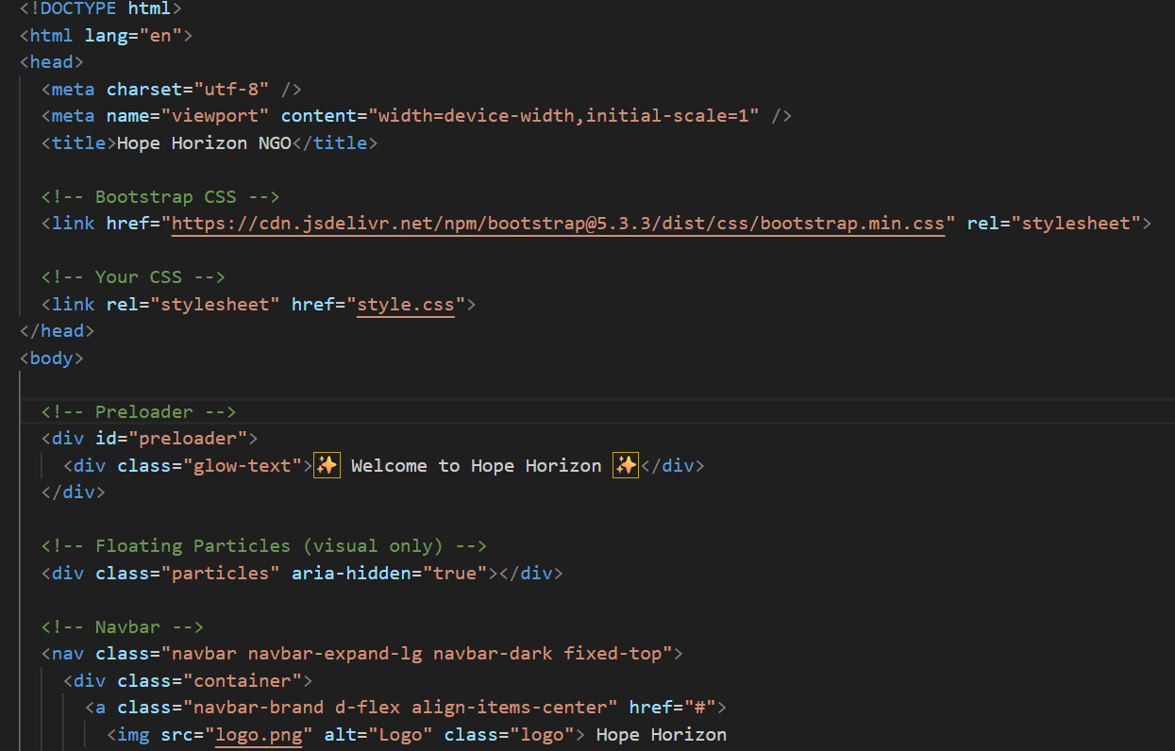

CSS:

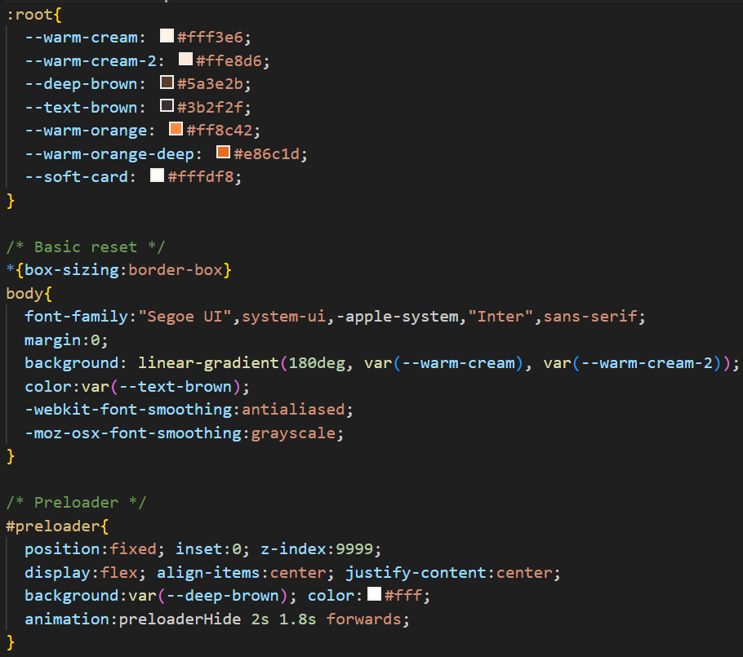

JS:

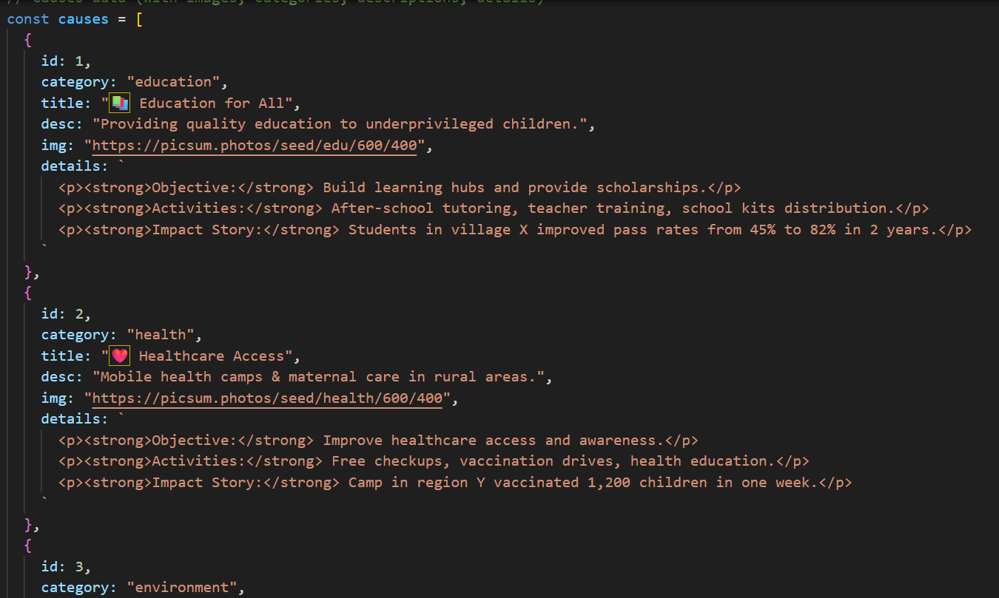

## 13. Screenshots of Final Output

## 

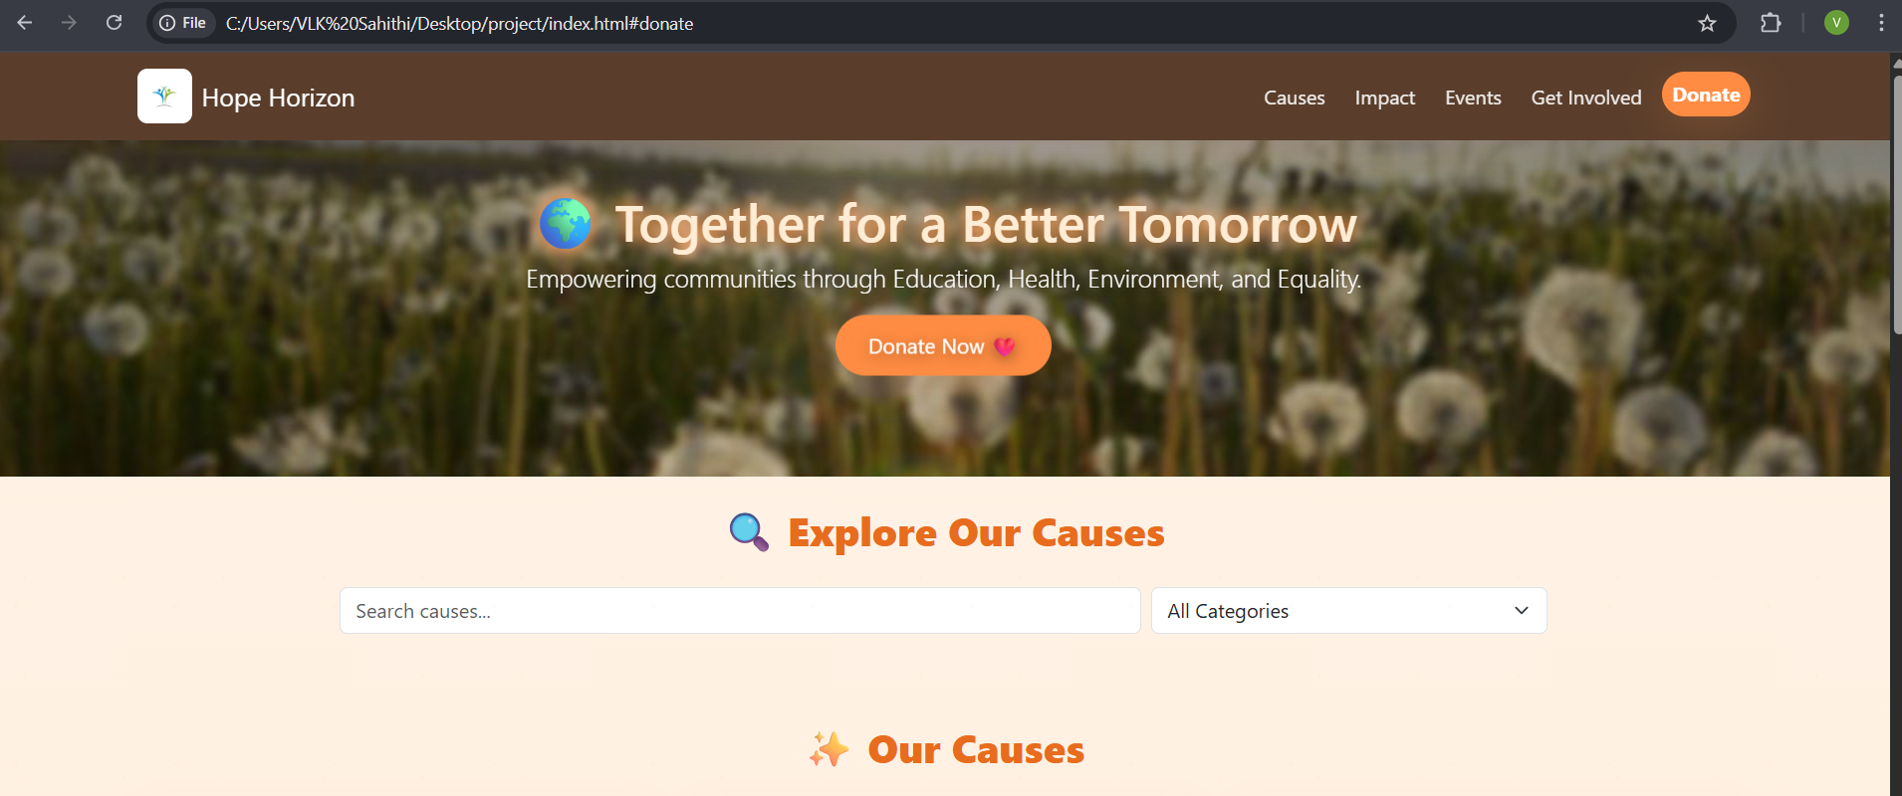

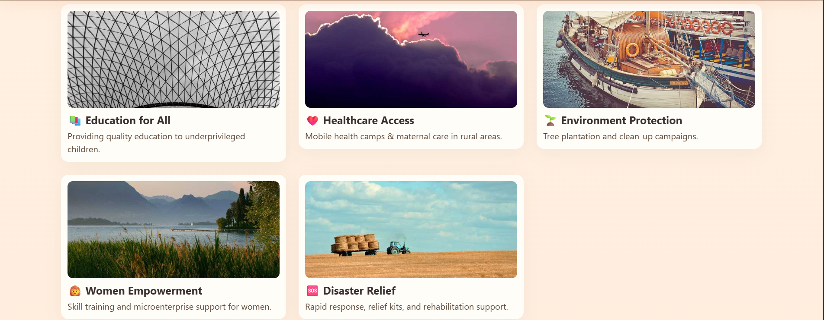

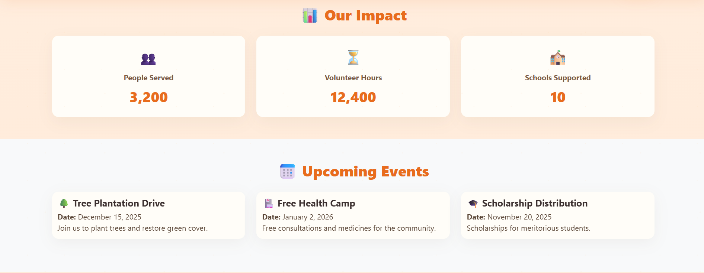

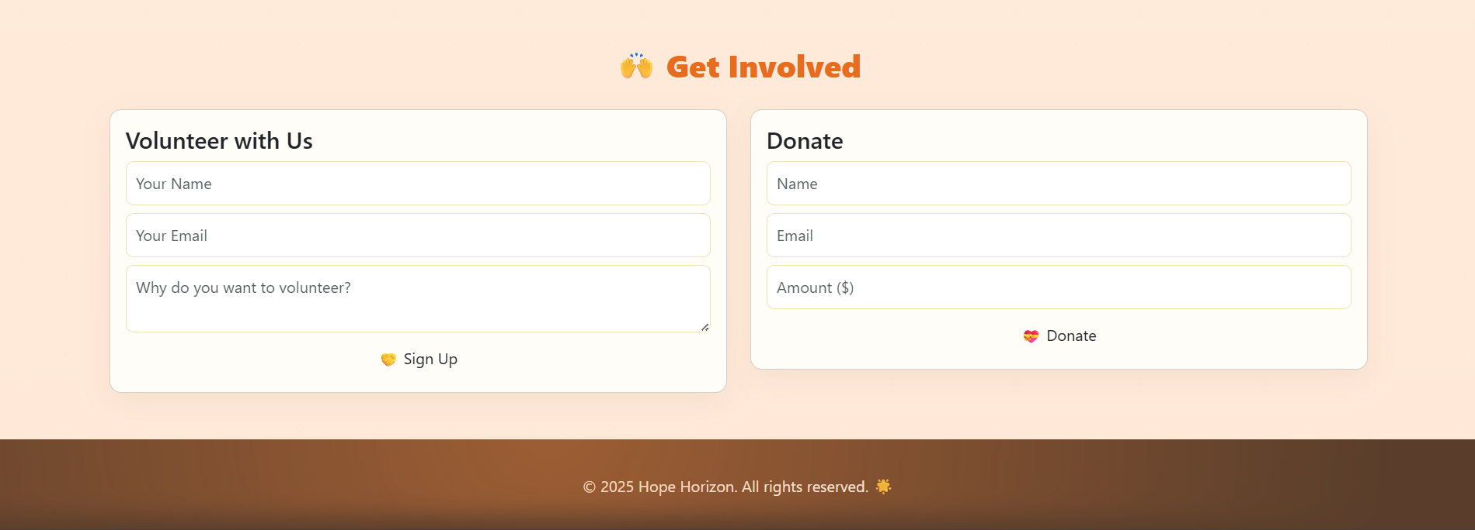

## 14. Conclusion

## The NGO Awareness Website successfully delivers a clean, responsive, and accessible platform The development of the interactive NGO portal has successfully created a dynamic and user-friendly platform that bridges the gap between the organization and the community. By providing detailed cause listings, donation and volunteer forms, animated impact counters, and an events and updates section, the portal effectively informs, engages, and motivates users to participate in social initiatives. The use of warm, consistent colors, smooth animations, and responsive design ensures an appealing and accessible experience across all devices. Overall, the project demonstrates how technology can enhance transparency, encourage community involvement, and support the NGO’s mission of driving positive social change. The portal lays a strong foundation for future enhancements, making it a sustainable tool for promoting awareness, collaboration, and active participation in various humanitarian causes.

## 15. References

• L&T LMS: https://learn.lntedutech.com/Landing/MyCourse