Front-End UI/UX Mini Project

## 1. Title Page

Project Title: NGO Awareness

Submitted By: Vadapalli Lakshmi Kalyani Sahithi(2462370)

Sacchit Kallara Viju(2462356)

College Email ID: [vadapalli.lakshmi@btech.christuniversity.in](mailto:vadapalli.lakshmi@btech.christuniversity.in)

sacchit.kallara[@btech.christuniversity.in](mailto:vadapalli.lakshmi@btech.christuniversity.in)

Course: UI/UX Design Fundamentals

Instructor Name: Ms.Nagaveena

Institution: Christ University

Date of Submission: 13/08/2025

## 2. Abstract

## This project presents the design and development of a fully responsive portfolio website using only HTML and CSS. The website serves as a digital identity for showcasing skills, completed projects, resume details, and a contact interface. Emphasis was placed on clean user interface design, intuitive navigation, and adaptability across devices, ensuring an optimal experience for desktop, tablet, and mobile users. By incorporating semantic HTML5 structure and organized CSS styling, the project demonstrates best practices in front-end development. Flexbox, CSS Grid, and media queries were utilized to achieve a modern and visually appealing layout. The absence of JavaScript highlights the capability of pure HTML and CSS to deliver interactive and professional results. This work reflects a comprehensive understanding of UI/UX principles, accessibility considerations, and responsive web design techniques.

## 3. Objectives

1. **Increase Public Awareness** – Provide a centralized platform to inform people about the NGO’s mission, values, and impact.
2. **Showcase Impact with Data** – Present real-time or periodically updated statistics through engaging visuals and animations to highlight progress.
3. **Encourage Participation** – Offer clear pathways for volunteering, donations, and advocacy involvement.
4. **Promote Transparency** – Share success stories, project updates, and financial information to build trust with the audience.
5. **Enhance Accessibility** – Design the website to be responsive and inclusive, ensuring usability for all users, including those with disabilities.
6. **Strengthen Brand Identity** – Use consistent colors, fonts, and tone to reflect the NGO’s ethos and professionalism.
7. **Foster Community Engagement** – Integrate features like contact forms, feedback sections, and social media links to connect with supporters.

## 4. Scope of the Project

## This project involves creating a front-end NGO Awareness Website using HTML5 and CSS3 to showcase the organization’s mission, impact, and ways to get involved. The site will be responsive, accessible, and visually engaging, featuring sections like About, Impact, Campaigns, and Contact. The scope is limited to static content without backend integration, with potential for future expansion into interactive and donation-enabled features.

## 5. Tools & Technologies Used

|  |  |
| --- | --- |
| Tool/Technology | Purpose |
| HTML5 | Markup and content structure |
| CSS3 | Styling and layout management |
| VS Code | Code editor |
| Chrome DevTools | Testing and debugging |

## 6. HTML Structure Overview

• Used semantic tags: <header>, <nav>, <main>, <section>, <footer>

• Structured into reusable sections: About, Projects, Contact

• Navigation menu using <ul> and anchor links for smooth scrolling

## 7. CSS Styling Strategy

• Used external CSS file (style.css)

• Organized with comments and sections

• Techniques used:

○ Flexbox and Grid for layout

○ Media Queries for responsiveness

## 8. Key Features

|  |  |
| --- | --- |
| Feature | Description |
| Responsive Design | Adapts seamlessly to all screen sizes |
| Smooth Navigation | Fixed top nav with anchor links |
| Project Cards | Flex-based layout with hover effects |
| Contact Form (non-functional) | Placeholder layout for inputs and button |
| Accessible Fonts & Colors | High contrast and readable typography |

## 9. Challenges Faced & Solutions

|  |  |
| --- | --- |
| Challenge | Solution |
| Overlapping elements on small screens | Used media queries to stack elements |
| Difficulty aligning items using float | Shifted to Flexbox and Grid |
| Typography scaling issue | Used relative units (em/rem) instead of px |

## 10. Outcome

• Achieved a clean, consistent, and visually engaging front-end layout

• All key components function as intended using just HTML and CSS

• Learned about layout responsiveness and UI hierarchy in depth

## 11. Future Enhancements

• Add JavaScript for interactivity (form validation, dynamic content)

• Integrate animations or transitions

• Backend integration for form submission

• Theme toggler (light/dark mode)

## 12. Sample Code

## 

## 13. Screenshots of Final Output

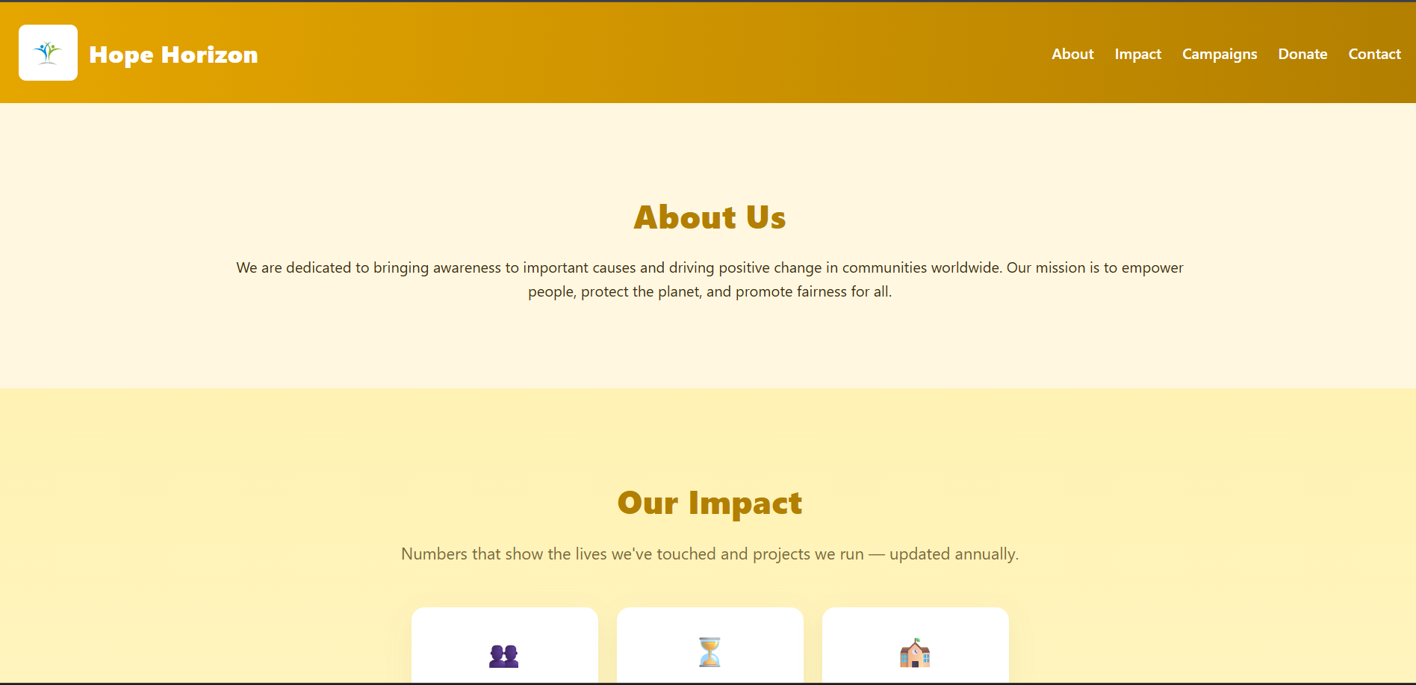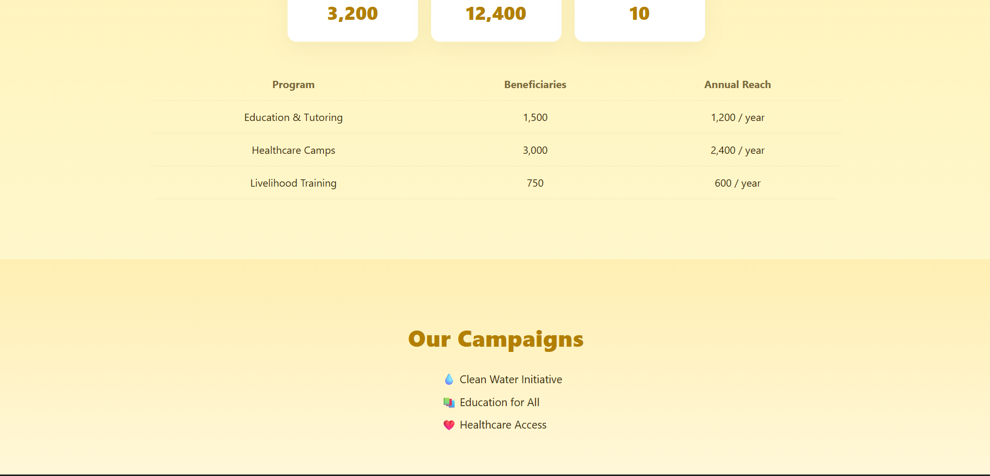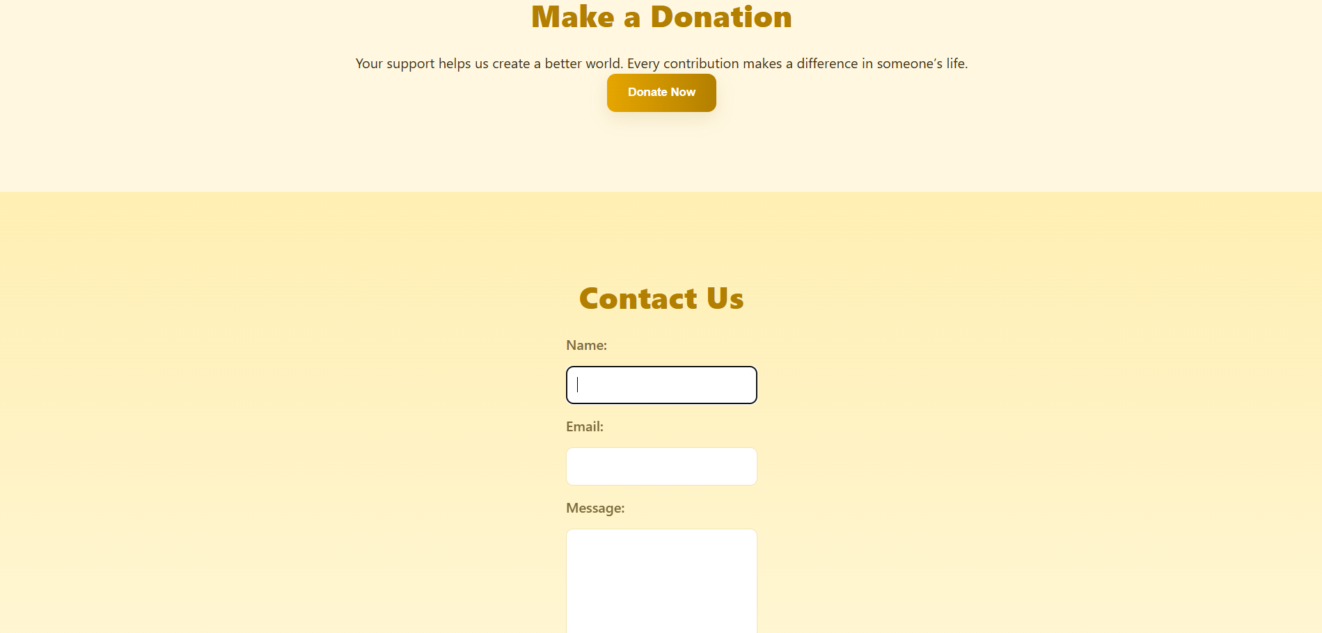



## 14. Conclusion

## The NGO Awareness Website successfully delivers a clean, responsive, and accessible platform to inform and engage the public about the organization’s mission, activities, and impact. By combining structured HTML5 with visually appealing CSS3 design, the site effectively communicates key information while encouraging participation through volunteering and advocacy. The focus on simplicity, responsiveness, and accessibility ensures that users across all devices can easily navigate and understand the content. While the current version is limited to static content, it establishes a strong foundation for future enhancements such as online donations, interactive dashboards, and real-time updates. This project demonstrates how thoughtful front-end design can strengthen outreach and foster meaningful community engagement for NGOs.

## 15. References

• L&T LMS: https://learn.lntedutech.com/Landing/MyCourse