CGAN

Epoch 15

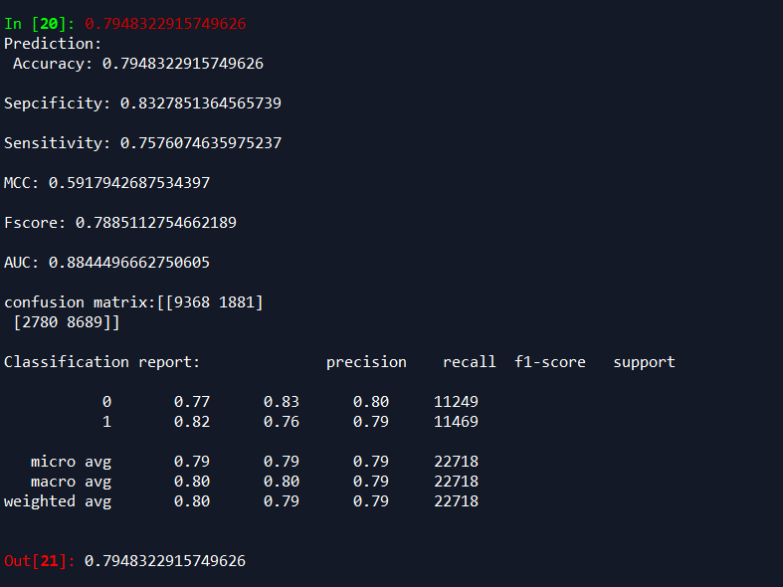

Epoch 21

