Deployment Proof — Fraud Detection System
Docker containerization and Render live deployment, with verified evidence
Prepared by: Thunga Sahithi Brunda

1. Docker — Local Containerized Run
The fraud detection API was built into a Docker image and run as a container locally. The screenshots below are from that live container session — the Swagger UI shown is being served directly from inside the running container, not the bare Python process.

1.1 Health Check — Container Responding
A GET request to the root endpoint confirms the containerized API is live and reports the trained model's PR-AUC (0.867), read directly from the deployed model artifact.
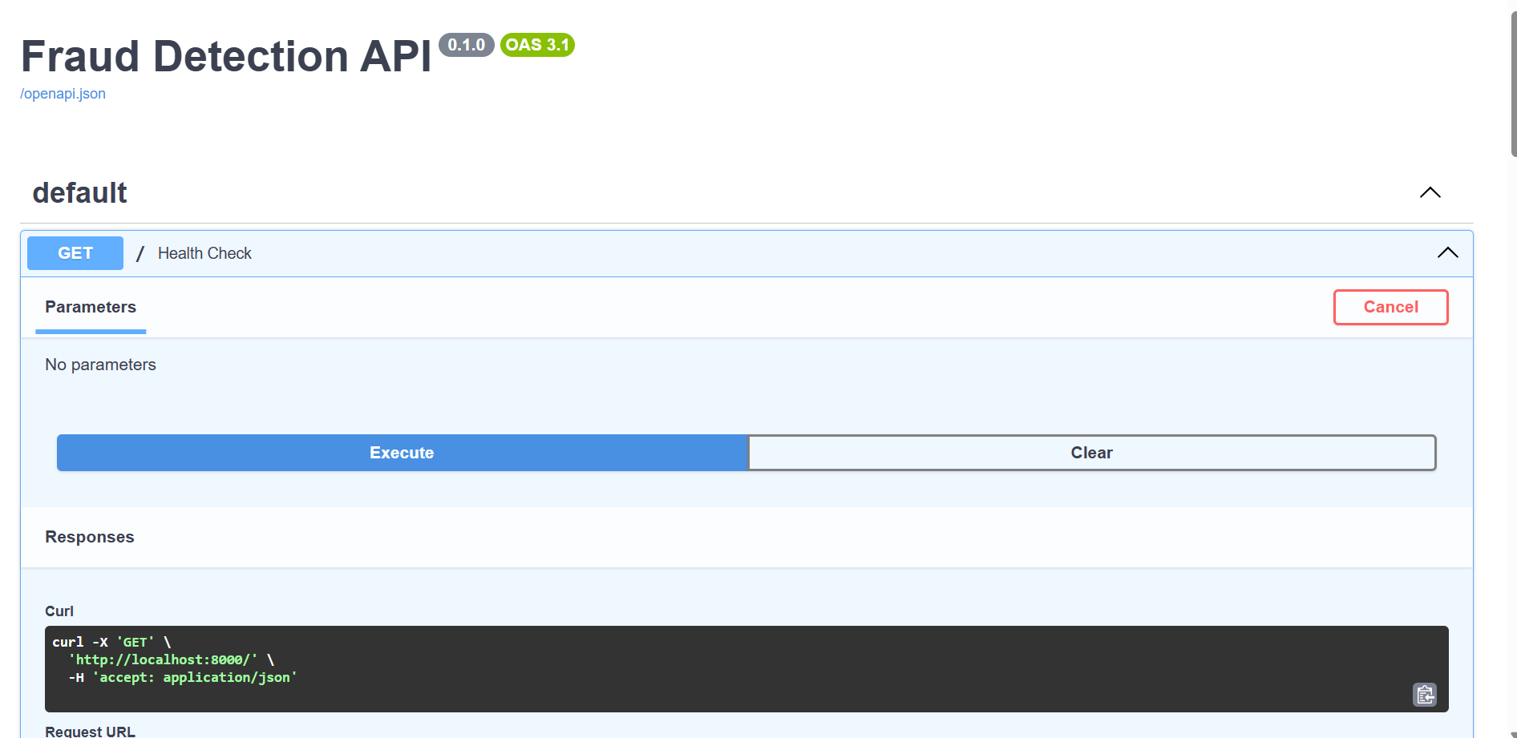
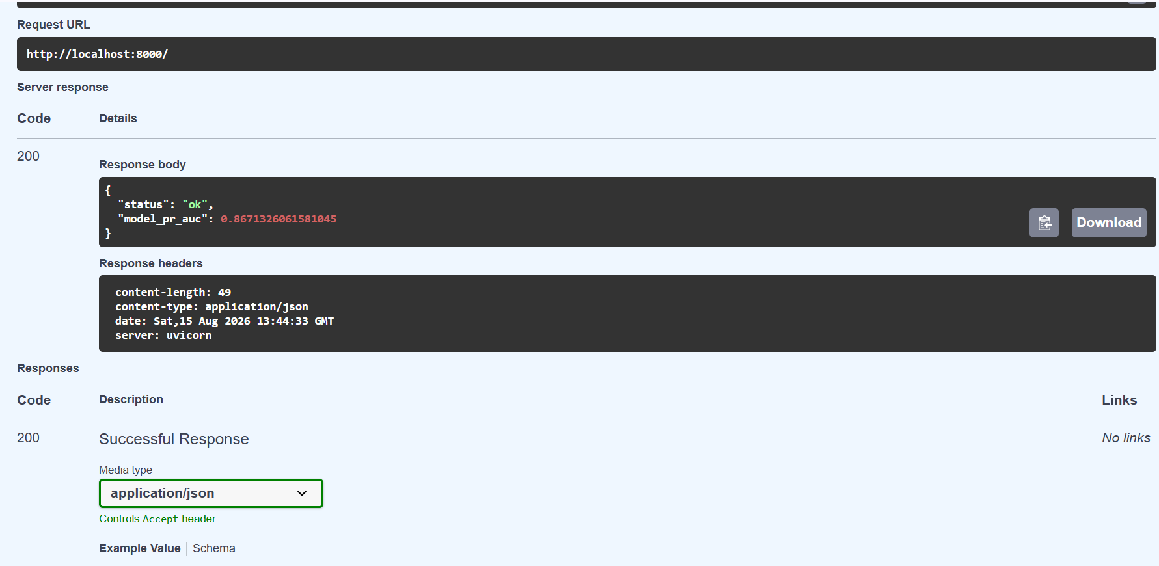
Response: {"status": "ok", "model_pr_auc": 0.8671326061581045} — confirmed live from the containerized app.

1.2 Fraud Prediction — Real Request/Response
A POST request to /predict, sent to the containerized API with a real transaction payload:
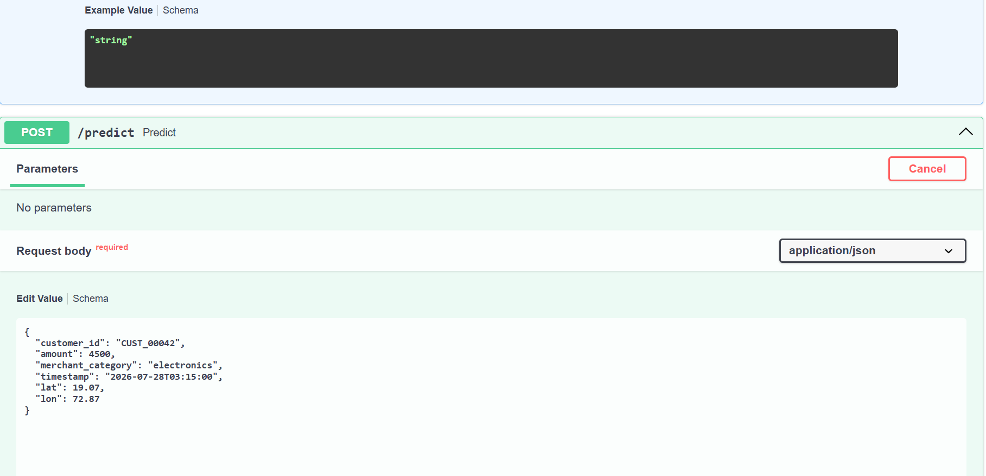
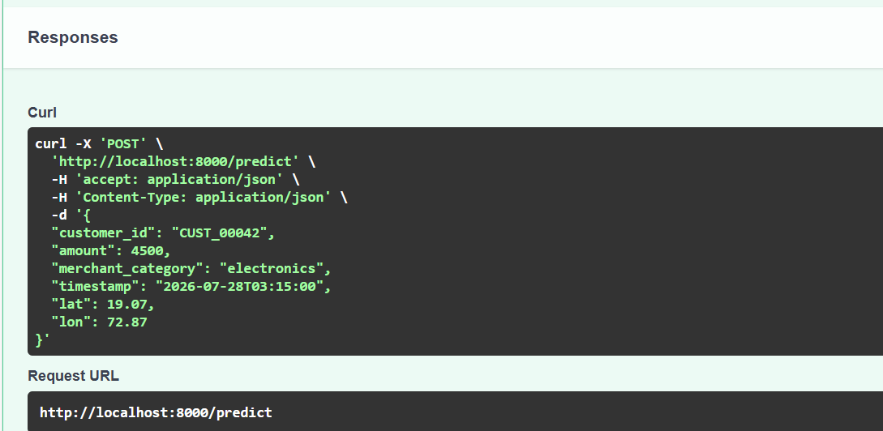
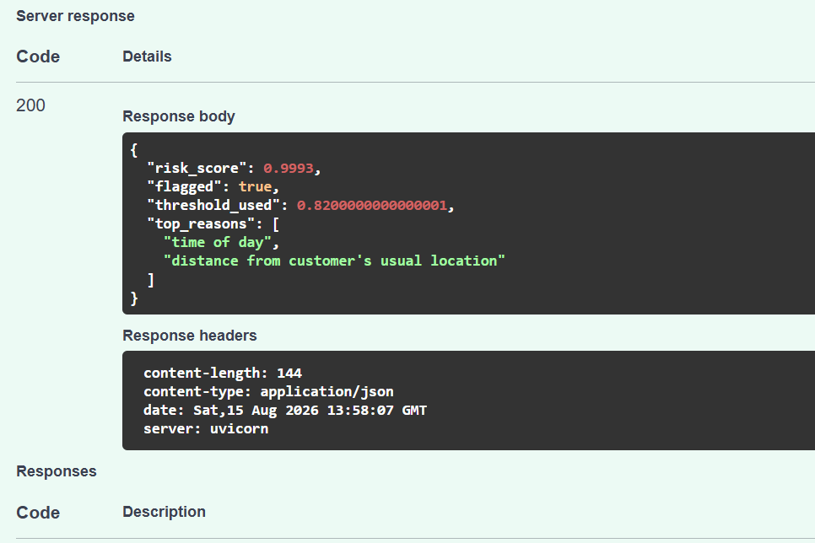
Response: risk_score 0.9993, flagged true, threshold_used 0.82, with the model's stated reasons ("time of day", "distance from customer's usual location") — the containerized model producing the same behavior verified earlier outside Docker.

1.3 API Schema
The full request/response schema, served by the containerized app's auto-generated OpenAPI documentation:
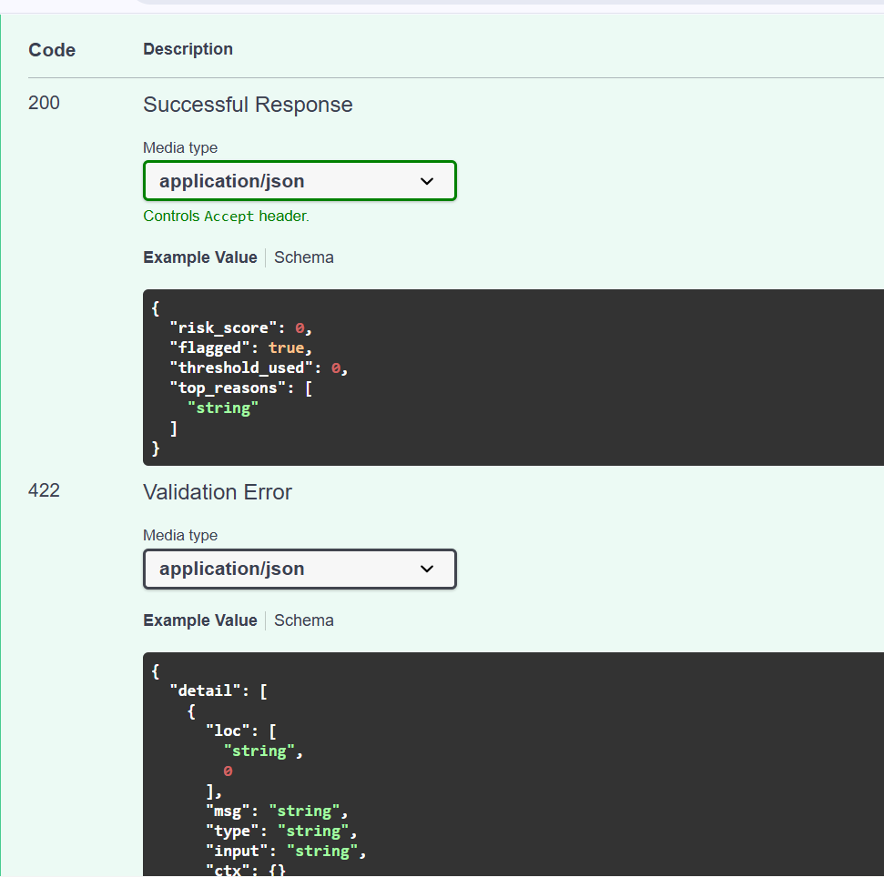
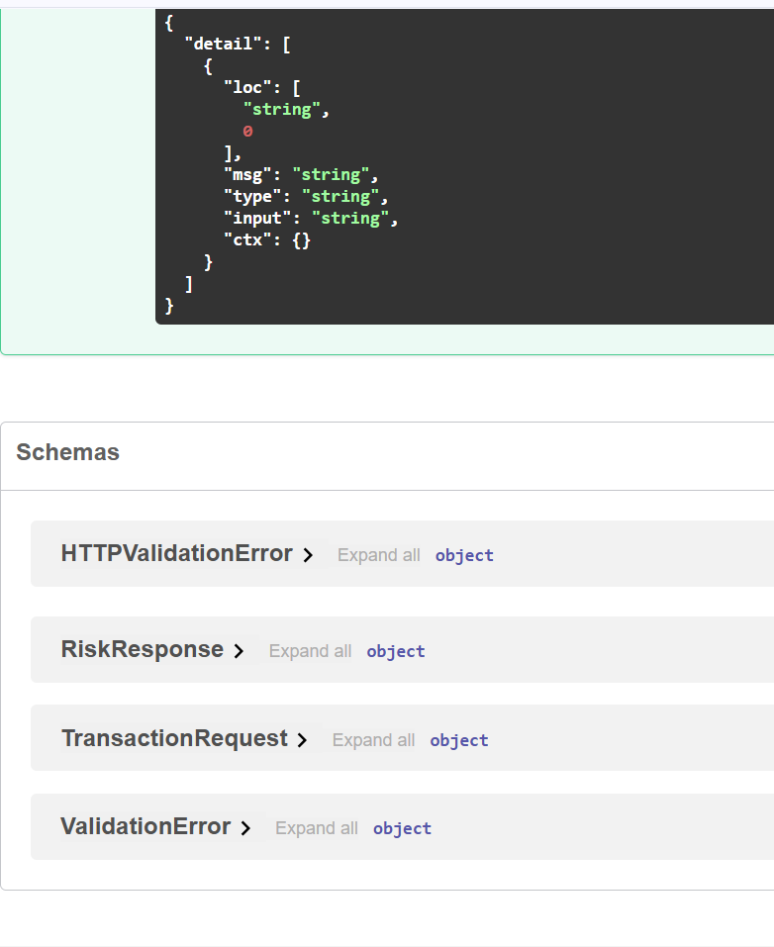

2. Docker Build & Run Logs
Raw logs exported from Docker Desktop, covering two separate build/run sessions on different dates — confirming the container has been rebuilt and re-verified more than once, not a single lucky run.
Metric | Value
Total log lines captured | 953
First log entry | 2026-07-29 08:41:08 UTC — Dockerfile build started
Container session 1 | priceless_proskuriakova — started 2026-07-29 09:10:13 UTC
Container session 2 | elastic_goldberg — started 2026-08-15 13:43:08 UTC
"Application startup complete" confirmed | Both sessions
POST /predict → 200 OK, total occurrences | 5 (across both sessions)
Last log entry | 2026-08-15 13:58:07 UTC — POST /predict, 200 OK
Both sessions show identical, clean startup sequences (dependency install from requirements.txt, model artifact loaded, Uvicorn server started on port 8000) with no errors, and every /predict request returned a 200 OK — full log file (docker_logs.csv) available alongside this document.

3. Render — Live Cloud Deployment
The same Docker image is deployed on Render (free tier) as a live, public web service.
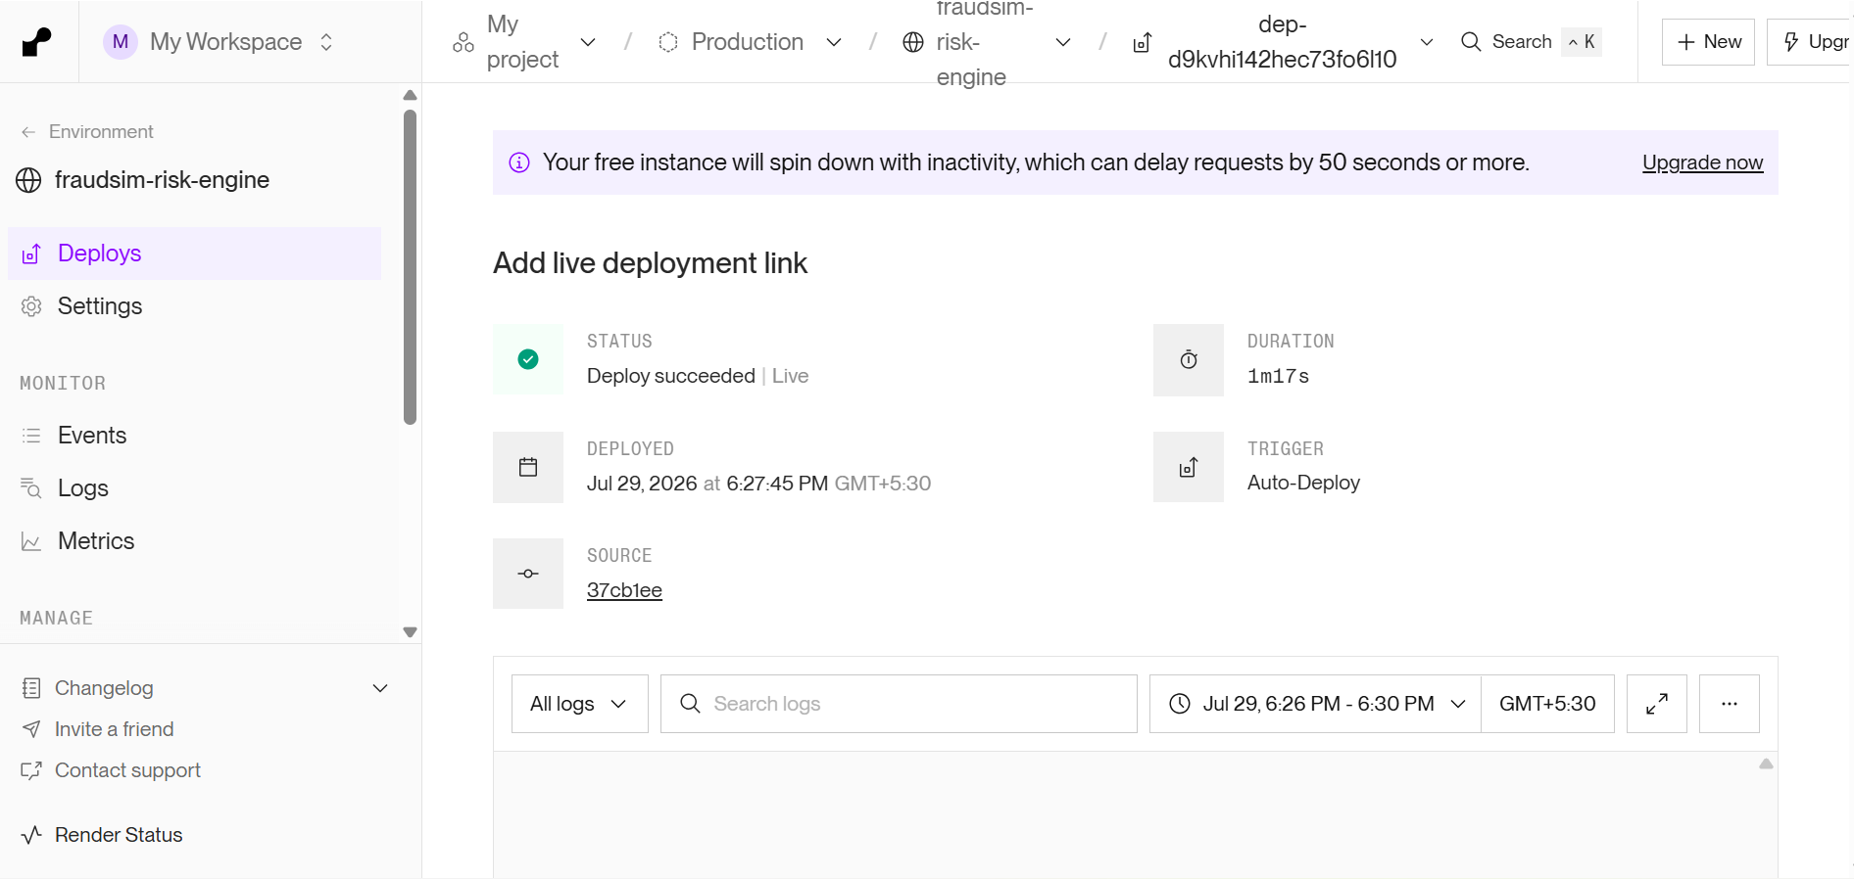
Render deploy dashboard: status "Deploy succeeded | Live", deployed 2026-07-29, deploy duration 1m17s, triggered automatically from a GitHub push (commit 37cb1ee).

4. Summary
Item | Status | Evidence
Docker image builds successfully | Confirmed | Build logs, Section 2
Container runs and starts cleanly | Confirmed | "Application startup complete", 2 separate sessions
API responds correctly inside container | Confirmed | Health check + /predict screenshots, Section 1
Deployed live on Render | Confirmed | Render dashboard, "Deploy succeeded | Live", Section 3
Live public URL actually responding | Not yet captured in this document | See note below
One honest gap: everything above proves the Docker container works and that Render confirms the deploy succeeded — but this document does not yet include a screenshot of the live public URL (https://fraudsim-risk-engine.onrender.com/predict) itself responding to a request. That's the one piece that most directly answers "does the deployed link actually work," as opposed to "did the deploy pipeline succeed." Worth adding before sending this to a recruiter — takes one more screenshot, same steps as Section 1.2 but against the live URL instead of localhost.

