|  |  |  |  |  |
| --- | --- | --- | --- | --- |
| Users  Features | | Admin | Instructor | Student |
| User | Add User | ✔ | **X** | **X** |
| Edit User | ✔ | **X** | **X** |
| Remove User | ✔ | **X** | **X** |
| Subject | Add Subject | ✔ | **X** | **X** |
| Edit Subject | ✔ | **X** | **X** |
| Remove Subject | ✔ | **X** | **X** |
| Enrollment | Enroll Student in class | ✔ | **X** | **X** |
| Drop Student in class | ✔ | **X** | **X** |
| Display/ List of students | ✔ | **X** | **X** |
| Schedule Class | In-Process Class | ✔ | ✔ | ✔ |
| Add Class | ✔ | ✔ | **X** |
| Display/ List of Class | ✔ | ✔ | ✔ |
| Edit Class | ✔ | ✔ | **X** |
| Remove Class | ✔ | ✔ | **X** |
| Grade | Add Grade | ✔ | ✔ | **X** |
| Edit Grade | ✔ | ✔ | **X** |
| Display Grade | ✔ | ✔ | ✔ |
| Send Email/Message | | ✔ | ✔ | ✔ |
| Audio/Video Call | | **X** | ✔ | ✔ |

Old:

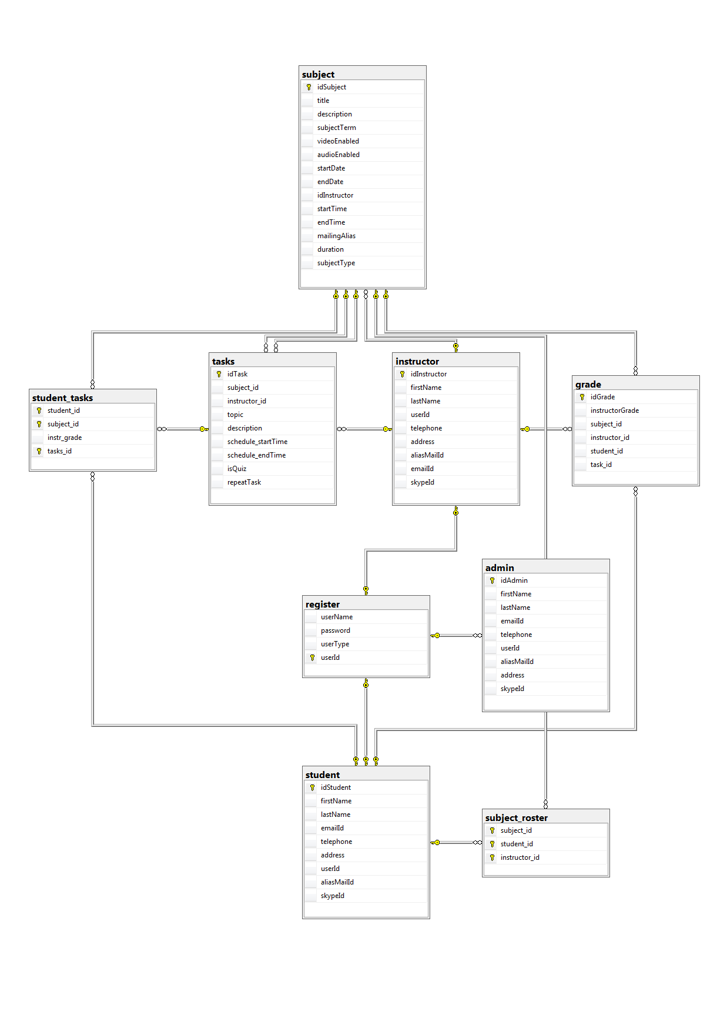

New:

