Annadanam – A Sacred Offering to the Divine

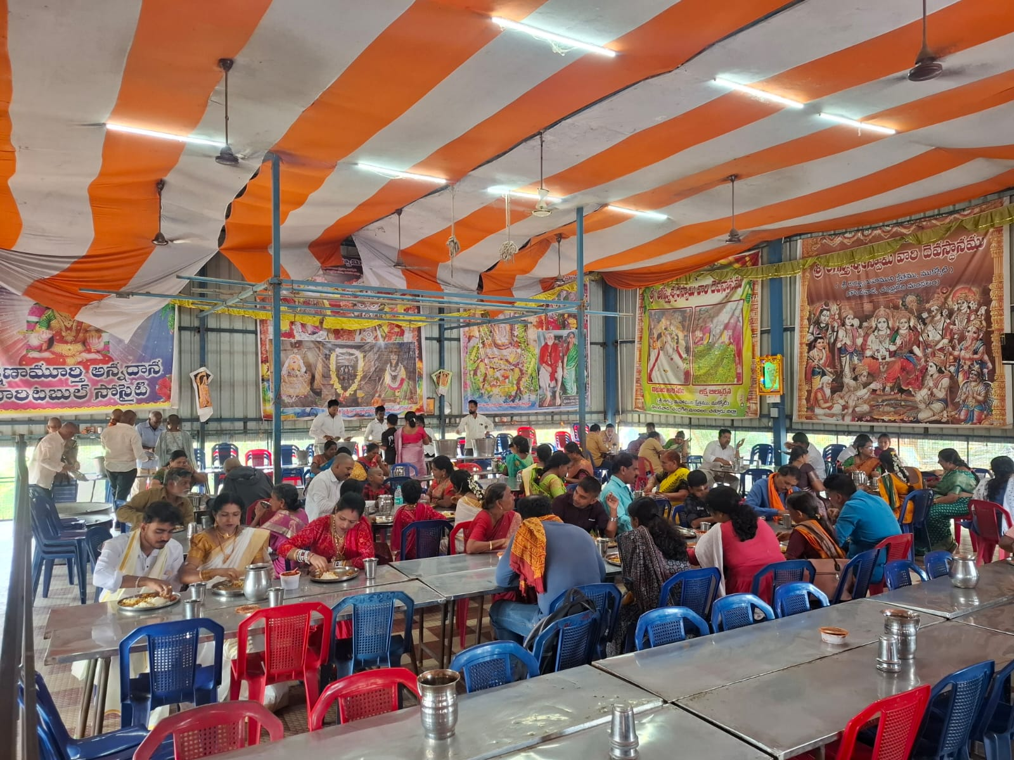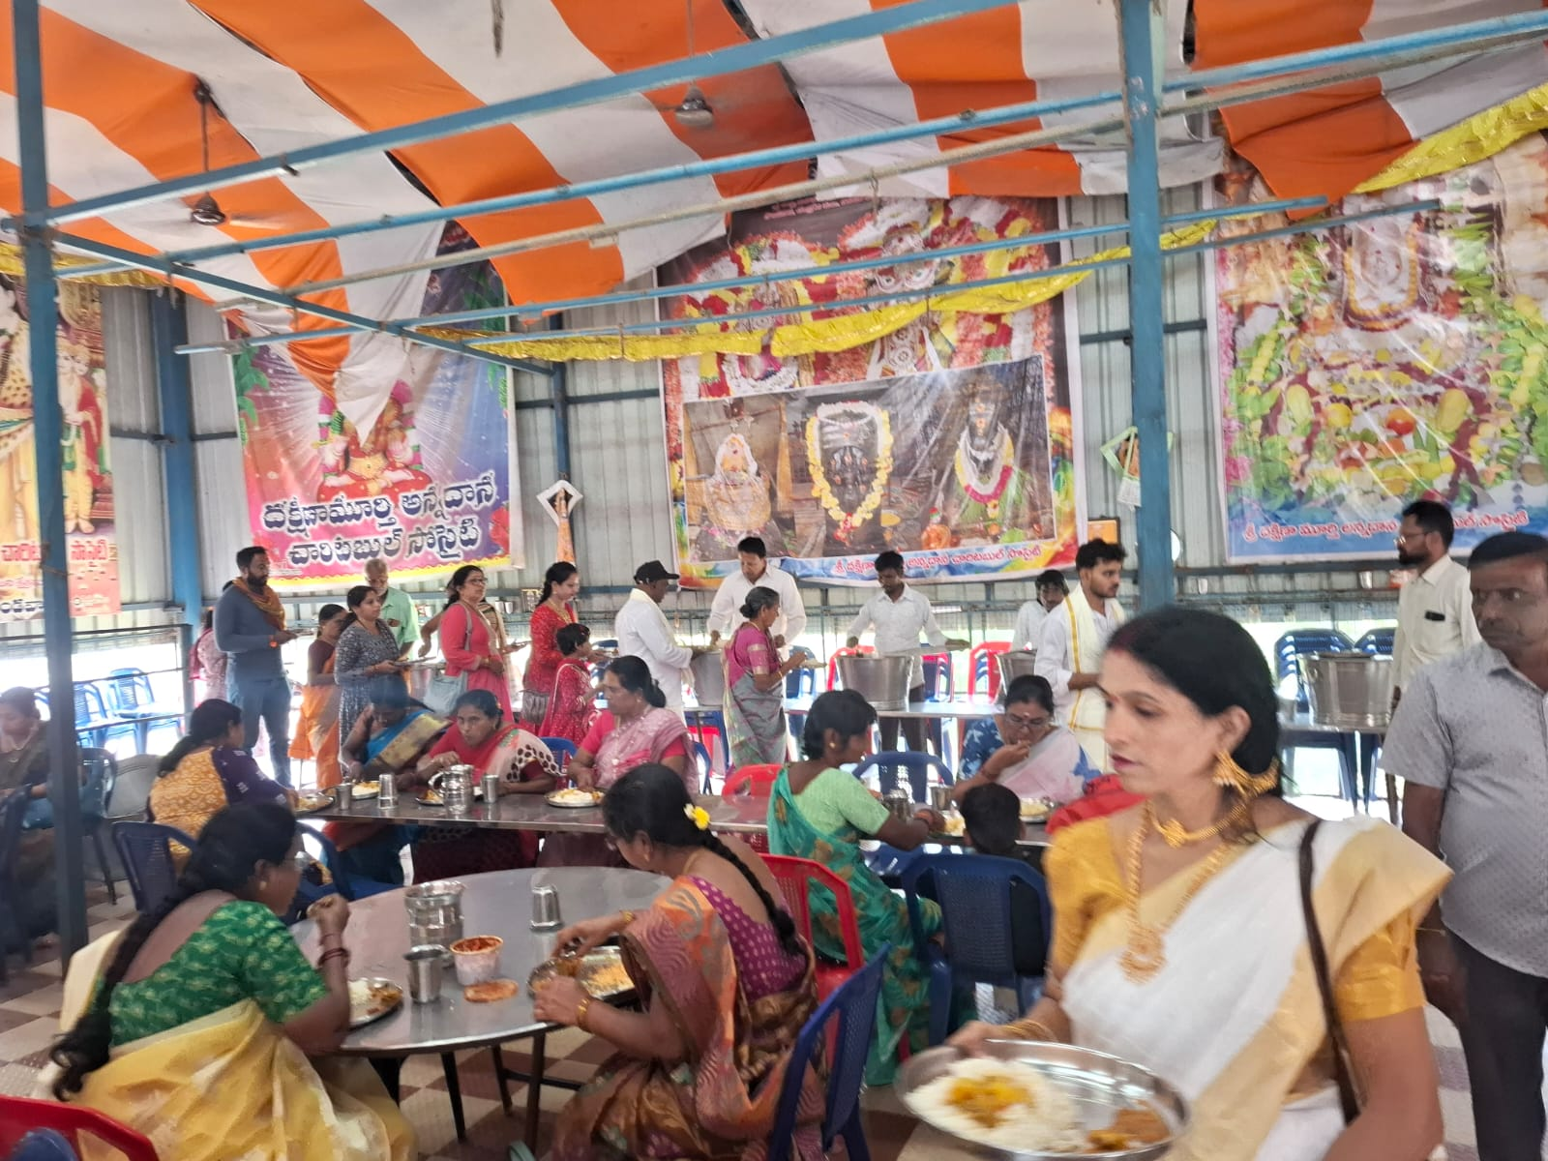

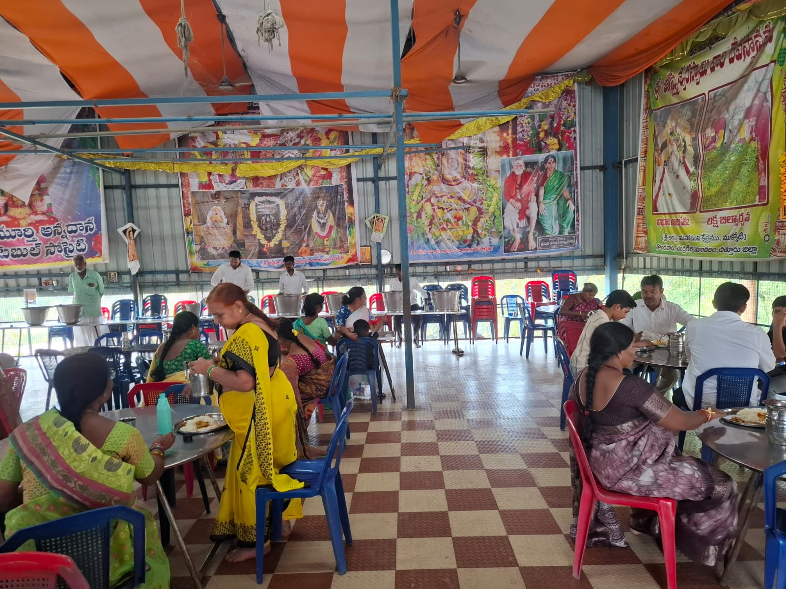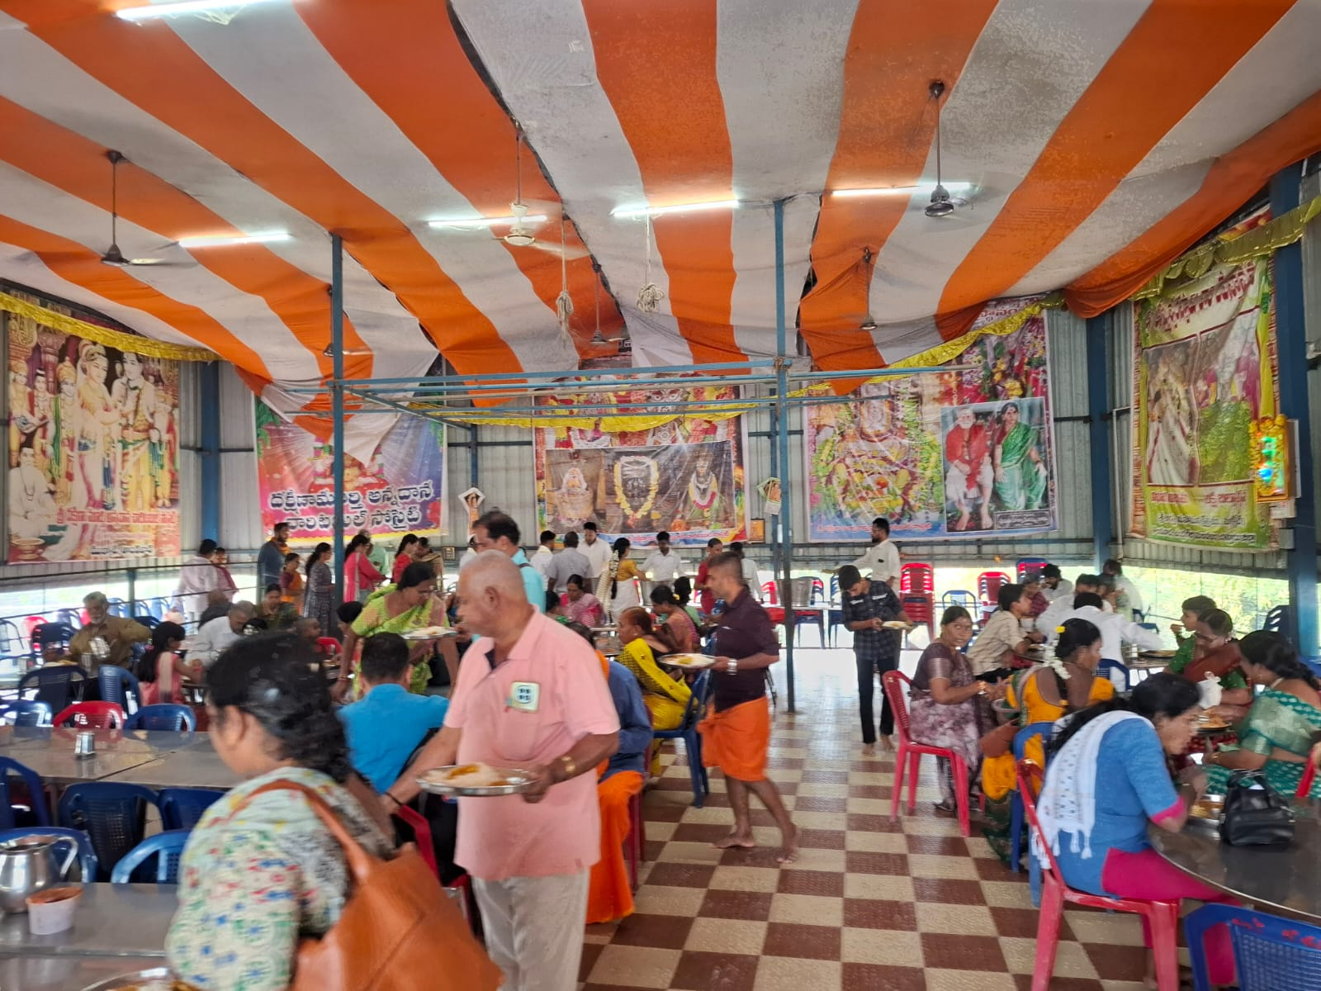
With the divine blessings of the Lord Agastheeshwara, the Trust humbly renders Annadanam, one of the most sacred forms of service, to visiting devotees. As per our ancient tradition, “Annam Parabrahma Swaroopam”—food is considered a divine form of the Supreme.
Every day, free, wholesome, and sanctified meals (Anna Prasadam) are lovingly served to all devotees at Sri Agastheeshwara Temple, Thondavada, at 12:30 PM. Through this noble service, nearly 300–400 pilgrims are blessed daily by partaking in the Prasadam offered to the Lord.
Devotees are graciously invited to sponsor Annadanam on auspicious occasions such as birthdays, wedding anniversaries, or other sacred days, as an act of devotion and gratitude. Donors may also have the blessed opportunity to participate personally in the Anna Prasadam Vitharanam (distribution) on the chosen day.
Those wishing to partake in this divine service or seeking further details regarding donations are requested to kindly contact the Temple Trustee.
May the Lord’s blessings shower abundantly upon all those who support and participate in this sacred Annadanam.
For online donations towards Annadanam at Lord Agastheeshwara Swamy Temple, please scan the UPI QR code below.

