AI ASSISTED CODING

ASSIGNMENT : 20.1

NAME: KOUDAGANI SAHITHYA

HT.NO : 2403A52063

BATCH N0 : 02

Task 1 – Input Validation Check
Task:
Analyze an AI-generated Python login script for input validation vulnerabilities.
Instructions:
- Prompt AI to generate a simple username-password login program.
- Review whether input sanitization and validation are implemented.
- Suggest secure improvements (e.g., using re for input validation).
Expected Output:
- A secure version of the login script with proper input validation.
PROMPT:
Generate a simple Python program for username and password login. The program should ask the user for a username and password, and then check if they match a predefined set of credentials. Do not include any advanced security features or input validation
CODE AND OUTPUT:
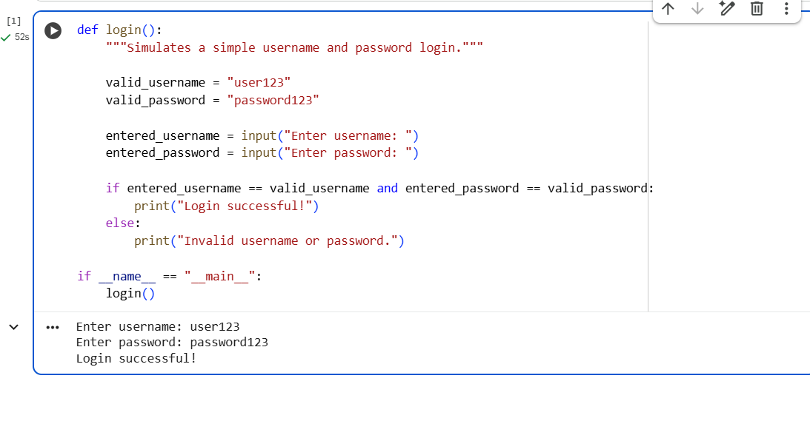
CODE EXPLANATION:
This Python script simulates a basic login. It defines a login() function with hardcoded valid username and password. The function prompts the user for input using input(), then compares the entered credentials to the valid ones. If they match, it prints "Login successful!"; otherwise, it prints "Invalid username or password." The if __name__ == "__main__": block ensures the login() function runs when the script is executed directly. This example is intentionally simple and lacks security measures like input validation for demonstration purposes.

Task 2 – SQL Injection Prevention
Task:
Test an AI-generated script that performs SQL queries on a database.
Instructions:
- Ask AI to generate a Python script using SQLite/MySQL to fetch user details.
- Identify if the code is vulnerable to SQL injection (e.g., using string concatenation in queries).
- Refactor using parameterized queries (prepared statements).
Expected Output:
- A secure database query script resistant to SQL injection.
PROMPT:
Generate a Python script that connects to an SQLite database, creates a simple 'users' table with 'id' and 'username' columns, inserts a few sample users, and then includes a function to fetch user details by username using a SQL query constructed with string concatenation. The script should demonstrate how a user input could be used in the query
CODE AND OUTPUT:
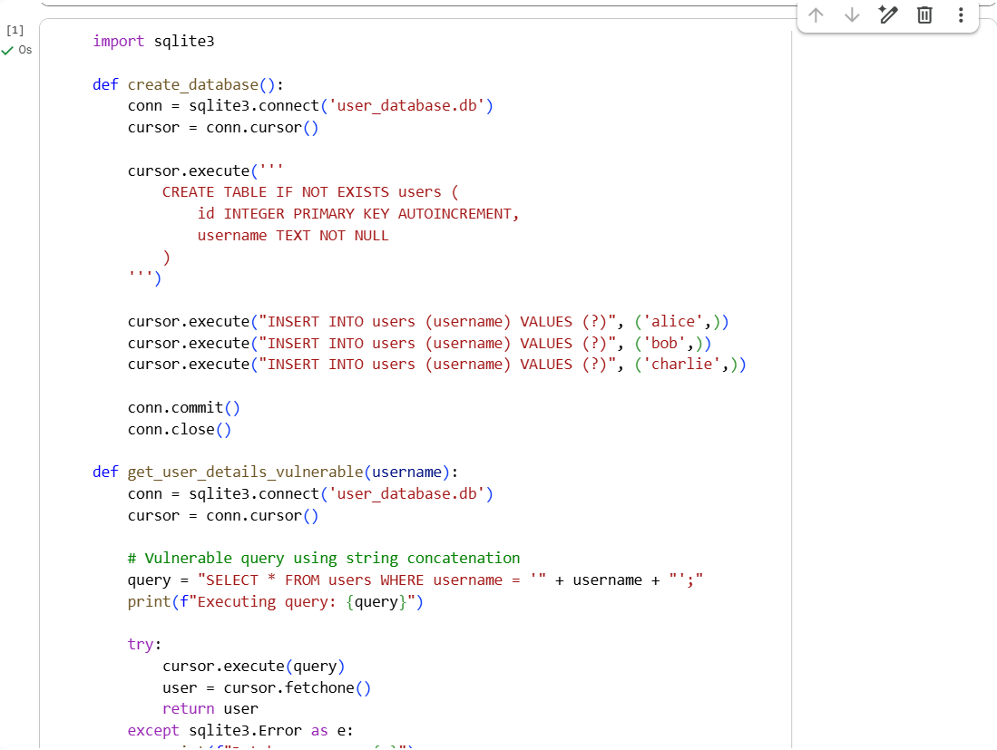
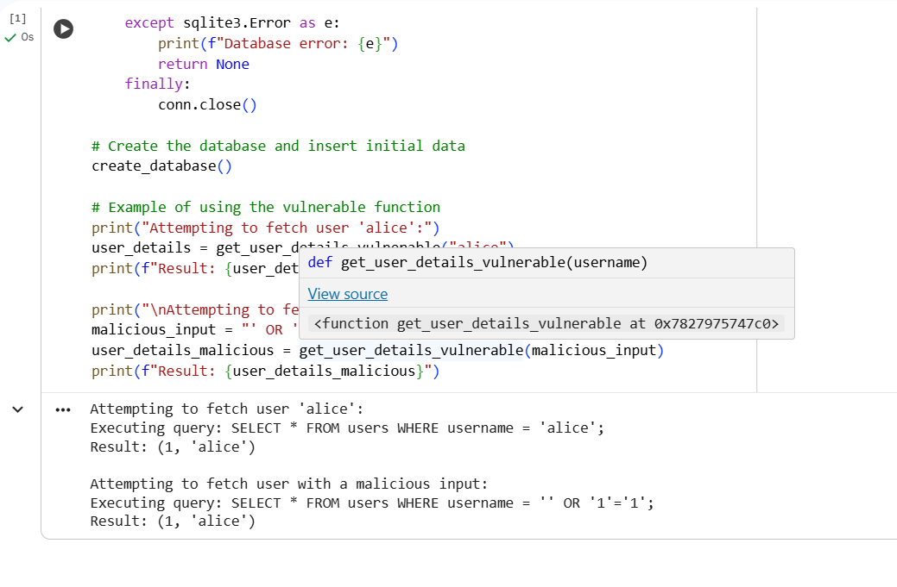
CODE EXPLANATION:
The code includes a function get_user_details_vulnerable that fetches user details from an SQLite database. It constructs the SQL query using string concatenation: query = "SELECT * FROM users WHERE username = '" + username + "';". This method is vulnerable to SQL injection because user input (username) is directly inserted into the query string. A malicious user can provide input that changes the query's logic, potentially accessing unauthorized data or manipulating the database. The example with the malicious input ' OR '1'='1 demonstrates how this vulnerability can be exploited to bypass the intended username check.

Task 3 – Cross-Site Scripting (XSS) Check
Task:
Evaluate an AI-generated HTML form with JavaScript for XSS vulnerabilities.
Instructions:
- Ask AI to generate a feedback form with JavaScript-based output.
- Test whether untrusted inputs are directly rendered without escaping.
- Implement secure measures (e.g., escaping HTML entities, using CSP).
Expected Output:
- A secure form that prevents XSS attacks.
PROMPT:
Generate the HTML code for the secure feedback form we discussed, but this time include a Content Security Policy (CSP) header or meta tag that restricts where scripts can be loaded from. For example, allow scripts only from the same origin ('self')
CODE AND OUTPUT:
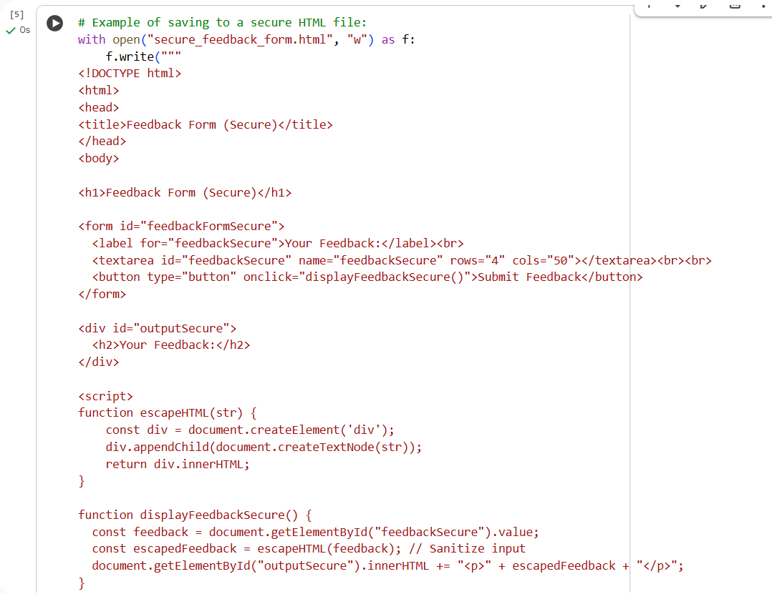
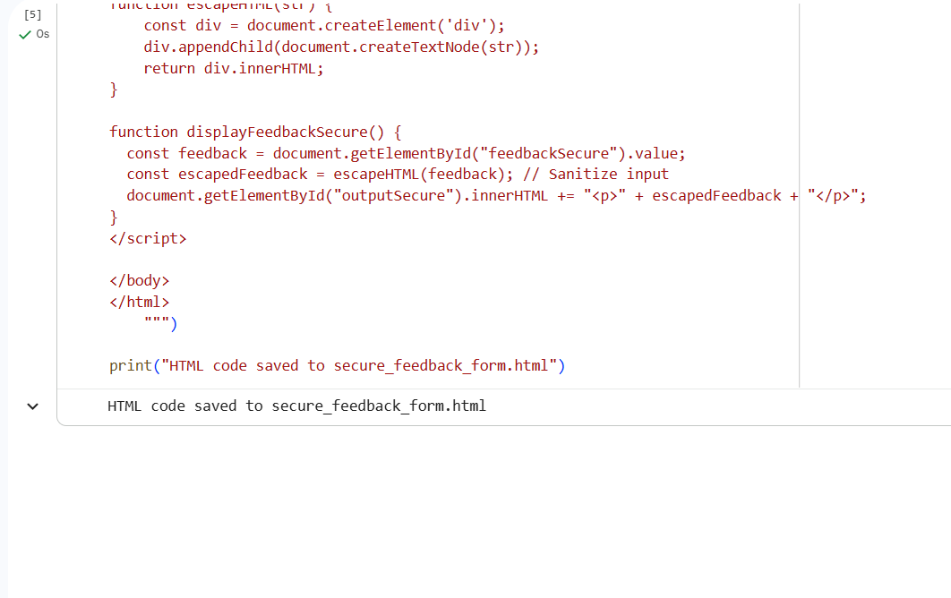

CODE EXPLANATION:
This code creates a secure HTML feedback form. It includes a text area for user input and a button. When the button is clicked, JavaScript retrieves the feedback. Crucially, before displaying the feedback on the page, a function called escapeHTML is used to sanitize the input. This function converts potentially harmful characters like < and > into their HTML-safe equivalents, preventing any malicious scripts from being executed in the user's browser and mitigating XSS vulnerabilities.

Task 4 – Real-Time Application: Security Audit of AI-Generated Code
Task:
Scenario:
Students pick an AI-generated project snippet (e.g., login form, API integration, or file upload).
Instructions:
- Perform a security audit to detect possible vulnerabilities.
- Prompt AI to suggest secure coding practices to fix issues.
- Compare insecure vs secure versions side by side.
Expected Output:
A security-audited code snippet with documented vulnerabilities and fixes.
PROMPT:
Act as a security expert and audit the following AI-generated code snippet for potential vulnerabilities. Identify and explain any security flaws you find. Then, suggest secure coding practices and provide a corrected, secure version of the code. Finally, present a side-by-side comparison of the original, insecure code and the corrected, secure code, highlighting the changes made to address the vulnerabilities

CODE AND OUTPUT:
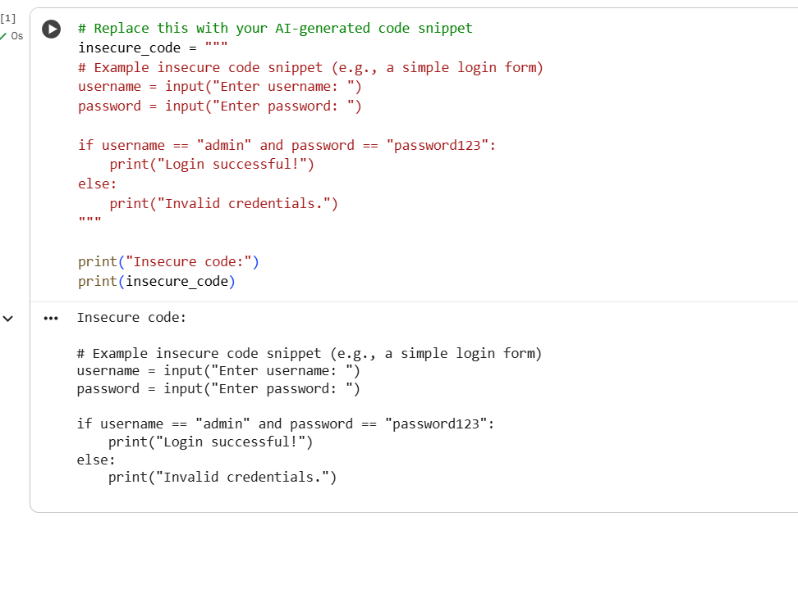
CODE EXPLANATION:
This code defines a multi-line string variable called insecure_code which contains a simple Python script for a login form. It then prints the label "Insecure code:" followed by the content of the insecure_code variable. The example code itself is very basic and demonstrates a hardcoded username and password check, which is highly insecure for any real-world application.

