**Inventory System – iOS Application**

User Manual for Basic User

**Vision Quest**

Sai Suneel Reddy Challa

Jeevitha Kamatham

Manoj Kumar Kotte

Meghana Thakkellapati

Sahithya Vuppala

Date: 11/27/2016

Prepared for

44-691 Computer Science Graduate Directed Project – I

Fall 2016

Instructor: Zhengrui Qin

Client: Zhengrui Qin

1. **Introduction:**

This is an iOS Mobile application that helps a businessman manage his online store.

**Configuration:**

This is an iOS Mobile application, which supports for all kinds of iPhone like iPhone 6, iPhone 6s and iPhone 6 plus with OS version of minimum 9.0

1. **Installation Instructions:**

**Step-1:** Download Xcode from App Store into your Mac system. Launch the .dmg file you downloaded. Follow the setup wizard to install Xcode Studio.

**Step-2:** Download inventory iOS project provided

**Step-3:** Select the device you want to run on at the top left corner of Xcode and click on run icon to build and run the app. The app runs on the simulator and can use the app.

**Step-4:** To deploy the app on your mobile device. Connect your mobile device and and select your mobile device under simulator. Run the app, you will be asked to enter the developer credentials. Enter your credentials, app gets deployed in the mobile device and you can use it.

1. **Basic user:**
   1. **Registration:**

* The new user have to register/ create account first. The application first launches the login screen, where there will be an option “New User ?”.
* If user clicks on it, he/she will be navigated to the registration screen.
* The user registers by providing information like full name, e-mail id, username, password etc. When user clicks on “Submit” button, the user will be successfully created an account and navigated to know your app screen.
* The user can cancel the registration by clicking on “cancel” button, which navigates to login page.

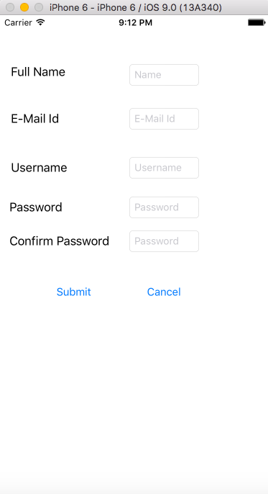

**Fig: 3.1.1 Registration screen**

* 1. **Login:**
* The basic user who have account prior directly login into the application by entering information - username and password.
* After entering the details the user should click on “submit” button.
* With correct username and password, the user gets navigated to the home screen of the application.

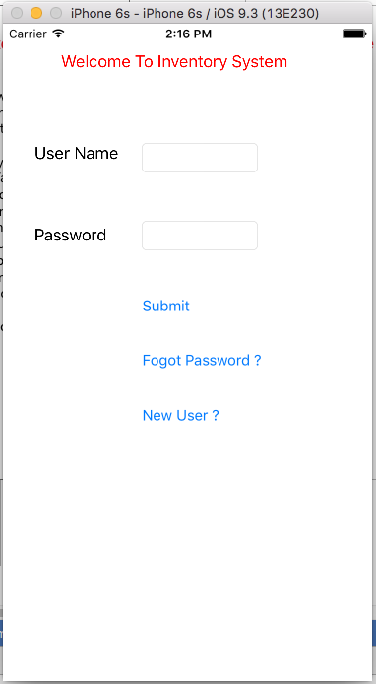

**Fig: 3.2.1 Login screen**

* 1. **Announcements Home Page:**
* Once the user successfully login into account. He/she will be directed to the Announcements page.
* The Announcements screen shows the list of all the announcements.
* When user clicks on a particular announcement, the application directs the user to the selected announcement.

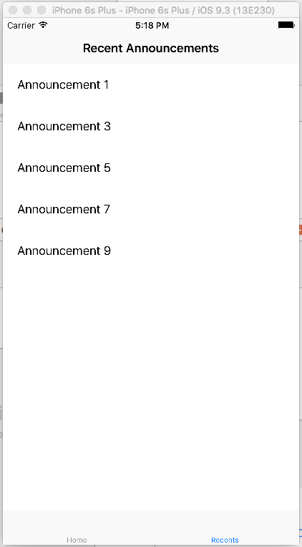

**Fig: 4.3.1 Announcements Screen**

* 1. **Select Announcement:**
* The select announcement screen shows the Announcements details

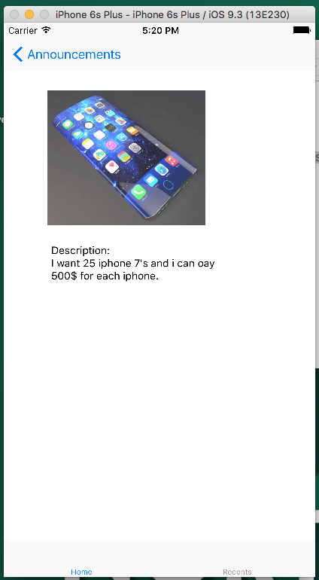 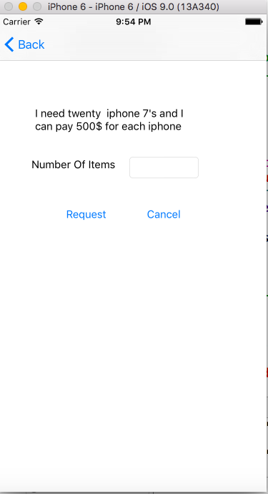

**Fig: 4.4.1 Select Announcement screen**