**PROTOTYPE DESIGN- INVENTORY SYSTEM –iOS**

**ER –DIAGRAM**

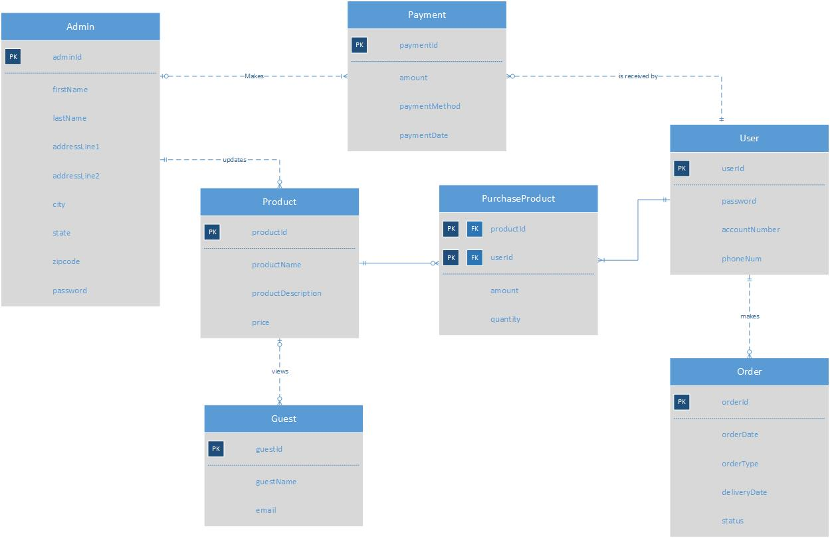

**INITIAL SCREENS**

This is the login screen of the Inventory System project which enables user to login and guest to request to access as a user.

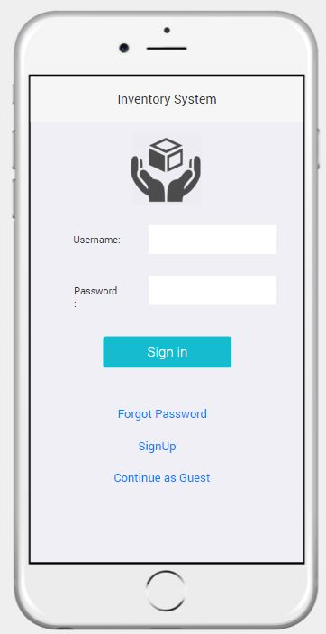

This is the side bar menu of the Admin page which consists of his profile , clients involved and his requests and guest approvals

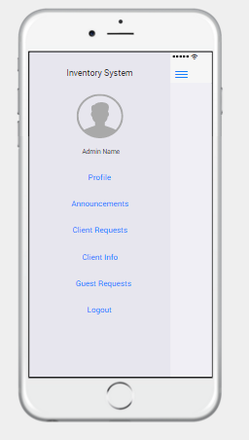

This screen shows the account information of the admin

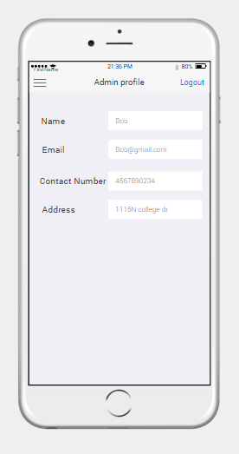

This screen shows the announcents

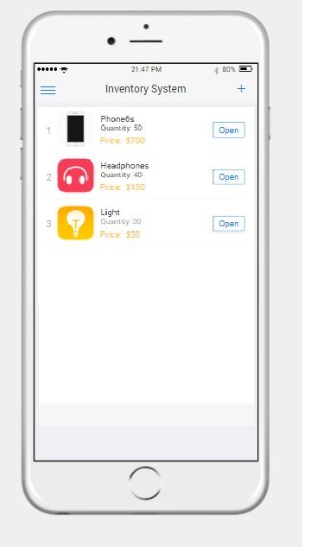

This scrren shows the clients and their information

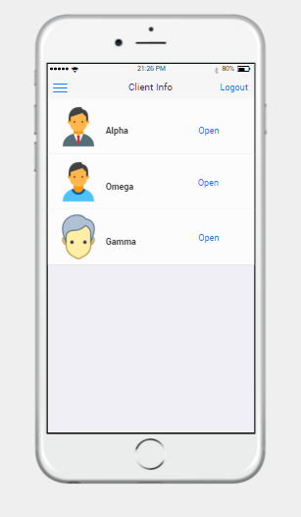 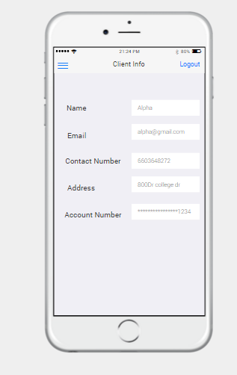

This screen shows the requests made by the client

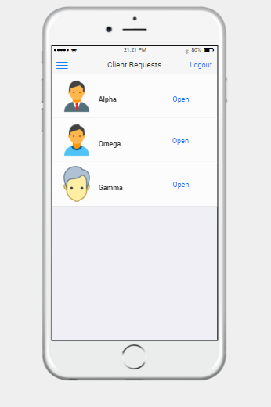

This screen shows the guest requests and their information

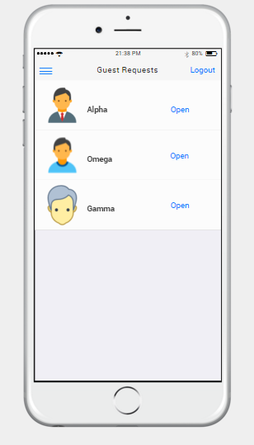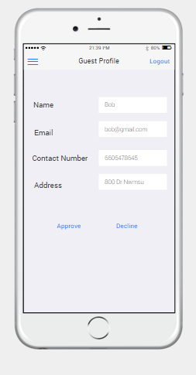

This screen shows the client login page and contains their profile and announcements

