**Procrastination as temporal decision making**  
*Sahiti Chebolu and Peter Dayan*

**Background**

Procrastination is a prevalent phenomenon, with a significant proportion of the population reporting interference and even harm from such delaying [1]. Why do people put off tasks despite their best intentions, or why do they deliberately defer in the face of prospective failure?

**Methods**

In this project, we aim to elucidate the plausible mechanisms behind such choices in a sequential decision-making framework using Markov Decision Processes. We model procrastination as a choice in time of delaying the starting, continuation or completing of a task at hand.

**Results**

We begin with simulating the effects of previously suggested mechanisms like those dependent on temporal discounting and related inconsistencies that stem from non-exponential and multiple discount factors. Moving beyond, we explore other possible routes including the resolution of uncertainty, anticipation of better conditions, expected or unexpected changes in circumstances which explain delays in cases where discounting fails to or is absent altogether. The simulations are carried out in a variety of scenarios, carefully delineating the influence of various aspects of task structure on these explanations.

**Outlook**

A next step would be to study learning mechanisms that might reinforce or diminish the aforementioned behaviors. A future aim is to test predictions from our theory using experimental data. Our simulations can offer a practically useful definition and classification of procrastination, providing insights to design future experiments and recommend interventions.

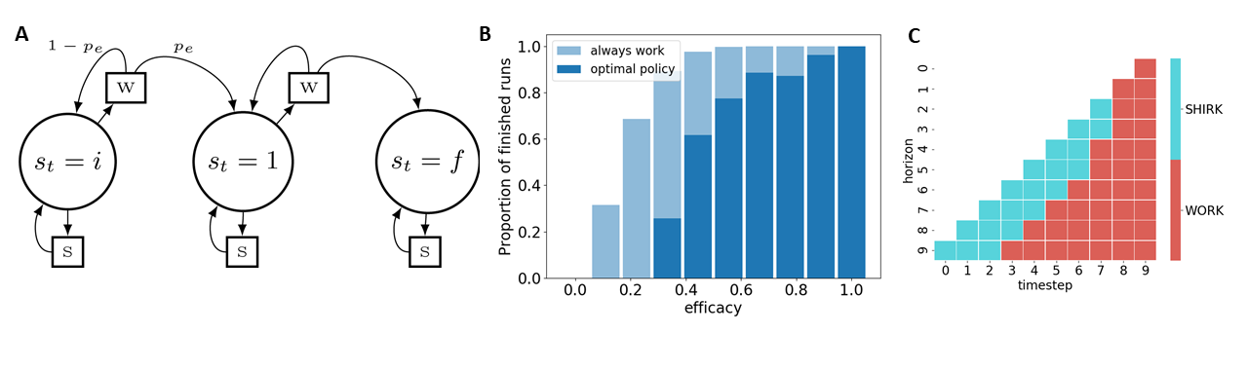 Figure 1: A. Graphical representation of an assignment submission problem with three states (i: initial, 1: intermediate state, f: final state) and two actions (w: work and s: shirk). B. Proportion of assignments a rational procrastinating agent completes vs one that always works. C. Policy of a defecting agent that shows a reversal in preference of when to start working as a function of horizon.

*References:*

[1] Steel, P. (2007). The nature of procrastination: A meta-analytic and theoretical review of quintessential self-regulatory failure. Psychological Bulletin, 133(1), 65–94. https://doi.org/10.1037/0033-2909.133.1.65