**Procrastination as temporal decision making**  
*Sahiti Chebolu and Peter Dayan*

**Background**

Procrastination is a prevalent phenomenon, with a significant proportion of the population reporting interference and even harm from such delays [1]. Why do people put off tasks apparently despite their best intentions, or why do they deliberately defer in the face of prospective failure?

**Methods**

In this project, we aim to elucidate plausible mechanisms behind such choices in a sequential decision-making framework using Markov Decision Processes (MDPs) and Partially Observable MDPs. We model procrastination as a choice in time of delaying the start, continuation or completion of a task at hand.

**Results**

We begin with a taxonomy of different potential sources of procrastination. We then simulate the operation of mechanisms that have been previously suggested, including those dependent on temporal discounting and also inconsistencies that stem from non-exponential and differential discount factors for rewards and efforts. Moving beyond, we explore other possible routes including the resolution of uncertainty, anticipation of better conditions, expected or unexpected changes in circumstances. These explain varieties of procrastination that do not depend on discounting. The simulations illustrate a number of scenarios, and systematically delineate the influence of the multiple components of task structure.

**Outlook**

A next step will be to study learning mechanisms that might reinforce or suppress these routes to procrastination. A farther future aim is to test predictions from our theory using experimental data. Our simulations can offer a practically useful definition and classification of procrastination, providing insights into the design of future experiments and even potential interventions.

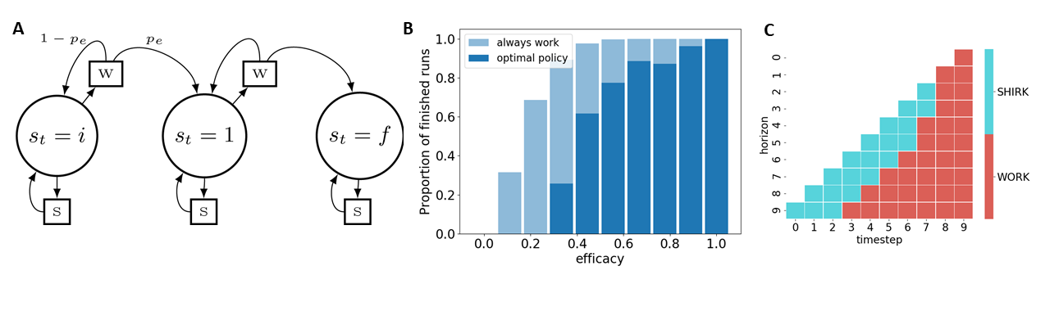 Figure 1: A. Graphical representation of an assignment submission problem with three states (i: initial, 1: intermediate, f: final state) and two actions (w: work and s: shirk). B. Proportion of assignments a rational procrastinating agent completes vs. one that always works. C. Policy of a defecting agent that shows a reversal in preference of when to start working as a function of horizon.

*References:*

[1] Steel, P. (2007). The nature of procrastination: A meta-analytic and theoretical review of quintessential self-regulatory failure. Psychological Bulletin, 133(1), 65–94. https://doi.org/10.1037/0033-2909.133.1.65