**Analysis Report**

In the given Students Performance data, there are 1000 rows and 7 columns

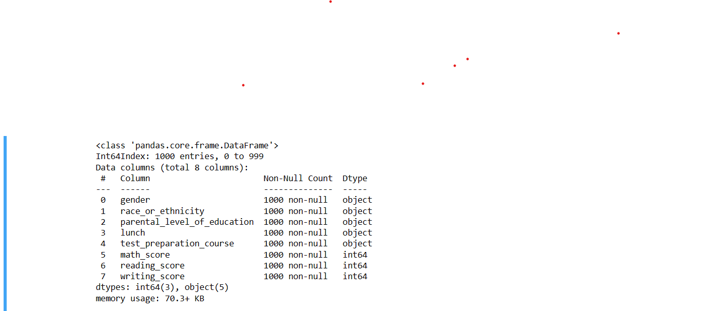

**Data Visualizations**

1. The Below Visualization is Pie Charts of Gender, Race/Ethnicity, Parental Education Level, and Lunch respectively.By this visualization, we see the occurrence of values and their distribution over the data

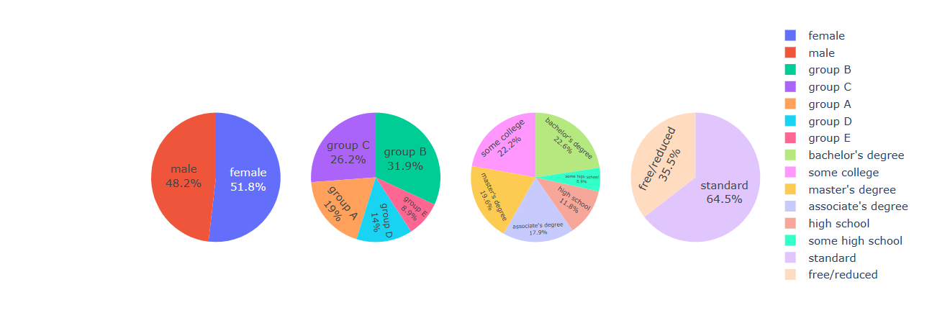

Gender Race/Ethnicity Parental Education Level Lunch

2. The below visualization is a heatmap of correlations over scores. By this visualization, we can conclude there is a positive and considerable correlation between math scores, writing scores, reading scores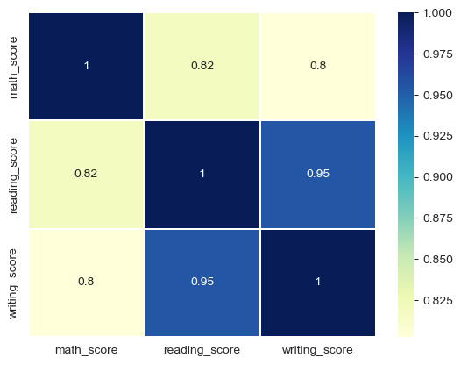

3. The below visualization depicts the analysis between parents’ education level of correlations over scores. By this visualization, the percentage of students with Parents whose education level is Bachelor’s and Master’s were provided standard lunch is better than the percentage of students with Parents whose education level is school and college

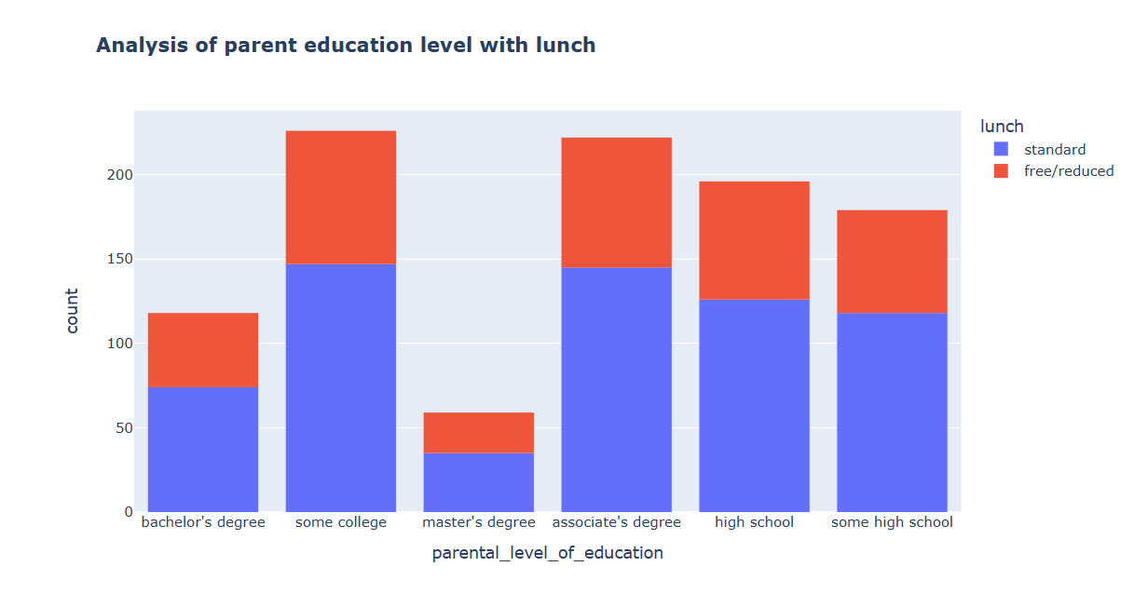

4. The below visualization depicts the analysis between parents’ education level and overall score. By this visualization, We can conclude that the overall marks of the students are directly proportional to the level of education of the parents

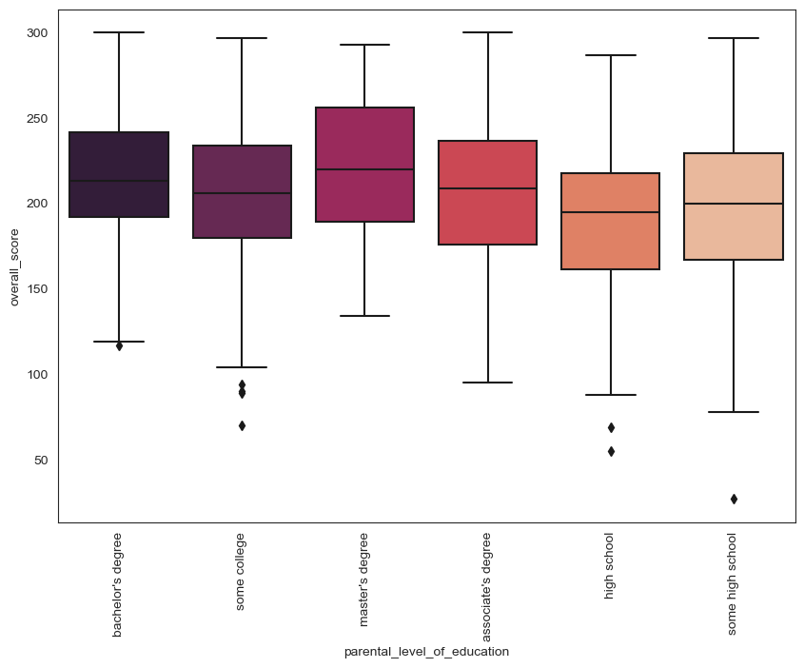

5. The below visualization helps us to analyze between gender and scores. By this visualization, We can conclude that female students performed well in reading and writing tests whereas male students performed well in math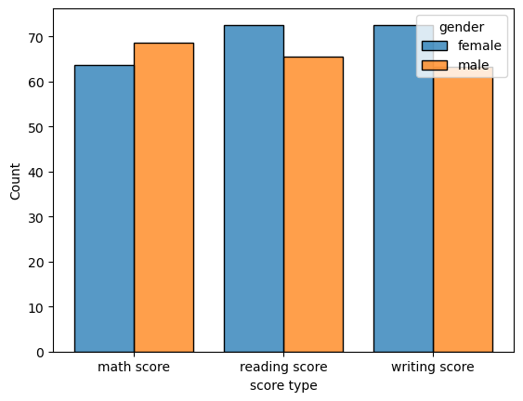

6. The below visualization helps us to analyze race/ethnicity and scores. By this visualization, We can conclude that students who belong to Group E scored well in the subjects compared to other groups