
Spatio-Temporal Analysis of Land Surface Temperature and Urban Heat Island Intensity using Deep Learning Based Classification MAJOR PROJECT REPORT submitted in partial fulfillment of the requirements
for the Award of the Degree of

BACHELOR OF TECHNOLOGY
In

INFORMATION TECHNOLOGY
By

PADMANABHUNI NAGA DURGA SAHITYA (228W1A1244)

PAKKI RAJESH (228W1A1245)

Under the Guidance of Dr.M.Suneetha, Ph.D Professor & Head

DEPARTMENT OF INFORMATION TECHNOLOGY V R SIDDHARTHA ENGINEERING COLLEGE
(AUTONOMOUS - AFFILIATED TO JNTU-K, KAKINADA)

Approved by AICTE &Accredited by NBA

KANURU, VIJAYAWADA-520007 ACADEMIC YEAR
(2025-26)

V.R.SIDDHARTHA ENGINEERING COLLEGE
(Affiliated to JNTUK: Kakinada, Approved by AICTE, Autonomous) (An ISO certified and NBA accredited institution)

Kanuru, Vijayawada – 520007
CERTIFICATE

This is to certify that this project report titled “Spatio-Temporal Analysis of Land Surface Temperature and Urban Heat Island Intensity using Deep Learning Based Classification” is a bonafide record of work done by by Padmanabhuni Naga Durga Sahitya (228W1A1244), Pakki Rajesh (228W1A1245)under my guidance and supervision is submitted in partial fulfillment of the requirements for the award of the degree of Bachelor of Technology in Information Technology, V.R. Siddhartha Engineering College (Autonomous under JNTUK) during the year 2025-26.

(Dr. M. Suneetha) (Dr. M. Suneetha)
Dean R&D, Professor &Head Dean R&D, Professor &Head
Dept. of Information Technology Dept. of Information Technology

EXTERNAL EXAMINER SIGNATURE
Date of examination:

DEPARTMENT OF INFORMATION TECHNOLOGY V.R.SIDDHARTHA ENGINEERING COLLEGE
PROJECT SUMMARY

S.No | Item | Description
1 | Project Title | Spatio-Temporal Analysis of Land Surface  Temperature and Urban Heat Island Intensity using Deep Learning Based Classification
2 | Student Names &  Numbers | Padmanabhuni Naga Durga Sahitya (228W1A1244)  Pakki Rajesh (228W1A1245)
3 | Name of The  Guide | Dr. M.Suneetha, Professor&Head
4 | Research Group | Geographic Information System & Remote Sensing
5 | Application Area | Environment
6 | Aim of the Project | To analyze the spatio-temporal variations of Land Surface Temperature (LST) and Urban Heat Island (UHI) intensity by examining land use and land cover (LULC) changes using remote sensing techniques and to evaluate the relationship between land cover transformations and surface temperature variations  over the study period (1994–2024).
7 | Project Outcomes | - Generated classified maps and datasets showing land cover types and temperature distribution patterns.  - Performed quantitative analysis of Urban Heat Island  intensity and its relationship with land cover changes and surface temperature.

Student Signatures 1.
2.
Signature of the Guide

ACKNOWLEDGEMENT

First and foremost, I sincerely salute our esteemed institution V.R SIDDHARTHA ENGINEERING COLLEGE for giving me this opportunity for fulfilling my project. I am grateful to our Principal Dr. A.V.RATNA PRASAD, for his encouragement and support all through the way of my project.
On the submission of this Project report, I would like to extend my honour to Dr. M.Suneetha, Head of the Department, IT for her constant motivation and support during the course of my work.
I feel glad to express my deep sense of gratefulness to my project guide Name, Dr.M.Suneetha, Professor & Head for her guidance and assistance in completing this project successfully.

I would also like to convey my sincere indebtedness to all faculty members, including supporting staff of the Department, friends and family members who bestowed their great effort and guidance at appropriate times without which it would have been very difficulty on my part to finish the project work.

TABLE OF CONTENTS
ACKNOWLEDGEMENT |  | iii
LIST OF FIGURES |  | v
LIST OF TABLES |  | vi
LIST OF EQUATIONS |  | vii
ABSTRACT |  | viii
CHAPTER-1 Introduction | 1-8
1.1 Origin of the Problem | 1
1.2 Basic definitions and Background | 2
1.3 Problem Statement with Objectives and Outcomes | 4
1.4 Related Applications | 7
CHAPTER-2 Review of Literature | 9-15
2.1 Description of Existing Systems | 9
2.2 Summary of Literature Study | 14
CHAPTER-3 Proposed Method | 16-35
3.1 Design Methodology | 16
3.2 System Architecture Diagram | 18
3.3 Description of Algorithms | 22
3.4 Description of datasets, Requirements and Tools | 31
CHAPTER-4 Results and Observations | 36-61
4.1 Stepwise description of Results | 36
4.2 Test case results/Result Analysis | 41
4.3 Observations from the work | 59
CHAPTER-5 Conclusion and Future work | 62-64
5.1 Conclusion | 62
5.2 Future study | 64
References | 65

LIST OF FIGURES

Figure Page
Figure3.1: Architecture diagram 19
Figure 4.1: Andhra Pradesh Boundary 37
Figure 4.2. SVM-based land use/land cover classification maps 42
Figure 4.3. RF-based land use/land cover classification maps 43
Figure 4.4. Temporal variation of land use/land cover classes 44
Figure 4.5. Zone maps 45
Figure 4.6: LST map of 1994 46
Figure 4.7: LST map of 2004 47
Figure 4.8: LST map of 2014 47
Figure 4.9: LST map of 2024 48
Figure 4.10: UHI map of 1994 48
Figure 4.11: UHI map of 2004 49
Figure 4.12: UHI map of 2014 49
Figure 4.13: UHI map of 2024 50
Figure 4.14.: CNN classification accuracy from 1994 to 2024. 51
Figure 4.15: Land Surface Temperature (LST) from 1994 to 2024. 52

LIST OF TABLES

Table Name Page
Table 2.1 Literature Review 11

Table 3.1 Random Forest Algorithm 23

Table 3.2 Support Vector Machine Algorithm 25

Table 3.3 U-Net Algorithm 26

Table 3.4 CNN Algorithm 27

Table 3.5 LST Algorithm 29

Table 3.6 UHI Algorithm 30

Table 3.7 Pearson Correlation Coefficient Algorithm 30

Table 4.1 Accuracy comparison 53

Table 4.2. Land use/land cover area distribution for different classes 54

Table 4.3 Spectral index values (NDVI, NDBI, SAVI, LST) 55

Table 4.4 Correlation values 56

Table 4.5 Urban Heat Island (UHI) intensity values for different years. 57

LIST OF EQUATIONS

Equation Brief Description

Equation 3.1 Random Forest Algorithm

Equation 3.2 Support Vector Machine Algorithm Equation 3.3 U-Net Algorithm
Equation 3.4 CNN Algorithm

Equation 3.5 LST Algorithm

Equation 3.6 UHI Algorithm

Equation 3.7 Pearson Correlation Coefficient Algorithm

ABSTRACT
Rapid urbanization and land use changes create direct impacts which alter Land Surface Temperature (LST) and create stronger Urban Heat Island (UHI) effects. The study shows a spatial and temporal assessment of Land Surface Temperature and land use land cover changes through multi- temporal Landsat satellite data which covers the years 1994, 2004, 2014, and 2024. Researchers compute spectral indices which include Normalized Difference Vegetation Index and Normalized Difference Built-up Index to study vegetation and urban expansion trends. Researchers derive Land Surface Temperature through thermal bands which use radiative transfer equations. The researchers utilize Convolutional Neural Network (CNN) technology to perform land cover classification which enables them to detect spatial distributions of vegetation built-up areas water bodies and barren land. The results show that surface temperature keeps rising through time while urban development expands and vegetation loss occurs. The analysis of correlation shows that NDVI negatively correlates with LST while NDBI positively correlates with LST which demonstrates that vegetation produces cooling effects while urbanization creates warming effects. The analysis of Urban Heat Island (UHI) intensity involves measuring temperature variations between urban centers and rural regions which shows that heat accumulation in cities is growing. The study shows that remote sensing data combined with deep learning methods creates an efficient system which monitors environmental changes while enabling sustainable urban development and climate change management.

Keywords: Land Surface Temperature (LST), Urban Heat Island (UHI), Land Use Land Cover (LULC), Convolutional Neural Network (CNN), Remote Sensing, NDVI, NDBI, Spatio-temporal Analysis, Urbanization, Climate Changes.

CHAPTER-1 INTRODUCTION
The increasing trend of urbanization and climate change has had a profound impact on the land surface characteristics which have resulted in variations in LST in various geographical locations. Urbanization, deforestation, and alteration of natural environments into an artificial landscape has amplified the effect of the urban heat island phenomenon. Such a phenomenon not only threatens the concept of sustainability and environmental conservation, but it is also harmful for human beings, in terms of their health, energy consumption, and ecosystems. The current methodologies used to analyze land cover and land temperatures lack the ability to efficiently handle large amounts of temporal remote sensing data.The proposed research uses remote sensing and geospatial techniques to analyze spatiotemporal variations in LST and UHI intensities. The correlation between LST and NDVI/NDBI will provide an understanding regarding the impact of land use/land cover variations on LSTs. Analysis of temporal Landsat images between the years 1994 and 2024 provides insight into the long-term environmental changes and trends that are taking place.

Origin of the Problem

The land use and land cover patterns of urban areas have been transformed by the combination of two factors: population growth and industrial development which occurred during the past several decades. Urban development has resulted in the replacement of natural areas which include forests and agricultural fields and water bodies with developed urban spaces. The process of transforming natural environments into urban spaces leads to the loss of vegetation which provides essential thermal regulation through its shading and evapotranspiration functions according to references [1]. Urban areas display higher heat retention abilities than rural regions because of this phenomenon which results in increased Land Surface Temperature (LST) according to references [2]. The Urban

Heat Island phenomenon causes cities to experience higher temperatures compared to their adjacent natural areas according to references [3]. The ongoing temperature increase causes two effects: it alters local climate patterns and it raises energy needs while also creating both ecological and health problems according to studies [4].

The studies show that remote sensing methods work effectively when combined with machine learning techniques to study urban thermal patterns. Researchers use satellite-derived indices which include Normalized Difference Vegetation Index (NDVI) and Normalized Difference Built-up Index (NDBI) to study how vegetation loss and urban development lead to increasing land surface temperatures. Studies such as [5] show that areas with higher built-up density and lower vegetation cover experience increased LST values because urbanization directly affects heat intensity. The research in [6]shows that machine learning methods improve UHI detection accuracy while enabling detailed temperature change analysis across different geographic areas and time periods.

Recent research has begun scientific work on forecasting urban heat patterns through predictive modeling and long-term evaluation to enable sustainable urban development. Researchers used deep learning together with convolutional neural networks to predict temperature changes and study future UHI threats according to [7] and [8]. The study in [9] shows how urban expansion leads to permanent temperature increases while the study in [10] identifies vulnerable areas within urban environments. The results demonstrate that cities should use data-based methods together with geospatial tools to track urban climate changes and create strategies which include growing green spaces and building climate-adaptable urban areas.

Basic Definitions and Background

Land Use Land Cover (LULC) System:
LULC classifies land into different categories which include urban areas and vegetation and water bodies and barren land based on their physical features and how people use them. Environmental monitoring of LULC changes enables researchers to track environmental transformations that occur in different regions. The two sources provide information about LULC environmental changes[1].

Land Surface Temperature (LST) Definition:
LST represents the Earth surface temperature which scientists measure through satellite thermal infrared sensors. The parameter offers essential information which researchers use to study urban heat patterns and climate change[2].

Urban Heat Island (UHI) Definition:
UHI describes the process which cities develop into hotter areas because of their expanded built environments and their loss of natural vegetation. The two sources explain the phenomenon which causes cities to experience warmer temperatures than their rural surroundings[3].

Normalized Difference Vegetation Index (NDVI) Definition:
NDVI serves as a tool which assesses both plant health and vegetation coverage. The measurement provides higher values for healthy plant life, while it delivers lower measurements for vegetation that exists in small amounts or has suffered damage. The two sources explain plant health characteristics which differentiate between healthy and unhealthy plant life[4].

Normalized Difference Built-up Index (NDBI) Definition:
NDBI serves as a tool which measures built-up areas which include urban areas that have grown throughout time. The system helps users identify which areas contain built structures and which areas maintain their natural state[5].

Remote Sensing Definition:
Remote sensing uses satellite sensors to capture Earth surface data. Environmental monitoring systems use this technology to track changes which occur to the environment across vast regions during different periods. The two sources provide information about environmental changes which occur throughout the vegetation variety[6].

Geographic Information System (GIS) Definition:
GIS provides tools which analysts use to study spatial information while they create visual representations of geographical data. The system helps users create visual data that displays spatial distributions across geographic regions. The two sources provide GIS users with tools to establish geographic data patterns through visual mapping[7].

Description of Study Area:
The study focuses on a region experiencing rapid urbanization and land transformation, such as Andhra Pradesh. The area includes urban centers, agricultural lands, vegetation zones, and water bodies. The different land cover types in the area create unique temperature distribution patterns. The ongoing process of urban development together with environmental[8].

Problem Statement with Objectives and Outcomes

Urbanization expansion leads to higher Land Surface Temperature (LST) levels because of the intensified Urban Heat Island (UHI) effect. The natural thermal equilibrium of urban areas experiences disturbance when they lose vegetation and their developed regions increase according to research [1] and [2]. Research studies show that traditional methods struggle to deliver accurate land cover classification results while they also face difficulties in analyzing temperature data from extensive multi-temporal datasets. Remote sensing needs advanced techniques for better spatio-temporal assessment according to existing research [3]

and [4]. The study will examine land cover changes from 1994 to 2024 to measure LST fluctuations and UHI strength.
The use of machine learning and deep learning methods has demonstrated their capability to enhance LST prediction accuracy and UHI mapping results. Satellite data analysis benefits from convolutional neural networks and geospatial models because these tools enable improved pattern detection and better classification accuracy according to research results in [5] and [6]. Researchers use long-term urban growth studies to show how land use changes impact thermal properties according to the research in [67. The combination of NDVI and NDBI indices enables researchers to study how vegetation and built environments interact with surface temperature through their comprehensive understanding of these relationships. The methods provide reliable urban climate analysis results that help create effective sustainable development plans for heat mitigation.

Objectives

- The study employs multi-temporal satellite data to investigate changes in land use and land cover (LULC) throughout different time periods.
- The study aims to calculate Land Surface Temperature (LST) measurements for multiple time periods while tracking temperature changes across those periods.
- The study aims to measure the Urban Heat Island (UHI) effect throughout the entire research area.
- The study aims to examine how NDVI and NDBI interact with LST through their relationship.
- The study creates thematic maps that show both land cover and temperature patterns throughout the area.

Outcomes

The project created hidden maps and hidden datasets which showed urban development and plant growth areas and water body positions and all other types of land cover together with temperature distribution data.

- The study used quantitative methods to evaluate Urban Heat Island intensity while examining how land cover changes and surface temperature rise affected the phenomenon.

- The study identified distinct spatial patterns which show that urban development together with vegetation loss creates major effects on temperature changes throughout the research area. The built-up development areas showed constant temperature increases while the densely vegetated regions maintained cooler temperatures because of natural cooling mechanisms. The results demonstrate that land transformation activities create a direct connection with temperature distribution patterns.

- The research used multi-temporal satellite data which scientists collected between 1994 and 2024 to study long-term environmental changes in the study area. The study achieved land use tracking by comparing yearly datasets which showed how land use patterns and vegetation cover and temperature changes evolved over time. It also helped in identifying trends such as increasing surface temperature and declining vegetation. Scientists need to perform temporal analysis because it helps them understand climate change impacts while creating effective future mitigation methods.

- The researchers achieved accurate land cover classification by combining remote sensing technologies with machine learning and deep learning systems. The combination of these two systems created an automated data processing system which required minimal manual work for feature extraction. The system

improved its capacity to identify subtle changes which occur in different land cover categories. The integrated approach developed in this study provides multiple advantages for research.

- The generated maps and datasets helped in visualizing spatial variations in temperature and land cover distribution. The visual representations of these data made it easier to understand complex environmental information. They also helped to locate areas that experienced high temperatures and areas that underwent major land changes. Such outputs are useful for planning and decision- making.

- The analysis demonstrated that land use changes strongly affected the thermal characteristics which define the region. Urban development and vegetation loss caused significant increases in temperature. The relationship between these two factors was demonstrated through index-based and correlation analysis. It shows how human activities contribute to climate change.

Related Applications

- Urban Planning and Development: The department creates environmentally friendly city models which combine appropriate land distribution with sustainable green systems.
- Climate Change Analysis: The tool provides assistance for studying temperature changes which occur over extended periods together with their effects on climate systems.
- Urban Heat Island Mitigation: The program discovers areas with elevated temperatures which need to receive cooling solutions.
- Environmental Monitoring: The system protects plant life together with all natural resources through its monitoring capabilities.
- Disaster Management: The system enables authorities to detect areas with high heat vulnerability while they work to control heatwave situations.

- Policy and Decision Making: The system offers urban planners and government officials access to evidence-based information which supports their planning activities.
- Land Management: The system enables officials to oversee land development activities while they work to prevent unplanned city growth.

CHAPTER – 2 REVIEW OF LITERATURE

The chapter conducts an examination of existing research studies which investigate Land Surface Temperature (LST) and Urban Heat Island (UHI) and Land Use Land Cover (LULC) transformations through remote sensing and machine learning methods. The selected studies highlight different approaches used to analyze temperature variations and urban climate patterns.

The review focuses on the application of satellite-based datasets, such as Landsat, for extracting thermal and spectral information to monitor environmental changes over time. It also examines how NDVI and NDBI indices are used to evaluate vegetation cover and urban development which impacts the distribution of surface temperatures.

The chapter examines how Geographic Information Systems (GIS) technologies combine with remote sensing capabilities to enable researchers to conduct spatial analysis and create urban heat pattern maps. The research investigates new developments in machine learning and deep learning methods which enable better environmental data classification and prediction and pattern analysis through advanced techniques.The reviewed studies demonstrate both traditional and modern methods which researchers use to manage extensive datasets that vary over time.

Description of Existing Systems
Researchers currently analyze Land Surface Temperature (LST) and Urban Heat Island (UHI) through remote sensing data together with Geographic Information System (GIS) and machine learning methods. The thermal and spectral data of Earth can be retrieved from Landsat satellite datasets which are common among researchers [1]. Researchers use NDVI and NDBI indices

to investigate both plant life and urban development patterns according to [2] and [3].

Researchers use traditional methods to conduct statistical and geospatial analysis which restricts their capability to manage extensive datasets that exhibit intricate spatial distribution patterns. The methods cannot effectively represent the temperature distribution patterns which result from changes in land cover elements according to research [4] and [5]. The field has achieved progress through the application of machine learning and deep learning technologies which enhance classification performance and temperature pattern forecasting capabilities according to [6] and [7].

Modern research studies now utilize advanced algorithms which include convolutional neural networks (CNNs) and geospatial foundation models to enhance their UHI detection capabilities through better feature extraction methods according to research [8] and [9]. The methods support the analysis of high-resolution spatial data across multiple time periods while delivering accurate results. Time-series analysis enables researchers to study long-term urban expansion trends and their effects on urban thermal patterns according to research [10].

Despite these improvements researchers still face difficulties with their models which struggle to generalize while needing extensive computations and high- quality datasets to function properly. The studies depend on preprocessed data and limited dataset access which reduces the strength of their findings according to [11] and [12]. Researchers require better frameworks that can scale up their capacity to conduct accurate UHI assessments through the integration of remote sensing and GIS alongside advanced machine learning methods.

Table 2.1: Literature Review

S.No | Title & Publication Details | Algorithm s / Technolog ies Used | Datasets | Results | Remarks
1 | M. H. E. Alzamili et al., “Assessment of urban heat island based on remote sensing and geo- spatial approach in Al-Kut Region, Iraq,” Journal of Earth System Science, 2025 | Remote Sensing, GIS, NDVI, NDBI | Landsat Satellite Data | Identified strong correlation between  built-up areas and increased LST | Effective use of indices but limited ML techniques
2 | J. Fleckenstein et al., “Detection and simulation of UHI using geospatial foundation model,” NeurIPS Workshop, 2025 | Machine Learning, Geospatia l Foundatio n Model | Satellite  +  Climate Data | Improved UHI  prediction accuracy using AI models | Advanced AI approach but computationally complex
3 | H. T. Hang & M. J. Alshayed, “Urbanization and LST analysis: Delhi case study,” Environmental Technology and Innovation, 2025 | Remote Sensing, Machine Learning | Multi- temporal Satellite Data | Showed urban expansion increases temperature significantly | Focused on single city case study
4 | C. Dimitriou et al., “UHI assessment using LST & NDBI: Cyprus,” Environmental Earth Sciences Proceedings, 2025 | Remote Sensing, NDBI, LST  Analysis | Satellite Imagery | Found direct relationship between NDBI and UHI intensity | Simple methodology, less predictive modeling
5 | R. Samb et al., “ML- driven LST prediction and UHI risk,” 2025 | Machine Learning Models | Remote Sensing Data | Accurate prediction of temperature and heat risk zones | Lacks detailed comparison of models
6 | S. Liaqat et al., “UHI dynamics in Rawalpindi: 30-year analysis,” Scientific Reports, 2025 | Remote Sensing, Time Series Analysis | Landsat Data (30 years) | Observed continuous rise in LST due to urban growth | Strong long-term analysis, less ML integration

Assessment of urban heat island based on remote sensing and geo- spatial approach in Al-Kut Region,Iraq
Authors: M.H.E. Alzamili, V.Mohammod and P.Jagadeeswara Rao

Year of Publishing:2025 Observations:
The first research study analyzes Urban Heat Island effects through remote sensing techniques and GIS methods to study the Al-Kut area. Scientists use Landsat satellite data to create Land Surface Temperature measurements which they use to study temperature patterns across different locations. The research findings show that urban development activities lead to higher surface temperatures because built-up regions produce more heat than adjacent natural areas. The research study proves that geospatial methods effectively detect and map Urban Heat Island zones.

Detection and simulation of urban heat islands using a fine-tuned geospatial foundation model
Authors:J.Fleckenstein et al Year of Publishing:2025 Observations:
The authors present their research about Urban Heat Islands through a geospatial foundation model that uses deep learning. The researchers enhanced the model's spatial prediction abilities by using satellite data to train better performance on tracking detailed urban heating patterns. The approach provides superior results to traditional techniques because it enables more precise analysis through automatic processes. The research demonstrates how deep learning technology can be used for both climate research and Urban Heat Island evaluation across extensive geographical areas.

Technological innovations in urbanization and land surface temperature analysis:A remote sensing and machine learning case study of Delhi

Authors: H.T.hang and M.J.Alshayed Year of Publishing:2025 Observations:
The study examines how urban development affects Land Surface Temperature
through machine learning and remote sensing methods. The research demonstrates that built-up area expansion in Delhi leads to higher surface temperatures which show a strong relationship with Landsat data. The research establishes that fast urban development creates major temperature changes which increase the intensity of Urban Heat Island effects. The research shows that urban climate analysis requires advanced analytical methods to achieve effective results.

Assessing Urban heat island effect using land surface temperature and normalized difference built -up index: A case study on Paphos , Cyprus Authors: C.Dimitriou et al
Year of Publishing:2025 Observations:
The research assesses the Urban Heat Island effect through the combination of Land Surface Temperature (LST) measurements and Normalized Difference Built-up Index (NDBI) data. The research indicates that areas with higher NDBI values which represent densely built-up zones show elevated temperature readings. The results establish a strong connection between urban development and increasing surface temperatures. The methodology offers an easy yet powerful method to study urban heat distribution through remote sensing data analysis.

- Machine learning driven land surface temperature prediction and urban heat risk assessment in the Greater Banjul area, The Gambia Authors: R. Samb et al.
Year of Publishing:2025

Observations:
The project uses machine learning models to forecast Land Surface Temperature and evaluate urban heat danger. The models employ satellite data to train operators in detecting high-temperature areas while assessing heat danger. The results show enhanced prediction accuracy which enables better detection of areas that need protection. The study demonstrates how machine learning technology improves urban climate research while helping cities develop heat reduction plans.

urban heat island dynamics in RawalPindi: A 30-year remote sensing analysis and future projections
Authors: S. Liaqat et al. Year of Publishing:2025 Observations:
The research presents a three-decade examination of Urban Heat Island effects which utilizes multi-temporal remote sensing data to conduct its study. The study demonstrates that Land Surface Temperature keeps increasing because cities expand and vegetation cover decreases. The study shows that urban climate development follows historical patterns of land use change. The results demonstrate that climate trend analysis and sustainable urban development planning require long-term climate monitoring as an essential element.

Summary of Literature Study:

Urban heat island Using remote sensing techniques
The research proves that Landsat data provides accurate results for observing thermal behavior and studying heat distribution in urban areas. The study shows that remote sensing methods together with GIS-based techniques successfully determine the locations of Urban Heat Island (UHI) zones and their corresponding temperature patterns.

Deep Learning-Based Detection of Urban Heat Islands
The research demonstrates that deep learning models enhance Urban Heat Island detection accuracy through their simulation capabilities. The combination of geospatial data with advanced artificial intelligence methods enables improved identification of intricate urban heat distribution patterns that existing techniques cannot match.

- Analysis of Urbanization Impact on Land Surface Temperature Machine learning combined with remote sensing technology establishes a direct link between urban development and increasing Land Surface Temperature. The study demonstrates that expanding built-up environments causes temperature increases.

UHI Analysis Using LST and NDBI Indices
The combination of LST and NDBI creates an effective method for detecting urban heat zones. The study shows that built-up areas experience elevated temperature levels which demonstrate the thermal impact of urban development on temperature changes.

Machine Learning-Based Urban Heat Risk Assessment
The machine learning models allow scientists to forecast Land Surface Temperature while they pinpoint areas that face high heat danger. The methods increase accuracy while they assist with urban planning activities and climate change mitigation efforts.

Long-Term Analysis of Urban Heat Island Dynamics
The multi-temporal remote sensing analysis shows that surface temperature keeps rising because of urban expansion and the decline of vegetation cover. Long-term studies are essential for understanding climate trends and supporting sustainable development.

CHAPTER – 3 PROPOSED METHODOLOGY

This chapter explains the methodology employed to conduct the analysis on LST variability and UHI intensity based on multi-temporal Landsat satellite image data. The process encompasses pre-processing, feature extraction, CNN- based classification and spatio-temporal change detection. The flow chart demonstrates the entire process from data acquisition to visualisation.

DESIGN METHODOLOGY

Data Collection
The satellite images undergo a preprocessing process which enhances their visual quality and uniformity. The process starts withb] Radiometric and atmospheric corrections which must be applied to the system. The system needs to eliminate all cloud and shadow pixels. The step enables systems to operate which extract features from documents.

Preprocessing
The preprocessed images contain essential indices which researchers need to extract. The NDVI index shows the presence of vegetation. The NDBI index shows the extent of developed spaces. The LST index shows the temperature at which surfaces exist. These characteristics serve as fundamental elements which enable researchers to study environmental conditions together with temperature trends.

Feature Extraction
From the preprocessed images, key indices are extracted:

- NDVI → represents vegetation
- NDBI → represents built-up areas
- LST → represents surface temperature
All extracted features create one complete multi-band dataset. The integrated dataset combines spectral data together with thermal data which enhances classification model performance.

Data Integration
The multi-band dataset combines all extracted features into one dataset. The integrated dataset contains both spectral data and thermal data, which enhances the classification model's performance.

Deep Learning Module (CNN)
The integrated dataset uses a Convolutional Neural Network (CNN) for its classification process. The system performs three main functions: The system automatically identifies spatial elements. The system divides land areas into distinct environmental categories. The system detects growth patterns of urban areas and plant life. The system produces precise classification results which depend on its operational functions.

Accuracy Assessment
The classification results undergo evaluation through accuracy assessment methods. The process assesses both total accuracy and specific class accuracy. The completed step establishes trusted classification outputs.

Urban Heat Island (UHI) Analysis
UHI analysis relies on temperature measurements which compare urban regions against rural regions. The system uses NDBI to determine which areas belong to urban spaces. The system uses NDBI to determine which areas belong to urban spaces. The system identifies all green spaces through the use of vegetation areas.

Visualization and Interpretation
The last phase of the project displays results through the following three types of visual outputs:
- LST maps
- UHI maps
- Land cover maps
- Graphs and statistical outputs
The visualizations provide essential information for result interpretation which assists decision-making processes in urban planning and environmental management.support decision-making for urban planning and environmental management.

SYSTEM ARCHITECTURE DIAGRAM
The system architecture diagram presents the full process to study Land Surface Temperature (LST) changes and Urban Heat Island (UHI) effects by using Landsat satellite images from 1994 to 2024. The architectural design shows the complete process from raw satellite data to environmental analysis results.

The workflow begins with the acquisition of multi-temporal Landsat satellite images from different years, followed by preprocessing steps such as radiometric correction, atmospheric correction, and cloud masking to ensure data accuracy and consistency. The study area is then extracted using a predefined boundary (shapefile), allowing focused analysis on the region of interest. The researchers used the spectral indices NDVI and NDBI to measure vegetation cover and built-up areas after they completed the preprocessing stage.Figure 3.1 shows the architecture diagram of the proposed system.

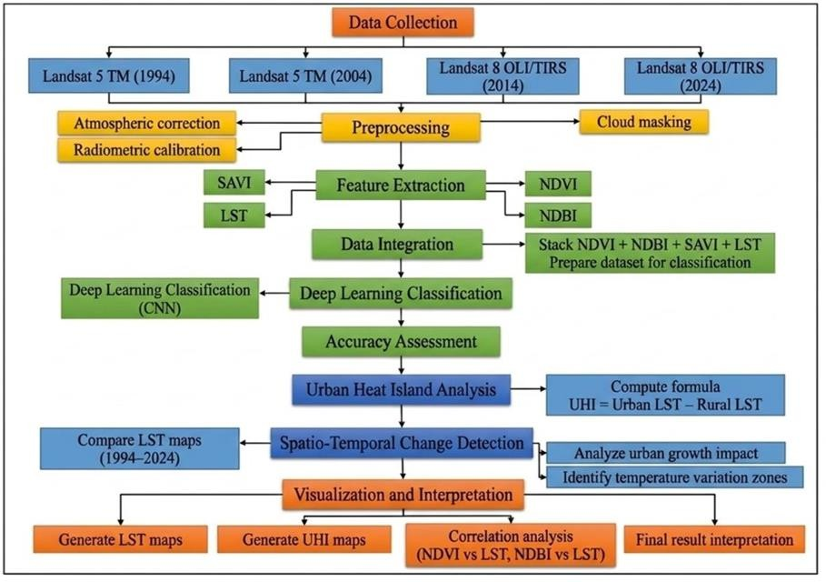
Figure 3.1: Architecture Diagram
The satellite imagery thermal bands provide the necessary data to calculate Land Surface Temperature (LST) through established conversion methods. The processed data is then integrated into a Geographic Information System (GIS) environment for spatial analysis and visualization. The researchers calculated UHI intensity through urban and rural temperature difference measurements to analyze results which showed how temperature patterns changed over time. The system produces outputs such as thematic maps, statistical graphs, and correlation analysis, which help in interpreting the impact of urbanization on temperature distribution.

Satellite Data Collection
Researchers used multiple satellite datasets from various Landsat missions to study land use changes and temperature changes throughout an extended period.
The following images were used:
·Landsat 5-TM (1994 & 2004)
·Landsat 8-OLI/TIRS (2014 & 2024)

These datasets provide consistent spatial resolution and spectral bands required for extracting vegetation indices and thermal information. The data serves as the foundation for analyzing LULC changes and temperature variations over a 30- year period.

2. Preprocessing

Preprocessing makes sure satellite images have been processed to achieve their accurate state and consistent quality which allows researchers to conduct further studies.
Radiometric Calibration: This process transforms raw digital numbers DN into spectral radiance measurements.
Atmospheric Correction: This process eliminates atmospheric interference to prouce precise surface reflectance measurements.
Cloud Masking: This technique removes cloud and shadow pixels from the image to enhance data accuracy and quality.
The steps establish consistent standards throughout the datasets which enhances the trustworthiness of index extraction and temperature measurement results.

3. Feature Extraction
The process of feature extraction creates essential indices that show vegetation coverages and urban development areas and temperature distribution patterns. The NDVI calculation method uses vegetation indexes to assess both health status and density of plant life. The NDBI calculation method enables researchers to identify both urban development areas and constructed environments. The Land Surface Temperature measurement uses thermal bands to determine how temperature spreads across different surfaces. The three extracted layers NDVI NDBI and LST data are combined into a multi-band composite dataset which serves as input for classification purposes.

4.Deep Learning-Based Classification
The integrated dataset is classified into multiple land cover categories through the application of a Convolutional Neural Network (CNN) system. CNN establishes
spatial feature extraction from satellite images through its automatic processing capabilities. The model training process uses the combined dataset which includes NDVI and NDBI and LST as its input. The model establishes patterns for three distinct categories which include vegetation and built-up areas and temperature distribution. The system identifies four different land cover classes through its classification process which includes urban areas and vegetation and water bodies and barren land. The system performance assessment uses accuracy assessment metrics which include confusion matrix and overall accuracy to evaluate model performance after classification.

5.Urban Heat Island (UHI) Analysis
The study determines Urban Heat Island intensity by measuring temperature variations which exist between urban areas and rural areas. The formula uses urban land surface temperature as its first component and rural land surface temperature as its second component to calculate UHI. NDBI values serve as the measurement tool which enables researchers to identify urban areas. NDVI values serve as the measurement tool which enables researchers to identify vegetation areas and rural areas. The study region shows different UHI intensity levels which researchers determined through temperature measurement.

6.Spatio-Temporal Change Detection
The research examines how land cover and temperature changes developed between 1994 and 2024. The study compares LST maps from various years. The study shows how cities expanded while vegetation areas decreased. The study identifies different temperature variation zones. The study investigates how urban development affects surface temperature changes.

7.Visualization and Interpretation
The final results are presented through visualizations which scientists use to study environmental temperature changes. The generated outputs include three types of
maps which are LST maps and UHI maps and land cover classification maps. The correlation analysis includes two studies which examine NDVI versus LST to show how vegetation affects temperature and NDBI versus LST to show how urbanization affects temperature. The research team uses maps and graphs to study trends and confirm their findings. The final interpretation shows how land cover changes affect temperature variations which help in sustainable urban planning and climate research.

Description of Algorithms
The algorithms used in the research study for feature extraction, temperature estimation, urban heat pattern analysis, and environmental parameter relationship evaluation are described in this section.

Random Forest:
The Random Forest algorithm functions as a strong machine learning method which can handle both classification and regression problems. The method belongs to ensemble learning techniques which create superior final predictions through the combination of several individual predictions. The algorithm operates by constructing multiple decision trees during training and producing the final output based on either the majority vote (for classification) or the average of predictions (for regression).
Random Forest provides its main benefit through its capability to decrease the overfitting problem which commonly affects decision tree models. The model uses random data sampling through bootstrapping and random feature selection to create tree diversity which results in better predictions. The system can efficiently process large datasets which

contain many high-dimensional features while maintaining high accuracy without needing detailed parameter adjustments.
Random Forest provides a feature importance estimation method which identifies the key variables that determine results. The system uses NDVI and NDBI and other environmental factors to analyze UHI. The system has better performance when dealing with noisy data and incomplete information than most other systems. Remote sensing applications use Random Forest extensively because it enables land cover classification and temperature prediction and environmental monitoring tasks.The Algorithm for Random Forest is as shown in Table 3.1.
Table 3.1: Random Forest Algorithm
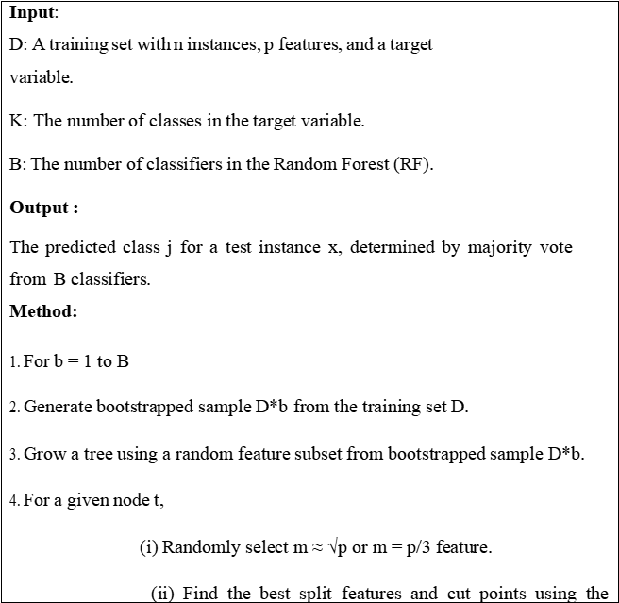

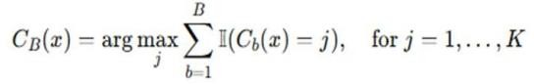
random feature subset.

(iii) Send down the data using the best split features and cut points.

5.Repeat (i)-(iii) until stopping rules are met. 6.Construct trained classifiers Cb.
7.Aggregate the B trained classifiers using simple majority vote. For a test instance x, the predicted as:

(Equation 3.1)

Support Vector Machine (SVM):

The Support Vector Machine (SVM) algorithm serves as an effective solution for both classification and regression tasks. The algorithm finds the best hyperplane which separates data points into different classes while fitting a regression line by maximizing the margin between classes or minimizing errors.

SVM provides its main advantage through its capacity to process high- dimensional data which enables it to handle complex datasets like satellite imagery used in remote sensing applications. The system works by selecting essential training data points known as support vectors which determine the optimal decision boundary. The method decreases computing requirements while achieving precise results.

SVM employs kernel functions that include linear, polynomial, and radial basis function (RBF) to change non-linear data into a higher-dimensional space which enables linear separation of the data. The algorithm achieves high adaptability because it can simulate intricate connections between variables such as NDVI and NDBI and LST.

SVM exhibits reduced overfitting tendencies because it maintains better performance when the feature count exceeds the sample count. The solution demonstrates high strength and effectiveness which leads to its widespread use in land use classification and temperature prediction and urban heat island analysis. The system needs precise kernel parameter selection but it becomes resource-intensive when handling extensive datasets.The algorithm for SVM is as shown in Table 3.2.

Table 3.2: Support Vector Machine Algorithm
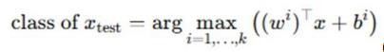
Input :
Training data X = {X1, X2,..., Xm} with labels Y E {1..K} and Test data Xtest. Here, K is the number of classes in the dataset.
Output:
Class Labels for test data Y_{test}.
Process:
- Select the regularization, kernel parameters for the classifier.
- Construct K LS-SVM models.
  - The ith i= {1,.., K} LS-SVM model is trained with all of the samples in the i^{th} class with positive labels, and all other samples with negative labels.
  - Use (17) to generate the i^{th} hyperplane.
- Test samples text is assigned the class label which has the largest value of the decision function
i=1,..,K

(Equation3.2)

U-Net algorithm
The U-Net algorithm functions as a deep learning-based convolutional neural network which researchers developed for searching purposes through its semantic segmentation capabilities. The system uses an encoder decoder structure to extract spatial information which it uses to build pixel-level classification results through its skip connection system. The encoder creates high-level features which it uses to compress data, while the decoder process restores complete spatial resolution in a gradual manner. The system achieves precise segmentation results through its skip connections which restore fine details lost during the downsampling process. Table 3.3 displays the U-Net algorithm according to your requested format.

Table 3.3: U-Net Algorithm
Input:
D: Training set with n images and corresponding pixel-wise segmentation masks.
E: Number of training epochs.
Output:
The predicted segmentation mask M(x)M(x)M(x) for a test image xxx.
Method:
- Initialize learnable parameters (weights and biases) of U-Net.
- For epoch = 1 to E:
- For each training mini-batch:
4.(i) Encoder path:
  - Apply repeated convolution → activation → pooling to extract deep spatial features.
- Decoder path:
  - Apply up-convolution and concatenate encoder feature maps for spatial detail recovery.

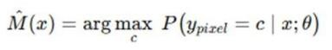
predictions.
- Compute segmentation loss (e.g., Dice loss or Cross-Entropy) using ground-truth masks.
- Perform backpropagation and update weights using an optimizer.
- Repeat steps (2–6) until stopping rule is met.
- Use the trained U-Net model to predict the segmentation mask for a test image xxx.

(Equation 3.3)

Convolutional Neural Network (CNN):
A Convolutional Neural Network is used for spatial feature extraction and classification of satellite imagery. CNN automatically learns hierarchical features from input data and classifies the study area into different land cover categories such as vegetation, built-up, water bodies, and barren land. It is effective in capturing spatial patterns and improving classification accuracy.The steps of the CNN algorithm used in this study are shown in Table.3.4.

Table.3.4:CNN Algorithm
Input:
D: A training set with n instances (images), each with H × W × C dimensions and corresponding target labels.
K: Number of classes in the target variable. E: Number of training epochs.
Output:
The predicted class jjj for a test image xxx, determined using the trained CNN model.

Method:

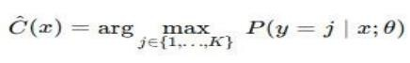
- Initialize learnable parameters (weights and biases) for all CNN layers.

- For epoch = 1 to E:

- For each training mini-batch:

4.(i) Apply convolution operation to extract feature maps using learnable kernels.
  - Apply non-linear activation function (e.g., ReLU).
  - Apply pooling operations to reduce spatial dimensions.
  - Repeat (i–iii) through successive layers until feature extraction is complete.

- Flatten the final feature map and pass it through fully-connected layers for classification.
- Compute loss using the true labels.

- Perform backpropagation and update weights using an optimizer (e.g., SGD or Adam).
- Repeat steps (2–7) until the stopping rule is met.

- Use the trained CNN model to classify a test image.

(Equation 3.4)

Land Surface Temperature (LST) Retrieval Algorithm:
The LST retrieval algorithm is used to estimate surface temperature from thermal infrared bands of Landsat imagery. It involves conversion of digital numbers into spectral radiance, followed by brightness temperature calculation and emissivity correction using radiative transfer equations. This process provides accurate temperature distribution across the study area.The steps of the LST algorithm used in this study are shown in Table.3.5.

Table.3.5:LST Algorithm
Input:
DN: Thermal band digital number ML, AL: Radiance scaling factors K1, K2: Thermal constants
NIR, R: Spectral bands

Output:
Land Surface Temperature (LST in °C)

Method:

- Convert DN to spectral radiance: Lλ=ML×DN+AL
- Convert radiance to brightness temperature (BT):
BT=K2ln(K1Lλ+1)
- Convert BT from Kelvin to Celsius: BT(∘ C)=BT−273.15
- Calculate NDVI:
NDVI=NIR−R/NIR+RNDVI
- Calculate proportion of vegetation (Pv):
- Calculate emissivity (ε): ε=0.004×Pv+0.986
- Compute Land Surface Temperature:

LST=BT/1+(ρλ⋅ BT)ln(ε)
(Equation 3.5)

Urban Heat Island (UHI) Intensity Formula:
The UHI intensity is calculated using the mean difference method between urban and rural Land Surface Temperature values. Urban areas are identified using built-up indices, while rural areas are identified using vegetation indices. The temperature difference represents the intensity of heat accumulation in urban regions.The steps of the UHI algorithm used in this study are shown in Table.3.6.

Table.3.6:UHI Algorithm
Input:
Urban LST values Rural LST values

Output:
UHI intensity

Method:

- Identify urban pixels using NDBI
- Identify rural pixels using NDVI
- Compute mean temperatures:

Rural_LST=mean(LSTrural)

- Calculate UHI intensity:

UHI = Urban_LST − Rural_LSTUHI (Equation 3.6)

Pearson Correlation Coefficient:
The Pearson correlation coefficient is used to measure the statistical relationship between indices such as NDVI, NDBI, and LST. It determines the strength and direction of the relationship, indicating whether the variables are positively or negatively correlated. This helps in understanding how vegetation and urbanization influence temperature variations.The steps of the Pearson Correlation Coefficient algorithm used in this study are shown in Table.3.7.
Table.3.7:Pearson Correlation Coefficient Algorithm

Input: NDVI values NDBI values

LST values

Output:
Correlation coefficient (r)

Method:

- Collect paired datasets (X, Y)
- Compute mean values
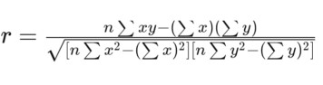 (Equation 3.7)

Description of Datasets and Tools
(

Satellite Imagery
Researchers use satellite image data from multiple Landsat missions to study land surface changes and temperature shifts throughout Andhra Pradesh. The datasets maintain constant spatial and spectral resolution which enables researchers to assess environmental changes that occurred over three decades. Landsat data provides researchers with free and uninterrupted access to worldwide satellite coverage which makes it an ideal tool for studying environmental changes over extended periods. Researchers can analyze land transformation patterns through time by examining both historical and contemporary datasets which provide consistent data for their studies.

Landsat 5 TM(1994,2004):
Thematic Mapper (TM) of Landsat 5 delivers historical satellite images which contain multiple spectral and thermal band data needed to study historical land cover changes. The sensor delivers 30-meter spatial resolution across its visible and Near Infrared (NIR) and Shortwave Infrared (SWIR) bands together with a thermal band used for Land Surface Temperature (LST) calculation. This

dataset serves as a fundamental resource which enables researchers to examine past environmental conditions and track changes throughout time.
The Landsat 5 data establishes an essential standard which scientists use to compare modern datasets with earlier datasets. This research process creates methods which demonstrate how cities begin to develop while showing how people altered natural environments throughout different time periods.

Landsat 8 OLI/TIRS(2014,2024):
Landsat 8 provides high-quality images through its Operational Land Imager and Thermal Infrared Sensor systems. The system delivers precise spectral data and enhanced radiometric capabilities. The optical bands are used for calculating indices such as NDVI and NDBI, while thermal bands are used for precise LST estimation. The dataset enables researchers to study recent changes in land cover and temperature patterns.

Landsat 8 enhances data quality through its improved signal-to-noise ratio and advanced calibration methods, which allow scientists to detect minor environmental changes with greater precision. The system demonstrates high efficiency for studying both recent urban development and its consequences on temperature distribution patterns.

Vegetation and Built-up Indices

Normalized Difference Vegetation Index (NDVI):

NDVI is derived from the red and near-infrared (NIR) bands of Landsat imagery. The index evaluates three aspects of vegetation which include its health status and its density and its spatial distribution. The study uses NDVI to identify vegetated areas which researchers will use to examine how these areas affect surface temperature distribution.
NDVI values extend between -1 and +1 with higher values representing dense vegetation and lower values showing uninhabited land or constructed areas.

The index provides essential information about how vegetation generates cooling effects and decreases urban heat island (UHI) intensity.

Normalized Difference Built-up Index (NDBI):

NDBI calculation requires the use of both shortwave infrared (SWIR) and near-infrared (NIR) bands. The system detects built-up urban regions through its ability to show impervious surfaces. The study uses NDBI to track urban growth while studying its connection to rising Land Surface Temperature. The system uses NDBI to separate urban regions from natural areas because this function enables users to track urban expansion while measuring its environmental effects.

Land Surface Temperature (LST)
LST is extracted from the thermal infrared bands of Landsat imagery and represents the radiative temperature of the Earth's surface. The parameter serves as a critical tool for studying the thermal properties of various land cover types. The research uses LST to track temperature changes between different locations and times while locating areas with extreme heat and measuring UHI effects.
The LST calculation process requires several steps which begin with converting digital numbers into radiance and end with determining brightness temperature and applying emissivity correction. The process establishes precise temperature measurement methods which enhance the dependability of the research findings.

Climate / Reference Data Temperature Data (IMD / ERA5):
The researchers used temperature information from both the Indian Meteorological Department (IMD) and ERA5 reanalysis datasets to check the accuracy of satellite-derived LST data. The datasets deliver trustworthy temperature data through their ground measurements and model-based

assessments which scientists use to evaluate thermal calculations and study climate patterns.
The combination of satellite data with ground observations increases result credibility while helping scientists understand seasonal patterns and long-term climate changes.

Shapefile
Andhra Pradesh Administrative Boundary:
The study area uses a vector shapefile which defines the entire region of Andhra Pradesh. The data is used to create satellite image boundaries which limit the research work to that designated area. The study area restrictions ensure that all geographic computations and mapping activities and visual displays remain focused on the designated research zone. The study area uses shapefiles to combine spatial data with attribute data which lets researchers analyze different zones of the area more effectively.

Tools and Software
Google Earth Engine (GEE):
Google Earth Engine (GEE) serves as a cloud-based geospatial platform which lets users access Landsat datasets while executing preprocessing tasks and performing efficient NDVI and NDBI and LST calculations. GEE allows users to process extensive data sets because the system does not need advanced computer equipment to manage multiple satellite data sets from different time periods.

Python:
Python serves as the programming language which develops and executes the Convolutional Neural Network (CNN) model while handling data processing tasks. Python delivers users the ability to create custom solutions through its extensive library collection which supports data analysis and machine learning and data visualization tasks.

Deep Learning Libraries (TensorFlow/Keras):
Deep Learning Libraries (TensorFlow/Keras) serve as tools which enable users to create and test CNN models which classify different land cover types. The libraries provide users with ready-made functions together with optimization methods which enable them to enhance their model development processes while achieving better results.

GIS Software (QGIS/ArcGIS):
GIS Software (QGIS/ArcGIS) provides tools for displaying and mapping and conducting spatial analysis of land surface temperature and urban heat island and land cover maps. The tools enable users to create thematic maps while executing spatial functions which include overlay analysis together with interpolation processes.

Microsoft Excel / Graph Tools:
The software enables users to create graphical representations which help them study temperature changes and accuracy assessments. The tool offers users an easy method to display data patterns which helps them understand their findings.

CHAPTER 4
RESULTS AND OBSERVATIONS

The results obtained from land use/land cover classification, spectral index analysis, and urban heat island (UHI) assessment were integrated to understand the environmental changes from 1994 to 2024. The analysis combines the outputs of Mini Project 1, Mini Project 2, and the Major Project to provide a comprehensive understanding of land surface dynamics. The land cover classification results reveal significant spatial and temporal variations in vegetation, urban, and barren areas over the study period. The development of built-up areas and the health of vegetation cover experienced changes, which spectral indices including NDVI, NDBI, and SAVI demonstrated. The Land Surface Temperature (LST) analysis indicates a continuous increase in temperature, which shows the impact of land cover transformation. The UHI results show that urban areas experience higher temperature levels compared to rural areas, which leads to greater urban heat stress. The correlation analysis establishes a strong relationship between land cover characteristics and temperature variation. The integration of these results shows that human activities and land use changes have caused major environmental changes to the study area during different periods.

Stepwise description of Result

Data Preparation and Study Area Extraction

The researchers gathered satellite datasets from various years which included the years 1994 2004 2014 and 2024 to prepare them for their analytical work. The researchers achieved uniform data acquisition through their execution of preprocessing tasks which included noise elimination and band selection and data clipping procedures. The research team utilized the study area boundary to extract specific regions which maintained consistent data distribution

throughout their entire dataset collection. The analysis quality improved through this preprocessing step which enabled researchers to track changes between different time periods. The boundary of Andhra Pradesh which researchers used to clip satellite images appears in Figure 4.1.
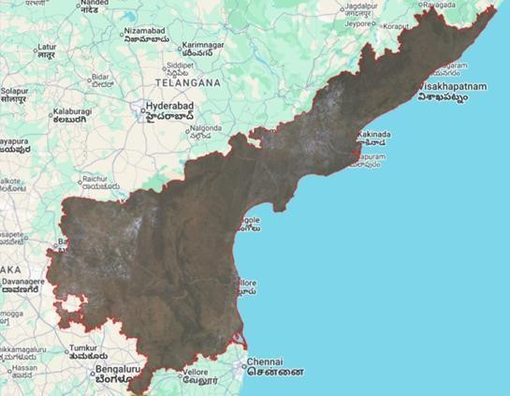

Figure 4.1: Andhra Pradesh Boundary

- Land Use/Land Cover Classification (Mini Project 1)
The researchers employed Support Vector Machine and Random Forest algorithms to conduct land use land cover classification which identified various surface features including vegetation and forest and urban areas and barren land and water bodies. The researchers conducted accuracy assessment tests to evaluate model performance based on the classification results which they generated for each selected year. The RF algorithm showed better classification performance compared to SVM because it produced more reliable results for additional analysis.

Spectral Indices and Zone Analysis (Mini Project 2)

Scientists evaluated vegetation health and urban development through spectral index computations which included NDVI and NDBI and SAVI measurements.

The spatial distribution of vegetation and urban areas became visible through these indices. Environmental patterns and land surface conditions become clearer through zone mapping which divides regions into distinct groups based on their specific attributes. The researchers combined their calculated indices with Land Surface Temperature (LST) data to study how vegetation cover and built-up areas interact with temperature changes. The presence of high NDVI and SAVI values in certain areas resulted in lower temperatures because vegetation produced a cooling effect, yet the regions with elevated NDBI values showed rising temperatures which demonstrated significant Urban Heat Island (UHI) effects. The combined analysis identified heat-intensive regions along with areas that needed environmental protection, which provided essential information for urban development and eco-friendly land management methods.

Land Surface Temperature (LST) Analysis

The analysis of temperature changes throughout the research area used Land Surface Temperature data which thermal satellite data provided. The researchers created annual LST maps to track changes in temperature patterns. Vegetated areas showed lower temperatures while urban and barren regions recorded higher temperatures. The results show that land use changes lead to a steady temperature rise which continues throughout the period of study.
The analysis of LST maps over time showed how temperature patterns changed because of both urban growth and the decrease of plant life. The yearly comparison demonstrates how urban areas have continually expanded into areas which were once covered by vegetation or used for farming, which has led to more temperature buildup. The current pattern creates two effects which strengthen the Urban Heat Island (UHI) effect, while the local climate system makes certain areas more susceptible to heat-related problems. The findings highlight how essential it is to develop environmentally friendly land use

strategies that will protect natural areas while making more green spaces available to control rising temperatures.

Urban Heat Island (UHI) Analysis (Major Project)

Urban Heat Island analysis was conducted through temperature comparison between urban and rural regions. The UHI maps were generated for all years to study the intensity of urban heat. The study found that UHI intensity started to increase over time and reached its highest level during the most recent years because urban areas expanded while plant life decreased. The analysis results show that UHI intensity distribution shows that areas with high population density and extensive development patterns experience higher temperatures than adjacent rural regions. The study results demonstrate that areas with lower vegetation coverage and higher impervious surface areas create greater heat accumulation. The UHI effect has become more noticeable because urban areas have expanded throughout the study period, which has increased the size of high-temperature clusters. The research results demonstrate that land use changes directly affect thermal properties, which underscores the need for urban planning methods that increase green spaces and implement sustainable development solutions to minimize heat stress.

Correlation Analysis

The researchers studied the relationship between spectral indices and Land Surface Temperature through their correlation study. The analysis demonstrated that vegetation indices developed a negative relationship with temperature while built-up indices established a positive relationship. The study used land cover data to determine its effect on thermal conditions in the research area.
The research established quantitative proof that various land cover types affect surface temperature changes according to the correlation analysis results. Vegetated areas with higher NDVI values required less land surface

temperature because vegetation produced a cooling effect through its shading and evapotranspiration process. The research found different relationships between the two variables because urban development progressed through the years. The study demonstrates how vegetation reduces heat while demonstrating how urban growth causes temperature increases which aids in measuring Urban Heat Island (UHI) intensity and its geographical spread.

CNN-Based Classification (Major Project)

The researchers used a Convolutional Neural Network (CNN) model to classify data which they compared against traditional machine learning methods. The team evaluated model performance by training and testing the system with available datasets. The results showed that CNN performance changed between years because land cover patterns became more complex.
The CNN model automatically extracted spatial features from satellite images which reduced the need for human feature development work. The system achieved better results because recent datasets contained higher image quality and more accurate land cover class representation. The classification task became more difficult because urban areas developed complex patterns which combined multiple land uses with broken vegetation areas. The comparison with traditional machine learning algorithms such as Random Forest and SVM showed that while CNN enables better feature learning, the system needs more training data and requires more processing power. The use of CNN allowed researchers to gain deeper understanding of complex spatial patterns which proved effective for advanced land cover classification and UHI-related studies.

Change Detection Analysis

Researchers conducted a comparative analysis to track land cover alterations and temperature changes throughout the years. The results show that built-up areas and temperature levels increased while vegetation cover experienced

multiple changes. Human activities throughout history have created these environmental alterations which show their actual effects on nature.
The year-by-year analysis showed that cities expanded while vegetated and agricultural spaces decreased. Urban areas experienced increased Land Surface Temperature (LST) because of the shift from natural spaces to developed land. Temperature rises occurred more severely in locations that experienced fast growth of their infrastructure. The research results show that human activities which transform land use lead to environmental changes, so cities need sustainable urban development plans and effective land use management systems to reduce Urban Heat Island (UHI) effects.

Result Analysis and Test case results

Classification Maps (Mini-1) SVM Maps(1994,2004,2014,2024)
The land use/land cover maps classified using the SVM algorithm for the years
1994, 2004, 2014, and 2024 are illustrated in Figure.4.2 (A–D). The land use/land cover map for the year 1994, shown in Figure.4.2(A), shows prevalence of vegetations and forests with little urbanization indicating a stability of land cover, with overall classification accuracy of 82%. The land use/land cover map for the year 2004, presented in Figure. 4.2(B), suggests gradual increase in barrenness and built-up land, indicating that the land is undergoing changes with a classification accuracy of 85.7%. The land use/land cover map for the year 2014, illustrated in Figure.4.2(C), reflects growth of urban and barren lands with decrease in dense vegetation land, which is indicative of human intervention, with overall accuracy of 83%. The land use/land cover map for the year 2024, illustrated in Figure.4.2(d), reveals increase in fallow and barren lands with scattered urban lands and moderate vegetation distribution with a classification accuracy of 82%. While SVM classifier offers a good visualization of the land cover map, there are cases

of misclassification of urban land and barren land, because of spectral similarity, thereby resulting in lower accuracies than other classifiers.Classification of land use/land cover based on random forest for varying periods is depicted in Figure 4.2.
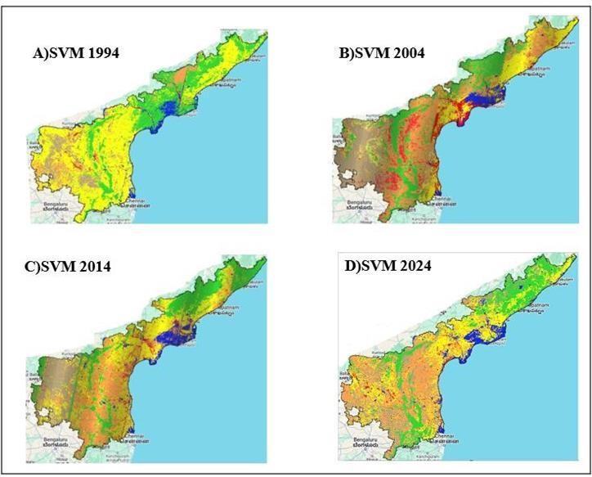

Figure 4.2. SVM-based land use/land cover classification maps: (A) 1994, (B) 2004, (C) 2014 and (D) 2024.

RF Maps (1994, 2004, 2014, 2024)

Classification maps derived from the application of the Random Forest (RF) algorithm for the years 1994, 2004, 2014, and 2024 are depicted in Figure. 4.3 (A- D). Figure. 4.3 (A) demonstrates that the 1994 classification map reflects the spatial distribution of vegetation, forests, and water bodies without much urban development, yielding an excellent accuracy of 98%. Figure. 4.3 (B) suggests that there is an expansion in barren and developed land use areas in 2004, but


vegetation distribution becomes more distinct, giving an accuracy of 98%. As shown in Figure. 4.3 (C), the 2014 classification map displays an increased proportion of urban and fallow lands, but with better class separation, providing an accuracy of 97%. Figure. 4.3 (D) indicates that there are major land cover changes in 2024, with increased fallow and barren lands, and vegetation is also clearly distinguished, providing an accuracy of 97%. Unlike SVM, the RF classifier ensures better class separation and minimizes misclassification, leading to improved accuracy.Maps of land use/land cover classification based on RF for the periods 1994, 2004, 2014, and 2024 are shown in Figure 4.3.

Figure 4.3. RF-based land use/land cover classification maps: (A) 1994, (B) 2004,
(C) 2014 and (D) 2024.

Change Detection Graph

Figure 4.4 displays how land use and land cover have shifted between 1994 and2024. Vegetation declines steadily until 2014, yet rebounds notably by 2024 - suggesting

regrowth. After two decades of reduction, forest extent ticks up slightly in the final year. Although barren surfaces dwindle through time, they begin creeping upward again near the end. Meanwhile, unused farmland expands consistently across all years, hinting at evolving farming rhythms. Changes unfold slowly, then suddenly reshape patterns. A small shift appears in urban zones, followed by a dip toward recent times - possibly due to shifts in how data was classified. After rising until 2014, rural terrain drops steeply by 2024. Though water surfaces vary slightly year to year, their overall pattern stays uneven but contained. Mining regions shrink steadily once past 2004. Taken together, transformations across landscapes emerge clearly, shaped by environmental processes and people's actions alike through the decades. This changing picture of land types appears visually laid out in Figure 4.4.

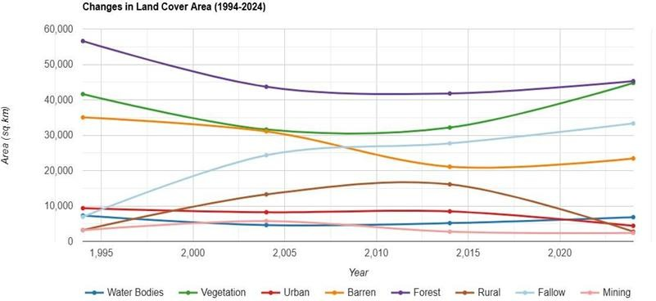

Figure 4.4. Temporal variation of land use/land cover classes from 1994 to 2024.

Zone Maps (Mini-2)

Figure 4.5 displays how various zones were spread across space in 1994, 2004, 2014,and 2024. Looking at part Figure. 4.5 (A), natural zones dominate the 1994 layout - especially vegetated areas - with little disruption visible. By 2004, shown in Figure. 4.5 (B), signs of change emerge: disturbed areas grow slowly, mainly toward the center, hinting that land conversion has begun. In Figure. 4.5 (C), which represents 2014, both disturbed and transition zones take up much more area,

pinting to stronger human influence and shifting ways of using land. The most recent snapshot, Figure. 4.5 (D) for 2024, reveals uneven outcomes - one region stabilizes or recovers, yet others remain altered under continuing construction pressure. Looking at the big picture, Figure 4.5 shows how land zones shifted across space and time. Each map reflects gradual changes tied to growing human activity. From one year to the next, patterns unfold - revealing transformation through shifting boundaries. These visuals capture environmental shifts without needing extra explanation. Over the study span, differences become harder to ignore. Year by year tells a quiet story of change.The zone maps for different years are illustrated in Figure 4.5.
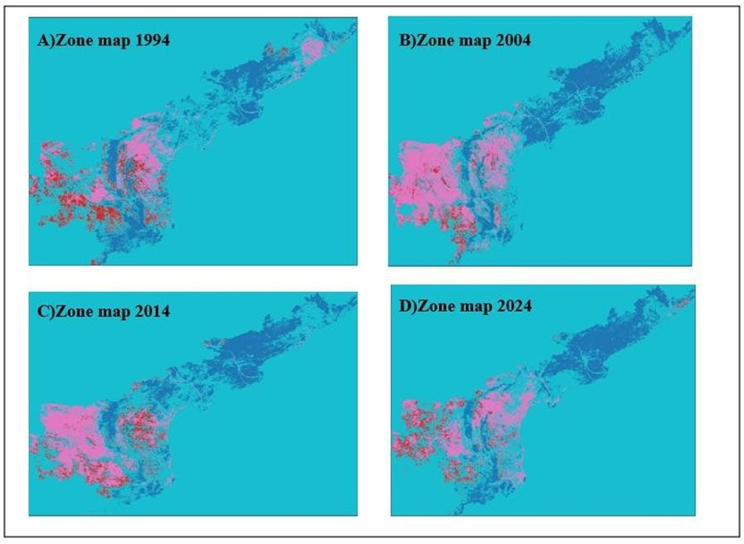

Figure 4.5. Zone maps for the years: (A) 1994, (B) 2004, (C) 2014 and (D) 2024

Land Surface Temperature (LST) Maps
Maps of the Land Surface Temperature (LST) were generated for the years 1994, 2004, 2014, and 2024 to analyze the spatial distribution of surface temperature across the study area.

LST MAP(1994)
The LST map of 1994 shows the study area experiencing lower temperature distribution. The study area shows cooler regions that exist primarily in places which have dense vegetation and water bodies that maintain lower surface temperatures. The study area contains only a few warmer zones which exist in areas with limited vegetation and developed urban areas. The temperature pattern of the area shows that thermal conditions remain balanced because there is little effect from urban development. The LST map of 1994 is illustrated in Figure 4.6
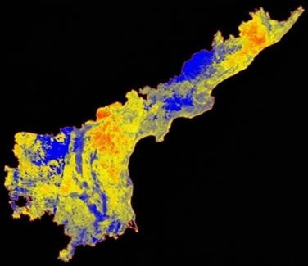
Figure 4.6:LST map of 1994

b)LST MAP(2004)

The LST map of 2004 shows a clear temperature increase which exceeds the 1994 temperature measurements. The development of moderately hot temperature regions shows how urban areas have expanded while their green space areas have decreased. Built-up areas start to experience hotter temperature zones while areas with vegetation remain at lower temperature levels. The present situation shows how land use changes drive surface temperature alterations which are currently starting to develop. The LST map of 2004 is illustrated in Figure 4.7


Figure 4.7:LST map of 2004

c)LST MAP(2014)
The 2014 LST map displays an extensive rise in surface temperatures throughout the entire research area. High-temperature zones become more widespread, particularly in urban and semi-urban regions. The reduction in vegetation and increase in built-up areas contribute to higher heat absorption. The spatial distribution clearly shows how fast urban development affects thermal properties of the area. The LST map of 2014 is illustrated in Figure 4.8

Figure 4.8:LST map of 2014

d)LST MAP(2024)

The LST map of 2024 shows the highest temperature distribution for all previous years. The study shows that urban areas experience extensive high-temperature zones because of Urban Heat Island effects which have become more severe. The process of vegetation cover reduction results in diminished cooling effects. The overall pattern shows a strong dominance of warmer regions, which results from ongoing urban


development and environmental alterations. The LST map of 2024 is illustrated in Figure 4.9.
Figure 4.9:LST map of 2024

5.Urban Heat Island (UHI) Maps
Urban Heat Island (UHI) maps were prepared to study temperature differences between urban zones and rural zones during the years 1994, 2004, 2014, and 2024. The UHI map of 1994 shows relatively low UHI intensity across the study area.

a)UHI MAP(1994)
Urban areas show higher temperatures than nearby rural areas, but their temperature difference remains small. The city maintains its current level of development, which leads to stable temperature conditions throughout the area. The UHI map of 1994 is illustrated in Figure 4.10.

Figure 4.10:UHI map of 1994

UHI MAP(2004)
The 2004 UHI map displays a moderate increase in UHI intensity. Built-up areas start to develop temperature differences which exceed the climate patterns of rural areas. Urbanization leads to greater heat absorption, which causes areas to
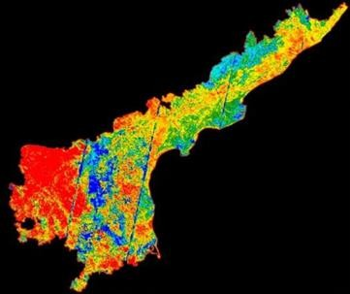
experience more intense temperature increases. The UHI map of 2004 is illustrated in Figure 4.11.
Figure 4.11:UHI map of 2004

c)UHI MAP(2014)
The 2014 UHI map shows a major rise in UHI intensity, which affects all key urban areas. Urbanization together with vegetation loss causes greater temperature differences between urban and rural areas. The UHI map of 2014 is illustrated in Figure 4.12.
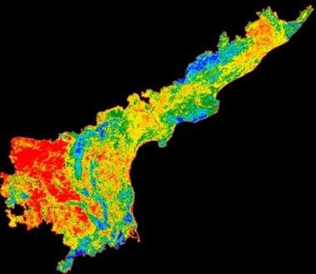

Figure 4.12: UHI map of 2014

d)UHI MAP(2024)
The 2024 UHI map displays the strongest urban heat island effect throughout the city. Urban areas which cover extensive land demonstrate significant temperature variations when compared to their adjacent rural areas. The ongoing development of built-up spaces combined with vegetation removal results in greater heat accumulation. The UHI map of 2024 is illustrated in Figure 4.13.
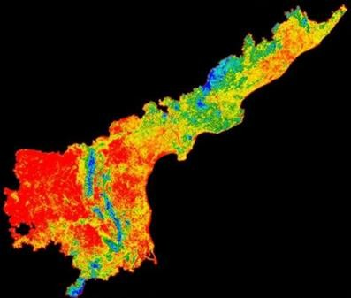
Figure 4.13: UHI map of 2024

CNN Accuracy Graph
The model performance of the CNN system shows different classification results between various years, which Figure 4.14 demonstrates. The graph shows that the CNN model reached its peak performance in 1994 with an accuracy value that approached 98% which indicates the model functioned well when land cover patterns appeared simple and distinct. The accuracy dropped to 68% in 2004 which resulted in medium performance because land cover classes became more complicated through ongoing urban development and changes to land use. The system showed major accuracy loss in 2014 when its performance dropped to about 44% which showed the system struggled to separate mixed land cover from diverse land cover types. The accuracy in 2024 shows a small increase to 47% which demonstrates low performance because land cover complexity still hampers CNN model efficiency. The accuracy decline exists because classes exhibit more spectral resemblance and mixed pixel issues arise and data quality differs and deep learning models lack enough training examples. The CNN model achieves unstable performance results which differ from

traditional machine learning methods like Random Forest because it struggles to process complex dynamic environmental conditions. The results demonstrate that better training methods and enhanced data representation methods. The CNN accuracy variation over the years is illustrated in Figure 4.14.
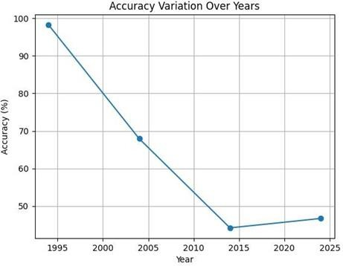

Figure 4.14. Graph showing variation of CNN classification accuracy from
- to 2024.

8.LST Trend Graph
The graph in Figure 4.15 displays Land Surface Temperature (LST) measurements from multiple years. The graph shows that LST values continuously increased from 1994 until 2024. The average temperature starts at 28.4°C for 1994 and advances to 30.1°C for 2004 before reaching 31.6°C in 2014 and almost 32°C in 2024. The region shows a warming trend because of its continuous temperature rise during the research period. The LST increase results from land cover changes that involve two main factors which include built-up area expansion and natural land transformation into urban and fallow areas. The urban environment creates a situation where vegetation loss leads to decreased cooling through evapotranspiration and urban materials like concrete and asphalt create heat retention because they soak up sunlight. The results show that urbanization together with human activities creates a growing impact on surface temperature. The temperature pattern shows continuous growth throughout every year which

confirms that environmental changes extend beyond brief time periods. The graph in the study area shows increasing thermal stress which proves that warming temperatures exist in that region. Figure 4.15 shows LST changes that occurred throughout different years.

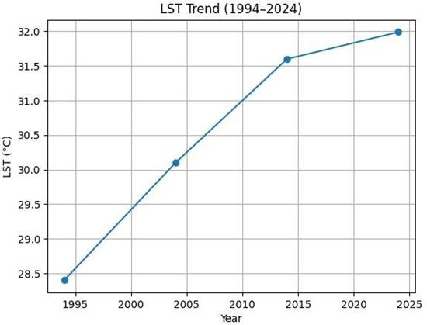

Figure 4.15. Graph showing variation of Land Surface Temperature (LST)
from 1994 to 2024

9.Tabulated Results and Analysis

Accuracy comparison between SVM and Random Forest (RF) classifiers.

Table 4.1 shows the classification accuracy results for comparing Support Vector Machine (SVM) with Random Forest (RF) algorithms. The RF classifier demonstrated 97% to 98% accuracy across all tested years, which showed its ability to maintain consistent performance throughout different data sets. The SVM classifier demonstrated decreased accuracy results, which ranged from 82% to 85.7%, because it struggled to process complex land cover patterns that displayed different characteristics. The Random Forest algorithm achieves better results because it employs an ensemble learning method that combines multiple decision

trees, which decreases overfitting, thus enhancing classification accuracy. SVM encounters difficulties when it needs to distinguish between classes that share similar spectral properties. The RF algorithm maintains its capacity to handle multi-temporal land cover assessment, which demonstrates its consistent performance throughout different testing periods. The Random Forest method demonstrates superior accuracy and reliable results for the study area, which proves its effectiveness according to the research findings. The accuracy comparison is presented in Table 4.1
Table 4.1. Accuracy comparison between SVM and Random Forest (RF)
classifiers.

Year | SVM  Accuracy (%) | RF Accuracy (%)
1994 | 82 | 98
2004 | 85.7 | 98
2014 | 83 | 97
2024 | 82 | 97

Land Cover Area
Table 4.2 displays the annual distribution of land use and land cover area across multiple land cover classes. The table demonstrates that vegetation cover exhibits progressive growth which reached its highest point during 2024 as certain areas acquired more green vegetation. The forest area decreased continuously from 1994 to 2014 before experiencing a minor uptick during 2024. The period assessment demonstrates that barren land areas have diminished through time because vacant land areas have transformed into different land cover categories. The study period witnessed agricultural practices and seasonal land use changes which resulted in fallow land becoming more common throughout the entire time frame. The study

results show that urban land distribution changes between different years while rural land distribution increases until 2014 before it drops during 2024. Water bodies display slight changes in their size while mining areas display a declining pattern that shows minimal changes during the past few years. The table displays dynamic land cover transformations which result from both natural phenomena and human activities throughout the entire table. The land cover area statistics are presented in Table 4.2.

Table 4.2. Land use/land cover area distribution for different classes from
1994 to 2024

Land Cover Class | 1994  (sq.km) | 2004  (sq.km) | 2014  (sq.km) | 2024  (sq.km)
Vegetation | 41608 | 40723 | 39012 | 44747
Forest | 56596 | 43679 | 41235 | 45281
Urban | 9358 | 6021 | 7452 | 4393
Barren Land | 35022 | 28450 | 21090 | 23428
Fallow Land | 6936 | 15890 | 25110 | 33320
Rural | 3179 | 12054 | 16107 | 2759
Water Bodies | 7296 | 7012 | 6884 | 6831

Index Values (NDVI, NDBI, SAVI, LST)

Table 4.3 shows how different land cover classes exhibit distinct patterns of spectral indices which include NDVI, NDBI, SAVI and Land Surface Temperature (LST). The table shows that vegetation and forest classes display higher NDVI and SAVI values which combine with lower temperature measurements to indicate healthy vegetation cover and strong cooling effects that result from evapotranspiration and canopy shading. Water bodies maintain their low temperature values because their high moisture content enables them to absorb heat. The urban and barren and mining areas exhibit NDBI values that exceed normal levels while their temperature readings show an upward trend because these areas use materials that absorb heat and lack any vegetation growth and have solid surfaces. The moderate index values of fallow and rural areas show that these areas contain mixed land characteristics which include partial vegetation and exposed soil. The results show that areas with higher vegetation cover experience lower surface temperatures while built-up and barren areas cause higher thermal conditions. The variation of SAVI values demonstrates how soil background affects areas with limited vegetation. The observed patterns confirm that spectral indices serve as effective indicators for determining land cover types together with their corresponding thermal characteristics. The table shows how land cover characteristics affect both spectral and thermal properties which demonstrates how land use changes affect environmental conditions. The table shows the index values which are displayed in Table 4.3

Table 4.3. Spectral index values (NDVI, NDBI, SAVI) and Land Surface Temperature (LST) for different land cover classes.

Land Cover Class | NDVI | NDBI | SAVI | LST (°C)
Water Bodies | 0.08 | -0.12 | 0.05 | 26.5
Vegetation | 0.49 | -0.08 | 0.45 | 27.5
Forest | 0.60 | -0.10 | 0.55 | 27.0
Urban | 0.18 | 0.32 | 0.20 | 36.0
Barren Land | 0.12 | 0.28 | 0.15 | 33.0
Fallow Land | 0.22 | 0.18 | 0.25 | 29.0
Rural | 0.30 | 0.12 | 0.28 | 28.5
Mining | 0.02 | 0.35 | 0.05 | 37.0

Correlation Values

Table 4.4 displays the connection between spectral indices and Land Surface Temperature. The table shows that NDVI develops a negative relationship with LST because its values decrease from -0.127 in 1994 to -0.529 in 2024 which shows that regions with more vegetation experience lower surface temperatures because of

cooling effects from evapotranspiration. The NDBI variable demonstrates a direct relationship with LST because its values rise from 0.406 in 1994 to 0.652 in 2024 which indicates that constructed environments cause higher temperatures through their capacity to absorb heat and decrease moisture levels. The rising correlation strength throughout the years demonstrates how land cover alterations increasingly affect thermal environmental conditions. The findings establish that vegetation decreases temperatures while urban development causes temperature increases. The correlation values are presented in Table 4.4.

Table 4.4. Correlation values between NDVI, NDBI and Land Surface Temperature (LST).

Year | NDVI vs LST | NDBI vs LST
1994 | -0.127 | 0.406
2004 | -0.367 | 0.508
2014 | -0.487 | 0.605
2024 | -0.529 | 0.652

UHI Values

Table 4.5 shows the UHI intensity values which were recorded in multiple years. The table shows that UHI intensity shows an increasing trend which started at 7.02°C in 1994 and reached 9.92°C in 2024. The temperature difference between urban areas and rural areas experienced a substantial increase which resulted from this temperature rise. The period from 1994 to 2004 showed a slight increase which

continued until 2014 before the second period reached its highest point in 2024. The rising UHI intensity results from cities expanding their developed areas while decreasing their green space. Urban surfaces such as concrete and asphalt create higher temperatures because they absorb heat and release it back into the environment at a slower rate than their adjacent rural areas. The results show an upward trend in thermal stress levels which demonstrates how urban development changes environmental conditions. The UHI values are presented in Table 4.5.

Table 4.5. Urban Heat Island (UHI) intensity values for different years.

Year | UHI (°C)
1994 | 7.02
2004 | 7.35
2014 | 7.12
2024 | 9.92

The results obtained from Mini Project 1, Mini Project 2, and the Major Project show a strong interrelationship between land cover changes and thermal variations. The classification results from Mini Project 1 show changes in vegetation and urban areas and barren land which the spectral index analysis in Mini Project 2 confirms. The built-up area expansion and vegetation reduction are confirmed through the NDBI increase and NDVI decrease. The Major Project research shows that these changes affect Land Surface Temperature (LST) and Urban Heat Island (UHI) intensity. The increasing LST trend together with the higher UHI values demonstrates how urbanization and land transformation have affected the area. The combined results of the study area show that land cover changes lead to substantial effects on both environmental conditions and thermal conditions.

4.3Observations from the Work

- The Random Forest (RF) classifier demonstrated superior accuracy compared to the Support Vector Machine (SVM) across all studied years. The ensemble learning method of the system combines various decision trees, which leads to better prediction outcomes. The system uses RF because it can manage high-dimensional data while minimizing overfitting problems. The system handles noisy data successfully while managing complex pattern recognition tasks. The system proved to be a better way to classify land cover in this research study.The vegetation showed continuous growth through all studied years with especially strong development during the most recent period which resulted in increased green cover.
- Vegetation cover showed a continuous increase throughout the study period, with significant growth observed in recent years. The present trend shows that afforestation efforts and agricultural methods and environmental awareness initiatives are making progress. The rise in vegetation cover helps maintain ecological balance while improving environmental conditions. The system functionsas a vital component because it helps decrease surface temperature. The study area experienced beneficial effects from increased vegetation growth.
- The growth of developed land areas has continued to increase because of fast urban development and rising population numbers. This development process transformed natural landscapes which included both plant life and farming territories. Built-up surfaces like concrete and asphalt absorb and retain more heat. The process directly resulted in higher Land Surface Temperature (LST) values. The research results demonstrate how urban development affects temperature patterns in urban areas.
- The study showed that barren land areas decreased during its first two years. The decrease in land area occurred because the land was transformed into agricultural space and urban development. The barren land areas of the study site showed minimal changes after the initial period when the site reached its permanent condition. The study detected minor changes that resulted from both environmental conditions and human activities.

The study demonstrates how land transformation progresses through time as a continuous process.NDVI values established a negative relationship with Land Surface Temperature (LST) because vegetation cover functions as a cooling mechanism that decreases temperature.
- The rise of fallow land shows that farmers have adopted different agricultural methods and they now use land in a different way. Some agricultural lands may have been left uncultivated due to economic or environmental reasons. The study area shows changing patterns of land use which reflect its active development. Fallow land can influence soil properties and local temperature conditions. The case study demonstrates the requirement for environmentally friendly land development plans.
- The study found that NDVI values showed a strong negative correlation with Land Surface Temperature (LST) measurements. The study found that areas with high NDVI values which indicated dense vegetation showed lower temperature measurements. The cooling effect of vegetation occurs because plants create shade and release moisture through their transpiration process. Plants in natural environments create an equilibrium state between hot and cold temperatures.
- The analysis of Land Surface Temperature (LST) revealed a consistent increasing trend from 1994 to 2024. The study area experiences gradual warming which has occurred throughout its entire history. The rise in temperature is closely associated with land use changes and urban expansion. Environmental degradation together with reduced vegetation caused this particular trend to develop. The results demonstrate how climate change will affect the environment over an extended period.
- Cities maintain higher temperature levels throughout the day because their built environment creates heat which sidewalks and streets and roofs and walls absorb. The built environment together with reduced vegetation cover between these two areas creates temperature differences. Urban materials store heat which prevents effective cooling methods. Rural spaces receive cooling advantages from their existing plant life and untouched natural areas. The different temperatures between these two locations demonstrate how the Urban Heat Island effect operates.
- The Urban Heat Island (UHI) intensity showed a significant increase over the years, reaching its peak in 2024. The increase can be attributed to two factors which include

rapid urban development and the loss of vegetation. Heat accumulation increased because impervious surfaces expanded throughout the area. The results demonstrate that urban areas face deteriorating thermal conditions. The situation demonstrates an urgent requirement for mitigation strategies.The analysis establishes that vegetation serves as a cooling mechanism while urban development leads to increased heat production.
- The zone mapping results highlight significant geographic differences that exist throughout the entire study area. Central urban regions showed higher disturbances due to intense human activities. The environmental conditions in peripheral areas
- remained mostly unchanged throughout the study period. The maps demonstrate how land transformation affects various regions of different zones. This process assists in locating essential locations that need to be addressed.
- The CNN model achieved high accuracy for earlier years because land cover patterns during that time period appeared less complicated than those used in subsequent testing. The system operated at a lower level of efficiency because land use patterns in the environment became more intricate. The system needed additional data and processing power to achieve improved results. The research demonstrates how deep learning systems struggle to operate effectively in environments that undergo constant transformation.
- The research findings demonstrate that vegetation operates as a natural cooling function. The study found that higher vegetation areas produced lower temperature measurements. Urban development activities resulted in increased heat production throughout the city. The relationship demonstrates that green space preservation represents an essential element for urban development. The study provides evidence that supports sustainable urban planning practice.

CHAPTER – 5 CONCLUSION AND FUTURE WORK

Conclusion
The study uses remote sensing indices NDVI and NDBI and Land Surface Temperature (LST) to perform deep learning analysis of land cover and temperature changes which occur over different time periods. The study achieved its goal of detecting changes through the combination of spectral indices and CNN-based classification which showed vegetation changes and built-up area transformations and thermal distribution shifts across multiple years.

The results demonstrate that vegetated areas have lower LST values because of evapotranspiration and natural cooling processes while urban areas and developed spaces maintain higher temperatures which show the development of the Urban Heat Island (UHI) phenomenon. The correlation analysis proves that vegetation maintains an inverse relationship with temperature while developed spaces create conditions that result in higher temperatures.

The research establishes that urbanization has increased together with rising surface temperatures from 1994 until 2024. The study area experienced its thermal properties disruption because of two factors which included vegetation cover decrease and impervious surface growth.

The combination of remote sensing information with deep learning classification methods establishes an effective system for monitoring and assessing environmental conditions. The methodology provides essential information for urban development and climate research and environmental conservation through

ecological effects assessment which helps decision makers choose effective methods to reduce Urban Heat Island impacts.
The research demonstrates that organizations need to implement modern geospatial technologies and artificial intelligence systems to enhance their long- term environmental tracking capability and decision-making process. The researchers used multi-temporal satellite data together with deep learning mo to conduct their study.

Future Study
Future research in land surface temperature analysis and urban heat monitoring can be extended in several directions:

Integration of Advanced Deep Learning Models
Researchers should investigate hybrid deep learning systems which combine different advanced deep learning techniques to achieve better accuracy in classification tasks. The combination of CNN technology with RNN and Transformer architectures will improve the system's ability to extract information from various data sources. The models demonstrate superior performance in extracting detailed spatial and temporal patterns from land cover datasets. The system will achieve enhanced accuracy in detecting environmental changes and urban heat island impacts.

Use of High-Resolution Satellite Data
High-resolution satellite data from Sentinel-2 and UAV imagery provides significant enhancements for analysis work. The datasets enable researchers to detect land cover changes and urban development at extremely detailed levels. The system delivers enhanced spatial resolution which enables users to identify areas with high heat risk and track vegetation distribution. The system delivers exact and trustworthy results for environmental assessment work.

Temporal Prediction and Forecasting

Future research studies will use time-series analysis together with forecasting models to create predictions of LST trends and urban development patterns.
LSTM and ARIMA models provide accurate time-based prediction capabilities. The models enable researchers to determine areas that will experience climate change impacts together with heat stress risks. The active planning process receives support from this element which aids in developing mitigation strategies.

Integration with Environmental and Socio-Economic Data
Scientists can study urban development through satellite data which they combine with environmental data and socio-economic information. Temperature patterns in an area show how different factors which include population density and rainfall and land use regulations affect temperature. The system's performance enhances when all relevant variables get included in the analysis.

Development of Real-Time Monitoring Systems

Future work can focus on developing automated systems or dashboards for real- time monitoring. The systems enable continuous tracking of LST and land cover changes and UHI intensity. Real-time data analysis helps in quick decision- making and environmental management. The system enables authorities to respond effectively during extreme heat conditions.

REFERENCES:
- M.H.E. Alzamili, V.Mohammod, and P.Jagadeeswara Rao,”Assessment of urban heat island based on remote sensing and geo-spatial approach in Al-Kut Region,Iraq,”Journal of Earth System Science,vol.134,2025.
- J.Fleckenstein et al,”Detection and simulation of urban heat islands using a fine-tuned geospatial foundation model,” in Proc.NeurIPS workshop on Tackling Climate Change with Machine Learning,2025.
- H.T.hang and M.J.Alshayed,”Technological innovations in urbanization and land surface temperature analysis:A remote sensing and machine learning case study of Delhi.” Environmental Technology and Innovation,vol.28,p.104164,2025.
[4]C.Dimitriou et al ,”Assessing Urban heat island effect using land surface temperature and normalized difference built -up index: A case study on Paphos , Cyprus,” Environmental Earth Sciences proceedings, 2025.
[5]R. Samb et al, “Machine learning driven land surface temperature prediction and urban heat risk assessment in the Greater Banjul area, The Gambia,” 2025.
[6]S, Liaqat et al,” urban heat island dynamics in RawalPindi: A 30-year remote sensing analysis and future projections,” Scientific Reports ,Vol.15, 2025 doi: 10.1038/s41598- 025 - 13844 - 0.
[7]H.Lin ,“Urban heat island distribution observation by integrating remote sensing technology and deep learning,” International Journal of Image and Data Fusion. Vol 16,no.1, pp. 1-17,2024.
[8]M Klinc et al,”HeatWatch: identification of parameters influencing the urban heat island effect through deep learning techniques,” Int Arch. Photogramm.Remote sens. spatial Inf.Sci, 2024.
[9]L. L Raiol et al,”Aassessment of urban heat islands in an Eastern Amazonian city,” Int Arch. Photogramm.Remote sens. spatial Inf.Sci, 2024.
[10]M Bhamjee and H.Debary,” Detection and characterization of urban heat islands with machine learning,” in proc. IEEE IGARSS, 2024.
[11]L Innocenti et al,” Maximum temperature prediction using remote sensing data via convolutional neural networks,” arXiv preprint arXiv:2405.20731,2024.

[12] O.J. Ambimbola et al, “Dynamics of urban heat island in Lafia, Nigeria: A remote sensing analysis ,”arXiv preprint arXiv:2503.17052,2025.

[13]I. Delgado,-Enales et al, “A Machine learning approach for the estimation of ground - level air temperature in urban areas,”arXiv preprint arXiv:2411.03162,2024.
[14]F Li et al, “A novel urban heat vulnerability analysis integrating machine learning and remote sensing.” Remote sensing, vol.16 ,no.16 2024 .
[15]W .Liu, “Integrating remote sensing and machine learning for real- time Urban Heat Islands monitoring,” 2024.
[16] A. Kumar et al., “Spatio-temporal analysis of urban heat island intensity using Landsat imagery and machine learning techniques: A case study of Hyderabad, India,” Remote Sensing Applications: Society and Environment, vol. 30, p. 101005, 2025.
[17] S. Gupta and R. Verma, “Urban heat island assessment and mitigation strategies using geospatial and deep learning approaches,” Sustainable Cities and Society, vol. 98, p. 104567, 2025.
[18] Y. Chen et al., “Monitoring urban thermal environment and heat island effect using multi-source satellite data and artificial intelligence,” IEEE Journal of Selected Topics in Applied Earth Observations and Remote Sensing, vol. 18, pp. 1–15, 2025.
[19] P. Singh et al., “Integration of GIS, remote sensing, and machine learning for urban heat island analysis in rapidly growing cities,” Environmental Monitoring and Assessment, vol. 197, no. 2, 2025.
[20] D. Sharma and K. Reddy, “Urban heat island mapping and prediction using convolutional neural networks and satellite imagery,” Journal of Environmental Management, vol. 345, p. 118765, 2025.

67

