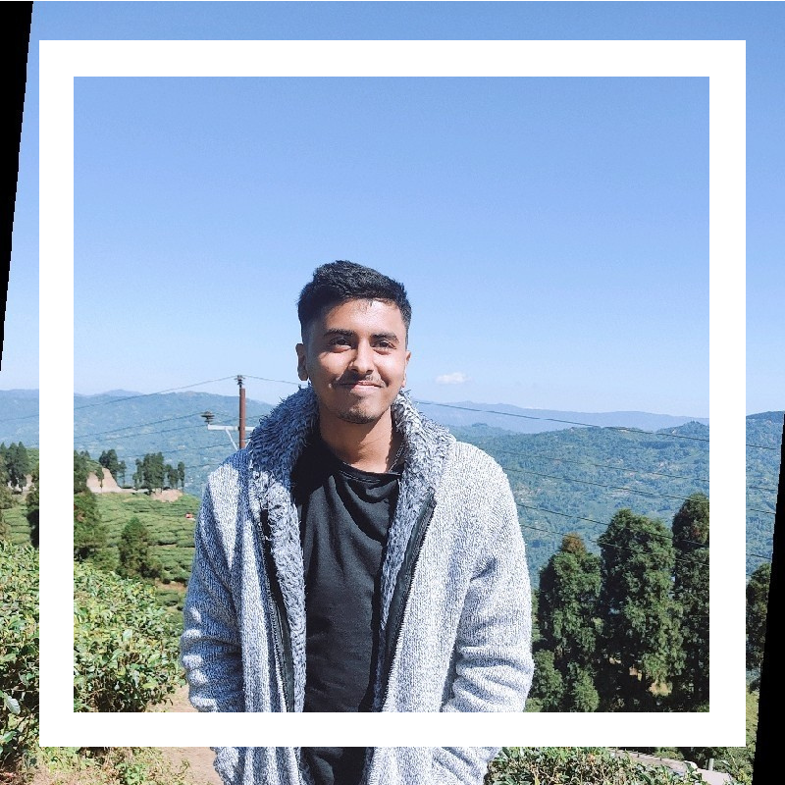

**Sahitya Neupane**

FRONTEND DEVELOPER | STUDENT

**Contact**

Biratnagar-09, Morang, Nepal

[neupanesahitya1@gmail.com](mailto:neupanesahitya1@gmail.com) sahitya1707.github.io/My-portfolio/

@sahitya neupane

**Skills**

**Html & Css**

**Javascript**

**C-Programming**

**Problem Solving**

# About

Hello, I'm Sahitya Neupane. I'm a self-learnt front-end developer based in Nepal. I'm currently studying computer science and information technology for my bachelor's degree (CSIT). Building websites is something I enjoy doing. In the year 2021, I began developing websites. This was quite intriguing to me. I'm a good learner who can quickly pick up new abilities and handle multiple projects and tasks. I develop websites in accordance to your demands.

# Education History

2061 - 2074 B.S Mount Everest Secondary School (SEE)

2074 - 2076 B.S Arniko HSS

(+2 at Computer Science)

2076 - Present Himalaya Darshan College (Tribhuvan University) (Bsc. CSIT)

# Work Experience

Over the past few years, I have been involved in lot of project. You can know more about my project in my website.