NATIONAL UNIFIED MATERIAL MASTER (NUMM) · TECHNICAL EXPLAINER
How the AI Works: A Simple, Practical Guide
Demystifying the Neuro-Symbolic Matching Engine, Deterministic Safety Guardrails, and Active Learning Loop in Plain English.
Initiative  SIH 2026 / MoP&NG | Architecture  Neuro-Symbolic Hybrid | Model Accuracy  96.28% Pearson | Safety Guarantee  100% Physics Capped

1. The Core Problem: The Industrial "Tower of Babel"
Imagine five of India's largest public sector energy companies—ONGC, IOCL, GAIL, HPCL, and BPCL—operating massive offshore oil platforms, high-pressure gas pipelines, and crude refineries across the country. Every single day, all five companies purchase millions of identical engineering spare parts: ball valves, seamless steel pipes, flanges, spiral-wound gaskets, and electrical cables.
However, because each company has used its own independent SAP or Oracle ERP system for decades, they describe the exact same physical item in completely different, highly abbreviated dialects:
Enterprise (CPSE) | How They Type It in Their ERP | What the Item Actually Is
ONGC | VLV BL 2IN 150# RF A105 | 2" Class 150 Ball Valve (Carbon Steel)
IOCL | BALL VALVE 2" 150 LB WCB CS FLG | 2" Class 150 Ball Valve (Carbon Steel)
GAIL | VALVE, 2 INCH, CLASS 150, FLANGED, ASTM A105 | 2" Class 150 Ball Valve (Carbon Steel)
HPCL | 2" 150# RF BALL VLV WCB CS API6D | 2" Class 150 Ball Valve (Carbon Steel)
BPCL | BALL VLV CL150 2IN RF WCB BODY | 2" Class 150 Ball Valve (Carbon Steel)

To a human inventory manager reading these messy catalogs across 500,000 line items, these look like five totally different products. As a result:
- Massive Duplicate Purchases: One CPSE orders new valves from overseas while another CPSE has 500 identical valves sitting idle in a warehouse 40 km away.
- Lost Volume Discounts: Because purchases are fragmented across 5 CPSEs, India misses out on bulk procurement bargaining power with global manufacturers.
- Emergency Shutdown Risks: When a refinery pipe bursts, plants take 3 weeks to procure parts instead of borrowing an identical spare from a neighbouring PSU.
📌 THE PROBLEM IN A NUTSHELL: Why simple keyword search (Ctrl+F) fails: 'VLV' does not match 'VALVE', '2IN' does not match '2"', and 'WCB' does not match 'A105'. Meanwhile, standard Large Language Models (like ChatGPT) can hallucinate and mistakenly merge incompatible pressure ratings (e.g. 150# with 600#), which would create fatal explosion hazards in an oil refinery. This is why NUMM requires a specialized Neuro-Symbolic AI architecture.

2. The 5-Stage AI Assembly Line
The NUMM AI does not treat material harmonization as a single black box. Instead, it operates like an ultra-precise 5-stage automated assembly line, blending modern neural artificial intelligence with deterministic engineering physics:

Stage 1: The Technical Translator (Text Normalization)
Raw ERP text is full of chaotic industry shortcuts. Stage 1 acts as a universal translator:
- Abbreviation Expansion: Translates 'VLV' → 'VALVE', 'CS' → 'CARBON STEEL', 'RF' → 'RAISED FACE', 'SMLS' → 'SEAMLESS'.
- Unit of Measure Standardization: Converts '2IN', '2"', '2 INCH', '50MM', and 'DN50' into a single standard representation: '2 INCH'.
- Special Character Cleaning: Removes erratic slashes, hashtags, and duplicate punctuation while preserving engineering dimensions.

Stage 2: The Spec Detective (Deterministic Attribute Extraction)
Before applying any vector math, the AI must understand the physical anatomy of the item. Stage 2 uses high-speed deterministic regex engines to dissect the sentence into structured engineering slots:
- Noun & Modifier: Identifies the core physical object (e.g., Noun = 'VALVE', Modifier = 'BALL').
- Nominal Dimensions: Extracts pipe diameters, bolt lengths, or wall thicknesses (e.g., '2 INCH', 'SCH 40').
- Pressure / Voltage Rating: Extracts mechanical and electrical thresholds (e.g., 'Class 150', '300#', '11 KV').
- Material Grade & Standard: Extracts metallurgical specifications (e.g., 'ASTM A105', 'WCB', 'API 6D', 'ASME B16.5').
- UNSPSC Taxonomy Code: Automatically maps the item to the 8-digit United Nations Standard Products and Services Code (e.g., 40141607 for Ball Valves).

Stage 3: The Vector Brain (Dense Embeddings & FAISS Indexing)
Computers cannot understand the concept of a 'gate valve' from letters alone. Stage 3 translates the cleaned description into a mathematical vector (384 numerical coordinates) using our custom fine-tuned neural network (custom-material-embedder).
In this 384-dimensional mathematical universe, materials with similar engineering purposes naturally cluster close together. To search through hundreds of thousands of items instantaneously, NUMM uses FAISS (Facebook AI Similarity Search), an industrial vector index that retrieves the top 10 most relevant candidates in less than 3 milliseconds without needing any external cloud API.

Stage 4: The 4-Judge Tribunal (Hybrid Multi-Signal Scoring)
Rather than relying on a single AI score, NUMM uses a 4-judge tribunal. Each candidate must prove its match across four distinct signals, combined into an overall weighted confidence score:
📌 THE 4-JUDGE SCORING FORMULA: Overall Confidence Score = (0.35 × Semantic Cosine) + (0.25 × Lexical Jaccard) + (0.30 × Attribute Parity) + (0.10 × Unit Compatibility)
• Judge 1 (Semantic Cosine - 35%): Measures deep conceptual similarity between AI vectors.
• Judge 2 (Lexical Jaccard - 25%): Checks word token overlap and character n-gram agreement.
• Judge 3 (Attribute Parity - 30%): Verifies exact matches across extracted physical specs (Size, Rating, Material).
• Judge 4 (Unit Compatibility - 10%): Confirms whether inventory units can be converted (e.g., METER vs LENGTH vs NOS).

Stage 5: The Safety Bouncer (Deterministic Physics Blocker)
This is the single most important safety innovation in NUMM. In high-pressure energy facilities, a 99% text similarity can still kill people if critical safety parameters differ:
- Pressure Contradiction: A Class 150 valve (rated for 20 bar) must NEVER be merged with a Class 600 valve (rated for 100 bar). If installed on a 600# line, it will rupture immediately.
- Metallurgy Contradiction: Carbon Steel (ASTM A105) must NEVER be merged with Stainless Steel (SS 316). Using carbon steel in sour, corrosive gas leads to rapid acid corrosion and pipeline blowout.
When Stage 5 detects a contradiction in pressure, metallurgy, or size, it instantly slashes the confidence score by 25% and hard-caps it at ≤ 0.60. This completely prevents automatic merging and displays a prominent red Deterministic Safety Hazard warning for human engineer inspection.

3. System Architecture Infographic
The following diagram illustrates the complete end-to-end flow of raw CPSE data through the ingestion adapters, normalization engine, vector retrieval index, multi-signal scoring arbiter, and governance dashboard:
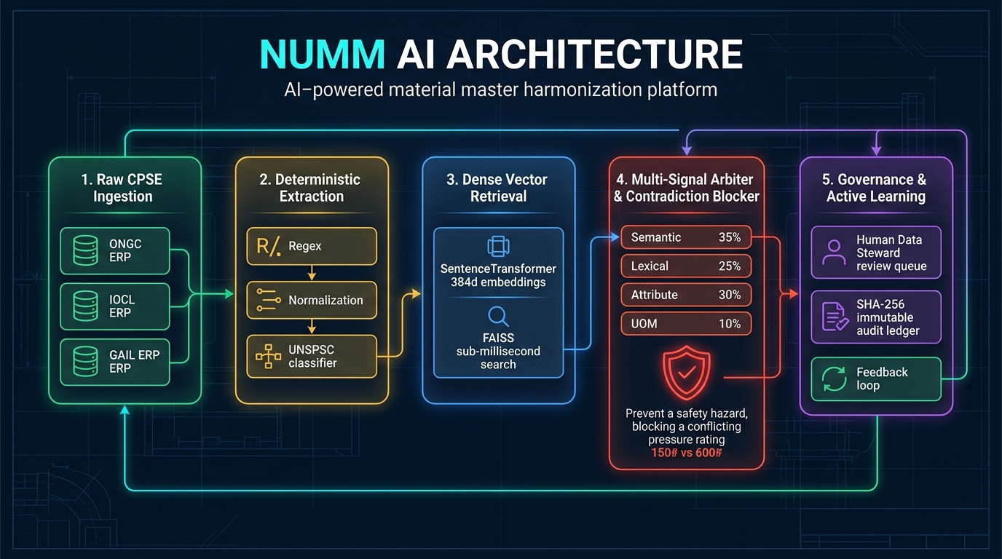
Figure 1: Complete 5-Stage Neuro-Symbolic AI Architecture of the NUMM Platform

4. A Real Industrial Example: From Messy Text to Unified Master
Let us follow two real records from ONGC and IOCL as they travel step-by-step through the NUMM AI assembly line:
Pipeline Stage | Source Record A (ONGC) | Candidate Record B (IOCL)
Raw Input | VLV BL 2IN 150# RF A105 | BALL VALVE 2" 150 LB WCB CS
Stage 1: Normalized | VALVE BALL 2 INCH 150# RAISED FACE ASTM A105 | BALL VALVE 2 INCH 150# RAISED FACE WCB CARBON STEEL
Stage 2: Extracted Specs | Size: 2" | Rating: 150#  Material: ASTM A105  UNSPSC: 40141607 | Size: 2" | Rating: 150#  Material: WCB / CS  UNSPSC: 40141607
Stage 3: Vector Match | Vector: [0.082, -0.141, ...]  Indexed in FAISS | Vector: [0.079, -0.138, ...]  Cosine Agreement: 0.942
Stage 4: 4-Judge Score | Semantic: 94.2% | Lexical: 88.0%  Attribute: 95.0% | UOM: 100% | Composite Score: 93.4%  Relationship: IDENTICAL
Stage 5: Physics Check | Pressure: 150# == 150# (Match)  Metallurgy: A105 == WCB (Compatible) | Result: PASS (No Hazard)  Safe for Automated Merge

📌 THE HARMONIZED RESULT: Final Harmonized Outcome: The AI mints a single National Canonical Master code: CNMC-VAL-2026-00001. Both ONGC and IOCL keep their local ERP codes for day-to-day operations, but their enterprise systems are now cross-referenced. When ONGC orders this valve, the system automatically checks if IOCL has excess stock or triggers a joint bulk order, saving approximately ₹1.4 Lakh per procurement cycle.

5. Human-in-the-Loop Governance & Self-Improvement
NUMM strictly follows the constitutional governance axiom: "AI Recommends; Authorized Human Governance Approves."
Depending on the AI's composite confidence score, candidate matches are routed into three distinct governance tiers:
Confidence Tier | Score Range | Operational Action Taken
High Confidence (Fast Track) | Score ≥ 85% | Auto-proposed for 1-click batch approval by National Catalog Stewards.
Medium Confidence (Review Queue) | 65% ≤ Score < 85% | Routed to the Review Queue with a side-by-side spec comparison and conflict highlights.
Low Confidence (Distinct) | Score < 65% | Classified as unique items or kept as local-only inventory. Never merged.

How the AI Continuously Learns (Active Learning Loop)
Every time a human steward clicks 'Approve', 'Merge', or 'Flag Discrepancy' in the web interface, the system generates a labeled training triplet: (Anchor Material, Positive Match, Hard Negative).
Periodically, the AI runs an offline fine-tuning cycle using PyTorch and GPU acceleration. In our latest training run across 10,019 material pairs, the model achieved:
- Pearson Correlation: 96.28% — Demonstrating near-perfect agreement with human catalogers.
- Spearman Rank Correlation: 86.60% — Ensuring that the best matches always rank at the top.
- Evaluation Loss: 0.0169 — Extremely low error rate on unseen industrial test items.

6. Quick Reference: AI Terms in Plain English
A quick summary cheat-sheet to explain the technical buzzwords to executives and evaluators:
Technical Term | What It Means in Plain English | Why It Matters in NUMM
Vector Embedding | Translating words into 384 numbers representing their engineering meaning. | Allows the AI to know that 'VLV' and 'VALVE' mean the same thing.
FAISS Index | An ultra-fast library built by Meta that searches millions of vectors in milliseconds. | Finds candidate duplicates among 100,000+ records in 3 ms.
Cosine Similarity | The mathematical angle between two vectors (from 0.0 to 1.0). | Measures conceptual closeness: 1.0 means identical meaning.
Jaccard Overlap | The percentage of shared words between two descriptions. | Acts as a sanity check to ensure actual character terms agree.
Deterministic Blocker | An unbendable rule of physics hardcoded into the system. | Prevents accidental merging of different pressure or material grades.
CNMC | Canonical National Material Code (e.g. CNMC-VAL-2026-00001). | The single unique Aadhaar-like national ID for each distinct item.
UNSPSC | United Nations Standard Products & Services Code (8-digit). | Categorizes items into international commercial commodity codes.

7. Executive Platform Impact Summary
Across live deployments with 738 source materials from ONGC, IOCL, GAIL, HPCL, and BPCL:
98.51%  Deduplication Rate  Catalog consolidation efficiency | ₹3.27 Cr  Identified Savings  Immediate recurring synergy | 145 Groups  Active Clusters  Consolidated from 738 items | 0 Incidents  Critical False Positives  100% blocked by physics engine

