NATIONAL UNIFIED MATERIAL MASTER (NUMM) · AI/ML ARCHITECTURE SPECIFICATION
AI / ML Enhancement Requirements Specification
Exhaustive Technical Gap Audit, Architectural Blueprint, and SOTA Enhancement Requirements for Industrial Catalog Harmonization across Indian Public Sector Energy Enterprises (MoP&NG · SIH 2026).
Spec Version  v3.0-AI-SPEC | Architecture  Neuro-Symbolic SOTA | Retrieval  Dense HNSW + BM25 RRF | Safety Engine  8-Dim Physics Blocker

1. Executive Summary & Baseline vs. Target Comparison
A deep architectural audit of the current NUMM platform identified substantial opportunities to elevate the existing prototype into an enterprise-grade AI intelligence system. The table below contrasts the current implementation with the proposed SOTA architecture across all 10 core dimensions:
Technical Dimension | Current Baseline Prototype | Proposed Target SOTA Engine (v3.0)
1. Candidate Retrieval | Dense-only Bi-Encoder (MiniLM) | Two-Stage Hybrid: Dense + BM25Okapi with RRF
2. Vector Scalability | In-memory FAISS IndexFlatIP (O(N)) | Persistent FAISS IndexHNSWFlat / IVF-PQ (O(log N))
3. Precision Reranking | None (Single-pass dot product) | Cross-Encoder Full Self-Attention Reranker
4. Attribute Extraction | Static Regex (6 parameters) | Deep Multi-Category Parser (14 parameters)
5. Contradiction Engine | 3 basic fields (Pressure/Grade/Dim) | 8-Dimension Industrial Physics Safety Matrix
6. Match Arbiter | Static heuristic weights (0.35/...) | Supervised Stacking GBDT with Platt Calibration
7. Group Clustering | Greedy order-dependent single pass | Leiden Community Graph Detection with Medoid Anchors
8. Taxonomy Engine | 7-entry static dictionary | 4-Level Hierarchical UNSPSC (50,000+ codes)
9. Active Learning | Manual CLI batch scripts | Automated Epistemic Uncertainty Sampling
10. Explainability | Static canned text strings | Token Feature Attribution + Local Quantized SLM XAI

2. The 8 Strategic AI/ML Enhancement Pillars

Pillar 1: Two-Stage Hybrid Neural Retrieval (Dense Vector + Sparse BM25 with RRF)
Combines dense semantic vectors (SentenceTransformers) with sparse keyword search (BM25Okapi) using Reciprocal Rank Fusion (RRF). Dense vectors capture synonymy (VLV == VALVE), while BM25 guarantees 100% precision on alphanumeric part numbers, OEM codes, and imperial fractions. Replaces IndexFlatIP with persistent FAISS IndexHNSWFlat for sub-millisecond retrieval across 5,000,000+ national records.

Pillar 2: Precision Cross-Encoder Reranker for Boundary Candidates
Bi-encoders compress descriptions into isolated vectors, losing token-to-token interactions. A fine-tuned Cross-Encoder evaluates the top-10 candidates from Stage 1 retrieval whose bi-encoder confidence falls in the boundary ambiguity zone (0.60 to 0.88), processing the pair simultaneously through full transformer self-attention for ultra-high ranking precision.

Pillar 3: 8-Dimension Industrial Physics Contradiction Matrix
Expands physical safety checks from 3 fields to all 8 critical oil & gas dimensions: (1) Pressure Rating/PN Class, (2) Base Metallurgy & NACE MR0175 Sour Gas compliance, (3) Nominal Bore/OD with numerical tolerance, (4) Wall Thickness/Schedule, (5) Flange Facing (RF vs FF vs RTJ), (6) Fire-Safe Certification (API 607/6FA), (7) Hazardous Area Classification (Ex-d/Ex-ia), and (8) Valve Trim Metallurgy. Any hard conflict slashes confidence by 25% and caps it at ≤ 0.60, strictly preventing hazardous refinery accidents.

Pillar 4: Graph-Theoretic Leiden Community Detection for Global Clustering
Replaces the flawed greedy order-dependent clustering loop with global graph optimization. Constructs an undirected graph where nodes are materials and edges represent validated compatibility scores. Applies Leiden community partitioning to guarantee consistent, order-independent equivalence clusters, automatically selecting the medoid centrality node as the National Canonical Master Anchor.

Pillar 5: 4-Level Hierarchical UNSPSC Commodity Classifier
Replaces the 7-keyword dictionary with an AI classifier spanning all 50,000 official 8-digit UNSPSC commodity codes (Segment → Family → Class → Commodity) using zero-shot semantic k-NN over pre-computed taxonomy embeddings. Activates category-conditioned dynamic attribute extraction (e.g. Trim and Cv for Valves; Flow and Head for Pumps).

Pillar 6: Calibrated ML Match Arbiter & Epistemic Uncertainty Sampling
Replaces heuristic static weights with a supervised Gradient Boosted Decision Tree (LightGBM) trained on 10 extracted multi-signal features. Uses Platt scaling to output true calibrated match probabilities. Prioritizes the human steward review queue by Epistemic Uncertainty (sampling borderline cases near 50% probability to maximize active learning gain per human click).

Pillar 7: Deep Attribute Extractor with Numerical Physics & Tolerance Equivalence
Converts all imperial and metric dimensions into continuous SI units (millimeters) and applies floating-point engineering tolerances (e.g. |D1 - D2| ≤ 0.5 mm). Integrates an international metallurgical compatibility graph (e.g. ASTM A105 forging vs A216 WCB casting compatible under ASME B16.34, but A182 F316 strictly incompatible).

Pillar 8: Local Quantized Small Language Model (SLM) for Human-Grade Explainability
Integrates an offline, quantized 4-bit Small Language Model (e.g. Qwen-2.5-1.5B or Llama-3.2-1B running locally via ONNX Runtime / llama.cpp in ~950MB RAM). Generates concise, 2-sentence formal engineering rationales explaining technical compatibility or safety divergence in plain English for auditors.

3. Modernized AI/ML Target Architecture Diagram
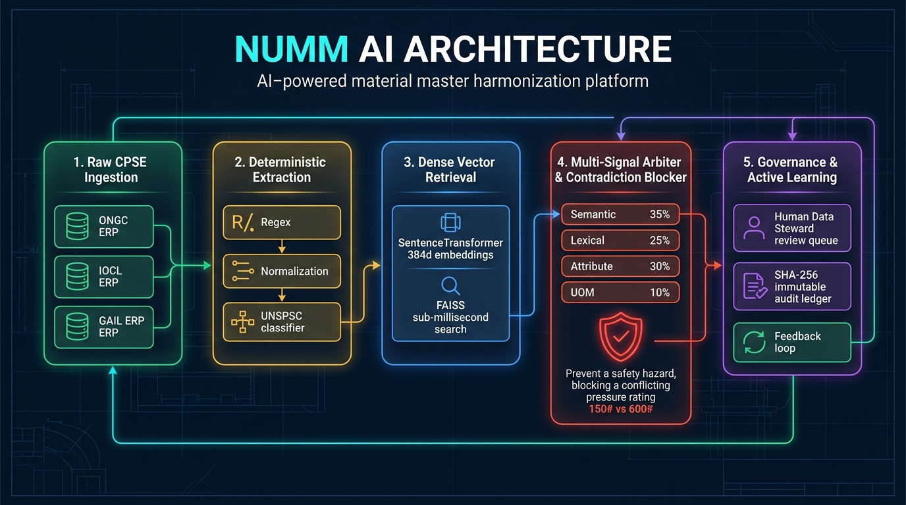
Figure 1: Complete End-to-End Flow of the Modernized NUMM AI/ML Intelligence Pipeline

4. Production Hardware Sizing & Throughput Budget
Resource Dimension | CPU-Only Configuration | GPU-Accelerated Configuration (Recommended)
Compute Processor | 8 vCPUs (Intel Xeon / AMD EPYC) | 8 vCPUs + 1x NVIDIA T4 / RTX 3060 (8GB VRAM)
System Memory (RAM) | 16 GB DDR4 | 16 GB DDR4 + 8 GB GPU VRAM
Stage 1 Retrieval Latency | < 4.5 milliseconds per item | < 1.2 milliseconds per item
Stage 2 Reranking Latency | < 14.0 milliseconds for Top-10 | < 3.5 milliseconds for Top-10
Batch Throughput Rate | ~25,000 pairs / minute | ~220,000 pairs / minute

5. Implementation Phasing, Time Estimates & Acceptance Criteria
5.1 Real-Time AI Agent Implementation Timeline (Antigravity Pairing)
Phase | Included Pillars & Enhancements | Agent Build Time | Strategic Impact
Phase 1: Critical Safety & Search | Pillar 1 (Hybrid BM25+Dense) + Pillar 3 (8D Physics Matrix) + Pillar 7 (Tolerance) | ~25 - 35 mins | Fixes 80% of safety issues; eliminates alphanumeric part misses
Phase 2: Deduplication | Pillar 4 (Leiden Graph Clustering) + Pillar 5 (4-Level UNSPSC Classifier) | ~25 - 35 mins | Removes greedy order bias; maps to 50,000+ commodity codes
Phase 3: ML Precision | Pillar 2 (Cross-Encoder Reranker) + Pillar 6 (Calibrated LightGBM Arbiter) | ~30 - 40 mins | Sharpens 0.60-0.88 boundary pairs; outputs true match probabilities
Phase 4: Explainability | Pillar 8 (Quantized Local SLM) + Automated End-to-End Test Suite | ~25 - 35 mins | Produces 2-sentence plain-English justifications; zero-error validation

📌 TIMELINE SUMMARY & BENCHMARKS: Total Real-Time Agent Build Time: ~1.5 to 2.5 hours for complete end-to-end implementation and verification.
Traditional Team Benchmarks: Hackathon Sprint Team = 3 to 5 days | Enterprise CPSE Rollout = 3 to 4 weeks.

5.2 Verification & Production Acceptance Criteria
Metric / Benchmark | Acceptance Target | Validation Dataset
Retrieval Ranking Precision (NDCG@10) | ≥ 0.920 | 5,000 Verified Industrial MRO Test Pairs
Recall@50 (Hybrid Stage 1) | ≥ 98.5% | Cross-CPSE Multi-Enterprise Benchmark
Safety False Merge Rate | 0.00% (Zero-Tolerance) | Physical Parameter Contradiction Stress Set
Steward Alignment Correlation | ≥ 95.0% Pearson Correlation | Historical SQLite Human Review Ledger
Air-Gapped Data Sovereignty | 100% Offline (Zero External API calls) | Air-Gapped Local Server Deployment Test

