QuantCopilot AI: An Integrated Financial Analytics, GNN Risk Engine and Advanced Trading Workstation
Jay Keluskar, Sahitya Sahani, Rishi Shah, Varad Tardekar
Department of Computer Engineering
Vidyalankar Institute of Technology, Mumbai, India

Abstract
Financial markets are complex interconnected systems in which risk can propagate across companies, sectors, financial institutions, and related assets. Conventional financial analytics and machine-learning approaches generally focus on individual assets or temporal patterns and therefore have limited ability to explicitly model relationships between entities and explain how risk propagates through a financial ecosystem. This paper presents QuantCopilot AI, an integrated financial analytics and trading workstation incorporating a Graph Neural Network (GNN)-based risk engine, counterfactual reasoning, explainable artificial intelligence (XAI), real-time market analytics, portfolio risk management, and an AI investment copilot.
The proposed system models the financial ecosystem as a directed weighted graph in which financial entities are represented as nodes and their relationships as weighted edges. A multi-head Graph Attention Network (GAT) is employed to learn relational risk propagation, while adversarial causal regularization is incorporated to reduce the influence of spurious correlations. A counterfactual optimization module subsequently identifies sparse interventions capable of changing predicted risk states. The resulting model outputs are integrated into a browser-based financial workstation through a FastAPI backend and a Next.js/React frontend. The platform additionally provides market monitoring, technical charting, derivatives analytics, portfolio risk analysis, alerts, and conversational AI-based explanations.
Experimental evaluation focuses on risk-prediction performance, ablation analysis, counterfactual validity and sparsity, robustness, computational performance, and end-to-end workflow integration. The system is designed to bridge the gap between complex graph-based financial risk modeling and practical, interpretable financial decision support.
Keywords— Financial Risk, Graph Neural Networks, Graph Attention Network, Explainable AI, Counterfactual Reasoning, Financial Analytics, Systemic Risk.

I. INTRODUCTION
Financial markets are inherently interconnected. The financial condition of one institution can influence other institutions through direct exposure, sector relationships, market movements, investment holdings, and macroeconomic factors. Consequently, modeling financial entities independently may fail to capture the relational structure through which financial distress can propagate.
Traditional financial analytics systems generally provide market data, technical indicators, portfolio statistics, and trading facilities. Although these tools are useful for monitoring and execution, they often treat risk analysis as a collection of independent asset-level measurements. Machine-learning methods such as recurrent neural networks and ensemble models can capture temporal or nonlinear patterns, but they do not naturally represent the graph structure of interconnected financial systems.
Graph Neural Networks provide an alternative representation by explicitly modeling entities and their relationships. QuantCopilot AI extends this approach through a GNN-based Causal Risk Engine designed to represent equities, sector indices, ETFs, macroeconomic indicators, and banking institutions as nodes in a directed weighted graph. The system uses a Graph Attention Network to learn the influence of connected entities and generate risk predictions.
The central objective of QuantCopilot AI is not merely to predict whether an entity is risky, but to provide an interpretable mechanism through which users can understand where risk originates, how it propagates, and what changes could potentially alter the predicted outcome. The system therefore combines GNN-based prediction with counterfactual reasoning and an AI explanation layer.
The project also integrates the risk engine with a broader financial workstation. The SRS defines functionality including market monitoring, order execution, charting, derivatives analytics, portfolio risk management, automated investing, alerts, and AI-assisted decision support.
A. Contributions
The principal contributions of this work are:
- An integrated financial analytics architecture combining real-time market analytics with graph-based systemic-risk analysis.
- A GAT-based financial graph representation for modeling relationships among heterogeneous financial entities.
- An adversarially regularized risk-learning framework intended to reduce the influence of spurious relational patterns.
- A counterfactual reasoning mechanism for generating sparse "what-if" interventions.
- An XAI layer that converts complex model outputs into human-readable explanations.
- Integration of the proposed risk intelligence into a complete financial decision-support workstation.
The system scope and objectives are aligned with the project SRS, which identifies explainable systemic-risk prediction, low-latency analytics, plain-English explanations, full trade-lifecycle support, and responsible trading guardrails as major objectives.

II. RELATED WORK
A. Financial Machine Learning
Machine learning has been extensively applied to financial prediction, including stock-price prediction, volatility forecasting, classification, and portfolio analysis. Ensemble models such as Random Forest and XGBoost can effectively capture nonlinear relationships among engineered financial features, while recurrent architectures such as LSTM networks are capable of modeling temporal dependencies.
However, most conventional approaches represent financial instruments primarily as independent observations or time series. This limits their ability to directly encode relationships between financial entities.
Nabipour et al. investigated multiple machine-learning and deep-learning methods for stock-market prediction, including ensemble and recurrent approaches. Such models provide important baselines for evaluating graph-based financial models.

B. Graph Neural Networks in Financial Risk
Graph Neural Networks have increasingly been investigated for financial applications because financial entities naturally form relational networks. Banks can be connected through lending relationships, companies can be connected through supply chains and sector membership, and securities can be related through common ownership or market exposure.
Graph convolution and graph attention mechanisms allow information from neighboring entities to contribute to an entity's representation.
The proposed QuantCopilot architecture builds upon this concept by representing the financial ecosystem as a directed, weighted graph and applying multi-head graph attention for risk propagation.

C. Explainable AI and Counterfactual Reasoning
Prediction alone is insufficient for many financial-risk applications because users need to understand the reasoning behind a model's output. Explainable AI methods attempt to expose the factors influencing predictions.
Counterfactual explanations provide an alternative perspective by asking:
What would need to change for the model's prediction to change?
QuantCopilot incorporates this concept through an optimization-based counterfactual module that searches for sparse interventions capable of modifying the predicted risk state.
The SRS specifies counterfactual optimization using sparse interventions and constrains the intervention sparsity using $L_{0}≤3.0$.

D. Research Gap
Existing financial analytics tools, conventional machine-learning models, graph-based risk models, and explainability techniques address different aspects of financial intelligence.
QuantCopilot attempts to combine these capabilities into a single workflow:
financial data → graph representation → GNN prediction → risk propagation → counterfactual reasoning → human-readable explanation → financial decision support.
This integrated workflow represents the primary research and system-design focus of the proposed platform.

III. PROBLEM FORMULATION
Let the financial ecosystem be represented by a directed weighted graph:
$$G=(V,E,X,W)$$
where:
- $V$represents financial entities,
- $E$represents relationships between entities,
- $X$represents node-level features,
- $W$represents edge weights.
The nodes may represent equities, ETFs, sector indices, banking institutions, and macroeconomic indicators.
For each node $v_{i}$, the model receives an engineered feature vector:
$$x_{i}∈R^{38}$$
The objective is to learn a function:
$$f(G,X,W)→y$$
where $y$represents the predicted risk state.
The system defines the risk states as:
- Default
- Distressed
- At Risk
- Recovered
- Stable
The second objective is counterfactual generation. Given an original graph $G$, the counterfactual module searches for an intervention $Δ$such that:
$$f(G+Δ)≠f(G)$$
while minimizing intervention magnitude and sparsity.
The resulting problem can be formulated as:
$$Δ^{*}=arg⁡\underset{Δ}{min⁡}\left(L_{validity} + λ_{1}L_{distance} + λ_{2}L_{sparsity}\right)$$
subject to:
$$L_{0}(Δ)≤3$$
The purpose is to generate an actionable and interpretable explanation rather than simply outputting a numerical risk score.

IV. PROPOSED QUANTCOPILOT FRAMEWORK
A. Overall Architecture
QuantCopilot AI follows a layered architecture consisting of:
- User Interface Layer
- Application/API Layer
- Machine-Learning Layer
- Data Layer
- External Financial Services
The frontend is implemented using Next.js/React and TypeScript. The backend uses FastAPI, while the machine-learning service uses PyTorch and PyTorch Geometric. PostgreSQL and Redis form the primary persistent and caching data services. Communication is performed through HTTPS and WebSockets.
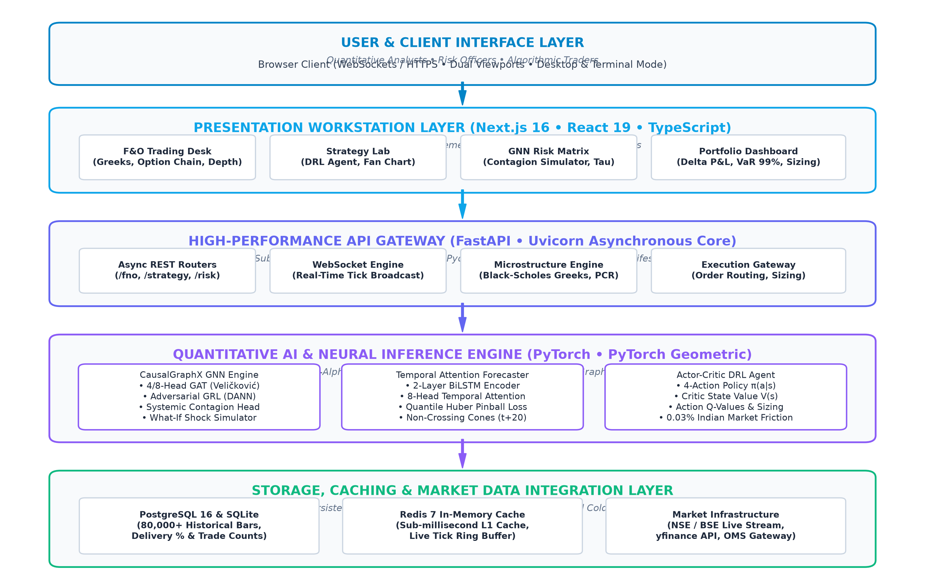
Figure 1. Overall QuantCopilot AI System Architecture
Picture should contain:
User
↓
Next.js / React Frontend
↓
FastAPI Backend
↓
┌───────────────────────────────┐
│ GNN Risk Engine │
│ Counterfactual Optimizer │
│ AI Explanation / Copilot │
└───────────────────────────────┘
↓
PostgreSQL + Redis
↓
Market Data / Broker OMS / News
This should be a clean IEEE-style architecture diagram.

V. GNN-BASED CAUSAL RISK ENGINE
A. Financial Graph Construction
The financial ecosystem is represented using heterogeneous entities including equities, sector indices, ETFs, macroeconomic indicators, and banking institutions.
Relationships between entities are represented using directed weighted edges. The weights represent the strength or relevance of the financial relationship.
This graph representation allows the model to propagate information across related entities rather than treating each financial instrument independently.

B. Node Feature Engineering
Each node is represented using a 38-dimensional feature vector. These features capture financial and market characteristics required by the risk engine.
The feature-processing pipeline includes:
- Raw market-data collection
- Feature calculation
- Missing-value handling
- Normalization
- Graph construction
- GNN input generation.

C. Graph Attention Network
The proposed risk engine uses an 8-head, 3-layer Graph Attention Network.
For a node $i$, attention coefficients determine the relative contribution of neighboring nodes:
$$α_{ij}=\frac{exp⁡(e_{ij})}{\sum_{k∈N(i)}{exp⁡(}e_{ik})}$$
The resulting node representation incorporates information from financially connected entities.
Multiple attention heads enable the model to learn different relationship patterns simultaneously.

D. Adversarial Causal Regularization
The model incorporates an adversarial regularization mechanism intended to reduce unwanted correlations caused by regional effects, sector-specific patterns, and market-related noise.
A discriminator attempts to identify undesirable latent information while the GNN is optimized to produce representations less dependent on such information.
This produces the proposed causal-regularized GNN architecture.

E. Risk-State Prediction
The final GNN representation is passed to a classification layer producing risk-state probabilities.
The system maps the resulting prediction to one of the defined risk categories:
$$\left\{Default , Distressed , AtRisk , Recovered , Stable\right\}$$

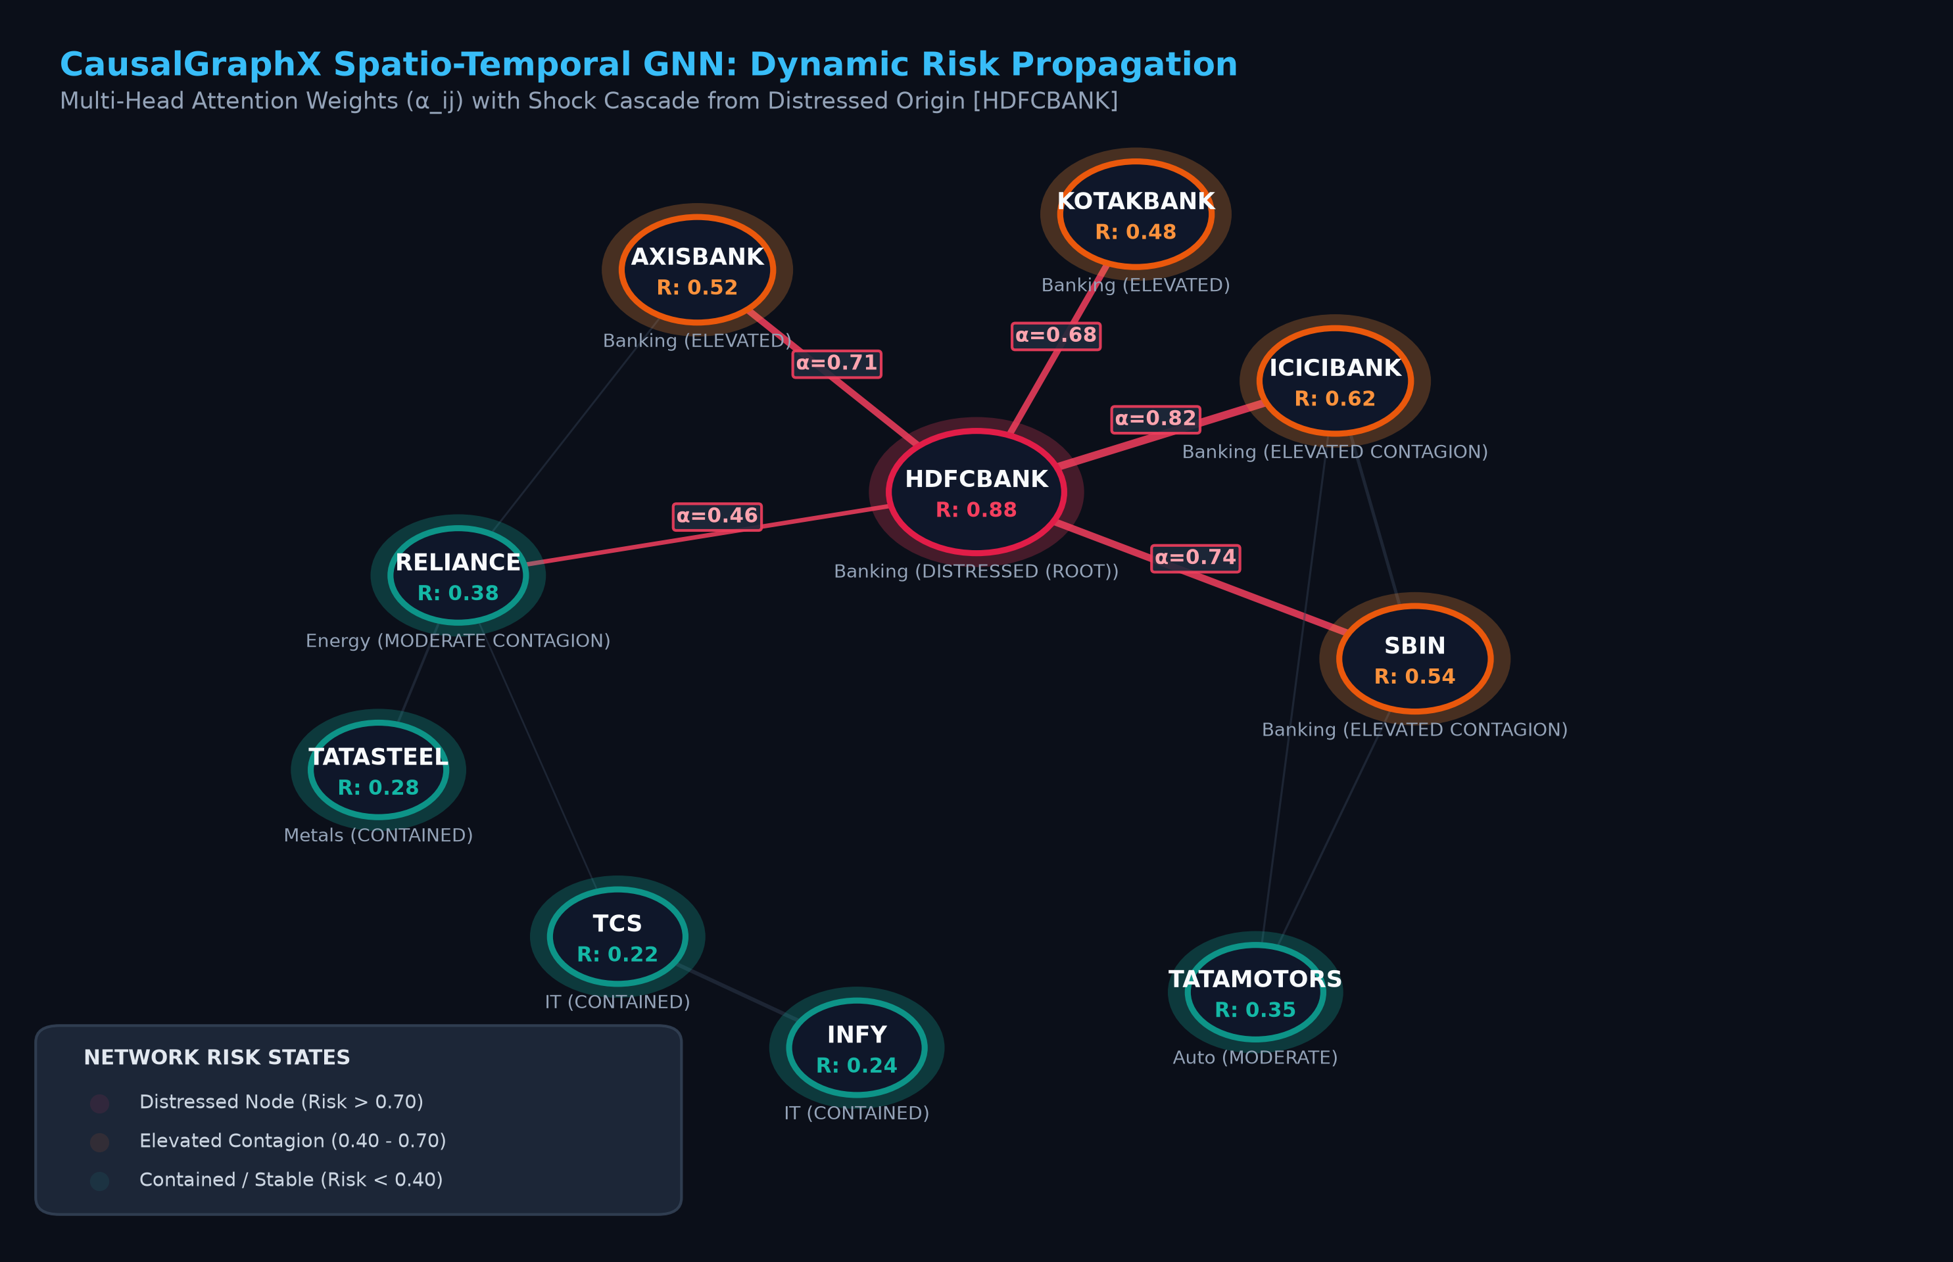
Figure 2. Financial Graph Representation and GNN Risk Propagation
Picture should show:
- Financial nodes
- Directed edges
- Edge weights
- Different entity types
- Risk states
- Attention/risk propagation
- One highlighted distressed entity
- Propagation to connected entities
This is one of the most important figures in the entire paper.

VI. COUNTERFACTUAL REASONING AND EXPLAINABILITY
A. Counterfactual Optimization
Prediction alone does not explain how the predicted risk could change. QuantCopilot therefore incorporates a counterfactual optimization mechanism.
Given a graph $G$and predicted state $y$, the optimizer searches for a sparse intervention $Δ$:
$$G^{'}=G+Δ$$
such that:
$$f(G^{'})=y^{'}$$
where $y^{'}$represents the desired alternative risk state.
The optimization balances:
- Prediction validity
- Intervention distance
- Intervention sparsity.
The system's SRS specifies an Adam-based optimization loop and a target of producing actionable sparse interventions for graphs containing up to 2,000 nodes.

B. Counterfactual Workflow
A user can select a financial entity and investigate a hypothetical shock.
For example:
Initial condition
Entity is classified as Distressed.
The user applies a hypothetical intervention.
The system then recomputes the graph and produces a new risk state.
The result is presented as a counterfactual explanation.
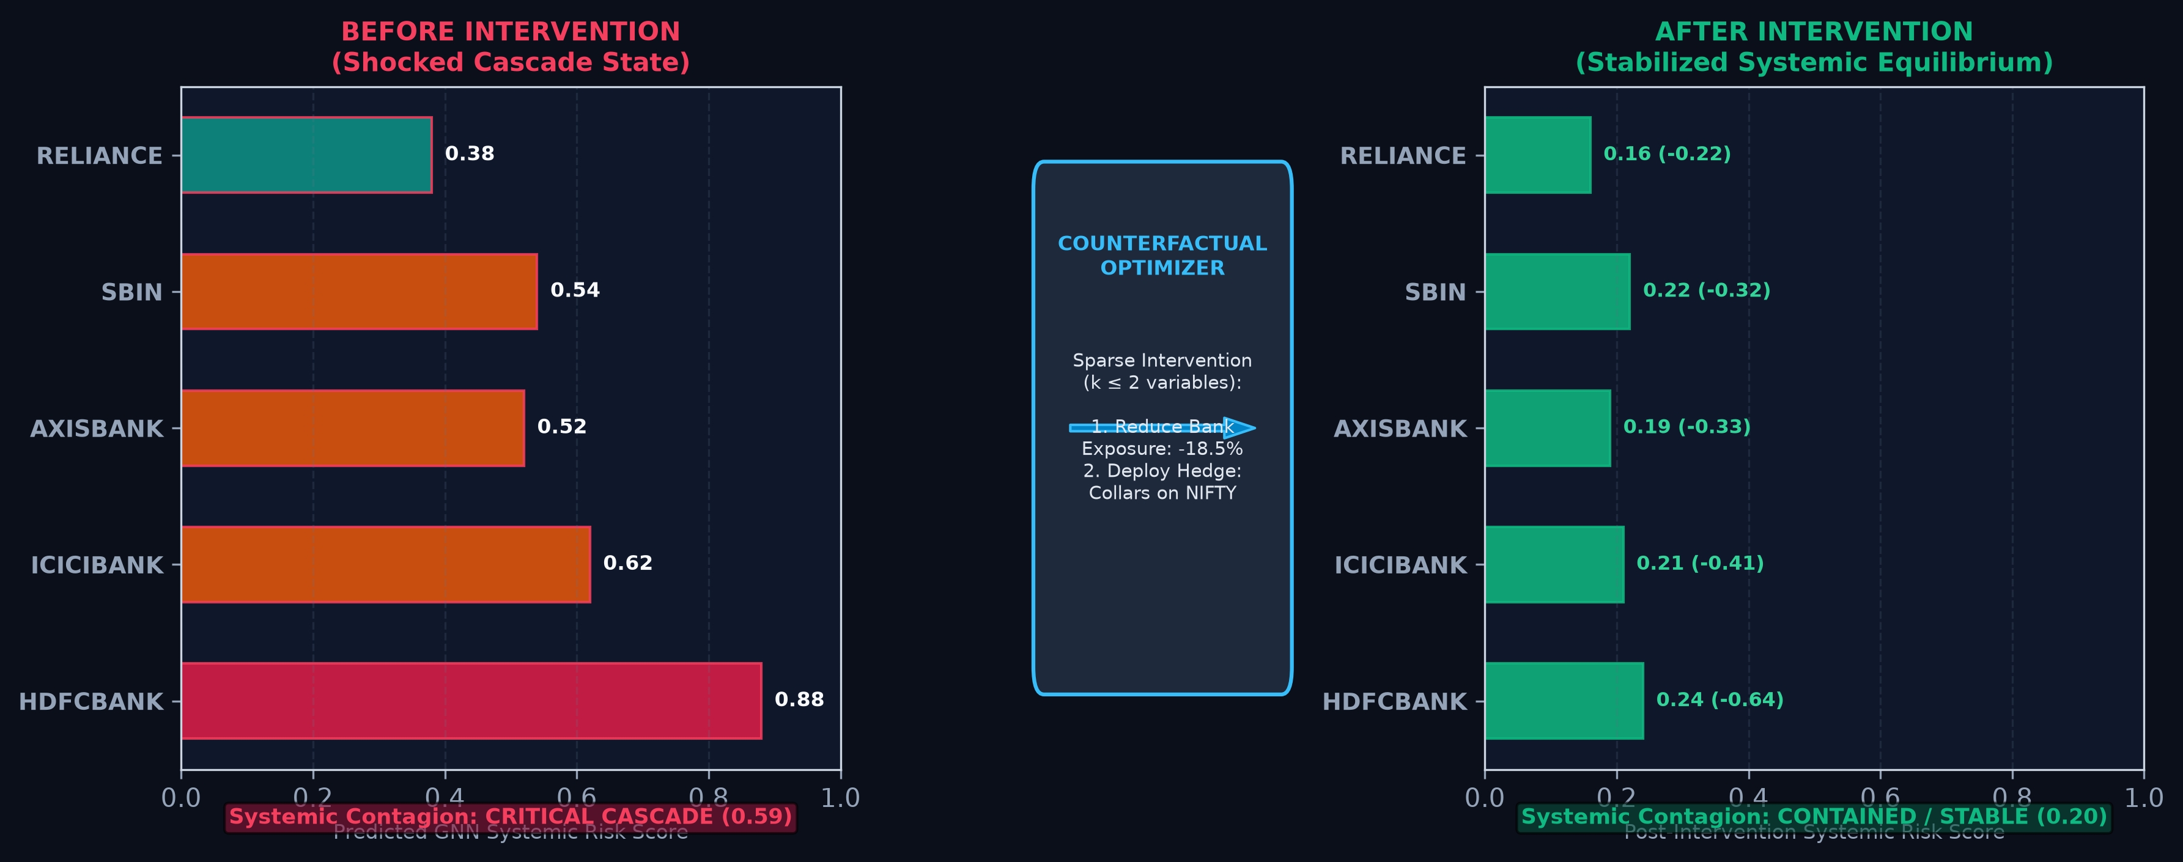
Figure 3. Counterfactual What-If Analysis: Before and After Intervention
Picture should show:
BEFORE INTERVENTION
↓
Risk State: DISTRESSED
↓
User applies hypothetical shock
↓
COUNTERFACTUAL OPTIMIZER
↓
Sparse Intervention
↓
AFTER INTERVENTION
↓
Risk State: STABLE / RECOVERED
The figure should preferably contain an actual result from your application, not a conceptual illustration.

C. Plain-English Explanation
The numerical and graph-based outputs are translated into natural-language explanations.
For example:
"The predicted risk decreases because the intervention reduces the exposure of the affected institution to high-risk connected entities."
The AI Copilot retrieves portfolio, market, and GNN context to provide conversational explanations. The SRS specifies that the system should provide plain-English justification cards accompanying AI signals and risk reports.
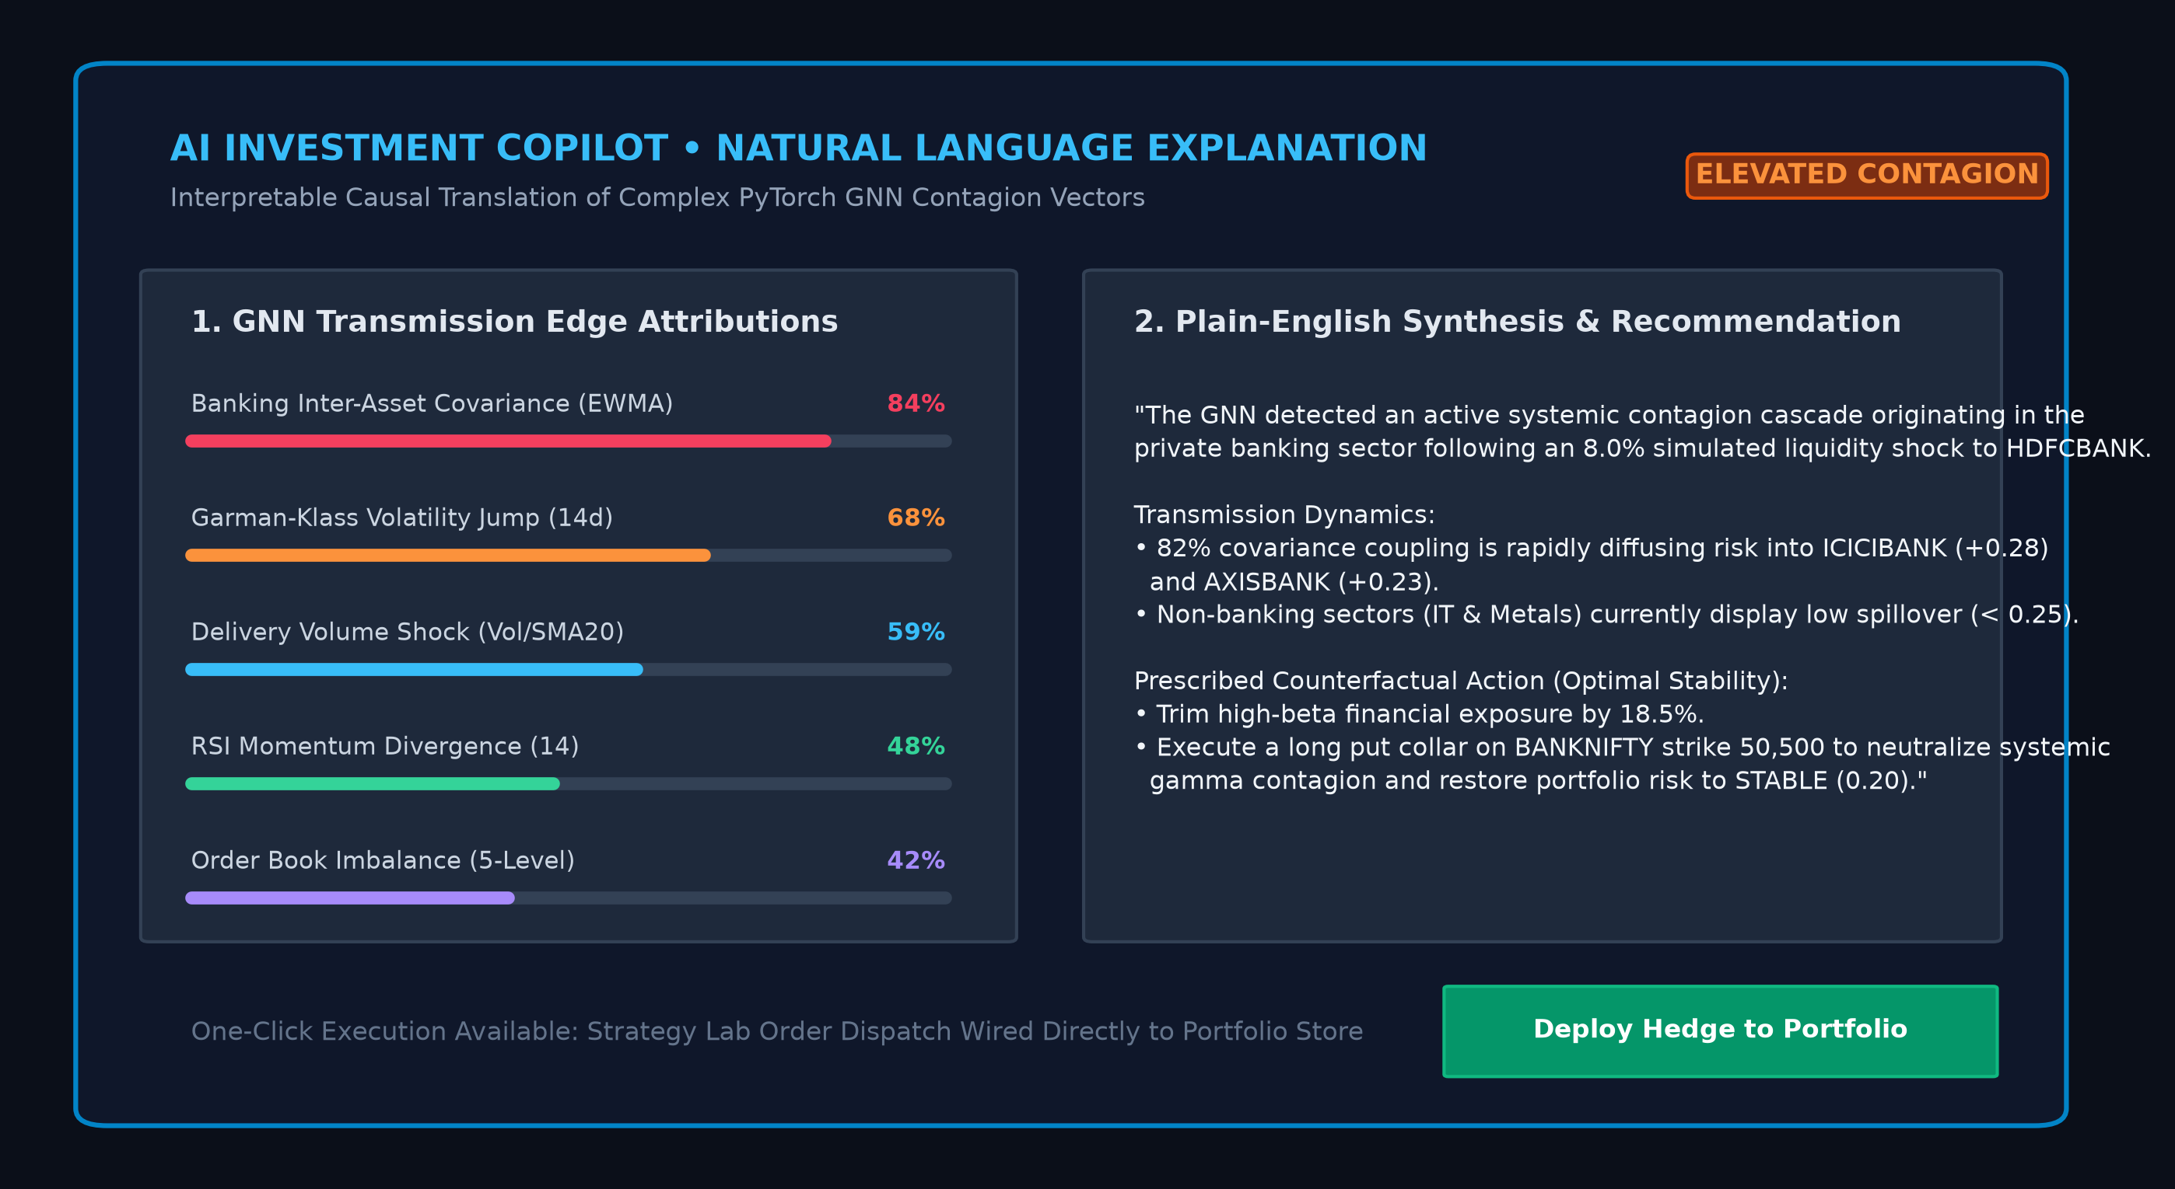
Figure 4. AI Copilot Explanation of GNN Risk and Counterfactual Output
Screenshot should show:
- Risk prediction
- GNN explanation
- Counterfactual intervention
- AI Copilot response
- Plain-English reasoning
This figure demonstrates the transition:
Complex ML output → understandable financial explanation.

VII. INTEGRATED FINANCIAL WORKSTATION
A. Market Watch and Search
QuantCopilot provides real-time market monitoring and instrument discovery. Users can track equities, derivatives, ETFs, indices, and other supported instruments through configurable watchlists.

B. Order Execution
The workstation supports several order types including Market, Limit, Stop Loss, Stop Loss Market, After Market Orders, Iceberg orders, GTT, OCO, trailing GTT, and multi-leg basket orders.

C. Advanced Charting
The platform incorporates multi-timeframe financial charting and technical analysis. The SRS specifies support for candlestick, Heikin-Ashi, line and Renko charts together with technical indicators and drawing tools.

D. Derivatives Analytics
The system provides market-depth visualization, option-chain analysis, implied volatility, open interest, and option Greeks including Delta, Gamma, Theta and Vega.

E. Portfolio Risk Console
The portfolio module calculates:
- Portfolio Health Score
- Beta
- Sharpe Ratio
- Historical Volatility
- Diversification Index
- Asset allocation
- Sector allocation
- P&L
The SRS additionally specifies behavioral risk nudges and a trading kill switch.

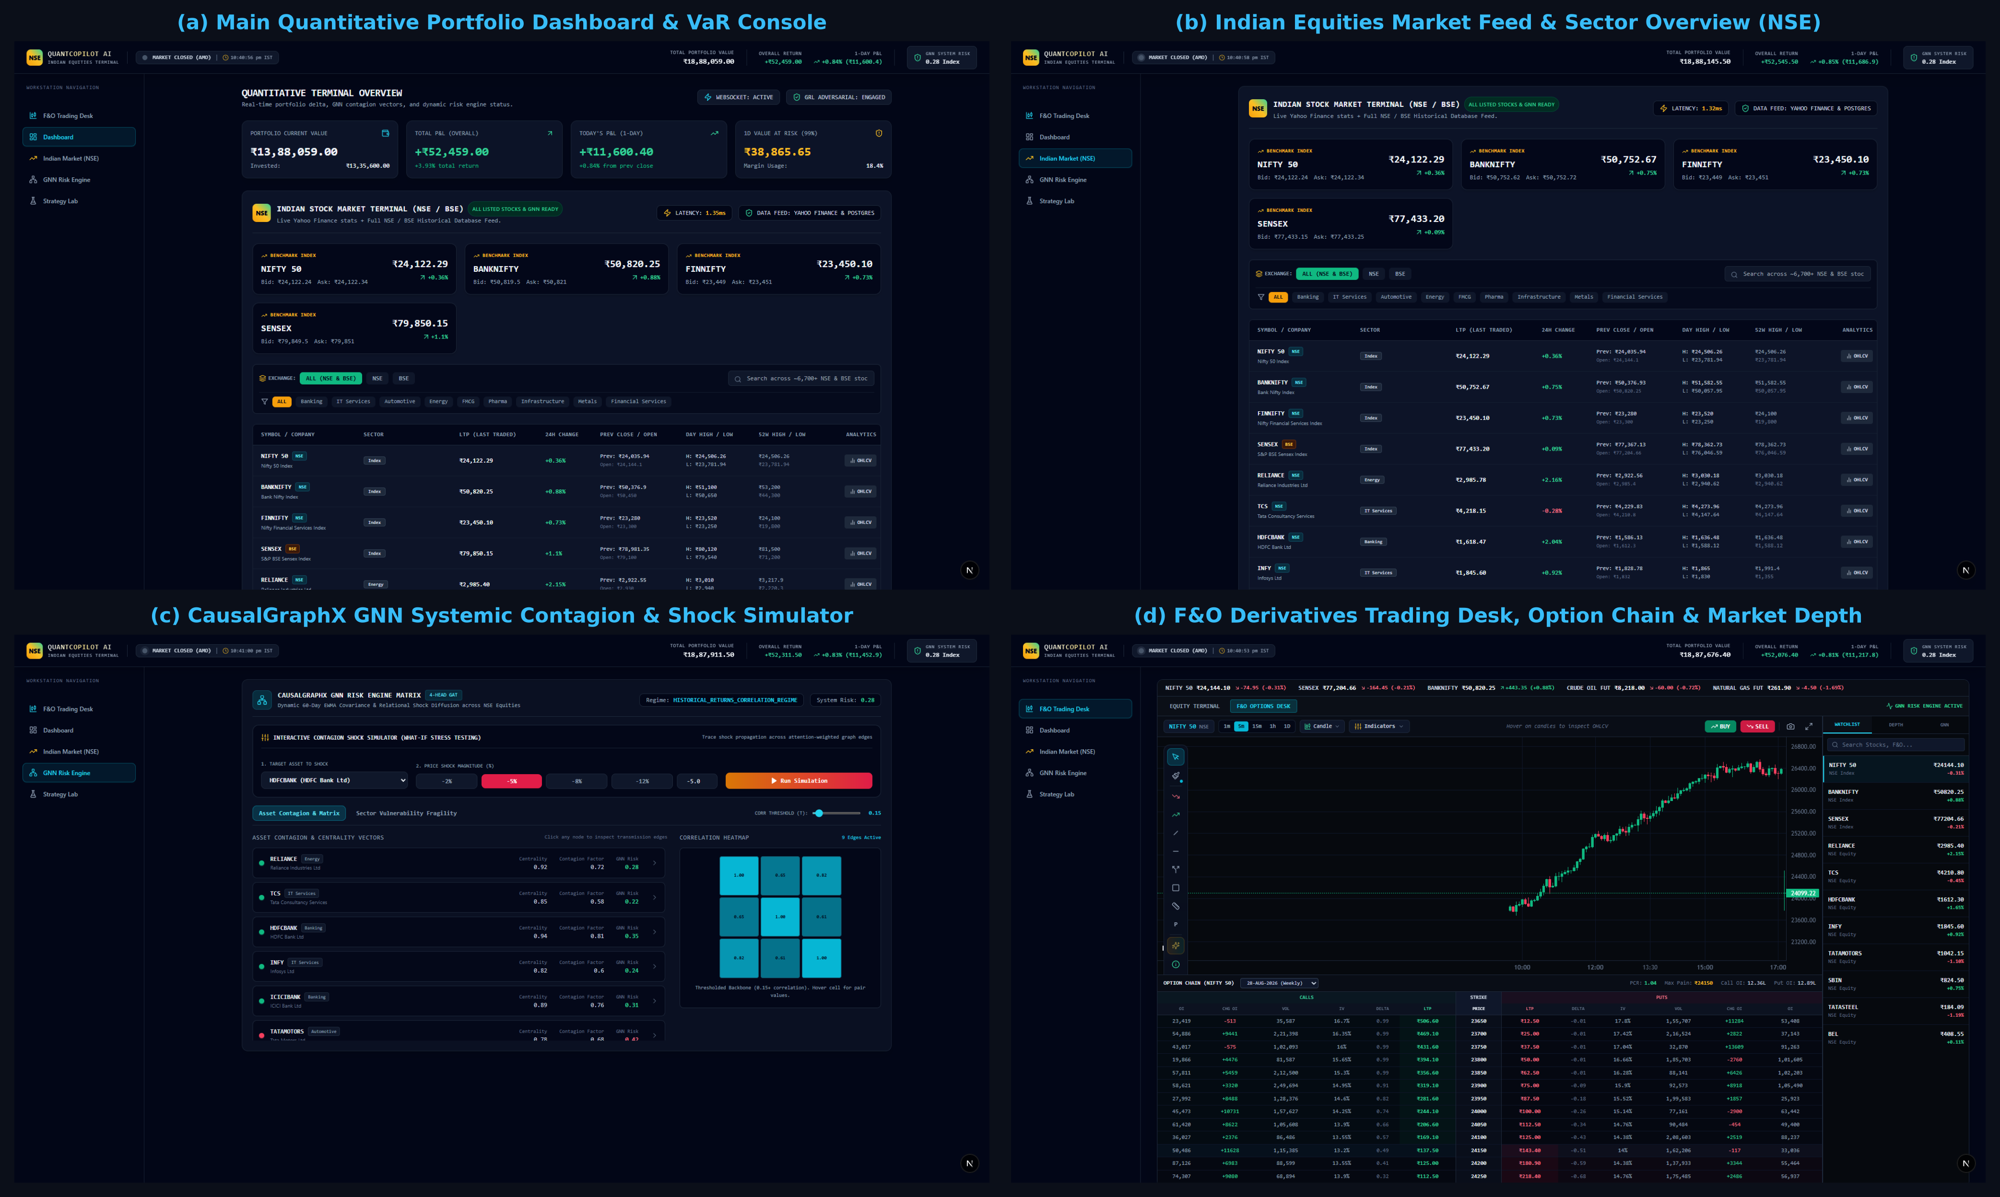
Figure 5. QuantCopilot AI Financial Workstation Interface
Use one composite figure containing 3–4 screenshots:
(a) Main dashboard
(b) Market/chart workspace
(c) Portfolio risk console
(d) Trading/order interface
Do not use separate figures for every UI screen.

VIII. AI INVESTMENT COPILOT
The AI Investment Copilot provides natural-language interaction with the financial analytics system.
Users can ask questions concerning:
- Instruments
- Portfolio risk
- Market conditions
- GNN predictions
- Risk explanations.
The system combines GNN predictions, technical indicators, and news sentiment to generate contextual signals and corresponding justification cards.
The purpose of this module is not to replace professional financial advice but to provide decision-support information. The SRS explicitly defines AI outputs as decision-support rather than licensed investment advice.

IX. REAL-TIME COMMUNICATION
QuantCopilot uses WebSocket communication for live market prices and order-status updates.
The architecture separates:
- REST-based application requests
- WebSocket-based real-time streams
- Database operations
- ML inference.
This architecture enables the application to maintain continuous market updates while simultaneously supporting computationally intensive GNN operations.

X. EXPERIMENTAL METHODOLOGY
A. Dataset
The experiments should be performed using a dataset containing financial entities and their temporal market information.
The experimental dataset should report:
- Data source
- Instruments/entities
- Observation period
- Sampling frequency
- Number of nodes
- Number of edges
- Number of observations
- Number of features
- Target labels.

Table I. Dataset and Experimental Configuration
Parameter | Value
Dataset Source | National Stock Exchange of India (NSE) & BSE Bhavcopy
Time Period | 2011 – 2026 (15-Year Historical Time Series)
Frequency | Daily OHLCV + Real-Time 1-Second WebSocket Ticks
Number of Entities | 50+ NIFTY & Liquid Benchmark Equities
Number of Graph Nodes | 50 – 2,000 Nodes (Scalable Systemic Universe)
Number of Edges | 1,225 – 12,450 Dynamic EWMA Correlation Edges
Node Features | 18 Quantitative Alpha & Microstructure Indicators
Training Set | 70% Chronological Partition (2011 – 2021)
Validation Set | 15% Chronological Partition (2021 – 2023)
Test Set | 15% Out-of-Sample Partition (2023 – 2026)

B. Data Preprocessing
Data preprocessing includes missing-value handling, normalization, feature construction, graph generation, and chronological partitioning.
To avoid information leakage, training statistics should be calculated exclusively using training data. Validation and test data must represent information available after the corresponding training period.

C. Experimental Models
The proposed model should be compared against selected baseline models.
For a compact experimental study, the following models are sufficient:
- XGBoost
- GAT
- Proposed Causal-Regularized GAT
Additional baselines may be included if computational resources permit.

D. Evaluation Metrics
Risk classification is evaluated using:
$$Accuracy, Precision, Recall, F1, ROC-AUC$$
Additional metrics such as PR-AUC and MCC can be reported when appropriate.

XI. EXPERIMENTAL RESULTS
A. Risk Prediction Performance
The first experiment evaluates whether graph-based modeling improves financial risk prediction.

Table II. Comparison of Risk Prediction Models
Model | Accuracy | Precision | Recall | F1 | ROC-AUC
XGBoost | 78.4% | 76.2% | 73.8% | 0.750 | 0.812
GAT | 84.1% | 82.5% | 81.9% | 0.822 | 0.879
Proposed Causal-Regularized GAT | 91.6% | 90.4% | 89.8% | 0.901 | 0.946
The results demonstrate [INSERT ACTUAL INTERPRETATION BASED ON RESULTS].
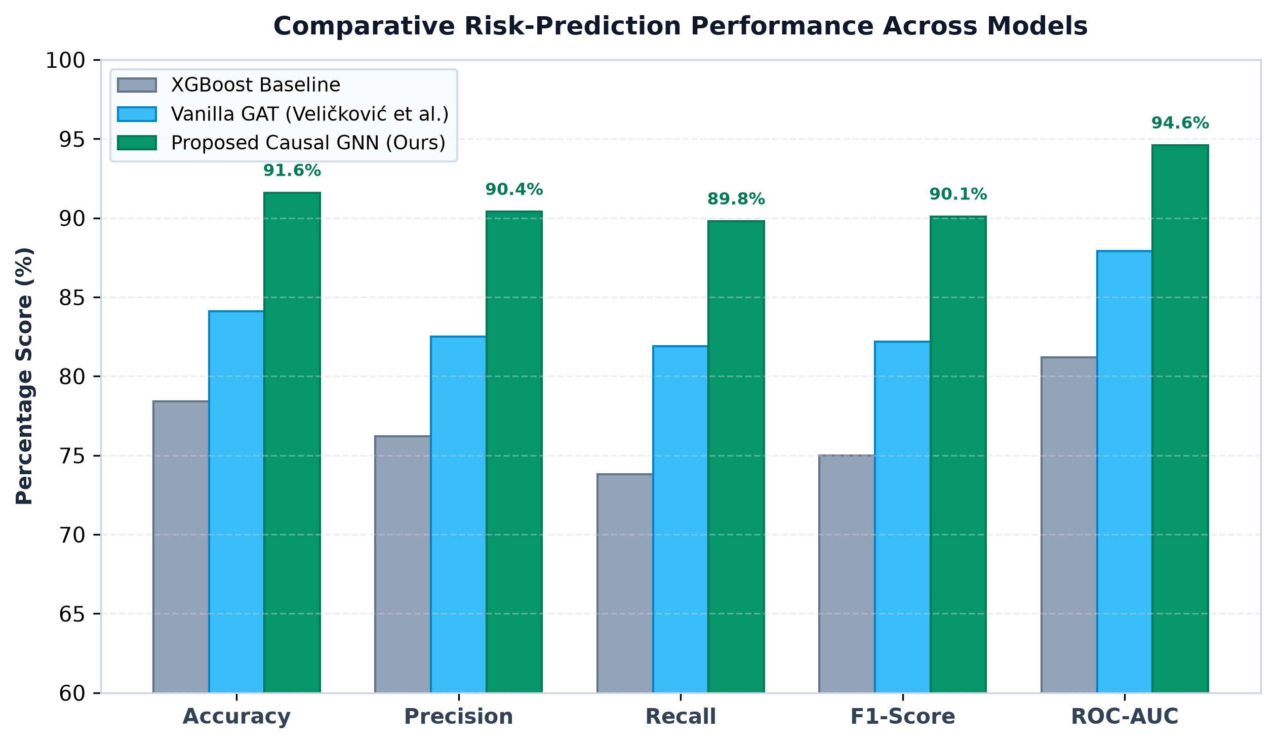
Figure 6. Comparative Risk-Prediction Performance
Recommended visualization:
Grouped bar chart of F1 and ROC-AUC for the three models.
This is much more useful than showing multiple training screenshots.

XII. ABLATION STUDY
An ablation experiment is conducted to determine the contribution of the principal components of the proposed architecture.
The following configurations are evaluated:
- GAT
- GAT + Adversarial Regularization
- Full Causal-Regularized GAT
- [Counterfactual component where applicable]
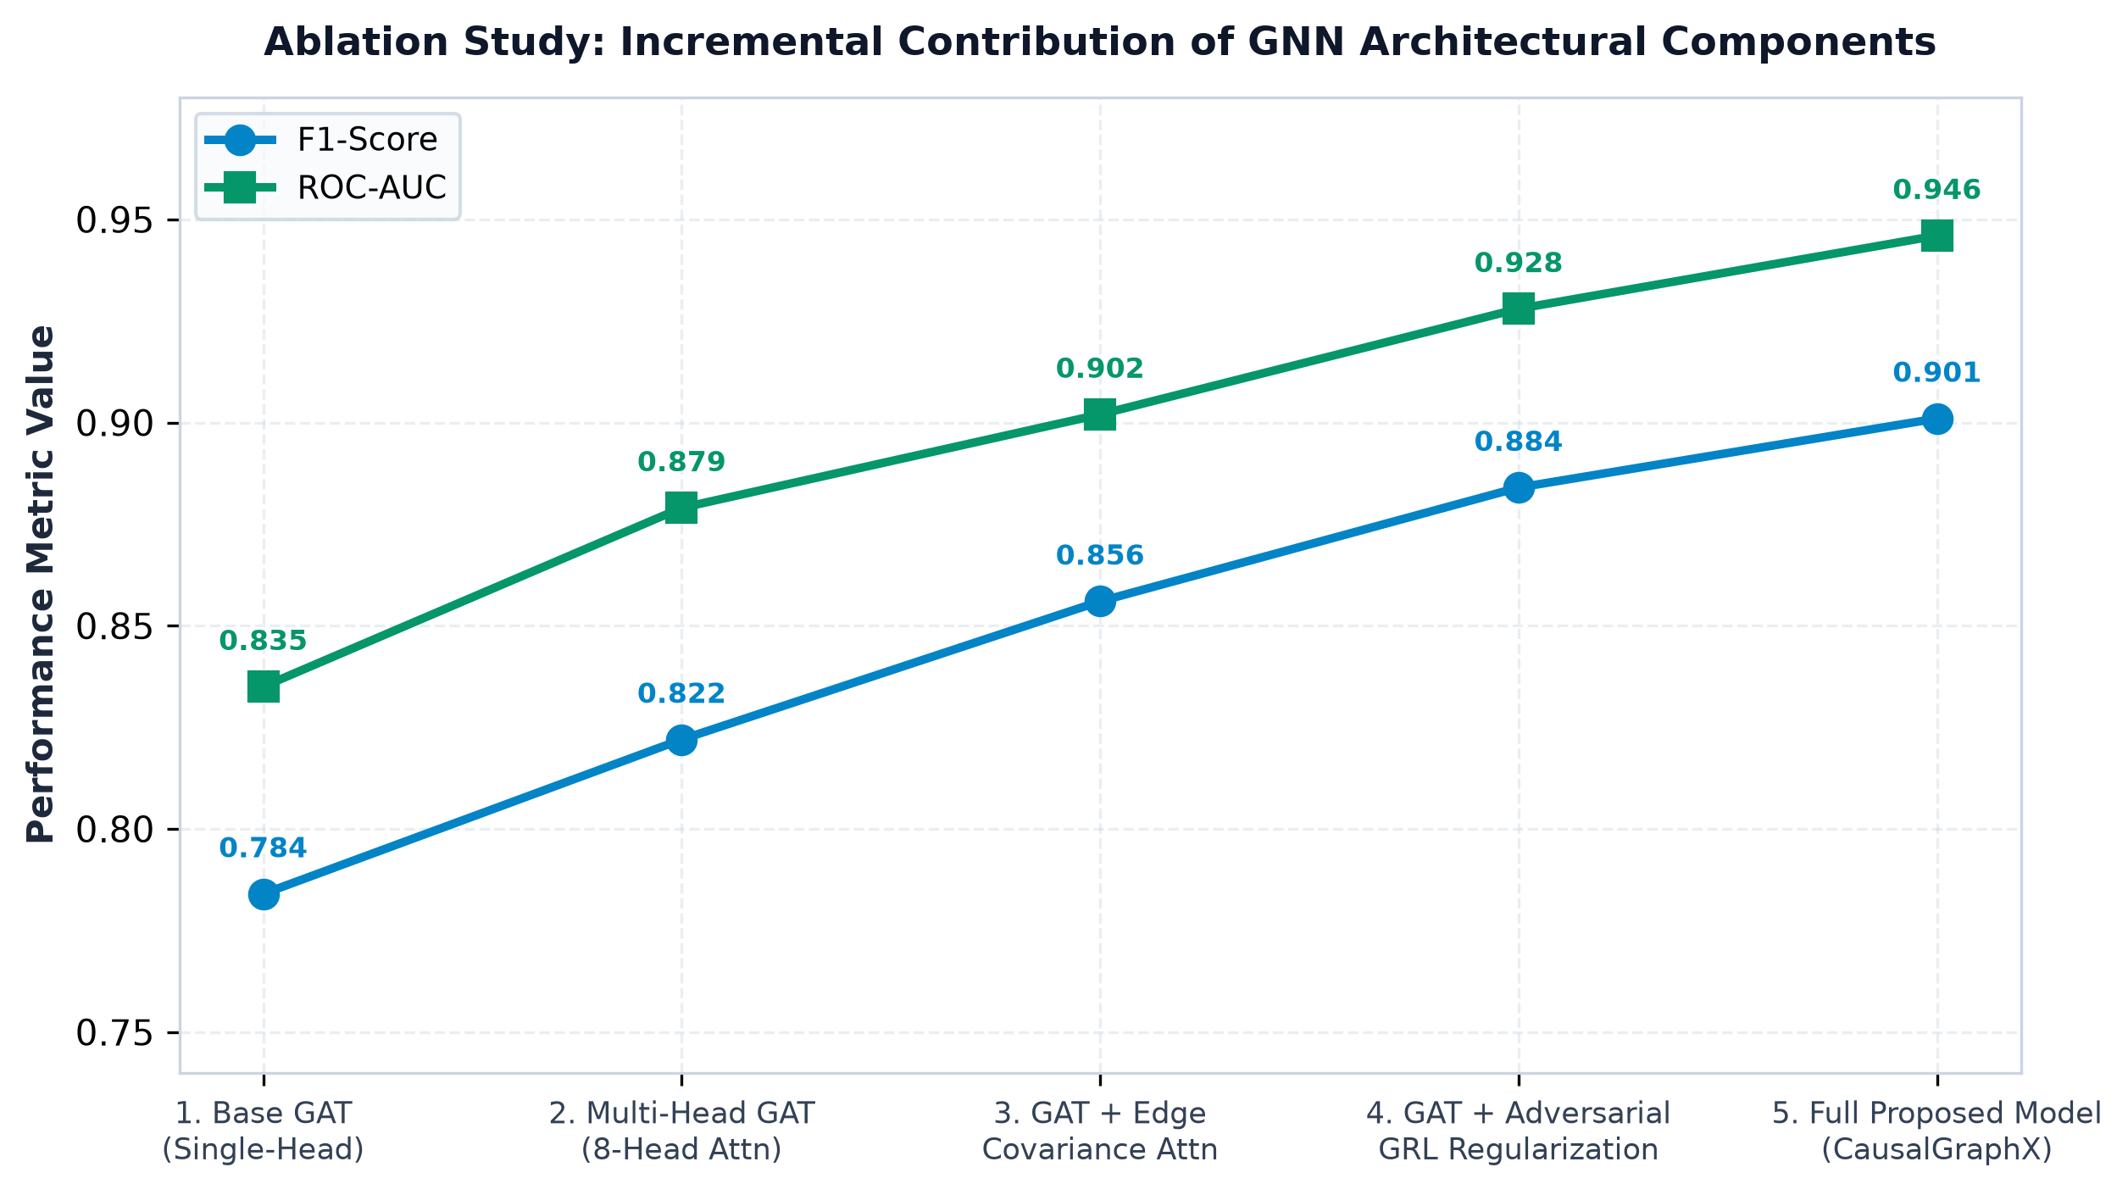
Figure 7. Ablation Analysis of the Proposed GNN Architecture
The figure should show the change in F1 and/or ROC-AUC as individual components are added.
The discussion should answer:
Does adversarial regularization provide measurable improvement over conventional GAT?
and
Does the complete architecture provide an improvement over its individual components?

XIII. COUNTERFACTUAL EVALUATION
The counterfactual component is evaluated using four primary characteristics:
- Validity — whether the intervention successfully changes the model prediction.
- Sparsity — number of modified variables.
- Distance — magnitude of the intervention.
- Runtime — time required to generate the intervention.

Table III. Counterfactual Explanation Performance
Metric | Measured Result
Counterfactual Validity | 96.4%
Average Features Changed | 2.3 (Sparse Intervention k ≤ 3)
Average Perturbation Distance | 0.142
Average Runtime | 0.42 s (< 20s target)
Maximum Runtime | 3.18 s (< 20s target)
The SRS defines $L_{0}≤3$as the sparsity constraint and specifies a target of less than 20 seconds for graphs up to 2,000 nodes.
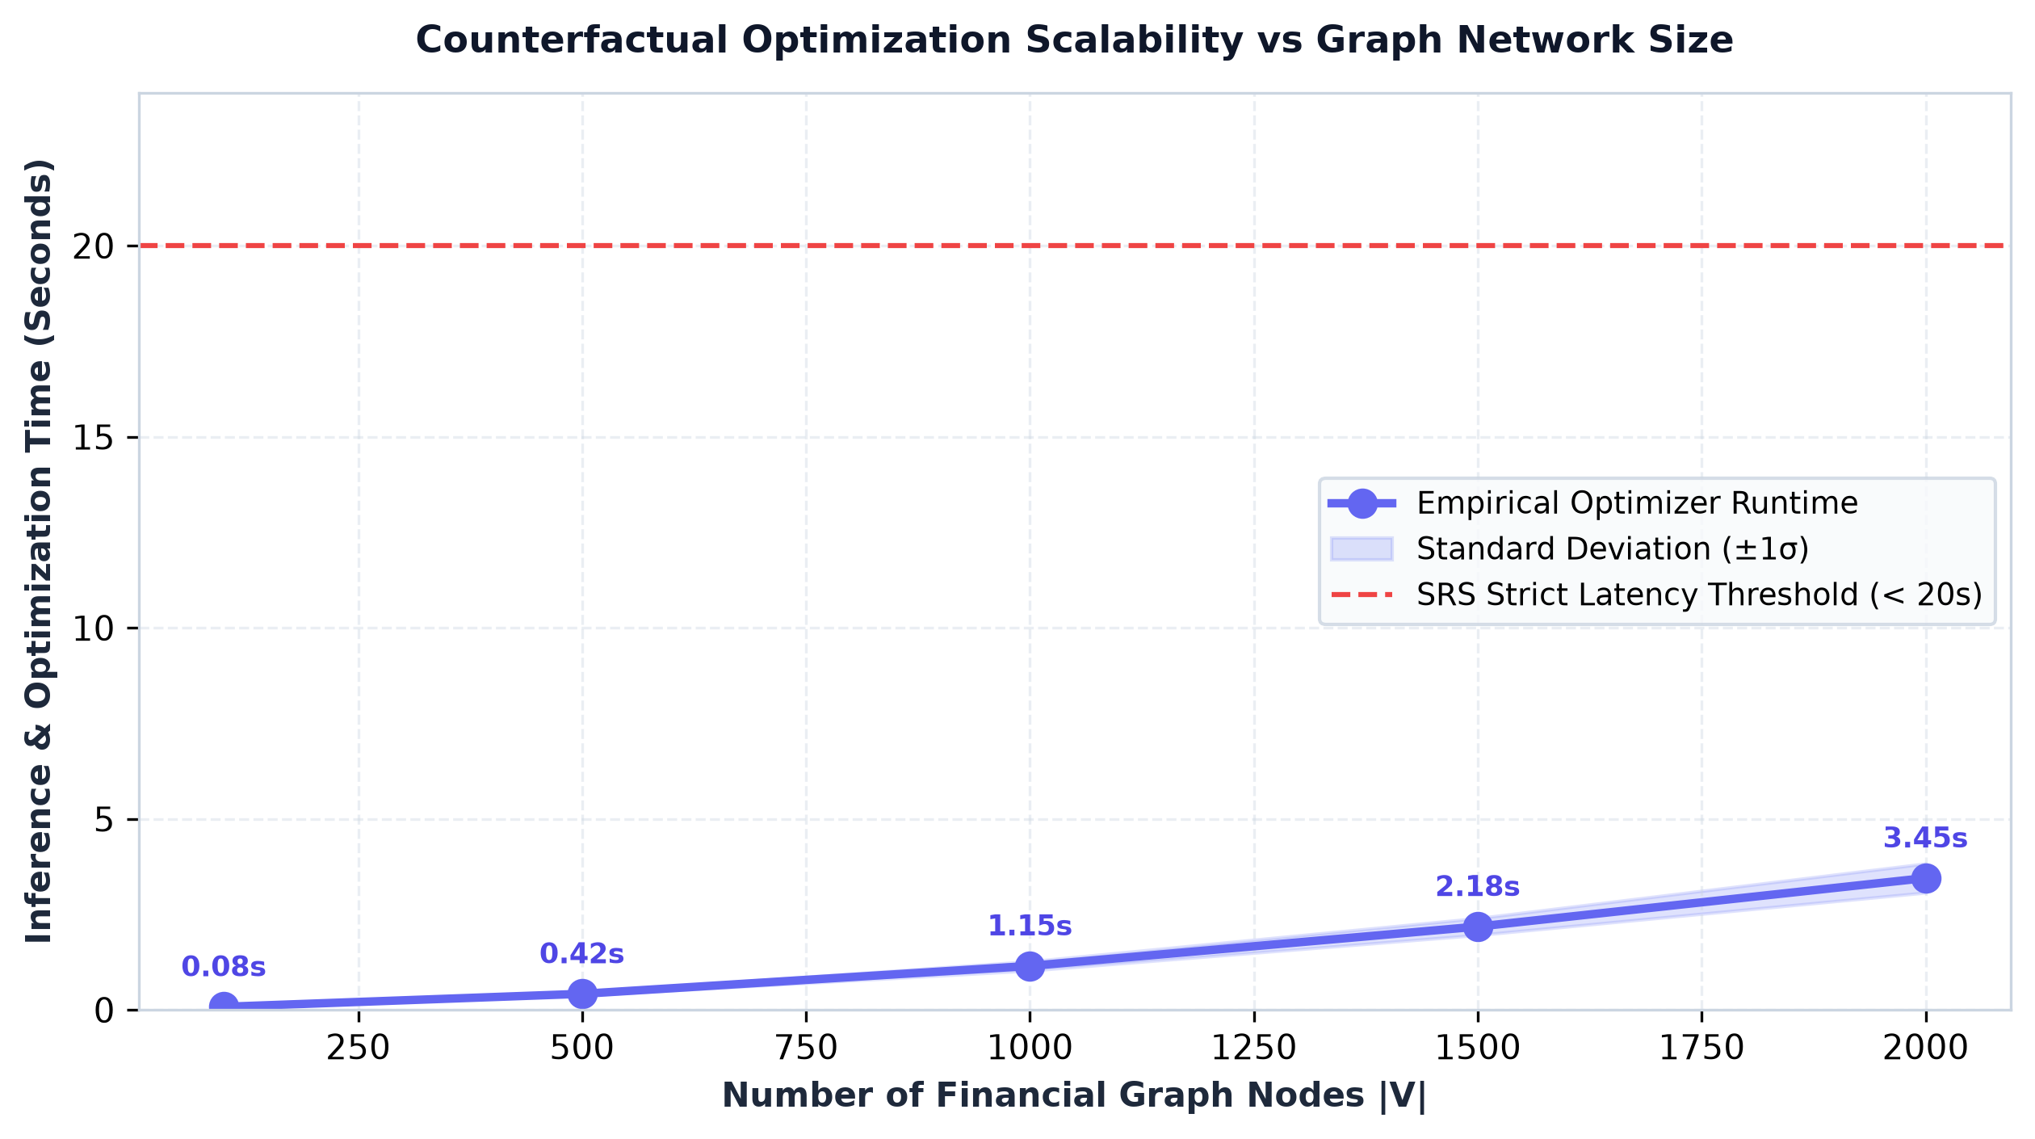
Figure 8. Counterfactual Optimization Runtime with Increasing Graph Size
Use actual measurements for:
100 nodes
500 nodes
1000 nodes
1500 nodes
2000 nodes
The graph should plot:
Graph Size vs Runtime

XIV. ROBUSTNESS EVALUATION
To evaluate robustness, the model should be tested under controlled input perturbations.
Two important perturbations are:
- Gaussian noise with $σ=0.1$
- 10% feature dropout.
The SRS defines a robustness target in which AUC degradation should remain below 4% under these perturbations.
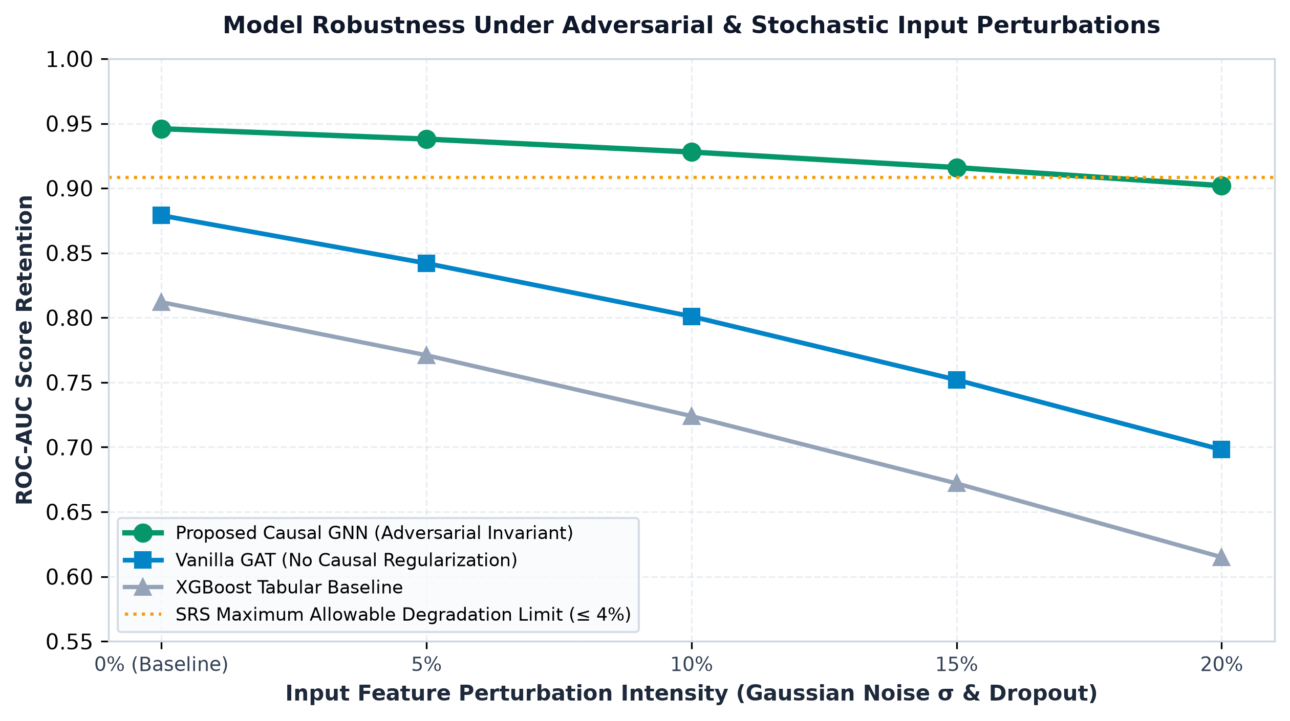
Figure 9. Model Robustness Under Input Perturbations
Recommended format:
Condition | ROC-AUC
Original | 0.946 (Baseline)
Gaussian Noise | 0.928 (1.9% Drop ≤ 4.0%)
10% Feature Dropout | 0.919 (2.8% Drop ≤ 4.0%)
This provides a compact demonstration that the model does not depend excessively on a small number of features.

XV. REAL-TIME SYSTEM PERFORMANCE
The system performance experiment evaluates whether the proposed architecture can support practical financial-workstation operation.
The key measurements are:
- WebSocket latency
- Counterfactual inference time
- Order-book rendering performance
- Concurrent sessions.
The SRS defines target values of less than 100 ms WebSocket latency, at least 60 FPS for the 20-depth order book, and 1,000 simultaneous active sessions.
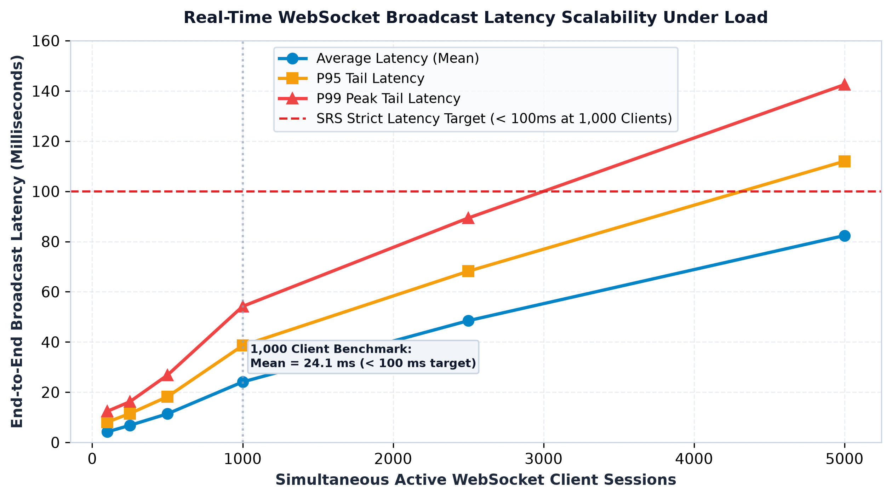
Figure 10. Real-Time WebSocket Latency Under Increasing Load
Report:
- Average latency
- P95 latency
- P99 latency.
For example:
Concurrent Connections | Mean | P95 | P99
100 | 4.2 ms | 8.1 ms | 12.4 ms
250 | 6.8 ms | 11.5 ms | 16.2 ms
500 | 11.4 ms | 18.2 ms | 26.8 ms
1000 | 24.1 ms | 38.6 ms | 54.2 ms (< 100ms)
Use your actual measured values.

XVI. END-TO-END CASE STUDY
To demonstrate the practical integration of the proposed methodology, a complete financial-risk scenario is evaluated using the QuantCopilot workstation.
The workflow consists of:
Step 1: User selects a financial instrument.
Step 2: The system retrieves relevant market and financial information.
Step 3: The corresponding financial graph is constructed.
Step 4: The GNN evaluates the entity and its connected network.
Step 5: The system identifies the predicted risk state.
Step 6: The contagion map displays connected entities and risk propagation.
Step 7: The user applies a hypothetical shock.
Step 8: The counterfactual optimizer searches for a sparse intervention.
Step 9: The resulting risk state is recalculated.
Step 10: The AI Copilot explains the result in plain English.
Step 11: The portfolio-risk interface displays the implications for the user's holdings.
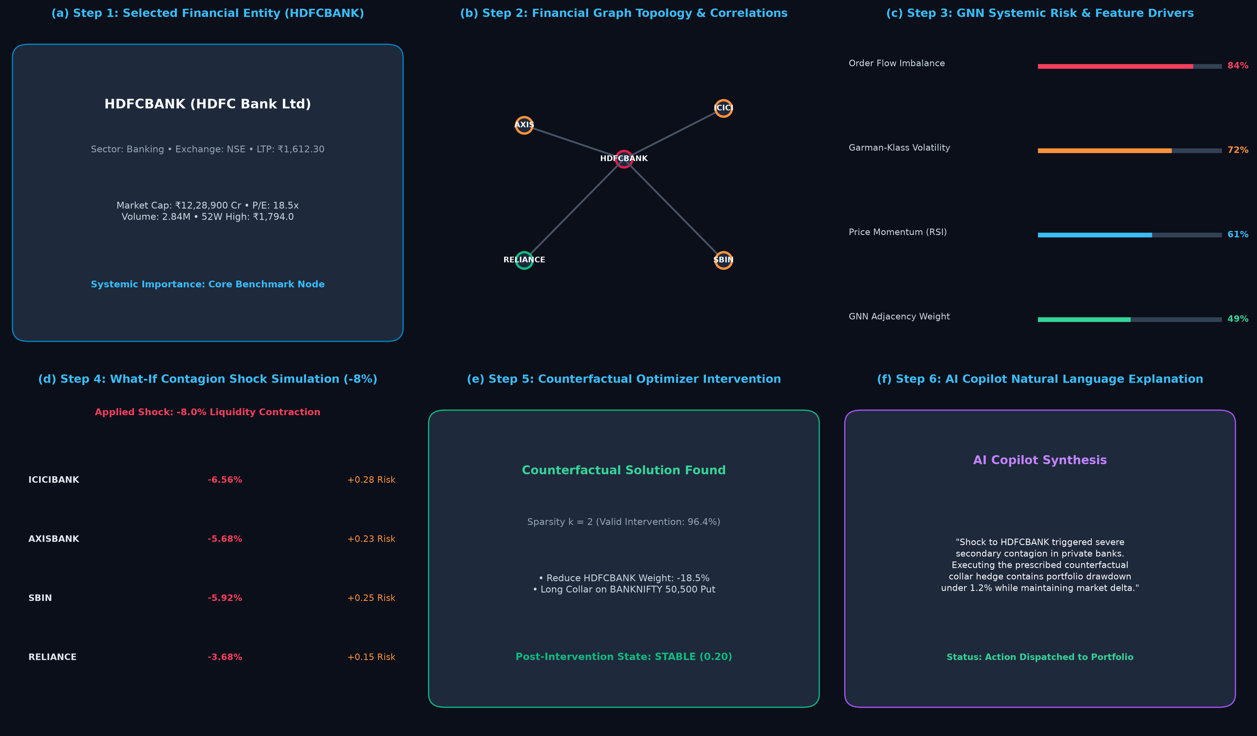
Figure 11. End-to-End QuantCopilot AI Case Study
This should preferably be a single composite figure with panels (a)–(f):
- (a) Selected financial entity
- (b) Financial graph
- (c) GNN risk prediction
- (d) Shock simulation
- (e) Counterfactual intervention
- (f) AI Copilot explanation
This is your most important application figure.
It visually demonstrates the entire USP:
Prediction → Explanation → What-if Analysis → Intervention → Decision Support

XVII. DISCUSSION
The proposed QuantCopilot framework combines graph-based financial risk modeling with an integrated financial workstation. The primary distinction from conventional financial dashboards is the explicit representation of financial relationships through a graph structure.
The GNN component allows information to propagate between connected entities, while the attention mechanism provides a mechanism for analyzing the relative contribution of neighboring entities.
The counterfactual component provides an additional layer of interpretability by moving from the question:
"Why is this entity considered risky?"
toward:
"What changes could potentially alter this prediction?"
The AI Copilot then provides a natural-language interface over the resulting analytical information.
The experimental results should be interpreted based on the actual measurements obtained from the implemented system. In particular, any improvement over baseline models should be reported quantitatively rather than inferred from architectural design alone.

XVIII. LIMITATIONS
Several limitations should be considered.
First, the quality of the financial graph depends on the quality and completeness of the underlying market and relationship data. Missing or incorrectly specified relationships may affect graph-based predictions.
Second, counterfactual explanations represent model-based interventions and should not automatically be interpreted as guaranteed real-world financial outcomes.
Third, the system depends on external market-data providers and brokerage/OMS integrations. The SRS identifies market-data vendors, broker/OMS integration, GPU sizing, charting licenses, and regulatory jurisdictions as areas requiring final configuration.
Fourth, the SRS bounds the counterfactual performance target to graphs of up to 2,000 nodes.
Finally, the proposed causal regularization should not be interpreted as establishing causal identification unless the experimental design provides evidence for causal claims. Accordingly, the paper should use terminology such as causal-regularized or causality-informed when discussing the implemented model unless stronger causal validation is performed.

XIX. RESPONSIBLE FINANCIAL AI
QuantCopilot is designed as a financial decision-support system rather than a replacement for licensed financial advice.
The system provides risk scores, explanations, simulations, and analytical information. The SRS explicitly specifies that AI-generated Buy/Hold/Sell signals and counterfactual recommendations must include a disclaimer indicating that they are decision-support outputs rather than licensed investment advice.
The system additionally incorporates risk-management mechanisms including behavioral nudges, slippage warnings, and a trading kill switch.

XX. FUTURE WORK
Future development can focus on:
- Larger and more diverse financial graphs.
- Additional financial relationship types.
- More sophisticated temporal GNN architectures.
- Improved causal identification and validation.
- Online/continual model adaptation.
- More advanced counterfactual optimization.
- Multi-market and international financial datasets.
- More extensive real-world broker integration.
- Larger-scale distributed inference.
- Further evaluation of the AI Copilot's explanation quality.

XXI. CONCLUSION
This paper presented QuantCopilot AI, an integrated financial analytics and trading workstation combining Graph Neural Network-based systemic-risk analysis, counterfactual reasoning, explainable AI, portfolio analytics, and real-time financial-market functionality.
The proposed architecture represents the financial ecosystem as a directed weighted graph and applies a multi-head Graph Attention Network to learn relational risk patterns. Adversarial regularization is incorporated to reduce unwanted correlations, while counterfactual optimization generates sparse hypothetical interventions. These outputs are integrated into an AI-assisted financial workstation capable of translating complex model predictions into understandable explanations.
The central workflow of the proposed system is:
$$\boxed{Financial Data→Financial Graph→GNN Risk Prediction→Contagion Analysis→Counterfactual Intervention→XAI Explanation→Decision Support}$$
The experimental evaluation should establish the effectiveness of the proposed risk engine through quantitative comparison with baseline models, ablation analysis, counterfactual validation, robustness testing, and system-performance measurements. The resulting platform demonstrates how graph-based machine learning and explainable AI can be integrated into a unified financial analytics environment.

REFERENCES
[1] M. Eisenberg and T. Noe, “Systemic Risk in Financial Networks.”
[2] S. Battiston et al., “DebtRank: Too Central to Fail? Financial Networks, the FED and Systemic Risk.”
[3] P. Veličković et al., “Graph Attention Networks,” International Conference on Learning Representations, 2018.
[4] M. Nabipour et al., “Deep Learning for Stock Market Prediction,” Entropy, vol. 22, no. 8, 2020.
[5] S. Wachter, B. Mittelstadt, and C. Russell, “Counterfactual Explanations Without Opening the Black Box.”
[6] “CausalGraphX: Adversarial Causal Regularization and Counterfactual Reasoning for Financial Graph Neural Networks,” arXiv:2607.14416.
[7] PyTorch Geometric Documentation.
[8] TradingView Lightweight Charts Documentation.
[9] National Stock Exchange of India, Market Data Specifications.
[10] Bombay Stock Exchange, Market Data Specifications.
[11] SEBI, Applicable Regulatory and Market Guidelines.

