Orbitly SalesOS — Product Specifications
Growth Tier · Platform release v2.6 · August 2026 · Document ID: SPEC-2026-08-G

1. Overview
Orbitly SalesOS is a revenue-intelligence platform for B2B sales organizations. It ingests every sales call (Teams, Zoom, or telephony), transcribes it, and builds a structured deal graph that connects conversations to CRM records, email threads, and billing data. Three engines operate on that graph: Conversation Intelligence (call scoring, objection and competitor extraction), Forecast Intelligence (weekly deal scoring with confidence and reasons), and Coaching & Ramp (playbook-aligned manager reviews and onboarding paths). The product is delivered as a native Salesforce application; reps never leave Salesforce.
This document specifies the Growth tier — the recommended tier for sales organizations that need forecast scoring and contracted adoption guarantees. Metrics quoted in customer-facing materials (85%+ forecast accuracy, 3-month ramp, +12% win rate) come from the FY2026 customer cohort and are detailed in the Orbitly case study pack.

2. Release history
Release | Date | Headline changes
v2.6 | Aug 2026 | SAP billing connector GA; forecast reasons v2 (per-deal factor list); Teams ingestion at 2× speed
v2.5 | May 2026 | EU data region (Enterprise); rep-facing coaching digest; 14 new playbook scoring dimensions
v2.4 | Feb 2026 | Adoption guarantee (Growth); pilot-gate reporting; Salesforce embedded UI refresh
v2.3 | Nov 2025 | Zoom telephony connector; objection taxonomy v3; bulk deal rescoring API

3. Module specifications

3.1 Conversation Intelligence
Specification | Value
Transcription languages | 40+ languages; English, Hindi, German, French, Spanish most deployed
Transcription word error rate | < 8% on sales-domain audio (internal eval set, FY2026)
Objection taxonomy | 22 categories (price, timing, competitor, security, authority, …) with per-objection confidence
Competitor detection | Automatic; custom competitor watchlists supported per workspace
Playbook scoring | Up to 40 scoring dimensions per call; custom playbooks per team
Manager review digests | Weekly; 2-minute highlight reels ranked by coaching value
CRM auto-capture | Call summary, next steps, objections, competitor mentions → Salesforce fields

3.2 Forecast Intelligence
Specification | Value
Scoring cadence | Nightly per-deal rescoring; weekly forecast snapshot (Monday 06:00 local)
Reported accuracy | 60% baseline → 85%+ within two quarters (customer cohort median)
Per-deal output | Confidence 0–100, reason factors, slippage risk flags, pull-through estimate
Data inputs | Calls, email threads, CRM stage history, SAP billing/fulfillment signals
Scenario views | Commit / best case / pipeline rollups with variance-vs-last-week
Alerting | Slippage and stalling alerts to owner + manager (email, Salesforce, Teams)

3.3 Coaching & Ramp
Specification | Value
Ramp compression | Median 6 months → 3 months to full quota (cohort median)
Onboarding paths | Role-based paths with call milestones and auto-graded practice pitches
Review workflow | Manager review target < 15 minutes per rep per week
Rep-facing mode | Self-coaching digest first; manager visibility configurable per team

4. Integrations
System | Mode | Notes
Salesforce | Native app, bi-directional | Embedded UI; no separate rep login. objects: Opportunity, Task, Call2, custom
SAP (SD/FI) | Certified connector (v2.6 GA) | Billing + fulfillment reconciliation into forecast factors
Microsoft Teams | Built-in ingestion | Auto-join or bot-join; recordings processed at 2× real time
Zoom | Built-in ingestion | Cloud recording connector; telephony bridge supported
Gmail / Outlook 365 | Email graph ingestion | Thread-level sentiment and commitment extraction
REST API + Webhooks | v2, JSON | Deal scores, call metadata, objection events; 600 req/min per workspace

5. Limits, retention, and SLA
Item | Team | Growth | Enterprise
Seats (min–max) | 10–250 | 25–1,000 | Unlimited
Call audio retention | 12 months | 24 months | 36 months, customer-managed keys
API rate limit | 200 req/min | 600 req/min | Custom
Data residency | US | In-region add-on (India/EU) | Included (India/EU/US)
Uptime SLA | — | 99.9% | 99.95% + priority support
Adoption guarantee | — | Contracted | Contracted
Price / seat / year | $480 | $600 | Custom

6. Ingestion performance
Pipeline latency from call end to searchable transcript and scored deal, by daily ingestion volume. The p99 SLO of six minutes holds to roughly 25,000 calls/day on a standard Growth deployment; above that, sharded ingestion is provisioned. Figure 1 below shows the measured cohort medians for release v2.6.
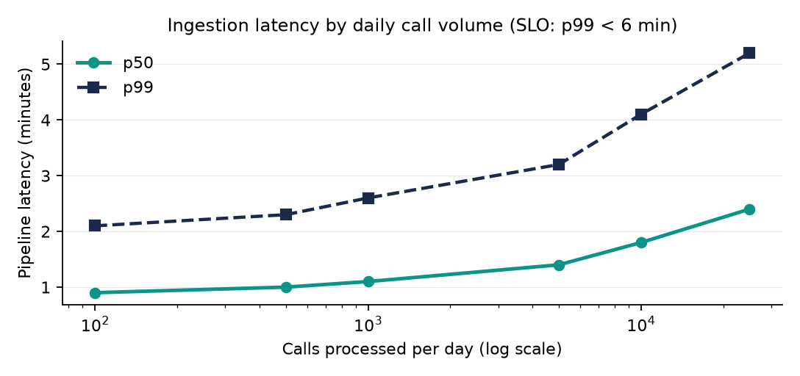
Figure 1 — Ingestion latency (minutes) by daily call volume, v2.6, FY2026 cohort.

7. Security and compliance
Orbitly maintains SOC 2 Type II and ISO 27001 certifications. Customer call data is never used to train any model. Data residency for India and the EU is included on the Enterprise tier and available as an in-region processing add-on on Growth. A signed DPA with EU Standard Contractual Clauses is provided in the security pack, alongside penetration-test summaries and the current sub-processor list.

