Style Guide for the SAMHSA.gov 2010 Redesign
Version 1.0 (May 16, 2011)
By SAMHSA Web Team (webmaster@samhsa.hhs.gov)

Style Guide for the SAMHSA.gov 2010 Redesign 1
Part I: Background and Usage 1
Part II: Section 508 Compliance 3
Part III: Standard Colors, Fonts, and General Markup Information 3
Colors 3
Fonts 4
General Markup Information 5
Part IV: Overall Specifications, Header, jQuery Text Resizer, and Footer 6
Overall Specifications 7
Header 8
jQuery Text Resizer 9
Footer 10
Part V: Creating Second Level Pages & Widgets 12
Important Notes & Errata 16
Part VI: Updating the Homepage 16
1 – The Feature Box/Carousel 18
2 – The “Find Help” Box 19
3 – The Strategic Initiatives Box (SI Box) 20
4 – The Youtube Box 20
5 & 6 – The Central & Right Widgets 21
Part VII: Specifications & Default Parameters 22
Alert System - Use of CSS-based notifications and alerts 23
Tooltip Documentation 25
Footer links for Connect with SAMHSA 25
Columns - Use of simple CSS-based content columns 27
Syntax 27
Part VIII: Contact Information 27
SAMHSA Web Team 27
SAMHSA Office of Communications 28
SAMHSA 508 Team 28

Part I: Background and Usage

NOTE: The site files described in this document are available for download at http://www.samhsa.gov/redesign/samhsaRedesignTemplate.zip

The purpose of this style guide is to provide guidance on the usage of the redesigned SAMHSA.gov site for both the SAMHSA Web Team and for other website designers and developers who are running sites funded by SAMHSA. The overall aim of this guide is to make sure that people who come to any SAMHSA property feel like they are always on the same site, no matter which SAMHSA center, office or program is sponsoring the site.

In order to maintain a unified look and feel for all of the sites directly connected to SAMHSA.gov usage of this guide is required.

This guide outlines the basic markup, structural, and graphical styles the new template was designed with, and will provide support for adding content. This guide also covers fonts, images, colors, cascading style sheets (css) and other important features of the template.

This guide is intended to be the first resource available for the creation of new and redesign of old websites on the SAMHSA network. The information provided within this guide is restrictive in that certain design elements such as the header, footer, web palette and font type and color have been established for all developers. However, the overall site navigation and content layout is not restrictive and gives website designers a lot of leeway in how they wish to customize their websites while helping to maintain a unified look and feel.

Before the guide begins, there are two very important pieces of information that all designers and developers need to be aware of before using the new SAMHSA.gov template:

First, the new template has been designed using semantic techniques. In the simplest of terms that means that the structure and the design of the template are divided up into two separate sections: the markup (html) for the page structure and the css for the actual design.

This is very different from the “old school” technique of designing websites using tables for structure. For more information about the semantic technique, please visit http://en.wikipedia.org/wiki/Semantic_Web & http://webdesign.about.com/od/semanticweb/a/aa022006.htm. Additionally, books written by Jeffery Zeldman and Jeremy Keith are excellent reference materials for this technique.

Secondly, the first thing you will notice about the pageTemplate.html file is that the first line of the code, the doctype declaration, is simply <!DOCTYPE html>. This is the HTML5 doctype. It was decided by the SAMHSA Web Team early on in the redesign process that in order to create a modern and scalable website, modern and scalable techniques would be required.

While the overall markup is not strict HTML5, you will note that in the samhsaScreen.css file there is an explanation as to how the HTML5 scaling process will work. Please note that modifying the doctype may produce different visual results.

The Sub-Site Template and this style guide were created and maintained by members of the SAMHSA.gov Web Team. All inquiries should be made to the SAMHSA Webmaster e-mail box, at webmaster@samhsa.hhs.gov.

Part II: Section 508 Compliance

In late 2007, HHS made implementation of Section 508 of the Rehabilitation Act a top priority for all HHS sub-agencies and OpDivs due to a number of issues. Since then, enforcement of Section 508 has increased dramatically and HHS has produced a number of documents outlining the standards, guidelines, and resources available to make all websites and documents within the HHS system meet full Section 508 compliance.

SAMHSA has been at the forefront of these efforts and has created a website, http://508.samhsa.gov, which contains all of the resources that SAMHSA employees and contractors would need to create and maintain Section 508 compliant websites, MS Office Documents, and Adobe PDF files.

In accordance with those standards, the SAMHSA Sub-Site Template meets full Section 508 compliance as-is when it is initially delivered to customers and contractors. At that point, it becomes a legal and contractual requirement that any site using this template, and the documents posted to it, must maintain full Section 508 compliance. If you have any questions or concerns, please visit the SAMHSA Section 508 website at http://508.samhsa.gov or contact the SAMHSA 508 Coordinator at 508@samhsa.hhs.gov.

Part III: Standard Colors, Fonts, and General Markup Information

Colors

The SAMHSA Standard Color Palette, as of July 2010:
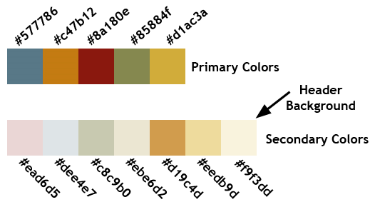

SAMHSA website developers are restricted to using the color scheme above. Any deviation from this color scheme must be approved by SAMHSA’s Office of Communication.

Fonts

On the template, only one font is being used currently: Trebuchet MS. Trebuchet MS is the primary font and must be used on all SAMHSA funded sites. Additionally, black text is the default standard for site content.

Trebuchet MS is highly readable and prints very nicely. All modern computers running all modern operating systems (Windows, OS X, and Linux) come with Trebuchet MS pre-installed, and as such it is considered to be one of the few universal fonts.
Standard Template Font Examples
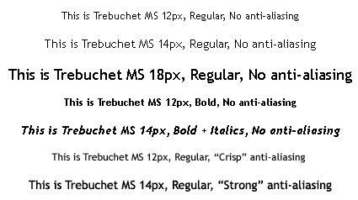

It should be noted that this style guide was written using the Trebuchet MS font.

Within the CSS, please take note that our fonts are measured in the unit “em” instead of pixels, picas, or points as we have done in the past. Wikipedia defines the “em” unit as:

An em is a unit of measurement in the field of typography. This unit defines the proportion of the letter width and height with respect to the point size of the current font. Originally the unit was derived from the width of the capital "M" in the currently used typeface. This unit is not defined in terms of any specific typeface, and thus is the same for all fonts at a given point size. So, 1 em in a 16 point typeface is 16 points. Note that this term is not an acronym or initialism and is pronounced the same as the letter it refers to, the letter "M".

The switch to Em was to ensure that users of all operating systems and browsers would be able to easily override the default browser font sizes and view the SAMHSA.gov website at whatever font size is easiest to read.

The baseline font size for the template is 0.8em, which is a fairly standard baseline size and on most browsers comes out to be roughly 10pt or 12px.

General Markup Information

Markup Language: HTML5
Cascading Style Sheets Versions: CSS1 and CSS2 utilized; no CSS3 or webkit elements present as of July 2010.
Preferred file nomenclature: “camelCase”
File/Directory Structure:
/ root
→ /site_css/
→/site_images/
→/universal/
→/icons/
→/site_includes/
→/jQuery/

Markup/CSS Errata taken from the samhsaScreen.css file:

Note: For up-scaling to full HTML5, the following classes upscale to elements:
.header → <header>
.nav → <nav>
.aside → <aside>
.footer → <footer>

For more information about using HTML5, please visit http://www.html5doctor.com.

Usage of PNG images: Please note that several images in the design are transparent PNG images. Internet Explorer 6 and below have a known issue with rendering transparent PNG’s properly. Please see http://support.microsoft.com/kb/294714 for more information about this issue. Internet Explorer 7 and up do not have this particular issue, which is one of the reasons why the minimal browser requirement for Internet Explorer is versions 7.0 and above (see Part V: Specifications & Default Parameters below for more information).

Part IV: Overall Specifications, Header, jQuery Text Resizer, and Footer

The redesigned SAMHSA.gov Homepage
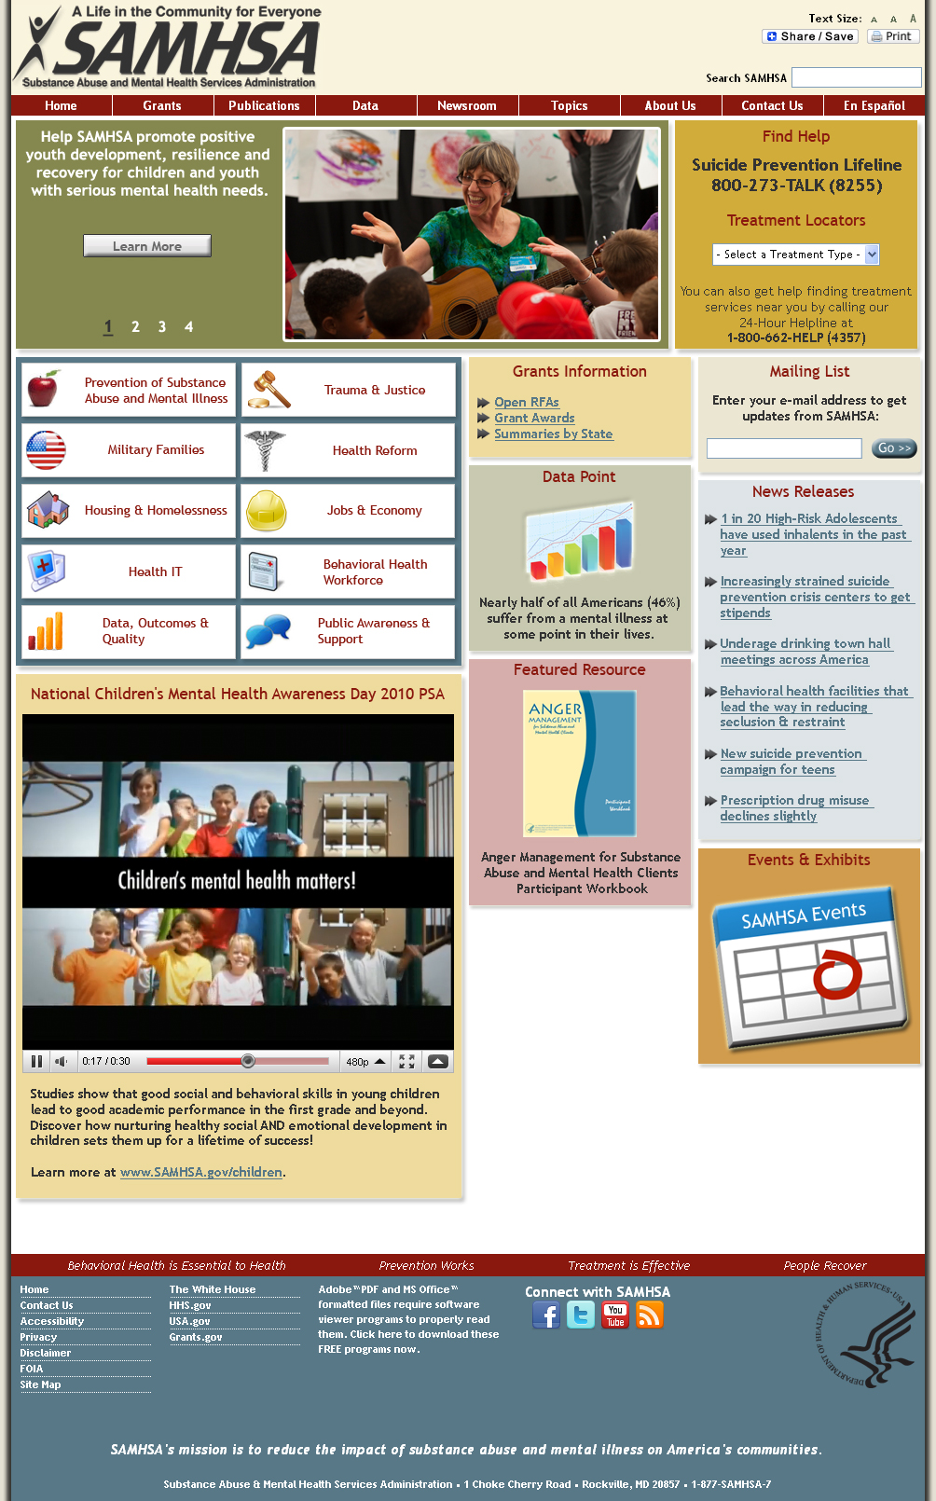

Overall Specifications

The new template is based on a static, centered layout with a total usable area of 980px. Several css floats are being used to position the content in the header, footer, and within the content area of the actual SAMHSA.gov pages themselves. That said, please be very careful when making changes to any of the structure of the template, as floats are notoriously easy to break and can be difficult to fix.

The overall width and primary structural properties of the template are located in the section of the css commented as “/* =Structural”. The five elements (two id’s and three classes) within this section of the css are integral to the entire structure of the template, so if you decide to modify these please make sure to back up the css and html files before you begin.

The shadowed left and right side of the design are created using a technique in which a background image is fully repeated over the y-axis of the page, thus creating a faux background in which the design and content rest on top of. The code for that is as follows:

body {
background: #eee9d6 url("/site_images/universal/brownWhiteBG1024x43.gif") repeat-y center center;
font-family: "Trebuchet MS", Verdana, san-serif;
font-size: 0.8em;
margin: 0 auto;
}

If you are having trouble making the background image show up, make sure that the url(“”) value within the body element in the css is pointing to the proper file and directory.

Note that the margin is set to “0 auto” which means that the top and bottom margins are 0px, and the left and right margins are centered (auto).

Header

As explained above, the working area within the SAMHSA.gov redesign template is 980 pixels wide, static and centered using the method explained in the previous section. The header matches those specifications. It has an overall width of 980px and overall height of 104px. The actual working area within that 104px is actually 93px, taking account of margins and padding on the top and bottom of the header. Full specifications are available in the diagram below.

The SAMHSA Header
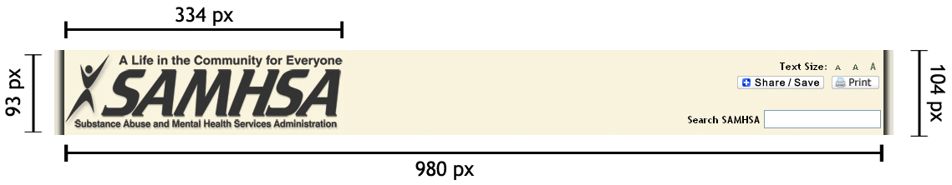
(Note – double-click on the image in MS Word and you can view it at full size)

As you can see from the diagram above, the header consists of four primary areas: the SAMHSA logo, the jQuery Text Resizer (described below), the Share/Save + Print buttons, and the search box.

The entire header is encapsulated inside a block, <div class=”header”>, and has two nested blocks, <div id=”headerLeftSide”> and <div id=”headerRightSide”>.

The SAMHSA logo takes up 334px by 93px, is vertically centered using css padding, and is left justified. The SAMHSA logo, as it looks in the new template the graphic above, is required to appear exactly as it is shown above. Alterations are not permitted. Within the code, the SAMHSA logo is located in a left-floated area (#headerLeftSide) as mentioned above.

No width is set for the logo area, which is important to note because it is intended for any custom branding (such as your own sites logo or title) to be placed in the <div id=”headerLeftSide”> area to the immediate right of the SAMHSA logo. For any questions about this, please contact the SAMHSA Webmaster and the SAMHSA Office of Communications as they will be quite happy to answer your questions.

The right side of the header, <div id=”headerRightSide”>, contains some of the new features of the SAMHSA design as mentioned above. The Share/Save & Print buttons are simple javascript plugins, the text resizer is an accessibility feature using a common jQuery script, and the search box can be setup to submit to your own search engine, any public search engine, or the SAMHSA.gov search engine. Please speak with the Office of Communications if you have questions as to whether or not these are required elements for your particular website.

jQuery Text Resizer

The jQuery Text Resize we are using in the new SAMHSA.gov template uses the script created by Mario J. Vargas and documentation for the script can be found at http://angstrey.com/index.php/jquery-text-resizer-plugin/. Operation and modification are fairly simple. The script is open source and freely available.

The code is very simple to modify. The properties you may need to modify are “target”, “type”, and “sizes” (see code snippet below). The “target” property is used to select the particular area within the html in which the text size will be changed. In the current template it’s set to target everything nested within the #wrapper element – which is what the entire design in encapsulated in, thus allowing all text within our design to be resized using this control.

The “type” property is explained in the /site_includes/jQuery/jquery.textresizer.js file. What this does is it selects how the resizing is done and where to look for the sizes of the text. We’ve selected the preferred method (according to the documentation), fontSize.

The actual three sizes of the resizer are modified through the “sizes” property. The smallest size is 100% - the default text size of the SAMHSA template (0.8em). The medium size is 110%, and the large size is 120% of standard. If you would like to increase or decrease the incremental text resizing, modify the highlighted & bolded parts of following code (in the <head> of the pageTemplate.html file):

<script type="text/javascript">
jQuery(document).ready( function() {
jQuery( "#textResizeControl a" ).textresizer({
target: "#wrapper",
type: "fontSize",
sizes: [ "100%", "110%", "120%" ],
selectedIndex: 1
});
});
</script>

Footer

The footer of the redesigned SAMHSA template is probably the most complicated part of the entire design, because part of it is a series of nested floats that are all interdependent on each other to maintain proper positioning. As with the rest of the page elements, the overall width is 980px, and in its current height is 265px.

The SAMHSA Footer
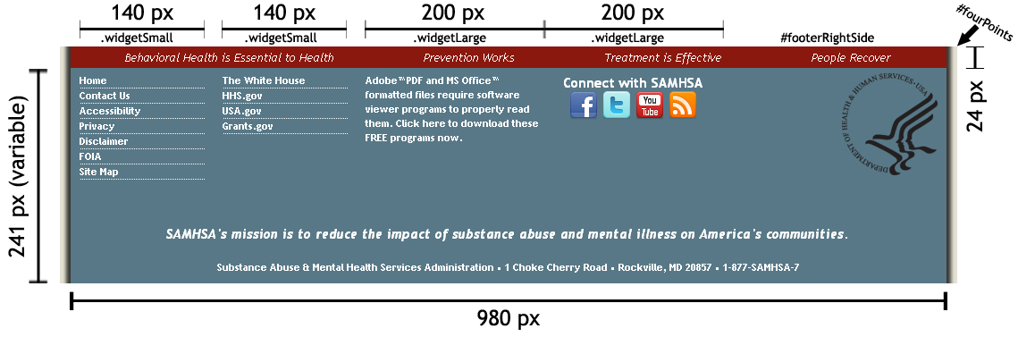
(Note – double-click on the image in MS Word and you can view it at full size)

The top area of the footer, called #fourPoints, outlines the four key properties about SAMHSA’s mission – Behavioral Health is Essential to Health, Prevention Works, Treatment is Effective, and People Recover. At the time this style guide is being written, these four key points must appear on SAMHSA websites.

The middle part of the footer contains the interdependent floats mentioned above. From left to right, the links and information within those areas are as follows: SAMHSA.gov links, required links to other key federal sites, a disclaimer about Section 508 and downloadable files (PDF’s/MS Word files) that require plugins, SAMHSA’s social media links, and the HHS “bird and word” logo as required by HHS policy.

The HHS “bird and word” are different from all of the other parts of the middle section, as it’s a more simplified nested float.

The middle section side-by-side lists are achieved using the elements listed under the /* =FooterNavList area of the css. Here is an explanation of some of the more important css elements:

- .innerWrap: Used like a capsule or wrapper, it ensures that the area it surrounds maintains an absolute width of 980px and also adds a little interior padding for visual flair.
- #footerLeftSide: First of the nested floats, has a left margin of 10px. Holds all of the widget classes (see below).
- #widgets-bottom: A container to hide some possible overflow issues. Allows for the other lists to be nested and render next to each other. Key component.
- .widgetSmall: Smallest of the nested float areas, it’s 140px wide with right and bottom margins of 20px.
- .footerSiteNav: Sets up the visual styles of the lists and links within.
- #footerSAMHSALinks: Placeholder for future changes/customization.
- #footerGovtLinks: Placeholder for future changes/customization.
- .widgetLarge: Largest of the nested float areas, it’s 200px wide with right and bottom margins of 20px.
- #footerRightSide: Contains the “bird and word” and has a right margin of 10px to match the 10px margin to the left of the #footerLeftSide.

The bottom section of the footer is reserved for two very important pieces of the SAMSHSA template: The full contact information for SAMHSA, and the mission statement. These must not be removed from the template. They are required.

For any questions about the information outlined in the Style Guide, please contact the SAMHSA Webmaster and the SAMHSA Office of Communications as they will be quite happy to answer your questions.

Part V: Creating Second Level Pages & Widgets

The new 2nd Level Page Design
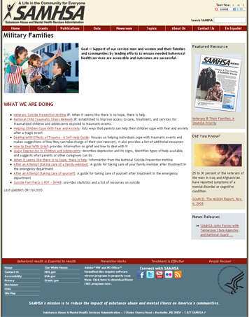

The instructions below explain how to create a Second Level page on the new SAMHSA design, as well as how to properly add widgets.

- Open up Visual Studio 2005 on your computer.
- Select the SAMHSA Redesign 2010 project from VSS (if you don’t already have it in your list, please see Scott or Sue).
- Once you’re into the project and online, please right-click on the root of the project in visual studio and select “Get Latest Version (Recursive).
- After the project has finished updating, select or create the directory you add the new page to.
  - To create a new directory, right-click on the /root/ of the project and select “New Folder”. It will create a new folder off of the root.
  - Right click on the new folder and select “Rename” to give the folder the name of your choice.
- Right-click on the directory you wish to add the page to and select “Add New Item”.
- In the prompt you’re shown, select the following options (see image below):
  - “Web Form”
  - Name: Whatever.aspx (make sure to include .aspx)
  - Language: Visual C# (should be default)
  - Check “Place code in separate file”
  - Check “Select Master Page”
  - Click “Add"

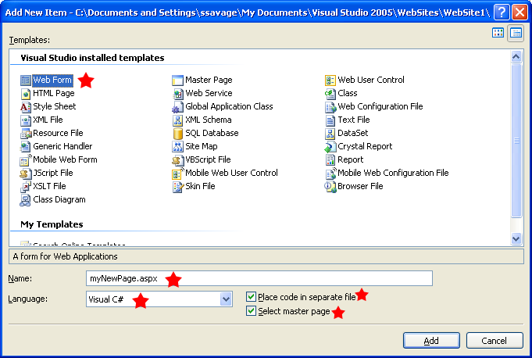

- You’ll now be presented with a screen that looks like this:
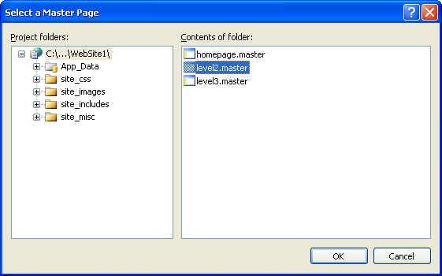

From the screen above, “select level2.master” and click “OK”.

- You’ll now be presented with your new document, showing five open/close elements:
  - placeholderTitleTag – Enter the text for the <title> of the page here.
  - placeholderMiscHeadData – Enter the meta keywords and description tags here, as well as any other information that needs to be contained in the <head> of the document such as extra CSS, javascript, and other meta tags.
  - placeholderContentTitleH2 – This is the page title as rendered on your new page as the first header. This should almost always match the <title> text.
  - placeholderL2LeftContent – This is where you create the actual content of the page. You MAY work on this in design mode or simply copy and paste your code created outside of Visual Studio (in Dreamweaver for example) into this area of the SOURCE (not DESIGN mode).
  - placeholderL2RightContent – This is where you drag and drop the widgets that float on the right side of the page. Please see step 9 below on how to add widgets to your page.

- In Visual Studio, navigate through the directory tree view to the “/site_includes/widgets/” directory.
- Open any of the three template files based on which color widget you’d like to create (OC might create guidelines for which colors to use for what kind of content later on).
  - The file names of the three widget templates are: blueWidgetTemplate.ascx, grayWidgetTemplate.ascx, and greenWidgetTemplate.ascx
- After opening the template, select all of the code inside of them EXCEPT for the very first line, which should say something to the effect of:
  - <%@ Control Language="C#" AutoEventWireup="true" CodeFile="greenWidgetTemplate.ascx.cs" Inherits="site_includes_widgets_greenWidgetTemplate" %>
- Right-click on the same directory (“/site_includes/widgets/”) and select “Add New Item” from the menu.
- In the prompt you’re shown, select the following options (see image below):
  - “Web User Control”
  - Name: Whatever.ascx (make sure to include .ascx – also note that this is CX and not PX – very important distinction as CX is for controls and PX is for pages.)
  - Language: Visual C# (should be default)
  - Check “Place code in separate file”
  - Click “Add”
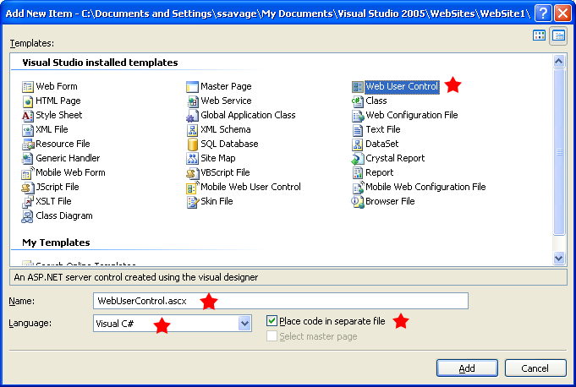

- In your new control page, paste in the code that you copied from the template you chose below the <%@ Control line (first line).
- Change the text in the <div class="smallWidgetTitle"> to the title of the widget you wish to use.
- Add your content to the area below the smallWidgetTitle area. Please ensure that all images are no larger than 190 pixels wide.
- After putting in all the content you need, save your new control (CTRL + S) then check it in by right-clicking on your new control in the tree view and selecting “Check In”.
- Copy your new widget (both the .ascx and .ascx.cs files if they both exist) from your working directory on your PC to the staging directory and check your work.

Important Notes & Errata

Please note that all pages require the following code at the end of the content area:

<p><em>Last updated: mm/dd/yyyy</em></p>

All new web pages for Samhsa.gov sites must have page titles. The procedure everyone should follow when adding a Page Title (using the TITLE tag) is outlined below.

Page Titles

Page Titles must be setup to go from “specific to general” (Page Topic, Site Section, Division / Center, Agency)

Rules to follow:
- Use the full spelled-out agency name for 2nd-level pages
- Use the acronym for 3rd level.
- No two pages on the site should have the same page title

Examples:
- Homepage: Substance Abuse & Mental Health Services Administration (SAMHSA)
- 2nd-level example: Housing and Homelessness, Substance Abuse & Mental Health Services Administration
- 3rd-level example: Co-Occurring Disorders and Housing and Homelessness, SAMHSA

Part VI: Updating the Homepage

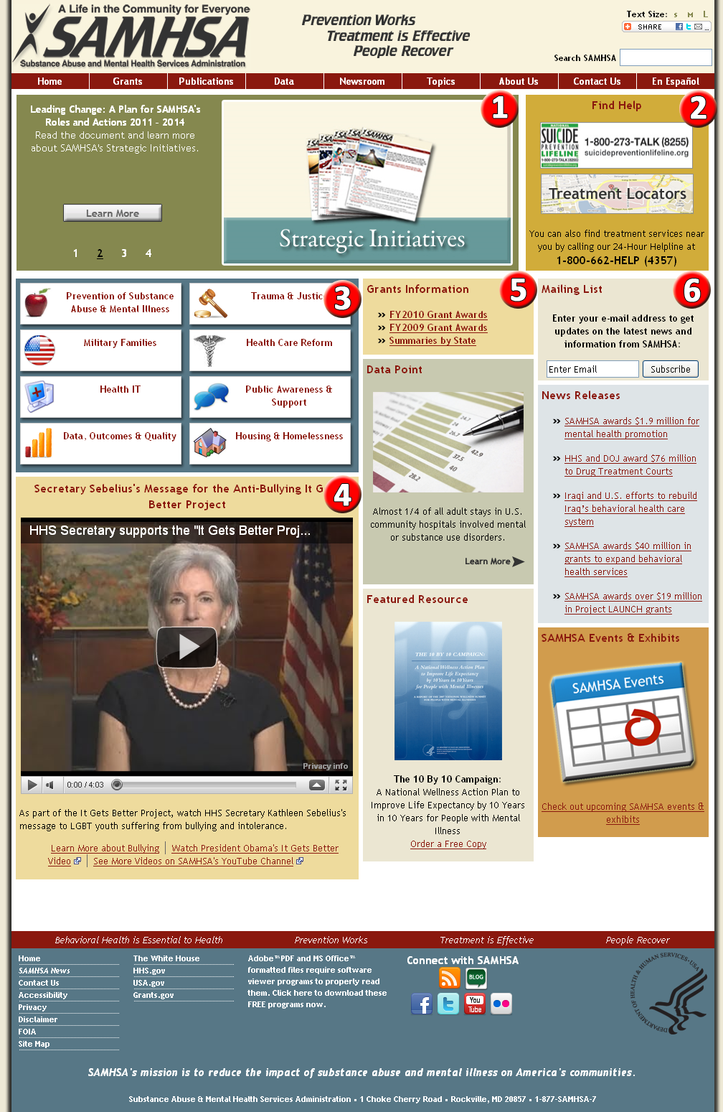

The redesigned SAMHSA.gov homepage is significantly different from the previous version of the homepage, but has some similarities in structure and operation as the new 2nd level pages (as showed in Part V above). Because the homepage is more complex than any other page on the website, the explanation of how it works and how to update it will be broken up into six sections as follows:

- The Feature Box/Carousel
- The “Find Help” Box
- The Strategic Initiatives Box (SI Box)
- The Youtube Box
- The Central Widget Area
- The Right Widget Area

These six sections correspond to the red and white numbers in the graphic above. Sections 5 and 6 are extremely similar and will be covered together.

Before the sections are explained, it should be noted that due to the way the homepage was constructed, changing the widths and locations of the different boxes and widgets on the page is extremely difficult, as every object on the page relies on the objects around it for positioning. Bear that in mind when making substantial updates to the homepage, and be sure to test all major structural changes in multiple browsers and operating systems to ensure that all visitors to SAMHSA.gov have the same browsing experience.

1 – The Feature Box/Carousel

The Carousel, as we refer to it in the vernacular, is one of the most important and well-placed features of the redesigned homepage. It is used to highlight important programs, campaigns, and events that are happening with SAMHSA. The carousel is based on the “jQuery Cycle Plug” by M. Alsup (for more information, visit http://jquery.malsup.com/cycle/).

The Carousel cycles between four slides, each of which is encapsulated in its own <div>. The four slides include a graphic that must be exactly 400px x 225px, associated text, and an anchor link. All content updates to the slide can be performed using the /site_includes/homepageObjects/carousel_v1.ascx file in the project. The javascript files and css files associated with the carousel should not need to be updated with any level of regularity, so they will not be covered in this guide. Also, the placement of this object should never change, so that also is being left out. For questions about those two things, please talk to Susette, Kym, or Scott.

To update the individual slides within the carousel, please use the following steps:

- Open up Visual Studio 2005 on your computer.
- Select the SAMHSA Redesign 2010 project from VSS (if you don’t already have it in your list, please see Scott or Sue).
- Once you’re into the project and online, please right-click on the root of the project in visual studio and select “Get Latest Version (Recursive).
- Navigate down to the /site_includes/homepageObjects directory and select the file “carousel_v1.ascx”.
  - Right-click on it, select check out, then open the file by hitting enter or right-clicking again and select “Open”.
- When the file is open, you’ll see several <div>’s, named “Slide1”, “Slide2”, “Slide3”, and “Slide4”. Each of those individual <div>’s represents one of the four slides on the carousel.
- Updating these slides should be relatively self-explanatory at this point, however please note the following:
  - The anchor links at the bottom of each slide are supposed to be empty (no content between the <a> and the </a>). Don’t worry about filling anything in – that’s done through the CSS.
  - Be sure to check that the <div> tags are properly closed.
  - Please comment out any slides you are replacing unless you are explicitly directed to delete them, as we use several slides, such as the Webinar slides, frequently.
- When updates to the slides are complete, please save and check the files into VSS.

2 – The “Find Help” Box

The “Find Help” box is a very simple user control, based on our standard widget template but modified to fit the space next to the Carousel. It is currently used to give users a quick, “above the fold” link to the most important resources for people in need of immediate assistance for critical issues. As of the writing of this style guide, the “Find Help” box contains only three content elements:

- Suicide Hotline graphic + link
- Treatment Locator graphic + link
- Treatment Services hotline

The maintenance on this particular object is minimal. The box itself resides in the /site_includes/homepageObjects/findHelpBox_v1.ascx. Access the object in the same way as instructed in “1 – The Feature Box/Carousel”. The object is simple HTML – two images with anchor’s and one area of text. Please remember to check in any files you have worked on when your task is complete.

3 – The Strategic Initiatives Box (SI Box)

Of all of the items on the homepage, the Strategic Initiatives Box (“SI Box”) is the second most complex (after the Carousel), but requires a bit more work to make updates to. As with the other controls on the homepage, the SI box control is located in the /site_includes/homepageObjects/ directory, and the files is named “siBox_v1.ascx”.

In order to achieve the hover effect on the eight SI links we’re using a combination of two graphics per initiative – one “on” and one “off”. The images are actually background images in the CSS instead of actual <img> tags within the code. The text for each SI link (Health Care Reform, Trauma & Justice, et al) is not part of the image, but instead actual text. The photoshop file which contains the template for each of the SI buttons is located in the /site_images/photoshopPSDs/ directory.

The eight SI links within the SI box are actually made up of two floating <div>’s, each with an unordered list <ul> supporting four of the eight items on either side. The HTML is fairly simple, and the CSS is fairly complex.

If adding or removing any SI buttons, you may want to make a button that is double the size of a normal button to prevent an odd gap from forming. Work with the Office of Communications to determine what might be best to fit in that area.

4 – The Youtube Box

Much like the “Find Help” box above, the Youtube box is a fairly simple object. Its purpose is to highlight videos and previously recorded webcasts. The Youtube box measures 463 x 385, which should stay static as the box wasn’t made to expand at all. The Youtube Box is located in /site_includes/homepageObjects/youtubeBox.ascx.

Updates to the Youtube box are fairly simple, just as with the Find Help box. Normal maintenance only requires the following three things to be done when a new video is sent down to be posted:

- Change the title of the box in the <div class=”widgetTitle center”> element
- Change the src attribute on the next line of code within the <embed> element
- Change the text below the <embed> object.

As always, remember to save all changed and check in the files to VSS before posting.

5 & 6 – The Central & Right Widgets

The central and right widget areas are for small objects that are likely to be updated more frequently than most of the other objects on the homepage. They tend to be little snippets and previews of content available elsewhere on SAMHSA.gov. The addition and removal of objects has been made very simple for this purpose.

One thing that should be considered before adding a new widget or removing an old widget is the colors of the widgets that are already there/will remain. As explained below, several different styles have been created for the homepage widgets so that we can have a diverse range of colors on the homepage (which helps to keep the content more lively). When adding or removing a widget, be sure to ensure that the colors are, if not all different, staggered so that the same or similar colored objects aren’t next to each other.

The homepage widgets, as with most of the other homepage objects, reside in the /site_includes/homepageObjects/ directory within VSS. As of November 2010, the following widgets appear on the homepage in the central and right areas:

- Grants Information
- Data Point
- Featured Resource
- Mailing List
- News Releases
- SAMHSA Events & Exhibits

With the exception of the News Releases widget, all of the widgets are currently based on static content. The News Releases widget was coded by Caiyun Dong and pulls data directly from the SAMHSA News Release database, where SAMHSA Press Releases are posted by the Office of Communications. That said, there should be virtually no maintenance necessary for that widget. Any questions regarding the News Releases widget should be directed to Caiyun, with the SAMHSA webmaster CC’ed.

As mentioned above, the homepage central/right widgets are based on a common template, which differs only in one particular place – the opening <div> tag of the widget, which specifies which color you wish to use, as well as the alignment of the content within.

The following colors (and their corresponding css classes) are as follows:

- Brown (.widgetHPSmall_Brown)
- Light Blue (.widgetHPSmall_LightBlue)
- Gray (.widgetHPSmall_Gray)
- Dark Blue (.widgetHPSmall_DarkBlue)
- Gun Metal Green (.widgetHPSmall_GunMetalGreen)
- Mustard (.widgetHPSmall_Mustard)
- Peach (.widgetHPSmall_Peach)

When creating a new widget of the homepage, please refer to the widgetTemplates.ascx file within the homepageObjects directory. You need only to copy and paste the code from one of the snippets within that file to create the shell for the widget. The simple shell for the widgets looks like this:

<div class="widgetHPSmall_GunMetalGreen left">
<div class="widgetTitle">This is the title</div>
[CONTENT AREA]
</div>

One thing you may notice with the opening class is that it’s declaring two classes at the same time, using the valid method of adding a space between each class. The first class, “widgetHPSmall_****” declares what color the background of your widget will be, and the second class declared will be the text justification of the content within (left, center, right). For widgets that contain lists (<ol> or <ul>), it’s best to use left jusitification.

As always, save and check your files into VSS when you’ve completed your tasks.

Part VII: Specifications & Default Parameters

The following are parameters that have been established as coding guidelines:

- Supported Operating Systems:
  - Microsoft Windows XP through Windows 7
  - Apple Mac OSX 10.2 through 10.6
  - Most standard Linux “flavors” such as SuSE, Debian, Ubuntu, and Redhat.
- Supported Web Browsers:
  - Microsoft Internet Explorer 7 and up.
  - Mozilla Firefox 3 and up.
  - Google Chrome 1 and up.
  - Apple Safari 4 and up.
- Supported Screen Resolutions:
  - Minimal resolution supported is 1024x768 (HHS & SAMHSA standard)
- Coding, Technologies & Plugins:
  - Javascript/Ajax/jQuery – These technologies are utilized more extensively than previously on SAMHSA.gov. That said, these technologies are allowed however precautions should be taken to ensure that all code is free of bugs and does not endanger the safety or privacy of anyone visiting our websites.
  - Adobe Flash – The use of Flash is permitted so long as any flash movies and/or applets are made 508 compliant with the latest version of Adobe’s Flash software, and that all movies contain active closed captioning as per Section 508 law. Additionally, the burden of proving to SAMHSA/HHS that Flash-based content is 508 compliant falls on the shoulders of the developers and not SAMHSA/HHS.
  - Adobe Acrobat (PDF) and Microsoft Office Files – Whenever PDF's are to be used, a link to download Adobe's free Acrobat reader must be in the same page as the link to the PDF, to comply with Section 508 § 1194.22 (m). PDF’s must also be checked for Section 508 compliance. Information on checking PDF files for 508 compliance are available at http://508.samhsa.gov.

Alert System - Use of CSS-based notifications and alerts
Notification boxes are ways of communicating important information with the user. This can be anything from an application's error message, an environmental warning message to an information message telling you about a new service. These visual and contextual cues help a user understand what you, the designer/developer/subject matter expert should believes requires immediate attention.
The notifications and alerts use both icons and color in order to convey their message.
Information |  | Possible uses include notices about services, updates to content
Warning |  | Be aware that the following contains information which should be consumed with caution. May also be used as a warning
Failure |  | Either a full on ‘stop’ or an indication that a user has failed
Messages |  | Contact information; a call to action to draw attention that a user has a message in an application
Success |  | An action taken by a user has resulted in success.
Lightbulb |  | May be used to show useful information or tips related to the page they are on.

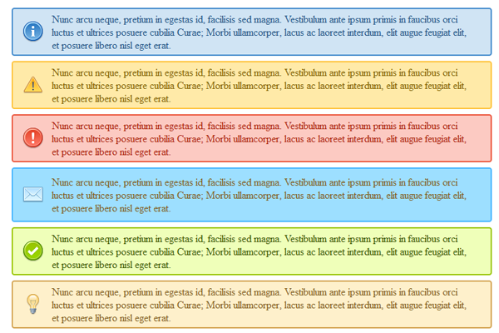

How to use
In order to use the notifications and alerts a minimum of two classes must be applied to a container.
- The class ‘notification’ is applied to each container in order to apply uniform margins, padding and rounded corners.
- A secondary class indicating the type of notification/alert is applied
- A final class may be applied named ‘remove’. This class allows the user to click on the container and it disappears from the page for that particular session.
For example, in order to generate the following information box
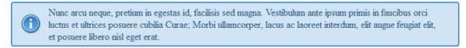
A designer/developer would use the following code
<p class="notification information">Nunc arcu neque, pretium in egestas id, facilisis sed magna. Vestibulum ante ipsum primis in faucibus orci luctus et ultrices posuere cubilia Curae; Morbi ullamcorper, lacus ac laoreet interdum, elit augue feugiat elit, et posuere libero nisl eget erat.</p>

Tooltip Documentation

Footer links for Connect with SAMHSA

Original Mark-Up
<a href="http://www.samhsa.gov/rss/"><img src="/site_images/icons/rss_32.png" width="32" height="32" alt="Link to RSS Feeds" /></a>
&nbsp;

- Wrap link in a span tag with class=”tip”

<span class="tip">
<a href="http://www.samhsa.gov/rss/"><img src="/site_images/icons/rss_32.png" width="32" height="32" alt="Link to RSS Feeds" /></a>
&nbsp;</span>

- Add span tag class=”tool-tip” with content (link to disclaimer) after the original link.

<span class="tip">
<a href="http://www.samhsa.gov/rss/"><img src="/site_images/icons/rss_32.png" width="32" height="32" alt="Link to RSS Feeds" /></a>
<span class="tool-tip">External link. Please review our <a href="http://www.samhsa.gov/about/Disclaimer.aspx">Disclaimer</a></span>&nbsp;</span>

Final Mark-Up
<span class="tip">
<a href="http://www.samhsa.gov/rss/"><img src="/site_images/icons/rss_32.png" width="32" height="32" alt="Link to RSS Feeds" /></a>
<span class="tool-tip">External link. Please review our <a href="http://www.samhsa.gov/about/Disclaimer.aspx">Disclaimer</a></span>&nbsp;</span>

CSS updates
/site_css/screenUniversal.css
Added styling for tools tips
/* Tool Tips Donnie 5-30-2012*/
.tip {
position:relative;
display: inline-block;
}
.tool-tip {
left:-9999px;
position:absolute;
width:250px;
-moz-border-radius: 4px;
-webkit-border-radius: 4px;
border-radius: 4px;
-moz-box-shadow: 0px 0px 5px #333;
-webkit-box-shadow: 0px 0px 5px #333;
box-shadow: 0px 0px 5px #333;
background:#fff;
border:1px solid #000;
overflow:hidden;
color:#000;
font-size:12px;
z-index:99999;
padding:2px;
text-align:center;
bottom: 100%;
}
.tool-tip a {
color:#900;
text-decoration:underline;
}
.tool-tip a:hover, .tool-tip a:focus, .tool-tip a:active {
color:#577786;
left: 0;
bottom: 100%;
}
.tip:hover .tool-tip, .tip:focus .tool-tip, .tip:active .tool-tip {
left: 0;
}
#widgets-bottom, #wrapper {
overflow: visible; /* so tool-tips dont get cut off */
}

Javascript Updates
/site_includes/jQuery/ jquery.options.js
Added to this file the Hover Intent jQuery Plug-in.
Added custom code below.
// Disclaimer Tool Tips Start
$('.tool-tip').hide().css('left','0');

var config = {
over: tipShow, // function = onMouseOver callback
timeout: 500, // number = milliseconds delay before onMouseOut
out: tipHide // function = onMouseOut callback
};

$(".tip").hoverIntent( config )
});

function tipShow(){$(this).children('.tool-tip').fadeIn('fast');}
function tipHide(){$(this).children('.tool-tip').fadeOut()}

Columns - Use of simple CSS-based content columns
The SAMHSA external production server has implemented a new method for columnar layouts. Although these layouts help to eliminate the need to use tables for layout purposes there are some limitations. The following are based on the available content area of the production SAMHSA external site as of 2011 which had a width of 741px.

Syntax
The basic concept of using CSS for columnar layout is to divide up a block into fractional pieces which eventual construct a whole. For example, given a generic div container you would use the following code to divide it into thirds (CSS class is in bold):
<div>
<div class="one-third"><p>Lorem ipsum dolor sit amet, consectetur adipiscing elit. Suspendisse ut elit magna, nec placerat mi. Praesent placerat, dolor et auctor porta, urna velit feugiat justo, vulputate ullamcorper tellus nisi et risus. Nullam condimentum ante nec leo volutpat adipiscing. Integer volutpat feugiat dui ac gravida.</p></div>
<div class="one-third"><p>Lorem ipsum dolor sit amet, consectetur adipiscing elit. Suspendisse ut elit magna, nec placerat mi. Praesent placerat, dolor et auctor porta, urna velit feugiat justo, vulputate ullamcorper tellus nisi et risus. Nullam condimentum ante nec leo volutpat adipiscing. Integer volutpat feugiat dui ac gravida.</p></div>
<div class="one-third last"><p>Lorem ipsum dolor sit amet, consectetur adipiscing elit. Suspendisse ut elit magna, nec placerat mi. Praesent placerat, dolor et auctor porta, urna velit feugiat justo, vulputate ullamcorper tellus nisi et risus. Nullam condimentum ante nec leo volutpat adipiscing. Integer volutpat feugiat dui ac gravida.</p>
</div>
</div>
Notice that the final third has an additional class added to it: last. The “last” class eliminates any margin to the right for the final container.

Part VIII: Contact Information

SAMHSA Web Team
The SAMHSA Sub-Site Template and this style guide were created and are maintained by members of the SAMHSA.gov Web Team. All inquiries should be made to the SAMHSA Webmaster e-mail box at webmaster@samhsa.hhs.gov.

SAMHSA Office of Communications
If you have any questions or concerns regarding branding, logos & placement, content or the content clearance process, please contact rich.morey@samhsa.hhs.gov or andrew.wilson@samhsa.hhs.gov in the Office of Communications.

SAMHSA 508 Team
If you have any questions or concerns regarding compliance with Section 508, please visit the SAMHSA Section 508 website at http://www.508.samhsa.gov or contact the SAMHSA 508 Coordinator at 508@samhsa.hhs.gov.

