Group Members
Hasan Master - 991698598
Gurleen Kaur - 991711466
Sahnavaz Choksi - 991732695
Project Disclaimer
The synthetically generated data will only be used for educational purposes and is not intended to be used for any research work.

Group project phase 3-4

HIVE PREREQUISITES
Figure 1 Creating a table
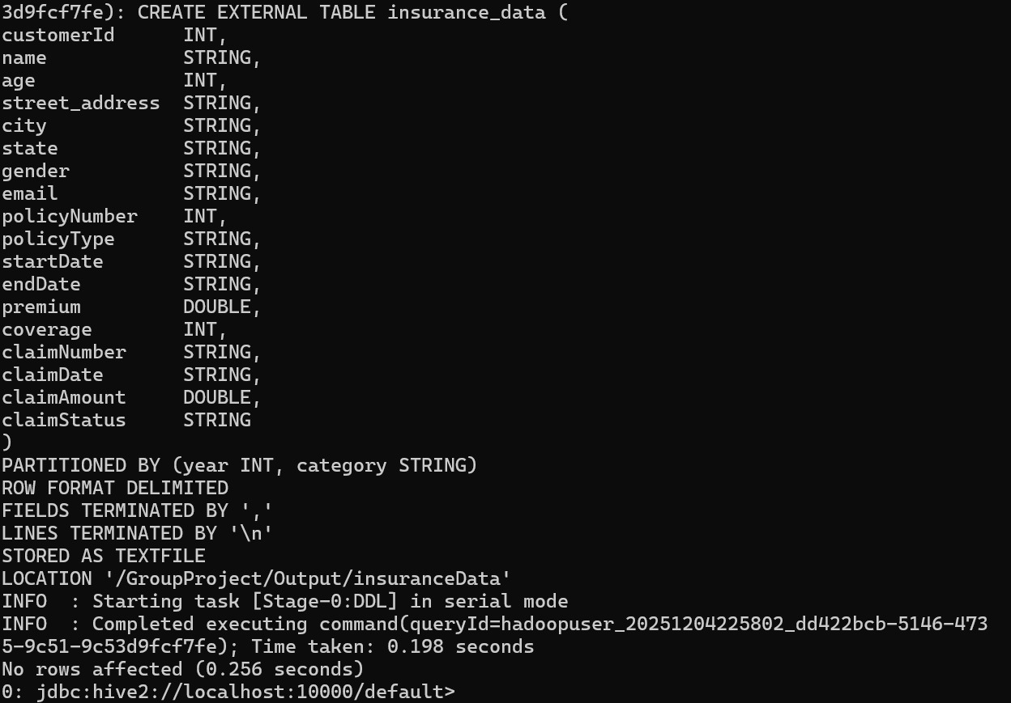

Figure 2 - Altering the table to add partitions
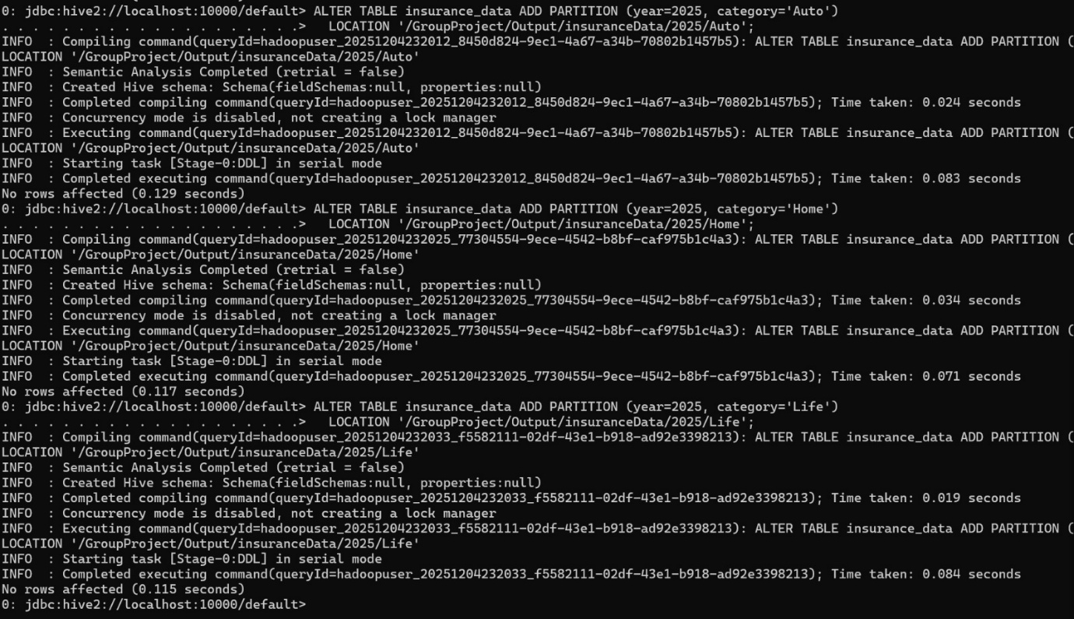
Attached screenshot is only of three cases, but we ran alter commands for all year and type combinations.
Figure 3 Show Partitions
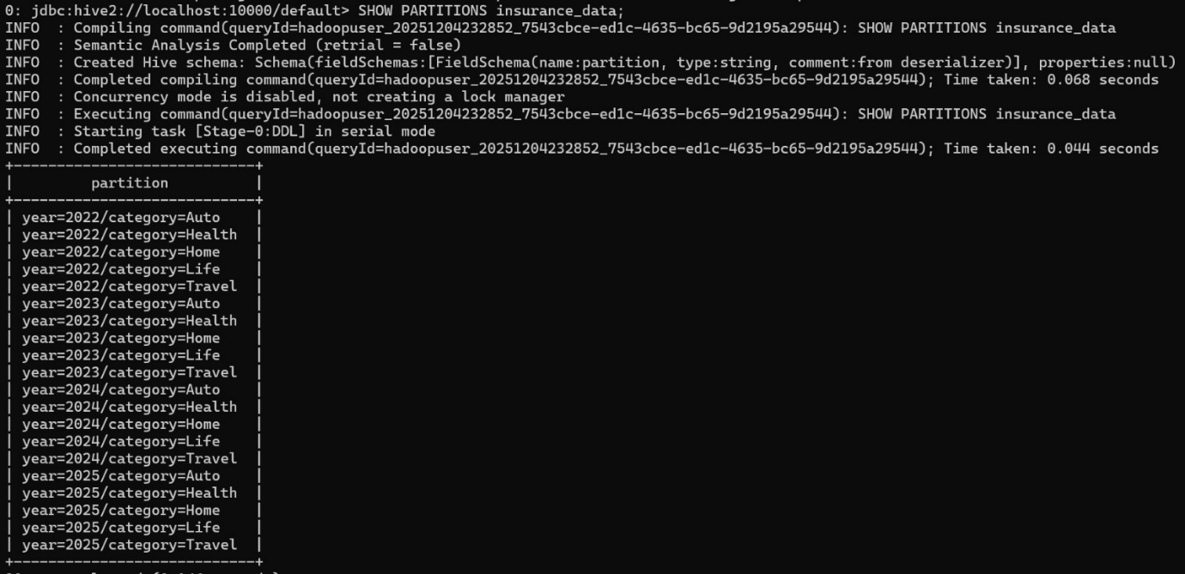

SPARK PREREQUISITES
Figure 4 Read Insurance Data and Check Schema

Figure 5 Renamed Columns accordingly

Figure 6 Data cleaned and Prepared


Loss Ratio Analysis
  - HiveQL
Figure 7 Loss - Ratio Command
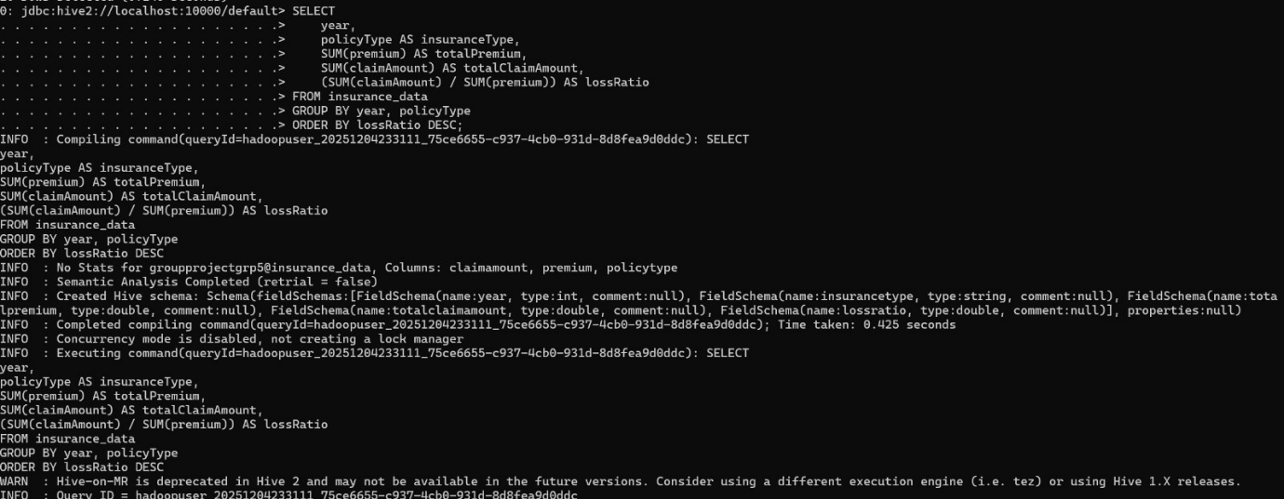
Figure 8 Loss - Ratio Output
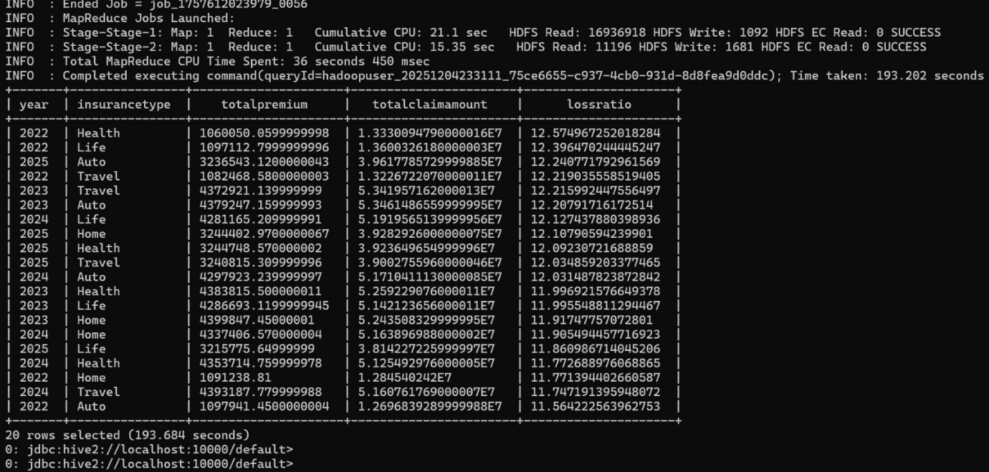

  - Spark
Figure 9 Loss Ratio queries using Spark Code and saved results in csv

  - Insights
The results show that the company is in a critical profitability concern across all the types. Loss ratios average around 11-12 meaning that the company is paying out 10-12 times more than what they are earning in premiums, which show to us that the policies are underpriced. The data received also tells us that we can observe that Health and Life insurance have the highest loss ratios which mean that the most amount of claim costs are in those sections and there are issues in pricing controls.

- Average Claim Amount by Gender
  - HiveQL
Figure 10 HiveQL Command - Average Claim Amount by Gender
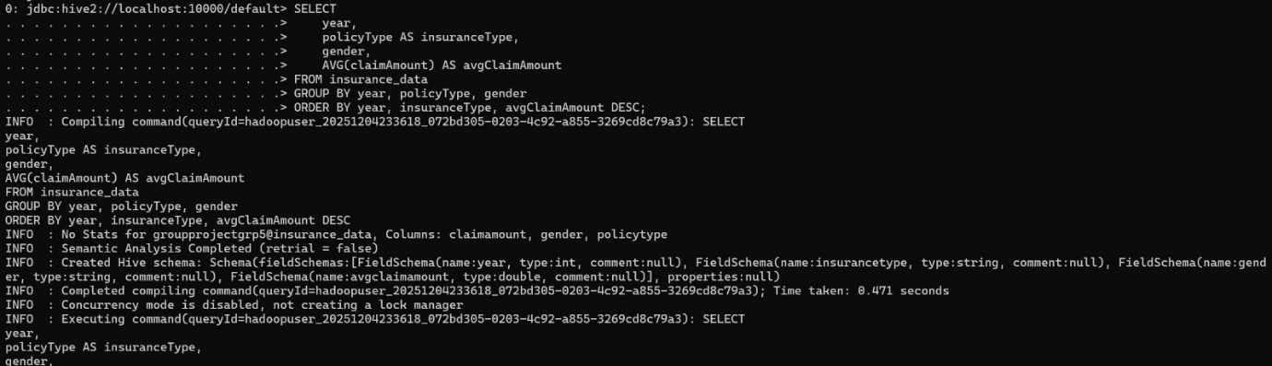
Figure 11 Average Claim Amount by Gender - Output 1
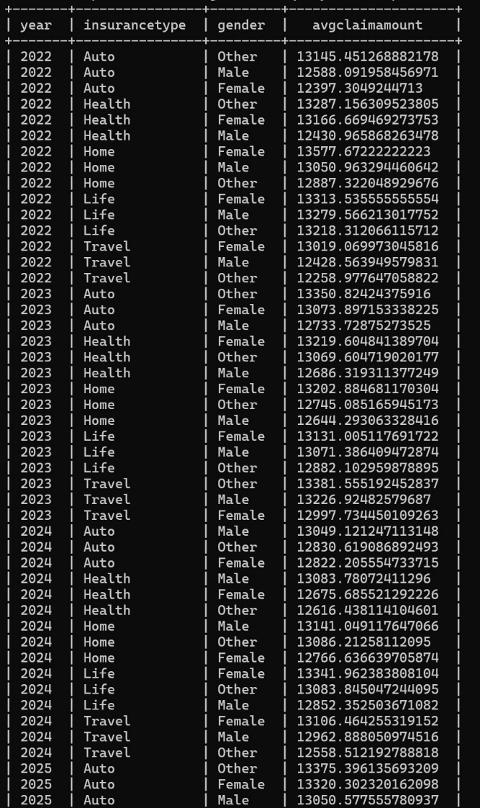
Figure 12 Average Claim Amount by Gender - Output 2
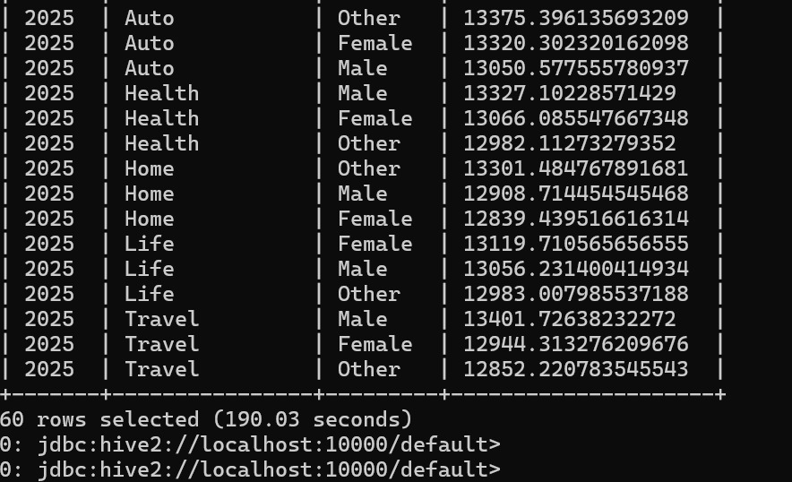
  - Spark
Figure 13 Average Claim Amount by Gender queries using Spark

Figure 14 Saved resulting data to CSV
  - Insights
The analysis shows that there is observable variation across the genders. The differences aren’t drastic in all segments, but some specific segments, and insurance types and years show higher claim averages for one gender compared to the other types. We can observe from this that gender-based claim patterns exist and in real environments, we can evaluate whether certain demographics go through a higher risk. These trends help us to adjust premiums or apply strategies to mitigate the risk if the behaviour is consistent.

- Average Premium by Age Group
  - HiveQL
Figure 15 Average Premium by Age Group - Command
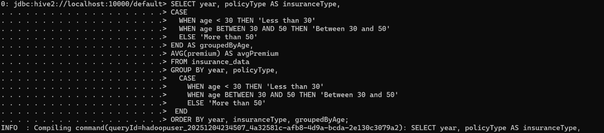
Figure 16 Average Premium by Age Group - Output 1
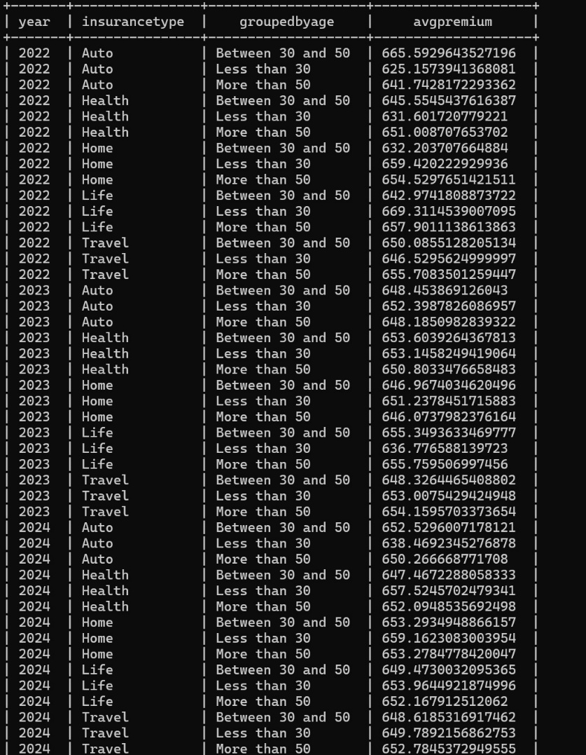
Figure 17 Average Premium by Age Group - Output 2
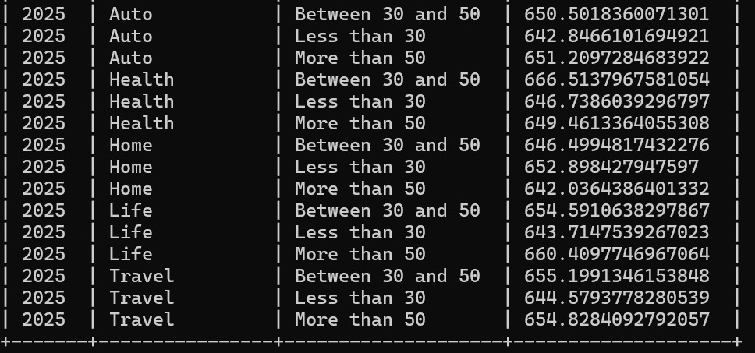
  - Spark
Figure 18 Average Premium by age group queries using Spark

Figure 19 Saved resulting data to CSV file

  - Insights
The average premium comparison according to the age brackets show us that the premiums increase with a direct comparison to age, the 50+ group consistently holds the highest number of premiums. This suits well with the expectations set within the industry such that older people usually represent a higher risk and therefore cost more for insurance. Younger groups as expected, have the lowest premiums, with the middle age bracket sitting in between. This analysis suits with the risk based pricing structure. The trend recommends applying age to risk model and adjust premium pricing to align with actual behaviours and market standards.

- Comparison of Hive, MapReduce, and Spark
The experience we got from this term working with all three technologies brought to us a clear understanding of the different technologies and the differences between them. MapReduce was realised to be a low-level and required writing Java logic using mapper and reducer logic manually, which is a slower development process.
Hive as compared to MapReduce feels easier because of the similarities with SQL, which makes it ideal to run analytical queries along with aggregations such as loss ratio, average claim and segmenting by age. Hive eliminates the complexity of MapReduce which allows to execute queries faster without having to write code.
In all three, Spark felt the most efficient and flexible as it helped to perform computations in memory, supporting dataframes and allowed complex transformations with less code. Spark also allowed the smoothest workflow, for tasks such as exporting results and delivering new fields.
At the gist of it, MapReduce was powerful and allowed more control over the task but was slow to develop. Hive is the best when to be used for analytical data queries and reports. Spark is fastest of all 3 with allowing flexibility for large scale processing.

