**ACKNOWLEDGEMENT**

We take this occasion to thank God, almighty for blessing us with his grace and talking our endeavor to a success culmination. We extend our sincere and heartfelt thanks to our esteemed guide, and we also take this opportunity to express to deep sense of graduate to our course teacher **Ali Azgar** for cordial support, valuable suggestion and guide . We extend our sincere thanks to our big Brothers for give us suggestions and guidance .

**ABSTRACT**

Library Management system is a project which aim and developing a computerized system to maintain all the daily work of library. This project his many futures which are generally not available in normal library management system like facility of admin login through which the admin can monitor the whole system . the librarian after logging into his account and add new book and to search any books.

**Introduction :**Modem generation is going to dependable on computer and through computer we use software , hence, we learning database ,php and html that’s why are create an application for managing library system by using mysql database,html,php by using this , we store a students information’s who find any books or add any books.

**Motivation :** libraries are essential in process of giving citizens access to knowledge . in digital times they are needed more than even before .i our country ,library , systems are written that’s why we make great use of paper .by making paper we cut trees. It is very harmful for our environment . for our environment we take this step to reduce this.

**Objectives**: the aim of this projects is to develop a system that can handle and manage the activities involved in a library in an efficient & reliable way. Less managing personnel & easy searching availability & user profile managing are major goals in this project.

* Develop a system that can replace the manual library managing system.
* Develop a database which stores user details & book details.
* Give reliable search facility for the users.
* All users should have account to login.

**Background:**

Library management system is an application which refers to library systems which are generally small or medium in size. It is used by librarian to manage the library using a computerized system where he/she can record various transactions like issue of books, return of books, addition of new books, addition of new students etc.

All these modules are able to help librarian to manage the library with more convenience and in a more efficient way as compared to library systems which are not computerized.

**Scope of the problem:**

* When connect with database table.

**Challenges:**

* Work with database

**Requirement specification:**

**Implementation of Database:**

|  |
| --- |
| Registration |
| ID |
| Username |
| Email |
| Password |
| Created_at |

**Context diagram:**

|  |
| --- |
| Book_info |
| ISBN |
| Title |
| Author |
| Edition |
| Publication |

Registration

Book_info

Registration

Book_info

**Test results and report:**

**Register-**

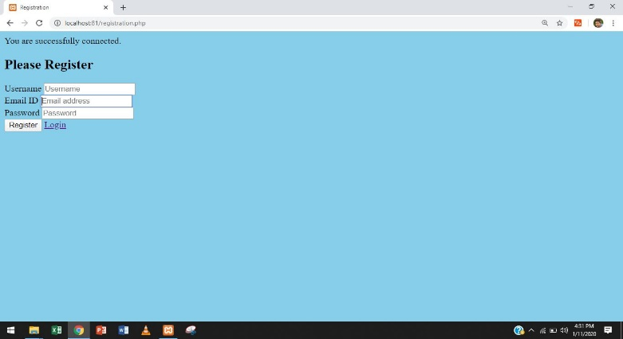

**Login-**

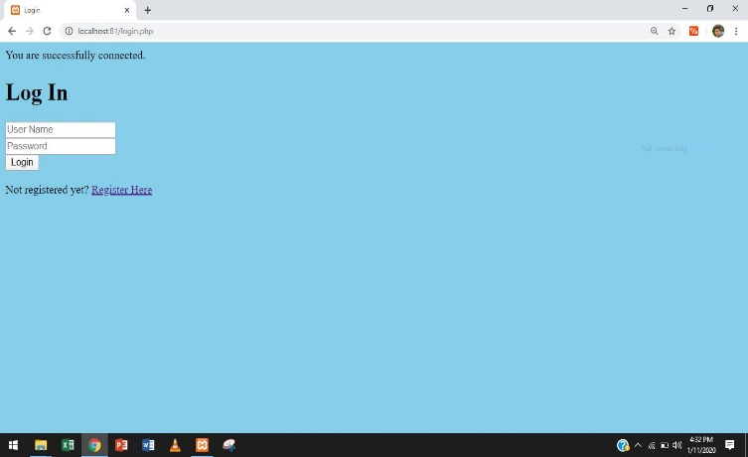

**Login success:**

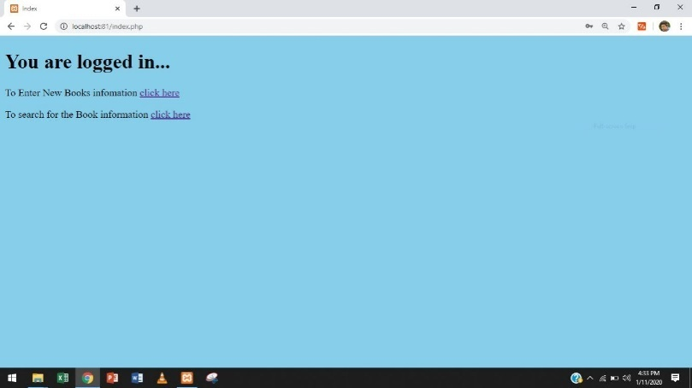

**Book_info insert:**

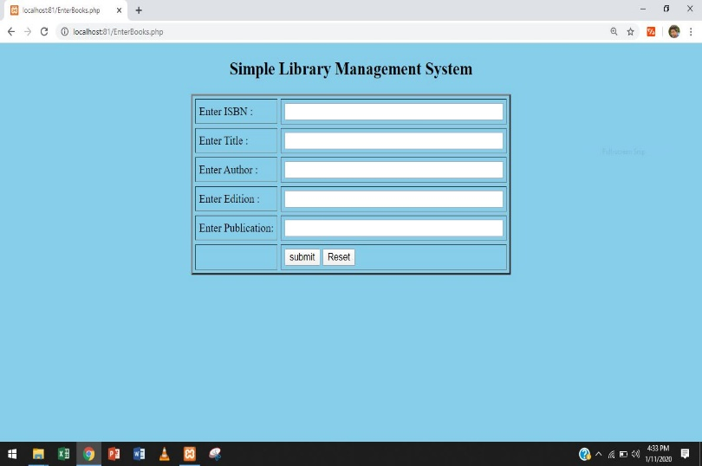

**Search book:**

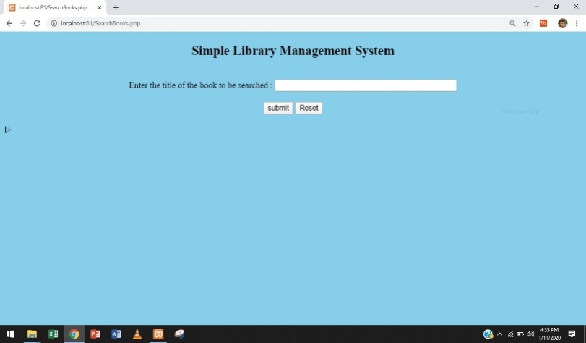

**Book details-**

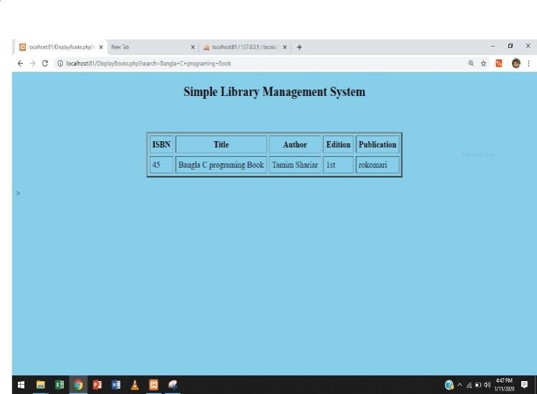

**Database details-**

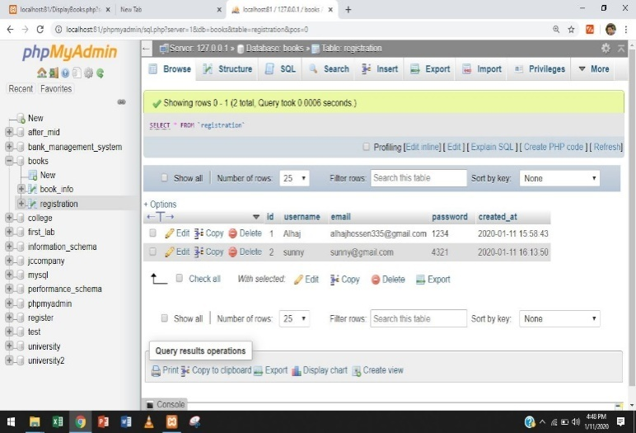

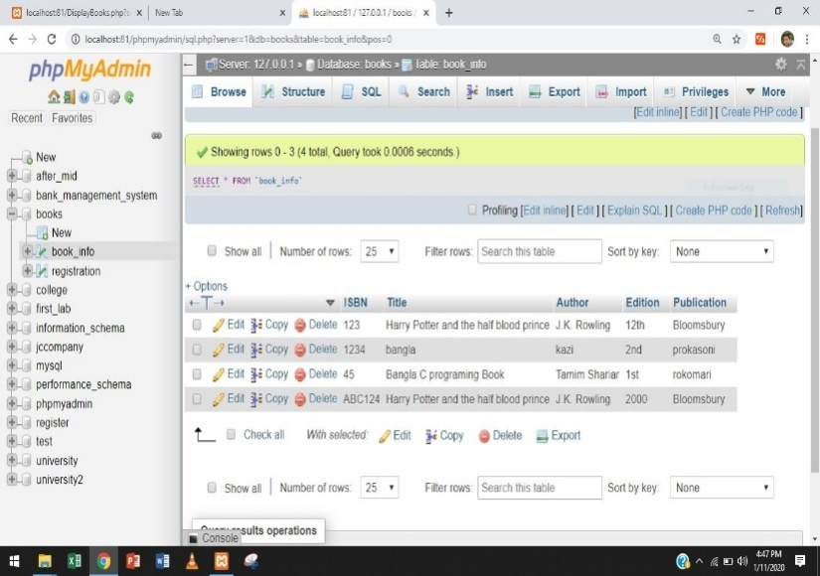

**Discussion & conclusion:** In this application we can entry log in page.we entrya new book which has a specific id,book name, publisher,author name. We also add to search books.