**Question 1:** Simulation of a pure pursuit problem.

A fighter aircraft sights an enemy bomber and flies directly toward it, in order to catch up with the bomber and destroy it. The bomber (the target) continues flying (along a specified curve) so the fighter (the pursuer) has to change its direction to keep pointed toward the target. We are interested in determining the attack course of the fighter and in knowing how long it would take for it to catch up with the bomber. If the target flies along a straight line, the problem can be solved directly with analytic techniques. However, if the path of the target is curved, the problem is much more difficult and normally cannot be solved directly. We will use simulation to solve this problem, under the following simplifying conditions:

1. The target and the pursuer are flying in the same horizontal plane when the fighter first sights the bomber, and both stay in that plane. This makes the pursuit model two-dimensional. (Input from screen)

2. The fighter's speed VF is constant (20 kms/minute). (from file)

3. The target's path (i.e., its position as a function of time) is specified.

4. After a fixed time span at (every minute, in this case) the fighter changes its direction in order to point itself toward the bomber.

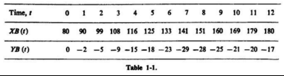Sample Input

**Question 2:** Simulation of critical path method.

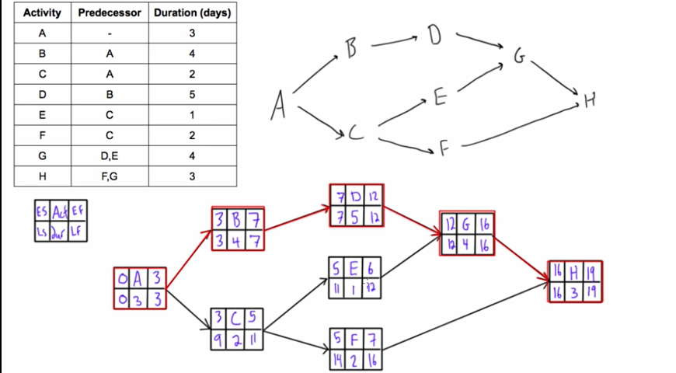Draw the activity graph and find the critical path from below data table.

**Input:** From file

**Output:** On screen & file

**Question 3:** Simulation of linear congruential generator method.

**Problem Statement:** Write a program for linear congruential generator method to generate a sequence of random integers between zero and M-1. For example, the following table shows the sequences that result for various choices of a (multiplicative constant), b (additive constant), c (seed), and M (modulus).

|  |  |  |  |  |  |  |  |  |  |  |  |  |  |  |  |  |
| --- | --- | --- | --- | --- | --- | --- | --- | --- | --- | --- | --- | --- | --- | --- | --- | --- |
| **a** | **b** | **c** | **M** | **x0** | **x1** | **x2** | **x3** | **x4** | **x5** | **x6** | **x7** | **x8** | **x9** | **x10** | **x11** | **x12** |
| 1 | 3 | 0 | 10 | 0 | 3 | 6 | 9 | 2 | 5 | 8 | 1 | 4 | 7 | 0 | 3 | 6 |
| 2 | 1 | 0 | 10 | 0 | 1 | 3 | 7 | 5 | 1 | 3 | 7 | 5 | 1 | 3 | 7 | 5 |

**Question 4:** Simulation of a Chemical Reactor.

**Problem Statement:** There are two substances A and B. They produce third substance C. The rate of formation of C is proportional to presence of A and B. Write a program to simulate how much of C has been produced as a function of time, ∆t = 0.1. Assume that a = 100g, b = 50g and c = 0g are quantities of A, B and C at time t = 0*.* Rate constants are also given as follows k1 = 0.008 and k2 = 0.002.

**Question 5:** Simulation of a cubic Bezier curve.

**Problem Statement:** There are four control points P0, P1, P2, and P3 position in 2D space. You have to write a program to construct the spline using Cubic Bezier curve construction approach. Also need to display the output for each new point.