1. **Time limits?**

Question: Do I understand the logic correctly? Below you basically say “run indefinitely, but if endtime – starttime < waittime, then wait x time and then re-run from the top”. Is this the logic behind time management?

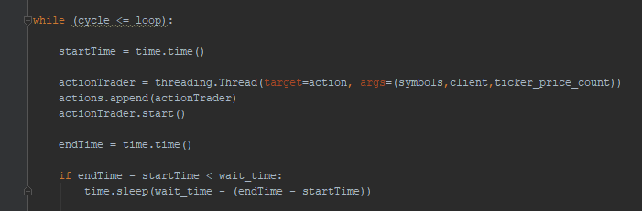

1. **All currencies?**

Question: This pulls all currencies as a string, right? And it does it from the beginning, every time the script runs again. This means I don’t have to care about new currencies being added to binance, since they will automatically be included when the script runs again. Is this correct?

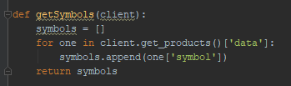

1. **Write price for the last 1200 calls?**

Question: My ultimate goal regarding data storage for review is to have the prices at each of the last 1200 calls (= 1 minute) once the position is closed. The idea behind it is to be able to review those and adjust my buy strategy. Right now I have no idea how the market is moving during such a price swing and I am only speculating. If I collect those prices for each of the last 1200 calls for each price swing, I will then better understand how to structure my market entry condition. That’s why I wanted to have the last 1200 prices before the position closure.

I am not sure that this is doing this. To me, it seems that you are currently only saving the latest and the 1200th values, but nothing in between.

* I was rather expecting something like: “if len(ticker_price) < ticker_price_count” >> then write value.

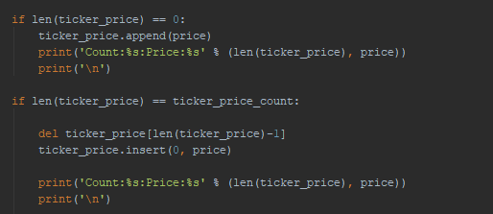

1. **Market orders (both buy and sell) independent of current price (since price might move faster)**

Question: why are you specifying price when executing a market order? It could be my mistake, but I thought for a market order, you don’t need to pass along the price. Also I thought you need to specify that it is a market order. i.e. type = MARKET (I looked it up on the binance API site). My logic behind it, is that it could be that the market has already moved faster than our script and it could be that the order does not get filled if we specify a price. This applies to both buy and sell orders.



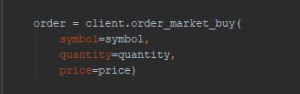

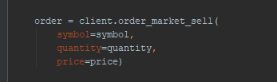

1. **Save data in excel for last 1200 calls for each new sell in a new excel file?**

Question: I cannot find the place where you save the last 1200 price calls after closing a position in a new excel file. In order to make sure there are no double excel file names, perhaps also include the date of the order, plus the currency.

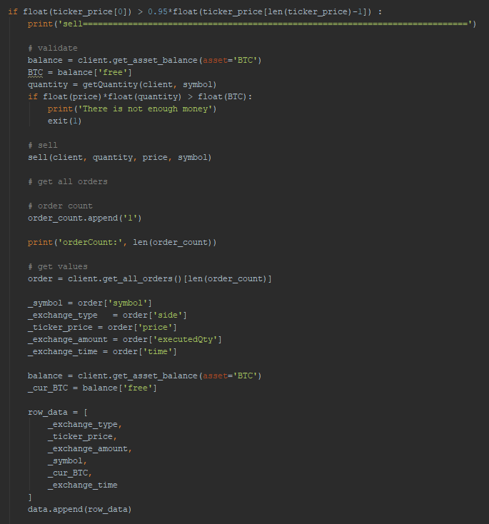

1. **Splitting orders in pyramid?**

Question 1: This is an additional request that after thinking a lot about it, I think makes sense, but I definitely wanted to ask you about your opinion. What do you think? I fear that the market might be too unpredictable to rely on comparing only the last 3 changes in tick data. Perhaps it is smarter to have a pyramid rule like:

If price drops to 80% of price[1200], enter with 20% of equity.

If price drops further to 70% of price[1200], enter with 20% more of equity.

If price drops further to 60% of price[1200], enter with 20% more of equity

If price drop further to 50% of price[1200], enter with 20% more of equity.

If price drop further to 40% of price[1200], enter with last 20% of equity.

Question 2: I don’t fully understand the logic right now that says “enter with full equity”. Right now you say “limit_sell_BTC = 0.01” and “quantity = limit_sell_BTC / price”. But you don’t consider the actual equity in the account. Or am I wrong?

