Assignment

AIM: Installation of Nagios on Ubuntu System

LO1: To undestand the fundamentals of DevOps engineering and be fully proficient with DevOps terminologies,concepts,benefits, and deployment options to meet your business requirements.

LO5: To understand concept of containerization and Analyze the containerization of OS images and deployment of applications over Docker.

THEORY:

What is Nagios?
Nagios is an open source IT system monitoring tool. It was designed to run on the Linux operating system and can monitor devices running Linux, Windows and Unix OSes.
Nagios software runs periodic checks on critical parameters of application, network and server resources. For example, Nagios can monitor memory use, disk use and microprocessor load, as well as the number of currently running processes and log files. Nagios also can monitor services such as Simple Mail Transfer Protocol (SMTP), Post Office Protocol 3, Hypertext Transfer Protocol (HTTP) and other common network protocols. Nagios initiates active checks, while passive checks come from external applications connected to the monitoring tool.
Originally released in 1999 as NetSaint, Nagios was developed by Ethan Galstad and subsequently refined by numerous contributors as an open source project. Nagios Enterprises, a company based around the Nagios Core technology, offers multiple products, such as Nagios XI, Log Server, Network Analyzer and Fusion.

How Nagios works
Users can choose to work in the command-line interface or select a web-based graphical user interface in some versions of Nagios and from third parties. Nagios' dashboard provides an overview of the critical parameters monitored on assets.
Based on the parameters and thresholds defined, Nagios can send out alerts if critical levels are reached. These notifications can be sent through email and text messages. An authorization system enables administrators to restrict access.
Nagios runs both agent-based and agentless configurations. Independent agents are installed on any hardware or software system to collect data that is then reported back to the management server. Agentless monitoring uses existing protocols to emulate an agent. Both approaches can monitor file system use, OS metrics, service and process states. Examples of Nagios agents include Nagios Remote Data Processor (NRDP), Nagios Cross Platform Agent and NSClient++.

Nagios plugins
Nagios can also run remote scripts and plugins using the Nagios Remote Plugin Executor (NRPE) agent. NRPE enables remote monitoring of system metrics such as system load, memory and disk use. It consists of the check_nrpe plugin, which is stored on the local monitoring machine, and NRDP, which runs on the remote machine. Nagios uses a plugin to consolidate data from the NRPE agent before it goes to the management server for processing. NRPE can also communicate with Windows agents to monitor Windows machines.
Nagios supports plugins that are stand-alone add-ons and extensions so users can define targets and which target parameters to monitor. Nagios plugins process command-line arguments and communicate commands with Nagios Core.
There are around 50 plugins developed and maintained by Nagios, while there are over 3,000 from the community. These plugins are categorized into lists including hardware, software, cloud, OSes, security, log files and network connections. As an example, when used in conjunction with environmental-sensing systems, a Nagios plugin can share data on environmental variables, such as temperature, humidity or barometric pressure.

Nagios tools
Nagios has proven popular among small and large businesses, as well as internet service providers, educational institutions, government agencies, healthcare institutions, manufacturing companies and financial institutions.
Users can choose among free and paid options, depending on the needed services and support.

Nagios Core
The service that was originally known as Nagios is now referred to as Nagios Core. Core is freely available as an open source monitoring software for IT systems, networks and infrastructure. Core contains a wide array of infrastructure monitoring through allowing plugins to extend its monitoring capabilities. It is the base for paid Nagios monitoring systems.
Nagios Core has an optional web interface, which displays network status, notifications and log files. Core can notify its user when there are server or host issues. Additionally, Core can monitor network services such as SMTP, HTTP and Ping.

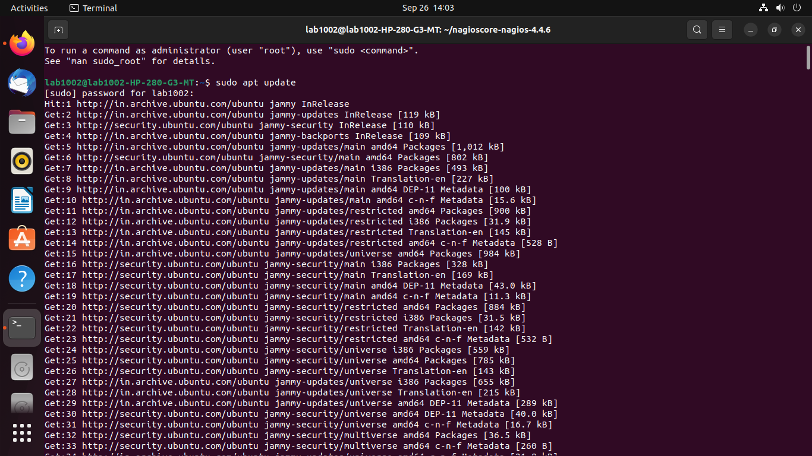
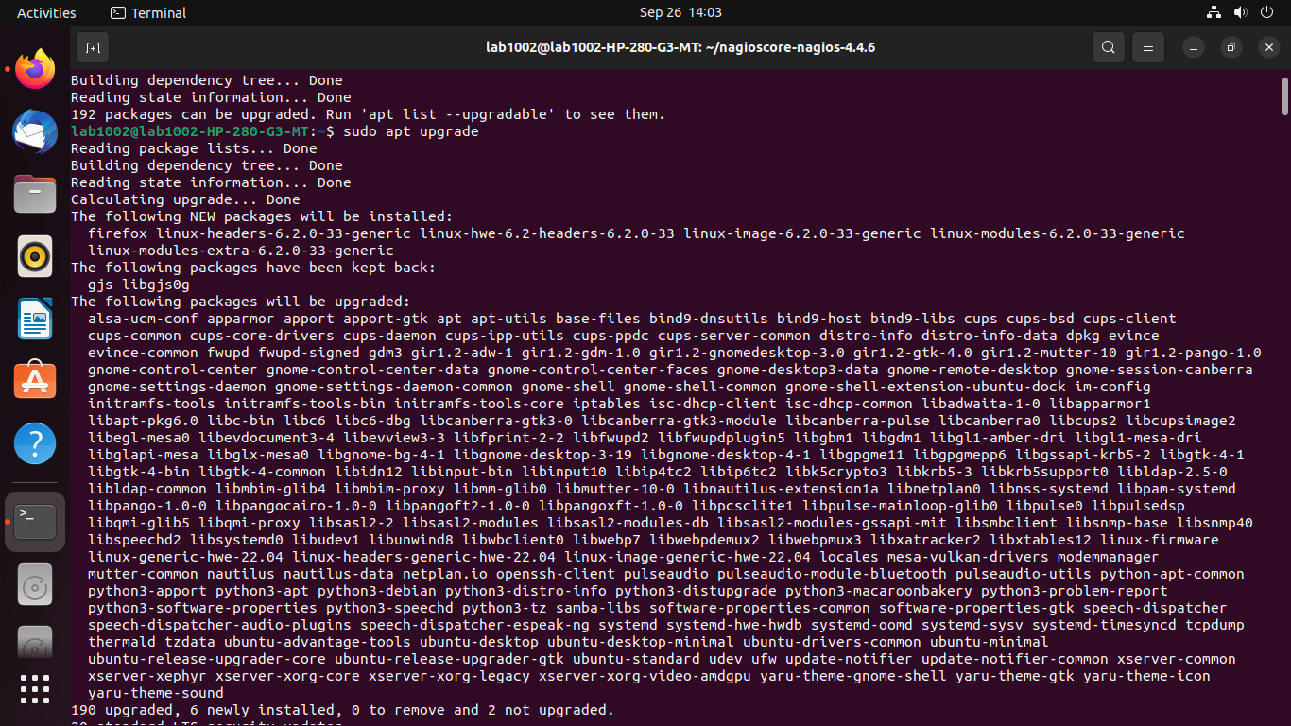

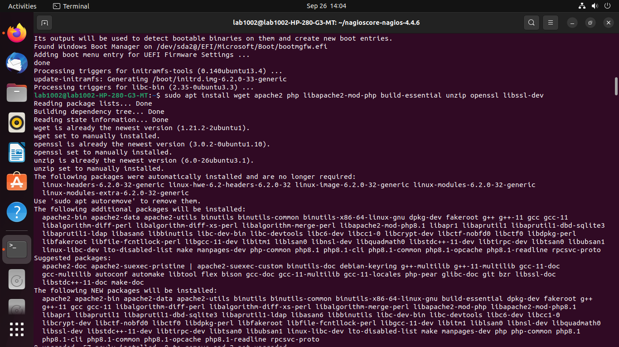
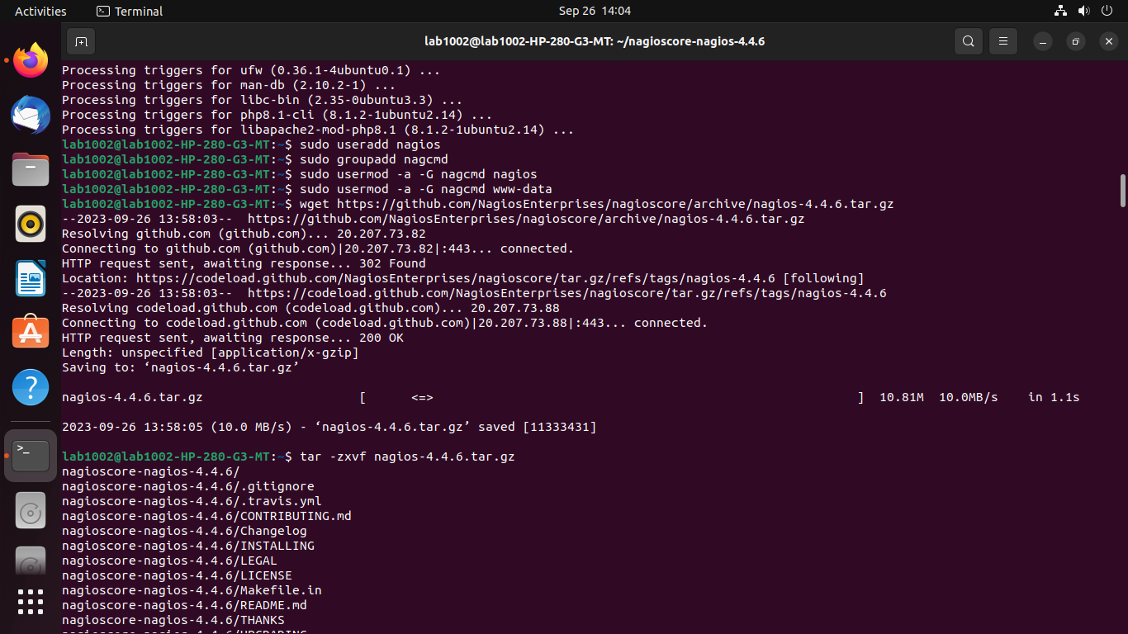
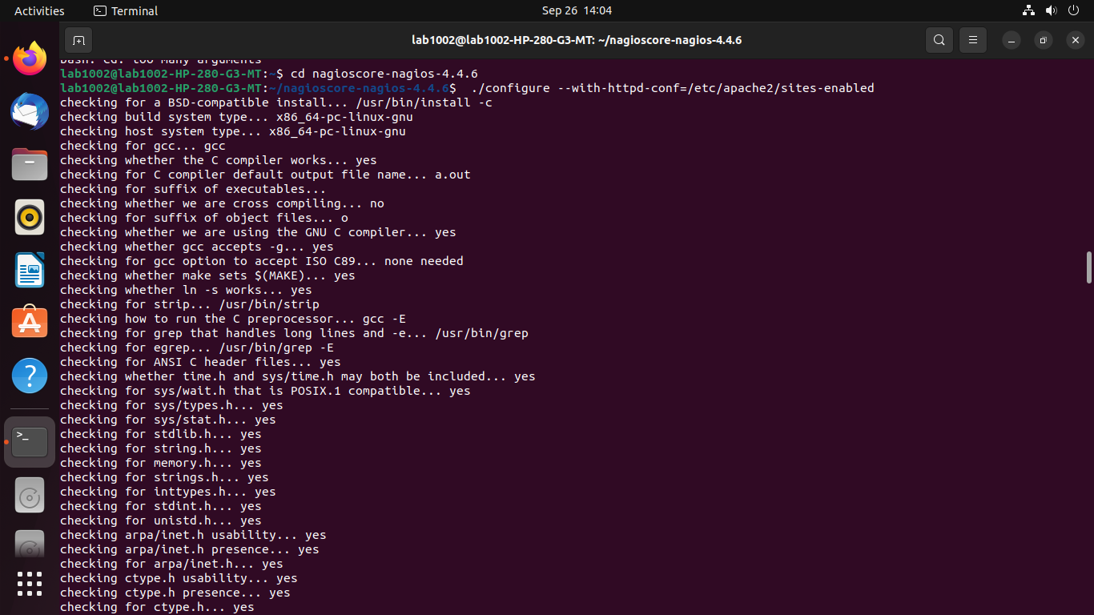

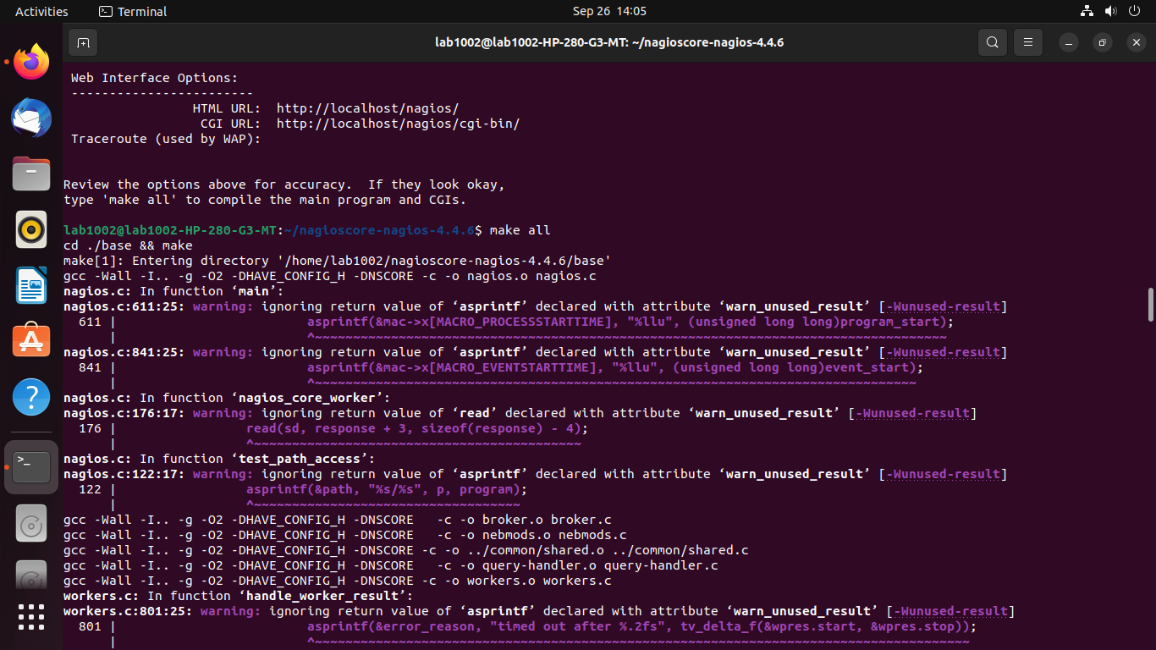
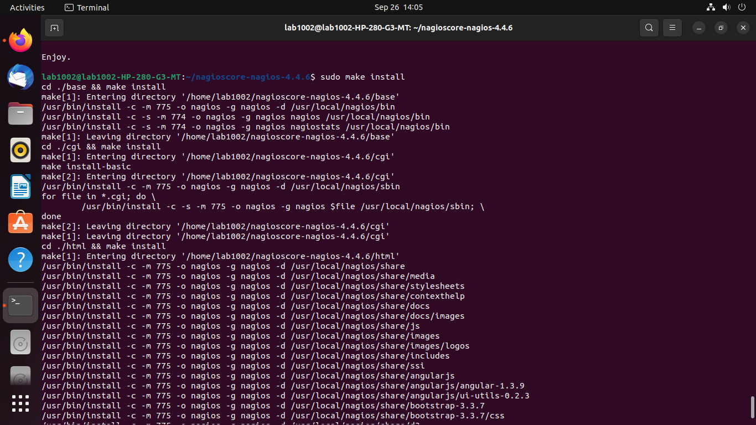
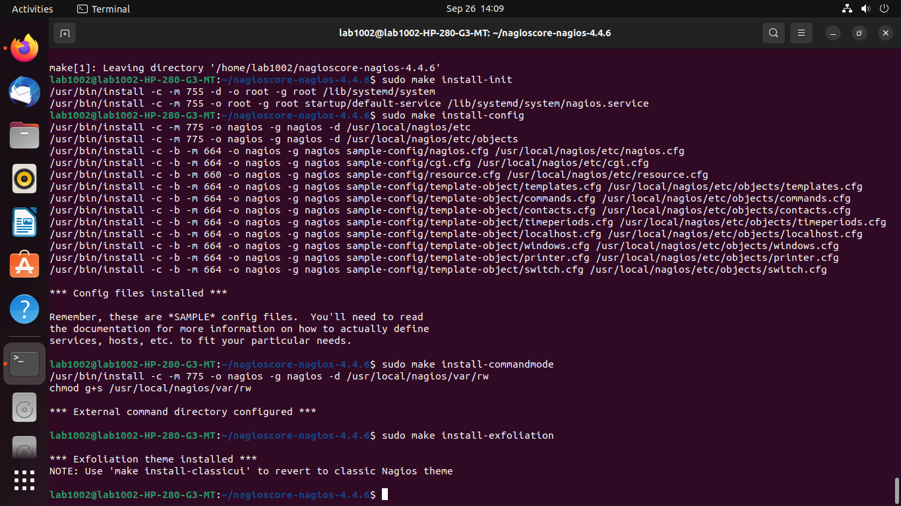

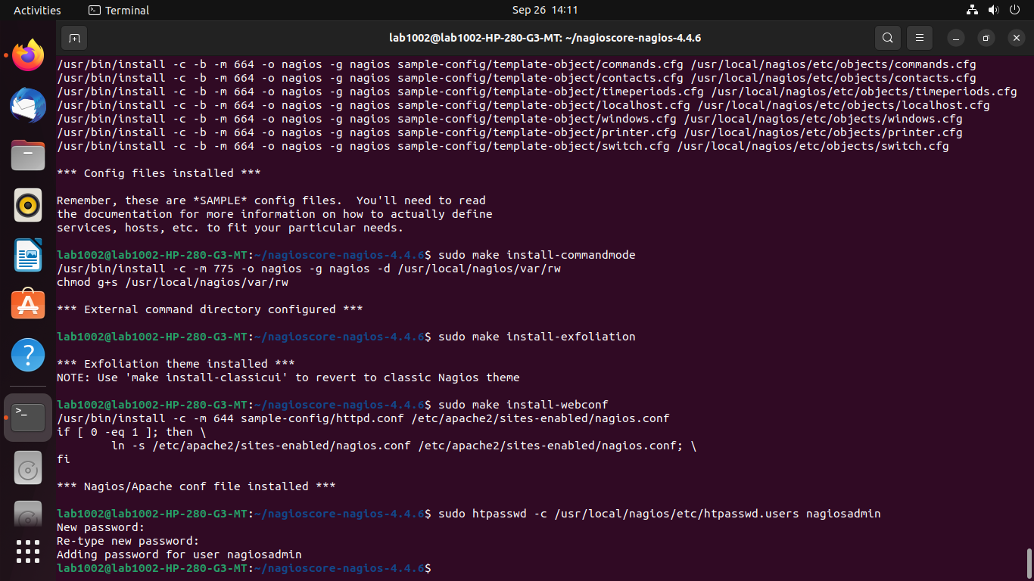

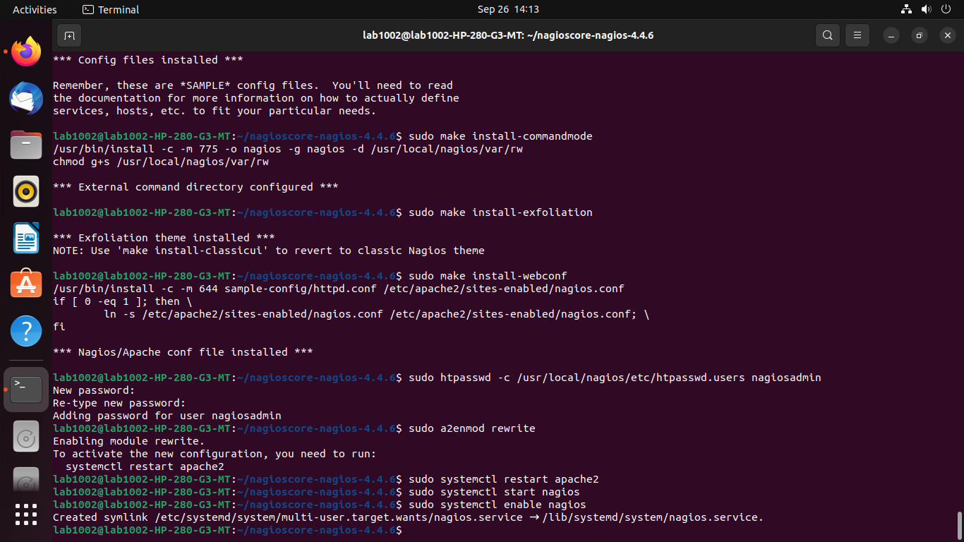

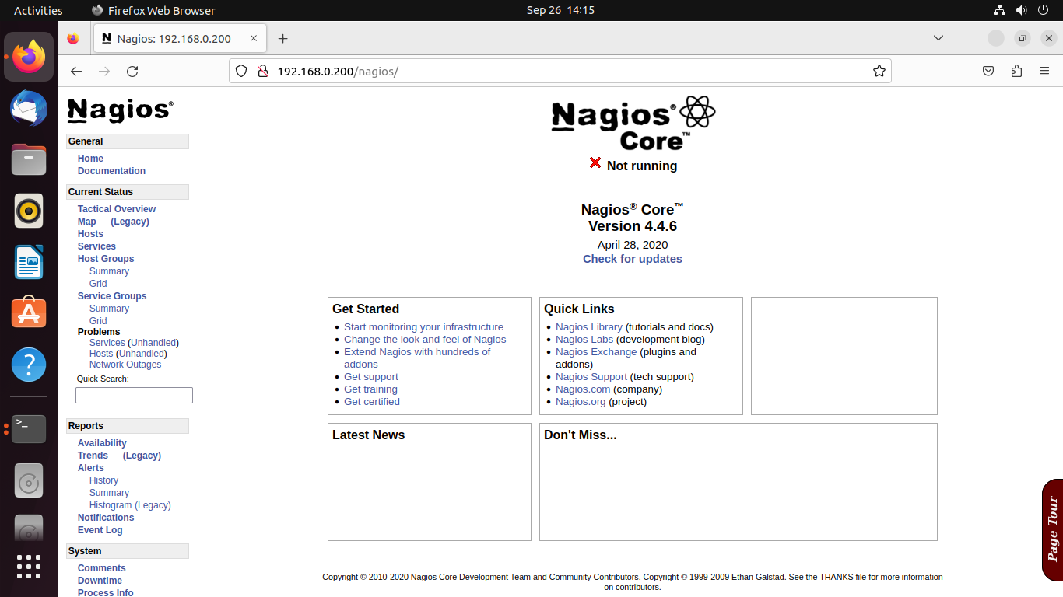
CONCLUSION: Here , we studied about Nagios and successfully installed nagios on ubuntu system.

