REPORT

Title : Covid-19 Cases

Problem Statement :
To analyze the Covid-19 Data associated with the India. By analyzing the data we define the statistical data required to understand how Covid-19 patients are incresed in india and the state wise patients which include confirmed patients and deaths.

Problem Description :
Today Covid cases are increasing day by day in all the countries across the world. The Given Dataset is the data representation of the Country India.
By Analyzing the Dataset we are going to check how the number of patients were increased in the india in different states. Also we are going check state wise deaths are confirmed patient numbers by using different data visualization techniques.
The Given Dataset and their analysis will help us to understand distribution of patients all over the india. This will help to medical service providers to provide the services in the area where more patients are located.
Due to Covid-19 situation more are more people are got shifted from one geographical area to another. This analysis also help them to check the localities and suggest them the right locations to live.

The Given Covid-19 Dataset is in the csv format.
Dataset Contains 9 Columns namely as :
1] Sno
2] Date
3] Time
4] State/Union Territory
5] Confirmed Indian National
6] Confirmed Foreign National
7] Cured
8] Deaths
9] Confirmed

The Data is from 30 January 2020 to 7 October 2020

We mainly focus on Date, State/Union Territory, Cured, Deaths, Confirmed attributes.

Sno : It is a index attribute.

Date : Date tell us about the date when the corona patient found.

State/Union Territory : The State of India where the corona patient found.

Cured : The number of patients got cured on the given date.

Deaths : The number of patients dead on the given date.

Confirmed : The number of confirmed covid-19 cases on the given date.
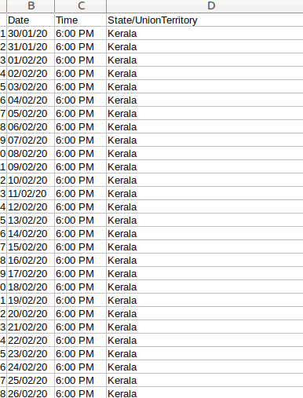
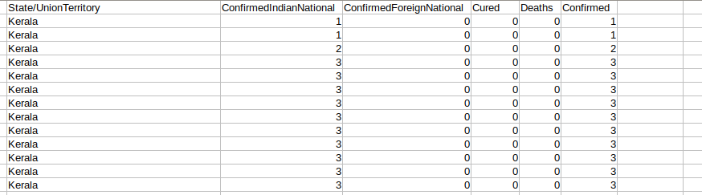

Data Visualization :

Bar Plot

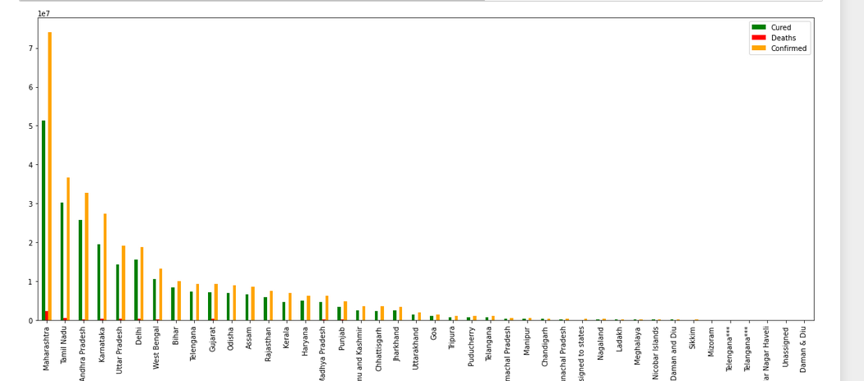
The Given Bar Plot is the state wise description of Cured, Dead and Confirmed Patients as you see in the graph Maharashtra State have more number of patients followed by Tamil Nadu State.
By viewing the graph we can also conclude that the number of deaths are much more less than number of confirmed patients on the other hand the number of Cured patients are good in numbers.

Scatter Plot
Maharashtra Gujarat
