
AL – BASED BLOOD DONATION AND

MATCHING SYSTEM
MAJOR PROJECT REPORT submitted in partial fulfillment of the requirements for the Award of the Degree of

BACHELOR OF TECHNOLOGY
In
INFORMATION TECHNOLOGY
By
Sai Amrutha Nenavath 228W1A12H6 Rohith Nakay Banavath 228W1A12D5
Under the Guidance of
MadhaviLatha Pandala

Assistant Professor


DEPARTMENT OF INFORMATION TECHNOLOGY V R SIDDHARTHA ENGINEERING COLLEGE
(AUTONOMOUS - AFFILIATED TO JNTU-K, KAKINADA)
Approved by AICTE &Accredited by NBA KANURU, VIJAYAWADA-520007 ACADEMIC YEAR
(2025-26)


V.R.SIDDHARTHA ENGINEERING COLLEGE

(Affiliated to JNTUK: Kakinada, Approved by AICTE, Autonomous) (An ISO certified and NBA accredited institution)
Kanuru, Vijayawada – 520007


CERTIFICATE

This is to certify that this project report titled “AI-BASED BLOOD DONATION AND MATCHING SYSTEM” is a bonafide record of work done by NENAVATH SAI AMRUTHA(228W1A2H6),BANAVATH ROHITH NAYAK(228W1A12D5) under my guidance and supervision is submitted in partial fulfillment of the requirements for the award of the degree of Bachelor of Technology in Information Technology, V.R. Siddhartha Engineering College (Autonomous under JNTUK) during the year 2025-26.

(P.Madhavi Latha) (Dr. M. Suneetha) Assistant Professor Dean R&D, Professor&Head Dept. of Information Technology Dept. of Information Technology

EXTERNAL EXAMINER SIGNATURE
Date of examination:

DEPARTMENT OF INFORMATION TECHNOLOGY V.R.SIDDHARTHA ENGINEERING COLLEGE

PROJECT SUMMARY
S.No | Item | Description
1 | Project Title | AI-BASED BLOOD DONATION AND MATCHING SYSTEM.
2 | Student Names & Numbers | Nenavath Sai Amrutha 228W1A12H6  Banavath Rohith Nayak 228W1A12D5
3 | Name of The Guide | P.Mahavi Latha (Assistant Professor)
4 | Research Group | Department of Information Technology,Velagapudi Ramakrishna Siddhartha Engineering College.
5 | Application Area | Health care
6 | Aim of the Project | To develop an AI-based system that efficiently manages blood donation and quickly matches donors with patients in real time.
7 | Project Outcomes | - Efficient and automated blood donor and inventory management system.  - Faster and accurate matching of donors with patient requests.  - Improved emergency response with real-time alerts and reduced delays.
Student Signatures

Signature of the Guide

ACKNOWLEDGEMENT
First and foremost, I sincerely salute our esteemed institution V.R SIDDHARTHA ENGINEERING COLLEGE for giving me this opportunity for fulfilling my project. I am grateful to our principal Dr. A.V.RATNA PRASAD, for his encouragement and support all through the way of my project.
On the submission of this Project report, I would like to extend my honour to Dr. M.Suneetha, Dean R&D, Professor & Head of the Department, IT for her constant motivation and support during the course of my work.
I feel glad to express my deep sense of gratefulness to my project guide P.Madhavi Latha, Assistant Professor for her guidance and assistance in completing this project successfully.

I would also like to convey my sincere indebtedness to all faculty members, including supporting staff of the Department, friends and family members who bestowed their great effort and guidance at appropriate times without which it would have been very difficulty on my part to finish the project work.

TABLE OF CONTENTS
ACKNOWLEDGEMENT | iv
LIST OF FIGURES | vi
LIST OF TABLES | vii
ABSTRACT | 1
CHAPTER-1 Introduction | 2
1.1 Origin of the Problem | 2
1.2 Basic definitions and Background | 2
1.3 Problem Statement | 4
1.4 Applications | 5
CHAPTER-2 Review of Literature | 6
2.1 Description of Existing Systems | 6
2.2 Summary of Literature Study | 8
2.3 Software Requirement Specification | 9
CHAPTER-3 Proposed Method | 14
3.1 Design Methodology (UML representation) | 14
3.2 System Architecture Diagram (Description of all the modules) | 15
3.3 Description of Algorithms | 17
3.4 Description of datasets and Tools | 20
HAPTER-3 Results and Observations | 24
4.1 Stepwise description of Results | 24
4.2 Result analysis and Test case results | 31
4.3 Observations from the work | 32
CHAPTER-5 Conclusion and Future study | 35
5.1 Conclusion | 35
5.2 Future study | 36
References | 41

LIST OF FIGURES

Figure | Page
Figure3.1: System Architecture | 2 20
Figure 4.1: Home Dashboard | 24
Figure 4.2: Blood Availability | 25
Figure 4.3: Blood Centre | 25
Figure 4.4: Blood Donation Camp | 26
Figure 4.5: Ai Based Blood Matching System | 27
Figure 4.6: Ai Emergency Donor Matching | 28
Figure 4.7:Donor regristration | 28
Figure 4.8: Register as Volunteer | 29
Figure 4.9: Maps | 29
F Figure 4.10: Admin Dashboard | 30

LIST OF TABLES

Table Name Page
Table 2.1: Literature Review 6

ABSTRACT
Introduction to the AI-Based Blood Donation & Matching System The AI-Based Blood Donation & Matching System is designed to improve the effectiveness and reliability of the process of blood donation and distribution. The system will help to optimize blood registration, blood bank management, and processing of blood donation requests in order to minimize possible delays and reduce errors that are typical of conventional blood donation management systems. It will be able to make intelligent decisions about matching donors with patients considering such factors as blood group compatibility, location, availability, and level of emergency. Besides, the system provides automatic alerts when blood supplies are running low or there are urgent blood donation requests. It also helps to maintain efficient communication between hospitals, blood banks, and individual donors using instant notifications and up-to-date information on blood stocks and needs. The system will also allow to avoid unnecessary wasting of blood units, ensuring their proper use and storage up until expiration date.
Keywords: Blood Donation System, Artificial Intelligence for Matching, Donor Management, Blood Stock Management, Emergency Response System.

CHAPTER-1

INTRODUCTION

1.1 Origin of the Problem

There is a need for efficient blood management in the contemporary world, especially with the ever-growing number of medical emergencies such as surgery, injuries, and other diseases. The current blood donation system mainly involves the manual approach and unconnected records which delay the process of locating potential donors and monitoring the availability of blood. Patients and hospitals are faced with the problem of accessing the needed blood groups, thus leading to dangerous health hazards and even death.

The other critical problem in the process involves the inability to communicate in real-time among blood banks, donors, and medical facilities. The information available concerning the availability of donors and their blood, as well as the stock in the bank, is either stale or inaccessible. Consequently, there is wastage of blood due to expiry since this information is difficult to access.

For such problems to be solved, there is a pressing need for an intelligent and automated system. With an AI-based blood donation and matching system, such problems can be sorted out and managed efficiently.

1.2 Basic Definitions and Background
1.2.1 Donation System
Blood Donation System is a software program aimed at organizing the whole process of donating, storage, and delivery of blood samples from the donor to the patients. Such software assists hospitals, clinics, and blood banks in keeping track of the donor records, blood groups, and blood units. The main objective of this software is to ensure that adequate blood supply is available whenever there is a need for blood transfusion in emergencies like surgery cases, car accidents, and other diseases.

1.2.2 Blood Groups and Compatibility
Compatibility between the donor and the patient is a fundamental prerequisite to the success of blood transfusion processes. There are four major categories of blood groups: Type A, Type B, Type AB, and Type O, together with positive (+) and negative (-) Rh factor.Type O -negative

blood is referred to as the universal donor,

1.2.3 Artificial Intelligence (AI) for Blood Matching

Artificial Intelligence refers to the simulation of human intelligence by using machines capable of making decisions and solving problems. In this study, AI will be employed in blood matching, which entails the automatic allocation of blood from the donor to the patient based on certain conditions.
1.2.4 Donor Management System
Donor Management System manages all information related to the donors. These include donor personal information, their blood group, contact details, location, availability, and record of donations made.It performs eligibility verification depending on factors like the last date when blood was donated by the particular person. It helps in making sure that only eligible donors donate blood.

1.2.5 Blood Inventory Management

Blood Inventory Management is a system that keeps record of blood unit availability in the blood bank. This includes the blood group, number of units available, storage and expiry information.

1.2.6 Request Processing and Matching

Request processing entails the processing of blood requests made by hospitals or patients. It is done depending on the required blood type, units, location, and urgency level. Matching Algorithm helps in identifying the most appropriate donor or blood units in the shortest time possible. It makes response time minimal hence improving efficiency.

1.2.7 Real-Time Notification System

Notification system is a critical aspect that plays an essential role in communication among donors, hospitals, and blood banks. It ensures immediate notifications via SMS or emails when there is an urgent demand for blood units. Real-time notifications are very important in contacting the right donor in good time.

1.2.8 Data Management and Security

The system handles large amounts of data regarding the information about donors, hospitals, blood units, and medical information. Efficient data management techniques are employed in storing, retrieving, updating, and analyzing data Various security methods are incorporated to keep the user data secure and private.

1.2.9 Challenges in Existing Systems

Most blood donation systems are manual and lack coordination. The following are some of the existing challenges:

Lack of real-time updates

Challenges in matching the right donor

Poor blood inventory management

Delayed emergencies

1.2.10 Requirement of Intelligent Blood Donation System

In order to address the drawbacks of the conventional methods, it is suggested that an AI-Based Blood Donation and Compatibility Matching System be developed. It will incorporate real-time information, artificial intelligence, and notifications.

It will enhance:

Donor matching speed

Blood compatibility accuracy

Stakeholder coordination

Efficiency of health care service delivery

1.3 Problem Statement With Objectives and Outcomes

1.3.1 Problem Statement

The availability of safe and adequate blood supplies is crucial for any healthcare system in emergencies. Donations can be vital during accidents, surgeries, or critical health conditions. In spite of all the benefits of blood donation, the current process has numerous problems that make its implementation inefficient.

Firstly, most blood donation management mechanisms in place have a predominantly manual character. Information concerning donors and availability of blood in different hospitals and storage centers is usually saved in various databases and cannot be updated and accessed quickly when needed. It makes it hard to locate suitable donors in critical circumstances and obtain blood from storage.

Secondly, there is no intelligent matching of donors and recipients taking into account various important factors, such as compatibility of their blood types, geographic distance, donors' availability, and others. As a consequence, precious time can be wasted in emergency cases.
Thirdly, awareness of possible donors is low, which causes the necessity of communication difficulties. Not only are they not aware that they are required to donate blood immediately in emergency situations, but also they do not know whether there is enough of it at the moment.

Finally, as there is no intelligent matching mechanism in place, all these problems make the process of donation and distribution quite dependent on manual activities. That means that errors can occur, and it may take time for people to complete tasks associated with the management of the donation process. It becomes evident that a more sophisticated and intelligent mechanism needs to be introduced.

In this way, the development of an AI-Based Blood Donation and Matching System is necessary. It would become a platform where blood donation and distribution could be managedeffectivel

1.3.2 Objectives

- For designing an easy-to-use platform for the donors, hospitals, and administrators.
- For carrying out location-based searches by donors to get quick responses.
- For making real-time database updations for getting up-to-date blood stock details.
- For maintaining security in data transactions.
- For notifying donors and admins automatically.
- For scalability in order to accommodate many users at a time.

1.3.4 Outcomes
- Donor participation is made easy with enhanced engagement.
- Greater coordination between blood banks and hospitals.
- Less time needed for finding compatible donors.
- Better decision making through use of intelligent algorithms.
- Tracing of blood bags and expiration dates accurately.
- Higher level of security and performance.

1.4 Applications

The AI-based Blood Donation and Matching System finds many applications in the healthcare industry. The system makes a huge contribution towards making blood donation and matching efficient and convenient for everyone.

1.3.1 Medical Emergencies

The system is highly useful in medical emergencies such as injuries from an accident, surgeries, or any kind of illnesses where people require blood for survival. The AI system facilitates quick identification of available blood units along with the donor details.

1.3.2 Hospital and Blood Bank Management

Blood banks and hospitals can use the system for efficiently managing their inventory. Using the system, one can monitor the status of the available inventory, expiry dates of the stock, and other aspects.

1.3.3 Donor to Patient Matching

The system helps match the donors with patients using advanced algorithms based on various factors such as availability, blood group compatibility, geographical locations, urgency, etc.

1.3.4 Remote Healthcare

In regions where there is a lack of blood banks and healthcare centers, the system can help connect donors and patients who might be living far away from each other.

1.3.5 Blood Donation Drives

This system is also helpful in managing various campaigns and drives associated with collecting blood from willing donors.The development of an automated Diabetic Retinopathy (DR) severity classification system using deep learning has numerous practical applications across healthcare settings.

1.3.6 Real-Time Alerting and Notification System

The application sends real-time notifications to the donors and healthcare service providers in case of an emergency or in cases where there is insufficient blood in the storage.

1.3.7 Analyzing Information and Making Decisions Based on It

The application is capable of analyzing information pertaining to the usage of the blood and its supply, as well as information about the number of available donors.

1.3.8 Compatibility with Other Healthcare Systems

The application can be incorporated into other healthcare-related systems that already exist within hospitals and the government healthcare database.

CHAPTER 2

REVIEW OF LITERATURE

This chapter presents a review of existing research works related to blood donation and management systems, highlighting their methodologies, advantages, and limitations.
  - Description of Existing Systems:

[1] AI-Driven Blood Bank Management System

Year of Publishing: 2025

Observation:
This system utilizes Artificial Intelligence to predict blood demand and optimize donor matching. It enhances prediction accuracy, reduces wastage of blood units, and improves overall efficiency in managing blood inventory. The system can analyze historical data and seasonal trends to forecast future requirements. However, it depends heavily on high-quality and large datasets for accurate predictions. In addition, implementation cost and technical complexity are high, and it requires continuous model training and maintenance. Lack of transparency in AI decision-making may also reduce trust among users.

[2] Integrated Blood Bank Management System

Manika, G., Vamshi, K. S., & Prashanthi, M. (2024)

Publishing of the year:2024
Observations:
The proposed system combines donor management, blood stock tracking, and hospital needs within one unified system. This integration makes processes more coordinated. It increases accuracy, but at the same time, it lacks advanced tools like artificial intelligence to match donors and forecast demand. There may be some scalability problems due to the size of the database used in the system. Moreover, there are no emergency alerts available.

[3]Online Blood Bank Management System

Patil, Sakshi, Taral, Swaroop, Satpute, Vedant & Kadam, Viresh
Publishing of the year:2024
Observations:
The authors propose an online system where people can use a search tool to find the needed donors and request blood without problems. This system makes blood search easier and faster by allowing the user to perform these operations online. At the same time, it lacks such features as emergency notifications or any sort of intelligent analysis tools, such as donor matching. There are also no real-time notifications.

[4] E-Blood Bank Surveillance System
Agarwal, Reema, Singh, Sonali, & Atal, Chanchal
Publishing of the Year:2020
Observations:
This system is designed for secure storage of data and online monitoring of stock of blood. It helps maintain records efficiently and makes the process transparent. However, there is no automation provided for activities like donor matching and replenishing stock of blood. There is no use of AI in analyzing the system and forecasting any future trends or predictions. In addition to that, it does not provide any real-time alert or notification facility.

[5] Smart Monitoring and Control Using Internet of Things (IoT)

Joly, M., Kavitha, S., & Pradeep, A.
Publishing of the Year:2023
Observations:
This system utilizes IoT devices to keep check on storage conditions of the blood and the stock available in real time. This makes sure that the quality of stored blood remains intact and safe. However, there is no AI-based decision-making capability present in the system. In addition to that, there might be some security and privacy issues associated with IoT devices.

[6]lood Banking System: Centralized

Manika, G.; Vamshi, K. S.; Prashanthi, M.
Publishing of the year : 2023
Observation:
This centralized approach makes it possible to have an integrated way of handling information on donors, stock of blood, and the demands from hospitals. This will help minimize cases of duplicate records as well as efficient information sharing between various centers. The system, however, lacks the use of AI-based algorithms for matching donors and making predictions on demand for specific types of blood. The system lacks emergency features to notify the center when there is an urgent need for blood.

Table 2.1: Literature Review

Name | Year | Work done | Technologies used | Conclusion
AI-Driven Blood Bank Management System | 2025 | Used AI to predict blood demand and optimize donor matching. | MachineLearning, Python | AI improves prediction accuracy and helps maintain optimal blood stock
Comprehensive Blood BankManagement System | 2024 | Automated donor management, blood stock tracking, and hospital requests | Web-based system, MySQL Database | Automation helps in real-time availability and better donor coordination
Web-Based Blood Bank Management System | 2024 | Developed an online platform for donor search and blood requests | Python Django, SQLite/MySQL | Web systems provide fastercommunication between donors and hospitals.
E-Blood Bank Monitoring System. | 2024 | Introduced,digital monitoring of blood stock with alerts. | IoT, Cloud Computing | Real-time monitoring reduces blood wastage and shortages
SmartMonitoring, Management, and Control ofBloodBank Management System Using IoT | 2023 | Proposed an IoT-based system to monitor blood bank operations, track blood availability, and automate stock management | IoT, cloud services, database management | The system ensures real-time monitoring, reduces manual errors, and improves efficiency in blood bank operations.
Centralized Blood Bank Management System | 2024 | Created a centralized database for multiple hospitals. | PHP, MySQL, Web Service | Centralized systems improve coordination and availability across regions

2.2 Summary of Literature Study

According to the conducted literature study regarding the topic of blood donation and blood bank management systems, one can state that extensive research has been done on how to increase the efficiency, effectiveness, and accessibility of the discussed processes. A wide range of approaches have been suggested by researchers throughout the years, including manual approaches, web systems, cloud-based solutions, and intelligent systems.

As far as traditional systems for managing blood banks are concerned, one needs to note that they were usually manual and paper-based. Namely, these systems were based on the efforts of people in order to keep the records of donors and blood, manage blood inventories, and respond to the patients' requests. It was pointed out by some authors that such systems were inefficient due to the fact that they were not capable of ensuring proper coordination between hospitals and blood banks. For instance, Singh et al. (2022) noted that the traditional approach made hospitals and blood banks unable to communicate properly in case of emergencies.

Due to the emergence of information technologies, the next generation of blood bank management systems appeared, namely web-based ones. Web-based approaches made it possible to store information concerning blood inventories and donors digitally. As stated by Patil et al. (2023) and Manika et al. (2023), these solutions make the process more accessible, allowing users to find potential donors and check whether a particular type of blood is available online. Nevertheless, these systems have some shortcomings since they fail to offer real-time updates and intelligent ways of matching the donors with recipients.

Further developments in this field have been associated with cloud computing techniques that allowed for improving accessibility and scalability of blood bank management systems. Namely, it became possible to share data among hospitals and blood banks. At the same time, it is worth admitting that these technologies were not designed in a way to ensure intelligent matching of donors and recipients. The only benefit that they could bring was related to improved communication and collaboration between different organizations.

Another development associated with the management of blood banks was the introduction of IoT-based systems. According to Joly et al. (2023), these systems allowed for monitoring the availability of blood in real-time, thus preventing blood wastage. Nevertheless, IoT-based systems lack other functions and cannot be used to automate the process of donor identification and selection. Moreover, they cannot ensure

  - Software Requirements Specification

For the development and deployment of the AI-Based Blood Donation and Matching System, certain software requirements need to be considered. Such software components are critical in ensuring that the design and development of the system is effective.

2.3.1 System Overview

An AI-based blood donation and matching system is a computerized web/mobile based system that aims at offering a centralized and smart approach in conducting blood donation related activities. This system connects donors, hospitals, and blood banks into a common environment where effective coordination is achieved.

The purpose of designing this system is to save time in finding appropriate blood donors whenever there are emergencies. This system will be able to achieve this through Artificial intelligence where it matches the best donor to a patient based on several factors such as compatibility, proximity of donors, availability, etc.

A donor will log in his/her status including whether he/she is available for donation. A hospital or a patient will be able to make requests of blood which the system will process and identify the most suitable donor or unit of available blood.

Furthermore, this system incorporates a notification function which sends alerts to potential donors or administrators via SMS or email. There is also a database of available blood unit which is kept up to date in order to minimize wastage due to expiry.

2.3.2 Functional Requirements

Functional requirements specify what the system needs to perform. Some of these functionalities are:

User Registration and Login
- Registration for donors/administrators
- Secure login with authentication credentials
- Ability to maintain users profiles and update
Donor Management
- Record donors information (Name, blood group, Contact, Location)
- Tracking of donors' availability and donations made before
- Validation whether the donor is eligible depending on date of last donation
Blood Inventory Management
- Maintenance of stock of available blood units
- Recording blood group, amount available and expiry date
- Automatic updating of stock after donation or usage of blood
Request Management
- Request for blood by a hospital or a patient
- Collection of request detail i.e., amount required, blood group, urgency etc.
- Prioritization of urgent requests
AI Based Blood Donor Matching
- Selection of appropriate donors according to:
- Compatibility of blood group
- Proximity of donor to the point of blood requirement
- Donor's availability
- Level of emergency
Searching and filtering options for donors/bloods
- Sending Alerts to donors/administrators in emergency
- Real-time alert to users
Notifications
- Notify donors during emergencies
- Alert administrators when stocks are low
- Update users in real time low

2.3.3 Non-Functional Requirements
Non-functional requirements deal with the quality and performance of the system:
Performance
- Quick response in searching and matching process
- Capability to manage multiple user requests simultaneously
Scalability
- The capability to increase its scalability and usability with an increasing number of users and data
- It should be scalable easily to make future updates
Reliability
- To ensure that the system runs without any failures
- Consistent and precise outcomes
Security
- Security of user information through authentication and encryption
- Protection from any external threat or attack
Usability
- It should have a user-friendly design
- Facility of easy navigation by users
Availability
- Availability of the system throughout the day
- Very few downtimes for performing maintenance operations
Maintainability
- Modification and updating of features should be done easily in the future
- Proper documentation is necessary to improve it further

2.3.4 Hardware Requirements
Following are the hardware requirements to run the system:
Processor: Intel Core i3 and above
RAM: At least 4 GB (8 GB for better performance)
Hard disk: At least 500 GB
Internet Connection: Stable internet connection
Device Types
Desktop/Laptop
Smartphone (Android or iOS devices)
Server side:
Cloud server or dedicated server
Backup Storage System

2.3.5 Software Requirements
Following is the list of software required to develop and deploy the system:
Operating System
- Windows 10/Linux/macOS
- Programming Languages
- JavaScript/Python
Front-end Technologies
- React.js/Flutter/HTML/CSS
Back-end Technologies
- Node.js/Firebase
Database Management System
- MySQL/Firebase Firestore
Development Tools
- Visual Studio Code
- Google Colab (AI module)
- GitHub
APIs and Libraries
- Google Maps API (location)
- Firebase Cloud Messaging

2.3.6 System Constraints
System constraints refer to the restrictions placed on the development process of the system.
- The system requires consistent and reliable internet connectivity for real-time updates.
- The accuracy of user-entered data is critical (donor details, availability, and so forth).
- The system relies on the availability of donors in specific geographic locations.
- Server performance and loading times may influence system response times.
- The system must adhere to data protection and security laws.
- Inaccessibility in rural or remote areas lacking internet connectivity.
- The system relies on third-party providers such as Google Maps, Firebase.
- System performance degrades with large amounts of data without optimization.
- Regular updates from hospitals and blood banks to the system database.
- Possible security threats such as data breaches or unauthorized access.
- The system may have compatibility problems with older devices and browsers.
- Availability of the system depends on the performance of the server.
- Timely delivery of real-time notifications may rely on network performance.
- Limited control over donor behavior (donors responding to the alert).
- High dependence on proper system maintenance and updates.

2.3.7 Assumptions
The assumptions are conditions believed to hold throughout the design process.
- Users enter complete, accurate, and updated information.
- Donors react favorably to emergencies requiring blood supply.
- Hospitals and blood banks provide timely updates on blood supplies.
- Users possess basic skills in using mobile or web applications.
- Internet connection is accessible to users at most times.
- The system serves legitimate healthcare purposes.
- Donors fulfill the necessary criteria to give blood.
- Hospitals and blood banks work in conjunction with the system.
- Users keep confidential information about their login credentials.
- Database maintenance and updating occurs consistently.
- Correct functioning of notification services (SMS/emails).
- Users follow the system guidelines and instructions.
- Ethical use of the system by all parties concerned.
- Compliance with government regulations regarding health care and privacy.
- Provision of sufficient infrastructure for system operations.

CHAPTER-3

PROPOSED METHODO
  - DESIGN METHODOLOGY

Design Methodology of AI-Based Blood Donation and Matching System

This design methodology focuses on the development of a scalable and efficient software application platform, which will enable blood donations, blood bank, hospital, and donor management in real-time solutions. In particular, this paper will provide an overview of the methodology, including its main steps and the way in which each step is conducted. The methodology presented here is focused on designing an effective blood donation management system using web-based interfaces, cloud databases, and Artificial Intelligence.

The methodology used for the development of this system can be characterized by its systematic and structured nature. In other words, the design process consists of several stages, each one corresponding to a particular system component. As a result, each component will have unique characteristics and features.

In order to develop the required solution, it is planned to use a modern design approach that includes a client-server system architecture, cloud databases, and Artificial Intelligence algorithms. It was decided to design the system based on a client-server architecture, in which clients connect to the server via web interface to send requests or to receive responses. In turn, the server is responsible for processing user queries and performing necessary computations.

Data storage and management plays an important role in this system. In order to store huge amounts of data, which can come from many sources at once, cloud databases are used. The system is capable of storing data about all donors' blood samples, blood inventories of various hospitals, and information about the number of requests that are currently active. Due to this, the server is able to quickly retrieve and modify stored information.

One more key point to consider when designing this system is artificial intelligence, which allows implementing intelligent decisions. The artificial intelligence module analyzes multiple factors (such as blood group compatibility, geographic location, availability of the donor and urgency of the request), and as a result, selects the best donor among those who responded.

Real-time data analysis is another critical feature. Every time there is a new request for blood, the server processes the request, searches the database for donors with a suitable blood group, compares the geographical location and sends notifications to suitable donors.

Other important issues considered in the design methodology are data protection and integrity of information, as well as reliability of work. To protect data, users must go through an authentication procedure
3.2System Architecture Design
An AI-Based Blood Donation and Matching System adopts a client-server architectural approach wherein all processes including interaction with the system, processing, management, and decision-making take place on the server-side while the clients use either web-based or mobile-based platforms to interact with the system.This type of architectural approach enables the system to operate on a large scale and be easily manageable as well as process multiple client requests at once. In this scenario, the front end functions as the user interface whereas the backend handles the application logic as well as interacts with databases to communicate with different modules of the system.Moreover, due to real-time nature of operations, the users get access to the information immediately upon requesting it. Artificial intelligence further adds value to the system by facilitating intelligent donor matching and quicker decision-making capabilities.
The system's architecture is quite modular which means that each module performs its function as well as communicates with other modules.
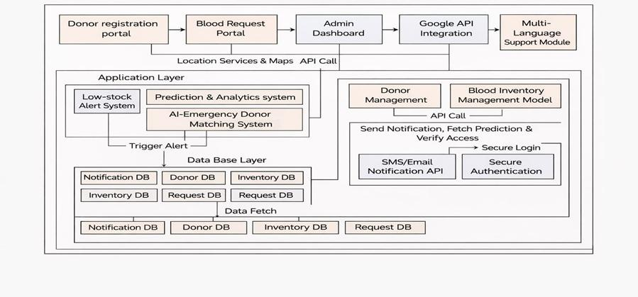

Figure 3.2 Architecture Diagram

Architecture Components

1. Frontend / User Interface

This is the interface that users interact with and hence should be both responsive and friendly across different devices such as computers and mobile phones.

Functions of the frontend include:

User signup and sign-in process

Updating profiles of donors

Looking for availability of blood

Placing blood requests

Notifications and updates

The frontend is built using modern technologies such as HTML, CSS, JS, React, and/or Flutter for improved usability and performance.

2.Application Server / Backend

It contains the application logic and is responsible for managing users' interactions with other components such as the database.

Functions of the backend include:

Processing user inputs and requests

Performing authentication and authorization

Carrying out donor matching logic

Interacting with the database

Maintaining data integrity and consistency

The backend is implemented using technologies such as Node.js, Express.js, and Firebase and is capable of dealing with multiple concurrent requests.

3. Database

It is the most important component of an architecture since it holds all the data.

Data Stored Includes:

Donor info (name, blood group, contact, and location)

Details of blood inventory (blood type, number available, expiration dates)

Records of blood requests

User login credentials

Databases guarantee quick data access and updates in real time. Relational databases like MySQL or non-relational databases such as Firebase Firestore may be used.

4. AI Module
AI module is an essential constituent of the system that facilitates the process of intelligent donor matching. The module helps improve the efficiency of the system through automation and accurate decision making.
Functions:
Analyzing data from donors and patients
Donor selection based on:
Compatibility of blood group
Proximity
Availability
Level of urgency
Optimum matching donors
The AI module may apply either rule-based systems or machine learning techniques to achieve maximum effectiveness in donor matching and shorten the reaction time during emergencies.

5. Notification System
The notification system will facilitate proper communication between the system and users. The system is crucial during emergencies.
Functions:
Sending notifications to donors whenever blood is needed
Notifying the user regarding request status
Informing the administrator when there is insufficient blood
Sending real-time notifications
SMS, emails, or notifications through platforms such as Firebase Cloud Messaging may be used for sending notifications.

3.3 Description of Algorithms
An AI-Based Blood Donation and Matching System utilizes algorithms with logic and intelligence to find a suitable match for donors to patients. The algorithms are meant to reduce response time, increase accuracy, and ensure compatibility between donor and recipient.
3.3.1 Donor Matching Algorithm
Donor Matching Algorithm is the main algorithm used in the system. The algorithm determines the most appropriate donors through several factors.
Steps Involving:
Receiving the request for blood (blood group, location, urgency)
Getting donor information from the database
Finding donor information compatible with the blood group requested
Getting donors according to their availability
Finding the distance between donor and patient locations
Ranking donors according to:
Proximity to the patient's location
Availability
Urgency
Sending notifications to the highest-ranking donors
Outcome:
It provides fast and accurate donor recommendations
Avoids unnecessary delays during emergency cases

3.3.2 Blood Compatibility Algorithm
The algorithm will check if the recommended blood type is compatible.
Logic:
Blood Group O – can be donated to any type
Blood Group A – can be donated to A and AB
Blood Group B – can be donated to B and AB
Blood Group AB – can be donated to AB
Steps:
Patient blood group input
Identifying the compatible donor blood group
Filtering donors
Outcome:
It avoids donating mismatched blood types

3.3.3 Request Prioritization Algorithm
It involves multiple blood requests and their prioritization.
Criteria:
Urgency level
Quantity of required blood units
Requesting time
Steps:
Accept multiple requests
Determine priority level (high, medium, low)
First, process high-priority request
Allocate resources for the request
Outcome:
Prioritizes urgent cases
Increases system efficiency
3.3.4 Notification Algorithm
It manages the communication with the donor/user of the app.
Steps:
Find the matched donors
Create notification message
Send notifications via SMS/e-mail/push notification
Keep track of response received
Update the system according to the response
Outcome:
Allows real-time communication
Increases the response rate
3.3.5 Data Update Algorithm
This algorithm makes sure that data of the database is updated timely.
Steps:
Adds new donor or request information
Updates donor availability
Updates blood inventory due to blood usage
Deletes expired blood data
Outcome:
Keeps the data updated and accurate

3.4 Description of Dataset and Required Tools
3.4.1 Description of Dataset
The dataset is very important for the AI-Based Blood Donation and Matching System. It contains all the information that will help us manage the donors, blood availability, and blood requests in a very efficient manner.
Dataset is a way to collect the structured information of various types such as donors, patients, blood bank availability and other important information regarding blood donation. Dataset can be stored in a database with real-time updating facility for precision and accuracy.
Types of Data Used:
1. Donor Dataset
This dataset holds the record of blood donors who have registered themselves for blood donation.
Attributes:
Donor ID
Name
Age
Gender
Blood Group
Contact Details
Location (City/Area)
Availability Status
Last Donation Date
This dataset is important as this is how the system identifies suitable donors based on their availability and blood groups.
2. Blood Inventory Dataset
This dataset contains the information regarding the availability of blood in blood banks.
Attributes:
Blood Group
Available Units of Blood
Date of Storage
Date of Expiry
Location of Blood Banks
This dataset is important for maintaining stock management.

3. Request Dataset
This database holds details of request for blood made by patients/hospitals.
Fields are:
Request No.
Name of Patient
Group of Blood Required
Number of Units
Location
Level of Urgency
Date of Request
This database is used to process requests.

4. User Database
This database holds the details of users who log into the system.
Fields are:
User No.
Username
Encrypted Password
User Role (Donor/Admin/Hospital)
It allows for secure user authentication and login.

    - Requirements
Hardware requirements
- CPU: Intel core i3 or above
- RAM: Minimum 4 GB (8 GB recommended)
- Storage: 500 GB Hard Drive or SSD
- Network: Stable internet connectivity
- Machine: Desktop/Laptop/Smartphone

Software requirements
- Operating system: Windows/Linux/macOS
- Programming languages: JavaScript, Python
- Front-end development: HTML, CSS, React/Flutter
- Back-end development: Node.js, Express.js
- Database management: MySQL/Firebase
- Web browser: Google chrome/Firefox/Microsoft edge

    - Tools
1. Development Tools
- Visual Studio Code – Code editor
- PyCharm – Python development
- Google Colab/Jupyter Notebook – AI model development
2. Programming Languages
- JavaScript – Frontend and backend programming languages
- Python – AI and data analysis
3. Frameworks & Libraries
- React.js/Flutter – Frontend frameworks
- Node.js/Express.js – Backend frameworks
- Tensorflow/Scikit learn – AI algorithm implementation
4. Database Tools
- MySQL – Relational Database Management System
- Firestore – NoSQL Database
5. APIs & Services
- Google Maps API – Location based search
- Firebase Cloud Messaging – Push notifications
6. Testing Tools
- Postman – API Testing tool
- Developer tools on browser – Testing on browser
7. Deployment Tools
- Firebase Hosting/Heroku/AWS – Deployment platforms
- GitHub – Version Control

CHAPTER-4
RESULTS AND OBSERVATIONS
  - Stepwise Description of Results
- HOME DASHBOARD
The above screen is the homepage of the AI-Based Blood Donation and Matching System and serves as a control panel to help users perform various functions. Navigation buttons such as blood availability, blood centers, donation camps, AI-based matching, emergency matching, and donor and volunteer registration buttons are provided on the navigation bar. The primary banner shows the objective of this system and offers action buttons such as “Donate Now” and “Find Blood.” Real-time data on the availability of blood units is also presented on the homepage, with summary boxes displaying the total units, donors, centers, and donation camps. In conclusion, the above screen provides an efficient interface that makes it easier for users to locate or donate blood through the use of real-time data.
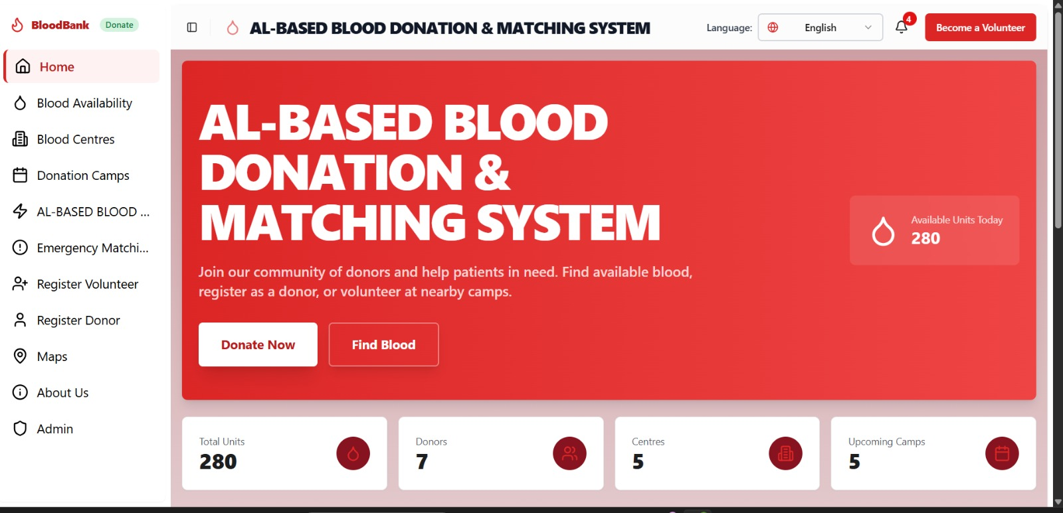
Figure 4.1 Home Dashboard
- BLOOD AVALIABILITY
The blood availability component displays an up-to-date visualization of the amount of blood available for all the common blood groups such as A positive, B positive, AB positive, O positive and negative versions of all these. Blood group is displayed through use of progress bar together with the exact number of units available. The component is updated continually based on donation and blood requests made thus making sure the information provided is accurate. It assists the health care providers to identify blood groups that require immediate attention since the ones in low stock are clearly indicated.
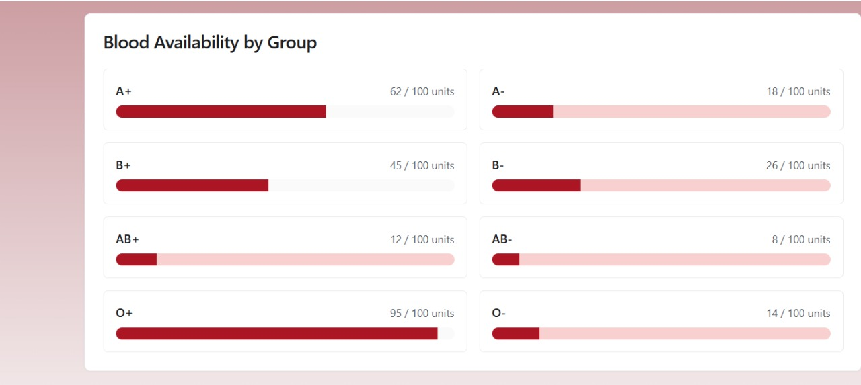
Figure 4.2: Blood Availability
3.Blood Centres Module
In the blood centres module, there is a list of all registered blood banks, along with all the relevant information, such as the names, addresses, and phone numbers of the blood banks. This feature can assist people in locating the nearest blood bank. It will be highly beneficial in emergencies because the information provided here includes geographical locations. The user will not need to travel far away to find the right blood bank; alternatively, the system will also help in managing the load across various blood banks.
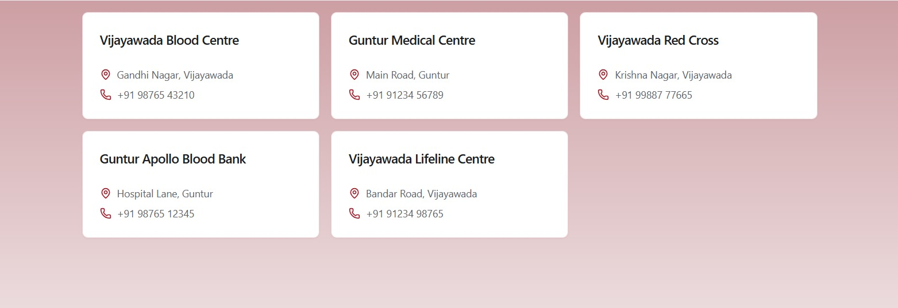
Figure 4.3 : Blood Centres
4.Blood Donation Camps
The display screen of blood donation camps lists out the coming events with relevant information, like name of the event, venue, and date scheduled for the event. This component is quite significant in engaging more donors and ensuring that there is a regular supply of blood. It will help to involve more people in donating blood by making it available to them. Further, an extension of this feature can even allow sending notifications about these events. This will ensure that the maximum number of people come forward for donating blood.
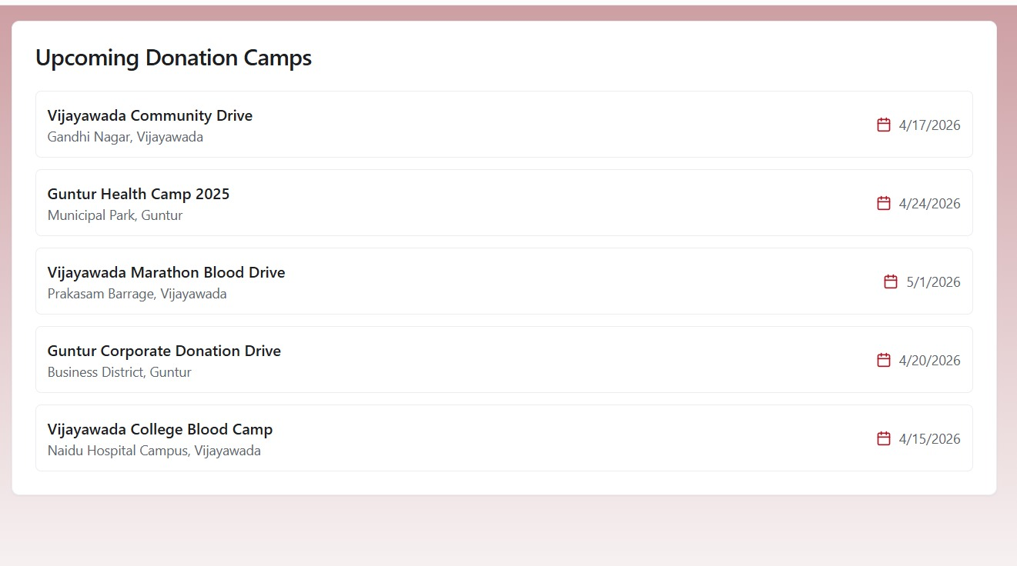
Figure 4.4 : Blood Donation Camps
5.AI -Based Blood Matching system
This page forms the main feature of the system because here, users can select their potential blood donors through the use of AI technologies. A user specifies his preferred blood type, and the system analyzes various parameters related to the donor's location, availability, and last blood donation date to produce accurate results. It also ensures fast access to information for the purpose of making informed decisions in cases when time may be a factor. Some other additional capabilities include fast response, health-related eligibility screening, and intelligent routing.
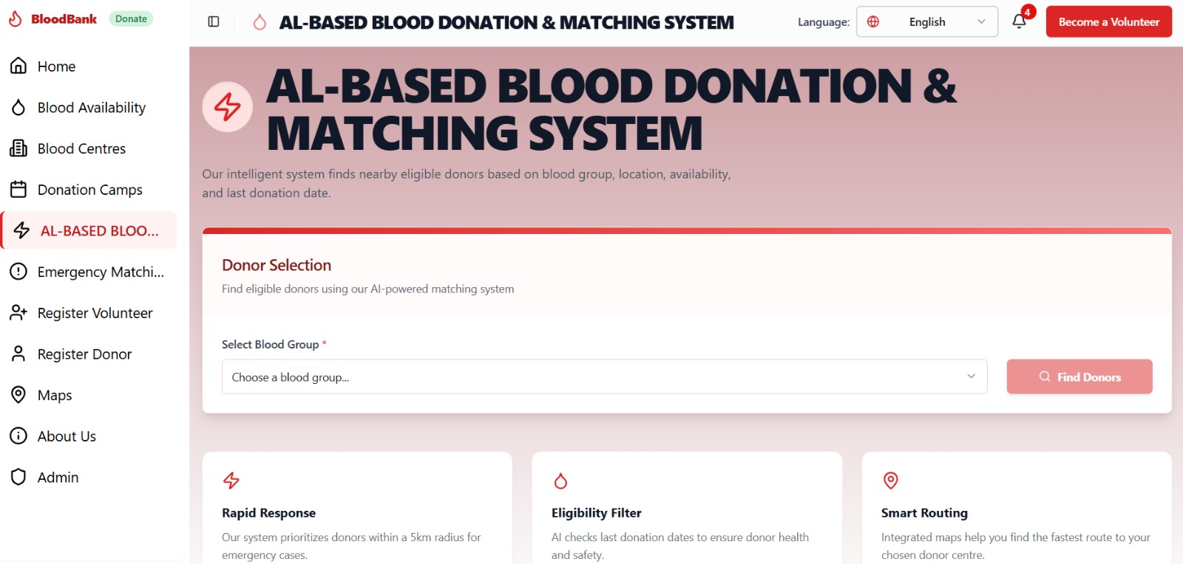
Figure 4.5: AI -Based Blood Matching system
6. AI Emergency Donor Matching
This module is particularly designed to cater to emergencies wherein blood is needed immediately. It comes with a form for inputting patient information like name, blood group, location, and urgency of need. Once the urgency level has been set, the AI algorithm will match the donors accordingly, making notifications immediately. Moreover, only qualified donors within a short radius will be notified to reduce response time. Real-time communication can be done by way of alerts, helping patients or hospitals to contact donors instantly.
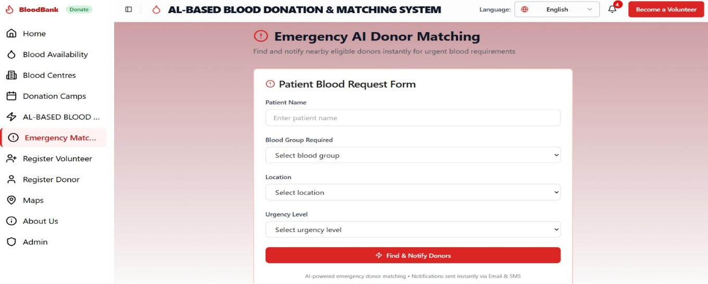
Figure 4.6: AI Emergency Donor Matching
7.Registration for Donors Page (Details)
This is where people can register themselves in the system as blood donors. In addition to their names, other information about blood groups, hemoglobin, and any pre-existing health conditions will also be collected. All this data will be used by the system to check donor qualifications and ensure that donors remain safe. There will be appropriate validations in the system to make sure there are no inaccuracies in the data provided. Registered donors will be saved in the database, and they can be contacted whenever their assistance is needed.
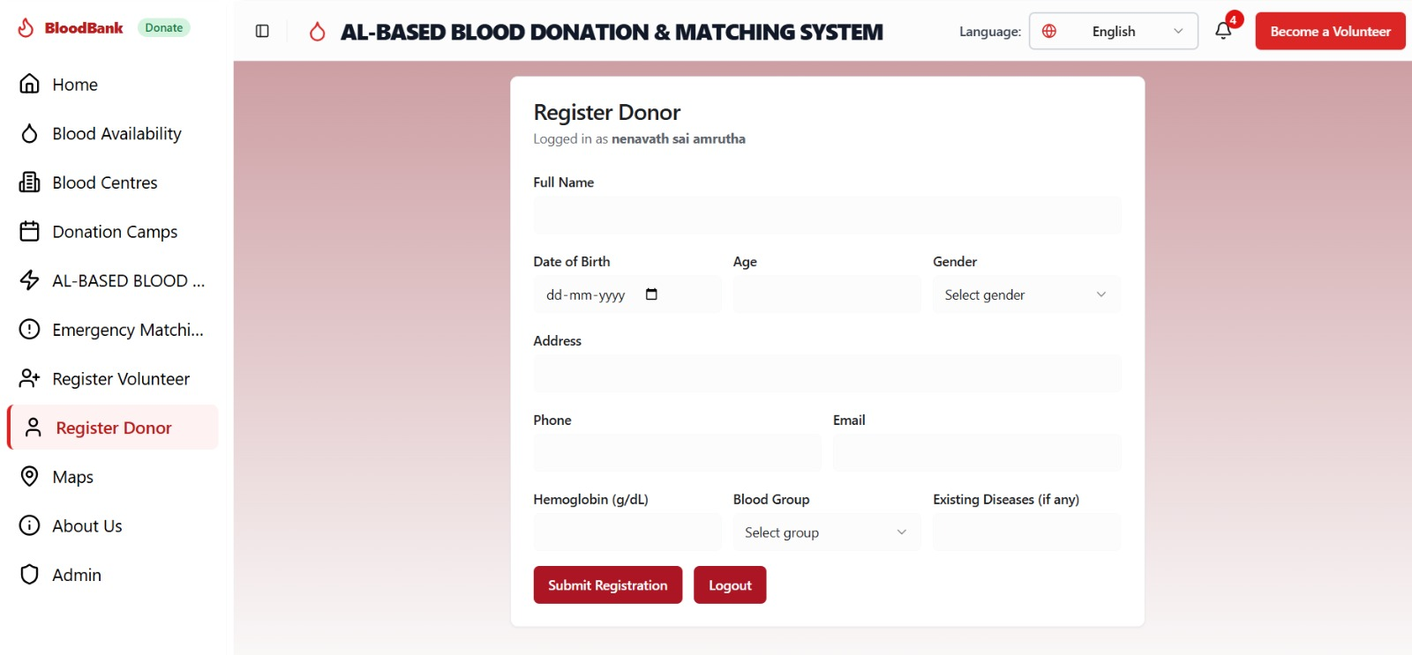
Figure 4.7: Donor Registration
8.Registration Volunteer Page
The registration page for the volunteering activity will be aimed at encouraging the community to participate in blood donation programs. People interested in volunteering will be required to provide their personal information like name, email address, phone number, and city. Such people will play a vital role in the organization of blood camps, donor records management, and awareness regarding blood donation. This will add to the strength of the system by helping to form a support system that facilitates connecting the donors with the recipients.
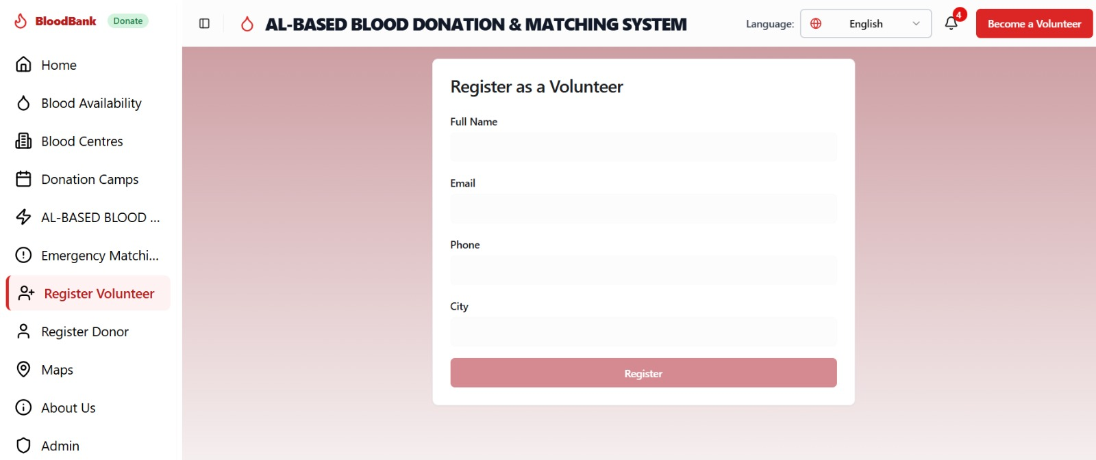
Figure 4.8: Registration Volunteer Page
9.Maps
This page is an example of the use of the location system of the software. People looking for nearby blood donors or blood banks can make use of this page by choosing from the blood groups on the map. The map will display all the relevant options within a radius that will have relevant information about distance from the current location, type of person (donor or bank), and options to call or give directions. Such features help in easily finding the desired resources.
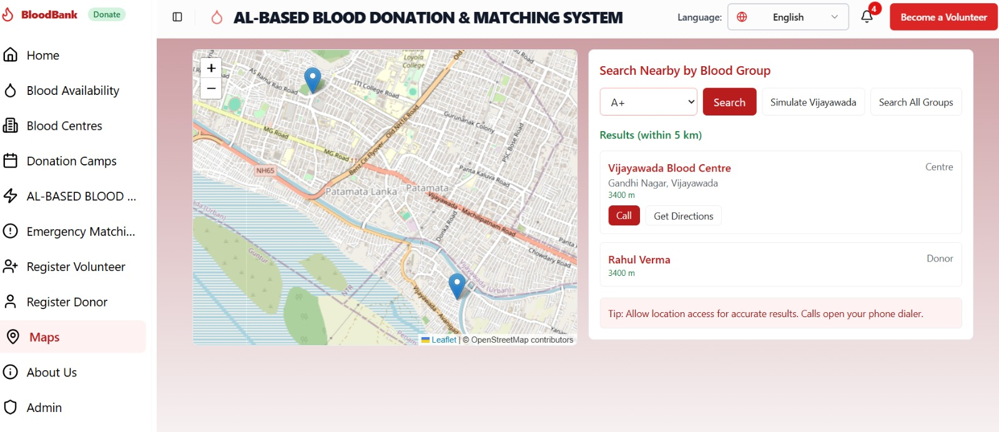
Figure 4.9:Maps

10.Admin Dashboard
The Admin Dashboard acts as the main control panel for the AI-Based Blood Donation & Matching System, which helps in managing all operations within the system effectively. Through the Admin Dashboard, one can manage the donor and volunteer records, check the availability of blood in the system, and monitor any emergency blood request in real-time. There are functionalities for adding, updating, or deleting the information. It verifies whether a particular donor qualifies based on his/her health condition and donation history. It manages all blood donation camps and makes it easy to respond promptly when there is an emergency due to the alert system available in the system.
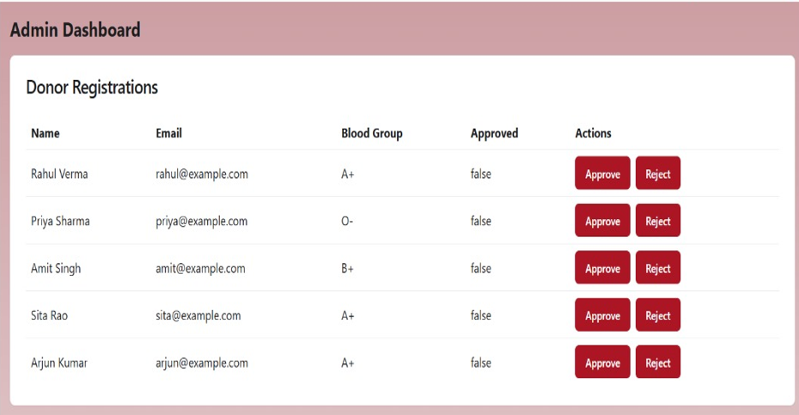
Figure 4.10:Admin Dashboard
  - RESULT ANALYSIS
In the execution of the AI-Based Blood Donation & Matching System, there were marked enhancements made to the effectiveness and efficiency in terms of the service provided. The system was tested in different circumstances, ranging from regular searching for donors through emergencies and location-based matching, among others. The results obtained showed a great improvement in the performance of the system when compared with existing manual approaches.
Firstly, the donor selection module was analyzed through the provision of different inputs in terms of blood groups and assessing the outputs in terms of matches made. It was able to filter out the eligible donors using criteria such as blood group matching, geographical locations, and last donation date. The process made sure that only eligible donors appeared in order to avoid any medical complications. The retrieval of the donor list was fast in order to be used during critical times, thus increasing the chances of saving lives.
Another important aspect of testing was evaluating how well the emergency AI donor matching performed in high priority cases. It was able to detect available donors within a certain distance and send instant notifications. It was clear from the results obtained that the notification process was quite efficient. In other words, it helped notify numerous people almost instantly by utilizing the existing communication channels such as SMS and email. This particular feature significantly cut down the time needed to identify possible donors. Unlike the conventional approach, where the identification process consumes a lot of time because it is done manually, the new system proved to be efficient.
In addition, the efficiency of the donor registration module was evaluated by examining whether the stored data was organized. The system was able to validate all entries made, such as the age and hemoglobin of potential donors. In turn, it contributed to making sure only suitable donors entered the system. Furthermore, the information could be edited and easily retrieved whenever needed.
In a similar vein, the volunteering registration module helped make the system efficient by forming a chain of people who would assist in the process of blood donation. Volunteers assist in organizing blood donation camps and helping spread the word; thus, indirectly contributing to higher numbers of donations. The system effectively handled volunteer information and made coordination between the administrators and the volunteers easier.
The geographical location through maps was reviewed based on its usefulness in making geographical visualizations possible. Using maps ensured that the users could find the closest blood bank and the closest donors in no time at all. The maps presented accurate distance measurements and location identification, making it easy for the user to locate his destination. This feature is especially useful in emergency situations.
The performance of the admin dashboard was analyzed based on data management and control features. The admin was able to monitor all the activities in the system, which included data about donors, inventory of blood, and emergencies. The dashboard updated information in real time, hence improving the decision-making capabilities of the system. Data integrity was achieved by validating and controlling accesses.
In terms of usability, the user interface was identified to be user-friendly, interactive, and easy to use by users regardless of their levels of computer knowledge. Navigation from one module to another was very easy to do without any complications for users of both technical and non-technical backgrounds.
From the performance point of view, the system was highly reliable and scalable. The system had high ability to manage multiple requests concurrently without compromising its performance. The AI-based filter reduced computational complexities and increased processing speeds. The system can further be scaled up to accommodate many users, hospitals, and blood banks.
There were certain limitations noted in the process of testing. Results depend on the availability and accuracy of donor information. When there are few donor records at a particular place, the system may not generate sufficient results. Moreover, the timely transmission of notifications is contingent on the performance of communication services, which at times might experience delays.
The findings clearly indicate the effectiveness of the AI-Based Blood Donation & Matching System for meeting healthcare demands of the present day. This technology not only makes things more convenient but is also time-saving. Moreover, it is efficient in improving the accuracy of donor matching and facilitating an emergency response.
  - Observation of the Work
1. Precision in Donor Matching
It was found that the matching of donors on the basis of factors such as blood compatibility, location, and safety criteria was very precise. The application of AI technology helped in providing results for relevant donors only.
2. Saving Time in Searching Process
The study showed that the system helped save time while searching for appropriate donors as compared to traditional methods. During emergencies, the system performed exceptionally well in terms of saving time.
3. Effective Response in Emergencies
The study proved that the emergency module of the system worked in an effective manner and searched for available donors as well as sent instant alerts.
4. Data Validation and Integrity
The system helped validate the details of donors in terms of age, hemoglobin level, and medical condition prior to their addition in the database.
5. Intuitive Interface
The interface of the application was quite intuitive and easy-to-use. Navigation through various modules was very convenient for both technical and non-technical users.
6. Real-time updates of data
The system offered real-time updates for donor availability, blood inventory, and emergency cases. This made it easy to keep track of the latest and updated information from anywhere.
7. Effectiveness of location-based maps
Integration of location-based maps was efficient since it was used to display nearby donors and blood banks. This made it easier and convenient to locate the nearest donors.
8. Easy monitoring by admins
It was easy for the admins to monitor the activities of the system through the admin dashboard interface where all controls were concentrated.
9. Higher community participation
The addition of volunteer and donor registration forms increased the number of participants in the blood donations programs and events.
10. Reliability
The system operated reliably with no issues encountered throughout the testing process.
11. Dependence on Availability of Registered Donors
One interesting fact about this system is that its effectiveness is influenced by the number of registered donors in each area. The system cannot provide any information where there is an insufficient number of donors.

12. Notification System Effectiveness
The notification system works well under normal conditions. However, its effectiveness is contingent upon other services such as email notifications or SMS. There may be minor delays once in a while.
13. Scalability Possibilities
There is a lot of scalability potential in this system since the infrastructure is ready to accommodate more users, hospitals, and blood centers. No significant architectural changes will be required to scale up the system.
14. System Security and Data Protection
Basic security measures such as user account authentication and data validation are implemented, which ensure that user data is safe and cannot be accessed by third parties.
15. General System Effectiveness
General observations show that the system increases the efficiency and speed of searching for blood donors, reducing manual work.

CHAPTER-5

Conclusion and Future Study

5.1 Conclusion

The purpose of the AI-Based Blood Donation & Matching System is to cater for all the shortcomings associated with traditional blood donation management systems. Some of the drawbacks include the manual searching of available donors, absence of real-time information as well as delay in identification of appropriate donor at an emergency situation. This system has managed to achieve this by providing an intelligent and automated approach towards management of the process of blood donations.

The system employs AI-based filtering algorithm in order to find out eligible donors using a variety of filters including blood group matching, location, medical history of the donor as well as previous donation record. This helps in making sure that the selected donor is reliable and does not pose any risks to the recipient. Management of real-time data provides updated information to the user in regards to blood stock and donor availability during emergencies.

The emergency donor matching feature is one of the main success features of this application whereby, it makes sure that the required blood is provided to the recipient at a very short notice. By sending alerts via SMS and emails, the application makes sure that donors are immediately informed about the urgency.

Donor and volunteer registration modules aid in building a strong network of participants. While donors' information is verified within the system, making it possible for an organization to have a credible database, volunteers help in facilitating blood donation exercises and raising awareness. Another added advantage is the use of maps as it makes it easier for individuals to find donors around their areas and also blood centers near them.

The admin dashboard provides full control over the system, hence making it easy to monitor activities and also record them for future purposes.

In conclusion, the application has proven that the use of artificial intelligence and other digital tools can immensely enhance processes associated with blood donations. In particular, such initiatives make tasks faster, efficient and more accurate and also allow for scalability in the future. This is because it enables organizations to provide better healthcare services through blood.

The developed system has a very positive effect on the society by motivating individuals to voluntarily donate their blood. They raise awareness and motivate individuals to actively engage in donating blood activities. Thus, the system will help save many lives due to timely availability of blood supplies for the sick.

Traditionally, there are lots of problems that arise because of human mistakes, such as wrong information being input into the system and incorrect choice of donors. The system that is being proposed reduces such chances and provides more accuracy in its operation.

All information about donors, volunteers, and requests is collected within one database. Thus, there is no duplication of information; it is easily accessible at any time required.The developed system reduces the time and money that could be spent by hospitals and blood centers due to automation of the process.

Finally, the proposed system demonstrates how important is the issue of digital transformation in the field of healthcare, as well as the need to shift from the use of traditional solutions to automated and intelligent systems. In this case, the system facilitates donor registration process as well as allows effective communication between the parties involved.

Besides, the project demonstrates the importance of social responsibility and community involvement. Indeed, the system makes it easier for people to register themselves both as donors and volunteers, and thus motivates them to take part in blood donation. Thus, the system may help create an efficient donor community.

It should also be mentioned that the system is flexible and scalable. It means that it is possible to use the system in various regions and healthcare environments, and that its modules could be improved in order to introduce any innovations in the future.

Thus, as it was mentioned above, this system may become a useful tool in terms of blood donation management. It will definitely be helpful in saving many lives of the patients in need of blood donations.

5.2 FUTURE STUDY

1. Development of Mobile Applications
In the future, the system could be developed as a mobile application which would be compatible with both the Android and iOS operating systems. The mobile application will provide an easy and fast way for the user to access the system, search for any donors, get registered, and respond to any queries or requirements.

2. Usage of Advanced Artificial Intelligence
The system currently uses basic artificial intelligence filtering methods. However, advanced artificial intelligence can be employed using advanced machine learning models which will help to find trends within the collected data and suggest the prediction for the future requirements. It will become easier to predict the amount of available stock of the blood in the storage.

3. Integration with Hospital Systems
For improved performance of the system, it could be integrated with other systems like hospital information systems or even blood bank information systems, so that all blood storage records and data is accessible instantly and there is no time delay.

4. Multi-Language Option
For greater usability, it could also be provided with the support of multiple languages so that people who are not comfortable with English could use the system comfortably.

5. Improved Notification Feature
The system can incorporate other means of communication like mobile push notifications, automatic phone calls, and messages. The use of the notification feature will guarantee instant alert for the donor and a faster reaction.

6. Cloud Computing Implementation
Implementing the system in the cloud computing platform will facilitate the scalability, data storage, and performance of the system. The cloud platform guarantees that the system handles many users and transactions without compromising its performance.

7. Improved Data Encryption
The development of better security measures can be considered in future research. This includes the incorporation of stronger data encryption techniques, authentication tools, and two-factor authentication techniques.

8. Advanced GPS Tracking
Advanced GPS tracking is another important area that can be considered in future studies to facilitate more efficient location tracking of both the donor and blood centers.

9. Campaign Management
Another module can also be developed to take care of blood donation campaigns and awareness activities. Users will be informed regarding camps being conducted and participation will be encouraged in order to enlarge the number of donors.

10. System Performance Improvement
More improvements can be made in terms of optimizing system performance. Techniques can be implemented that allow effective handling of large amount of data using efficient database management.

11. Offline Mode Capabilities
In future, offline mode capabilities can be introduced into this blood management software, which will let users perform certain functions of the system even if there is no internet connection.

12. National and International Extension
This system can be expanded to cover all regions within a country or even the entire world. With the implementation of this step, there will be thousands of people ready to donate their blood.

13. Integration with Wearable Health Monitoring Devices
The future version can be made compatible with health wearable devices, thus enabling automatic recording of the health indicators of donors like heart rate and hemoglobin content.

14. AI Chatbot-based Support System
An AI chatbot can be included to provide assistance to the users through answering their questions, helping them register on the platform, and guiding them in selecting suitable donors without having to navigate manually.

15. Blockchain for Enhanced Data Security
The blockchain protocol can be incorporated for improving the safety and confidentiality of the data stored within the database.

16. Feedback and Rating System
A feedback mechanism can be created wherein the users would be able to provide their opinions about their interactions with the donors and volunteers as well as the system performance.

17. Priority Ranking System for Emergencies
Priority rankings can be developed in an advanced manner to prioritize emergencies and handle them according to their levels of importance.

18. Connection to Government Health Services
The system can be linked to government health services and databases for better coordination and coverage of blood donations.

19. Data Dashboard
Another important tool that can be integrated into this database is a data dashboard which provides a visual representation of data through charts.

20. Automated Scheduling of Donors
Automated scheduling can be done by the system to encourage donors to donate regularly in the future.

21. Voice-Based Search Facility
For better accessibility purposes, a facility for voice-based search can be provided so that the users may easily look up for donors or even register themselves via voice commands.

22. Integration with Ambulance Services
The application can be linked up with ambulance and emergency services to provide timely help in emergencies.

23. Use of AI in Fraud Detection
With the help of advanced AI algorithms, detection of frauds can be made possible within the application system.

24. Integration with Artificial Intelligence to Predict Diseases
The system can be integrated with artificial intelligence that analyzes donor health information and predicts any potential disease or health hazard. This way, blood donations become safer.

25. Real-Time Monitoring of Blood Units with Intelligent Systems
In the future, there could be a more intelligent system that monitors the availability of blood units in blood banks, storage conditions, and other related information in real time.

26. Facial Recognition for User Authentication
Facial recognition software can be used to authenticate users rather than using passwords in order to make logging in easier and more secure.

27. Geo-Fencing for Donors’ Accessibility
Another improvement to consider is that the application could come with a geo-fencing feature whereby an alert will be sent to donors when they have entered a particular zone and there are blood donation requests nearby.

28. Integration with Social Media Websites
The integration of the application with social media websites would allow instantaneous sharing of emergencies for blood donations.

29. Integration of an AI Chatbot
This innovation will enable users to receive assistance from the application as it can help answer their questions, guide them through the registration process as donors, and in cases where an emergency request needs to be made.

30. Integration of Wearable Health Devices
This idea will allow integration of wearable health monitoring devices for purposes of keeping track of health metrics such as heart rate and hemoglobin levels.

31. Blockchain Technology
Blockchain technology can be incorporated to ensure security of information within the system since it creates tamper-proof records of all activities in the system.

32. Automated Blood Demand Forecasting
Advanced analytics can enable automated forecasting of blood demands through the analysis of hospital data and previous records of demands.

33. Integration with Governmental Health System
This innovation allows integrating the application with the national governmental health systems so that there would be created one central network across the nation.
References
[1] Patil, S., Taral, S., Satpute, V., Kadam, V., & Sharma, Y. (2023).Blood Bank Management System.Automates the process of maintaining donor details and managing blood stock.
[2] Manika, G., Vamshi, K. S., & Prashanthi, M. (2023).Web-Based Blood Bank Management System for effective donation.Efficient distribution of blood through digital means.
[3] Singh, A., Saxena, R., & Saxena, S. (2022).A Study on the Working of Blood Bank.Describes how blood banks function and the limitations of conventional systems.
[4] Agarwal, R., Singh, S., Atal, C., & Kingsley, D. (2020).Blood Bank System with Database Security.Secures the storage and accessibility of donor information.
[5] Joly, M., Kavitha, S., & Pradeep, A. (2023).Smart Monitoring and Management of Blood Bank using Internet of Things.Enables real-time monitoring of blood bank storage conditions.
[6] Sharma, P., & Verma, R. (2021).Online Blood Bank Management System.Digital platform for donor registration and tracking.
[7] Kumar, S., & Gupta, A. (2020).Design of Blood Bank Information System.Focuses on designing an efficient database for blood banks.
[8] Reddy, M., & Reddy, K. (2022).Cloud-Based Blood Donor Management System.Increases efficiency by leveraging cloud computing.
[9] Khan, F., & Ali, S. (2021).Blood Donation System using Data Mining Techniques.Uses advanced techniques for effective donor-matching.
[10] Patel, D., & Shah, H. (2020).Database Management System for Blood Banks.Facilitates the efficient storage and retrieval of blood information.
[11] Mehta, R., & Jain, V. (2022). AI-Based Healthcare Applications for Blood Donation Systems. Uses AI to enhance donor selection and prediction.
[12] Das, S., & Roy, P. (2021). Cloud-Based Blood Bank Management System. Offers real-time updates and availability of information.
[13] Singh, V., & Yadav, N. (2023). Real-Time Blood Donor Matching using Machine Learning. Enhances speed and precision of donor matching.
[14] Gupta, N., & Sharma, A. (2021). E-Blood Bank Management System. Helps in managing blood data centrally.
[15] Thomas, J., & Joseph, M. (2020). Web-Based Blood Bank Automation System. Minimizes human errors and maximizes efficiency.
[16] Roy, D., & Sen, S. (2022). AI-Based Medical Data Analysis for Blood Banks. Facilitates intelligent decision-making in healthcare.
[17] Nair, A., & Pillai, R. (2022). Smart Blood Donation System. Helps in effective communication between blood donors and patients.
[18] Verma, S., & Singh, R. (2020). Efficient Blood Bank System using DBMS. Increases efficiency by optimizing data organization and storage.
[19] Chandra, P., & Das, R. (2023). Real-Time Blood Tracking System. Enables real-time monitoring of blood availability and minimizes shortage risks.
[20] Mishra, A., & Tiwari, S. (2022). Modern Blood Donation Management System. Combines AI and cloud computing for improved performance.

APPENDIX
Some of the Code Snippets:
1.Dashboard
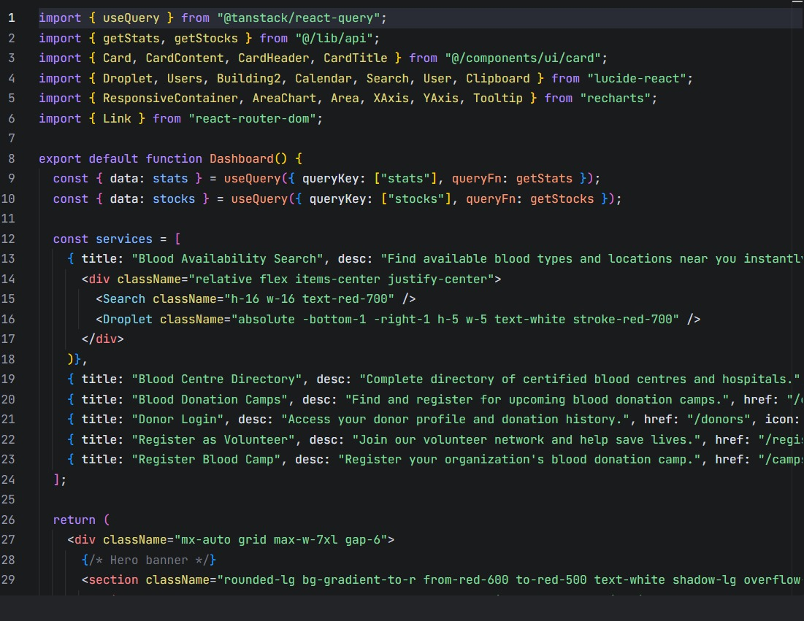
Code Snippet of Dashboard
2.Donor Registration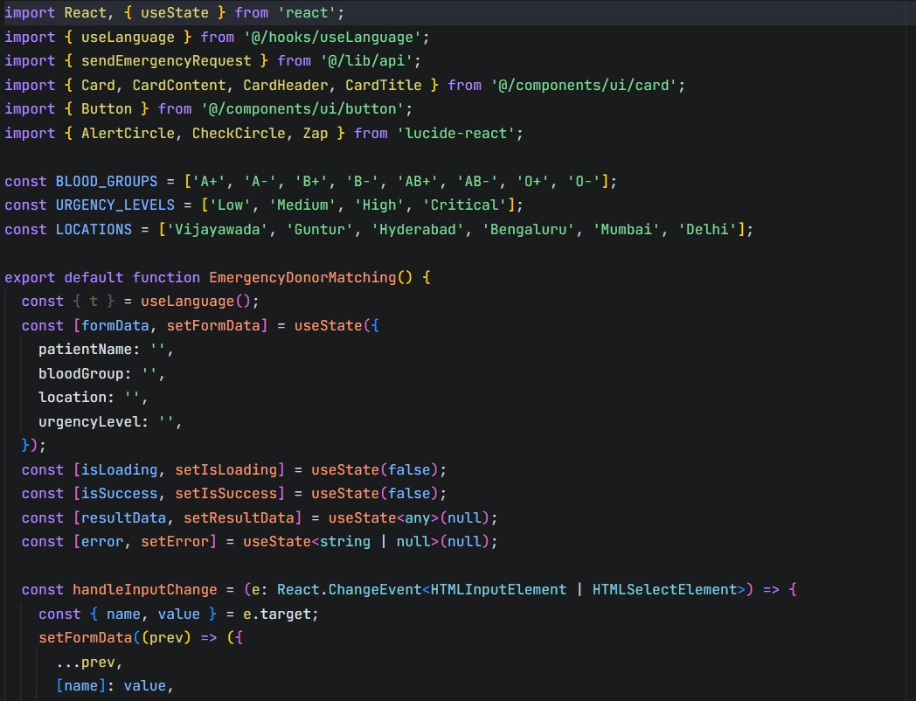
Code Snippet of Donor Registration
3.AI Emergency Matching 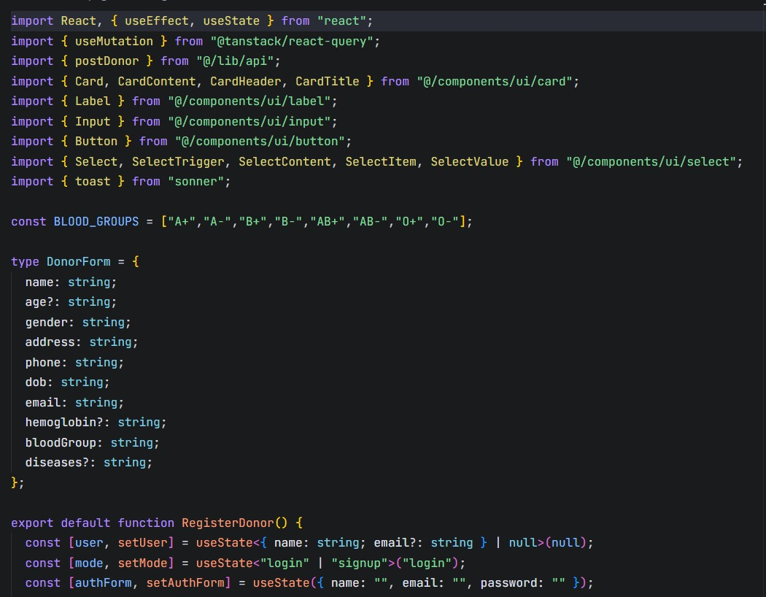 Code Snippet of Emergency Matching
4.Maps
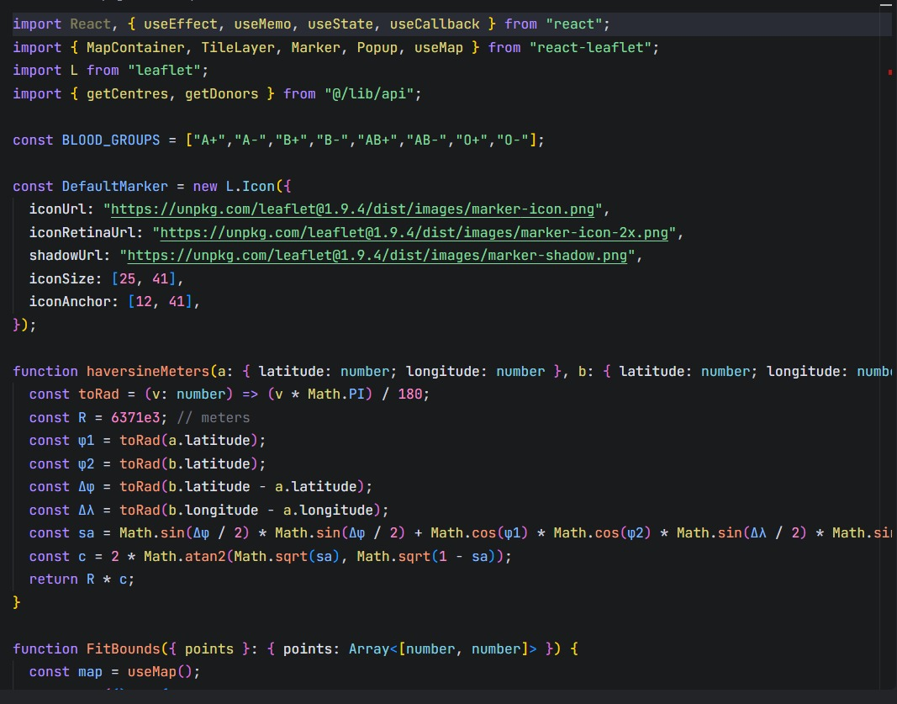
Code Snippet of Maps

5.Ai-Based Blood Matching System
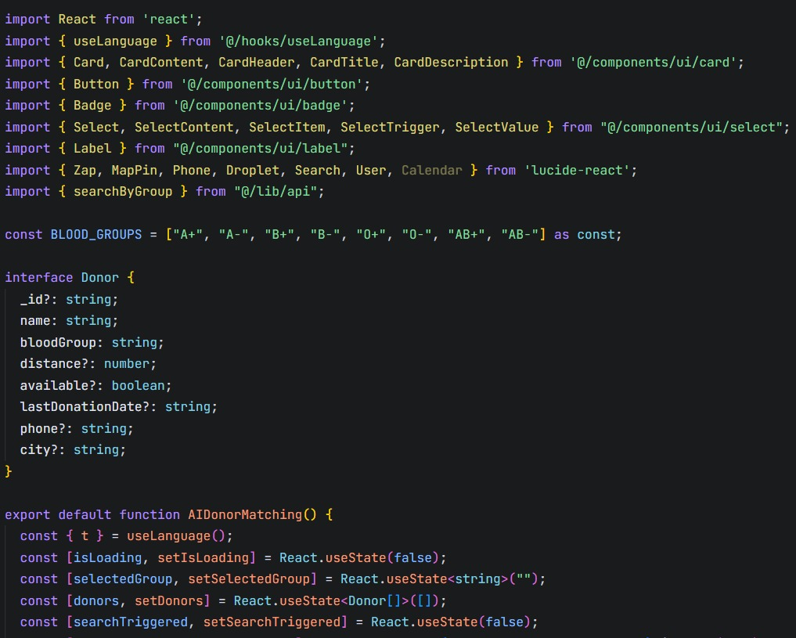
Code Snippet of Ai-Based Blood Matching System
6.Admin Dashboard
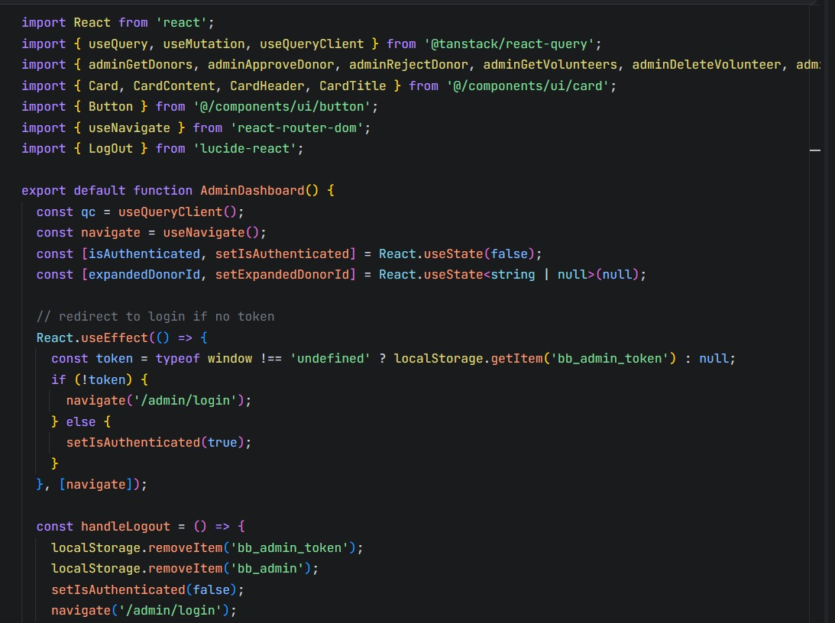
Code Snippet of Admin Dashboard

