What is GIT?

it is a Version Control System (VCS). It’s software that lives on your computer and tracks every single change you make to your files. If you accidentally delete a paragraph or break your code, Git lets you "time travel" back to a version that actually worked.

VCS- version control system is a tool that tracks every changes made to a file over time.

Its primary jobs are:

- Reversibility: If you break your project, you can roll back to a "last known good" state.
- Collaboration: It allows multiple people to work on the same project simultaneously.
- History: It provides a detailed log of who changed what, when, and why.
There are three types of VCS
- Local version control systems – on personalised computers(database)
- centralised version control systems – one single server
- Distributed version control systems – making copy of the entire repository
Commands in GIT

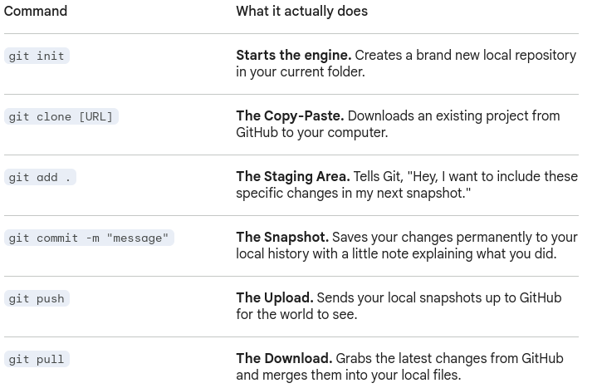
what is GitHub?
GitHub is a cloud-based hosting service. It’s a website where you upload your Git projects (called "repositories") so you can share them with others, collaborate on code, and keep a backup online.

