TABLE OF CONTENTS

ABSTRACT

It is true that technology has become an essential tool for online marketing nowadays. However, there are numerous small shops and grocery stores with mostly offline business model in Vietnam recently. With this commerce model, it will bring a lot of bad experiences for both buyers and sellers. For instance, the seller has the product want to offer but the buyer may not know it, or the buyer may urgently need to purchase something, but the store is out of stock. Electronic commerce in the world is becoming an increasingly popular form of trade. Most shoppers start looking for products, descriptions and quality features online before buying a product. In order to provide customers with more convenience, more and more companies and existing stores are setting up their own online stores where a person can buy at a convenient time, even at night when regular stores are no longer working. Online stores allow you to save time spent by a person searching for a particular product and driving through shops. However, customers still find it difficult to choose the products they want because of the large variety of products on these sites and not focus on specific things. Moreover, the sellers have to spend a high amount of money on marketing or paying for fees. From there disadvantages, implement an online e-commerce web application for small grocery stores helps retailers can manage products on their own systems and not depend on the 3rd party website. For the customers, they can quickly search the products if it is available and come to store to pick it up and they can contact directly to the shop owner to learn more about the products that they are looking for.

In order to make a website that can acquire the needs of both customers and retailers, The tools Such as Redux, ReactJs, used for the frontend Frameworks and SrpingBoot Framework used for the backend technologies and MySql and MongoDB databases are used for storing the data.

AIM : The aim of this project is to build an User friendly ecommerce website for commercial and retails users.

OBJECTIVES:

User Stories:

1. As a user I should be able to login, Logout and Register into the application.

2. As a user I should be able to see the products in different categories.

3. As a user I should be able to sort the products.

4. As a user I should be able to add the products into the shopping cart

5. As a user I should be able to increase or decrease the quantity added in the cart.

6. As a user I should be able to add n number of products in the cart.

Admin Stories :

1. As an Admin I should be able to login, Logout and Register into the application.

2. As an Admin I should be able to perform CRUD on Users.

3. As an Admin I should be able to Perform CRUD on the products.

4. As an Admin I should be able to get bulk upload option to upload a csv for products

5. As an Admin I should be able to get the stocks.

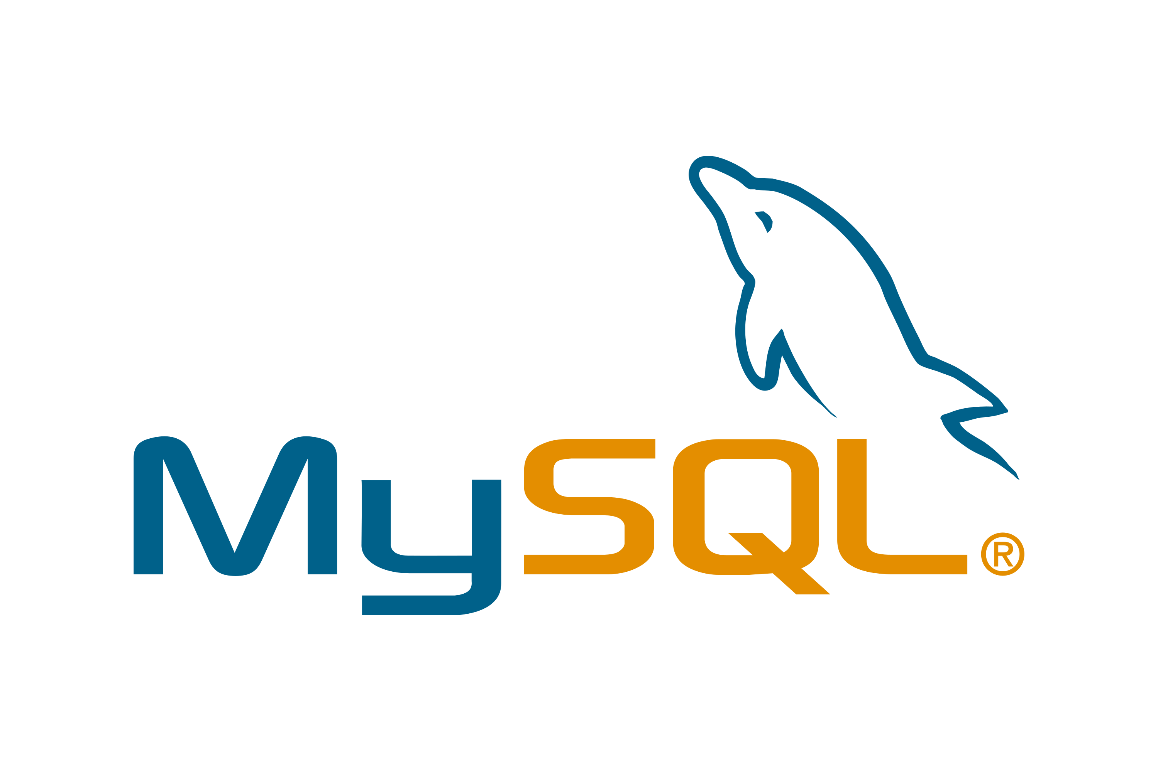TECHNOLOGIES USED



FRONTEND OPERATIONS

REDUX ARCHITECUTE

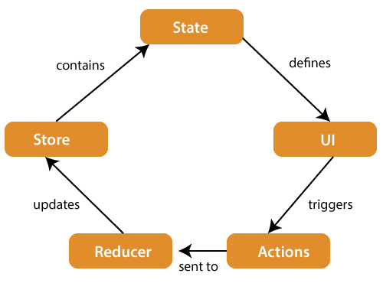

SETUP:

VERIFYING API LINKS

1. It’s the For most first step before beginning any project. Open postman and try to check weather the API links are working or not.

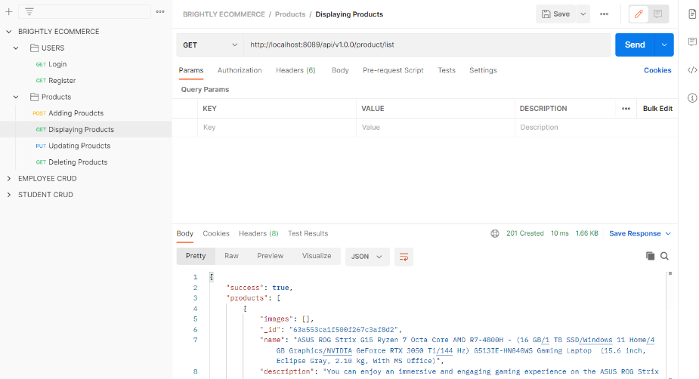

Result : If API working properly then we will get following result

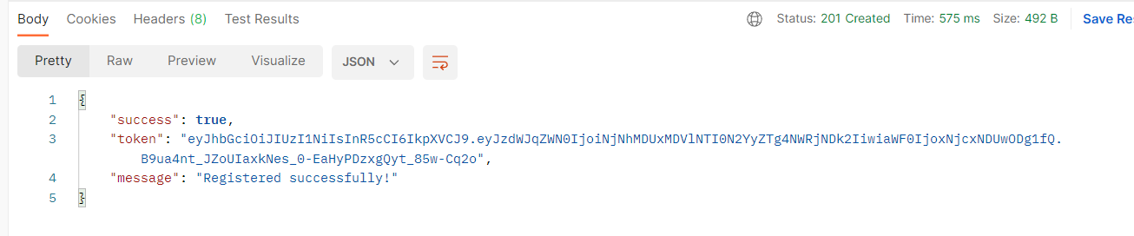

CHECKING DATA  IN THE MONGODB

Establish the connection in MongoDB and check the data is storing or not.

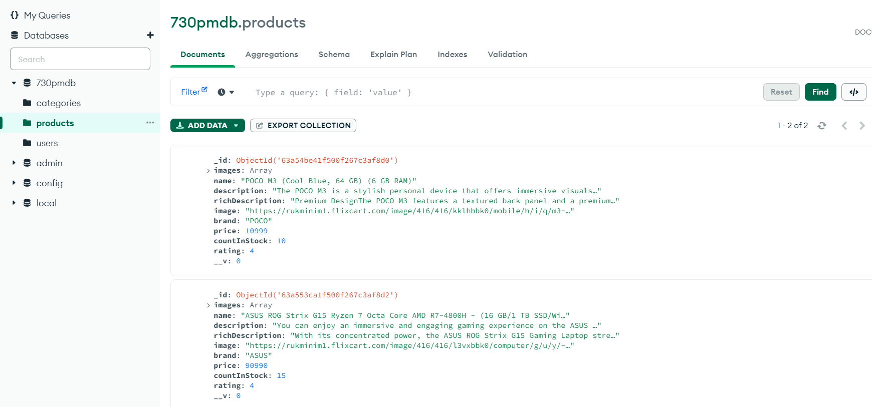

Login, Logout and Register into the application.

User View :

Registration

Admin View :

Code For Registration :

Containers :

Register

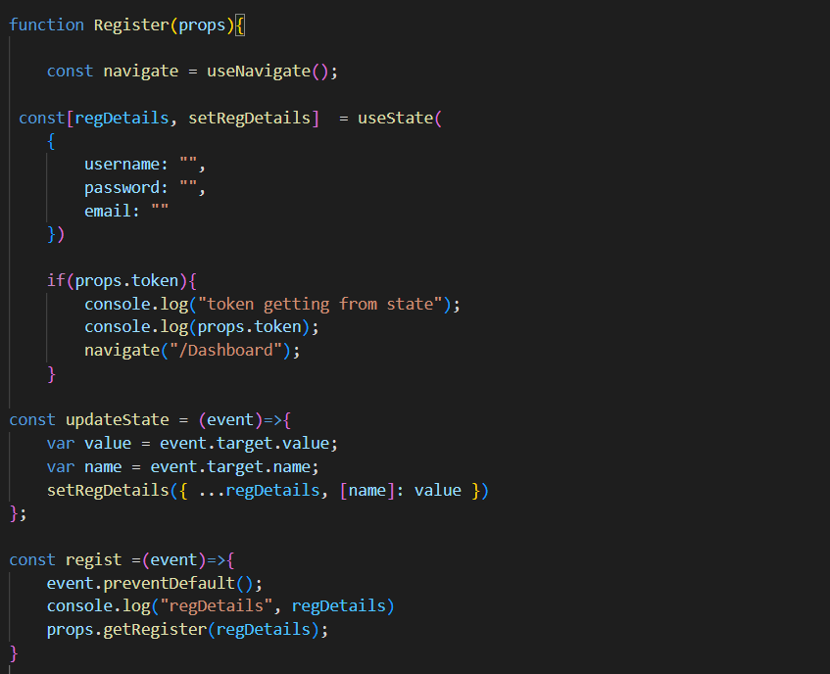

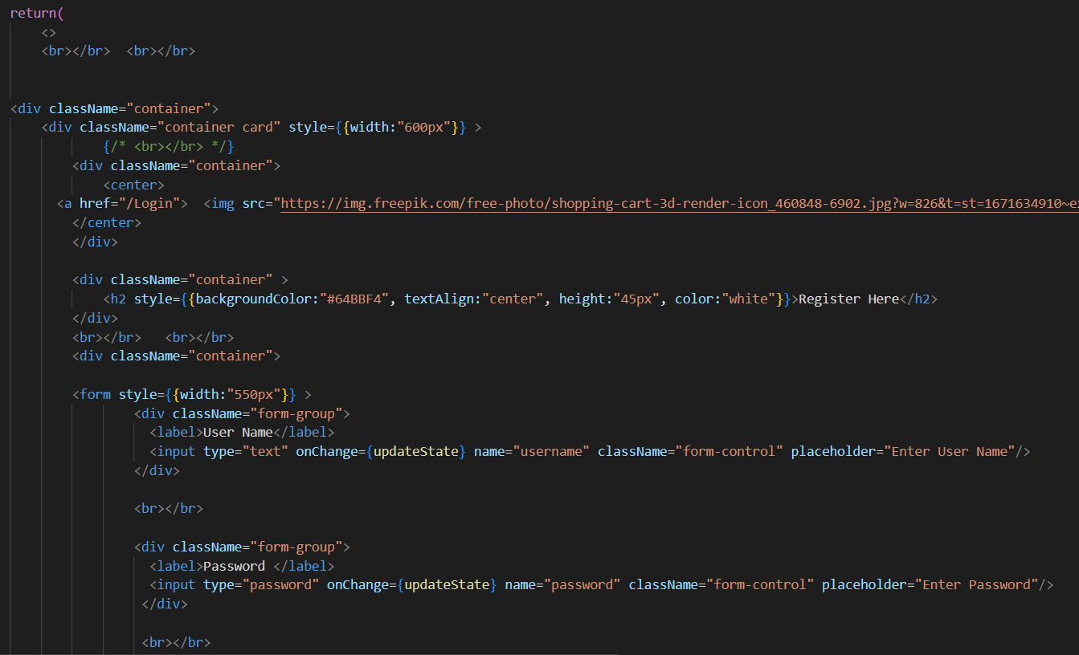

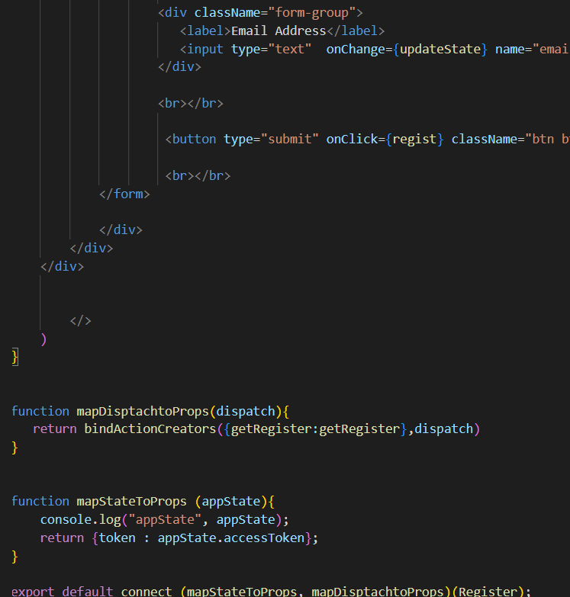

Actions:

User Action:

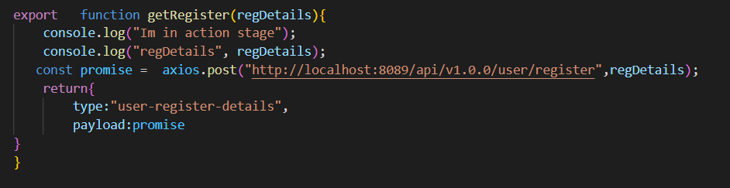

Reducer

User Reducer (Here all the Actions are store in a single reducer. And this reducer will store in root reducer.

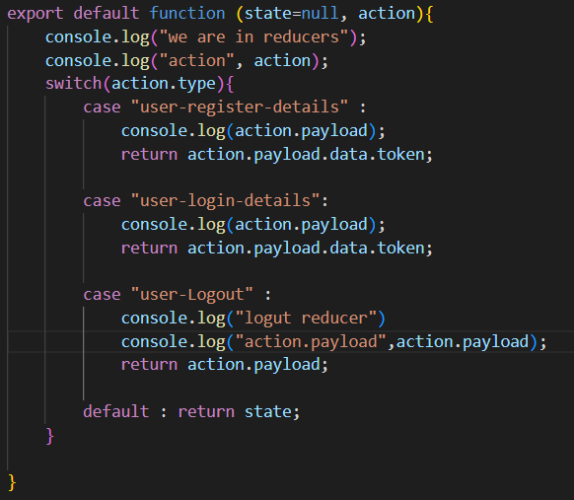

Root Reducer

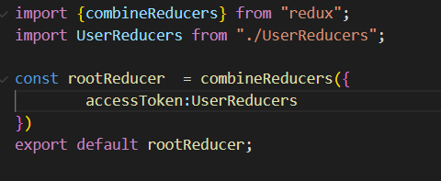

Store

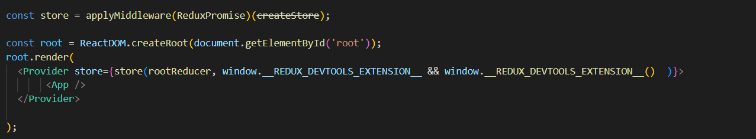

Result :

As the User Register with credentials, A token will be generated with the details from the backend.

Initially the state supposed to be null, and after registration the state gets updated with token. And this will furtherly used for all the user activities.

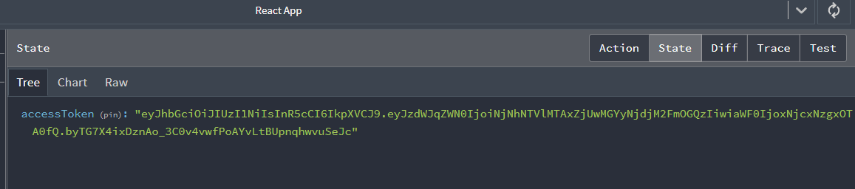

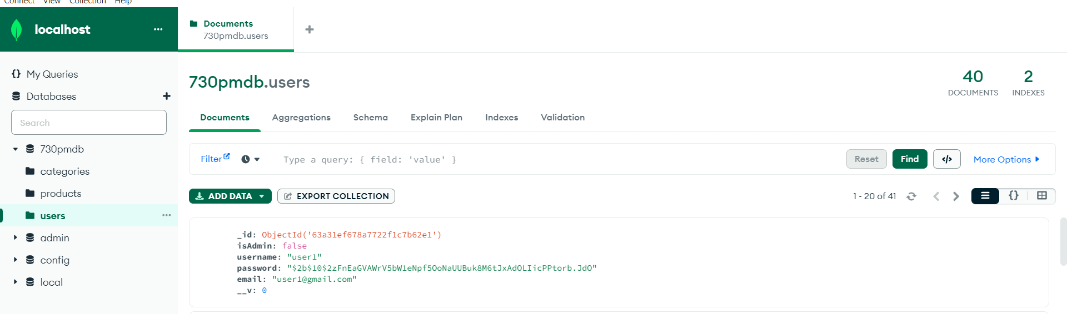

Login

CODE FOR LOGIN

CONTAINER

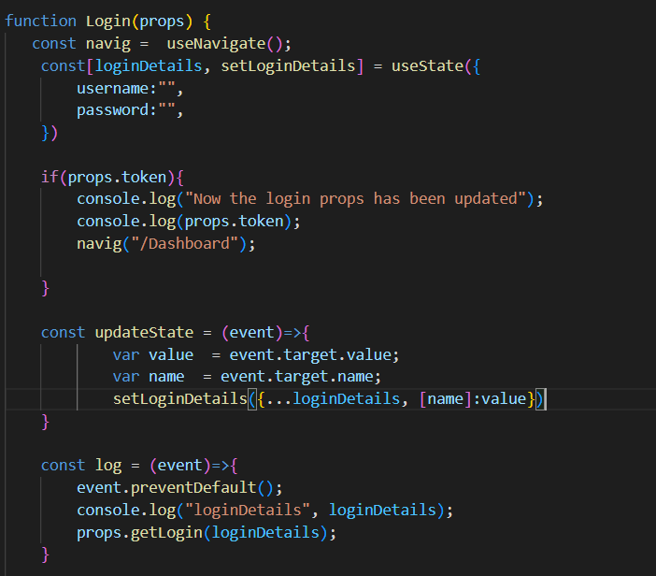

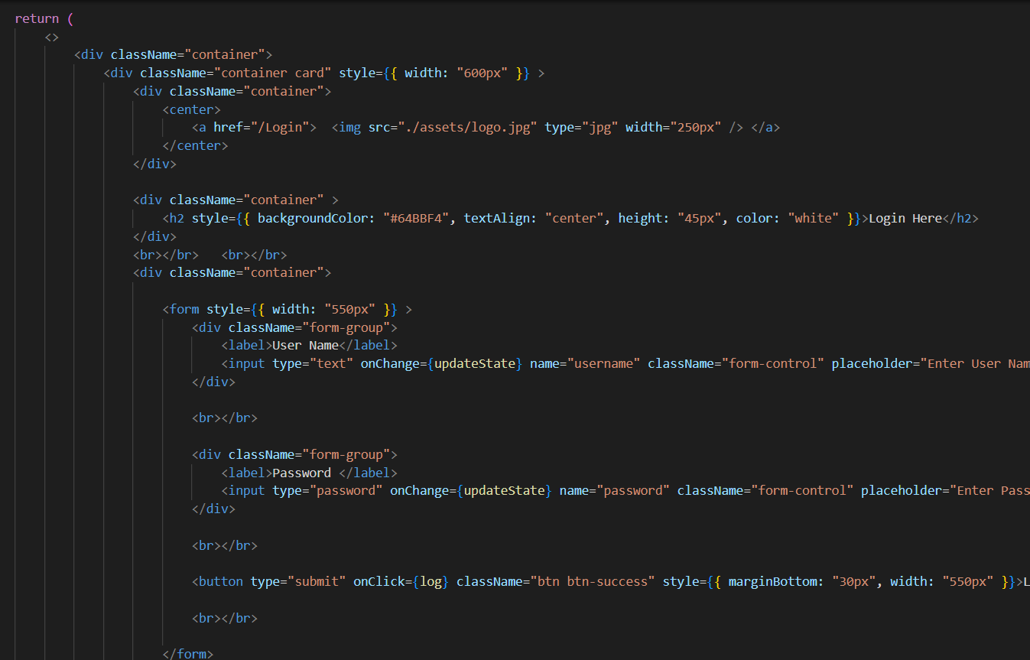

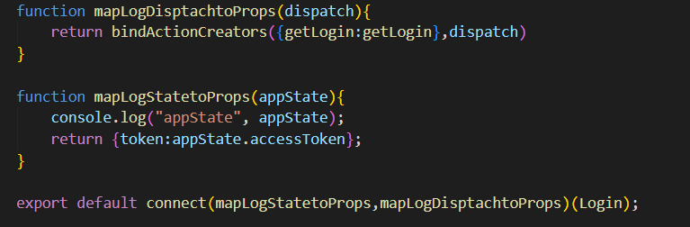

Action

