Productivity Enhancement Proposal: Handheld Stickering Machines
During our recent observation of the packing process at Ayrloom, I analyzed the time spent by individual team members on manually applying stickers to gummy pouches. I’d like to propose the use of handheld stickering machines to improve efficiency and reduce time spent on this repetitive task.

Time Savings Analysis per Worker
Based on the timing data we collected, here's how long it currently takes each worker to apply stickers manually versus how much faster it would be with a handheld applicator (approx. 50–55 stickers per minute):
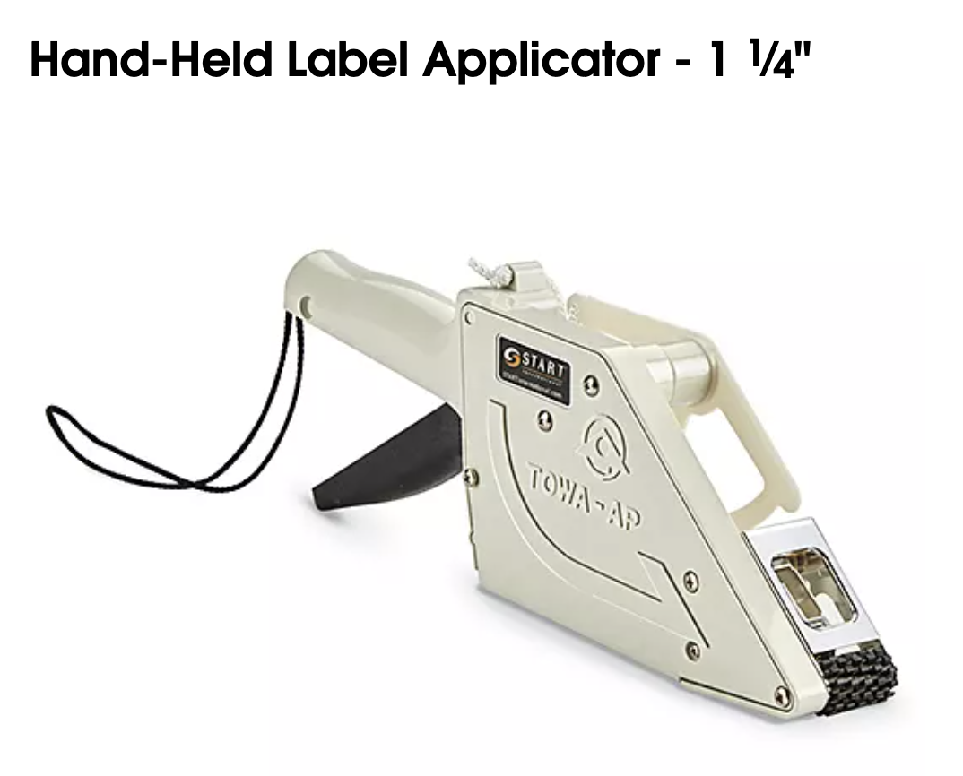
Link to the video
https://www.youtube.com/watch?v=NtoSqpcVDdk&ab_channel=Uline
Worker | Manual Time (mins) | Machine Time (mins) | Time Saved (mins)
Anna | 9.42 | 2.93 | 6.49
Amy | 19.35 | 2.93 | 16.42
Madaline | 14.06 | 2.93 | 11.13
Assuming each worker processes around 7 sheets a day, we can estimate the daily time savings as follows:
- Anna: 45.4 minutes/day
- Amy: 114.9 minutes/day
- Madaline: 77.9 minutes/day

Reallocation of Time
The saved time can be strategically used to enhance other parts of the packing workflow, especially where manual work is still a bottleneck. This includes:
- Cleaning sticky sour gummies
- Filling and counting (currently without an SOP)
- Leveraging the sealing machine, which is underutilized
- Improving quality control and reducing rework

Annual Cost Savings Estimate
Assuming 6 workers are doing stickering tasks and each works on 1,750 sheets per year, we estimate the total annual time saved as follows:
- Anna: ~189 hours
- Amy: ~479 hours
- Madaline: ~324 hours
- Total: ~992 hours per year
With an average labor rate of $18/hour, this translates to:
992 hours × $18/hour = $17,856 in annual savings

Implementation Cost & ROI
The investment in 3 handheld applicators (at ~$135 each) totals only $405.
This would provide a net savings of approximately $17,451 in the first year alone, yielding an ROI of around 4,310%.

Conclusion
Introducing handheld stickering machines is a cost-effective way to improve worker efficiency, reduce labor hours, and reallocate resources to critical points in the process. It’s a small investment with significant returns.

