DMN

Decision Model and Notation (DMN) is an industry standard for modeling and executing decisions that are determined by business rules.

 Part of the DMN standard is the **Friendly Enough Expression Language (FEEL)**.

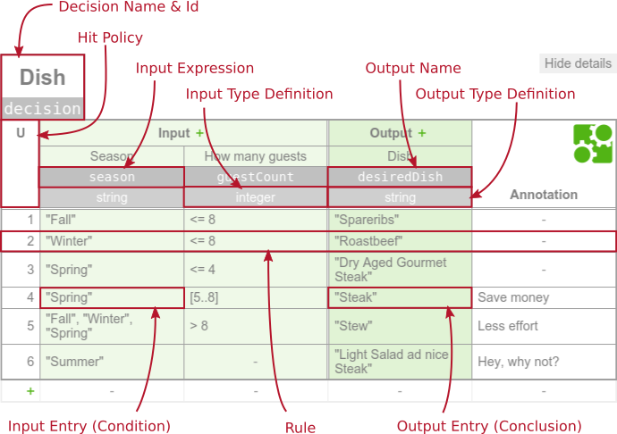

A decision table represents decision logic which can be depicted as a table in DMN 1.1. It consists of inputs, outputs and rules.

### why should I use DMN anyway, I can express those rules with BPMN gateways!

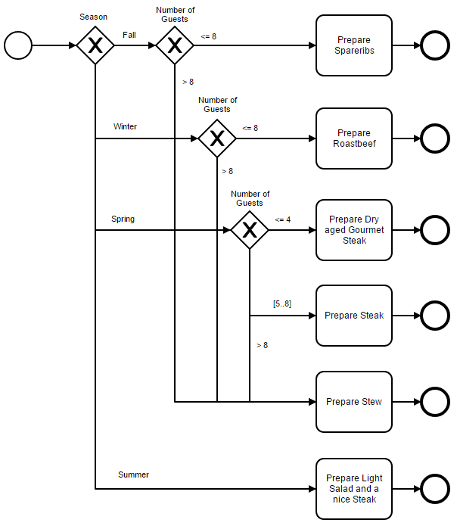

The following mappings are available:

|  |  |  |
| --- | --- | --- |
| **Mapper** | **Result** | **Is suitable for** |
| singleEntry | TypedValue | decision literal expressions and decision tables with no more than one matching rule and only one output |
| singleResult | Map<String, Object> | decision tables with no more than one matching rule |
| collectEntries | List<Object> | decision tables with multiple matching rules and only one output |
| resultList | List<Map<String, Object>> | decision tables with multiple matching rules and multiple outputs |

The following hit policies are supported by the Camunda DMN engine:

|  |  |
| --- | --- |
| **Visual representation** | **XML representation** |
| U | UNIQUE |
| A | ANY |
| F | FIRST |
| R | RULE ORDER |
| C | COLLECT |

Querying the Decision

repository service API

DecisionDefinition decisionDefinition = processEngine

.getRepositoryService()

.getDecisionDefinition("decisionDefinitionId");

Decision service

DecisionService ds = execution.getProcessEngineServices().getDecisionService();

DmnDecisionTableResult deb = ds.evaluateDecisionTableByKey("complementary", variables);