**TASKS 5: SUBQUERY**

1. *Retrieve the customer(s) with the highest account balance.*

select customer_id,balance from accounts where balance= (select max(balance)from accounts);

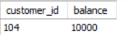

*2. Calculate the average account balance for customers who have more than one account.*

select avg(balance) AS average_balance from Accounts where customer_id in (select customer_id from Accounts group by customer_id having count(*) > 1) group by customer_id;

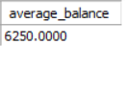

*3. Retrieve accounts with transactions whose amounts exceed the average transaction amount.*

select transaction_id, account_id,amount from transactions where amount > All (select avg(amount) from transactions);

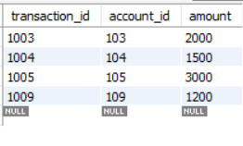

*4. Identify customers who have no recorded transactions.*

select customer_id from Customers where customer_id not in ( select distinct customer_id from Transactions);

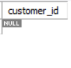

*5. Calculate the total balance of accounts with no recorded transactions.*

select sum(balance), c.customer_id, c.first_name, c.last_name from Customers c left join Accounts a on c.customer_id = a.customer_id left join Transactions t on a.account_id = t.account_id where t.transaction_id is null group by c.customer_id, c.first_name, c.last_name;

*6. Retrieve transactions for accounts with the lowest balance.*

select transaction_id,account_id from Transactions where account_id in (select account_id from Accounts where balance = (select min(balance) from Accounts));

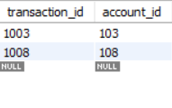

*7. Identify customers who have accounts of multiple types.*

select customer_id from accounts where account_type in ( select count(*) from accounts group by account_type having account_type< 1);

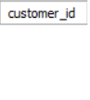

*8. Calculate the percentage of each account type out of the total number of accounts.*

select account_type, count(*) * 100 / (select count(*) from Accounts) as percentage from Accounts group by account_type;

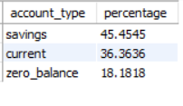

*9. Retrieve all transactions for a customer with a given customer_id.*

select * from transactions where account_id in (select account_id from accounts where customer_id=(select customer_id from customers where customer_id=101));

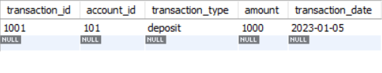

*10. Calculate the total balance for each account type, including a subquery within the SELECT*

*clause.*

select account_type,(select SUM(balance) from Accounts where account_type = a.account_type)

as total_balance from Accounts a group by account_type;

