**Flask**

**Flask:** Flask is used to build web applications using Python.

**Sample Flask Program(Without HTML) along with Output & Explanation**

**Code:**

from flask import Flask

app = Flask(__name__)

# This creates a Flask web application instance called 'app'.

@app.route("/")

def home():

return "This is Home Page"

# This defines a route for the home page ("/").

# When you visit http://127.0.0.1:5000/, this function runs and returns the text.

@app.route("/about")

def about():

    return "This is About Page"

@app.route("/contact")

def contact():

    return "This is Contact Page"

if __name__ == "__main__":

app.run(debug=True)

# This checks if the script is being run directly.

# If so, it starts the Flask development server with debug mode enabled.

# Debug mode gives you helpful error messages and auto-reloads the server on code changes.

**Output:**

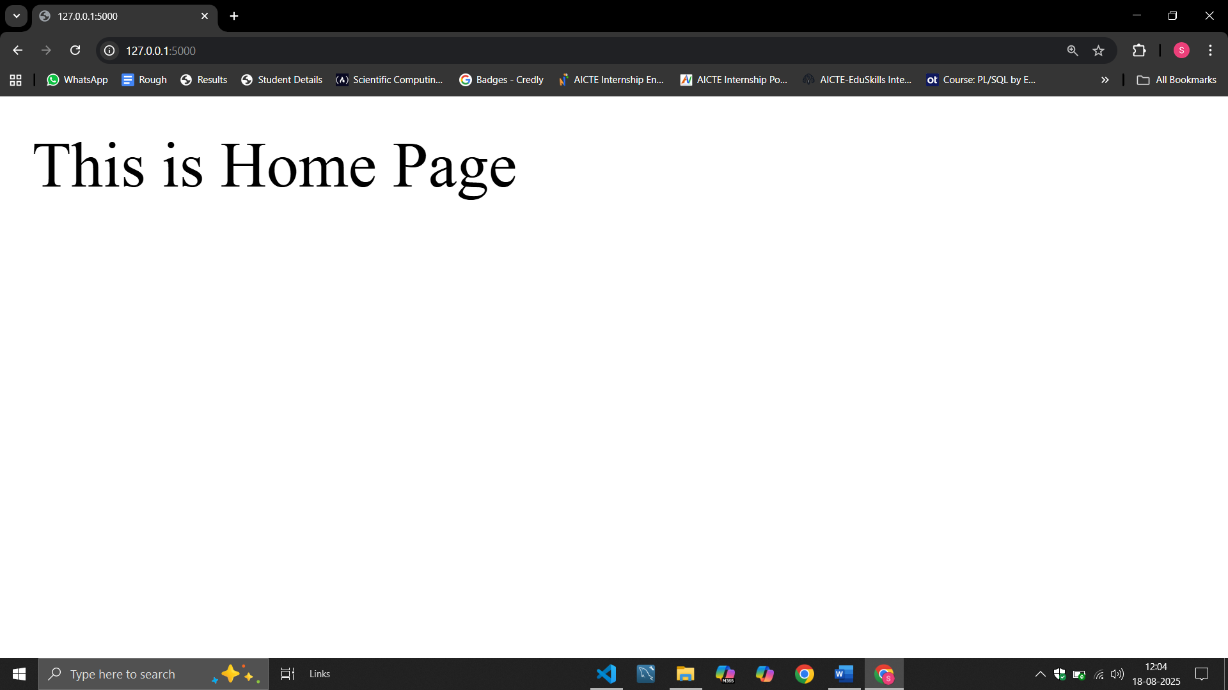 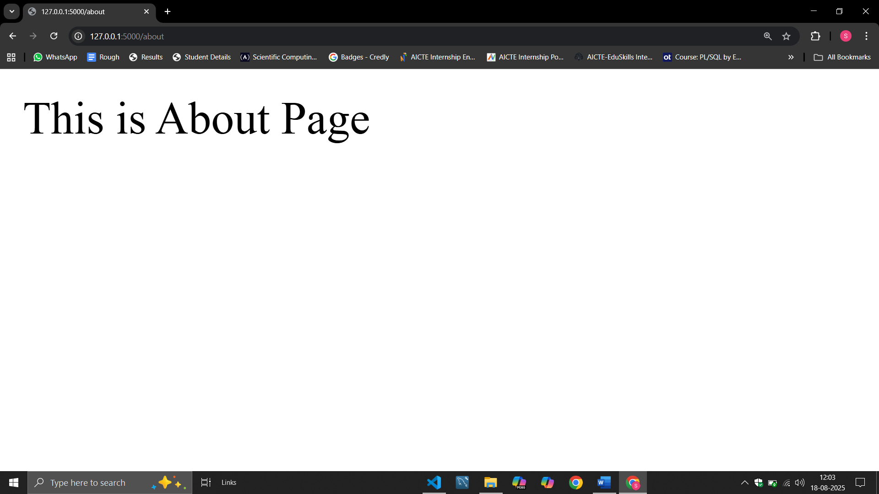 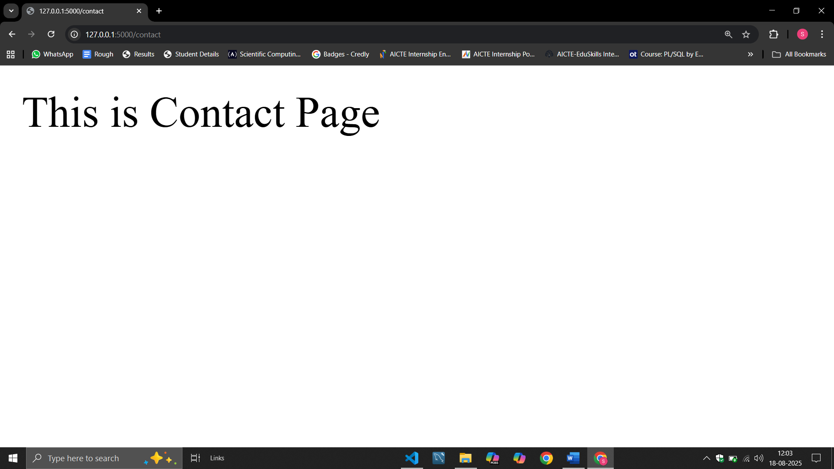

**Explanation:**

* You created a Flask app with three routes: /, /about, and /contact.
* Each route returns a simple text message.
* The app runs in debug mode for easier development.

**Sample Flask Program(With HTML) along with Output & Folder Structure**

**Code:**

**#File3.py**

from flask import Flask, render_template

app = Flask(__name__)

@app.route("/")

def home():

    return render_template("home1.html")

@app.route("/about")

def about():

    return render_template("home2.html")

@app.route("/contact")

def contact():

    return render_template("home3.html")

if __name__ == "__main__" :

    app.run(debug=True)

**home1.html**

<!DOCTYPE html>

<html>

    <head>

        <title> First Program (Flask) </title>

    </head>

    <body>

        <h1 align="center"> Home </h1>

        <p> This is Home Page! </p>

    </body>

</html>

**home2.html**

<!DOCTYPE html>

<html>

    <head>

        <title> First Program (Flask) </title>

    </head>

    <body>

        <h1 align="center"> About </h1>

        <p> This is About Page! </p>

    </body>

</html>

**home3.html**

<!DOCTYPE html>

<html>

    <head>

        <title> First Program (Flask) </title>

    </head>

    <body>

        <h1 align="center"> Contact </h1>

        <p> This is Contact Page! </p>

    </body>

</html>

**Output:**

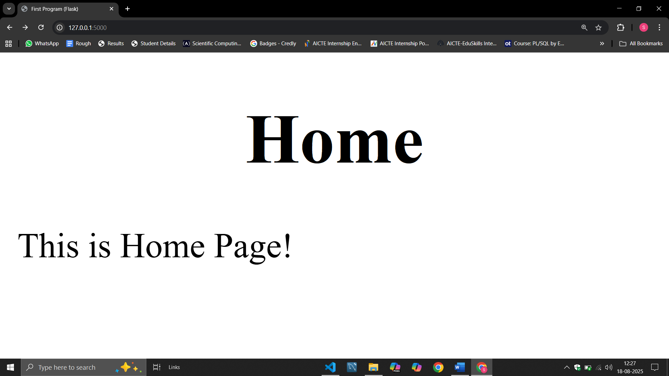 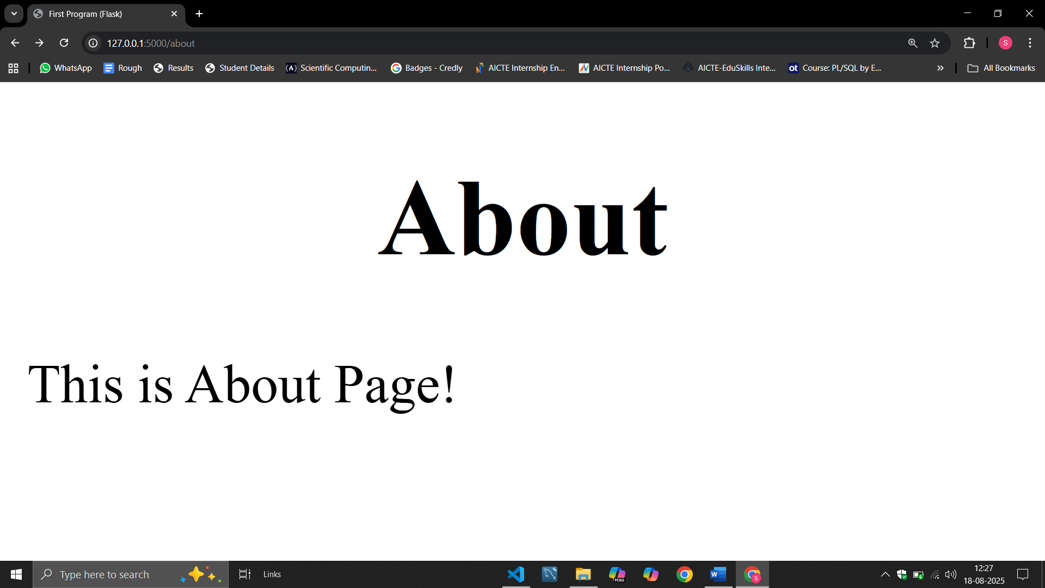 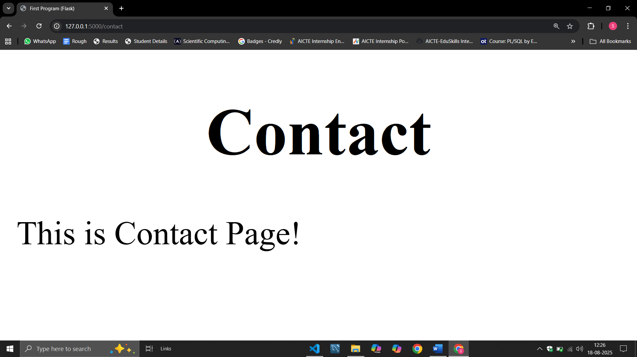

**Folder Structure:**

Project_Folder\

├── File3.py

└── templates\

├── home1.html

├── home2.html

└── home3.html