**MY PORTFOLIO**

**Laptop/Desktop View**

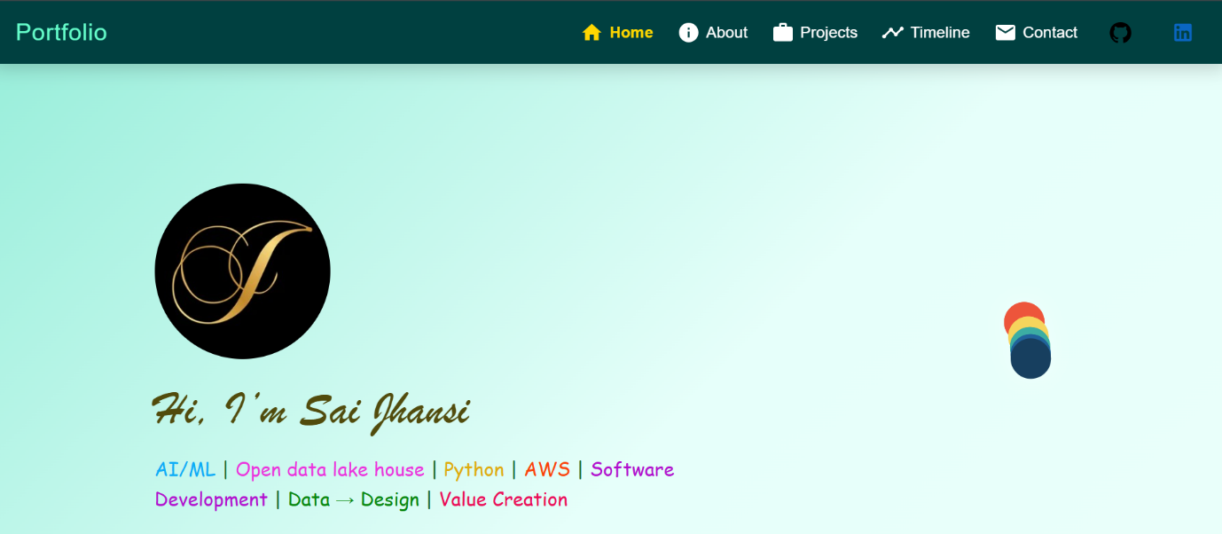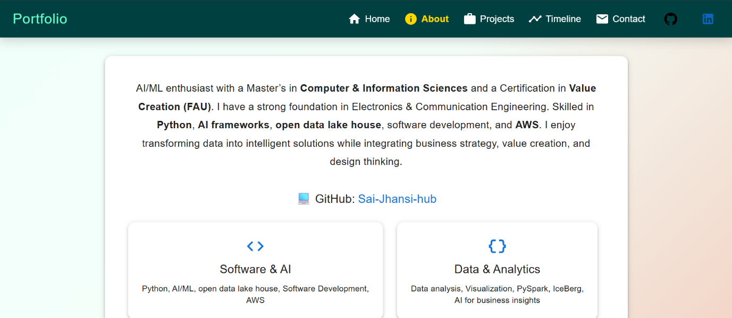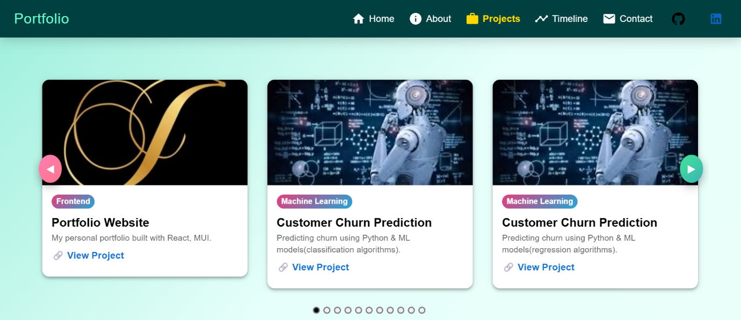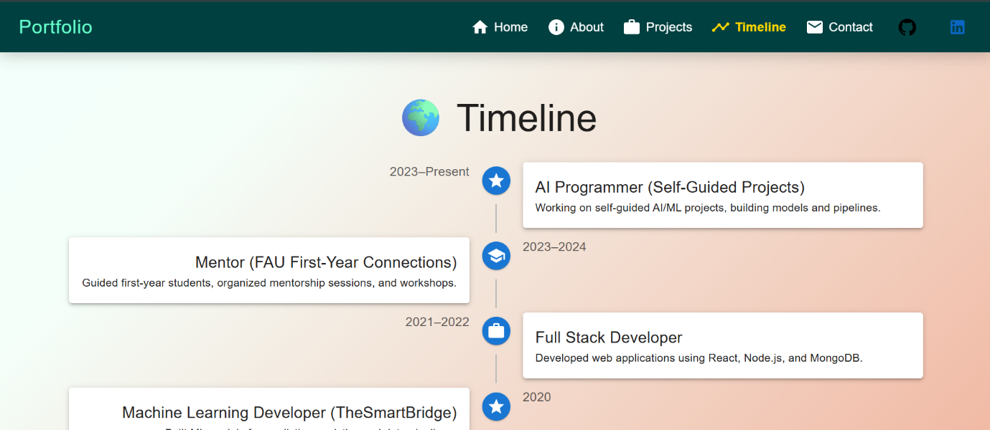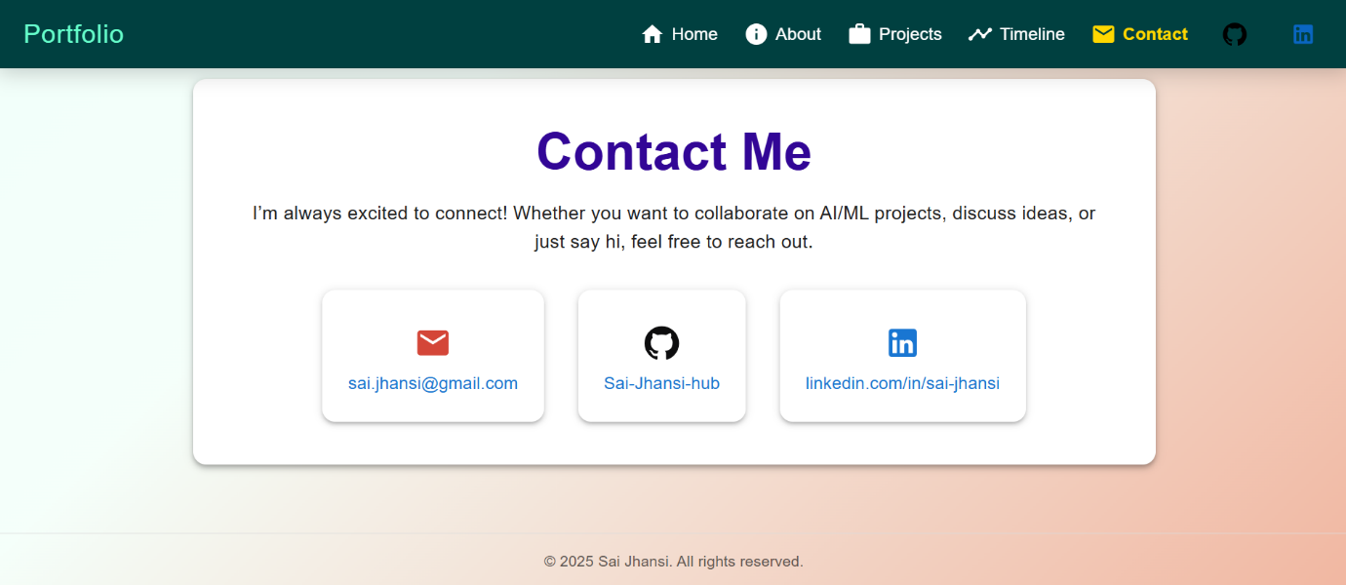

**Tablet View:**

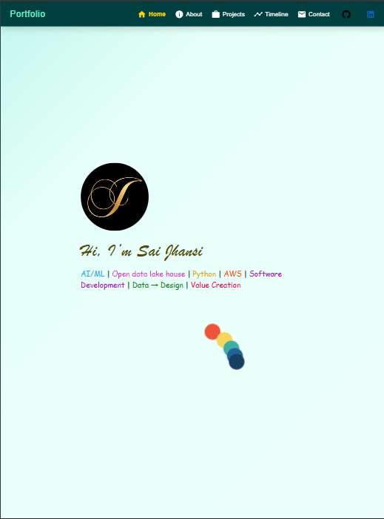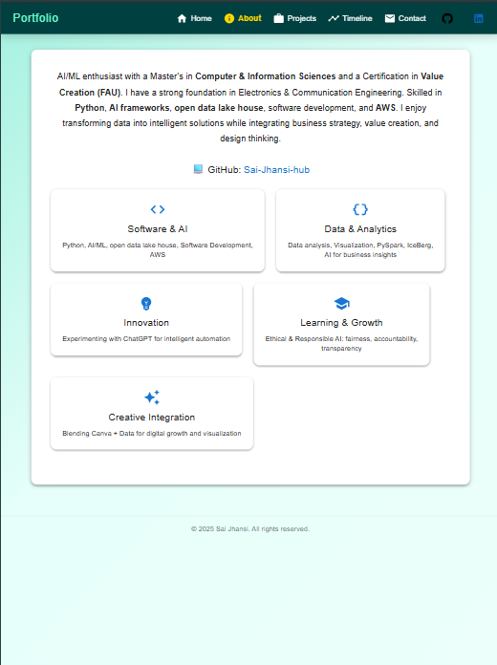

**Phone view:**

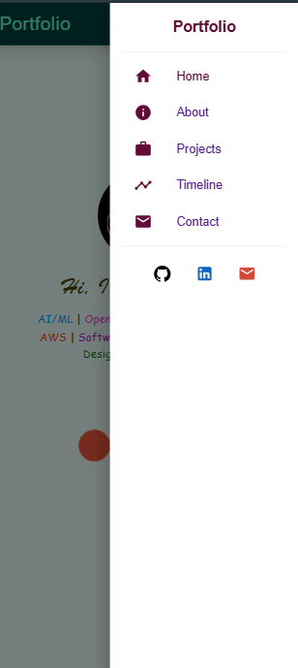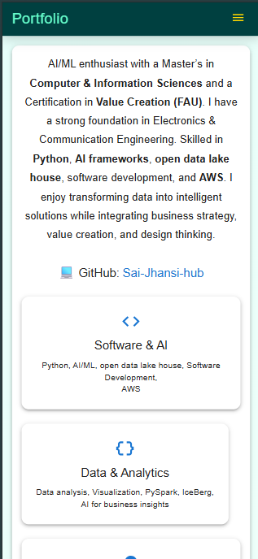

**App.js**

// src/App.js

import React from "react";

import { Routes, Route } from "react-router-dom"; // React Router for navigation

import {

  ThemeProvider,   // Provides Material-UI theme to the entire app

  createTheme,     // Function to create a custom theme

  CssBaseline,     // Resets and normalizes browser styles

  GlobalStyles,    // Allows adding global CSS styles

  Box,             // MUI Box component for layout

} from "@mui/material";

import Navbar from "./components/Navbar";   // Navbar component

import Home from "./components/Home";       // Home page component

import About from "./components/About";     // About page component

import Projects from "./components/Projects"; // Projects page component

import Timeline from "./components/Timeline"; // Timeline page component

import Contact from "./components/Contact";   // Contact page component

import Footer from "./components/Footer"; //  import Footer

// Create a default Material-UI theme

const theme = createTheme();

function App() {

  return (

    // Wraps the app with the theme provider

    <ThemeProvider theme={theme}>

      {/* Normalizes CSS across browsers */}

      <CssBaseline />

      {/* Global animated background applied to body and #root */}

      <GlobalStyles

        styles={{

          body: {

            margin: 0, // Removes default body margin

            minHeight: "100vh", // Ensures full height

            fontFamily: "Roboto, sans-serif", // Global font

            background:

              "linear-gradient(-45deg, #ee7752, #F5FFFA, #E6FFFA, #23d5ab)", // Gradient background

            backgroundSize: "400% 400%", // Enlarges background for animation

            animation: "gradientBG 8s ease infinite", // Background animation

          },

          "#root": {

            minHeight: "100vh", // Ensures React root spans full height

            background: "transparent", // Prevents root from blocking background

            display: "flex", // use flexbox to push footer down

            flexDirection: "column",

          },

          "@keyframes gradientBG": {

            "0%": { backgroundPosition: "0% 50%" },   // Start position

            "50%": { backgroundPosition: "100% 50%" }, // Middle position

            "100%": { backgroundPosition: "0% 50%" }, // End position

          },

        }}

      />

      {/* Navbar component always visible at the top */}

      <Navbar />

      {/* Main page content, positioned above background */}

      <Box sx={{ position: "relative", zIndex: 1, p: { xs: 2, md: 4 } }}>

        <Routes>

          <Route path="/" element={<Home />} />         {/* Home route */}

          <Route path="/about" element={<About />} />   {/* About route */}

          <Route path="/projects" element={<Projects />} /> {/* Projects route */}

          <Route path="/timeline" element={<Timeline />} /> {/* Timeline route */}

          <Route path="/contact" element={<Contact />} />   {/* Contact route */}

        </Routes>

      </Box>

          {/* Footer is always at the bottom */}

      <Footer />

    </ThemeProvider>

  );

}

export default App; // Exports App component

**Home.js**

This is LottieFile taken from Lordicon.com

Hero.json

{"v":"5.5.7","meta":{"g":"LottieFiles AE 0.1.20","a":"","k":"","d":"","tc":""},"fr":30,"ip":45,"op":120,"w":2000,"h":2000,"nm":"1","ddd":0,"assets":[],"layers":[{"ddd":0,"ind":1,"ty":4,"nm":"Shape Layer 2","sr":1,"ks":{"o":{"a":0,"k":100,"ix":11},"r":{"a":0,"k":0,"ix":10},"p":{"a":1,"k":[{"i":{"x":0.802,"y":0.426},"o":{"x":0.595,"y":0},"t":47,"s":[1774,1000,0],"to":[0,427.468,0],"ti":[427.468,0,0]},{"i":{"x":0.569,"y":0.653},"o":{"x":0.288,"y":0.305},"t":57.972,"s":[1000,1774,0],"to":[-427.468,0,0],"ti":[0,427.468,0]},{"i":{"x":0.533,"y":0.695},"o":{"x":0.227,"y":0.347},"t":62,"s":[226,1000,0],"to":[0,-427.468,0],"ti":[-427.468,0,0]},{"i":{"x":0.476,"y":1},"o":{"x":0.18,"y":0.574},"t":69.646,"s":[1000,226,0],"to":[427.468,0,0],"ti":[0,-427.468,0]},{"t":107,"s":[1774,1000,0]}],"ix":2},"a":{"a":0,"k":[-714,50,0],"ix":1},"s":{"a":0,"k":[100,100,100],"ix":6}},"ao":0,"shapes":[{"ty":"gr","it":[{"d":1,"ty":"el","s":{"a":0,"k":[276,276],"ix":2},"p":{"a":0,"k":[0,0],"ix":3},"nm":"Ellipse Path 1","mn":"ADBE Vector Shape - Ellipse","hd":false},{"ty":"fl","c":{"a":0,"k":[0.090196078431,0.247058838489,0.372549019608,1],"ix":4},"o":{"a":0,"k":100,"ix":5},"r":1,"bm":0,"nm":"Fill 1","mn":"ADBE Vector Graphic - Fill","hd":false},{"ty":"tr","p":{"a":0,"k":[-714,50],"ix":2},"a":{"a":0,"k":[0,0],"ix":1},"s":{"a":0,"k":[100,100],"ix":3},"r":{"a":0,"k":0,"ix":6},"o":{"a":0,"k":100,"ix":7},"sk":{"a":0,"k":0,"ix":4},"sa":{"a":0,"k":0,"ix":5},"nm":"Transform"}],"nm":"Ellipse 1","np":3,"cix":2,"bm":0,"ix":1,"mn":"ADBE Vector Group","hd":false}],"ip":0,"op":4035,"st":47,"bm":0},{"ddd":0,"ind":2,"ty":4,"nm":"Shape Layer 3","sr":1,"ks":{"o":{"a":0,"k":100,"ix":11},"r":{"a":0,"k":0,"ix":10},"p":{"a":1,"k":[{"i":{"x":0.802,"y":0.426},"o":{"x":0.595,"y":0},"t":51,"s":[1774,1000,0],"to":[0,427.468,0],"ti":[427.468,0,0]},{"i":{"x":0.569,"y":0.653},"o":{"x":0.288,"y":0.305},"t":61.972,"s":[1000,1774,0],"to":[-427.468,0,0],"ti":[0,427.468,0]},{"i":{"x":0.533,"y":0.695},"o":{"x":0.227,"y":0.347},"t":66,"s":[226,1000,0],"to":[0,-427.468,0],"ti":[-427.468,0,0]},{"i":{"x":0.476,"y":1},"o":{"x":0.18,"y":0.574},"t":73.646,"s":[1000,226,0],"to":[427.468,0,0],"ti":[0,-427.468,0]},{"t":111,"s":[1774,1000,0]}],"ix":2},"a":{"a":0,"k":[-714,50,0],"ix":1},"s":{"a":0,"k":[100,100,100],"ix":6}},"ao":0,"shapes":[{"ty":"gr","it":[{"d":1,"ty":"el","s":{"a":0,"k":[276,276],"ix":2},"p":{"a":0,"k":[0,0],"ix":3},"nm":"Ellipse Path 1","mn":"ADBE Vector Shape - Ellipse","hd":false},{"ty":"fl","c":{"a":0,"k":[0.125490196078,0.388235324037,0.607843137255,1],"ix":4},"o":{"a":0,"k":100,"ix":5},"r":1,"bm":0,"nm":"Fill 1","mn":"ADBE Vector Graphic - Fill","hd":false},{"ty":"fl","c":{"a":0,"k":[0.125490196078,0.388235324037,0.607843137255,1],"ix":4},"o":{"a":0,"k":100,"ix":5},"r":1,"bm":0,"nm":"Fill 2","mn":"ADBE Vector Graphic - Fill","hd":false},{"ty":"tr","p":{"a":0,"k":[-714,50],"ix":2},"a":{"a":0,"k":[0,0],"ix":1},"s":{"a":0,"k":[100,100],"ix":3},"r":{"a":0,"k":0,"ix":6},"o":{"a":0,"k":100,"ix":7},"sk":{"a":0,"k":0,"ix":4},"sa":{"a":0,"k":0,"ix":5},"nm":"Transform"}],"nm":"Ellipse 1","np":4,"cix":2,"bm":0,"ix":1,"mn":"ADBE Vector Group","hd":false}],"ip":4,"op":4039,"st":51,"bm":0},{"ddd":0,"ind":3,"ty":4,"nm":"Shape Layer 4","sr":1,"ks":{"o":{"a":0,"k":100,"ix":11},"r":{"a":0,"k":0,"ix":10},"p":{"a":1,"k":[{"i":{"x":0.802,"y":0.426},"o":{"x":0.595,"y":0},"t":55,"s":[1774,1000,0],"to":[0,427.468,0],"ti":[427.468,0,0]},{"i":{"x":0.569,"y":0.653},"o":{"x":0.288,"y":0.305},"t":65.972,"s":[1000,1774,0],"to":[-427.468,0,0],"ti":[0,427.468,0]},{"i":{"x":0.533,"y":0.695},"o":{"x":0.227,"y":0.347},"t":70,"s":[226,1000,0],"to":[0,-427.468,0],"ti":[-427.468,0,0]},{"i":{"x":0.476,"y":1},"o":{"x":0.18,"y":0.574},"t":77.646,"s":[1000,226,0],"to":[427.468,0,0],"ti":[0,-427.468,0]},{"t":115,"s":[1774,1000,0]}],"ix":2},"a":{"a":0,"k":[-714,50,0],"ix":1},"s":{"a":0,"k":[100,100,100],"ix":6}},"ao":0,"shapes":[{"ty":"gr","it":[{"d":1,"ty":"el","s":{"a":0,"k":[276,276],"ix":2},"p":{"a":0,"k":[0,0],"ix":3},"nm":"Ellipse Path 1","mn":"ADBE Vector Shape - Ellipse","hd":false},{"ty":"fl","c":{"a":0,"k":[0.235294132607,0.682352941176,0.639215686275,1],"ix":4},"o":{"a":0,"k":100,"ix":5},"r":1,"bm":0,"nm":"Fill 1","mn":"ADBE Vector Graphic - Fill","hd":false},{"ty":"fl","c":{"a":0,"k":[0.235294132607,0.682352941176,0.639215686275,1],"ix":4},"o":{"a":0,"k":100,"ix":5},"r":1,"bm":0,"nm":"Fill 2","mn":"ADBE Vector Graphic - Fill","hd":false},{"ty":"tr","p":{"a":0,"k":[-714,50],"ix":2},"a":{"a":0,"k":[0,0],"ix":1},"s":{"a":0,"k":[100,100],"ix":3},"r":{"a":0,"k":0,"ix":6},"o":{"a":0,"k":100,"ix":7},"sk":{"a":0,"k":0,"ix":4},"sa":{"a":0,"k":0,"ix":5},"nm":"Transform"}],"nm":"Ellipse 1","np":4,"cix":2,"bm":0,"ix":1,"mn":"ADBE Vector Group","hd":false}],"ip":8,"op":4043,"st":55,"bm":0},{"ddd":0,"ind":4,"ty":4,"nm":"Shape Layer 5","sr":1,"ks":{"o":{"a":0,"k":100,"ix":11},"r":{"a":0,"k":0,"ix":10},"p":{"a":1,"k":[{"i":{"x":0.802,"y":0.426},"o":{"x":0.595,"y":0},"t":59,"s":[1774,1000,0],"to":[0,427.468,0],"ti":[427.468,0,0]},{"i":{"x":0.569,"y":0.653},"o":{"x":0.288,"y":0.305},"t":69.972,"s":[1000,1774,0],"to":[-427.468,0,0],"ti":[0,427.468,0]},{"i":{"x":0.533,"y":0.695},"o":{"x":0.227,"y":0.347},"t":74,"s":[226,1000,0],"to":[0,-427.468,0],"ti":[-427.468,0,0]},{"i":{"x":0.476,"y":1},"o":{"x":0.18,"y":0.574},"t":81.646,"s":[1000,226,0],"to":[427.468,0,0],"ti":[0,-427.468,0]},{"t":119,"s":[1774,1000,0]}],"ix":2},"a":{"a":0,"k":[-714,50,0],"ix":1},"s":{"a":0,"k":[100,100,100],"ix":6}},"ao":0,"shapes":[{"ty":"gr","it":[{"d":1,"ty":"el","s":{"a":0,"k":[276,276],"ix":2},"p":{"a":0,"k":[0,0],"ix":3},"nm":"Ellipse Path 1","mn":"ADBE Vector Shape - Ellipse","hd":false},{"ty":"fl","c":{"a":0,"k":[0.964705942191,0.835294177485,0.360784313725,1],"ix":4},"o":{"a":0,"k":100,"ix":5},"r":1,"bm":0,"nm":"Fill 1","mn":"ADBE Vector Graphic - Fill","hd":false},{"ty":"fl","c":{"a":0,"k":[0.964705942191,0.835294177485,0.360784313725,1],"ix":4},"o":{"a":0,"k":100,"ix":5},"r":1,"bm":0,"nm":"Fill 2","mn":"ADBE Vector Graphic - Fill","hd":false},{"ty":"tr","p":{"a":0,"k":[-714,50],"ix":2},"a":{"a":0,"k":[0,0],"ix":1},"s":{"a":0,"k":[100,100],"ix":3},"r":{"a":0,"k":0,"ix":6},"o":{"a":0,"k":100,"ix":7},"sk":{"a":0,"k":0,"ix":4},"sa":{"a":0,"k":0,"ix":5},"nm":"Transform"}],"nm":"Ellipse 1","np":4,"cix":2,"bm":0,"ix":1,"mn":"ADBE Vector Group","hd":false}],"ip":12,"op":4047,"st":59,"bm":0},{"ddd":0,"ind":5,"ty":4,"nm":"Shape Layer 6","sr":1,"ks":{"o":{"a":0,"k":100,"ix":11},"r":{"a":0,"k":0,"ix":10},"p":{"a":1,"k":[{"i":{"x":0.802,"y":0.426},"o":{"x":0.595,"y":0},"t":63,"s":[1774,1000,0],"to":[0,427.468,0],"ti":[427.468,0,0]},{"i":{"x":0.569,"y":0.653},"o":{"x":0.288,"y":0.305},"t":73.972,"s":[1000,1774,0],"to":[-427.468,0,0],"ti":[0,427.468,0]},{"i":{"x":0.533,"y":0.695},"o":{"x":0.227,"y":0.347},"t":78,"s":[226,1000,0],"to":[0,-427.468,0],"ti":[-427.468,0,0]},{"i":{"x":0.476,"y":1},"o":{"x":0.18,"y":0.574},"t":85.646,"s":[1000,226,0],"to":[427.468,0,0],"ti":[0,-427.468,0]},{"t":123,"s":[1774,1000,0]}],"ix":2},"a":{"a":0,"k":[-714,50,0],"ix":1},"s":{"a":0,"k":[100,100,100],"ix":6}},"ao":0,"shapes":[{"ty":"gr","it":[{"d":1,"ty":"el","s":{"a":0,"k":[276,276],"ix":2},"p":{"a":0,"k":[0,0],"ix":3},"nm":"Ellipse Path 1","mn":"ADBE Vector Shape - Ellipse","hd":false},{"ty":"fl","c":{"a":0,"k":[0.929411824544,0.333333333333,0.231372563979,1],"ix":4},"o":{"a":0,"k":100,"ix":5},"r":1,"bm":0,"nm":"Fill 1","mn":"ADBE Vector Graphic - Fill","hd":false},{"ty":"fl","c":{"a":0,"k":[0.929411824544,0.333333333333,0.231372563979,1],"ix":4},"o":{"a":0,"k":100,"ix":5},"r":1,"bm":0,"nm":"Fill 2","mn":"ADBE Vector Graphic - Fill","hd":false},{"ty":"tr","p":{"a":0,"k":[-714,50],"ix":2},"a":{"a":0,"k":[0,0],"ix":1},"s":{"a":0,"k":[100,100],"ix":3},"r":{"a":0,"k":0,"ix":6},"o":{"a":0,"k":100,"ix":7},"sk":{"a":0,"k":0,"ix":4},"sa":{"a":0,"k":0,"ix":5},"nm":"Transform"}],"nm":"Ellipse 1","np":4,"cix":2,"bm":0,"ix":1,"mn":"ADBE Vector Group","hd":false}],"ip":16,"op":4051,"st":63,"bm":0}],"markers":[]}

**// src/components/Home.js**

// Import React (required to define React components)

import React from "react";

// Import Lottie React wrapper to render Lottie animations

import Lottie from "lottie-react";

// Import the JSON animation file used in the hero section

import animationData from "../lotties/hero.json"; // Replace with your Lottie animation

// Import Material UI layout and UI primitives used in this component

import { Box, Typography, Avatar, Grid, Container } from "@mui/material";

// Default exported functional component for the Home (hero) page

export default function Home() {

return (

// Outer Box: acts as the main page wrapper and applies full-screen layout

<Box

sx={{

minHeight: "100vh", // ensure the section fills the viewport height

display: "flex", // use flexbox for centering content

alignItems: "center", // vertically center children

justifyContent: "center", // horizontally center children

// background intentionally commented out here (global background is handled in App)

color: "white", // default text color inside this wrapper

p: { xs: 2, sm: 3, md: 6 }, // responsive padding for different screen sizes

}}

>

{/* Container centers content and constrains maximum width */}

<Container maxWidth="lg">

{/* Grid container organizes the hero into two responsive columns */}

<Grid

container

spacing={4} // space between grid items

alignItems="center" // vertically align grid items

justifyContent="center" // center grid contents horizontally

>

{/* Left Side - Profile and descriptive text */}

<Grid

item

xs={12} // full width on extra-small screens

md={6} // half width on medium and larger screens

textAlign={{ xs: "center", md: "left" }} // center text on mobile, left-align on desktop

>

{/* Avatar: profile image with responsive sizing and hover transform */}

<Avatar

src="/profile.jpg" // image placed in public/profile.jpg

alt="Sai Jhansi" // accessibility text

sx={{

width: { xs: 120, sm: 150, md: 180 }, // responsive width

height: { xs: 120, sm: 150, md: 180 }, // responsive height

mb: { xs: 2, md: 3 }, // bottom margin varies by breakpoint

mx: { xs: "auto", md: 0 }, // center on mobile, align left on desktop

"&:hover": { transform: "scale(1.05)" }, // subtle scale on hover

transition: "transform 0.3s", // smooth hover transition

}}

/>

{/* Name heading: large cursive-styled name with responsive sizing */}

<Typography

variant="h3" // semantic size for the heading

fontWeight="medium" // font weight

gutterBottom // adds margin-bottom consistent with typography spacing

sx={{

fontFamily: "'Brush Script MT', cursive", // cursive font for a personal touch

fontSize: { xs: "2.5rem", sm: "3rem", md: "3.5rem" }, // responsive font sizes

color: "#1c0453ff", // name color

}}

>

Hi, I’m Sai Jhansi

</Typography>

{/* Tagline: short list of specialties with colored spans */}

<Typography

sx={{

fontFamily: "'Pacifico', cursive", // cursive font for the tagline

fontSize: { xs: "0.9rem", sm: "1rem", md: "1.2rem" }, // responsive text size

maxWidth: { xs: "100%", md: "600px" }, // constrain width on larger screens

mb: { xs: 3, md: 4 }, // responsive bottom margin

lineHeight: 1.6, // comfortable line height

color: "#186929ff", // default tagline color

}}

>

{/* Each skill/keyword is wrapped with an inline span colored individually */}

<span style={{ color: "#0cadf7ff" }}>AI/ML</span> |{" "}

<span style={{ color: "#ea32deff" }}>Open data lake house</span> |{" "}

<span style={{ color: "#dead0bff" }}>Python</span> |{" "}

<span style={{ color: "#fa4008ff" }}>AWS</span> |{" "}

<span style={{ color: "#b20dcfff" }}>Software Development</span> |{" "}

<span style={{ color: "#05870cff" }}>Data → Design</span> |{" "}

<span style={{ color: "#eb0954ff" }}>Value Creation</span>

</Typography>

</Grid>

{/* Right Side - Lottie animation to visually support the hero */}

<Grid

item

xs={12} // full width on extra-small screens

md={6} // half width on medium+ screens

sx={{

display: "flex", // use flexbox to center the animation

justifyContent: "center", // horizontally center

alignItems: "center", // vertically center

}}

>

{/* Lottie animation component with responsive sizing and subtle drop shadow */}

<Lottie

animationData={animationData} // animation JSON imported above

loop // keep animation looping

style={{

width: "60%", // relative width inside the grid cell

maxWidth: "200px", // cap the animation size on large screens

height: "auto", // preserve aspect ratio

filter: "drop-shadow(0px 0px 12px rgba(255,255,255,0.4))", // visual depth

}}

/>

</Grid>

</Grid>

</Container>

</Box>

);

}

**Navbar.js**

// src/components/Navbar.js

import React from "react";

import {

  AppBar,

  Toolbar,

  Typography,

  IconButton,

  Box,

  Drawer,

  List,

  ListItem,

  ListItemIcon,

  ListItemText,

  Divider,

} from "@mui/material";

import MenuIcon from "@mui/icons-material/Menu";

import GitHubIcon from "@mui/icons-material/GitHub";

import LinkedInIcon from "@mui/icons-material/LinkedIn";

import HomeIcon from "@mui/icons-material/Home";

import InfoIcon from "@mui/icons-material/Info";

import WorkIcon from "@mui/icons-material/Work";

import TimelineIcon from "@mui/icons-material/Timeline";

import EmailIcon from "@mui/icons-material/Email";

import { NavLink } from "react-router-dom";

export default function Navbar() {

  const [open, setOpen] = React.useState(false);

  const toggleDrawer = (state) => () => setOpen(state);

  // ✅ Navigation links

  const navItems = [

    { label: "Home", path: "/", icon: <HomeIcon /> },

    { label: "About", path: "/about", icon: <InfoIcon /> },

    { label: "Projects", path: "/projects", icon: <WorkIcon /> },

    { label: "Timeline", path: "/timeline", icon: <TimelineIcon /> },

    { label: "Contact", path: "/contact", icon: <EmailIcon /> },

  ];

  // ✅ Social icons

  const socialIcons = [

    {

      icon: <GitHubIcon sx={{ color: "#000" }} />,

      link: "https://github.com/Sai-Jhansi-hub",

    },

    {

      icon: <LinkedInIcon sx={{ color: "#0A66C2" }} />,

      link: "http://linkedin.com/in/sai-jhansi-831a871a4",

    },

  ];

  return (

    <>

      {/* ✅ AppBar (Sticky Navbar) */}

      <AppBar

        position="sticky"

        sx={{

          background: "#004040",

          backdropFilter: "blur(6px)", // glass effect

          color: "#E6F1FF",

          boxShadow: "0 4px 20px rgba(0,0,0,0.2)", // softer shadow

        }}

      >

        <Toolbar sx={{ display: "flex", justifyContent: "space-between" }}>

          {/* ✅ Brand Name (Portfolio) */}

          <NavLink

            to="/"

            style={{ textDecoration: "none", color: "inherit", }}

          >

            <Typography

              variant="h5"

              sx={{

fontFamily: "'Poppins', sans-serif",

                fontWeight: "medium",

                letterSpacing: 0.7,

                color: "#66FFCC",

              }}

            >

              Portfolio

            </Typography>

          </NavLink>

          {/* ✅ Desktop Navigation */}

          <Box

            sx={{

              display: { xs: "none", md: "flex" },

              alignItems: "center",

              gap: 3,

            }}

          >

            {navItems.map((link) => (

              <NavLink

                key={link.path}

                to={link.path}

                style={({ isActive }) => ({

                  color: isActive ? "#FFD700" : "#fff", // gold when active

                  textDecoration: "none",

                  fontWeight: isActive ? "bold" : "normal",

                  display: "flex",

                  alignItems: "center",

                  gap: "6px",

                })}

              >

                {link.icon}

                {link.label}

              </NavLink>

            ))}

            {/* ✅ Social Icons */}

            {socialIcons.map((item, idx) => (

              <IconButton

                key={idx}

                component="a"

                href={item.link}

                target="_blank"

              >

                {item.icon}

              </IconButton>

            ))}

          </Box>

          {/* ✅ Mobile Hamburger Menu */}

          <IconButton

            sx={{ display: { xs: "block", md: "none" }, color: "#FFD700" }}

            onClick={toggleDrawer(true)}

          >

            <MenuIcon />

          </IconButton>

        </Toolbar>

      </AppBar>

      {/* ✅ Drawer for Mobile Navigation */}

      <Drawer anchor="right" open={open} onClose={toggleDrawer(false)}>

        <Box

          sx={{ width: 250, p: 2 }}

          role="presentation"

          onClick={toggleDrawer(false)}

        >

          {/* Drawer Header */}

          <Box sx={{ textAlign: "center", mb: 2 }}>

            <Typography

              variant="h6"

              sx={{ fontWeight: "bold", color: "#630b37" }}

            >

              Portfolio

            </Typography>

          </Box>

          <Divider />

          {/* Nav Links */}

          <List>

            {navItems.map((item) => (

              <ListItem

                button

                key={item.label}

                component={NavLink}

                to={item.path}

                sx={{

                  "&.active .MuiListItemText-root": { color: "#630b37" },

                }}

              >

                <ListItemIcon sx={{ color: "#630b37" }}>

                  {item.icon}

                </ListItemIcon>

                <ListItemText primary={item.label} />

              </ListItem>

            ))}

          </List>

          <Divider />

          {/* ✅ Social Icons + Email */}

          <Box

            sx={{ display: "flex", justifyContent: "center", mt: 2, gap: 2 }}

          >

            {socialIcons.map((item, idx) => (

              <IconButton key={idx} component="a" href={item.link} target="_blank">

                {item.icon}

              </IconButton>

            ))}

            <IconButton component="a" href="mailto:yourmail@example.com">

              <EmailIcon sx={{ color: "#D44638" }} /> {/* Gmail red */}

            </IconButton>

          </Box>

        </Box>

      </Drawer>

    </>

  );

}

**About.js**

**// src/components/About.js**

// Import React to define the functional component

import React from "react";

// Import Material UI components for layout and styling

import { Typography, Paper, Grid } from "@mui/material";

// Import Material UI icons used for different sections

import SchoolIcon from "@mui/icons-material/School";

import CodeIcon from "@mui/icons-material/Code";

import DataObjectIcon from "@mui/icons-material/DataObject";

import EmojiObjectsIcon from "@mui/icons-material/EmojiObjects";

import AutoAwesomeIcon from "@mui/icons-material/AutoAwesome";

// Define the AboutPage functional component

const AboutPage = () => {

return (

// Outer Paper component provides a card-like background with elevation

<Paper

elevation={4} // shadow depth

sx={{

p: { xs: 2, md: 5 }, // responsive padding

maxWidth: 900, // constrain max width of the section

mx: "auto", // center horizontally

borderRadius: 3, // rounded corners

}}

>

{/* Introduction Paragraph */}

<Typography

variant="body1" // paragraph style

align="center" // center align text

sx={{

mb: 4, // margin bottom

fontSize: "1.1rem", // slightly larger font size

lineHeight: 1.8, // comfortable line spacing

}}

>

AI/ML enthusiast with a Master’s in{" "}

<strong>Computer & Information Sciences</strong> and a Certification in{" "}

<strong>Value Creation (FAU)</strong>. I have a strong foundation in

Electronics & Communication Engineering. Skilled in{" "}

<strong>Python</strong>, <strong>AI frameworks</strong>,{" "}

<strong>open data lake house</strong>, software development, and{" "}

<strong>AWS</strong>. I enjoy transforming data into intelligent

solutions while integrating business strategy, value creation, and

design thinking.

</Typography>

{/* GitHub Profile Link */}

<Typography variant="h6" align="center">

GitHub:

<a

href="https://github.com/Sai-Jhansi-hub"

target="_blank"

rel="noreferrer" // security fix for opening in new tab

style={{

marginLeft: 5,

color: "#1976d2", // link color

textDecoration: "none", // remove underline

}}

>

Sai-Jhansi-hub

</a>

</Typography>

<br />

{/* Grid of Skills / Highlights */}

<Grid container spacing={3} sx={{ mb: 4 }}>

{/* Card: Software & AI */}

<Grid item xs={12} sm={6}>

<Paper

elevation={3}

sx={{ p: 3, textAlign: "center", borderRadius: 3 }}

>

<CodeIcon fontSize="large" color="primary" />

<Typography variant="h6" gutterBottom>

Software & AI

</Typography>

<Typography variant="body2">

Python, AI/ML, open data lake house, Software Development,

<br /> AWS

</Typography>

</Paper>

</Grid>

{/* Card: Data & Analytics */}

<Grid item xs={12} sm={6}>

<Paper

elevation={3}

sx={{ p: 3, textAlign: "center", borderRadius: 3 }}

>

<DataObjectIcon fontSize="large" color="primary" />

<Typography variant="h6" gutterBottom>

Data & Analytics

</Typography>

<Typography variant="body2">

Data analysis, Visualization, PySpark, IceBerg,

<br />

AI for business insights

</Typography>

</Paper>

</Grid>

{/* Card: Innovation */}

<Grid item xs={12} sm={6}>

<Paper

elevation={3}

sx={{ p: 3, textAlign: "center", borderRadius: 3 }}

>

<EmojiObjectsIcon fontSize="large" color="primary" />

<Typography variant="h6" gutterBottom>

Innovation

</Typography>

<Typography variant="body2">

Experimenting with ChatGPT for intelligent automation

</Typography>

</Paper>

</Grid>

{/* Card: Learning & Growth */}

<Grid item xs={12} sm={6}>

<Paper

elevation={3}

sx={{ p: 3, textAlign: "center", borderRadius: 3 }}

>

<SchoolIcon fontSize="large" color="primary" />

<Typography variant="h6" gutterBottom>

Learning & Growth

</Typography>

<Typography variant="body2">

Ethical & Responsible AI: fairness, accountability,

<br />

transparency

</Typography>

</Paper>

</Grid>

{/* Card: Creative Integration */}

<Grid item xs={12}>

<Paper

elevation={3}

sx={{ p: 3, textAlign: "center", borderRadius: 3 }}

>

<AutoAwesomeIcon fontSize="large" color="primary" />

<Typography variant="h6" gutterBottom>

Creative Integration

</Typography>

<Typography variant="body2">

Blending Creativity and Data for Digital Growth and Visualization

</Typography>

</Paper>

</Grid>

</Grid>

</Paper>

);

};

// Export AboutPage component to be used in routing

export default AboutPage;

**Projects.js**

import React from "react";

import {

  Box,

  Card,

  CardMedia,

  CardContent,

  Typography,

  Link,

  Chip,

} from "@mui/material";

import Carousel from "react-multi-carousel";

import "react-multi-carousel/lib/styles.css";

// ✅ Projects Data (same as yours)

const projects = [

  {

    id: 1,

    title: "Portfolio Website",

    category: "Frontend",

    description: "My personal portfolio built on my own using React.",

    image: "/profile.jpg",

    repo: "https://github.com/Sai-Jhansi-hub/frontend",

  },

  {

    id: 2,

    title: "Customer Churn Prediction",

    category: "Machine Learning",

    description:

      "Predicting churn using Python & ML models(classification algorithms).",

    image: "/ml.jpeg",

    repo: "https://github.com/Sai-Jhansi-hub/AI-/blob/main/customer_churn_prediction%20using%20classification%20algorithms(supervised%20learning).ipynb",

  },

  {

    id: 3,

    title: "Customer Churn Prediction",

    category: "Machine Learning",

    description:

      "Predicting churn using Python & ML models(regression algorithms).",

    image: "/ml.jpeg",

    repo: "https://github.com/Sai-Jhansi-hub/AI-/blob/main/customer_churn_prediction%20using%20regressor%20algorithms(supervised%20algorithms).ipynb",

  },

  {

    id: 4,

    title: "Loan & Iris Data Analysis",

    category: "Machine Learning",

    description:

      "Applied unpredictive ML models to discover hidden patterns.",

    image: "/ml.jpeg",

    repo: "https://github.com/Sai-Jhansi-hub/AI-/blob/main/loan_prediction%20using%20k-means(unsupervised%20learning).ipynb",

  },

  {

    id: 5,

    title: "Open Data Lakehouse",

    category: "Data Engineering",

    description:

      "Preprocessed structured, semi-structured, and unstructured data using PySpark & Iceberg.",

    image: "/opendata.jpeg",

    repo: "https://github.com/Sai-Jhansi-hub/data_engg",

  },

  {

    id: 6,

    title: "Chatbot using Deep Learning",

    category: "Deep Learning",

    description: "Chatbot project built using deep learning.",

    image: "/chatbot.jpeg",

    repo: "https://github.com/Sai-Jhansi-hub/AI-/blob/main/chatbot_using_deep_learning_techniques.ipynb",

  },

  {

    id: 7,

    title: "Image Classifiers",

    category: "Deep Learning",

    description:

      "Developed Neural Network classifiers using TensorFlow/Keras.",

    image: "/dl.jpg",

    repo: "https://github.com/Sai-Jhansi-hub/ms_projects/blob/main/Image%20Classifiers%20Using%20Neural%20Networks%20and%20the%20MNIST%20and%20Fashion%20MNIST%20Datasets.ipynb",

  },

  {

    id: 8,

    title: "Clustering Analysis on Multiple Datasets",

    category: "Machine Learning",

    description:

      "Implemented k-means, DBSCAN, and hierarchical clustering.",

    image: "/ml.jpeg",

    repo: "https://github.com/Sai-Jhansi-hub/ms_projects/blob/main/Intro_to_data_science_final_project.py",

  },

  {

    id: 9,

    title: "Audio Description of Images",

    category: "Deep Learning",

    description:

      "Generated audio descriptions of images.",

    image: "/dl.jpg",

  },

  {

    id: 10,

    title: "Home Automation using Arduino",

    category: "IoT / Embedded Systems",

    description:

      "Controlled household appliances like lights, fans, ACs, speakers using a smartphone app.",

    image: "/automation.jpg",

  },

  {

    id: 11,

    title: "University Admission Prediction",

    category: "Machine Learning",

    description:

      "Predicted admission chances with 98% accuracy using Linear Regression.",

    image: "/ml.jpeg",

  },

];

// ✅ Carousel Responsiveness

const responsive = {

  desktop: { breakpoint: { max: 3000, min: 1024 }, items: 3 },

  tablet: { breakpoint: { max: 1024, min: 768 }, items: 2 },

  mobile: { breakpoint: { max: 768, min: 0 }, items: 1 },

};

// ✅ Custom Arrows

const CustomLeftArrow = ({ onClick }) => (

  <button

    onClick={onClick}

    style={{

      position: "absolute",

      left: "10px",

      top: "40%",

      transform: "translateY(-50%)",

      background: "linear-gradient(135deg, #ff7eb3, #ff758c)",

      border: "none",

      borderRadius: "50%",

      padding: "12px",

      cursor: "pointer",

      zIndex: 10,

      color: "#fff",

      fontSize: "18px",

      boxShadow: "0px 6px 15px rgba(0,0,0,0.3)",

    }}

  >

    ◀

  </button>

);

const CustomRightArrow = ({ onClick }) => (

  <button

    onClick={onClick}

    style={{

      position: "absolute",

      right: "10px",

      top: "40%",

      transform: "translateY(-50%)",

      background: "linear-gradient(135deg, #42e695, #3bb2b8)",

      border: "none",

      borderRadius: "50%",

      padding: "12px",

      cursor: "pointer",

      zIndex: 10,

      color: "#fff",

      fontSize: "18px",

      boxShadow: "0px 6px 15px rgba(0,0,0,0.3)",

    }}

  >

    ▶

  </button>

);

const Projects = () => {

  return (

    <Box sx={{ p: 3 }}>

      <Carousel

        responsive={responsive}

        infinite

        autoPlay

        autoPlaySpeed={3500}

        keyBoardControl

        showDots

        arrows

        customLeftArrow={<CustomLeftArrow />}

        customRightArrow={<CustomRightArrow />}

      >

        {projects.map((project) => (

          <Card

            key={project.id}

            sx={{

              maxWidth: 350,

              m: 2,

              borderRadius: 3,

              boxShadow: 4,

              "&:hover": { boxShadow: 8, transform: "scale(1.02)" },

              transition: "0.3s",

            }}

          >

            {/* Image */}

            <CardMedia

              component="img"

              height="180"

              image={project.image}

              alt={project.title}

            />

            {/* Content */}

            <CardContent>

              {/* Category as Chip */}

              <Chip

                label={project.category}

                size="small"

                sx={{

                  background: "linear-gradient(135deg, #e73c7e, #23a6d5)",

                  color: "white",

                  fontWeight: "bold",

                  mb: 1,

                }}

              />

              {/* Title */}

              <Typography

                variant="h6"

                sx={{ fontWeight: "bold", color: "#020805ff" }}

              >

                {project.title}

              </Typography>

              {/* Description */}

              <Typography variant="body2" color="text.secondary" sx={{ mb: 1 }}>

                {project.description}

              </Typography>

              {/* View Project as link */}

              {project.repo && (

                <Link

                  href={project.repo}

                  target="_blank"

                  underline="hover"

                  sx={{ fontWeight: "bold", color: "#1976d2" }}

                >

                  🔗 View Project

                </Link>

              )}

            </CardContent>

          </Card>

        ))}

      </Carousel>

    </Box>

  );

};

export default Projects;

**Timeline.js**

import React from "react";

import {

  Timeline,

  TimelineItem,

  TimelineSeparator,

  TimelineConnector,

  TimelineContent,

  TimelineDot,

  TimelineOppositeContent

} from "@mui/lab";

import { Typography, Paper, Box } from "@mui/material";

import WorkIcon from "@mui/icons-material/Work";

import SchoolIcon from "@mui/icons-material/School";

import StarIcon from "@mui/icons-material/Star";

const experiences = [

  {

    role: "AI Programmer (Self-Guided Projects)",

    duration: "2023–Present",

    icon: <StarIcon />,

    description: "Working on self-guided AI/ML projects, building models and pipelines."

  },

  {

    role: "Mentor (FAU First-Year Connect)",

    duration: "2023–2024",

    icon: <SchoolIcon />,

    description: "Guided first-year students, organized mentorship sessions."

  },

  {

    role: "Full Stack Developer",

    duration: "2021–2022",

    icon: <WorkIcon />,

    description: "Developed web applications using React, Node.js, and MongoDB."

  },

  {

    role: "Machine Learning Developer (TheSmartBridge)",

    duration: "2020",

    icon: <StarIcon />,

    description: "Built ML models for predictive analytics."

  },

];

const TimelinePage = () => {

  return (

    <Box sx={{ p: 3 }}>

      <Typography variant="h3" align="center" gutterBottom>

        🌍 Timeline

      </Typography>

      <Timeline position="alternate">

        {experiences.map((exp, index) => (

          <TimelineItem key={index}>

            <TimelineOppositeContent color="text.secondary">

              {exp.duration}

            </TimelineOppositeContent>

            <TimelineSeparator>

              <TimelineDot color="primary">{exp.icon}</TimelineDot>

              {index !== experiences.length - 1 && <TimelineConnector />}

            </TimelineSeparator>

            <TimelineContent>

              <Paper elevation={3} sx={{ p: 2 }}>

                <Typography variant="h6">{exp.role}</Typography>

                <Typography variant="body2">{exp.description}</Typography>

              </Paper>

            </TimelineContent>

          </TimelineItem>

        ))}

      </Timeline>

    </Box>

  );

};

export default TimelinePage;

**Contact.js**

import React from "react";

import { Paper, Typography, Grid, IconButton, Link } from "@mui/material";

import EmailIcon from "@mui/icons-material/Email";

import GitHubIcon from '@mui/icons-material/GitHub';

import LinkedInIcon from "@mui/icons-material/LinkedIn";

const ContactPage = () => {

  return (

      <Paper elevation={4} sx={{ p: { xs: 2, md: 5 }, maxWidth: 900, mx: "auto", borderRadius: 3 }}>

        {/* Header */}

        <Typography variant="h3" align="center" gutterBottom sx={{ fontWeight: 'bold', color: '#320696ff' }}>

          Contact Me

        </Typography>

        <Typography variant="body1" align="center" sx={{ mb: 4, fontSize: '1.1rem' }}>

          I’m always excited to connect! Whether you want to collaborate on AI/ML projects, discuss ideas, or just say hi, feel free to reach out.

        </Typography>

        {/* Contact Grid */}

        <Grid container spacing={4} justifyContent="center">

          {/* Email */}

          <Grid item xs={12} sm={6}>

            <Paper elevation={3} sx={{ p: 3, textAlign: "center", borderRadius: 3 }}>

              <IconButton sx={{ fontSize: 50 , color: '#D44638'}}>

                <EmailIcon fontSize="large" />

              </IconButton>

             <br/>

              <Link href="mailto:sai.jhansi@gmail.com" sx={{ textDecoration: 'none', color: '#1976d2' }}>

                sai.jhansi@gmail.com

              </Link>

            </Paper>

          </Grid>

          {/* GitHub */}

          <Grid item xs={12} sm={6}>

            <Paper elevation={3} sx={{ p: 3, textAlign: "center", borderRadius: 3 }}>

              <IconButton  sx={{ fontSize: 50 , color: '#0d0d0eff'}}>

                <GitHubIcon fontSize="large" />

              </IconButton>

              <br/>

              <Link href="https://github.com/Sai-Jhansi-hub" target="_blank" rel="noopener" sx={{ textDecoration: 'none', color: '#1976d2' }}>

                Sai-Jhansi-hub

              </Link>

            </Paper>

          </Grid>

          {/* LinkedIn */}

          <Grid item xs={12} sm={6}>

            <Paper elevation={3} sx={{ p: 3, textAlign: "center", borderRadius: 3 }}>

              <IconButton color="primary" sx={{ fontSize: 50 }}>

                <LinkedInIcon fontSize="large" />

              </IconButton>

              <br/>

              <Link href="https://www.linkedin.com/in/sai-jhansi/" target="_blank" rel="noopener" sx={{ textDecoration: 'none', color: '#1976d2' }}>

                linkedin.com/in/sai-jhansi

              </Link>

            </Paper>

          </Grid>

        </Grid>

      </Paper>

  );

};

export default ContactPage;

**Footer.js**

// src/components/Footer.js

import React from "react";

import { Box, Typography } from "@mui/material";

const Footer = () => {

  return (

    <Box

      component="footer"

      sx={{

        py: 2, // padding top & bottom

        textAlign: "center", // center text

        borderTop: "1px solid #ddd", // light border on top

        mt: 4, // margin above footer

      }}

    >

      {/* Dynamic year with your name */}

      <Typography variant="body2" color="text.secondary">

        © {new Date().getFullYear()} Sai Jhansi. All rights reserved.

      </Typography>

    </Box>

  );

};

export default Footer;

**index.js**

// src/index.js

import React from "react";

import ReactDOM from "react-dom/client";

import { BrowserRouter } from "react-router-dom"; // React Router for navigation

import App from "./App"; // Main App component

import reportWebVitals from "./reportWebVitals"; // Optional performance measuring

// Create a root element for rendering React

const root = ReactDOM.createRoot(document.getElementById("root"));

// Render the application

root.render(

  <React.StrictMode>

    {/* Wrap App in BrowserRouter so routing works */}

    <BrowserRouter>

      <App />

    </BrowserRouter>

  </React.StrictMode>

);

// Measure app performance (optional)

reportWebVitals();

**App.test.js**

import { render, screen } from '@testing-library/react';

import App from './App';

test('renders learn react link', () => {

  render(<App />);

  const linkElement = screen.getByText(/learn react/i);

  expect(linkElement).toBeInTheDocument();

});

**Index.html**

<!DOCTYPE html>

<html lang="en">

  <head>

    <meta charset="utf-8" />

    <link rel="icon" href="%PUBLIC_URL%/favicon.ico" />

    <meta name="viewport" content="width=device-width, initial-scale=1" />

    <meta name="theme-color" content="#000000" />

    <meta

      name="description"

      content="Web site created using create-react-app"

    />

    <link rel="apple-touch-icon" href="%PUBLIC_URL%/logo192.png" />

    <!--

      manifest.json provides metadata used when your web app is installed on a

      user's mobile device or desktop. See https://developers.google.com/web/fundamentals/web-app-manifest/

    -->

    <link rel="manifest" href="%PUBLIC_URL%/manifest.json" />

    <!--

      Notice the use of %PUBLIC_URL% in the tags above.

      It will be replaced with the URL of the `public` folder during the build.

      Only files inside the `public` folder can be referenced from the HTML.

      Unlike "/favicon.ico" or "favicon.ico", "%PUBLIC_URL%/favicon.ico" will

      work correctly both with client-side routing and a non-root public URL.

      Learn how to configure a non-root public URL by running `npm run build`.

    -->

    <title>Sai Jhansi Portfolio</title>

  </head>

  <body>

    <noscript>You need to enable JavaScript to run this app.</noscript>

    <div id="root"></div>

    <!--

      This HTML file is a template.

      If you open it directly in the browser, you will see an empty page.

      You can add webfonts, meta tags, or analytics to this file.

      The build step will place the bundled scripts into the <body> tag.

      To begin the development, run `npm start` or `yarn start`.

      To create a production bundle, use `npm run build` or `yarn build`.

    -->

  </body>

</html>