Approach:

Download the JSON File -> Check the schema of the JSON -> preprocess it and un-nest/ flatten the JSON for easier analysis -> handle nulls, use median for the numerical columns to not disturb the distribution and perform an ML model to impute nulls in the completed column -> use the final cleaned up data for answering all the questions -> Dockerize and push the images to dockerhub

Questions and Answers:

1. What is the longest Jira ticket description?  
   Answer) 'Carmela sibling musicology patron gunpoint Canfield mammal Santayana Freddie Waterhouse estuary eligible Todd bashaw repellent Jovanovich integrity windbreak halide pestilential italic desiccate Hanoverian Riordan Lathrop connotative ratify Chattanooga phenol enjoinder chase breakdown alkaloid homology cleric consistent pickle rather Barney dogma crocodile liaison endometrial embroider methodology within marketeer cope patrol paycheck Nevins Spokane theorem Jorgensen Wilma transoceanic Mansfield arboretum attribution chemistry Woodbury Cottrell prosodic lox fallacious tachyon coprocessor Furman putdown Pickford goose ignition icosahedral chemic reconnaissance aggravate marinade furthest converge Apocrypha formula cocky landlocked Hopkins stamp Bennington injudicious bulletin spontaneous whalebone prolific scavenge aliphatic balsam offprint shepherdess underling Banbury Rebecca flush'
2. Which repo has the most lines of code added?  
   Answer) 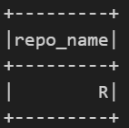
3. Provide the maximum number of Slack messages in any ticket for each engineer  
   Answer) 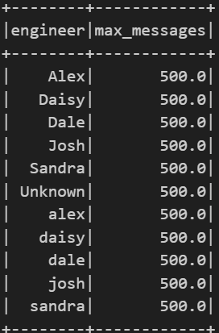
4. Mean hours spent on a ticket in June 2023  
   Answer) 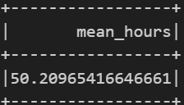
5. Total lines of code contributed by completed tickets to the repo 'A'   
   Answer) 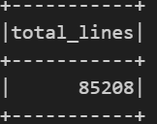
6. Total new revenue per engineer per company initiative  
   Answer) 