**2D PLOTTER CNC MACHINE**

**A Project Report**

***Submitted to***



**Jawaharlal Nehru Technological University Hyderabad**

*In partial fulfillment of the requirements for the award of the degree of*

**BACHELOR OF TECHNOLOGY**

**in**

**ELECTRONICS & COMMUNICATION ENGINEERING**

By

**KAASOJU. SAI TEJA (18VE1A04E1)**

**A. ANIRUDH REDDY (18VE1A04C2) SAI KRUTHI KANAKUNTLA (18VE1A04G7)**

**Under the Guidance of Mr. S. SUBRAHMANYAM**

**Assistant Professor**



**SREYAS** Institute of Engineering & Technology

**DEPARTMENT OF ELECTRONICS AND COMMUNICATION ENGINEERING**

(Approved by AICTE, New Delhi | Affiliated to JNTU, Hyderabad | Accredited by NBA & NAAC)Hyderabad | PIN: 500068

(2017 – 2021)



**SREYAS** Institute of Engineering & Technology

**DEPARTMENT OF ELECTRONICS AND COMMUNICATION ENGINEERING**

(Approved by AICTE, New Delhi | Affiliated to JNTU, Hyderabad | Accredited by NBA & NAAC) Hyderabad | PIN: 500068

Certificate

This is to certify that the Project Report on ***“2D PLOTTER CNC MACHINE***” submitted by **Kaasoju Sai Teja, A. Anirudh Reddy, Sai Kruthi Kanakuntla** bearing Hall Ticket No. **18VE1A04E1, 18VE1A04C2, 18VE1A04G7** in partial fulfillment of the requirements for the award of the degree of **Bachelor of Technology** in **Electronics & Communication Engineering** from Jawaharlal Nehru Technological University, Kukatpally, Hyderabad for the academic year 2020-21 is a record of bonafide work carried out by them under our guidance and Supervision.

**Guide Head of the Department**

**MR. S. SUBRAHMANYAM Prof. Mr. B. SREENIVASU**

**Project Coordinator Signature of the External Examiner Prof. S V MARUTHI RAO CHINNAM**



**SREYAS** Institute of Engineering & Technology

**DEPARTMENT OF ELECTRONICS AND COMMUNICATION ENGINEERING**

(Approved by AICTE, New Delhi | Affiliated to JNTUH, Hyderabad | Accredited by NBA & NAAC) Hyderabad | PIN: 500068

Declaration

I, **Kaasoju Sai Teja, A. Anirudh Reddy, Sai Kruthi Kanakuntla**, bearing **18VE1A04E1, 18VE1A04C2, 18VE1A04G7** here by declare that the Project titled "***2D PLOTTER CNC MACHINE***” done by us under the guidance of **MR. S. SUBRAHMANYAM**

, which is submitted in the partial fulfillment of the requirement for the award of the B.Tech degree in **Electronics & Communication Engineering** at **Sreyas Institute of Engineering & Technology** for Jawaharlal Nehru Technological University, Hyderabad is my original work.

**Kaasoju Sai Teja (18VE1A04E1)**

**A. Anirudh Reddy (18VE1A04C2) Sai Kruthi Kanakuntla (18VE1A04G7)**

**ACKNOWLEDGEMENT**

The successful completion of any task would be incomplete without mention of the people who made it possible through their guidance and encouragement crowns all the efforts with success.

We take this opportunity to acknowledge with thanks and deep sense of gratitude to **Mr.**

**S. Subrahmanyam , Assistant Professor, Department of ECE** for his constant encouragement and valuable guidance during the Project work.

A Special note of Thanks to **Mr. B. Sreenivasu, Associate Professor and Head of the Department**, who has been a source of Continuous motivation and support in the completion of this project. He had taken time and effort to guide and correct us all through the span of this work.

We owe very much to the **Department Faculty, Principal** and the **Management** who made our term at Sreyas a Stepping stone for my career. We treasure every moment we have spent in college.

Last but not least, our heartiest gratitude to our parents and friends for their continuous encouragement and blessings. Without their support this work would not have been possible.

**KAASOJU. SAI TEJA (18VE1A04E1)**

**A. ANIRUDH REDDY (18VE1A04C2) SAI KRUTHI KANAKUNTLA (18VE1A04G7)**

**CONTENTS**

ABSTRACT i

LIST OF FIGURES ii

Chapter 1 1

INTRODUCTION 1

* 1. Overview 1
  2. Introduction about Arduino Uno 2
  3. L293D motor driver 4

Chapter 2 7

PROJECT PLANNING 7

Chapter 3 13

METHODOLOGY 13

* 1. DESIGN OF CNC MACHINE 13
  2. WORKING 14
  3. Main Parts of CNC Plotter 15
  4. BLOCK DIAGRAM OF PROCESS 16

Chapter 4 18

SOFTWARES 18

4.1 Inkscape 0.48.5 18

4.2 Processing 21

Chapter 5 22

Advantages, Disadvantages & Application 22

* 1. CNC Machine Advantages 22
  2. CNC Machine Disadvantages 23
  3. Applications 23

Chapter 6 25

* 1. Conclusion 25
  2. Future Work 25

References 26

# ABSTRACT

This project shows how to design and building low-cost Arduino Mini CNC Plotter. For the X and Y axis we will use stepper motors and rails from two DVD / CD ROMs! Printing area will be max 4x4cm.

With the advancement of technology, demand for Computer Numerical Control (CNC) plotter machines in Educational Institutions and Laboratories is rapidly rising. Low cost manufacture of Printed Circuit Board (PCB) has become a basic need in electronics laboratories, for mechanical engineering students and for electronics hobbyists. This paper will present an affordable model of a CNC plotter machine which is able to draw a circuit layout on PCB or any other solid surface using simple algorithms and available components. At first the user needs to convert any image file or text file into G code using Inks pace software and then feed it to the machine using Processing software. Arduino Uno with an ATmega328P microcontroller is used as the control device for this project. The microcontroller converts G-code into a set of machine language instructions to be sent to the motor driver of the CNC plotter.

# LIST OF FIGURES

Figure 1. 1: Assembly of Project 2

Figure 1. 2: Arduino Uno 3

Figure 1. 3: L293D Motor Drive 4

Figure 1. 4: Servo Motor 5

Figure 1. 5: Stepper Motor 6

Figure 2. 1: Disassembly of Drivers 7

Figure 2. 2: Circuit 10

Figure 3. 1: Design of CNC Machine 14

Figure 3. 2: Main Parts of CNC Plotter 16

Figure 3. 3: Block Diagram 17

Figure 4. 1: Inkscape 18

Figure 4. 2: Diagram 20

Figure 4. 3: Outline of Diagram 20

Figure 4. 4: Processing 21

**Chapter 1****INTRODUCTION**

## Overview

Cost of the project and increased Reliability and Flexibility. In this we have to replace pen with mechanical tools such as drilling, grinding, machining etc. This will be used for soft material cutting or machining; a laser cutting machine tool is also used for this setup. We have reduced the cost, in the setup of a mini CNC plotter machine. The Mini CNC plotter machine is described as being based on an Arduino controller and CNC shield. CNC is a computer numerical control machine. G codes are preparatory functions. G codes are pre-defining functions Associated with the movement on machine axes. In a CNC Plotter Machine only G codes are used. G codes give the Direction to move the pen in X, Y, Z directions. Pen can be changed by drilling tools, laser cutting tools, and milling. It can be worked, if it is made in large size. The aim is to make a mini CNC plotter machine which is capable of drawing difficult designs on paper or the surface of metal, To cut it with great accuracy. We have used 3 stepper motors with lead screw in Cartesian coordinate X, Y, Z directions. Stepper motor converts the digital pulse into lead screw rotations. Stepper drivers are used to give commands to the system. The main aim is to fabricate a MINI CNC plotter Machine to draw an object using G codes.

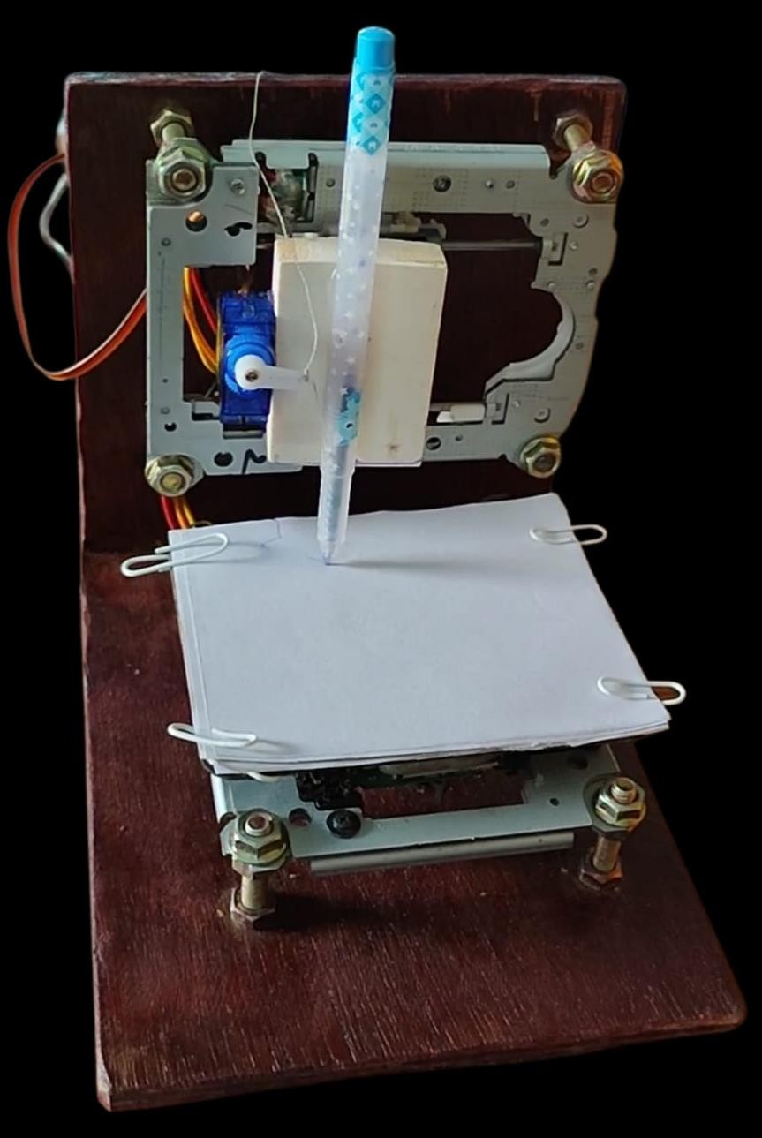

*Figure 1. 1: Assembly of Project*

## Introduction about Arduino Uno

Arduino Uno is a microcontroller based on the ATmega328P Atmel AVR family microcontroller (MCU). It is an open source software and hardware

design and manufacture of a single microcontroller. It has 14 digital Input/output pins and 6 Analogue input can be sampled using on-chip ADC. By using open source programming Arduino Uno. Arduino will be defined as it receives the command or data from the computer and with the help of a USB cable. It is mounted on a CNC shield, it will transfer data from Arduino to CNC shield using a stepper driver. Arduino UNO is a microcontroller board, it contains everything needed to support the microcontroller, simply connect it to a computer with a USB cable and a power source. It controls the position of the stepper motor with the help of a program. It is an open source platform based on easy to use hardware and software. They have digital and analog input/output pins which can interface into various expansion boards and other circuits and a microcontroller with complementary components that helps in programming and incorporation into other circuits. Current supplied 5 volts with a USB cable.

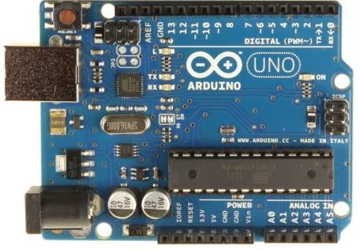

*Figure 1. 2: Arduino Uno*

## L293D motor driver

L293D is a typical motor driver or motor driver LC which allows DC motors to drive in either direction L293D is a 16-pin LC which can control a set of two DC motors simultaneously in any direction .it means that you can control two DC motors with a single L293D.

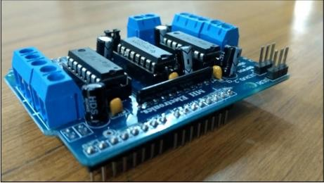

*Figure 1. 3: L293D Motor Drive*

* 1. **Introduction about Mini Servo Motor**

A servo motor is an entirely different story; the function of the servo is to receive a control signal that represents a desired output position of the servo shift and apply power to its Dc motor until its shaft turns to that position.

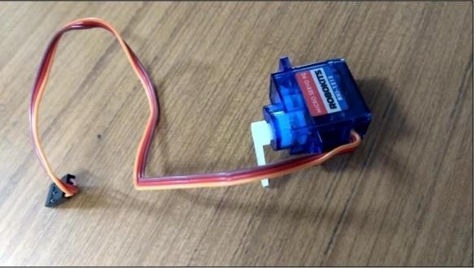

*Figure 1. 4: Servo Motor*

* 1. **Introduction about Stepper Motors**

Stepper can be converted from a digital pulse into a movement of a pen with respect to axis X, Y, Z direction. A stepper motor is a brushless motor that divides a full rotation into a number of equal steps; the stepper motor is known by its property to convert a number of impulses into a defined increment in the shaft position. Each pulse moves the shaft through a fixed angle. We have used 3 stepper motors with lead screws. Motor output will be in the form of rotation of the lead screw.

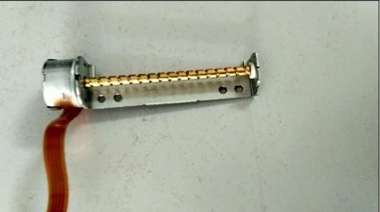

*Figure 1. 5: Stepper Motor*

**Chapter 2****PROJECT PLANNING**

**Step 1: Disassembly DVD/CD Drives**

First step to start building this CNC machine is to disassemble two DVD/CD drives and take off the stepper motors. Use the screwdriver to open them and take them off the rails. Next step is to choose our base for this CNC machine. I used one surface from the remaining DVD garbage' stuff. Finally we will need to find something to attach the one of the stepper-rails vertically to our construction.

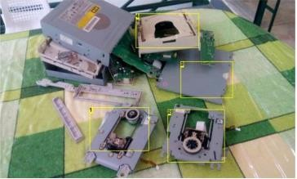

*Figure 2. 1: Disassembly of Drivers*

**Step 2: X and Y axis**

In the first image above you will see the Y axis of our CNC machine. Attach it on your surface, in this part you will need some screws and nuts. In the second image you will see the X and Y axis. The X axis is attached to two plastic parts that I took from remaining 'garbage' stuff. I cut it to fit the construction. This is an easy procedure. Just make sure to put the Y axis straight to the CNC base and the X axis vertically in this (90 degrees)

**Step 3: The Z axis**

That's the most difficult part of our construction. You will need something to attach it to the X axis, a flat surface. On that surface you will attach the servo motor (Z axis) and the pen base. Pen (or pencil) must be able to move up and down with the help of a servo motor. Servo motor must be able to move up and down the pen.

**Step 4: Paper base**

Now you will have to attach a wood (or plastic) surface on the Y axis (5x5cm will be fine). On this you will put the paper piece to print your texts or images. Remember, the printing area is 4x4cm.

**Step 5: The Circuit**

Now that we have our contraction ready, it's time to build the circuit and test stepper motors (X and Y axis). Watch the above image with the breadboard circuit schematic. Steppers motors wiring is something that needs patience. In the next step you will find a 'testing' code for the x and y axis. If yours steppers doesn't work properly you must find correct working combination by changing the cables between them and the L293D IC On mine CNC , X axis motor connection are: L293 A: Pins 1 and 3 & B: 2 and 4, but on Y axis motor connection are A: 1 and 2 & B: 3 and 4.

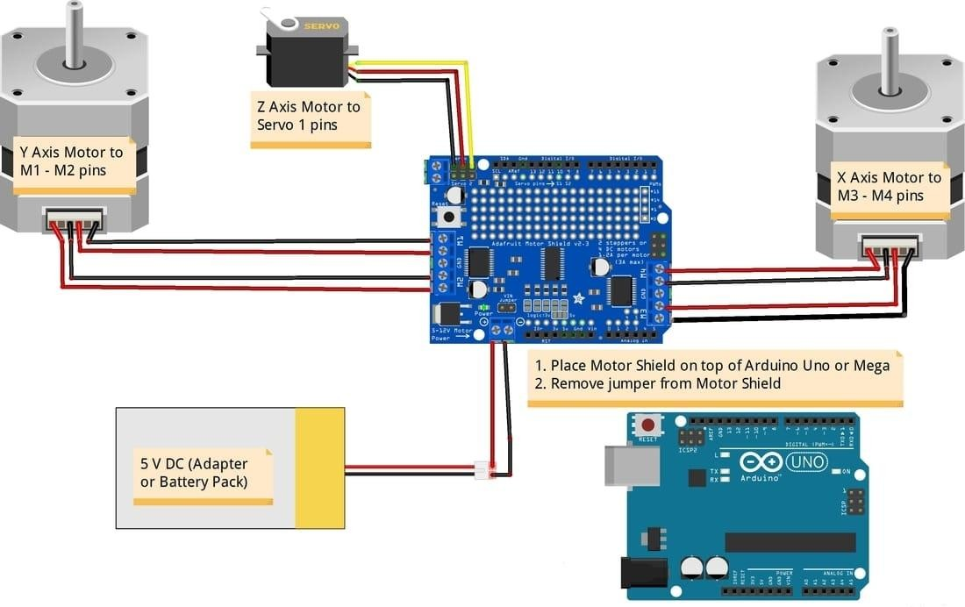

*Figure 2. 2: Circuit*

**Step 6: Testing X and Y axis movement**

Here is the X and Y axis testing code embedded using code bender For X axis: For Y axis: If you see any movement here that means that the stepper motor wiring is correct! if you don't, try to change the cables.

**Step 7: Uploading the CNC code**

Here is the main CNC code embedded using code bender In this part you will see your pen go up. If don't, change the pen Up and pen Down variables that control the servo motor. Press the "Run on Arduino" button and program your board from your browser

**Step 8: The GCTRL program**

Now we are ready to print our first image! To do this we will use the gctrl.pde processing program. This program sends 'G code' images to the CNC plotter. What is G code? G code is a file with X,Y and Z coordinates. Header of this file is set to: M300 S30.00 (Servo down) G1 X10.00 Y10.00 F2500.00 G1 X20.00 Y10.00 F 2500.00 M300 S50.00 (Servo up) Download Processing from here, now download and open GCTRL.pde application. Click the "play" icon/button to start the program. ~Watch the above image~ Now press 'p' and select your Arduino serial port. Press 'g' and select the 'drawing g code' file.

**Step 9: Make your own G code file**

To make g code files that are compatible with this CNC machine you have to use Inkscape. Inkscape is professional quality vector graphics software which runs on Windows, Mac OS X and Linux. It is used by design professionals and hobbyists worldwide, for creating a wide variety of graphics such as illustrations, icons, logos, diagrams, maps and web graphics. Inkscape uses the W3C open standard SVG (Scalable Vector Graphics) as its native format, and is free and open-source software. Download and install Inkscape from here (Important: download 0.48.5 version) Now you need to install an Add-on that enables the export of images to g code files. This add-

on can be found here with installation notes. Setup Inkscape for first use. Open the Inkscape, go to the File menu and click "Document Properties". See the 1st image above and make the changes, make sure to change first to "cm ''. Now close this window. We will use the area within 4 to 8 cm. See the 2nd image above. How to print texts: Put text, change font to Times New Roman and size to 22. Now click on the cursor icon and center the text like the 3rd image above. Select Path from the menu and "Object to Path". How to print images This is more difficult than texts. Images must have a transparent background. Drag and drop the arduino logo image (download it from files) in Inkscape. Click ok to the next window. Now you have to resize the image to fit our printing area, see the 4th image above. Click Path from the menu and "Trace Bitmap". Make changes as shown in the 5th image above. Click ok and close the window. Now, move the gray scale image, and delete the color one behind it. Move the grey image to the correct place again and click from the Path menu "Object to path". The 6th image above shows how to delete an image outline.

Export as g code.

Finally, go to the file menu, click save as and select g code. Click ok on the next window. That's it! Ready to go! Use the gctrl.pde app to print the g code file on your new Arduino CNC Plotter!

**Chapter 3****METHODOLOGY**

We have supplied the current in Arduino with a USB DATA cable to transfer Data from Computer to Arduino Board. Here we have used 3 Stepper Drivers to supply the G codes in Sequence to the stepper motors. The Arduino will be mounted on a CNC shield. The CNC shield will be distributing the Current in the command of Arduino. The CNC shield will convert the command of G codes into a digital pulse using a Stepper motor. In X direction Stepper motor will be move left and Right ,Y direction stepper motor will be move in front and back direction, Z direction Stepper motor will be move in Up and down. We have made a very difficult design using this machine. The accuracy of this machine's result is very high. So we have used it in industry to reduce the cost of design printing and maintain accuracy. Drafting and Scaling of CNC Plotter machines is very precious.

## DESIGN OF CNC MACHINE

There are 3 movements of using 3 CD ROMs. The horizontal movement(X) i.e. forward & backward movement is provided by the lower CD Rom. The 2nd CD Rom is mounted between the 2 columns which provide side

movements(Y) i.e. left and right hand side movements. The spindle which is mounted on the 3rd CD Rom provides vertical movement (Z) for the feed of the tool.

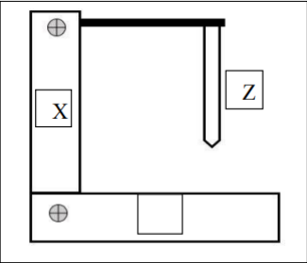

*Figure 3. 1: Design of CNC Machine*

## WORKING

The plotter has 3 degrees of freedom. The pen can move up and down in the Z axis and the pen is free to move along the 2D plane (X-Y axis). The pen is gripped by a servo motor for upward and downward movement. The setup has a base to enclose the circuitry. Above the base mechanism to move the plotter in the X and Y direction and ahead , the pen is assembled on the base. Two bi-directional motors are used in which one motor is used for the X axis and another for Y axis.

The coordinates are uploaded to the machine controller by a separate program. The image file is transformed into a G-code via software. Then the code is transferred to the microcontroller by which the motor mechanism is instructed to draw an image. In this paper, we are going to present a simple design for a 2D plotter. Our idea is an Arduino based on the Arduino Uno and L293D motor driver. The machine will have three motors to implement the X, Y and Z axis. A servo motor will be used along the Z axis for positioning the pen which will go up for logic ‘0’ and down for logic ‘1’ . Drawing will be done on the X-Y plane where the positioning will be controlled by stepper motors. System. The X axis is attached to two plastic parts and was cut to fit the construction. Ensure to put the Y axis straight to the 2D plotter base and the X axis vertically in this. On that surface the servo motor (Z axis) will be attached to the pen base. Pen must be able to move up and down with the aid of a servo motor. Now it will have to attach a hard surface on the Y axis. On this, it will put the paper piece to print the text or image that we programmed. The area of printing is 4cm x 4cm.

## Main Parts of CNC Plotter

The Mini CNC Plotter Machine works on input as a G code of Design and converts it via use of Arduino, Stepper Drivers, CNC Shield, Stepper Motor into a Rotation of Lead screw. We have to work to maintain the lowest

cost of our project. We have designed a simple construction of our project. This is an easier way to use a stepper motor with lead screw, CNC shield, Stepper drivers, Arduino Board, etc. The Setup of the machine is flexible that’s why it will be easily transported and Maintenance time is short. The basic diagram of a CNC Plotter machine is shown in figure.

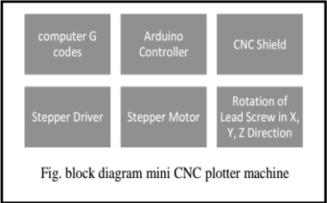

*Figure 3. 2: Main Parts of CNC Plotter*

## BLOCK DIAGRAM OF PROCESS

In this project, an Arduino microcontroller platform with an ATMEGA

328 core is used. It can be easily interfaced with PC using FTDI module whereas also with the easy drivers and stepper motors to. The basic block diagram is as shown. The explanation is given as follows

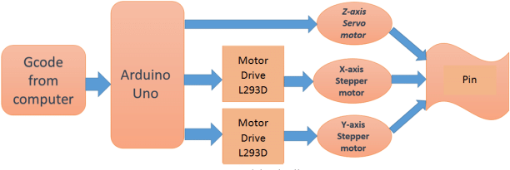

*Figure 3. 3: Block Diagram*

**Chapter 4****SOFTWARES**

## Inkscape 0.48.5

Inkscape is used to design the plotted diagram or text. In this project by using this software G-code file of a selected image or text is created; G- code is a commonly used numerical control programming language which includes X, Y, Z coordinates.

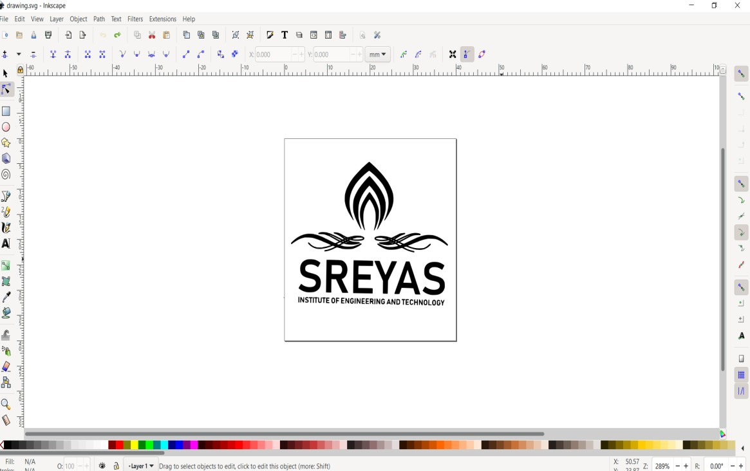

*Figure 4. 1: Inkscape*

* + 1. **Creating G-Code File Using Inkscape**

The CNC plotter of our project will work within 20cm×20cm area So we choose the document properties of the Inkscape 40cmx40cm (Width × Height) which is four times the working area of the plotter because the plotter can draw only in the first quadrant. So we have initially kept the axes at the nearest end of the motors which is considered the origin to easily modify the design. The working area of the CNC plotter is shown with the text written in the predefined area. The text is selected using the cursor and then select “object to path” from the drop down window to save the G code form of the selected text. To create a G-code of an image, the file must have a transparent background. The image should be dragged into the selected area then select “trace bitmap” from the drop down window to create a transparent image. Scans are selected as 8 and “Edge detection” is selected to create black & white image. After adding this transparent image in the predefined area we used the “object to path” command to create the G-code file of the selected image by following the steps described earlier.

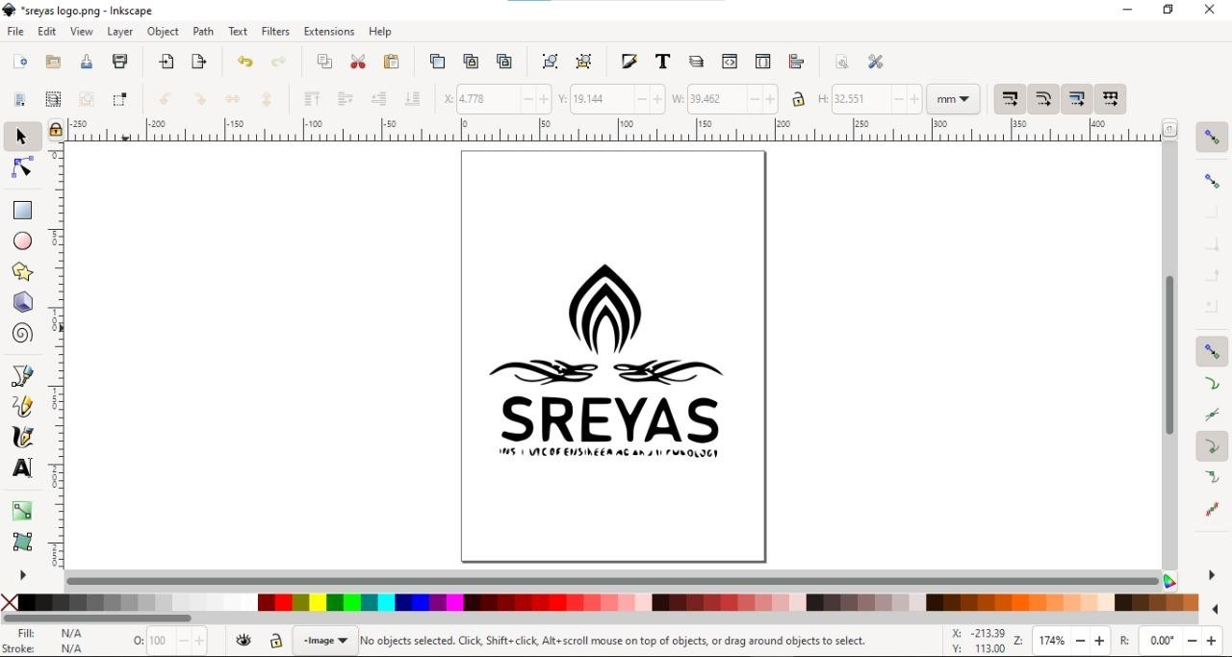

*Figure 4. 2: Diagram*

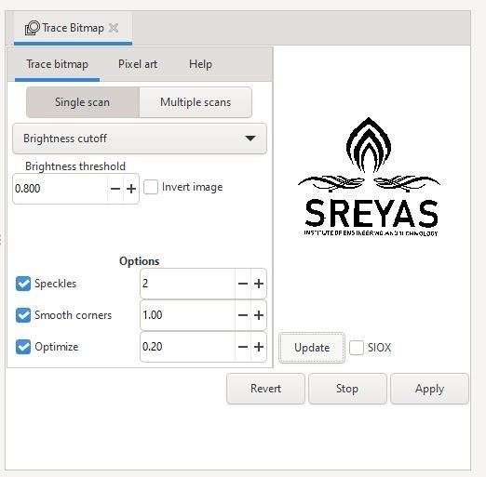

*Figure 4. 3: Outline of Diagram*

## Processing

Processing is open source programming language software which is used for electronic drawings. The GCTRL processing program is used to send a G-code file from the user interface to a CNC plotter. The user interface of processing 2.2.1 software after running the GCTRL program. The port of Arduino Uno is selected by pressing „P‟ button on keyboard hence G button is used to upload our desired G-code file. Immediately CNC machine will start sketching selected G-code file. Sketching can be stopped by pressing the X button.

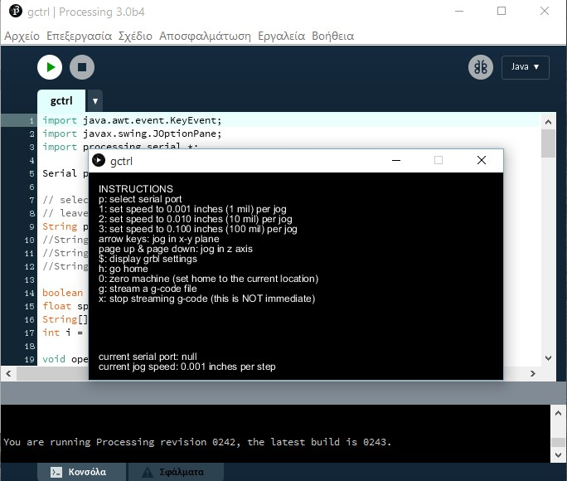

*Figure 4. 4: Processing*

# Chapter 5

# Advantages, Disadvantages & Application

## CNC Machine Advantages

1. CNC machines can be used continuously 24×7 throughout the year and only need to be switched off for occasional maintenance.
2. CNC machines are programmed with a design which can then be manufactured hundreds or even thousands of times. Each manufactured product will be exactly the same.
3. Less skilled/trained people can operate CNC machines unlike manual lathes / milling machines etc. which need skilled engineers.
4. CNC machines can be updated by improving the software used to drive the machines
5. Training for correct use of CNC machines is available through the use of ‘virtual software’. This software is like a computer game that allows the operator to practice using the CNC machine on the screen of a computer.
6. Modern design software allows the designer to simulate the manufacture of his/her idea. There is no need to make a prototype or a model. This saves time and money.
7. One person can supervise many CNC machines as once they are programmed they can usually be left to work by themselves. Only the cutting tools need replacement occasionally.

## CNC Machine Disadvantages

The machine runs at a slow pace and generates excess heat which causes the heat sink to be heated quickly. A slight error may remain on the image file after it has been plotted due to one side of the Y-axis fixed to the moving mechanism and the other end is free to move. The Z-axis is not very rigid so it causes slight vibration.The machine runs at a slow pace and generates excess heat which causes the heat sink to be heated quickly. A slight error may remain on the image file after it has been plotted due to one side of the Y-axis fixed to the moving mechanism and the other end is free to move. The Z-axis is not very rigid so it causes slight vibration.

## Applications

1. Aerospace
   * Nearly every industry requires accuracy, but it is very crucial that

airplane parts like turbine engines are built and operate at high accuracy levels. Aircraft cannot be considered safe or reliable for both goods and humans for travel purposes without exact parts.

1. Automotive
   * CNC machining is used in gears, pins, brakes, shafts, and other

parts which are used on various types of vehicles of various models and sizes. From military cars to specialized auto vehicles, CNC machines play a major role in the production of both small and large parts.

1. Milling
   * With CNC machines, you can mill all materials. Different variants like synchronized milling and standard milling are used.
2. Cutting
   * You can also use a CNC machine as a cutting machine or as a plotter. There are many possible applications in this respect; the

choice of the tool entirely depends on the material to be processed. CNC cutters are usually used to describe logos or lettering and cut them out of foil perfectly.

# Chapter 6

## Conclusion

In this paper we have presented the concept of a low cost three-axis mini CNC plotter. The existing CNC machines are of high cost, difficult to maintain and require highly skilled operators. Our CNC plotter overcomes these problems. It is of low cost and easy to control and there is no need for highly skilled operators. It can be used for long hours at a stretch which is not possible in existing ones. It is hoped to extend this work for future development.

## Future Work

The pen of the machine can be replaced by a laser to make it work like a laser engraving or cutting machine. Engraving machines can be used on wood. The pen can also be replaced with a powerful drill so that it can be used for both milling and drilling purposes. The servo can be replaced with a stepper motor and the pen with a 3-D pen to make it a 3-D printer which can print objects with dimensions. By extrapolation of the axes, the working area of the machine can be extended, keeping the algorithm unaltered.

**References**

* + 1. <https://www.arduino.cc/en/guide/Enviroment>
    2. <https://www.inkscape.org/>
    3. <https://github.com/martymcguire/inkscape-uinicorn>
    4. [https:/](https://processing.org/download)
    5. [/processing.org/download](https://processing.org/download).
    6. V.K. Pabolu and K.N.H. Shrinivas, "Design and implementation of a three -dimensional CNC machine", Int. J. Computer Science and Engineering, vol. 2,pp. 2567-2570 2010 .
    7. I. Nae and T. Andrei, "Designing and building a CNC router using stepper motors'', Serial Technical, vo. LXII, pp. 55-62, 2010 .
    8. I. Pahole, L. Rataj, M. Ficko, S. Klancnik, S.Brezovnik, M.Brezovnik, and J. Balic, "Construction and evaluation of low cost table CNC milling machine", Scientific Bulletin, Series C: Mechanics, Tribology, MachineManufacturing Technology, vol. XXIII, pp. 1-7, 2009.