Industrial Inventory Control using Reinforcement Learning
Project Report -- Roll Number DA25M579, Variant V030

1. Implementation Summary
Assigned parameter variant: V030, generated deterministically from roll number DA25M579. The variant sets the demand multiplier, initial-inventory and lead-time-delay profiles within the declared public ranges; the core environment, action space and cost/reward definitions are unmodified and identical for every student.
Five distinct reinforcement-learning techniques were submitted:
- PPO: Actor-critic policy-gradient with a clipped surrogate objective (Stable-Baselines3). Trained on 35-dim engineered features with a MultiDiscrete([11,11,11]) action head; recovered from a badly under-trained iteration-1 baseline via a learning-rate/entropy screen followed by a 1.5M-timestep promotion run.
- DQN: Value-based Q-learning with a neural Q-network over a joint Discrete(1331) action space (base-11 encoding of the 3 per-product order levels). Unchanged since its first training run -- already the strongest baseline technique.
- Neural Network SARSA: On-policy value-based method: the TD target evaluates Q at the action the epsilon-greedy behaviour policy actually took next (never the greedy argmax), verified with a dedicated unit test. Uses a 76-dim raw+engineered feature representation with explicit inventory-position-gap and days-of-supply signals.
- A2C: Synchronous actor-critic with an entropy bonus, trained on the same 35-dim feature pipeline and MultiDiscrete action space as PPO/DQN.
- TD(lambda): True Online SARSA(lambda) with linear function approximation and dutch eligibility traces over 54 sparse, coarse-coded state-band features, acting over a curated 48-action catalogue rather than the full 1,331-action space.

2. Experimental Approach
Two independent state-representation pipelines are used across the five techniques. PPO, DQN and A2C use a 35-dimensional hand-engineered feature vector (inventory, arrival pipeline, 3/7-day demand statistics, day index, capacity utilisation and a few derived ratios). Neural Network SARSA uses a 76-dimensional representation: 38 raw normalized features plus 38 further-engineered features (per-product inventory-position gap, lead-time-demand estimate, days-of-supply, demand trend; 8 global capacity/horizon features). TD(lambda) uses its own 54-dimensional sparse, coarse-coded band discretisation purpose-built for a linear function approximator. All three pipelines were built only from the documented observation dictionary; none inspect future demand or scenario identity.
Reward shaping: all five techniques were trained with an auxiliary shaping wrapper (ShapedReward) that adds three dense terms derived from the environment's own info dict -- an extra stockout penalty, a discard/utilisation penalty, and a mild order-batching nudge -- each annealed linearly to zero over the training budget. Every cost/service number reported in this report and in the notebook is computed on the raw, unshaped environment reward; shaping only affects the training signal and never affects evaluation or the frozen leaderboard submissions.
Hyperparameters that materially affected performance: for PPO, learning rate dominated over the entropy coefficient (lr=3e-4 configurations reached 135k-147k local cost while lr=1e-4 configurations collapsed to ~928k, regardless of entropy). For Neural Network SARSA, correcting a feature-engineering bug (early-episode demand means were including zero-padded history rows) and running a proper multi-seed promotion of the winning learning-rate/gamma/epsilon configuration reduced local cost by roughly 28% relative to a single earlier screening run. For TD(lambda), an 18-configuration grid search over gamma/lambda/alpha found gamma=0.98, lambda=0.7, alpha=0.01 to be both cheapest and most stable across 3 training seeds (standard deviation of only ~1,578 across seeds).
Local validation approach: every technique is evaluated on three fixed episode suites generated by the project's own local harness -- Suite A (40 seeds x 5 scenario modes = 200 episodes, assigned configuration; the primary local comparison basis), Suite B (7 legal configuration variants x 5 scenario modes x 6 seeds = 210 episodes, robustness check against configurations other than the exact assigned one), and Suite C (125 episodes on a locked, held-out seed range never used for any hyperparameter search, used as a local proxy for out-of-sample generalisation). The 5 scenario modes used locally are the 4 declared demand families (stationary, seasonal, trend, shock) plus a local random/mixed testing mode that combines them -- not five separately declared families.

3. Results
Compact comparison of the five selected techniques on Suite A (local validation; public/private leaderboard numbers will be produced by the course evaluator after submission):
Technique | Mean cost | Std cost | Service level | Suite C cost
PPO | 91,470 | 11,639 | 98.8% | 91,670
DQN | 96,871 | 11,858 | 98.9% | 98,781
Neural Network SARSA | 111,731 | 9,941 | 99.3% | 113,286
A2C | 114,669 | 24,492 | 96.9% | 108,096
TD(lambda) | 122,769 | 11,749 | 98.9% | 125,099

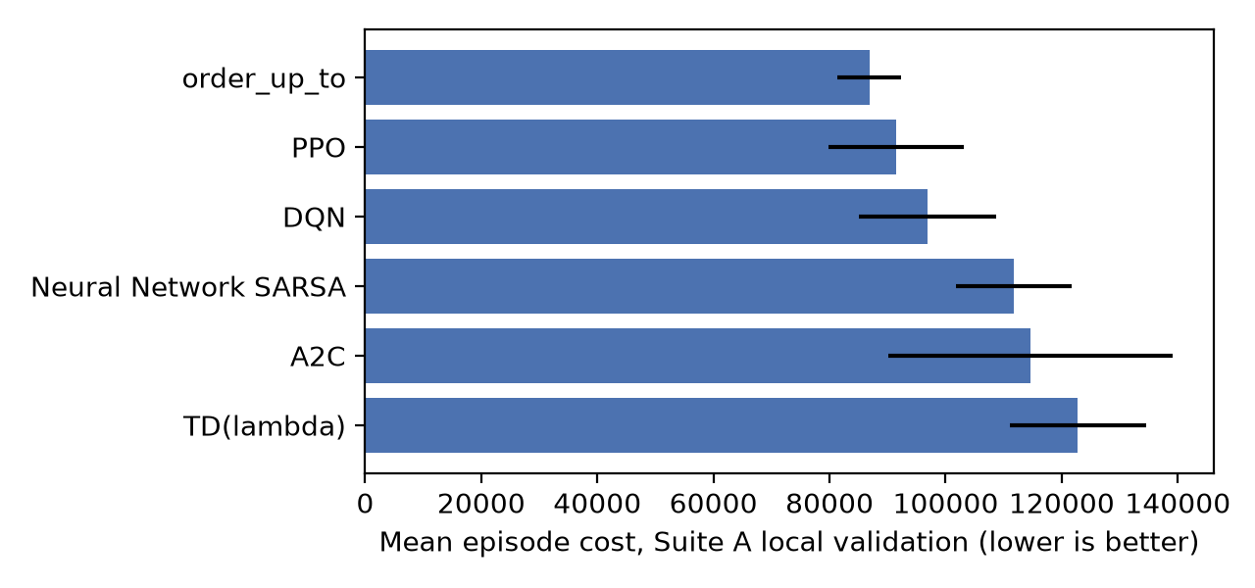
All five techniques clear the project's internal 95% service-level screening threshold (a local selection rule used to narrow seven implemented techniques down to five, not an official leaderboard qualification rule) with wide margins (96.9%-99.3%). Two additional techniques were implemented and locally validated but are not part of the primary five: Double DQN (126,999 local cost, 98.8% service) and REINFORCE (213,392 local cost, 90.9% service, excluded by the internal service threshold). Every one of the five selected policy files was independently verified via the provided policy_validation_tests.py, an exported-vs-training-side action-parity check on 30 representative observations (exact match for all five), and a black-box test that copies each policy file alone into a clean directory outside this project and runs a complete 50-day episode through it with no access to any other local package -- all five reproduced their recorded Suite A cost exactly under this isolation test.

4. Observations and Inference
PPO and DQN are the two strongest techniques locally, both within ~10% of the simple order-up-to heuristic baseline. PPO's on-policy clipped updates and DQN's off-policy value learning both converge to similarly efficient, low-variance ordering policies once correctly tuned -- the earlier under-performance of PPO traced entirely to learning rate, not to any structural limitation of the algorithm.
Neural Network SARSA improved the most of any technique across the project (a ~28% cost reduction from a fixed feature bug plus a disciplined multi-seed promotion), ending up as the third-strongest technique -- evidence that on-policy value learning with the true SARSA target is competitive with DQN once given an equally informative feature set and a properly-conducted hyperparameter search.
A2C is the most variable of the five on Suite A (highest standard deviation, 96.9% service -- still comfortably above the internal threshold) but was, surprisingly, the only one of the five whose locked-proxy Suite C cost improved relative to its Suite A cost, and it narrowly outperforms Neural Network SARSA specifically on that locked suite. This is flagged as an open question rather than resolved: it suggests A2C's policy may generalise unusually well to configurations it was not tuned against, and the Suite A ranking between these two techniques should not be treated as fully settled.
TD(lambda), a purely linear model over coarse features and a reduced 48-action catalogue, reaches within ~34% of PPO's cost while being three to four orders of magnitude faster at inference than any neural-network technique and the most stable across independent training seeds of anything built. This indicates the inventory-control problem has significant learnable structure that a well-designed linear representation captures cheaply, even though its action-space reduction caps its ultimate ceiling below the neural-network techniques.
Key lesson: for this problem, feature-engineering correctness (the SARSA zero-padding bug) and disciplined hyperparameter search with multi-seed promotion (PPO, Neural SARSA, TD(lambda)) produced larger, more reliable cost reductions than any single algorithmic novelty -- Double DQN's algorithmic fix (decoupling action selection from evaluation) only translated into a real improvement once combined with the corrected feature set and a longer exploration warm-up, underscoring that implementation correctness and training discipline dominate raw algorithm choice in this environment.

