Shared Task Coordination Service (STCS)
Project: Phase 2 Report (One Client and One Server)
Student: Sai Praneeth Bhattu
Course: CIS 527 - Computer Networks

Table of Contents
1. Implementation Overview 4
1.1 What Phase 2 delivers 4
1.2 Scope of this phase 4
1.3 Technology 4
2. Implementation Architecture 5
2.1 Architecture diagram (updated for Phase 2) 5
2.2 Modules and responsibilities 5
2.3 Session state machine 6
2.4 Server control flow 6
2.5 Phase 3 migration points 7
3. Implementation Details 7
3.1 Message framing 7
3.2 Strict JSON 7
3.3 Validation pipeline 8
3.4 Application logic 8
3.5 Server session handling and disconnect detection 8
3.6 Client 8
3.7 Resource cleanup 9
4. Updated Protocol Specification - STCS - P2 9
4.1 Framing 9
4.2 Encoding and limits 9
4.3 Message envelope 9
4.4 Session states 10
4.5 Commands 10
4.5.1 HELLO 10
4.5.2 HELP 11
4.5.3 LIST_TASKS 11
4.5.4 CREATE_TASK 11
4.5.5 CLAIM_TASK 12
4.5.6 RELEASE_TASK 12
4.5.7 COMPLETE_TASK 13
4.5.8 DELETE_TASK 13
4.5.9 QUIT 13
4.6 Error codes 14
5. Data Design 14
5.1 Task 14
5.2 Other structures 15
5.3 Shared state and locking (Phase 3 plan) 15
6. Sequence Diagrams 15
6.1 Connection and HELLO 15
6.2 CREATE_TASK (valid, then invalid) 16
6.3 LIST_TASKS 16
6.4 CLAIM_TASK, including CONFLICT 17
6.5 Error and retry 17
6.6 QUIT and graceful close 18
6.7 Framing 18
7. Logging 18
7.1 Format 18
7.2 What is logged 18
7.3 Privacy 19
7.4 Sample log 19
8. Phase 2 Testing 19
8.1 Approach 19
8.2 Results 19
8.3 Status of the Phase 1 test plan 20
8.4 Test report (detailed) 21
8.4.1 Suite 1 - Framing unit tests (12) 21
8.4.2 Suite 2 - Unit and in-process protocol tests (34) 21
8.4.3 Suite 3 - Integration tests over TCP (28) 24
8.4.4 Manual checks (4) 26
8.4.5 Deferred tests (not executed) 26
8.5 Requirement traceability matrix 27
Functional requirements 27
Nonfunctional requirements 27
8.6 Phase 2 error scenarios demonstrated 28
8.7 Limits of the testing 28
9. Design-Change Summary 28
10. Phase 2 Demonstration 30
10.1 What the demonstration shows 30
10.2 Demonstration script 30
10.3 Talking points for each component 30
10.4 Captured demonstration: Ana (client terminal) 30
10.5 Captured demonstration: error handling 31
10.6 Captured demonstration: Ben (second session) 32
11. Limitations and Phase 3 Preparation 32
11.1 Known limitations of Phase 2 32
11.2 Phase 3 plan 32

1. Implementation Overview

1.1 What Phase 2 delivers
Phase 2 is the first complete vertical slice of the Shared Task Coordination Service (STCS): one client connects to one server over TCP, exchanges newline-delimited JSON messages, uses all nine Phase 1 commands to change and read a shared task list and disconnects gracefully. The server serves one client at a time and returns to listening when the session ends. Concurrency is deliberately left for Phase 3.
The Phase 1 report is the source of truth. The wire protocol (STCS v1) is implemented as designed: no command, field, error code or framing rule was added, removed or renamed. Section 9 lists the clarifications that were needed where Phase 1 left a detail open.

1.2 Scope of this phase
Area | Delivered in Phase 2 | Left for Phase 3 / future
Networking | Server: socket, bind, listen, accept, recv, send_all, close. Client: getaddrinfo, non-blocking connect with a 10 s deadline, send_all, recv, close. | One thread per client (accept loop change only).
Protocol | Framer for partial reads and coalesced messages; strict JSON; full envelope and payload validation; all 12 error codes defined (11 emitted). | No protocol change.
Commands | HELLO, HELP, LIST_TASKS, CREATE_TASK, CLAIM_TASK, RELEASE_TASK, COMPLETE_TASK, DELETE_TASK, QUIT. | -
State | In-memory task list and session record; session state machine CONNECTED, READY, CLOSING, CLOSED. | task_lock, session_lock, logger mutex.
Logging | Timestamped file log with echo to the terminal. | Session-tagged lines already present.
Client UI | Plain-text prompt within 80 columns; local validation; connection-failure reporting. | -
Persistence | None (tasks live for the life of the server process). | FR-27 (future work).

1.3 Technology
- Language: C++17, standard library only, no third-party packages. Compiled with g++ 13.3 using -Wall -Wextra -Wpedantic; builds without warnings.
- Sockets: POSIX TCP sockets called directly (socket, bind, listen, accept, connect, send, recv, poll, close). No HTTP, REST, WebSocket, RPC framework, database or GUI is used.
- Size: about 4,400 lines of source (shared 1,659, server 1,471, client 1,311) and about 1,700 lines of tests.
- Build: a single Makefile (make, make tests, make check, make clean). Binaries are bin/server and bin/client.

2. Implementation Architecture

2.1 Architecture diagram (updated for Phase 2)
The Phase 1 architecture is unchanged; Figure 1 shows the part that now exists (one client, one server) and marks the Phase 3 migration point.
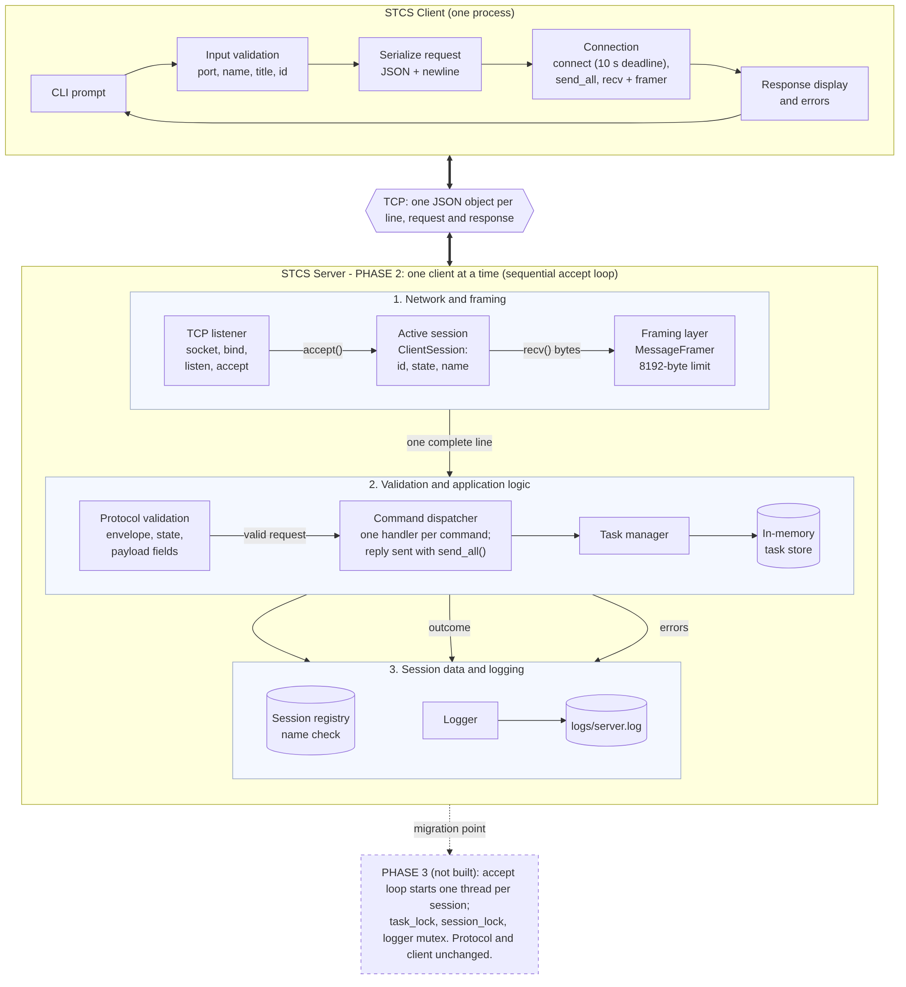
Figure 1. STCS Phase 2 architecture: one client, one server (Phase 3 shown as the future migration point)

2.2 Modules and responsibilities
Networking, framing, protocol validation, application logic, data, user interface and logging each live in their own module (NFR-12). The shared/ modules are used by both programs.
Dir | Module | Responsibility | Phase 3 effect
shared/ | net | RAII Socket, send_all (loops over partial sends, MSG_NOSIGNAL), peer address formatting, SIGPIPE handling. | None
shared/ | framing | MessageFramer: buffers bytes, extracts lines, strips CR, reports Blank / TooLarge, bounded memory, resynchronises. frame_message adds the newline. | None; one framer per session
shared/ | json | Strict RFC 8259 parser and serializer; ordered keys; duplicate keys rejected; depth limit 32; integers distinguished from doubles. | None
shared/ | utf8 | UTF-8 validation, code-point counting, safe truncation. | None
shared/ | protocol | Constants, command table, error codes, envelope parsing and response building, Task type. | None
shared/ | validation | Display name, title, port and task-id rules. | None
shared/ | timeutil | ISO-8601 UTC timestamps. | None
server/ | server | Listener, accept loop, per-session receive loop, disconnect detection, shutdown via self-pipe. | Accept loop starts a thread per session
server/ | dispatcher | Envelope, state check and payload validation order; one handler per command; builds replies; logs outcomes. | None
server/ | request_validation | Payload field readers (read_title, read_task_id, ...). | None
server/ | task_manager | Task store: create, list, claim, release, complete, delete. Each method is one check-then-act unit. | Add task_lock_ (marked // PHASE 3)
server/ | session | ClientSession and SessionRegistry (ids, name uniqueness). | Add session_lock
server/ | logger | Timestamped log to file and terminal; sanitises client text. | Add a mutex in write_line
client/ | connection | Connect with deadline and friendly errors, send_line, receive_line (own framer), graceful close. | None
client/ | input_parser | Turns a typed line into a UserCommand with local validation. | None
client/ | display | Tables, task detail, error and help text, 80-column wrapping. | None
client/ | client_app | Session flow: HELLO with name retry, command loop, request/response exchange, request id matching. | None

2.3 Session state machine
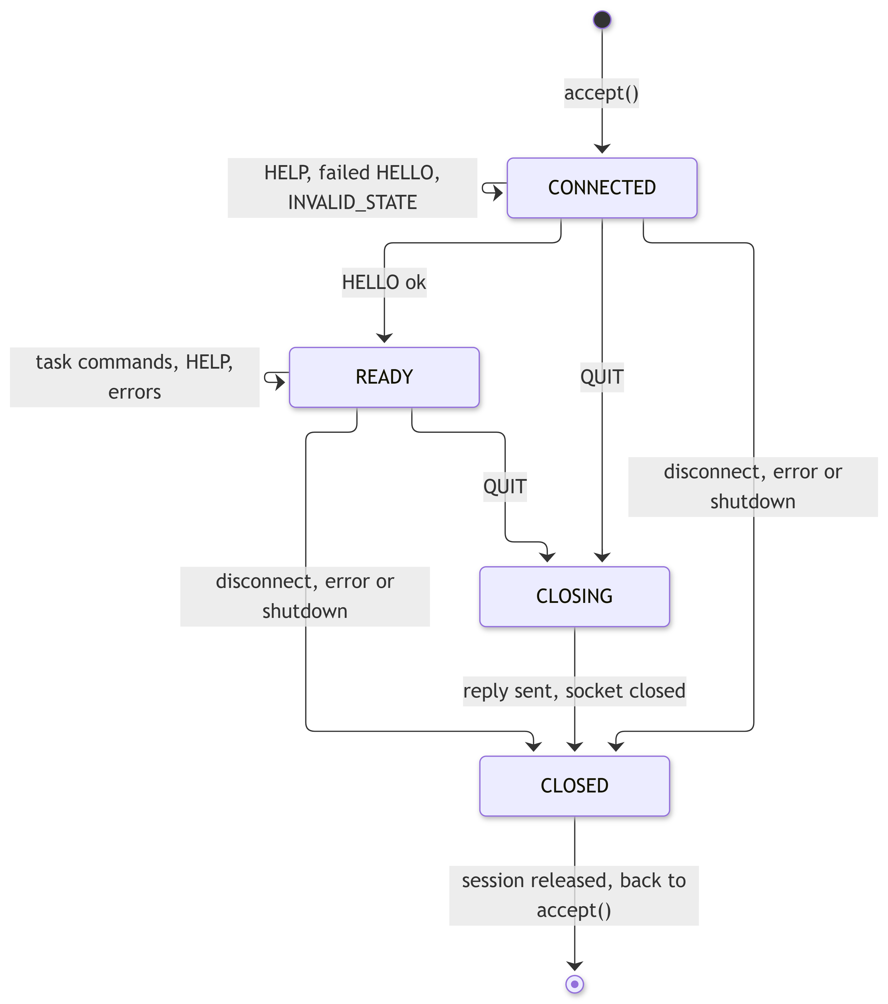

Figure 2. Session states (unchanged from Phase 1, section 7.4)

2.4 Server control flow
The server is a plain sequential loop:
- start(): create the wake-up pipe, socket(), setsockopt(SO_REUSEADDR), bind() to 0.0.0.0:port, listen() with backlog 5; log "Server listening on 0.0.0.0:PORT".
- run(): poll() on the listening socket and the wake-up pipe; when the listener is readable, accept(), create a ClientSession, log the connection.
- serve_client(): poll() on the client socket and the wake-up pipe; recv() into a 4096-byte chunk; feed the framer; for every complete frame call the dispatcher and send_all() the reply; stop on QUIT, on recv() returning 0 or an error, or on shutdown.
- Log the end of the session ("disconnected gracefully" or "disconnected unexpectedly"), release the session and its display name, close the socket and go back to step 2.
- SIGINT or SIGTERM writes one byte to the wake-up pipe (the only thing the signal handler does). poll() returns, any active session is closed, "Shutdown requested" and "Server shutdown complete" are logged and the process exits with status 0. No timeouts or flags are polled.

2.5 Phase 3 migration points
Phase 3 changes are confined to four places; the protocol, the framer, the dispatcher and the client stay as they are.
Where | Change
Server::run() accept loop | Instead of calling serve_client() inline, start one thread that runs it, then continue accepting (marked // PHASE 3).
TaskManager public methods | std::lock_guard on task_lock_ as the first statement; no caller changes.
SessionRegistry | session_lock around add, reserve_name, remove (never held together with task_lock_).
Logger::write_line | A mutex so lines from different threads do not interleave.

3. Implementation Details

3.1 Message framing
TCP is a byte stream, so one send() is never assumed to equal one recv(). Each side owns a MessageFramer. Every recv() appends its bytes to the framer; the program then asks for frames until none is left:
char chunk[4096];
n = recv(fd, chunk, sizeof chunk, 0); // n == 0: peer closed
framer.feed(chunk, n);
while (framer.next_frame(frame)) { // zero, one or many frames per recv
handle(frame); // Message, Blank or TooLarge
}
- A line is the bytes before \n; a trailing \r is stripped. Incomplete data stays buffered until its newline arrives, so partial reads need no delay or retry timer.
- Several complete lines in one read are returned one after another in arrival order; a trailing fragment stays buffered.
- A blank line is reported as Blank (the server answers INVALID_MESSAGE).
- A line over 8192 bytes is reported once as TooLarge (the server answers MESSAGE_TOO_LARGE). The rest of that line is discarded up to its newline and normal framing resumes. A line that has not ended by 8192 bytes is reported immediately and the buffer is cleared, so per-session memory stays bounded (NFR-11).
- Outgoing messages are serialised with every control character escaped, so a framed message never contains a raw newline; frame_message throws if one slips through.
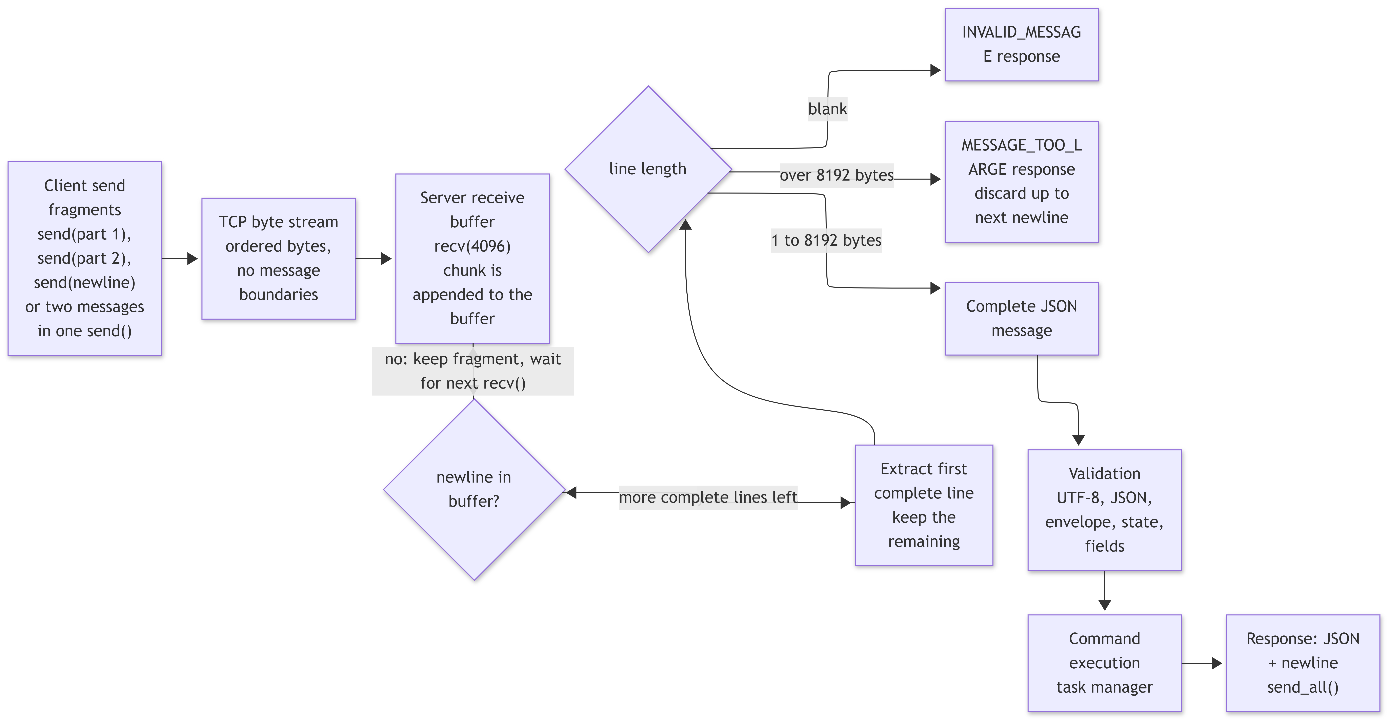
Figure 3. Framing and validation pipeline

3.2 Strict JSON
A small hand-written parser and serializer (no library) implements RFC 8259 strictly: UTF-8 is validated, surrogate pairs are decoded, duplicate keys and trailing commas are rejected, nesting is limited to 32 levels and integers are kept distinct from floating-point numbers so that "task_id": 7.0 is not accepted as an integer.

3.3 Validation pipeline
RequestDispatcher::handle_frame() applies the checks in a fixed order and stops at the first failure. The order is part of the specification (section 4.3):
- The line must be valid UTF-8 and a JSON object, else INVALID_MESSAGE (request_id and command null).
- version: missing gives MISSING_FIELD; a non-integer gives INVALID_FIELD; an integer other than 1 gives INVALID_VERSION (payload lists supported_versions).
- type must be the string "REQUEST" (missing gives MISSING_FIELD, other values give INVALID_FIELD).
- request_id: missing gives MISSING_FIELD; anything other than a string of 1-64 bytes gives INVALID_FIELD.
- command: missing gives MISSING_FIELD; a non-string gives INVALID_FIELD; a name outside the table gives UNKNOWN_COMMAND.
- payload must be a JSON object.
- Session-state check: a command that is not legal in the current state gives INVALID_STATE.
- Payload field validation (MISSING_FIELD / INVALID_FIELD).
- Execution (NOT_FOUND / CONFLICT, or success).
Every reply is built from the same two functions (make_ok_response, make_error_response), so the field order is always version, type, request_id, command, status, [error_code, message,] payload. request_id and command are echoed whenever they could be recovered and are null otherwise.

3.4 Application logic
TaskManager knows nothing about sockets or JSON. Each public method (create, list, claim, release, complete, delete) reads the task, checks its status and writes the change in one uninterrupted unit and returns Ok, NotFound or Conflict together with the task as it now is. A Conflict never changes the task. Task ids come from a counter that only increases, so ids are never reused. The dispatcher turns each result into the Phase 1 response, for example CONFLICT with claimed_by in the payload.

3.5 Server session handling and disconnect detection
- recv() returning 0 means the client closed without QUIT: the server logs "disconnected unexpectedly (connection closed without QUIT)", adds "; N bytes of an incomplete message discarded" if the framer still held a fragment, then releases the session. A recv() error (for example a reset) is logged as a receive error.
- After QUIT the reply is sent, the session is CLOSING, "disconnected gracefully" is logged and the socket is closed. Every path ends with "session released".
- SIGPIPE is ignored and send_all uses MSG_NOSIGNAL, so writing to a dead peer returns an error instead of killing the server.
- A second client may complete connect() while the first is served (the kernel queues it in the listen backlog); its HELLO is answered after the first session ends (clarification C-7).

3.6 Client
- connection: getaddrinfo, non-blocking connect() with poll() and a 10 second overall deadline (NFR-09), friendly messages for refused, unresolved or timed-out connections, graceful close with shutdown(SHUT_WR).
- input_parser: validates locally (empty line, unknown verb, task id, list filter) before anything is sent.
- client_app: sends HELLO automatically (retrying with a new name on NAME_IN_USE or an invalid name), then loops reading commands. Each request gets a fresh request_id; a reply with another id is treated as a protocol failure rather than shown. Prompts re-ask on invalid title or priority; /cancel aborts; end of input acts as quit.
- display: tables and messages wrapped to 80 columns, errors shown as Error [CODE]: sentence plus a hint, never a stack trace or path (NFR-06, NFR-16).
- A developer command raw <COMMAND> [json] sends any command name with a JSON-object payload so that server-side errors (unknown command, missing field) can be demonstrated; it is documented in the README and the help text.

3.7 Resource cleanup
Sockets are held in an RAII Socket object (closed in the destructor on every path, including errors). Sessions are removed from the registry on every exit path. The log file is flushed after each line. On shutdown an active session is closed and logged as "closed by server shutdown", then the listening socket is closed.

4. Updated Protocol Specification - STCS - P2
This section replaces Phase 1 section 7 as the implemented protocol. It is the same protocol (STCS v1): the differences are clarifications of details that Phase 1 left open (listed with identifiers C-1 to C-12 in section 9). All examples below were captured from the running server (docs/protocol_examples.json); they are shown pretty-split here but are sent as one line each. A standalone copy of this specification is in docs/STCS_Protocol_Spec_P2.md.

4.1 Framing
Framing rule: one message = one JSON object, encoded as UTF-8, containing no raw newline, followed by exactly one \n byte. The receiver buffers bytes, processes nothing until a \n arrives, handles each complete line in arrival order and keeps a trailing fragment. No delay or sleep() is used to separate messages. Senders loop until every byte is sent.

4.2 Encoding and limits
Property | Value
Encoding | UTF-8, no BOM
Delimiter | \n (a single trailing \r is stripped)
Max request size | 8192 bytes per line (the limit applies to requests received by the server)
Max response size accepted by the client | 1 MiB (a LIST_TASKS reply can legitimately exceed 8192 bytes; clarification C-1)
Receive chunk | 4096 bytes per recv()
Timestamps | ISO-8601 UTC, for example 2026-10-04T15:01:17Z
Request id | string of 1-64 bytes
JSON nesting depth | at most 32 (clarification C-11)
An oversize line is answered with one MESSAGE_TOO_LARGE; the bytes up to the next newline are discarded and the stream resynchronizes.

4.3 Message envelope
Request
Field | Type | Required | Notes
version | integer | yes | 1
type | string | yes | "REQUEST"
request_id | string | yes | 1-64 bytes; client-generated, unique per session, echoed back unchanged
command | string | yes | One of the nine commands
payload | object | yes | {} when the command takes no arguments
Response: the same version, type "RESPONSE", the echoed request_id and command (or null when they could not be recovered), status ("OK" or "ERROR"), payload and, only for errors, error_code and a human-readable message.
{"version":1,"type":"REQUEST","request_id":"r3","command":"HELLO","payload":{"display_name":"Ana"}}
{"version":1,"type":"RESPONSE","request_id":"r3","command":"HELLO","status":"OK","payload":{"session_id":"sess-0001","display_name":"Ana","server_version":1,"commands":["HELLO","HELP","LIST_TASKS","CREATE_TASK","CLAIM_TASK","RELEASE_TASK","COMPLETE_TASK","DELETE_TASK","QUIT"]}}
Order of validation (the first failing check decides the reply):
- The line must be valid UTF-8 and a JSON object, else INVALID_MESSAGE (request_id and command null).
- version: missing gives MISSING_FIELD; a non-integer gives INVALID_FIELD; an integer other than 1 gives INVALID_VERSION (payload lists supported_versions).
- type must be the string "REQUEST" (missing gives MISSING_FIELD, other values give INVALID_FIELD).
- request_id: missing gives MISSING_FIELD; anything other than a string of 1-64 bytes gives INVALID_FIELD.
- command: missing gives MISSING_FIELD; a non-string gives INVALID_FIELD; a name outside the table gives UNKNOWN_COMMAND.
- payload must be a JSON object.
- Session-state check: a command that is not legal in the current state gives INVALID_STATE.
- Payload field validation (MISSING_FIELD / INVALID_FIELD).
- Execution (NOT_FOUND / CONFLICT, or success).
Unknown extra fields in the envelope or the payload are ignored. Duplicate keys are rejected as invalid JSON (C-11).
Versioning: version 1 only. A missing version is MISSING_FIELD, a non-integer is INVALID_FIELD, any other integer is INVALID_VERSION with supported_versions. Request ids are chosen by the client and echoed unchanged; the client treats a reply with another id as a protocol failure. Notifications: none; every server message answers one request.

4.4 Session states
State | Legal commands
DISCONNECTED | none (no socket)
CONNECTED | HELLO, HELP, QUIT; anything else returns INVALID_STATE
READY | all task commands, HELP, QUIT (a second HELLO returns INVALID_STATE)
CLOSING, CLOSED | none; the socket is closed and the session released
CONNECTED, HELLO, READY, commands, QUIT, CLOSING, CLOSED. A failed HELLO leaves the session in CONNECTED. An INVALID_STATE error never closes the connection.

4.5 Commands
The Task entity in every message has: task_id (integer >= 1), title (string), priority ("LOW" | "MEDIUM" | "HIGH"), status ("OPEN" | "CLAIMED" | "DONE"), claimed_by (string or null), created_by (string), created_at (ISO-8601 UTC string). Any command can also fail with the envelope errors INVALID_MESSAGE, INVALID_VERSION, MISSING_FIELD / INVALID_FIELD (envelope), UNKNOWN_COMMAND, MESSAGE_TOO_LARGE, INVALID_STATE and SERVER_ERROR; the per-command lists below name the errors specific to that command.

4.5.1 HELLO
Purpose | Starts the session: registers the client's display name and moves the session from CONNECTED to READY.
State | CONNECTED only (a second HELLO returns INVALID_STATE).
Sender | Client (automatically, as the first request after connecting).
Receiver | Server; the session record is created at accept() and completed here.
Required fields | display_name
Optional fields | none
Types | display_name: string.
Validation | 1-24 characters; only ASCII letters, digits, space, _, -, .; no leading or trailing space; must not equal (exact, case-sensitive match) the name of another active session.
Behavior | On success the session state becomes READY and the name is reserved until the session is released. A failed HELLO leaves the session in CONNECTED so the client can retry with another name.
Success response | session_id (string, e.g. "sess-0001"), display_name, server_version (1), commands (array of the 9 command names).
Errors | MISSING_FIELD, INVALID_FIELD, NAME_IN_USE, INVALID_STATE (also INVALID_VERSION, INVALID_MESSAGE from the envelope).
Example request (captured from the running server; sent as one line):
{"version":1,"type":"REQUEST","request_id":"r3","command":"HELLO","payload":{"display_name":"Ana"}}
Example success response:
{"version":1,"type":"RESPONSE","request_id":"r3","command":"HELLO","status":"OK","payload":{"session_id":"sess-0001","display_name":"Ana","server_version":1,"commands":["HELLO","HELP","LIST_TASKS","CREATE_TASK","CLAIM_TASK","RELEASE_TASK","COMPLETE_TASK","DELETE_TASK","QUIT"]}}
Example error responses:
{"version":1,"type":"REQUEST","request_id":"r2","command":"HELLO","payload":{"display_name":"bad!"}}
{"version":1,"type":"RESPONSE","request_id":"r2","command":"HELLO","status":"ERROR","error_code":"INVALID_FIELD","message":"Field 'display_name' may contain only letters, digits, space, '_', '-' and '.'.","payload":{"field":"display_name"}}
{"version":1,"type":"REQUEST","request_id":"r4","command":"HELLO","payload":{"display_name":"Ana"}}
{"version":1,"type":"RESPONSE","request_id":"r4","command":"HELLO","status":"ERROR","error_code":"INVALID_STATE","message":"HELLO has already been completed for this session.","payload":{"state":"READY"}}

4.5.2 HELP
Purpose | Returns the server's command list, or the entry for one command.
State | CONNECTED or READY.
Sender | Client (help server [COMMAND]).
Receiver | Server dispatcher.
Required fields | none
Optional fields | command
Types | command: string.
Validation | If present, command must be one of the nine command names (exact upper-case match).
Behavior | Read-only. Without command the reply lists all nine commands in protocol order.
Success response | commands: array of objects with name, summary, required_fields.
Errors | INVALID_FIELD (command not a string or not a known command name).
Example request (captured from the running server; sent as one line):
{"version":1,"type":"REQUEST","request_id":"r5","command":"HELP","payload":{"command":"CLAIM_TASK"}}
Example success response:
{"version":1,"type":"RESPONSE","request_id":"r5","command":"HELP","status":"OK","payload":{"commands":[{"name":"CLAIM_TASK","summary":"Take ownership of an OPEN task.","required_fields":["task_id"]}]}}
Example error response:
{"version":1,"type":"REQUEST","request_id":"r6","command":"HELP","payload":{"command":"ARCHIVE"}}
{"version":1,"type":"RESPONSE","request_id":"r6","command":"HELP","status":"ERROR","error_code":"INVALID_FIELD","message":"Unknown command name 'ARCHIVE'.","payload":{"field":"command"}}

4.5.3 LIST_TASKS
Purpose | Returns the shared task list; the way every client sees the current server state.
State | READY.
Sender | Client (list [open|claimed|done]).
Receiver | Server dispatcher, task manager.
Required fields | none
Optional fields | status
Types | status: string.
Validation | If present, status must be exactly OPEN, CLAIMED or DONE.
Behavior | Read-only; tasks are returned in ascending task_id order. The reply line can exceed 8192 bytes for large lists (see clarification C-1).
Success response | tasks (array of Task), count (integer).
Errors | INVALID_FIELD, INVALID_STATE.
Example request (captured from the running server; sent as one line):
{"version":1,"type":"REQUEST","request_id":"r10","command":"LIST_TASKS","payload":{"status":"OPEN"}}
Example success response:
{"version":1,"type":"RESPONSE","request_id":"r10","command":"LIST_TASKS","status":"OK","payload":{"tasks":[{"task_id":1,"title":"Write methodology section","priority":"HIGH","status":"OPEN","claimed_by":null,"created_by":"Ana","created_at":"2026-10-04T20:11:25Z"}],"count":1}}
Example error response:
{"version":1,"type":"REQUEST","request_id":"r11","command":"LIST_TASKS","payload":{"status":"INVALID"}}
{"version":1,"type":"RESPONSE","request_id":"r11","command":"LIST_TASKS","status":"ERROR","error_code":"INVALID_FIELD","message":"Field 'status' must be OPEN, CLAIMED, or DONE.","payload":{"field":"status"}}

4.5.4 CREATE_TASK
Purpose | Adds a task to the shared list.
State | READY.
Sender | Client (add [title]).
Receiver | Server dispatcher, task manager.
Required fields | title
Optional fields | priority (default MEDIUM)
Types | title: string. priority: string.
Validation | title: after trimming ASCII whitespace, 1-120 Unicode code points, not blank, no control characters (U+0000-001F, U+007F, U+0080-009F). priority: exactly LOW, MEDIUM or HIGH.
Behavior | The server assigns task_id from a counter (never reused), sets status OPEN, claimed_by null, created_by = the session's display name and created_at = server UTC time. The trimmed title is stored.
Success response | task (full Task object).
Errors | MISSING_FIELD, INVALID_FIELD, INVALID_STATE.
Example request (captured from the running server; sent as one line):
{"version":1,"type":"REQUEST","request_id":"r7","command":"CREATE_TASK","payload":{"title":"Write methodology section","priority":"HIGH"}}
Example success response:
{"version":1,"type":"RESPONSE","request_id":"r7","command":"CREATE_TASK","status":"OK","payload":{"task":{"task_id":1,"title":"Write methodology section","priority":"HIGH","status":"OPEN","claimed_by":null,"created_by":"Ana","created_at":"2026-10-04T20:11:25Z"}}}
Example error responses:
{"version":1,"type":"REQUEST","request_id":"r8","command":"CREATE_TASK","payload":{"priority":"HIGH"}}
{"version":1,"type":"RESPONSE","request_id":"r8","command":"CREATE_TASK","status":"ERROR","error_code":"MISSING_FIELD","message":"Field 'title' is required.","payload":{"field":"title"}}
{"version":1,"type":"REQUEST","request_id":"r9","command":"CREATE_TASK","payload":{"title":"x","priority":"URGENT"}}
{"version":1,"type":"RESPONSE","request_id":"r9","command":"CREATE_TASK","status":"ERROR","error_code":"INVALID_FIELD","message":"Field 'priority' must be LOW, MEDIUM, or HIGH.","payload":{"field":"priority"}}

4.5.5 CLAIM_TASK
Purpose | Takes visible ownership of an OPEN task so that nobody duplicates the work (the distinctive feature).
State | READY.
Sender | Client (claim <id>).
Receiver | Server dispatcher, task manager.
Required fields | task_id
Optional fields | none
Types | task_id: JSON integer.
Validation | A JSON integer >= 1. Strings (even "7"), floats, booleans and null are rejected with INVALID_FIELD. The task must exist; its status must be exactly OPEN.
Behavior | In one check-then-act step the task manager re-reads the task, checks OPEN and sets status CLAIMED and claimed_by = the session's display name. A task that is not OPEN is left unchanged.
Success response | task (full Task object).
Errors | MISSING_FIELD, INVALID_FIELD, NOT_FOUND, CONFLICT (payload: task_id, current status and claimed_by when owned), INVALID_STATE.
Example request (captured from the running server; sent as one line):
{"version":1,"type":"REQUEST","request_id":"r12","command":"CLAIM_TASK","payload":{"task_id":1}}
Example success response:
{"version":1,"type":"RESPONSE","request_id":"r12","command":"CLAIM_TASK","status":"OK","payload":{"task":{"task_id":1,"title":"Write methodology section","priority":"HIGH","status":"CLAIMED","claimed_by":"Ana","created_by":"Ana","created_at":"2026-10-04T20:11:25Z"}}}
Example error responses:
{"version":1,"type":"REQUEST","request_id":"r13","command":"CLAIM_TASK","payload":{"task_id":1}}
{"version":1,"type":"RESPONSE","request_id":"r13","command":"CLAIM_TASK","status":"ERROR","error_code":"CONFLICT","message":"Task 1 is already claimed by Ana.","payload":{"task_id":1,"status":"CLAIMED","claimed_by":"Ana"}}
{"version":1,"type":"REQUEST","request_id":"r14","command":"CLAIM_TASK","payload":{"task_id":9999}}
{"version":1,"type":"RESPONSE","request_id":"r14","command":"CLAIM_TASK","status":"ERROR","error_code":"NOT_FOUND","message":"No task exists with id 9999.","payload":{"task_id":9999}}
{"version":1,"type":"REQUEST","request_id":"r15","command":"CLAIM_TASK","payload":{"task_id":"abc"}}
{"version":1,"type":"RESPONSE","request_id":"r15","command":"CLAIM_TASK","status":"ERROR","error_code":"INVALID_FIELD","message":"Field 'task_id' must be an integer greater than or equal to 1.","payload":{"field":"task_id"}}
{"version":1,"type":"REQUEST","request_id":"r16","command":"CLAIM_TASK","payload":{}}
{"version":1,"type":"RESPONSE","request_id":"r16","command":"CLAIM_TASK","status":"ERROR","error_code":"MISSING_FIELD","message":"Field 'task_id' is required.","payload":{"field":"task_id"}}

4.5.6 RELEASE_TASK
Purpose | Returns a CLAIMED task to OPEN so that someone else can take it.
State | READY.
Sender | Client (release <id>).
Receiver | Server dispatcher, task manager.
Required fields | task_id
Optional fields | none
Types | task_id: JSON integer.
Validation | JSON integer >= 1; the task must exist and be CLAIMED. Any session may release any claimed task (Phase 1 open question Q2); the releasing user is the released_by value.
Behavior | Sets status OPEN and claimed_by null.
Success response | task (full Task object), released_by (string).
Errors | MISSING_FIELD, INVALID_FIELD, NOT_FOUND, CONFLICT (not claimed), INVALID_STATE.
Example request (captured from the running server; sent as one line):
{"version":1,"type":"REQUEST","request_id":"r17","command":"RELEASE_TASK","payload":{"task_id":1}}
Example success response:
{"version":1,"type":"RESPONSE","request_id":"r17","command":"RELEASE_TASK","status":"OK","payload":{"task":{"task_id":1,"title":"Write methodology section","priority":"HIGH","status":"OPEN","claimed_by":null,"created_by":"Ana","created_at":"2026-10-04T20:11:25Z"},"released_by":"Ana"}}
Example error response:
{"version":1,"type":"REQUEST","request_id":"r18","command":"RELEASE_TASK","payload":{"task_id":1}}
{"version":1,"type":"RESPONSE","request_id":"r18","command":"RELEASE_TASK","status":"ERROR","error_code":"CONFLICT","message":"Task 1 is not claimed, so it cannot be released.","payload":{"task_id":1,"status":"OPEN"}}

4.5.7 COMPLETE_TASK
Purpose | Marks work finished so the remaining-work view stays accurate.
State | READY.
Sender | Client (done <id>).
Receiver | Server dispatcher, task manager.
Required fields | task_id
Optional fields | none
Types | task_id: JSON integer.
Validation | JSON integer >= 1; the task must exist and be OPEN or CLAIMED.
Behavior | Sets status DONE and keeps claimed_by as the record of who did the work (a task completed directly from OPEN keeps claimed_by null).
Success response | task (full Task object).
Errors | MISSING_FIELD, INVALID_FIELD, NOT_FOUND, CONFLICT (already DONE), INVALID_STATE.
Example request (captured from the running server; sent as one line):
{"version":1,"type":"REQUEST","request_id":"r20","command":"COMPLETE_TASK","payload":{"task_id":1}}
Example success response:
{"version":1,"type":"RESPONSE","request_id":"r20","command":"COMPLETE_TASK","status":"OK","payload":{"task":{"task_id":1,"title":"Write methodology section","priority":"HIGH","status":"DONE","claimed_by":"Ana","created_by":"Ana","created_at":"2026-10-04T20:11:25Z"}}}
Example error response:
{"version":1,"type":"REQUEST","request_id":"r21","command":"COMPLETE_TASK","payload":{"task_id":1}}
{"version":1,"type":"RESPONSE","request_id":"r21","command":"COMPLETE_TASK","status":"ERROR","error_code":"CONFLICT","message":"Task 1 is already marked done.","payload":{"task_id":1,"status":"DONE"}}

4.5.8 DELETE_TASK
Purpose | Permanently removes an obsolete task so the list stays trustworthy.
State | READY.
Sender | Client (delete <id>).
Receiver | Server dispatcher, task manager.
Required fields | task_id
Optional fields | none
Types | task_id: JSON integer.
Validation | JSON integer >= 1; the task must exist. A task in any status may be deleted.
Behavior | Removes the record; the id is never reused.
Success response | task_id (integer), deleted (true).
Errors | MISSING_FIELD, INVALID_FIELD, NOT_FOUND, INVALID_STATE.
Example request (captured from the running server; sent as one line):
{"version":1,"type":"REQUEST","request_id":"r23","command":"DELETE_TASK","payload":{"task_id":2}}
Example success response:
{"version":1,"type":"RESPONSE","request_id":"r23","command":"DELETE_TASK","status":"OK","payload":{"task_id":2,"deleted":true}}
Example error response:
{"version":1,"type":"REQUEST","request_id":"r24","command":"DELETE_TASK","payload":{"task_id":2}}
{"version":1,"type":"RESPONSE","request_id":"r24","command":"DELETE_TASK","status":"ERROR","error_code":"NOT_FOUND","message":"No task exists with id 2.","payload":{"task_id":2}}

4.5.9 QUIT
Purpose | Ends the session gracefully so the server can log a clean disconnect and release resources.
State | CONNECTED or READY.
Sender | Client (quit, or automatically at end of input).
Receiver | Server dispatcher; the server loop closes the socket.
Required fields | none
Optional fields | reason
Types | reason: string.
Validation | If present, reason is a string of at most 200 bytes. It is logged only (sanitised), never stored.
Behavior | The server sends the response, moves the session to CLOSING, closes the socket, releases the session (freeing the display name), logs "disconnected gracefully" and returns to listening. Claims held by the session remain (Q2). A malformed QUIT gets an error and does NOT close the session.
Success response | message ("Session closed."), session_id.
Errors | INVALID_FIELD (bad reason). Envelope errors as for every command.
Example request (captured from the running server; sent as one line):
{"version":1,"type":"REQUEST","request_id":"r31","command":"QUIT","payload":{}}
Example success response:
{"version":1,"type":"RESPONSE","request_id":"r31","command":"QUIT","status":"OK","payload":{"message":"Session closed.","session_id":"sess-0001"}}
Example error response:
{"version":1,"type":"REQUEST","request_id":"r30","command":"QUIT","payload":{"reason":5}}
{"version":1,"type":"RESPONSE","request_id":"r30","command":"QUIT","status":"ERROR","error_code":"INVALID_FIELD","message":"Field 'reason' must be a string of at most 200 bytes.","payload":{"field":"reason"}}

4.6 Error codes
Code | When generated | Phase 2 implementation | Client behavior
INVALID_MESSAGE | Line is not valid UTF-8 JSON, not a JSON object, or is empty. | Implemented. request_id and command are null. | Report that the message could not be understood; do not resend unchanged.
INVALID_VERSION | version is an integer other than 1. | Implemented. Payload: field, supported_versions [1]. | Show the supported versions.
UNKNOWN_COMMAND | command is not one of the nine commands. | Implemented. Checked before the payload; payload {"field":"command"}. | Show the command; suggest help; session continues.
MISSING_FIELD | An envelope or payload field is absent. | Implemented. Payload {"field": name}. | Prompt for the named field.
INVALID_FIELD | A field has the wrong type, length or value (also a non-integer version). | Implemented. Payload {"field": name}. | Explain the constraint and re-prompt.
NOT_FOUND | The task_id does not exist. | Implemented. Payload {"task_id": n}. | Say the task does not exist; suggest list.
CONFLICT | Well-formed request that conflicts with current state (claim a non-OPEN task, release an unclaimed task, complete a DONE task). | Implemented. Payload: task_id, status, claimed_by when owned. The task is unchanged. | Show the owner/status; the normal outcome of a lost race.
INVALID_STATE | Command not legal in the session state (e.g. before HELLO; second HELLO). | Implemented. Payload {"state": ...}. Never closes the connection. | Send HELLO first.
NAME_IN_USE | Display name held by another active session. | Implemented and unit-tested; cannot occur with a single client, so integration testing is deferred to Phase 3. | Prompt for a different name and retry.
MESSAGE_TOO_LARGE | A request line exceeded 8192 bytes. | Implemented. One error per oversize line; the stream resynchronises at the next newline. | Shorten the input.
SESSION_ERROR | The session cannot continue. | Defined, never emitted in Phase 2 (see C-8). | Report and close.
SERVER_ERROR | Unexpected server-side failure on a valid request. | Implemented as the dispatcher catch-all (unit test U-D7); details go to the log only. | Report that the request could not be completed.
No error message contains a stack trace, file path, line number or internal identifier. NOT_FOUND means the task does not exist; CONFLICT means it exists but its state does not allow the operation.

5. Data Design
The data design of Phase 1 section 8 is implemented as specified. This section records how each structure appears in the code.

5.1 Task
Field | Type | Mutable | Implementation
task_id | integer >= 1 | No | Assigned from next_task_id_; never reused
title | string | No | Stored trimmed; 1-120 code points; no control characters
priority | LOW, MEDIUM, HIGH | No | Default MEDIUM
status | OPEN, CLAIMED, DONE | Yes | Changed by claim, release, complete only
claimed_by | string or null | Yes | Display name; kept when the task becomes DONE
created_by | string | No | Display name of the creating session
created_at | ISO-8601 string | No | Server UTC clock
Status transitions: OPEN to CLAIMED (claim); CLAIMED to OPEN (release); OPEN or CLAIMED to DONE (complete); any status to deleted. Everything else is CONFLICT and leaves the record unchanged.

5.2 Other structures
Structure | Owner | Contents and Phase 3 note
TaskManager (TaskStore) | Server, shared | std::map<long long, Task> ordered by id (so LIST is ascending), next_task_id_. task_lock_ is added in Phase 3 (comment in task_manager.hpp).
ClientSession | Server, one per connection | session id, peer address, display name, state, MessageFramer (8192-byte bound). Touched by one thread only.
SessionRegistry | Server, shared | Active sessions and names; exact-match name uniqueness; id counter producing sess-0001, sess-0002, ... session_lock in Phase 3.
Client state | Client process | host, port, display name, session id, request counter, framer. The client keeps no task list: every display comes from the reply that produced it.

5.3 Shared state and locking (Phase 3 plan)
Data | Mutated by | Read by | Phase 3 lock
tasks, next_task_id | create, claim, release, complete, delete | list | task_lock on every access
sessions | connect, disconnect | HELLO name check | session_lock
log sink | every log write | - | logger mutex
session socket, buffer, state | its own thread | - | none
In Phase 2 there is one thread, so no lock is needed. The check-then-act units are already one method each, so adding the lock does not change any caller.

6. Sequence Diagrams

6.1 Connection and HELLO
Figure: Connection and HELLO

6.2 CREATE_TASK (valid, then invalid)
A valid task is committed and logged; a request with a missing title is rejected with no state change.
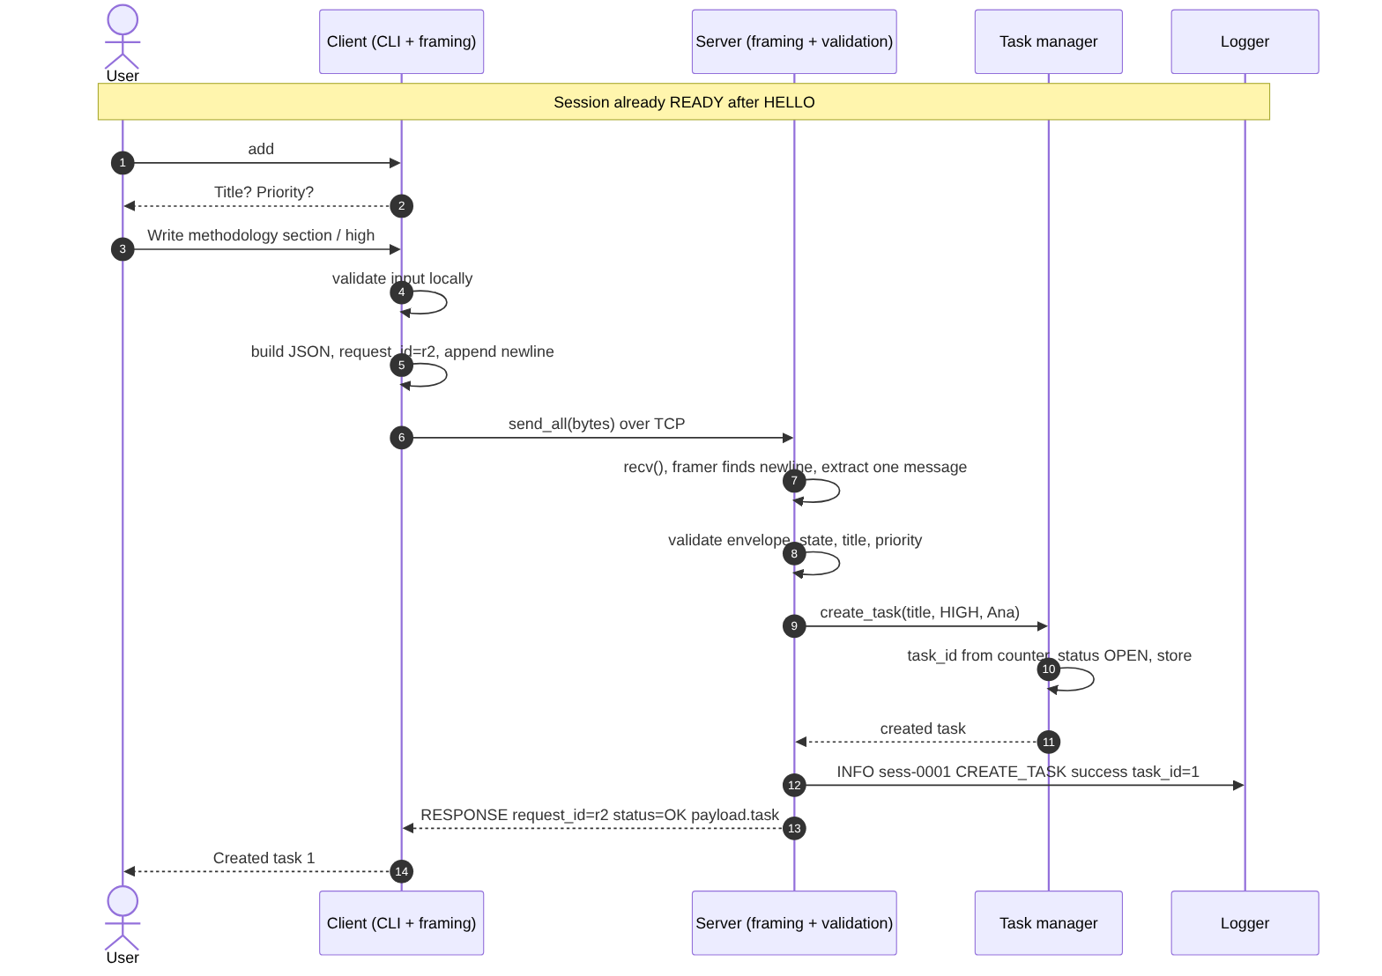
Figure: CREATE_TASK (valid, then invalid)

6.3 LIST_TASKS
The client holds no list; every display comes from a fresh reply.
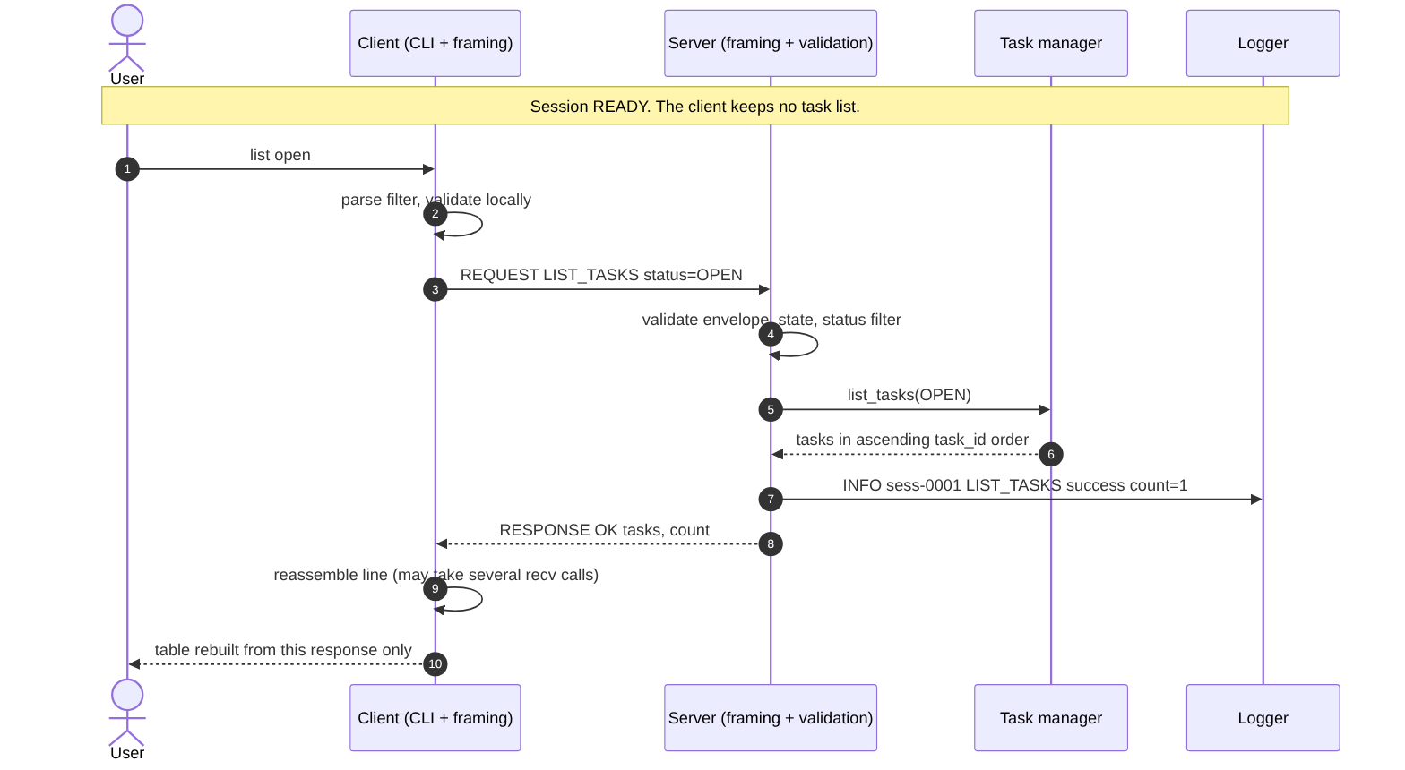
Figure: LIST_TASKS

6.4 CLAIM_TASK, including CONFLICT
The claim succeeds when the task is OPEN. A second claim on the same task returns CONFLICT with the current owner and changes nothing. (The two-client race is Phase 3 test T-11.)
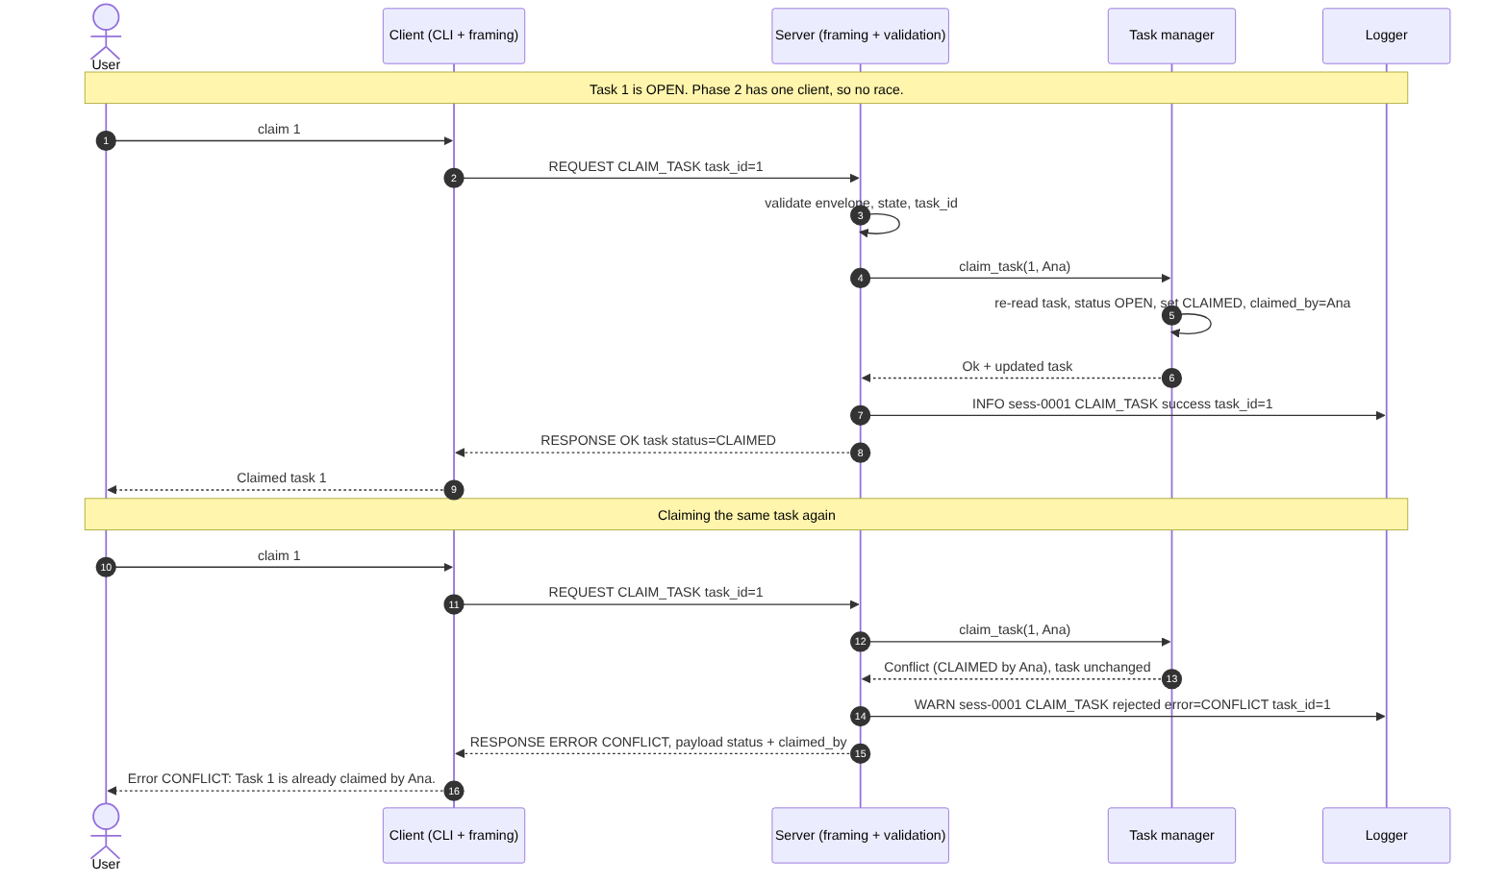
Figure: CLAIM_TASK, including CONFLICT

6.5 Error and retry
An unknown command and a missing field are rejected with structured errors and the session continues.
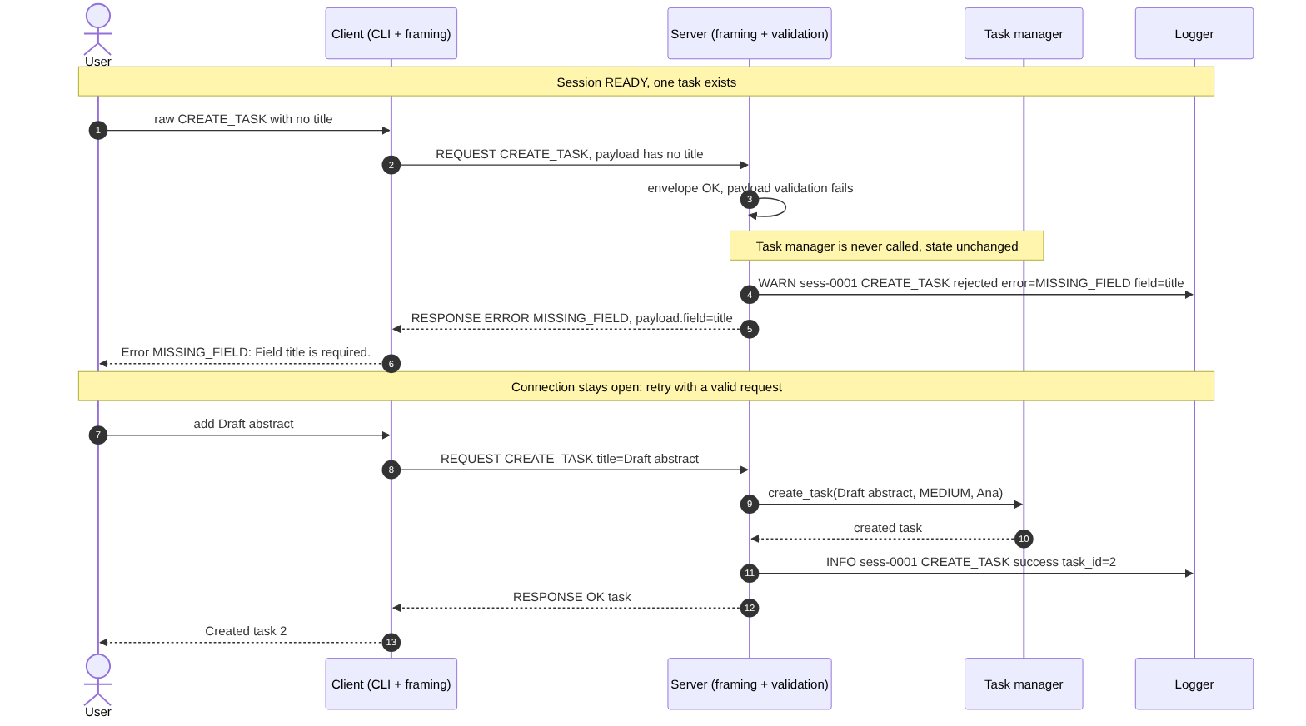
Figure: Error and retry

6.6 QUIT and graceful close
The server replies, closes the socket, releases the session and returns to listening.
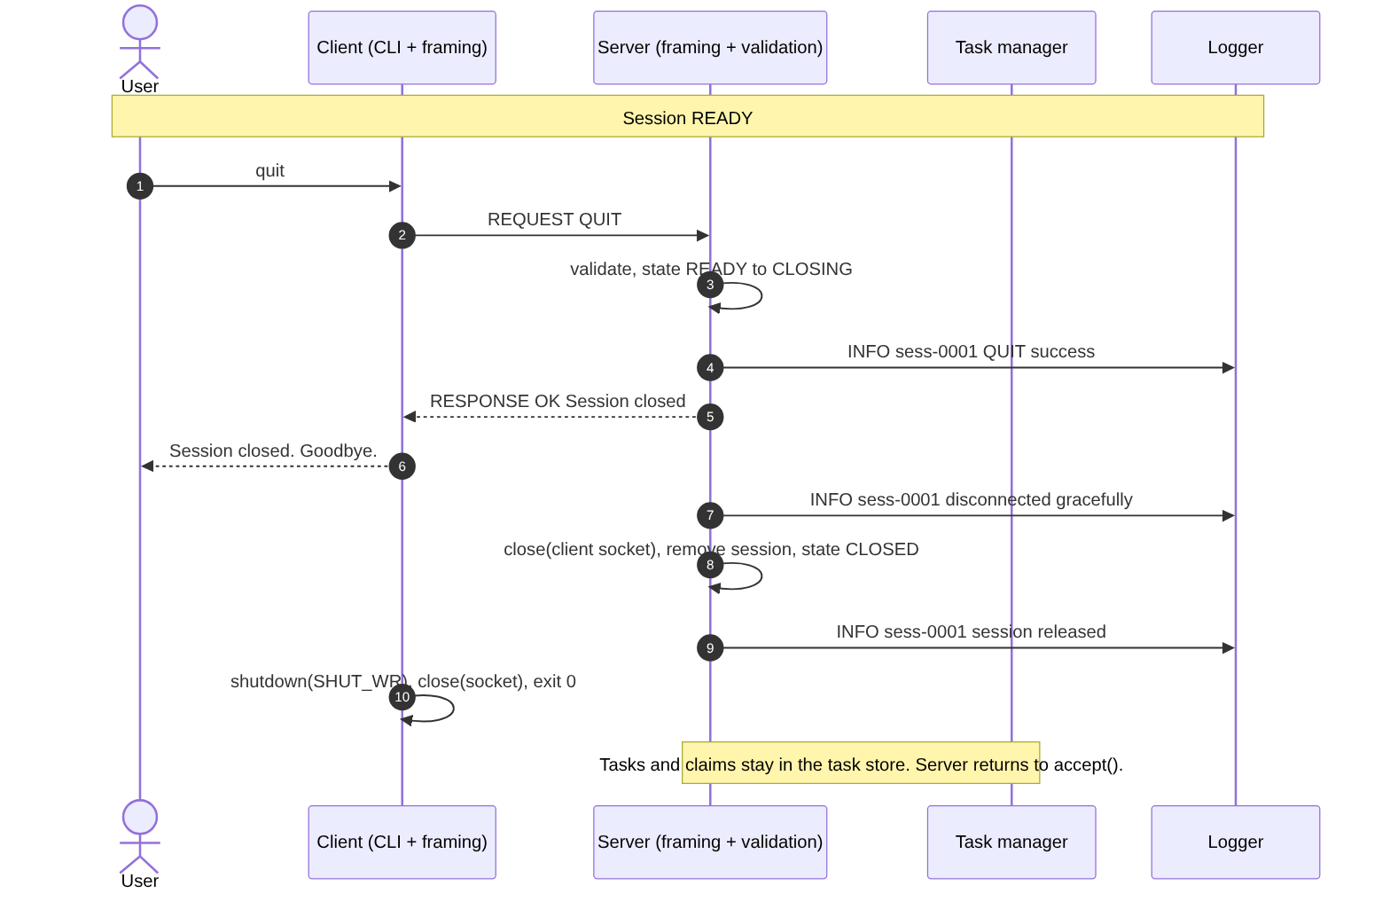
Figure: QUIT and graceful close

6.7 Framing
The framing flow is shown in Figure 3 (section 3.1): partial data stays buffered, several lines in one read are handled in order, oversize lines are reported once and skipped.

7. Logging

7.1 Format
<ISO-8601 UTC timestamp> <LEVEL> <text> with one space between the parts. Levels are INFO, WARN and ERROR. Session lines start with the session identifier (sess-0001). The log goes to logs/server.log (or the optional second server argument), is flushed after every line and is echoed to the server terminal.

7.2 What is logged
Event | Example text
Server startup, listening address and port | Server listening on 0.0.0.0:5050
Client connection with identifier and address | Client sess-0001 connected from 127.0.0.1:45290
Request type and outcome | sess-0001 CREATE_TASK success task_id=1
Rejected request (state or validation) | sess-0001 CLAIM_TASK rejected error=NOT_FOUND task_id=9999
Envelope and protocol error | sess-0001 invalid request command="MAKE_COFFEE" error=UNKNOWN_COMMAND field=command
Graceful disconnect | sess-0001 disconnected gracefully
Abrupt disconnect | sess-0002 disconnected unexpectedly (connection closed without QUIT)
Session released | sess-0001 session released
Server shutdown | Shutdown requested; stopping the server / Server shutdown complete

7.3 Privacy
Task titles and QUIT reasons are not logged. Display names are logged (they identify the session). Any client-supplied text that is logged (command names, display names) is sanitised: control characters become ? and long text is truncated.

7.4 Sample log
A real log from a demonstration run (docs/sample_server.log): Ana runs the full task lifecycle and some invalid requests and quits; Ben connects, lists and disconnects without QUIT; the server is stopped with Ctrl-C. The first two banner lines (starting and "Logging to") are printed to the terminal before the file is opened, so the file begins with the logging line.
2026-10-04T15:01:17Z INFO Logging to logs/server.log
2026-10-04T15:01:17Z INFO Server listening on 0.0.0.0:5050
2026-10-04T15:01:17Z INFO Waiting for a client connection (one active client at a time)
2026-10-04T15:01:17Z INFO Client sess-0001 connected from 127.0.0.1:45290
2026-10-04T15:01:17Z INFO sess-0001 HELLO success name="Ana"
2026-10-04T15:01:17Z INFO sess-0001 HELP success
2026-10-04T15:01:17Z INFO sess-0001 CREATE_TASK success task_id=1
2026-10-04T15:01:17Z INFO sess-0001 LIST_TASKS success count=1
2026-10-04T15:01:17Z INFO sess-0001 CLAIM_TASK success task_id=1
2026-10-04T15:01:17Z INFO sess-0001 RELEASE_TASK success task_id=1
2026-10-04T15:01:17Z INFO sess-0001 CLAIM_TASK success task_id=1
2026-10-04T15:01:17Z INFO sess-0001 COMPLETE_TASK success task_id=1
2026-10-04T15:01:17Z INFO sess-0001 LIST_TASKS success count=1
2026-10-04T15:01:17Z INFO sess-0001 CREATE_TASK success task_id=2
2026-10-04T15:01:17Z INFO sess-0001 DELETE_TASK success task_id=2
2026-10-04T15:01:17Z INFO sess-0001 LIST_TASKS success count=1
2026-10-04T15:01:17Z WARN sess-0001 invalid request command="MAKE_COFFEE" error=UNKNOWN_COMMAND field=command
2026-10-04T15:01:17Z WARN sess-0001 CREATE_TASK rejected error=MISSING_FIELD field=title
2026-10-04T15:01:17Z WARN sess-0001 CREATE_TASK rejected error=INVALID_FIELD field=priority
2026-10-04T15:01:17Z WARN sess-0001 CLAIM_TASK rejected error=NOT_FOUND task_id=9999
2026-10-04T15:01:17Z WARN sess-0001 CLAIM_TASK rejected error=CONFLICT task_id=1
2026-10-04T15:01:17Z INFO sess-0001 QUIT success
2026-10-04T15:01:17Z INFO sess-0001 disconnected gracefully
2026-10-04T15:01:17Z INFO sess-0001 session released
2026-10-04T15:01:17Z INFO Client sess-0002 connected from 127.0.0.1:45294
2026-10-04T15:01:17Z INFO sess-0002 HELLO success name="Ben"
2026-10-04T15:01:17Z INFO sess-0002 LIST_TASKS success count=1
2026-10-04T15:01:17Z WARN sess-0002 disconnected unexpectedly (connection closed without QUIT)
2026-10-04T15:01:17Z INFO sess-0002 session released
2026-10-04T15:01:17Z INFO Shutdown requested; stopping the server
2026-10-04T15:01:17Z INFO Server shutdown complete

8. Phase 2 Testing

8.1 Approach
- Three automated suites run by make check: framing unit tests (no sockets), unit and in-process protocol tests (JSON, validation, envelope, task manager, registry, dispatcher, client input and display) and integration tests that start the real bin/server and bin/client and talk to them over TCP.
- No test uses `sleep()` or a timing delay. A test waits for an event (a log line, a reply, end of file). The only timeout is a watchdog (15 seconds per read, 300 seconds for the whole run) so a hung program fails instead of hanging the test.
- Controlled splits. The unit tests choose the exact chunk boundaries. The socket tests send separate send() calls, but TCP may merge small writes, so they assert the correct result (one reply per request, in order, no duplicates) rather than a particular read pattern. Both levels are reported separately.
- IDs. Phase 1 test IDs are kept (T-01 to T-14). Variants carry a suffix: a/b (framing unit halves), u (in-process version), b/c (extra case, command-line client). Phase 2 additions are U-* (unit/in-process, integration helper) and X-* (extra scenarios); T-17 is the new "server disappears" test.
- Honesty rule. A row is PASS only if it was executed. Tests that need concurrency are Deferred, not passed.

8.2 Results
Run recorded in docs/test_results.txt: 2026-10-05T01:54:04Z - g++ (Ubuntu 13.3.0-6ubuntu2~24.04.1) 13.3.0 - Linux 6.18.44-fc-v70, after a clean rebuild (make clean && make check).
Suite | Executed | Passed | Failed | Not run
1. Framing unit tests | 12 | 12 | 0 | 0
2. Unit and in-process protocol tests | 34 | 34 | 0 | 0
3. Integration tests (real server and client over TCP) | 28 | 28 | 0 | 0
Total automated | 74 | 74 | 0 | 0
Manual checks (section 8.5) | 4 | 4 | 0 | 0
Deferred to Phase 3 (section 8.3) | - | - | - | 4 items (not executed)

8.3 Status of the Phase 1 test plan
Phase 1 section 9 listed 14 tests, all "Planned". Their status after Phase 2:
ID | Phase 1 subject | Status | Executed as / reason
T-01 | Connect and HELLO | Executed - PASS | T-01 (TCP), T-01u (in-process)
T-02 | CREATE_TASK | Executed - PASS | T-02
T-03 | LIST_TASKS and filter | Executed - PASS | T-03, T-03u
T-04 | Claim, release, complete, delete, quit | Executed - PASS | T-04 (protocol), T-04c (command-line client)
T-05 | Unknown command | Executed - PASS | T-05, T-05u
T-06 | Invalid input (a-f) | Executed - PASS | T-06, T-06u, U-E1, U-I1, U-D6
T-07 | Server not running | Executed - PASS | T-07
T-08 | Invalid host and port | Executed - PASS | T-08, T-08b
T-09 | Client exits unexpectedly | Executed - PASS | T-09, T-09b
T-10 | Three simultaneous clients | Deferred - Phase 3 | Needs concurrency; the Phase 2 server serves one client at a time. Not executed.
T-11 | Simultaneous claim race (20 trials) | Deferred - Phase 3 | Needs concurrency and task_lock. Not executed. Sequential CONFLICT behaviour is tested (U-T2, U-D5, T-04c).
T-12 | Malformed input isolation | Deferred - Phase 3 | Needs two other live sessions. The single-session part is covered (T-06, U-I2, T-09).
T-13 | Partial message | Executed - PASS | T-13 (TCP), T-13a, T-13b (framer, byte by byte and in three pieces)
T-14 | Two messages in one read | Executed - PASS | T-14 (TCP), T-14a, T-14b (framer)
Phase 2 also adds T-17 (server disappears while the client is active) and the U-* / X-* tests in section 8.4.

8.4 Test report (detailed)
Every automated test below was executed in the recorded run and passed; its PASS line is in docs/test_results.txt. "Actual result" states what the test observed; "As expected" means every assertion of the test held. The unit and in-process tests (suite 2) run the real modules directly; the integration tests start the real binaries.

8.4.1 Suite 1 - Framing unit tests (12)
ID | Requirements | Initial conditions | Input / action | Expected result | Actual result | Status / Result
T-13a | NFR-13, 7.1 (partial) | Framer (no socket); one valid CREATE_TASK request serialised to bytes | Feed the bytes one byte at a time; after each byte, drain frames | Zero frames until the byte holding "\n" is fed; then exactly one frame with the right content | No frame before the newline; one correct frame after it | Variant of Phase 1 test T-13  Executed (unit)  PASS
T-13b | NFR-13, 7.1 (partial) | Framer; one valid request | Feed in three pieces (the Phase 1 split); the last piece is only "\n" | No frame after the complete JSON without newline; one frame after "\n" | As expected | Variant of Phase 1 test T-13  Executed (unit)  PASS
T-14a | NFR-13, 7.1 (coalesced) | Framer, empty buffer | Feed two complete framed messages in a single feed() | Two frames, in arrival order | Two frames returned in order | Variant of Phase 1 test T-14  Executed (unit)  PASS
T-14b | NFR-13, 7.1 (coalesced) | Framer, empty buffer | Feed two complete messages plus an unterminated third in one feed() | Two frames; the fragment stays buffered (its byte count is kept); nothing lost | Two frames; fragment retained in full | Variant of Phase 1 test T-14  Executed (unit)  PASS
U-F1 | NFR-14 | Framer | Feed a line ending in CR LF | Frame content without the trailing CR | CR stripped | Added in Phase 2  Executed (unit)  PASS
U-F2 | FR-16 | Framer | Feed blank lines between messages | Blank frames reported (not dropped); following messages still delivered | As expected | Added in Phase 2  Executed (unit)  PASS
U-F3 | NFR-14, 7.2 | Framer, limit 8192 | Feed a line of exactly 8192 bytes, then one of 8193 bytes | 8192 accepted as a Message; 8193 reported as TooLarge | Boundary behaved as specified | Added in Phase 2  Executed (unit)  PASS
U-F4 | NFR-11, NFR-14 | Framer | Feed 8192 bytes with no newline | Bytes held; no TooLarge yet | Held; no error event | Added in Phase 2  Executed (unit)  PASS
U-F5 | NFR-02, NFR-11, 7.2 | Framer | Feed 48 KiB without a newline in twelve 4096-byte chunks, then the rest of the line, its newline and a good message | Exactly one TooLarge event; buffer never above 8192 bytes; next message delivered | One event; buffer bounded; stream resynchronised | Added in Phase 2  Executed (unit)  PASS
U-F6 | NFR-02 | Framer | One feed: valid message, oversize line, valid message | Message, TooLarge, Message in order | As expected | Added in Phase 2  Executed (unit)  PASS
U-F7 | NFR-13 | Framer; a stream of 25 messages (with accented characters) | Re-feed the stream with 200 deterministic pseudo-random chunkings | The same messages every time | Identical output for every chunking | Added in Phase 2  Executed (unit)  PASS
U-F8 | NFR-13, 7.1 | Serialiser | Serialise a request whose title holds a newline, CR, tab and quotes; call frame_message on text containing a raw newline | No raw newline or CR in the serialised text; frame_message adds exactly one byte; the raw-newline call throws logic_error | As expected | Added in Phase 2  Executed (unit)  PASS

8.4.2 Suite 2 - Unit and in-process protocol tests (34)
ID | Requirements | Initial conditions | Input / action | Expected result | Actual result | Status / Result
U-J1 | NFR-14 | JSON module | Parse then dump an object with nested array/object, true/false/null, an escaped newline and a non-ASCII character | Key order preserved; control characters escaped | As expected | Added in Phase 2  Executed (unit)  PASS
U-J2 | NFR-14 | JSON module | Parse a \uD83D\uDE00 surrogate pair | One 4-byte UTF-8 character | As expected | Added in Phase 2  Executed (unit)  PASS
U-J3 | FR-16 | JSON module | Parse 12 malformed documents: empty, truncated, trailing commas, text after the value, single quotes, leading zero, duplicate key, lone surrogate, invalid UTF-8, raw tab in a string, 40-level nesting | Every one rejected with a message | All rejected | Added in Phase 2  Executed (unit)  PASS
U-J4 | NFR-14 | JSON module | Parse 7, 7.0, 1e2 and a 20-digit number | Integers distinguished from non-integers | As expected | Added in Phase 2  Executed (unit)  PASS
U-V1 | FR-04, NFR-14 | Validation module | Check "Ana", "a_b-c.D 9", 24 characters (accepted); empty, 25 characters, "Ana!", a non-ASCII letter, leading space, trailing space, only spaces (rejected) | Only 1-24 characters of letters, digits, space, _ - . without edge spaces accepted | As expected | Added in Phase 2  Executed (unit)  PASS
U-V2 | FR-15, NFR-14 | Validation module | Titles: padded; 120 and 121 characters; blank/tab-only; empty; U+0001 and U+007F inside; 120 two-byte characters | Trimmed; 120 accepted (also 120 multi-byte characters), 121 rejected; blank, empty and control characters rejected | As expected | Added in Phase 2  Executed (unit)  PASS
U-V3 | FR-25, NFR-07 | Validation module | Parse ports "5050", "1", "65535" (accepted) and "0", "65536", "70000", "abc", "-1", "", "50 50", 20 digits (rejected); task ids "12" (accepted), "0", "-3", "abc", "1.5", 20 digits (rejected) | Only ports 1-65535 and whole task ids >= 1 accepted | As expected | Added in Phase 2  Executed (unit)  PASS
U-E1 | FR-15, NFR-14 | Envelope parser | Not JSON; a JSON array; missing version (request_id QUIT echoed); version 2; version "1"; missing payload; payload that is an array | INVALID_MESSAGE; INVALID_MESSAGE; MISSING_FIELD version with request_id and command recovered; INVALID_VERSION with supported_versions; INVALID_FIELD; MISSING_FIELD; and so on, request_id recovered when possible | As expected | Added in Phase 2  Executed (unit)  PASS
U-E2 | FR-16 | Envelope parser | A line containing an invalid UTF-8 byte | INVALID_MESSAGE | INVALID_MESSAGE | Added in Phase 2  Executed (unit)  PASS
U-T1 | FR-06 | Task manager, empty | Create tasks | Ids 1, 2, ...; OPEN; claimed_by null; list ascending | As expected | Added in Phase 2  Executed (unit)  PASS
U-T2 | FR-08, FR-09, FR-10, FR-24 | Task manager | Claim, release, complete in legal and illegal orders | Legal transitions succeed; illegal ones give Conflict and leave the task unchanged | As expected | Added in Phase 2  Executed (unit)  PASS
U-T3 | FR-10, FR-11 | Task manager | Complete from OPEN; delete then create | Complete from OPEN allowed; ids never reused | As expected | Added in Phase 2  Executed (unit)  PASS
T-03u | FR-07, FR-26 | Task manager with OPEN, CLAIMED and DONE tasks | List with each status filter | Only matching tasks returned | As expected | Variant of Phase 1 test T-03  Executed (unit)  PASS
U-S1 | FR-04, FR-05 | Session registry | Add sessions, reserve names, remove | Unique session ids; a held name is refused; a removed session frees its name | As expected | Added in Phase 2  Executed (unit)  PASS
T-01u | FR-04, FR-05 | Dispatcher driven in-process | HELLO | session_id, server_version 1, 9 commands; READY | As expected | Variant of Phase 1 test T-01  Executed (unit)  PASS
U-D1 | FR-05 | Dispatcher; session CONNECTED | Task commands before HELLO; HELP and QUIT | INVALID_STATE for task commands; HELP and QUIT allowed | As expected | Added in Phase 2  Executed (unit)  PASS
U-D2 | FR-05 | Dispatcher | Failed HELLO then good HELLO; a second HELLO | Failed HELLO leaves CONNECTED; retry works; second HELLO is INVALID_STATE | As expected | Added in Phase 2  Executed (unit)  PASS
U-D3 | FR-04 | Dispatcher with a second session already named Ana | HELLO "Ana" | NAME_IN_USE with message "The display name 'Ana' is already in use." and payload.field = display_name | As expected | Added in Phase 2  Executed (unit)  PASS
T-05u | FR-14, NFR-01 | Dispatcher, READY | Unknown command, then LIST_TASKS | UNKNOWN_COMMAND, then a normal list | As expected | Variant of Phase 1 test T-05  Executed (unit)  PASS
T-06u | FR-15, FR-16, FR-17 | Dispatcher, READY, one task | Missing field, invalid fields, unknown id | MISSING_FIELD / INVALID_FIELD / NOT_FOUND; the task list unchanged | As expected | Variant of Phase 1 test T-06  Executed (unit)  PASS
U-D4 | FR-06 | Dispatcher | CREATE_TASK with padded title and no priority | Priority MEDIUM; trimmed title; created_by = session name | As expected | Added in Phase 2  Executed (unit)  PASS
U-D5 | FR-09 | Dispatcher; task claimed by another name | CLAIM_TASK on it | CONFLICT payload gives current status and owner | As expected | Added in Phase 2  Executed (unit)  PASS
U-D6 | FR-16, NFR-14 | Dispatcher | Blank frame; oversize frame | INVALID_MESSAGE; MESSAGE_TOO_LARGE | As expected | Added in Phase 2  Executed (unit)  PASS
U-D7 | NFR-02, NFR-06 | Dispatcher with a task manager that throws | CREATE_TASK | SERVER_ERROR without internals in the reply (details only in the log) | As expected | Added in Phase 2  Executed (unit)  PASS
U-D8 | FR-18 | Dispatcher | QUIT; a malformed QUIT | QUIT moves the session to CLOSING; malformed QUIT does not | As expected | Added in Phase 2  Executed (unit)  PASS
U-D9 | FR-23 | Dispatcher | HELP, then HELP for one command | All 9 commands, then one | As expected | Added in Phase 2  Executed (unit)  PASS
U-L1 | FR-22 | Logger | Log text with control characters and a very long string | Control characters replaced, text truncated | As expected | Added in Phase 2  Executed (unit)  PASS
U-C1 | NFR-16 | Client display module | Format tables with long titles, long owners, large ids | Every line <= 80 columns | All lines within 80 columns | Added in Phase 2  Executed (unit)  PASS
U-C2 | FR-07 | Client display | Format empty lists | Clear "No tasks" messages | As expected | Added in Phase 2  Executed (unit)  PASS
U-C3 | NFR-06, NFR-16 | Client display | Format each error code | Code and sentence shown; 80 columns; no internals | As expected | Added in Phase 2  Executed (unit)  PASS
U-C4 | FR-07 | Client display | Convert task JSON (good and broken) | Good accepted, broken rejected | As expected | Added in Phase 2  Executed (unit)  PASS
U-C0 | FR-25, NFR-07 | Client input parser | Empty line; unknown verb | Empty / Invalid, decided locally with no network | As expected | Added in Phase 2  Executed (unit)  PASS
U-C5 | FR-25, NFR-07 | Client input parser | claim 7, CLAIM 7, claim with no id, claim abc, claim 0, claim -2, claim 1 2 and release/done/delete 3 | Valid ids parsed (case-insensitive verb; missing id means prompt); bad ids are Invalid locally before any request | As expected | Added in Phase 2  Executed (unit)  PASS
U-C6 | FR-23, FR-26 | Client input parser | list filters, add shorthand, help forms, quit | Parsed to the right commands | As expected | Added in Phase 2  Executed (unit)  PASS

8.4.3 Suite 3 - Integration tests over TCP (28)
ID | Requirements | Initial conditions | Input / action | Expected result | Actual result | Status / Result
T-01 | FR-01, FR-02, FR-04, FR-05, FR-22 | Real bin/server on a free port; no clients | Connect a raw TCP client; send HELLO "Ana" | OK; non-empty session_id; display_name Ana; server_version 1; 9 commands; log has "Client sess-0001 connected from 127.0.0.1" and "HELLO success" | As expected | Inherited from Phase 1 plan  Executed (integration)  PASS
T-02 | FR-06, FR-12 | T-01 state; empty list | CREATE_TASK "Write methodology section", HIGH | task_id 1; OPEN; claimed_by null; created_by Ana; 20-character UTC timestamp; log "CREATE_TASK success task_id=1" | As expected | Inherited from Phase 1 plan  Executed (integration)  PASS
T-03 | FR-07, FR-26 | Three tasks: one OPEN, one CLAIMED, one DONE | LIST_TASKS; then LIST_TASKS status=OPEN | Three tasks ascending, all seven fields, count 3; filtered: 1 task, the OPEN one | As expected | Inherited from Phase 1 plan  Executed (integration)  PASS
T-04 | FR-08, FR-10, FR-11, FR-18, FR-24 | Tasks 1 and 2 OPEN | claim 1, release 1, claim 1, complete 1, complete 1 again, delete 2, list, QUIT | Claim OK (Ana); release back to OPEN; complete DONE with claimed_by kept; second complete CONFLICT; delete OK; list shows 1; QUIT OK, socket closed by server; log "disconnected gracefully" and "session released" | As expected | Inherited from Phase 1 plan  Executed (integration)  PASS
T-05 | FR-14, NFR-01 | Session READY | MAKE_COFFEE, then LIST_TASKS | UNKNOWN_COMMAND; connection open; the list then returns OK; log has UNKNOWN_COMMAND | As expected | Inherited from Phase 1 plan  Executed (integration)  PASS
T-06 | FR-15, FR-16, FR-17, NFR-06 | Session READY; one task | (a) CREATE_TASK {} (b) priority URGENT (c) task_id "abc" (d) task_id 999 (e) truncated JSON line (f) empty line (g) LIST status INVALID | (a) MISSING_FIELD title (b),(c),(g) INVALID_FIELD (d) NOT_FOUND (e),(f) INVALID_MESSAGE with null request_id; no internals in replies; list afterwards shows exactly one task | As expected | Inherited from Phase 1 plan  Executed (integration)  PASS
X-05 | FR-05 | Connected, no HELLO | LIST_TASKS; CREATE_TASK; HELP; HELLO "bad!"; LIST_TASKS; HELLO "Ana"; HELLO again; LIST_TASKS | INVALID_STATE, INVALID_STATE, OK, INVALID_FIELD, INVALID_STATE, OK, INVALID_STATE, OK; connection never closed | As expected | Added in Phase 2  Executed (integration)  PASS
U-I1 | FR-16, NFR-14 | Session READY | Send version 2; missing type; missing request_id; a JSON array; an extra unknown field; invalid UTF-8 | INVALID_VERSION (request_id "v" echoed); MISSING_FIELD type; MISSING_FIELD with null request_id; INVALID_MESSAGE; OK (extra field ignored); INVALID_MESSAGE | As expected | Added in Phase 2  Executed (integration)  PASS
U-I2 | NFR-02, NFR-14, 7.2 | Session READY | Send a 20,000-byte line plus a valid request in one send; then 30,000 + 30,000 bytes in two sends ending with a newline | One MESSAGE_TOO_LARGE; the very next reply is for the valid request; second oversize line: one MESSAGE_TOO_LARGE; session usable | As expected | Added in Phase 2  Executed (integration)  PASS
U-I3 | FR-07, C-1 | 60 tasks with 120-character titles | LIST_TASKS | Reply line longer than 8192 bytes, delivered intact: count 60 and 60 tasks | Reply exceeded 8192 bytes and parsed completely | Added in Phase 2  Executed (integration)  PASS
T-13 | NFR-13, 7.1 (partial) | Session READY; real TCP | CREATE_TASK sent in three send() calls; a second split inside a multi-byte UTF-8 character; a third sent one byte per send() | Each processed once and only after its newline; first reply is the one for the request (no fragment error); 3 tasks in the list; title with accented characters intact | As expected | Inherited from Phase 1 plan  Executed (integration)  PASS
T-14 | NFR-13, 7.1 (coalesced) | Session READY; empty list | Two requests in one send; then two requests plus 9-byte-short third in one send, then the last 9 bytes | Replies A, B in order with ids 1, 2; D, E replied while C waits; C replied after completion; 5 tasks, no loss or duplicate | As expected | Inherited from Phase 1 plan  Executed (integration)  PASS
T-09 | FR-19, NFR-02 | Client READY with one task | Abort the connection (RST) without QUIT; then connect a new client; then close it plainly without QUIT; then a third client | Log "disconnected unexpectedly" and "session released"; server keeps listening; the new client sees the task; plain close logged the same way; third client served | As expected | Inherited from Phase 1 plan  Executed (integration)  PASS
T-09b | FR-19, NFR-02 | Client READY | Send half a request, then close | Log "bytes of an incomplete message discarded"; next client served | As expected | Variant of Phase 1 test T-09  Executed (integration)  PASS
X-04 | FR-12 | Server running | Ana creates and claims a task and QUITs; Ben connects and lists | Task still present, claimed by Ana | As expected | Added in Phase 2  Executed (integration)  PASS
X-01 | Phase 2 design (C-7) | Ana connected | A second client connects and sends HELLO; Ana creates a task and QUITs | Second TCP connect succeeds; its HELLO is answered only after Ana quits (sess-0002); it sees the task | As expected | Added in Phase 2  Executed (integration)  PASS
X-02 | FR-19, FR-22 | Client connected | SIGTERM to the server | Client sees EOF; exit code 0; log "closed by server shutdown", "Shutdown requested", "Server shutdown complete" | As expected | Added in Phase 2  Executed (integration)  PASS
X-03 | FR-22 | Server idle | SIGINT | Clean shutdown; exit 0; shutdown logged | As expected | Added in Phase 2  Executed (integration)  PASS
U-N1 | FR-01 | None | Start bin/server with no argument, 0, abc, 70000, -1 | Usage message; exit code 2 each time | As expected | Added in Phase 2  Executed (integration)  PASS
U-N2 | FR-01 | A server already listening on port P | Start a second server on P | Message about bind failure; exit 1 | As expected | Added in Phase 2  Executed (integration)  PASS
T-07 | FR-03, NFR-09 | Nothing listening on the chosen port | Start the client against it | "Could not connect" and "Is the server running?"; exit 1; no crash text | As expected | Inherited from Phase 1 plan  Executed (integration)  PASS
T-08 | FR-03, FR-25 | None | Client with ports 70000, 0, abc, -5, empty, 65536, 50.5; name "bad!name"; missing arguments | "invalid port" / "invalid display name" / Usage; exit 2; no connection attempted | As expected | Inherited from Phase 1 plan  Executed (integration)  PASS
T-08b | FR-03 | None | Client with host not.a.real.host.invalid | "Could not find host"; exit 1 | As expected | Variant of Phase 1 test T-08  Executed (integration)  PASS
X-06 | FR-25, NFR-07 | Server running | Client input: blank line, spaces, list, quit | "Enter a command" prompt; list works; "Session closed. Goodbye."; exit 0 | As expected | Added in Phase 2  Executed (integration)  PASS
T-04c | FR-18, FR-22, FR-23, FR-24, NFR-06 | Server running | Scripted client session: help, add, list, claim, release, claim, done, list, claim again, bad ids, unknown command, raw errors, help server, delete, quit | All expected output lines present; exit 0; log shows the successes and NOT_FOUND; titles absent from the log | As expected | Variant of Phase 1 test T-04  Executed (integration)  PASS
X-07 | FR-18 | Server running | Client stdin ends without quit | Client sends QUIT itself; exit 0; server logs graceful disconnect | As expected | Added in Phase 2  Executed (integration)  PASS
X-08 | FR-25, NFR-07 | Server running | add with blank title, bad priority, then valid; add then /cancel | Re-prompts with "must not be blank" and "Priority must be LOW, MEDIUM or HIGH"; task 1 created; "Cancelled." | As expected | Added in Phase 2  Executed (integration)  PASS
T-17 | FR-19, NFR-06 | Client active, one task added | Stop the server, then type list | "Error:" and "The session has ended"; exit 1; not killed by a signal | As expected | Added in Phase 2  Executed (integration)  PASS

8.4.4 Manual checks (4)
ID | Requirement | Initial conditions | Input / action | Expected result | Actual result | Status / Result
M-01 | NFR-08 | Server and client on one machine | Timed individual requests by hand | Reply within 100 ms | Maximum observed 0.85 ms (below the 100 ms limit) | Executed manually  PASS
M-02 | NFR-09 | Address that does not answer | Client connects to an unreachable address | Gives up and reports within 10 s | Reported failure after 10.013 s | Executed manually  PASS
M-03 | FR-02 | Server on the same machine | Client uses 127.0.0.1, "localhost" and a non-loopback address (192.0.2.2) | Connection works for each | All three connected (the non-loopback address was local to this machine; no second computer was used) | Executed manually  PASS
M-04 | NFR-13 (test strength) | framing.cpp temporarily broken on purpose | Run the framing and integration tests | The tests fail | The tests detected the fault; the file was restored from backup and 12/12 and 28/28 passed again | Executed manually  PASS

8.4.5 Deferred tests (not executed)
ID | Requirements | What it would show | Status / reason
T-10 | FR-13, FR-20, NFR-10 | Three simultaneous clients with distinct session ids; change by one visible to others | Deferred - NOT executed  Phase 3 (concurrency)
T-11 | FR-08, FR-09, NFR-03 | Two clients claim the same task simultaneously, 20 trials: exactly one OK and one CONFLICT | Deferred - NOT executed  Phase 3 (concurrency)
T-12 | FR-21, NFR-02 | One client stream malformed input while two others work normally | Deferred - NOT executed  Phase 3 (concurrency)
NAME_IN_USE live | FR-04 | Second connected client requests a name already held | Deferred - NOT executed  Phase 3 (needs two simultaneous sessions); unit-tested as U-D3 and U-S1

8.5 Requirement traceability matrix
Status: Verified = implemented and a test passed; Partial = part verified, the rest explained; Phase 3 = needs concurrency and is deferred; Future = Future Work in Phase 1.

Functional requirements
ID | Requirement (short) | Implemented in | Verified by | Status
FR-01 | Listen on a port given at startup | server/main.cpp, Server::start | T-01, U-N1, U-N2; every integration test starts a server on a free port | Verified
FR-02 | Client connects to host and port from arguments | client/main.cpp, Connection | T-01, M-03 (loopback, localhost, a local non-loopback address) | Verified (one machine)
FR-03 | Connection failure reported in plain language | Connection::connect_to | T-07, T-08, T-08b | Verified
FR-04 | Unique session id in HELLO reply | SessionRegistry | T-01, T-01u, U-S1, X-01 (sess-0001, then sess-0002) | Partial: three simultaneous ids = T-10 (Phase 3)
FR-05 | HELLO first; other commands INVALID_STATE | Dispatcher state check | X-05, U-D1, U-D2 | Verified
FR-06 | CREATE_TASK creates an OPEN task | TaskManager, on_create_task | T-02, U-T1, U-D4 | Verified
FR-07 | LIST_TASKS returns all tasks and fields | TaskManager, on_list_tasks | T-03, U-I3 | Verified
FR-08 | CLAIM_TASK only if OPEN | TaskManager::claim_task | T-04, U-T2; race = T-11 | Verified sequentially; race Phase 3
FR-09 | CONFLICT names the owner, task unchanged | conflict_error | U-D5, U-T2, T-04c | Verified sequentially; race Phase 3
FR-10 | COMPLETE_TASK; DONE again is CONFLICT | TaskManager::complete_task | T-04, U-T2 | Verified
FR-11 | DELETE_TASK removes the task | TaskManager::delete_task | T-04, T-04c | Verified
FR-12 | Task list outlives client sessions | TaskManager in the server process | X-04 | Verified
FR-13 | Change by one client visible to others | Single shared TaskManager | T-10 (Phase 3). One client sees its own changes: T-03, T-04 | Phase 3
FR-14 | Unknown command: UNKNOWN_COMMAND, continue | parse_request_line | T-05, T-05u | Verified
FR-15 | MISSING_FIELD / INVALID_FIELD, no state change | request_validation | T-06, T-06u, U-E1, U-I1 | Verified
FR-16 | Bad JSON or empty line: INVALID_MESSAGE, stay open | Framer, parse_request_line | T-06, U-I1, U-D6, U-J3 | Verified
FR-17 | Unknown task_id: NOT_FOUND | TaskManager | T-06, T-04c | Verified
FR-18 | QUIT sends request, closes, confirms | on_quit, ClientApp | T-04, T-04c, X-07 | Verified
FR-19 | Release session on graceful and abrupt disconnect | Server::serve_client | T-09, T-09b, X-01 | Verified
FR-20 | Serve at least three clients at once | - | T-10 | Phase 3
FR-21 | Failure in one session does not affect others | Dispatcher try/catch, serve_client | Single session: T-06, U-I2, T-09, U-D7. Multi-session: T-12 | Partial; isolation Phase 3
FR-22 | Timestamped log of all events | Logger, dispatcher, server | Sample log, T-01, T-02, T-04c, T-09, X-02, X-03 | Verified
FR-23 | help lists commands | display, input_parser | T-04c, U-C6, U-D9 | Verified
FR-24 | RELEASE_TASK | TaskManager::release_task | T-04, U-T2 | Verified
FR-25 | Client validates input before sending | input_parser, validation | X-06, X-08, U-C0, U-C5, U-V3, T-08 | Verified
FR-26 | LIST_TASKS status filter | read_status_filter | T-03, T-03u | Verified
FR-27 | Restore the task list on startup | not implemented | - | Future work
FR-28 | Push updates to clients | not implemented | - | Future work

Nonfunctional requirements
ID | Requirement (short) | Implemented in | Verified by | Status
NFR-01 | Keep serving after an unsupported command | Dispatcher | T-05 | Verified
NFR-02 | Malformed or oversize message never kills the server | Framer, dispatcher catch-all | U-I2, U-D7, T-06, T-09 | Verified
NFR-03 | Simultaneous claim: exactly one winner (20 trials) | - | T-11 | Phase 3
NFR-04 | No OK for an uncommitted change | Reply built after the TaskManager call returns | U-T2, U-D7 (failure gives SERVER_ERROR, never OK) | Verified
NFR-05 | help works without a server connection | Client-side help sends nothing | U-C6, T-04c | Partial: help needs no request, but the client must start and connect first
NFR-06 | Errors: sentence plus code, no internals | display::format_error | U-C3, T-06, T-17 | Verified
NFR-07 | Invalid input re-prompts, never exits | ClientApp | X-06, X-08 | Verified
NFR-08 | Reply within 100 ms on localhost | - | M-01 (max 0.85 ms) | Verified (manual)
NFR-09 | Unreachable server reported within 10 s | Connect deadline | M-02 (10.013 s) | Verified (manual)
NFR-10 | Three simultaneous clients | - | T-10 | Phase 3
NFR-11 | Per-client buffer bounded at 8 KiB | MessageFramer | U-F4, U-F5 | Verified
NFR-12 | Separate modules | Directory and module layout (section 2.2) | Inspection | Verified
NFR-13 | Framer testable without a socket | shared/framing | test_framing (12 tests) | Verified
NFR-14 | Validate every field; reject lines over 8192 bytes | Validation, framer, parser | U-V1 to U-V3, U-E1, U-I1, U-I2, U-F3 | Verified
NFR-15 | Names identify, not authenticate | Documented | README section 15, spec 4.5 (HELLO) | Documented
NFR-16 | Plain text within 80 columns | display | U-C1, U-C3, T-04c | Verified

8.6 Phase 2 error scenarios demonstrated
The assignment asks for at least four of eleven scenarios. All eleven are covered by executed tests:
Scenario | Test(s) | Seen in the demonstration
Server not running when the client connects | T-07 | Script step 2 (live)
Invalid port | T-08 | Script step 2 (live)
Empty command | X-06, U-C0 | Yes (10.5)
Unknown command | T-05, T-05u, T-04c | Yes (10.5)
Request with a missing field | T-06 (a), T-04c | Yes (10.5)
Field with an invalid value | T-06 (b, c, g), X-08 | Yes (10.5)
Message split across several reads | T-13, T-13a, T-13b | Test output (8.4)
Two messages in one read | T-14, T-14a, T-14b | Test output (8.4)
Client exits unexpectedly | T-09, T-09b | Yes (server log, Ben)
Server disconnects while the client is active | T-17 | Test output (8.4)
Request for a nonexistent record | T-06 (d), T-04c | Yes (10.5)

8.7 Limits of the testing
- The framing unit tests control chunk boundaries exactly; the TCP tests cannot, because the operating system may merge small writes. Together they show correctness at both levels.
- FR-02 was verified on one machine only (loopback, localhost and a local non-loopback address). No second computer was used.
- NAME_IN_USE needs two simultaneous sessions, so it is unit-tested (U-D3, U-S1) and its live test is deferred.
- SESSION_ERROR is defined but cannot be produced in Phase 2 (C-8), so it has no test.
- NFR-08 and NFR-09 were measured by hand, with a small number of requests; they are not automated.
- There is no automated test for the SIGPIPE path other than T-09 and T-17 (a peer that has gone away).

9. Design-Change Summary
The wire protocol is unchanged: the same framing, envelope, nine commands, twelve error codes, session states and task model as Phase 1. No field, command or code was added or removed. The twelve items below are clarifications of details Phase 1 left open, decisions taken while implementing and two small additions to existing payloads. Each is documented in section 4 and has no compatibility effect on a client that follows Phase 1.
ID | Original decision (Phase 1) | Implemented decision | Reason | Compatibility and Phase 3 effect
C-1 | Limit of 8192 bytes per line (7.2), per-client buffer 8 KiB (NFR-11), without saying which direction. | The limit applies to requests the server receives. The client accepts replies up to 1 MiB. | A LIST_TASKS reply with about 50 or more tasks exceeds 8192 bytes (test U-I3: 60 tasks). A client limited to 8192 would fail on a valid reply. | No wire change. The server buffer per session stays 8 KiB. Phase 3: unchanged.
C-2 | Display name: 1-24 characters, letters/digits/space/_/-/., unique among active sessions. | ASCII letters and digits only; no leading or trailing space; uniqueness is an exact, case-sensitive match. | Phase 1 did not define "letters" or "the same name". | A stricter reading of the same rule. Phase 3: the check runs under session_lock.
C-3 | Title: 1-120 characters after trimming, not blank, no control characters. | Trim ASCII whitespace; count Unicode code points; control characters are U+0000-001F, U+007F, U+0080-009F. | Defines "character" and "control". | None.
C-4 | request_id is null only if it cannot be retrieved. (The Phase 1 QUIT error example showed null for a request that did have an id.) | request_id and command are echoed whenever they can be recovered from the line, including envelope field errors; null otherwise. | Follows the rule in the text and lets the client match the reply to its request. | None; the example in Phase 1 was illustrative.
C-5 | Client command words not fixed. | help, add, list, claim, release, done (alias complete), delete, quit, plus help server [COMMAND] and the developer command raw. | Usability and a way to show server-side errors on demand. | Client only; no protocol effect.
C-6 | Error payloads carry the field or task details. | Adds payload details: UNKNOWN_COMMAND {"field":"command"}, INVALID_STATE {"state":...}, INVALID_VERSION supported_versions. | Lets the client explain the error without parsing the message text. | Additive; extra payload fields do not change the version.
C-7 | The server accepts one active client. | A second client's connect() succeeds (listen backlog 5) but its HELLO is answered only after the first session ends. No "busy" reply. | A busy reply would need a new error code. TCP already queues the connection. | Disappears in Phase 3.
C-8 | SESSION_ERROR: the session cannot continue. | Defined but never emitted in Phase 2. | Every session-ending path either has its own reply or has no writable socket. | Kept for compatibility; may be used in Phase 3.
C-9 | Session id example "sess-3f9a". | Ids are sequential: sess-0001, sess-0002, ... | Easy to follow in the log. The format was only an example. | None. Phase 3: counter under session_lock.
C-10 | Server takes a port; client takes host, port and name. | Server also accepts an optional log file path (default logs/server.log). Binaries are bin/server and bin/client. | Configurable log location; source directories already use the names server/ and client/. | None.
C-11 | Additional fields and commands do not change the version (7.3). | Unknown extra fields are ignored; duplicate JSON keys are rejected; nesting depth is limited to 32. | Defines the parser behaviour for malformed or hostile input. | None.
C-12 | No unsolicited server messages (7.3). | On shutdown the server closes the active session without a message; the client reports "The server closed the connection." | Keeps the "one request, one reply" rule. | None.
The Phase 1 requirements, risks and open questions are unchanged. Q1 (persistence) and Q2 (claims after disconnect) keep their Phase 1 answers: tasks live in memory and claims stay when the owner disconnects (test X-04).

10. Phase 2 Demonstration

10.1 What the demonstration shows
Required by the assignment | Where it is shown
Server startup | Step 1; first log lines
Client connection | Step 2; "Session sess-0001 started as 'Ana'.
At least three useful operations | add, list, claim, release, done, delete (steps 3-6)
A server-side data update | The task changes from OPEN to CLAIMED to DONE; Ben later sees it in his own session
A valid protocol exchange | Section 4.5 examples, captured from the same server
At least two invalid requests | Unknown command, missing field, invalid priority, nonexistent task, bad id, conflicting claim (step 7)
Recovery after an error | Every error is followed by a working command in the same session
Graceful client termination | quit: "Session closed. Goodbye." and "disconnected gracefully" in the log
Relevant server log entries | Section 7.4

10.2 Demonstration script
- Terminal 1: ./bin/server 5050 and show the "listening" line.
- Terminal 2: ./bin/client 127.0.0.1 5050 Ana. Also show a refused connection (./bin/client 127.0.0.1 5999 Ana with no server) and an invalid port (./bin/client 127.0.0.1 70000 Ana).
- add: title "Write methodology section", priority high; then list.
- claim 1, release 1, claim 1, done 1, list.
- add Draft abstract, delete 2, list.
- Press Enter on an empty line; help; help server.
- Errors: make_coffee, raw MAKE_COFFEE, raw CREATE_TASK {"priority":"HIGH"}, raw CREATE_TASK {"title":"x","priority":"URGENT"}, claim 9999, claim abc, claim 1 (already done). Show that list still works.
- quit. Show the server log: graceful disconnect, session released.
- Connect a second client (Ben), list (the task is still there), then close it with Ctrl-C to show the unexpected-disconnect log line. Stop the server with Ctrl-C to show the shutdown lines.

10.3 Talking points for each component
This is an individual project (Phase 1 contribution plan), so one person presents every component. Suggested order: framing (framer: partial reads, coalesced messages, size limit), protocol and validation (envelope order, error codes), application logic (TaskManager check-then-act), server session handling (accept, poll, disconnect detection, shutdown), client (connection, validation, display), logging, tests (make check).

10.4 Captured demonstration: Ana (client terminal)
Real output from bin/client 127.0.0.1 5050 Ana, captured from a run against the server whose log is in section 7.4. (Refused-connection and invalid-port output are shown in the test results, T-07 and T-08.)
Connecting to 127.0.0.1:5050 ...
Connected.
Session sess-0001 started as 'Ana'.
Type 'help' for a list of commands.
stcs> help
Commands (type one, then press Enter):
help Show this list (works without a server).
help server [COMMAND] Ask the server for its command list.
add [title] Add a task; prompts for anything missing.
list [status] Show tasks; status = open, claimed or done.
claim <id> Take ownership of an OPEN task.
release <id> Return a CLAIMED task to OPEN.
done <id> Mark a task DONE.
delete <id> Remove a task permanently.
quit End the session and exit.
raw <COMMAND> [json] Send a raw protocol request (for testing).
stcs> help server
Server commands:
HELLO: Start the session and register a display name.
requires: display_name
HELP: List the commands the server supports.
LIST_TASKS: List tasks, optionally filtered by status.
CREATE_TASK: Add a task to the shared list.
requires: title
CLAIM_TASK: Take ownership of an OPEN task.
requires: task_id
RELEASE_TASK: Return a CLAIMED task to OPEN.
requires: task_id
COMPLETE_TASK: Mark a task as DONE.
requires: task_id
DELETE_TASK: Remove a task permanently.
requires: task_id
QUIT: End the session gracefully.
stcs> add
Title (or /cancel): Write methodology section
Priority [LOW/MEDIUM/HIGH, Enter = MEDIUM]: high
Created task 1.
Title: Write methodology section
Priority: HIGH
Status: OPEN
Claimed by: -
Created: by Ana at 2026-10-04T15:01:17Z
stcs> list
ID PRIO STATUS OWNER TITLE
-- ------ ------- -------------- -------------------------------------------
1 HIGH OPEN - Write methodology section
1 task
stcs> claim 1
Claimed task 1.
Title: Write methodology section
Priority: HIGH
Status: CLAIMED
Claimed by: Ana
Created: by Ana at 2026-10-04T15:01:17Z
stcs> release 1
Released task 1 (released by Ana).
Title: Write methodology section
Priority: HIGH
Status: OPEN
Claimed by: -
Created: by Ana at 2026-10-04T15:01:17Z
stcs> claim 1
Claimed task 1.
Title: Write methodology section
Priority: HIGH
Status: CLAIMED
Claimed by: Ana
Created: by Ana at 2026-10-04T15:01:17Z
stcs> done 1
Marked task 1 as done.
Title: Write methodology section
Priority: HIGH
Status: DONE
Claimed by: Ana
Created: by Ana at 2026-10-04T15:01:17Z
stcs> list
ID PRIO STATUS OWNER TITLE
-- ------ ------- -------------- -------------------------------------------
1 HIGH DONE Ana Write methodology section
1 task
stcs> add Draft abstract
Created task 2.
Title: Draft abstract
Priority: MEDIUM
Status: OPEN
Claimed by: -
Created: by Ana at 2026-10-04T15:01:17Z
stcs> delete 2
Deleted task 2.
stcs> list
ID PRIO STATUS OWNER TITLE
-- ------ ------- -------------- -------------------------------------------
1 HIGH DONE Ana Write methodology section
1 task
stcs> make_coffee
Unknown command 'make_coffee'. Type 'help' to see the commands.
stcs>
Enter a command (type 'help' for the list).
stcs> raw MAKE_COFFEE
Error [UNKNOWN_COMMAND]: Unknown command 'MAKE_COFFEE'. Send HELP to list the
supported commands.
Hint: Type 'help' to see the supported commands.
stcs> raw CREATE_TASK {"priority":"HIGH"}
Error [MISSING_FIELD]: Field 'title' is required.
Hint: Check the value and try again.
stcs> raw CREATE_TASK {"title":"x","priority":"URGENT"}
Error [INVALID_FIELD]: Field 'priority' must be LOW, MEDIUM, or HIGH.
Hint: Check the value and try again.
stcs> claim 9999
Error [NOT_FOUND]: No task exists with id 9999.
Hint: Use 'list' to see which tasks exist.
stcs> claim abc
Task id 'abc' must be a whole number such as 3.
stcs> claim 1
Error [CONFLICT]: Task 1 is already marked done.
Hint: Use 'list' to see the current owner and status.
stcs> quit
Session closed. Goodbye.

10.5 Captured demonstration: error handling
The end of the Ana transcript above (from make_coffee to the last claim 1) is the error-handling part: each rejected request prints Error [CODE]: sentence and a hint, nothing is changed and the next command works.

10.6 Captured demonstration: Ben (second session)
Ben connects after Ana has quit, sees the task Ana completed and the terminal is then closed without quit; the server logs this as "disconnected unexpectedly" and keeps running.
Connecting to 127.0.0.1:5050 ...
Connected.
Session sess-0002 started as 'Ben'.
Type 'help' for a list of commands.
stcs> list
ID PRIO STATUS OWNER TITLE
-- ------ ------- -------------- -------------------------------------------
1 HIGH DONE Ana Write methodology section
1 task
stcs>

11. Limitations and Phase 3 Preparation

11.1 Known limitations of Phase 2
- One client at a time. A second client can connect but is not answered until the first session ends (C-7).
- No persistence. Tasks live in server memory and are lost when the server stops (FR-27 is future work).
- IPv4 only; no authentication. Display names identify, they do not authenticate (NFR-15).
- No shutdown notice. A client connected during shutdown simply sees the connection close (C-12).
- Limited verification of multi-machine use. FR-02 was verified on one machine only.
- NFR-05 is only partly met: the help command works without sending anything, but the client must be started and connected first.
- No concurrency tests (T-10, T-11, T-12 and the live NAME_IN_USE test) because the server is deliberately sequential.

11.2 Phase 3 plan
# | Step | Detail
1 | Thread per client | In Server::run() start a thread that runs serve_client() and keep accepting (comment // PHASE 3 marks the line). Use std::thread with a joinable list or detach plus a counter, so shutdown can wait for sessions.
2 | task_lock | Add std::mutex task_lock_ to TaskManager and a lock_guard as the first statement of each public method. The check and the write already live in one method each.
3 | session_lock | Guard SessionRegistry (add, reserve_name, remove, id counter). Never hold it together with task_lock_.
4 | Logger mutex | Lock inside write_line so lines never interleave.
5 | Shutdown | Extend the wake-up pipe handling to close every session socket and join the threads.
6 | Phase 3 tests | T-10 (three clients), T-11 (20-trial claim race with a start barrier, no delays), T-12 (malformed input isolation), live NAME_IN_USE and a repeat of the Phase 2 suite.
Risks carried forward from Phase 1: race condition on the task list (mitigated by one lock around each check-then-act method) and dangling sessions after an abrupt disconnect (already handled in Phase 2: T-09).

