Audio DeepFake Detection using Machine Learning

Abstract:

Fake voices are one of the hottest topics in cyber security, forensics, and social media. There are a variety of usage scenarios, from speech disorders to fake news to telephone and financial fraud. With products using artificial intelligence technology such as Google Audio LM, it is possible to produce realistic, well-structured, and consistent sound sequences. These products, although synthetic, can accurately replicate intonation, accents, and other unique features by mimicking the human voice. A solution using machine and deep learning methods to recognize fake voices is proposed. In the feature extraction stage, Mel-frequency cepstral coefficients (MFCCs) are used. Then these features are classified using machine and deep learning-based models. According to the results obtained, the sound is judged to be real or fake.
The rapid advancement in artificial intelligence has led to the emergence of deepfake audio, a technique where synthetic voices are generated to closely mimic real human speech.
This poses significant threats, including misinformation, fraud, and the erosion of trust in digital communications. We propose a novel detection framework leveraging state-of-the-art neural network architectures, including convolutional neural networks (CNNs) and recurrent neural networks (RNNs), to analyze audio features and identify synthetic manipulations.
Extensive experiments demonstrate the effectiveness of our approach, achieving high detection accuracy and outperforming existing methods.

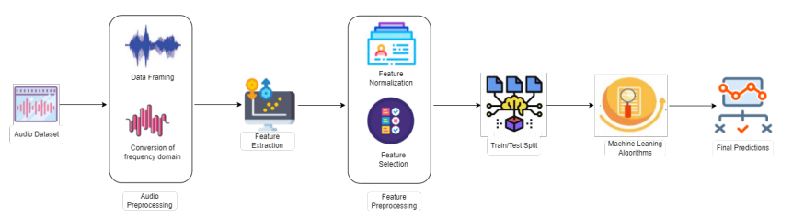

Existing system
- CNNs are employed to analyze spectrograms, which are visual representations of audio signals.
- By examining patterns in the frequency domain, CNNs can detect anomalies indicative of deepfake audio.
- Systems like ResNet and VGG have been adapted for this purpose, showing promising results in distinguishing between real and fake audio samples.
- Some systems focus on extracting specific features from audio signals, such as Mel-frequency cepstral coefficients (MFCCs), pitch, and formant frequencies.
- Machine learning classifiers like support vector machines (SVMs) or random forests are then used to analyze these features and identify potential deepfakes.

Drawbacks in existing system project
- Limited Temporal Understanding: ResNet primarily focuses on spatial features in images and lacks built-in mechanisms for capturing temporal dependencies in video data. Deepfake detection often requires understanding the temporal context, which ResNet may not handle optimally.
- Large Computational Requirements: ResNet architectures are deep and can be computationally expensive, especially when dealing with high-resolution video frames. This can pose challenges in real-time deepfake detection or applications with limited computational resources.
- Vulnerability to Adversarial Attacks: ResNet architectures, like many deep learning models, are susceptible to adversarial attacks. Adversarial examples specifically crafted to deceive the model could potentially lead to false negatives in deepfake detection.

Proposed system
- In this project, we propose a deepfake audio detection system leveraging the capabilities of Recurrent Neural Networks (RNNs), specifically Long Short-Term Memory (LSTM) networks.
- The proposed system aims to exploit the sequential nature of audio signals, capturing temporal dependencies and subtle inconsistencies that are characteristic of deepfake manipulations.
- Our approach begins with preprocessing the audio data to extract relevant features such as Mel-frequency cepstral coefficients (MFCCs), which serve as inputs to the LSTM network.
- The LSTM model is designed to process these features over time, learning to identify patterns and anomalies that distinguish genuine audio from synthetic counterparts.

Advantages of proposed system in project
- Effective Handling of Sequential Data: LSTMs are specifically designed to process sequential data, making them well-suited for analyzing audio signals, which unfold over time.
- Capturing Temporal Dependencies: By capturing long-term dependencies within audio sequences, LSTMs can identify subtle inconsistencies and anomalies often present in deepfake audio.
- Robustness to Deepfake Manipulations: LSTMs can learn to differentiate between genuine and synthetic audio patterns, making the system resilient to evolving deepfake techniques.
- Potential for High Accuracy: The combination of feature extraction (MFCCs) and LSTM modeling can lead to high accuracy in distinguishing between real and fake audio.
- Adaptability: LSTMs can be trained on large datasets, allowing for continuous improvement in detection capabilities as new deepfake techniques emerge.

