**RAG_GENAI.ipynb (Gemini‑Powered RAG)**

**Cell 1: Install Dependencies:**

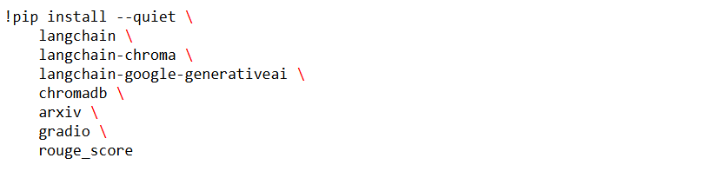

**Purpose:**  
Pull in LangChain core, Chroma integration, Gemini adapters, arxiv data loader, Gradio, and ROUGE scorer.

**Cell 2: Imports & Auth:**

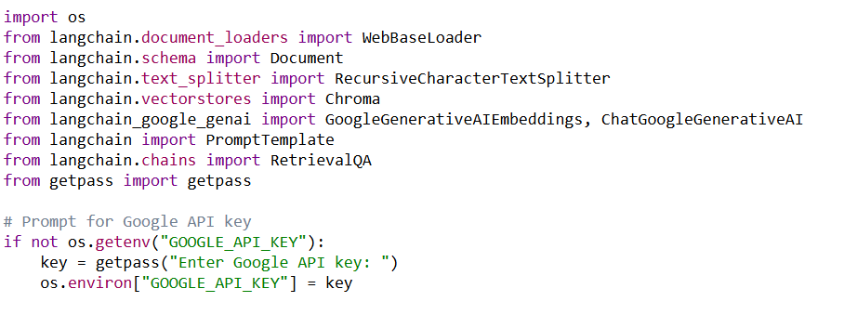

**Purpose:**

* Import all necessary classes
* Securely prompt for GOOGLE_API_KEY used by langchain-google-generativeai.

**Notes:**

* Document is LangChain’s standard class for passing text + metadata through the pipeline.

**Cell 3: Fetch Real arXiv Abstract’s:**

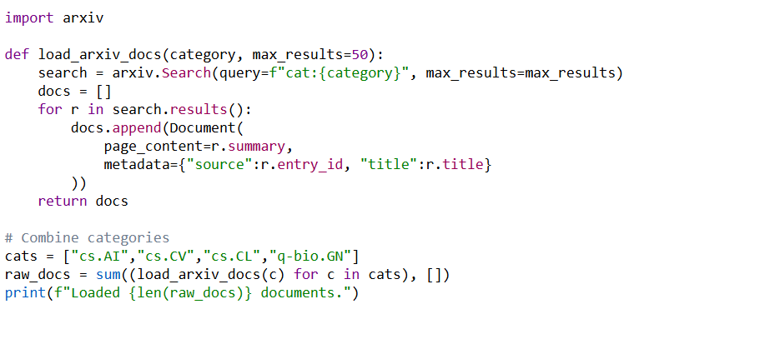

**Purpose:**  
Use the arxiv package to pull **actual abstracts** (not just HTML listings) from multiple categories for broad coverage.

**Inputs / Outputs:**

* **Input:** Category strings
* **Output:** raw_docs list of LangChain Document objects.

**Cell 4: Chunk, Embed & Index:**

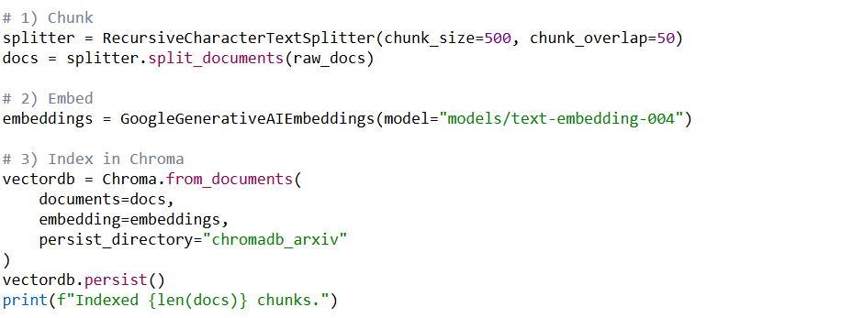

**Purpose:**  
Mirror the tiny‑corpus pipeline but on ~200 abstracts × ~2 chunks each = ~400 embeddings indexed.

**Cell 5: Retrieval Wrapper:**

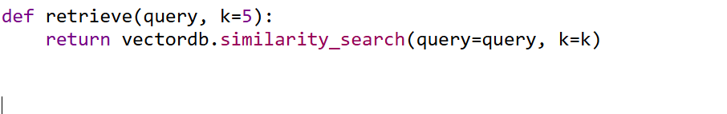

**Purpose:** Simple wrapper around Chroma’s similarity_search.

**Cell 6: Build Gemini RetrievalQA Chain:**

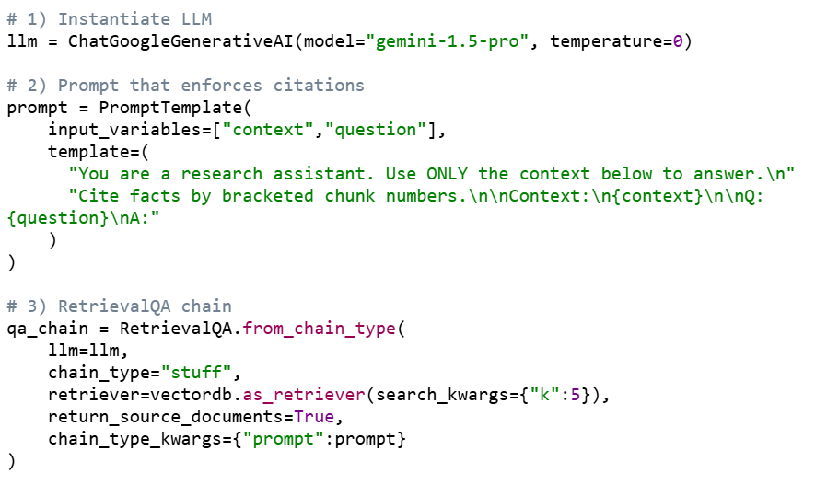

**Purpose:**

* Sets up a LangChain RetrievalQA object combining:
  1. Chroma retriever
  2. Gemini LLM with a custom prompt

**Notes:**

* chain_type="stuff" means we stuff all retrieved chunks into one prompt.
* return_source_documents=True ensures we get back the chunks for citation display.

**Cell 7: Helper & Quick Test:**

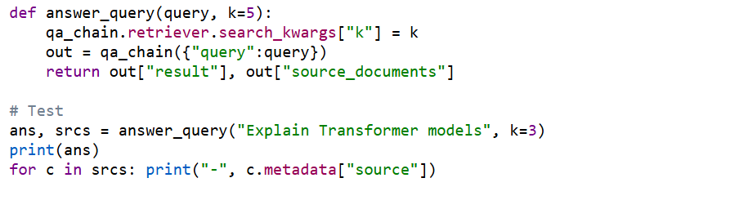

* **Purpose:**  
  Simplifies calling the chain and prints both the generated answer and the sources’ URLs.

**Cell 8: Evaluation Metrics:**

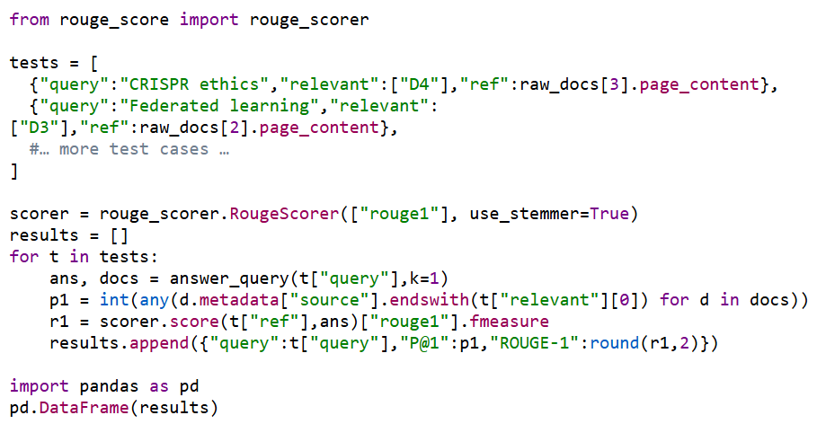

* **Purpose:**  
  Same evaluation approach as before, adapted to the Gemini pipeline and Document metadata.

**Cell 9: Gradio UI (Blocks):**

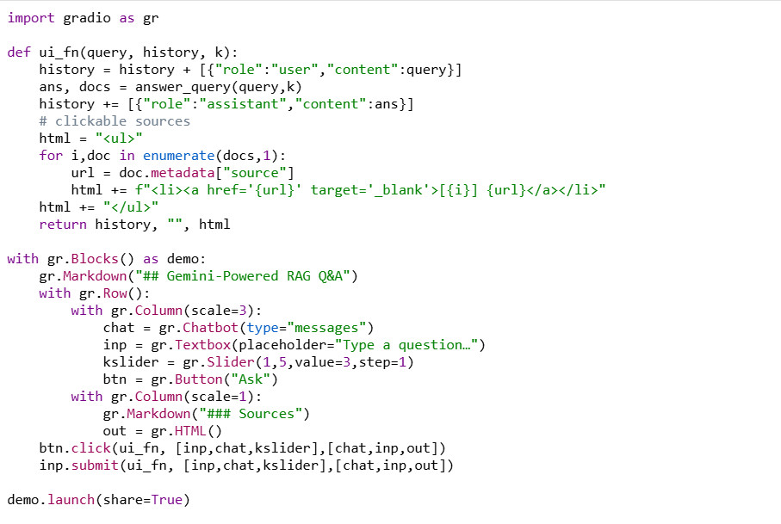

**Purpose:**  
Mirrors the full‑Arxiv UI but plugged into Gemini’s answer_query.  
Chat history is maintained; sources render as clickable arXiv links.