
PROJECT TITLE
Micro-Credit Defaulter Model

Submitted by:
SAI KUMAR M

ACKNOWLEDGMENT
- Referred Google to gain more knowledge on telecom companies
- To learn more about python I referred w3school
- To know more about machine learning I went through few documents.
- For visualization I used plot websites to learn them

INTRODUCTION

- Business Problem Framing
A Microfinance Institution (MFI) is an organization that offers financial services to low income populations. We are working with one such client that is in Telecom Industry from Indonesia. They understand the importance of communication and how it affects a person’s life, they are providing their services and products to low income families and poor customers that can help them in the need of hour. They are collaborating with an MFI to provide micro-credit on mobile balances to be paid back in 5 days as condition.

- Conceptual Background of the Domain Problem
Dataset with is extracted for this business requirement can solve business hurdles and difficulties by analyzing the previous data taking right decisions towards the growth in the business, These things are possible by using machine learning and python.

- Review of Literature
Studied about the Microfinance Institution (MFI) and there various services towards society. Done research on other institution which provide similar services. Gained some knowledge on telecom industries and there services.

- Motivation for the Problem Undertaken
Telecom Company is providing a effective service like micro loan for the society which is useful for in times of emergency. It is a huge service to run this smoothly and effectively few terms and conditions are set and it must be managed in a professional ways, this motivated me to undertake this project

Analytical Problem Framing
- Mathematical/ Analytical Modeling of the Problem
After analyzing the data with target variable which states that whether the customer will be paying back the loaned amount within 5 days of issuance of loan. In this case, Label 1 indicates that the loan has been payed, while Label 0 indicates that the loan has not been payed. 87% of user are following the companies terms and conditions and paying the loan with in 5 days rather 13 % users are not following them.
- Data Sources and their formats
Here the data is provided by the flip robo technologist. The data was in the csv format. It consists of 209593 rows and 36 columns with 33 as numeric data type and rest 3 columns had object as their data type were label is considered as target.
- Data Preprocessing Done
In the preprocessing part had to remove columns like user id service circle. Few columns had object has their data type I had to split that date column into year, month and day and changed the data types of those columns to int.

- Data Inputs- Logic- Output Relationships
Here we are taking a csv format data as input to our machine learning project. Once the proper data cleaning is done and preprocessing is done, At the end we will convert all the other dat types to numeric data types because machine learning accepts only numbers later will split the data into independent and dependent variable. To the split data we will apply various models for model building.
- Hardware and Software Requirements and Tools Used
Used windows 10 with 4GB ram laptop, software are python 3 with machine learning, sk-learn libraries, pandas, numpy and so on..
Model/s Development and Evaluation

- Identification of possible problem-solving approaches
To analyse the data I used info(), dtypes(), nunique() and for statistical I used describe(), corr(). Analyzing is done with the help of visualization.
- Testing of Identified Approaches (Algorithms)
I used the following alogrithms
LinearRegression()
Ridge()
Lasso()
RandomForestRegressor()
DecisionTreeRegressor()
GradientBoostingRegressor()

- Run and Evaluate selected models

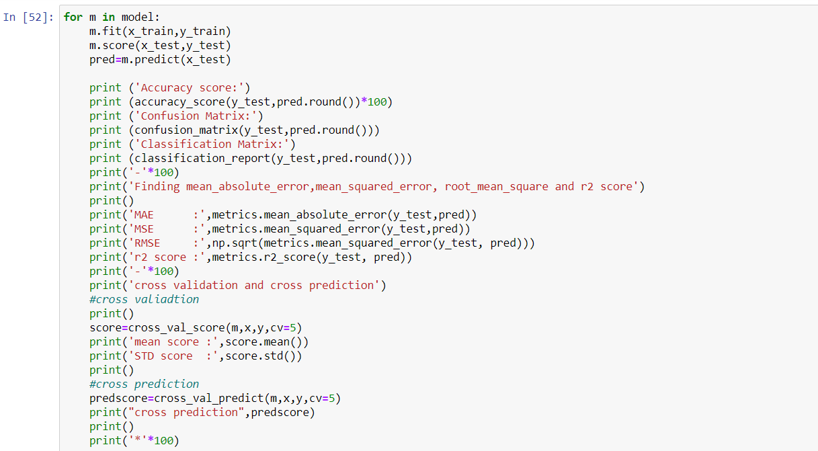

Logistic regression is a supervised learning classification algorithm used to predict the probability of a target variable. The nature of target or dependent variable is dichotomous, which means there would be only two possible classes.

Random forest classifier creates a set of decision trees from randomly selected subset of training set. It then aggregates to decide the final class of the test object.

Decision Tree algorithm belongs to the family of supervised learning algorithms. Unlike other supervised learning algorithms, the decision tree algorithm can be used for solving regression and classification problems too.

Model Accuracy score
LinearRegression 87.52266264623371
Ridge 87.52266264623371
Lasso 87.54938071337239
RandomForestRegressor 92.03610755930457
DecisionTreeRegressor 88.49596366342868
GradientBoostingRegressor 91.55709078417527

- Visualizations & Interpretation of the Results

Uni-variate Plot

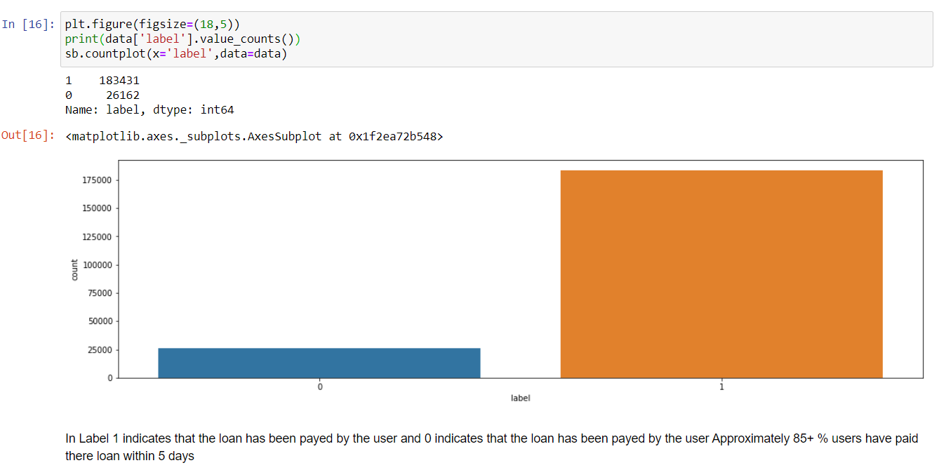

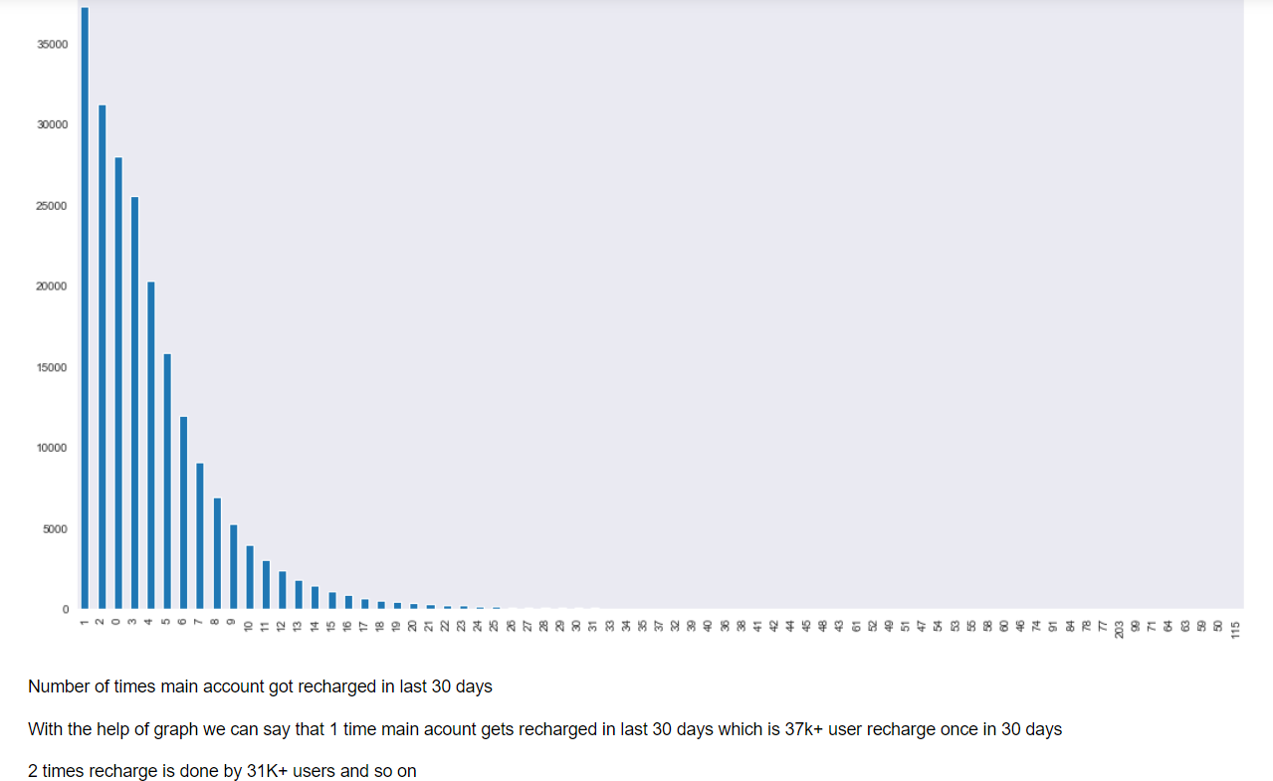

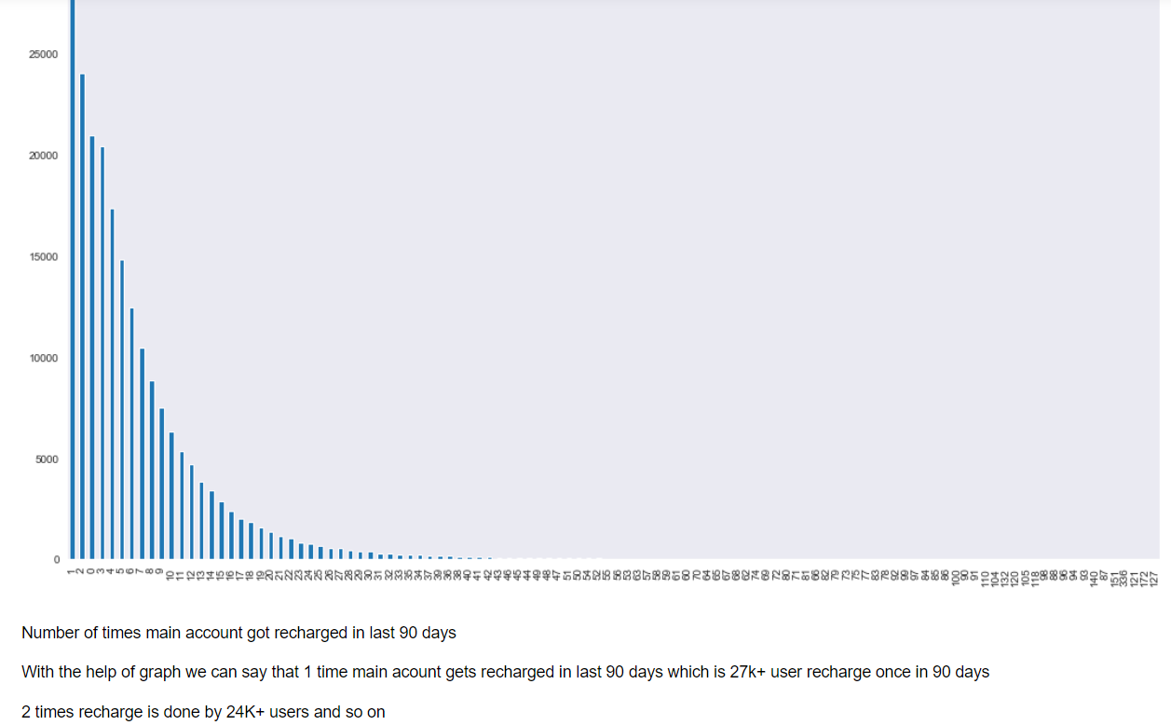

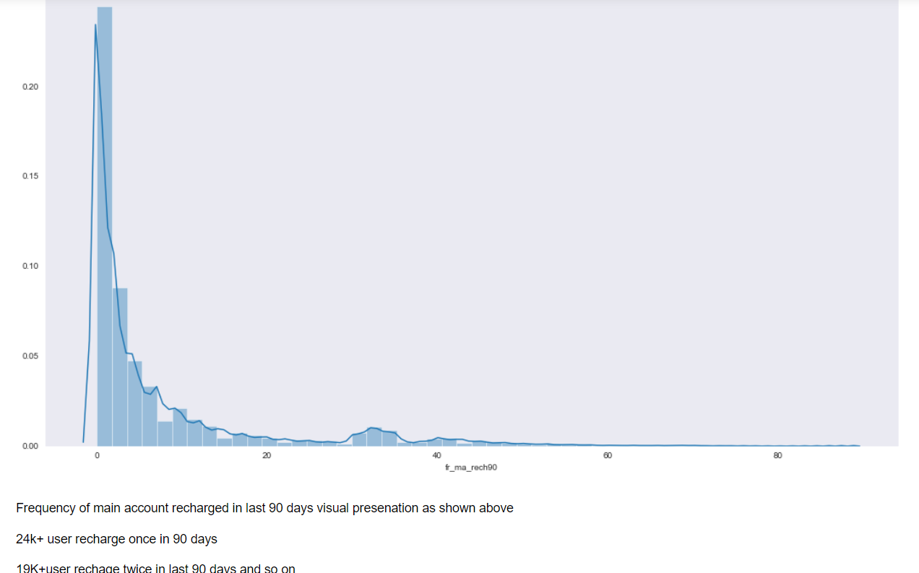

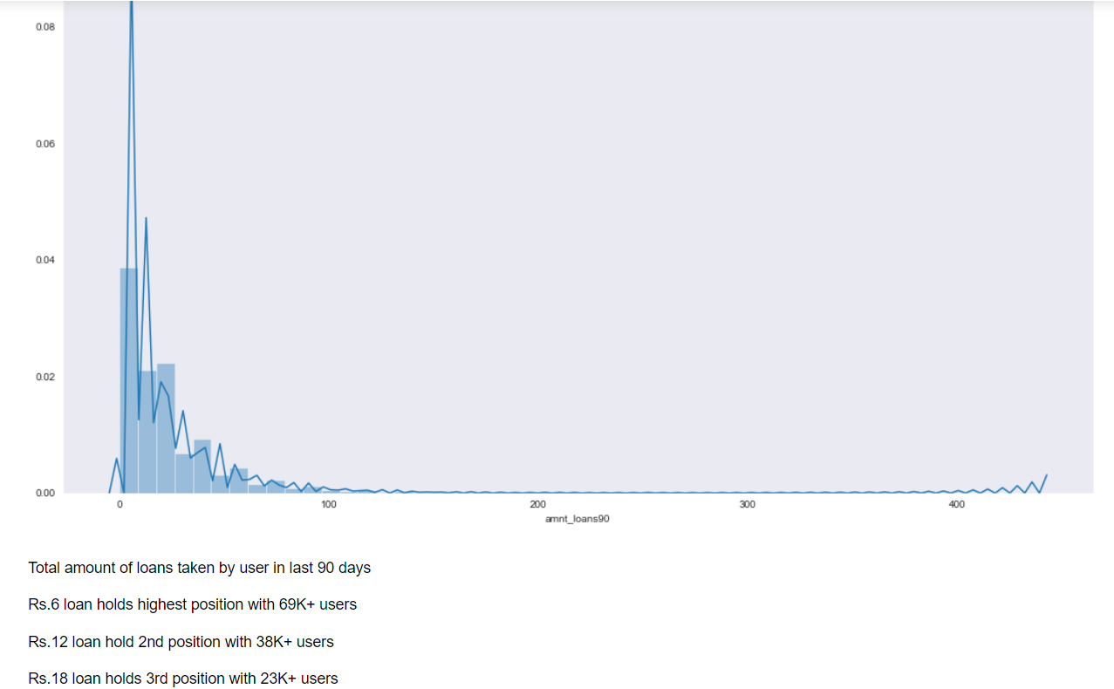

Bi-variate Plot

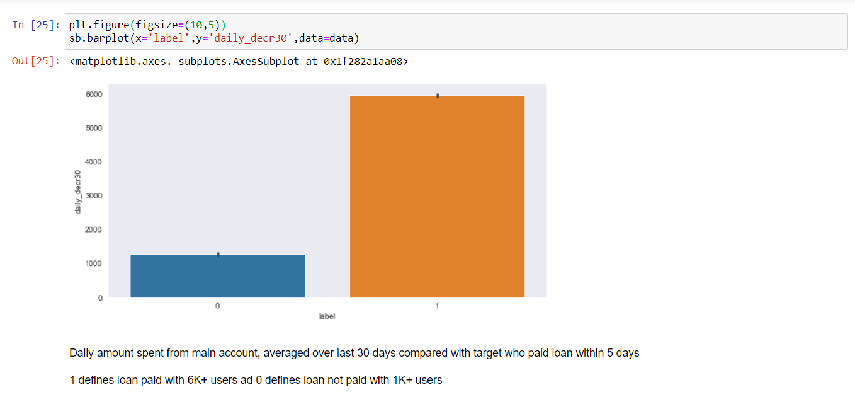

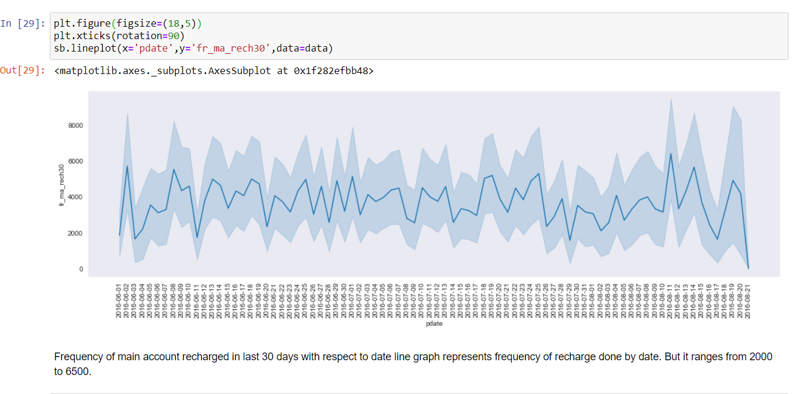
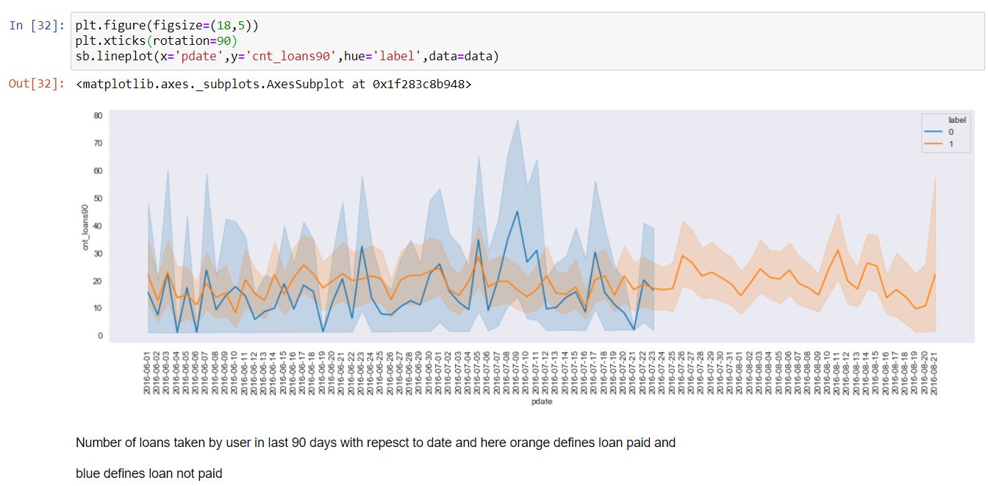

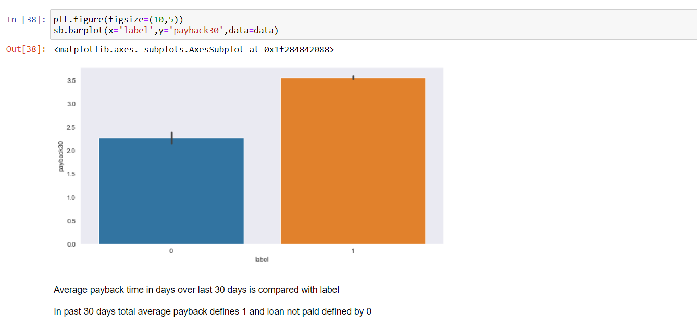

CONCLUSION
- Key Findings and Conclusions of the Study
Key finding after the study of dataset is 87% of the users are following the terms and conditions of the telecom company. Most of the users are taking loans only once in last 30 days . If you consider 30 or 90 days majority of the users are taking loan only once. By analyzing the data we can say the users are increased and showing interested in taking loans.
- Learning Outcomes of the Study in respect of Data Science
By the end of the project gained knowledge how telecom companies are providing the services I,e micro loans. Learned few more algorithms which provide accuracy of 80+. Gained knowledge in presenting the data through visualization.

- Limitations of this work and Scope for Future Work
Limitations
Instead of average data we need actual data
Data was too large instead we want small size data so we can analyse and extract more from it.

