

**IMAGE CLASSIFICATION**

Deep learning CNN Project

Submitted by:

SAI KUMAR M

**ACKNOWLEDGEMENT**

For Image classification project data is collected from scraping a website called amazon. Refered kagal and GitHub for better understanding and to get advanced techniques. Official websites like w3schools and others for base knowledge.

**INTRODUCTION**

* Business Problem Framing

Images are one of the major sources of data in the field of data science and AI. This field is making appropriate use of information that can be gathered through images by examining its features and details. We are trying to give you an exposure of how an end to end project is developed in this field.

* Conceptual Background of the Domain Problem

The idea behind this project is to build a deep learning-based Image Classification model on images that will be scraped from e-commerce portal. This is done to make the model more and more robust.

This task is divided into two phases: Data Collection and Mode Building.

* Motivation for the Problem Undertaken

This model will then be used by the management to understand how exactly the prices vary with the variables. They can accordingly manipulate the strategy of the firm and concentrate on areas that will yield high returns.

**Analytical Problem Framing**

* Data Sources and their formats

In this data needed to be scrape images from e-commerce portal, Amazon.

The clothing categories used for scraping will be:

* Saree (women)
* Trousers (men)
* Jeans (men)

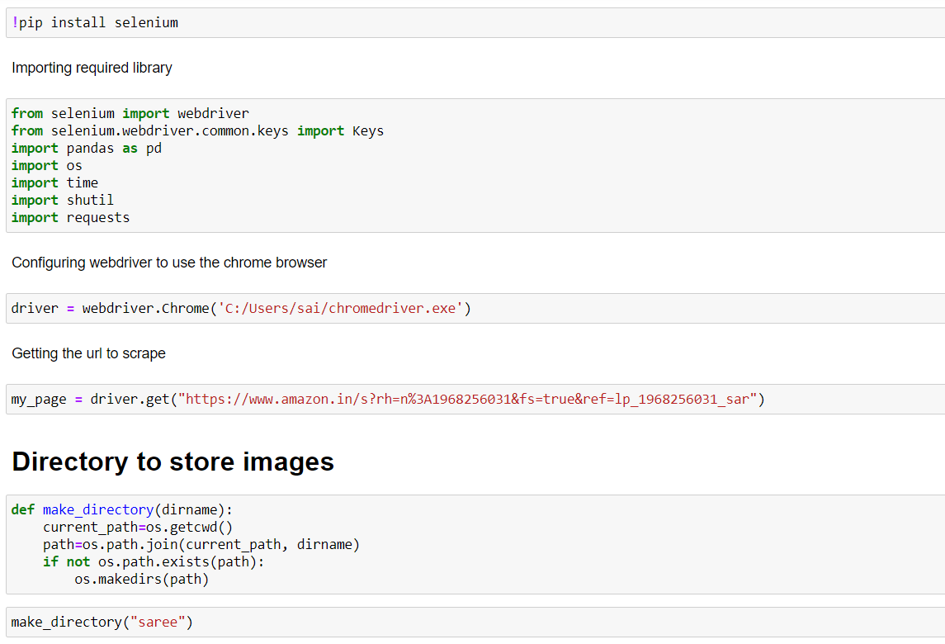

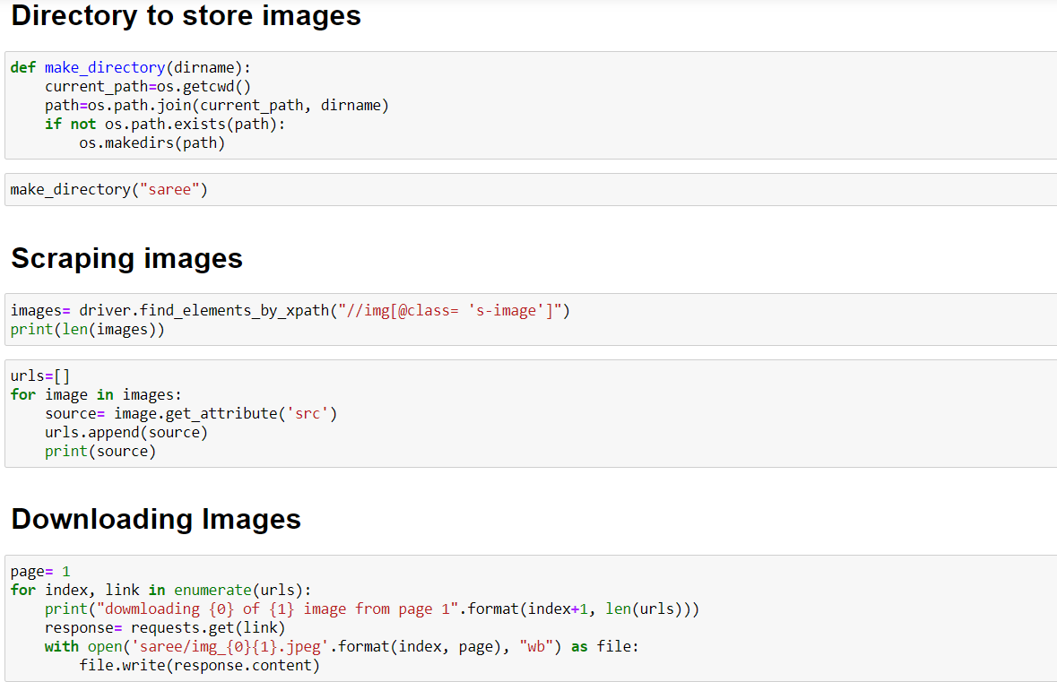

* Data Inputs- Logic- Output Relationships

The data which scraped from amazon is stored in a folder. While using in deep learning it is called

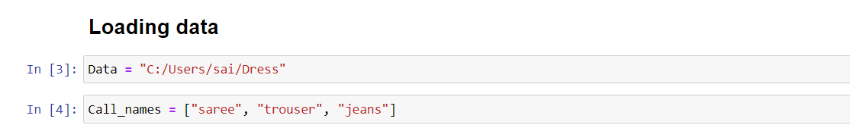

* Hardware and Software Requirements and Tools Used

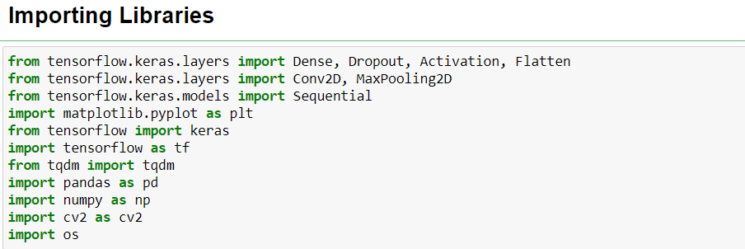Hardware required are laptop with minimum 6gb ram, software required are jupyter notebook with tensor-flow GPU for Deep learning and for web scarping. These are the libraries

* imported from tensorflow.keras.layers import Dense, Dropout, Activation, Flatten
* from tensorflow.keras.layers import Conv2D, MaxPooling2D
* from tensorflow.keras.models import Sequential
* import matplotlib.pyplot as plt
* from tensorflow import keras
* import tensorflow as tf
* from tqdm import tqdm
* import pandas as pd
* import numpy as np
* import cv2 as cv2
* import os

**Model/s Development and Evaluation**

* Testing of Identified Approaches (Algorithms)

All the algorithms used for the modelling

**Building Model**

## **Create the convolutional base**

model = Sequential()

model.add(Conv2D(256, (3, 3), input_shape=data_x.shape[1:]))

model.add(Activation('relu'))

model.add(MaxPooling2D(pool_size=(2, 2)))

model.add(Conv2D(256, (3, 3)))

model.add(Activation('relu'))

model.add(MaxPooling2D(pool_size=(2, 2)))

## **Add Dense layers on top**

model.add(Flatten())

model.add(Dense(64))

model.add(Dense(1))

model.add(Activation('sigmoid'))

model.summary()

## **model compile**

model.compile(loss='binary_crossentropy',

optimizer='adam',

metrics=['accuracy'])

## **Model Fitting**

model.fit(data_x, data_y, batch_size=32, epochs=5, validation_split=0.1)

* Run and Evaluate selected models

All the algorithms used along with the snapshot of their code.

For web scraping





For Deep learning

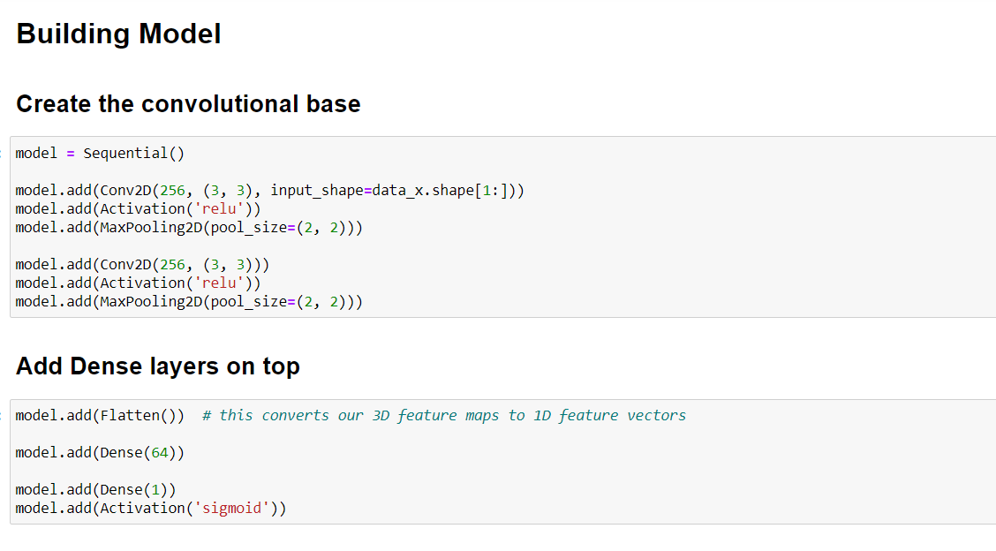

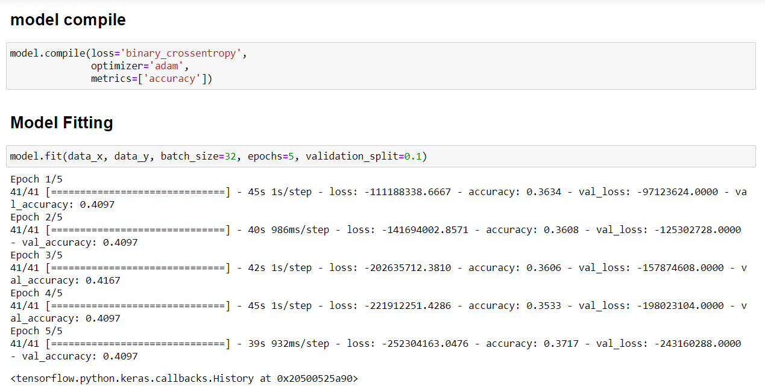

* Key Metrics for success in solving problem under consideration

metrics=['accuracy'] is the metric used to get the accuracy of the model

snapshot as shown below

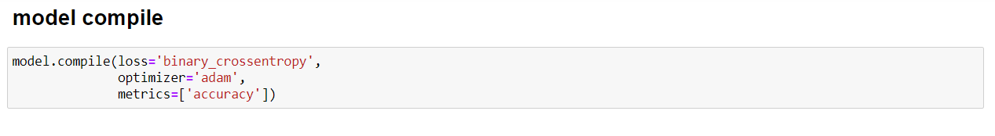

* Visualizations

Here visualization is very low

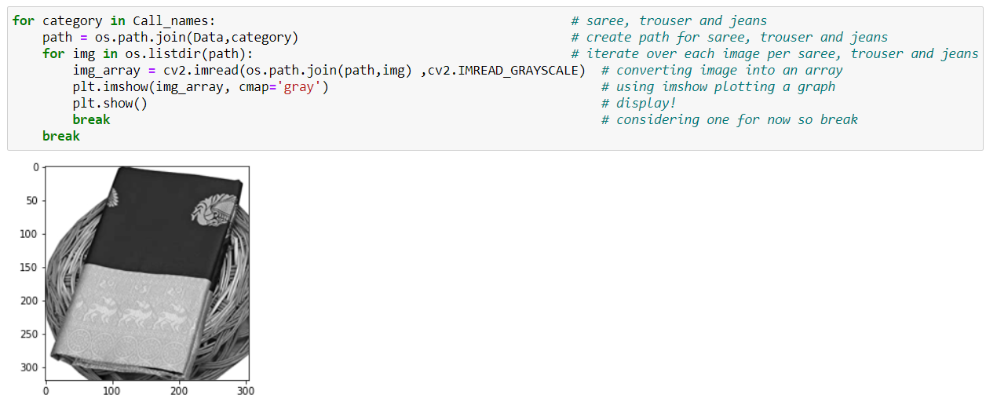

Consider the first image getting the details of the image size.

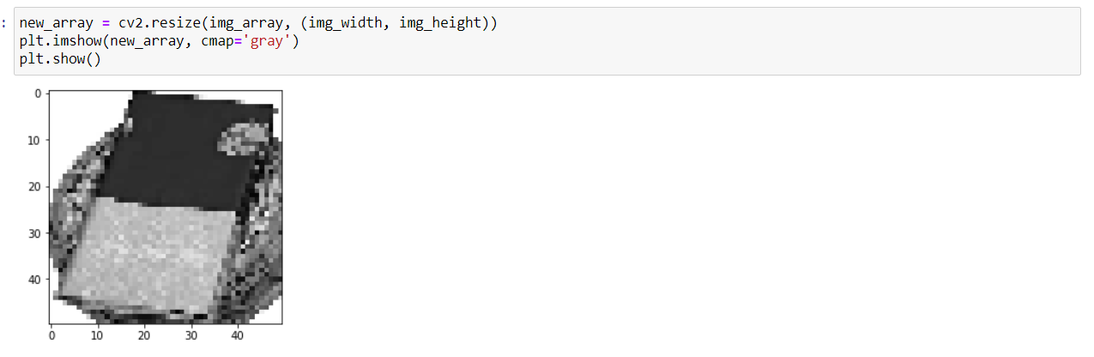This is after setting the image size by changing img width and img height as shown above figure.

**CONCLUSION**

* Key Findings and Conclusions of the Study

Here by using limited data deep learning results was not up to the mark, if we had huge amount of data we would have got higher results.

* Learning Outcomes of the Study in respect of Data Science

Learning Outcomes of the Study in respect of Data Science are we got practical experience in web scraping and in deep learning model. We were able to use solve minor problems which comes on the way of modelling.

* Limitations of this work and Scope for Future Work

Here by using limited data deep learning results was not up to the mark, if we had huge amount of data we would have got higher results.

Setup knowledge for tensorflow GPU

Time consuming while web scraping and setting up tensorflow gpu