# COLLEGE DATA SYSTEM

*A*

*Mini Project Report*

*Submitted in partial fulfilment of the Requirements for the award of the Degree of*

### BACHELOR OF ENGINEERING

IN

### INFORMATION TECHNOLOGY

By

V. SAI RISHITHA – 1602-19-737-096

G. SRAVANI YADAV – 1602-19-737-108

M.ANANYA – 1602-19-737-065



### Department of Information Technology Vasavi College of Engineering (Autonomous) (Affiliated to Osmania University) Ibrahimbagh, Hyderabad-31

**2020**

**Vasavi College of Engineering (Autonomous) (Affiliated to Osmania University)**

**Hyderabad-500 031**

### Department of Information Technology



**DECLARATION BY THE CANDIDATE**

We, V. SAI RISHITHA, G. SRAVANI and M. ANANYA bearing hall ticket numbers, 1602-19-737-096,1602-19-737-108 and 1602-19-737-065 hereby declare that the project report entitled “COLLEGE DATA SYSTEM” is submitted in partial fulfilment of the requirement for the award of the degree of Bachelor of Engineering in Information Technology.

This is a record of bonafide work carried out by us and the results embodied in this project report have not been submitted to any other university or institute for the award of any other

degree or diploma.

V. SAI RISHITHA

1602-19-737-096

G. SRAVANI YADAV

1602-19-737-108

M. ANANYA

1602-19-737-065

(Faculty In-Charge) (Head.Dept IT)

# Acknowledgements

The satisfaction that accompanies the successful completion of this project would not be in complete without the mention of the people who made it possible, without whose constant guidance and encouragement would have made efforts go in vain. We consider ourselves privileged to express gratitude and respect towards all those who guided us through the completion of this project.

We would like to thank our faculty Mrs.Prasanna for providing encouragement, constant support and guidance which was of a great help to complete this project successfully.

Last but not the least, we wish to thank our parents for financing our studies in this privileged Vasavi College of Engineering as well as for constantly encouraging us to learn engineering. Their personal sacrifice in providing this opportunity to learn engineering is gratefully acknowledged.

# Abstract

The College data system using C is a location where a student can have

all the information they need. Each section has different information according

to need of student like search class routine, bus schedule, teacher information,

subjects list, assignments, quizzes and college events.

This system is very useful for fresher student because they have no idea about college

teachers and many more things.

Admin section have their separate login system.

With the password given to Admin, they can access the page from where

they can change, update, delete the information.

Whenever student accesses

timetables, if there are any pending assignments or quizzes the

student gets remainders.

# Table of contents

|  |  |
| --- | --- |
| **Topic** | **Page Number** |
| **Introduction** | **6** |
| **Technology** | **8** |
| **Proposed Work** | **9** |
| **Results** | **19** |
| **Additional Knowledge Acquired** | **26** |
| **Conclusions and Future work** | **27** |
| **References** | **28** |

## INTRODUCTION

In our project we provided two users, one is the student and the other is the faculty. Here faculty need to enter the login credentials to get in to our college data system whereas students need not bother about logging in as they directly open our software they can view all the details. Students are only able to view the data and faculty can view ,add and modify the data.

The objective of College Data System is to allow the administrator of any organization to edit and find out the personal details of a student .It’ll also facilitate keeping all the records of students . So all the information about a student will be available in a few seconds. Overall, it’ll make Student Information an easier job for the administrator and the student of any organization. The main purpose of this project is to illustrate the requirements of the project College Data System and is intended to help any organization to maintain and manage personal data. It is a comprehensive project develope from the ground up to full fill the needs of colleges as they guide their students. This education edge integrated information management system connects daily operations in the college environment ranging from registration to finance, faculty, and library. This reduces data error and ensures that information is always up-to-date throughout the college.

It provides a single source of data repository for streamlining your business processes and for all reporting purposes. It has a simple user interface and is intuitive. This insures that the users spend less time in learning the system and hence, increase their productivity. Efficient security features provide data privacy and hence increase their productivity.

Our project contains 8 modules:

1. Login
2. Class timetable
3. Bus routines
4. Teacher information
5. Quizzes
6. Assignments
7. Events in college
8. List of subjects

It’s purpose is to automate and centralise the whole system of the department. We are attempting to improve our existing system that runs on pen and paper. The main goal of the system is to automate the process carried out in the organization with the improved performance and realize the vision of the paperless work.

It is more efficient and convinient for the college. It reduces the man power needed to perform the entire administration task by reducing the paper work needed.If all the works are done by the computer there is less chance of errors.Moreover storing and retrieving the information becomes easier and so work can be done faster and in time.

## TECHNOLOGY

All compute software needs certain hardware components or other software components resources to be present. In order for computers to used efficiently these are the primary requisites. There are two different categories of this section.

### Software Requirements:

Software requirements mainly share out with defining the software resource requirements that need to be installed on a computer to provide optimal functioning of a particular application. These conditions are not included in the software installation package and need to be installed separately.

In order to use “College Data System” the following are the prerequisites,

* + - 1. Operating System – Windows 7 and above
      2. C Compiler – GNU Compiler(GCC)
      3. Editor – Any basic editor is preferable

### Hardware Requirements:

Hardware requirements refer to the common set requirements defined by any operating system or software application and are usually the physical computer resources. In this section we basically deal with primary memory, secondary memory, processing power.

In order to use “College Data System” one should have the following,

* + - 1. Processor - Intel Core i5 and above
      2. Memory – 4GB Ram

## PROPOSED WORK

### a.Design

### i.Use Case Diagram

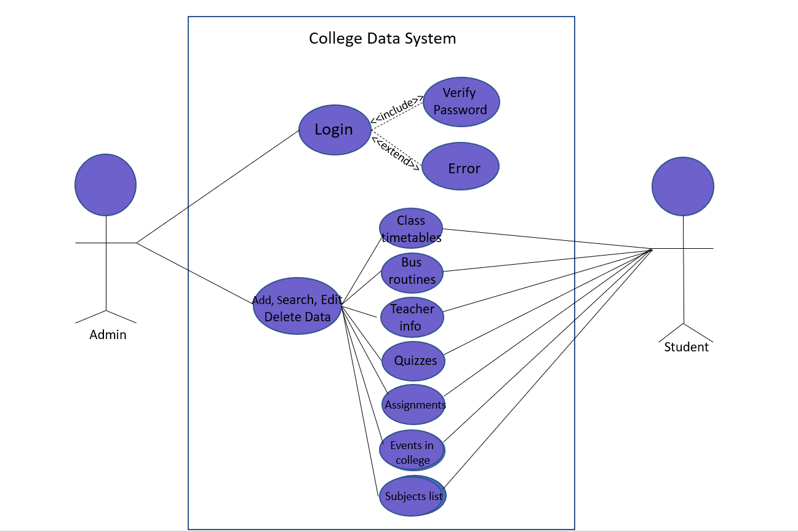

**ii. Flowchart**

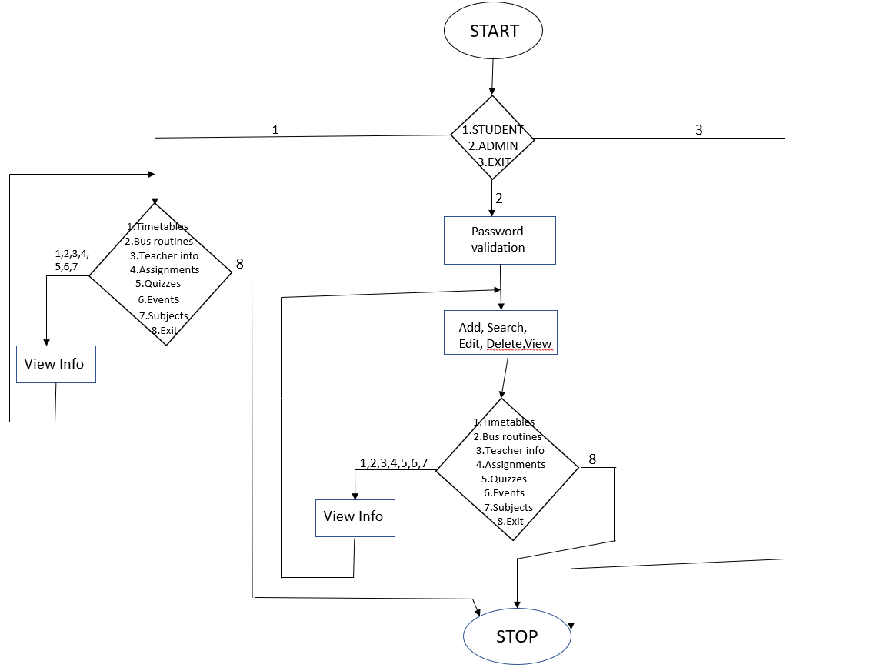

**b.Implementation**

1. **Description of main modules/classes/components**

Module Name: Login

Actors: Admin

Description: Allows only the admins to access and change data.

Pre-Conditions: The admin must be already registered and has the password.

Post Conditions: After successful login, he/she can modify the information.

Main Flow:

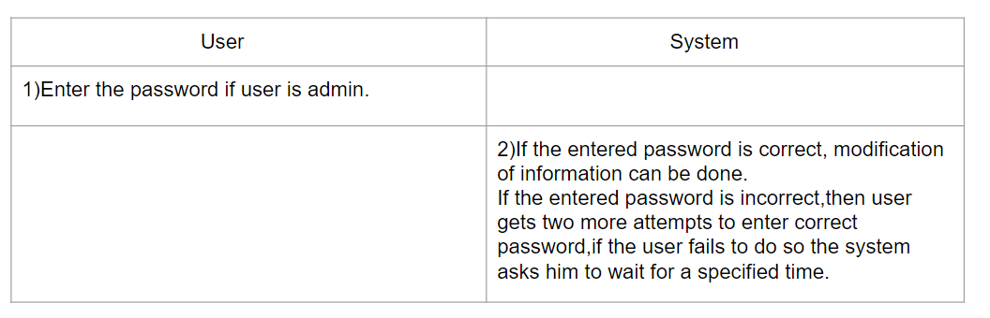

Module Name: Class timetables

Actors: Admin, Student

Description: It allows admin to modify timetables and students can view it. When we enter a particular

day the assignments or quizzes of that day are also displayed.

Pre-Conditions: The admin must successfully login and students should select timetables option.

Post-Conditions: If nothing is uploaded by the admin, it shows no class on that day.

Main Flow

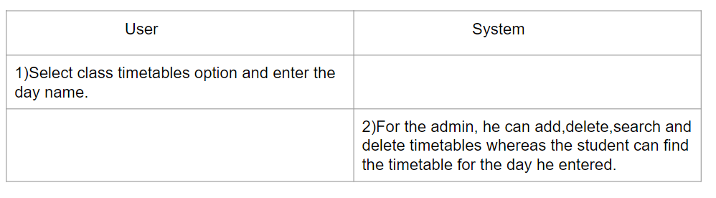

Module Name: Bus Routines

Actors: Admin, Student

Description: Allows student to view the bus details(routes) modified by the admin

Pre-condition: Student should login to the student account and select bus routine to view the details.

Post condition: Admin should modify the routes, else it will show the previous routes

Main flow:

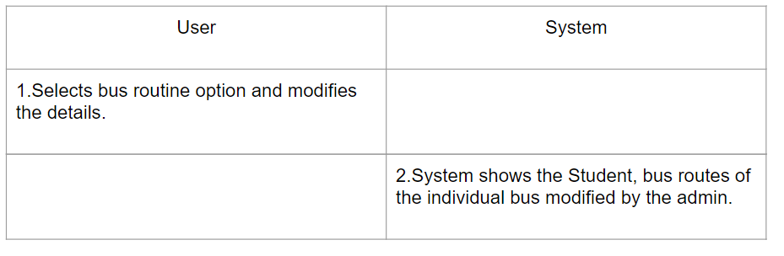

Module Name: Teacher information

Actors: Admin, Student

Description: Allows only admin to modify data and student to view it.

Pre-conditions: Students should login to their account successfully and can view the teacher information

Post conditions: If the details are not modified, it’ll show the previous details or else blank.

Main Flow:

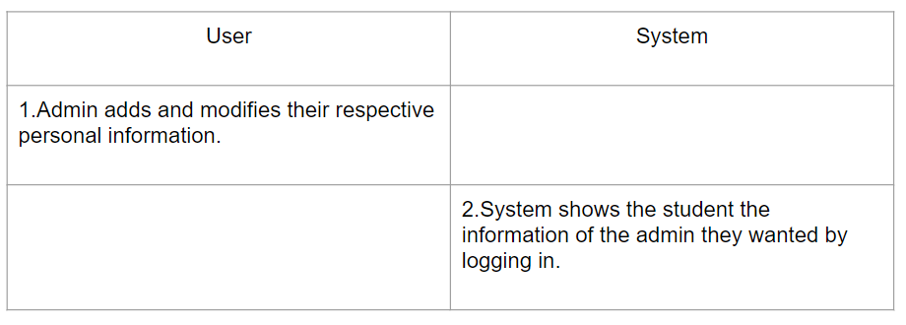

Module Name: Quizzes

Actors: Admin, Student

Description: Allows student to view the quiz dates, assigned by the admin and gives a reminder.

Pre-condition: Firstly student should login to their account and they can view the quiz dates.

Post condition: If nothing is assigned by the admin, it shows no quiz is being assigned.

Main flow:

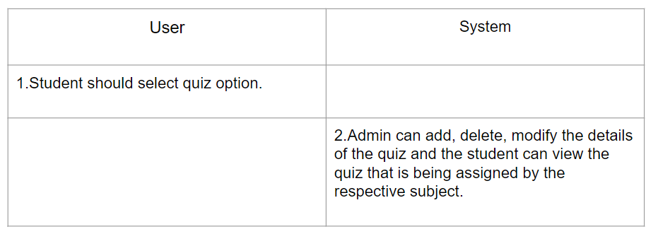

Module Name:  Assignments

Actor: Admin, Student

Description:  It allows student to view the assignment given by the admin and admin can add

                             edit and delete assignments

Pre-conditions: Student should select the option student after opening the application and admin

                              should successfully login to the application

Post-conditions: If the admin didn't upload any assignments, it displays it is empty to the student and

                               for the admin it asks to add assignment

Main flow:

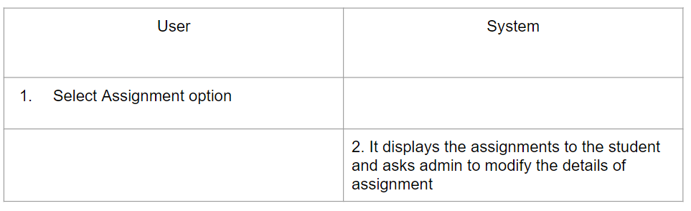

Module Name: Events in College

Actor: Student, Admin

Description: It allows student to view the details of events and allows admin to

                                add and edit the event details.

Pre-conditions: Student should choose student option after opening the application

                                and admin should successfully sign-in the application

Post-conditions: Admin will have options to add and edit the data

Main flow:

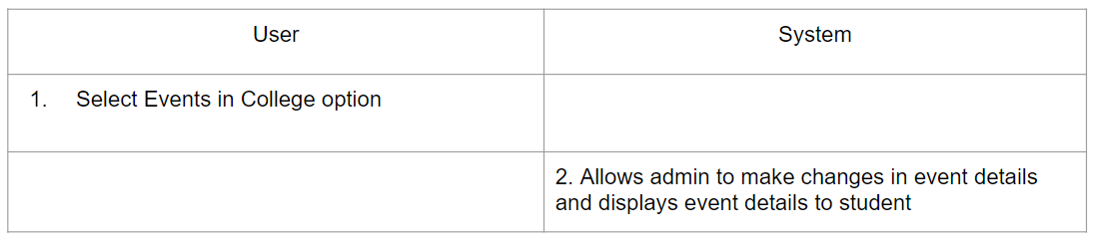

Module Name: List of subjects

Actor: Student,Admin

Description : It displays the subjects for different semisters to the

                      student and for the admin it asks to eidt and add data

Pre-conditions: Student should choose student option after opening

                         application and admin should successfully signed-in

                        to the application

Post-conditions: Admin will successfully edits the data and student

                           is able to know the subjects

Main flow:

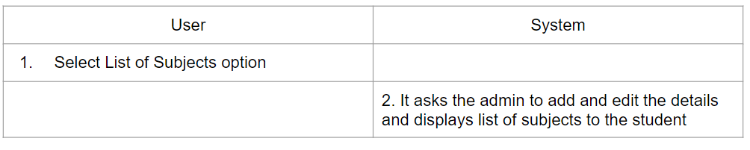

**ii. Any specific algorithms/logic to be highlighted**

🡪We used gotoxy function for changing the cursor position on the screen and

So that we can move to our desired position.

#include<conio.h> //header file for gotoxy

void gotoxy (int x, int y)

{

COORD coord = { 0 ,0 };

coord.X = x; coord.Y = y;

SetConsoleCursorPosition(GetStdHandle(STD_OUTPUT_HANDLE), coord);

}

🡪 We used sleep function to make the program wait for a specific amount of time

Instead of displaying everything at a time.

#include<windows.h> //header file for sleep function

char d[40] = "WELCOME TO COLLEGE DATA SYSTEM";

int i,j,k,l,m;

gotoxy(20,5);

for(j=0;j<40;j++)

{

Sleep(10);

printf("\xb2");

}

gotoxy(20,5);printf("\xB2");

Sleep(20);

gotoxy(20,6);printf("\xB2");

Sleep(20);

gotoxy(20,7);printf("\xB2");

Sleep(20);

gotoxy(20,8);printf("\xB2");

gotoxy(20,9);printf("\xB2");

Sleep(20);

gotoxy(20,10);printf("\xB2");

Sleep(20);

for(m=0;m<30;m++)

{

Sleep(50);

printf("%c",d[m]);

}

🡪For adding color to the text, we used ANSI color code

Eg-

|  |
| --- |
|  |
|  |
|  | Red="\[\033[0;31m\]" # Red |
|  | Green="\[\033[0;32m\]" # Green |
|  | Yellow="\[\033[0;33m\]" # Yellow |
|  | Blue="\[\033[0;34m\]" # Blue |
|  | Purple="\[\033[0;35m\]" # Purple |
|  | Cyan="\[\033[0;36m\]" # Cyan |
|  | White="\[\033[0;37m\]" # White |
|  | Black="\[\033[0;30m\]" # Black |
|  |  |

🡪While entering the password, inorder to make the letters invisible on the screen we

Used getch().

#include<conio.h> //header file for getch.

printf("\n\n\t\t\t\tEnter Password: ");

while(ch!=13)

{

ch=getch();

if(ch!=13)

{

printf("*");

passw[i] = ch;

i++;

}

}

**iii. Github links and folder structure**

<https://github.com/Sai-Rishitha>

<https://github.com/Sravaniyadav>

<https://github.com/Ananyaaa-m>

The README contains a brief description of the code.

We have a file which contains all the text files.

The project.c is the actual code for our mini project.

**c.Testing**

Testing is a method to check whether the actual product matches the expected

requirements and to ensure that the product is defect-free. This process involves execution

of various parts of the product either using manual or automated tools. The purpose is to identify

errors, gaps or missing requirements in contrast to the actual requirements.

We approached testing our console application by analysing each module separately.

First, we coded the requirements and then manually tested each feature present in the

module to cover any gaps that might occur

* In the admin section, while entering the password if the user enters an invalid password,

an error message saying invalid password is displayed and the user gets another chance to

reenter the password.

The user gets five chances to reenter the password. If the user enters wrong password five,

times then the user is supposed to wait for 20 seconds.

* In the choice, if the user enters some other number other than the given number then

a message saying invalid is displayed and the user has to reenter the choice.

* While searching for the record, if it is not found then a ‘record not found’ message is

displayed.

* While deleting the record, if it is not found then a ‘record not found’ message is

displayed.

* While modifying the record, if it is not found then a ‘record not found’ message is

displayed.

* While viewing record, if it is not found then a ‘record not found’ message is

displayed.

RESULTS

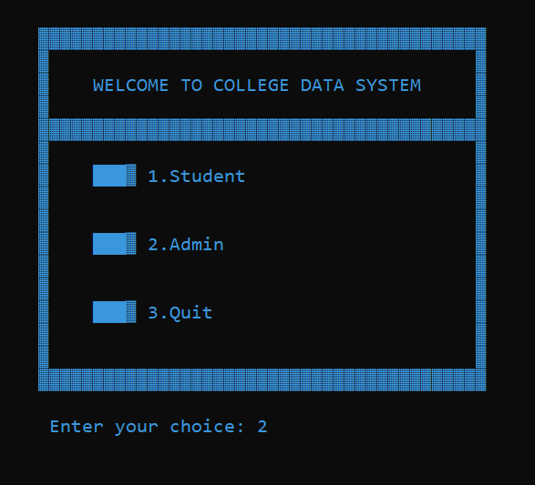

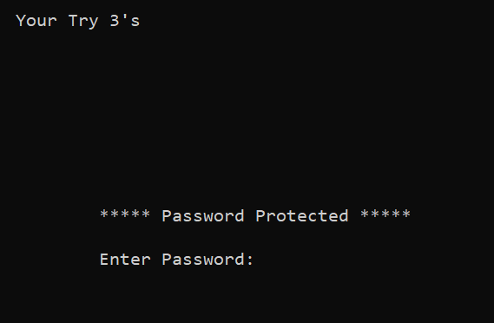

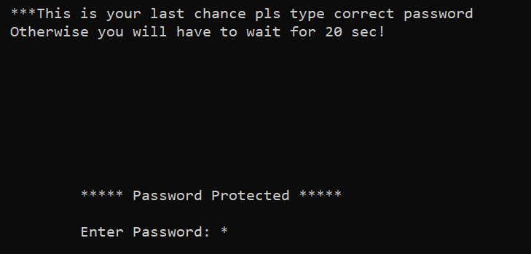

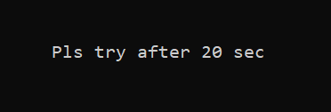

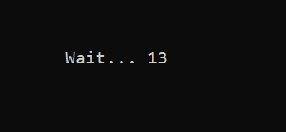

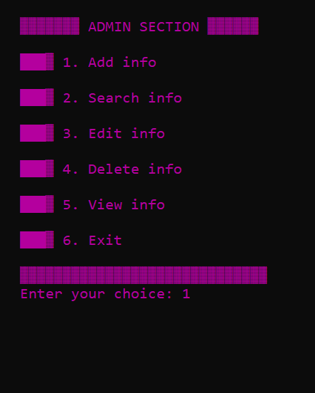

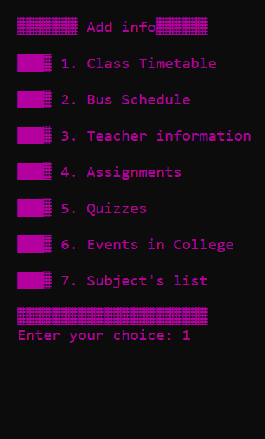

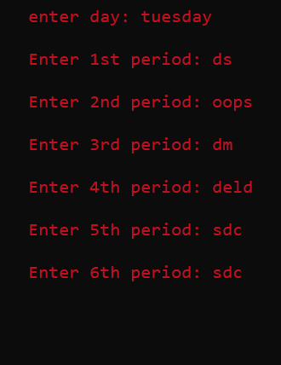

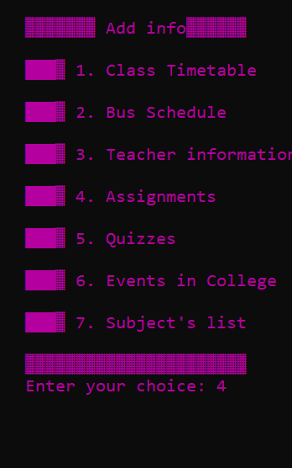

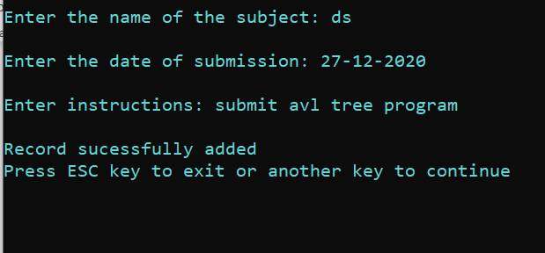

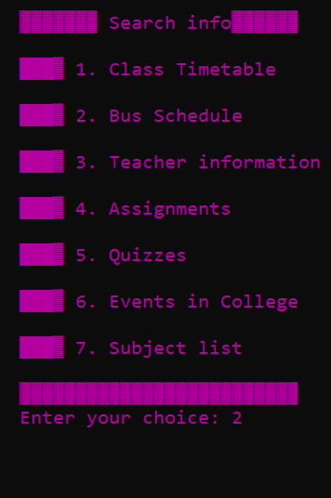

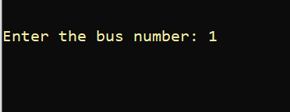



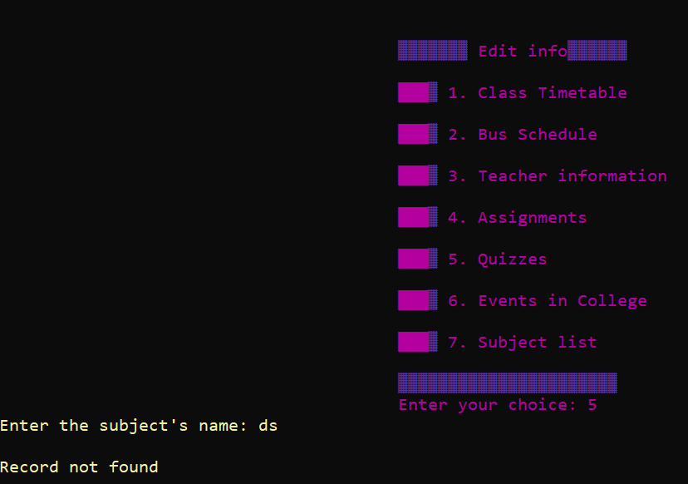

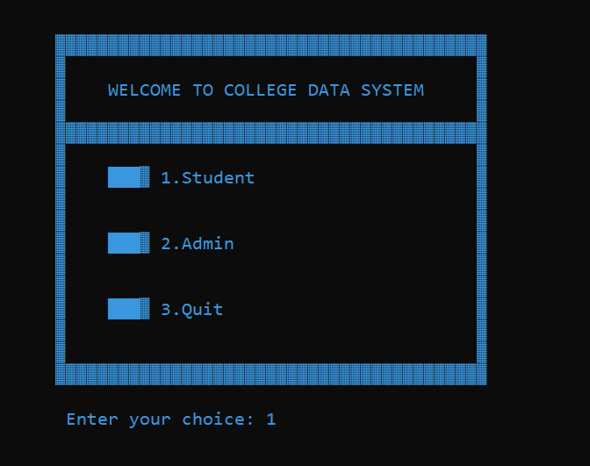

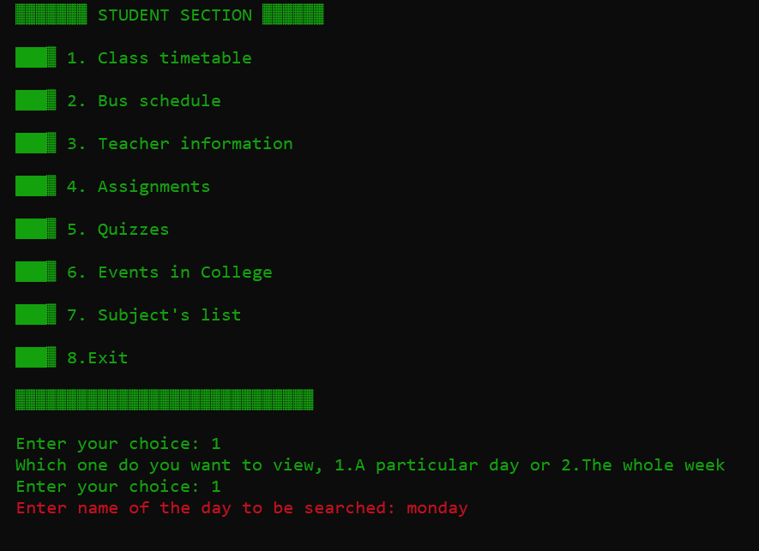

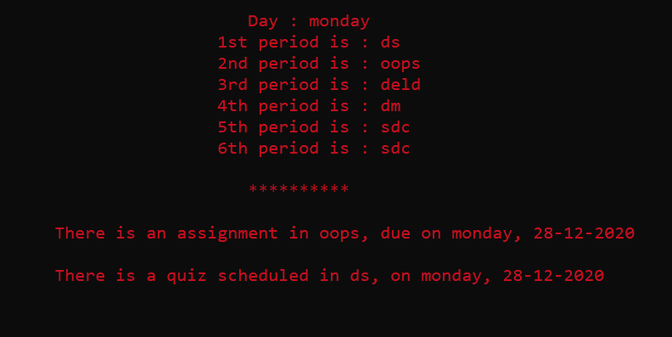

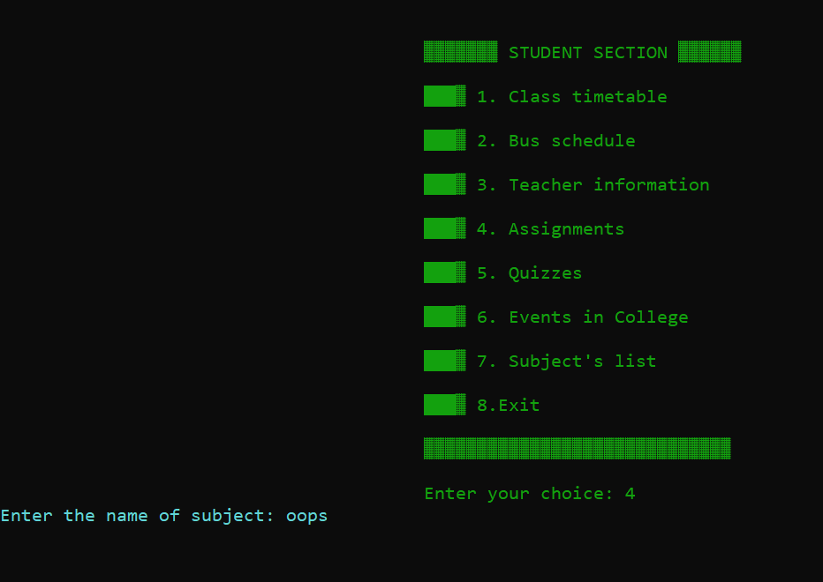

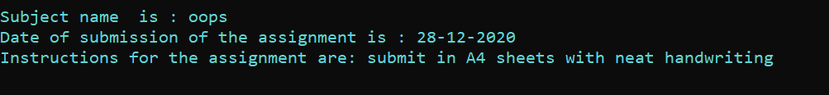

**What was the additional learning apart from the course programming for problem solving relate the ideas that you have gained implementing this miniproject.**

Implementing this project in C Language has introduced us to different libraries such as: ‘conio.h’, ‘time.h’ and ‘windows.h’. We used conio.h for password validation to make the characters not be printed on the screen. We also used the gotoxy function so that we can move the cursor to any place as we wish. We learnt about various graphics concepts in C programming.We also learnt how to add colours to the program.

We learnt about ANSI color code. We learnt how to use the sleep function. We explored the ‘time.h’ and ‘conio.h’ libraries for achieving a look-and-feel of an actual window application by constructing our own time delay function. Also, we have further improved in our knowledge in file-handling because of the vast amount of data manipulation we have done using text files.

Also, we have learnt the value of team spirit and have understood the intention behind working in teams. We have learnt to be team players.

# Discussion and Future work

To conclude, we built a program which is similar to a college website and more or less like

a notice board.

Our future work includes incorporating more concepts such as Data Structures in our code.

Also, we would like to include a feature which allow the student to send requests to the Admin for any changes they require. Other than this, we are deliberating on increasing the authority of the Admin by shifting some features from read-only to editable access as well.

This project can be further improved by converting it into a Web Application using Python and the Django Framework or a Mobile Application using Flutter or React Native.

**REFERENCES**

C Language Documentation:

<https://docs.microsoft.com/en-us/cpp/clanguage/?view=msvc-160>

Stack Overflow (for debugging errors):

<https://stackoverflow.com/>