<https://github.com/singh-preeti/module4-amazon/tree/main>

<https://github.com/singh-preeti>

solid arrow heads represents synchrounous calls, open arrow heads represents asynchronous messages, and dashed line represents reply messages

Credit Card Processing System Sequence Diagram  
(Explanation)  
The explanation for the credit card processing system discusses how the illustration works.  
It has the figures which will clarify the sequence of activities and their alternatives. The box figures  
represent the object, the stick man is for the user, and the broken lines are for the lifelines.  
Messages are then presented by vertical arrows.  
The sequence diagram is designed to portray a timeline that starts at the top and gradually  
lowers to show the sequence of interactions. Each item has a column, and arrows indicate the  
messages that are sent between them.  
The credit card processing system sequence diagram has several boxes (objects) which are  
the credit card processing system, validated Information, credit card information, and credit and  
payment reports. Its user is the card applicant and holders.

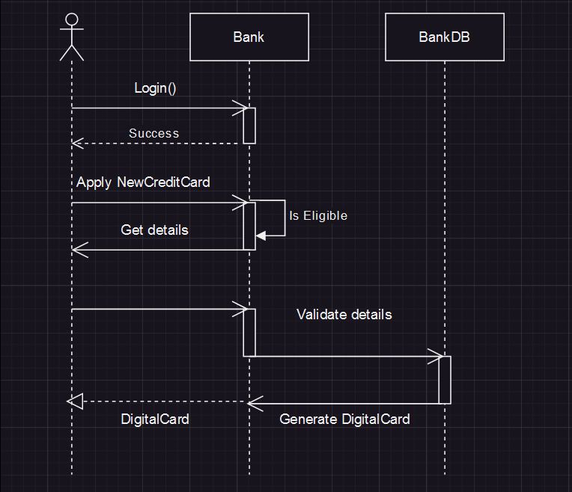

**Home Loan Sequence Diagram:**

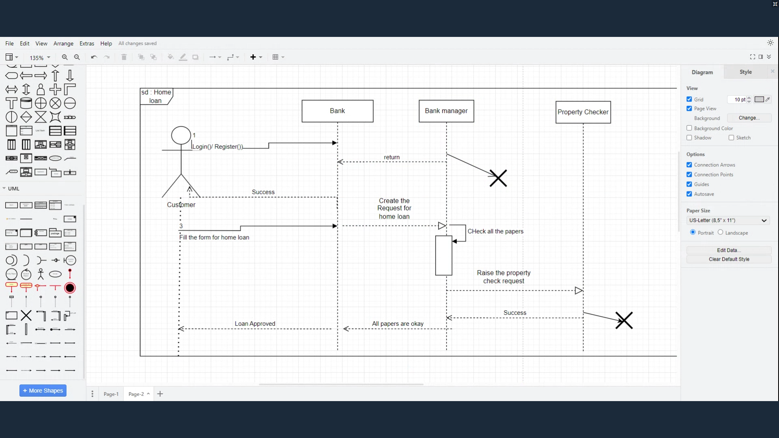

**State Transition Diagram:**

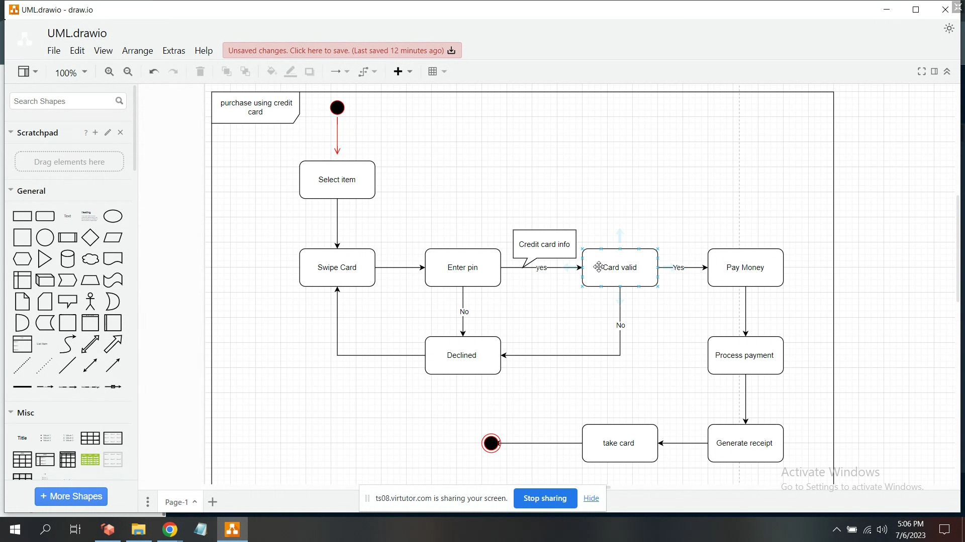

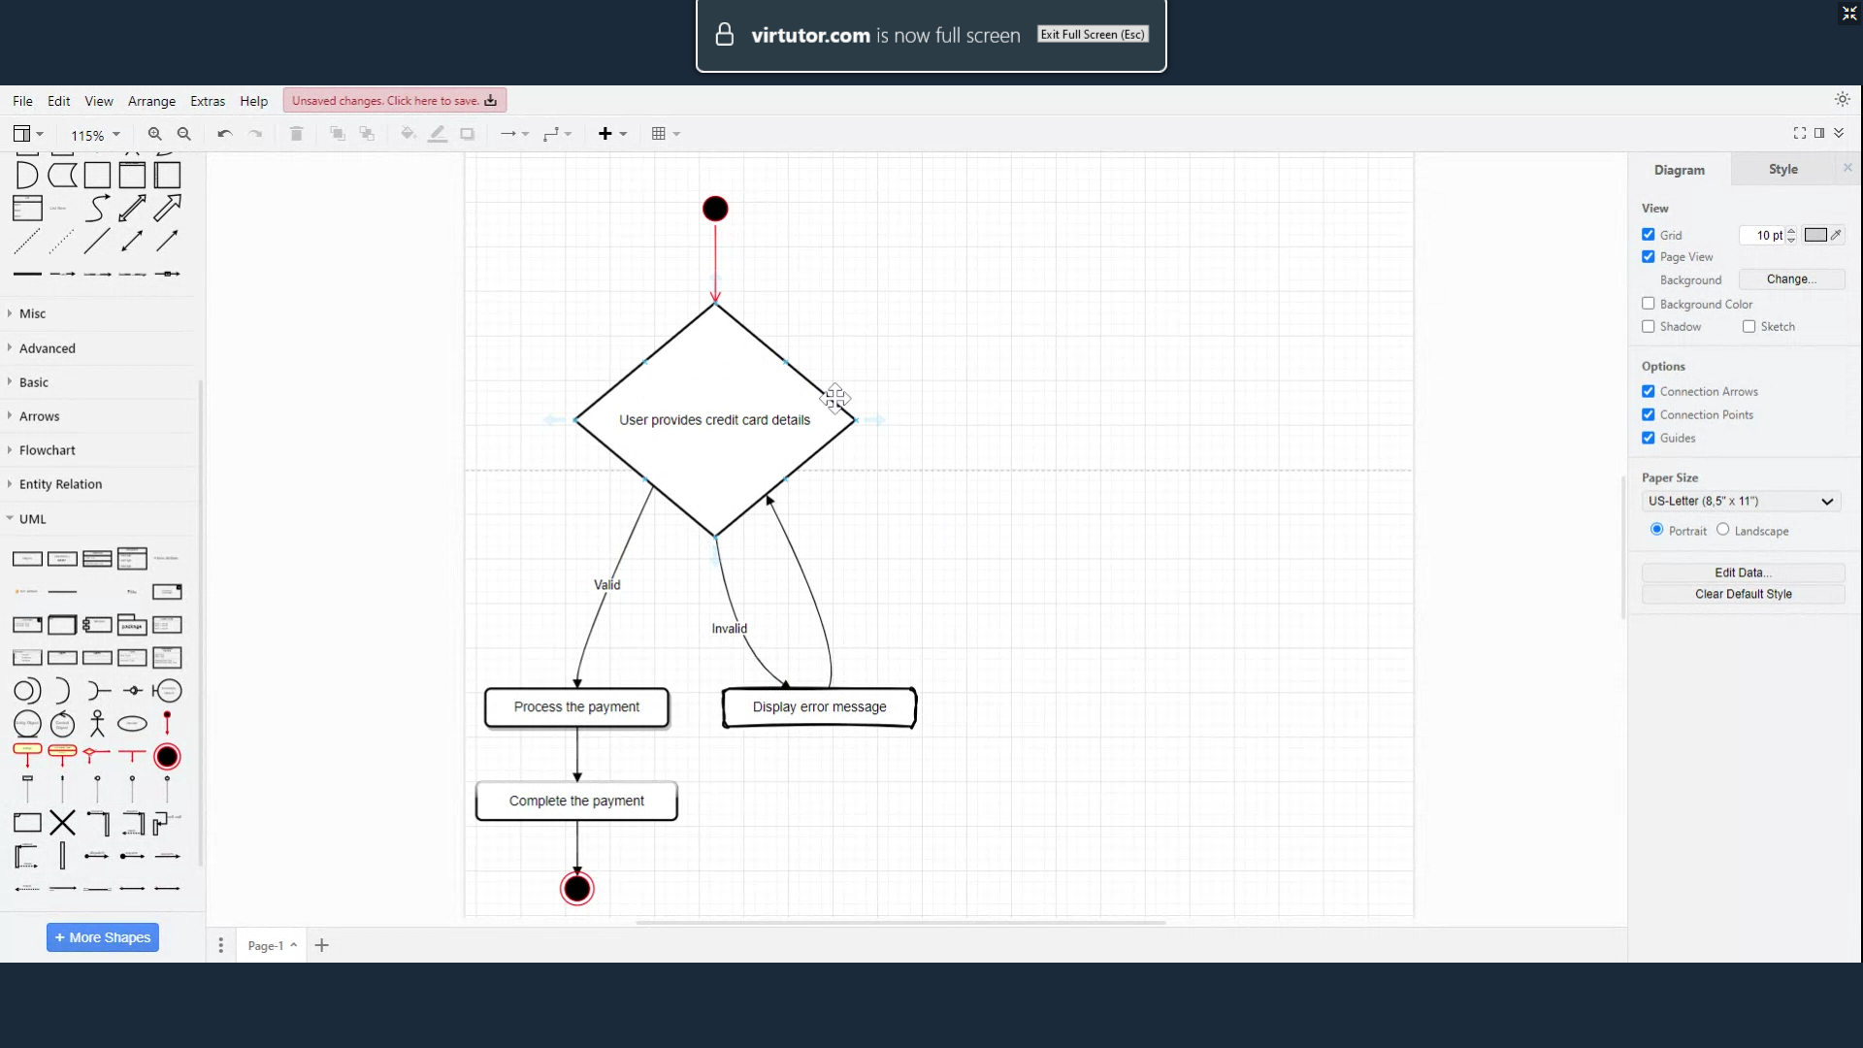

**IMP Questions:**

Define UML.  
What is the difference between structure and behavior UML diagrams?  
Define a state diagram.  
What is the difference between a state diagram's fork and join components?  
What is the difference between the state and class diagrams?

Draw the sequence diagram with parallel / concurrent frames