enum Gender {

    MALE,

    FEMALE,

    OTHER

}

public class Main {

    public static void main(String[] args) {

        Gender g = Gender.MALE;

        System.out.println(g);

    }

}

<https://t4tutorials.com/case-studies-examples-scenarios-oop/>

<https://nscpolteksby.ac.id/ebook/files/Ebook/Computer%20Engineering/Object%20Oriented%20Programming%20Using%20Java%202%20(2009)/11%20-%20Case%20Study.pdf>

**Class Diagram:**

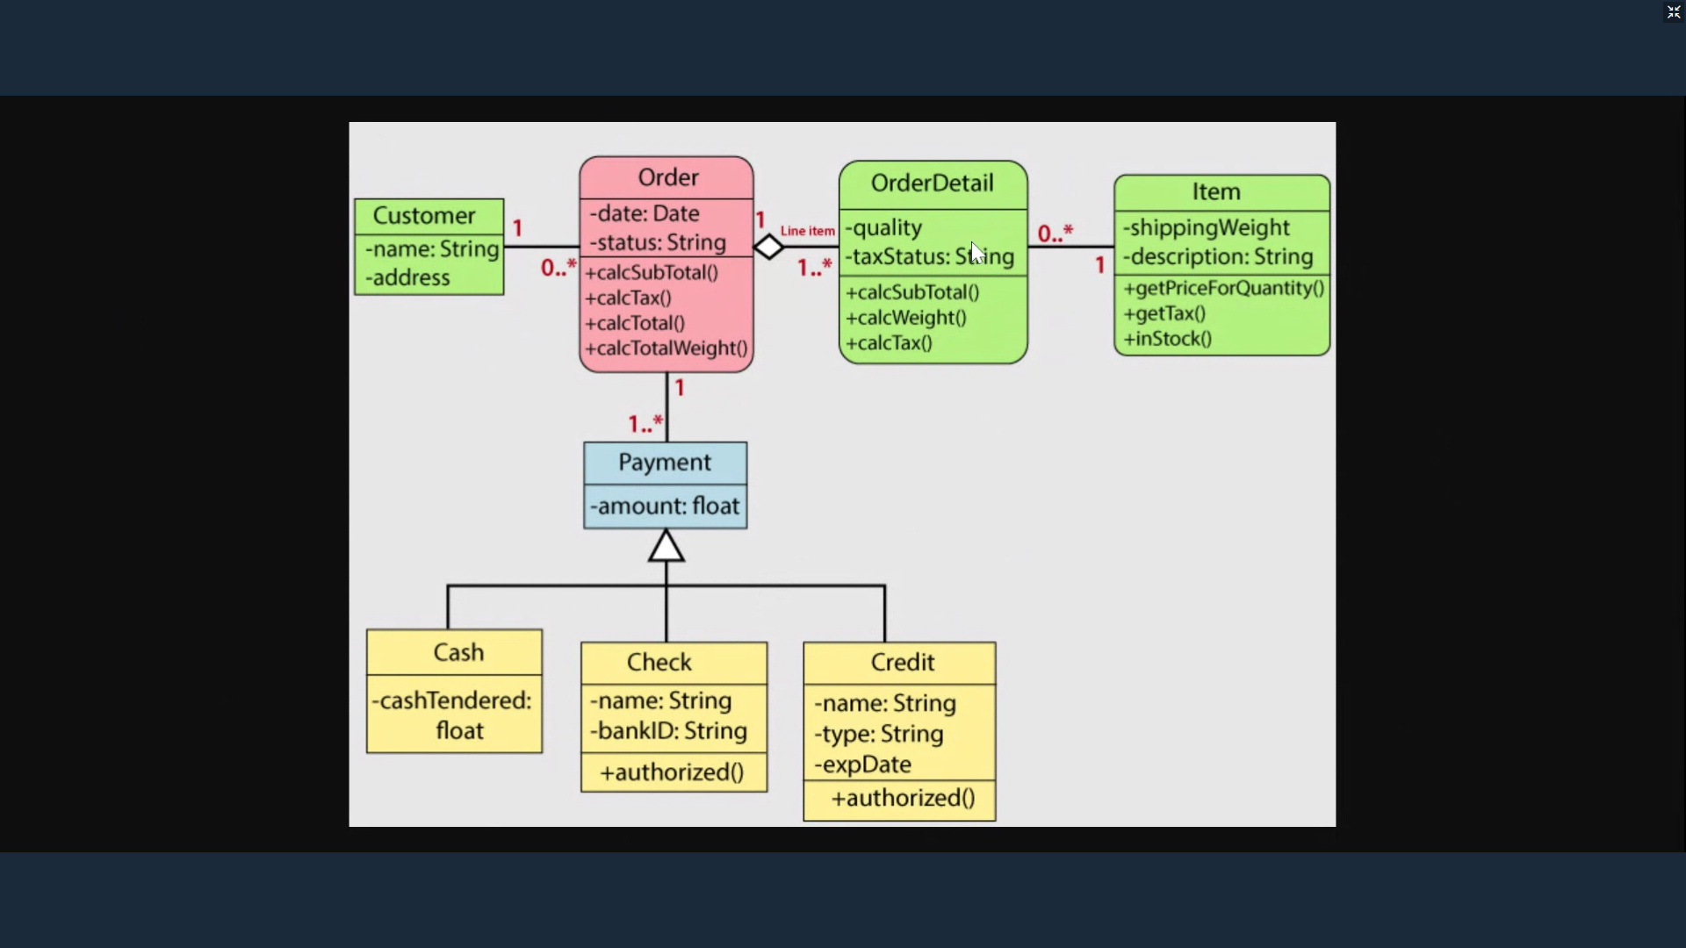

**Class Diagram for Library Management System:**

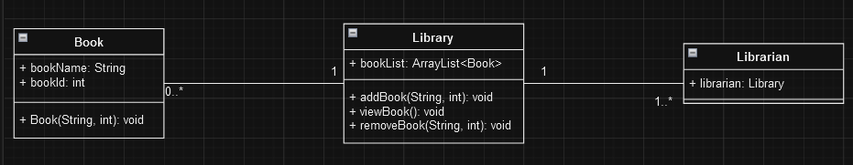

**Class Diagram for Banking Management System:**

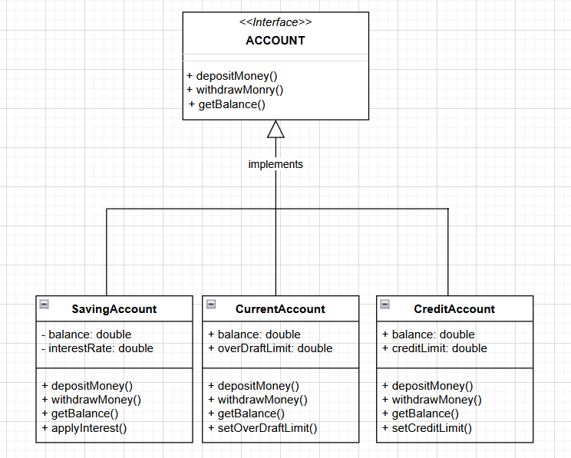

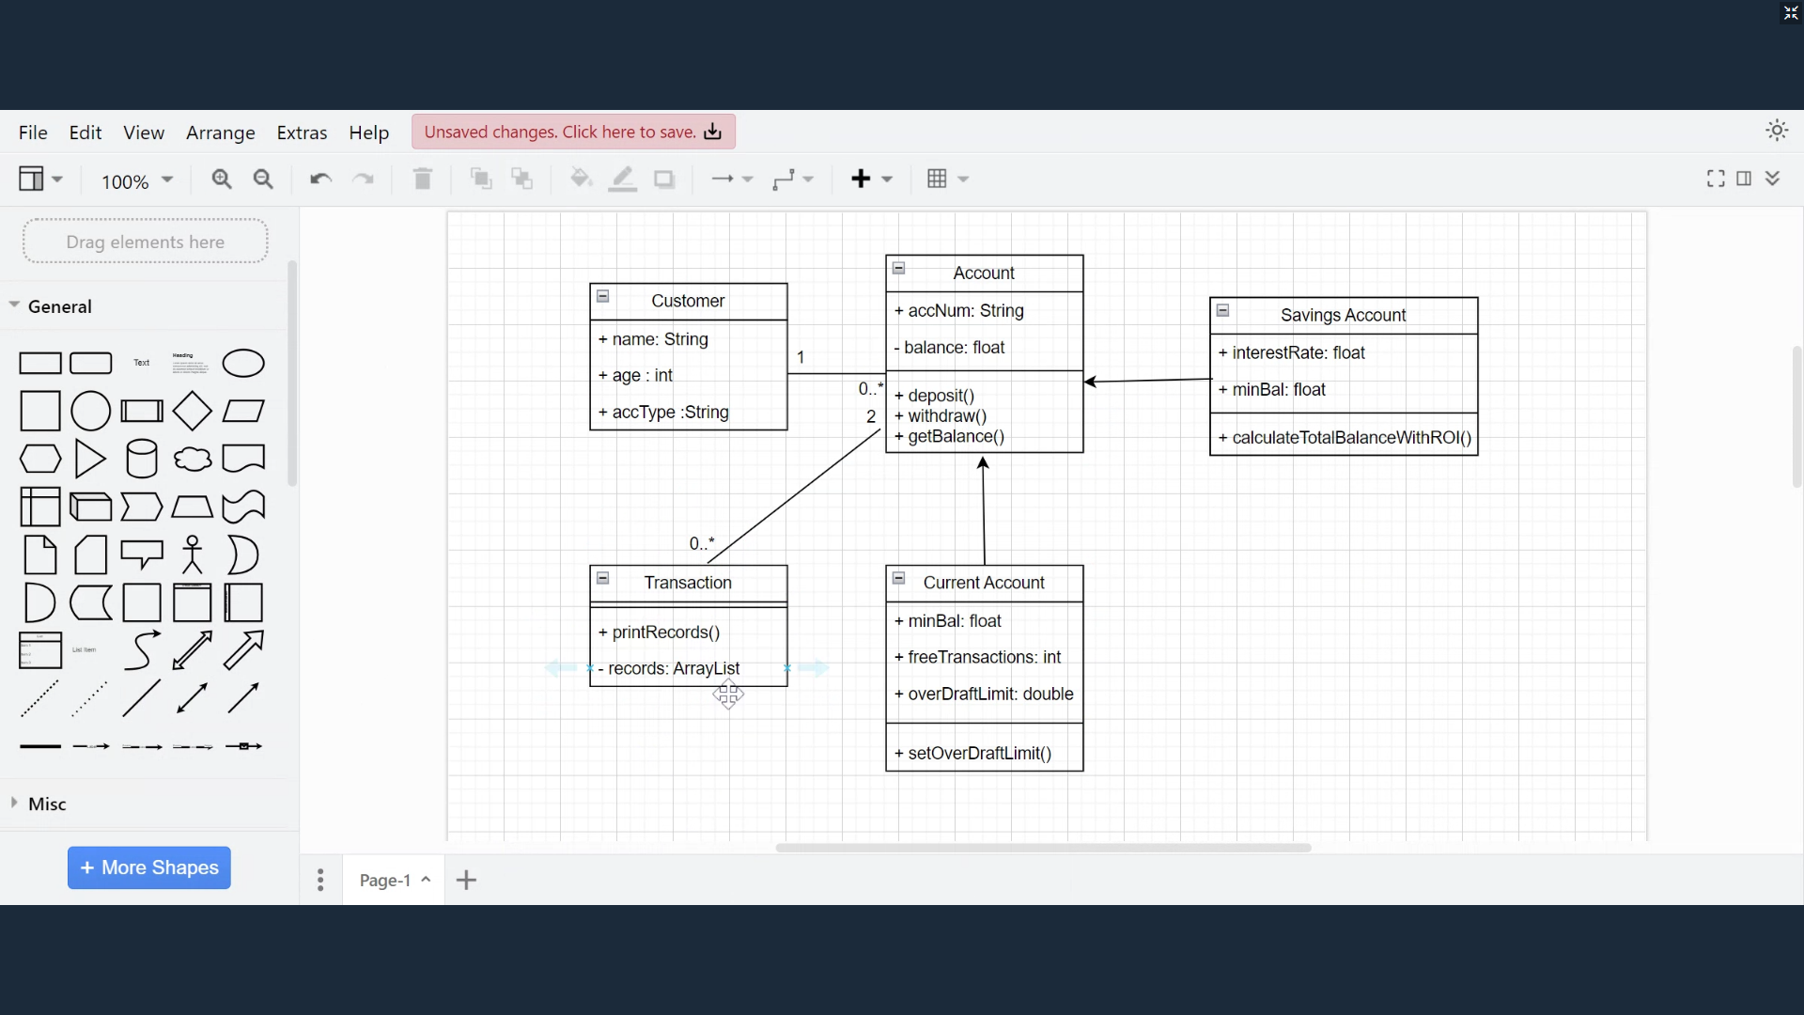

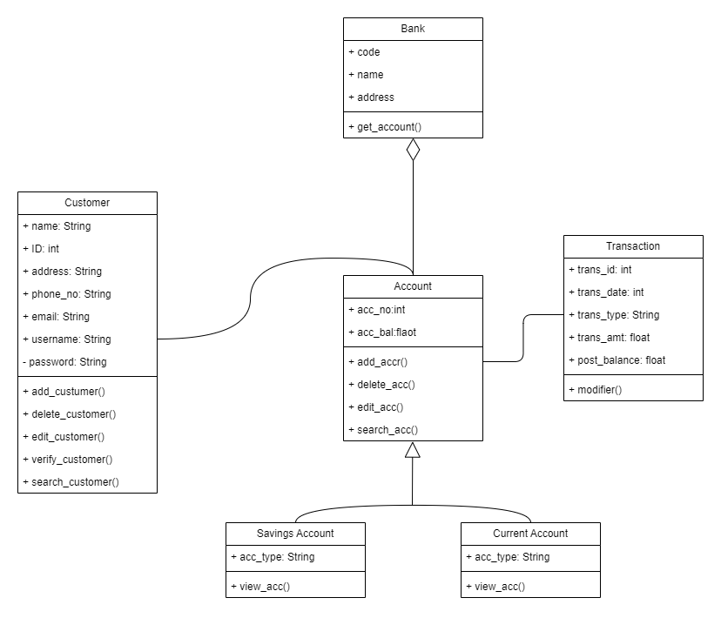

[**https://www.javatpoint.com/uml-building-blocks**](https://www.javatpoint.com/uml-building-blocks)

**Use Case Diagram:**

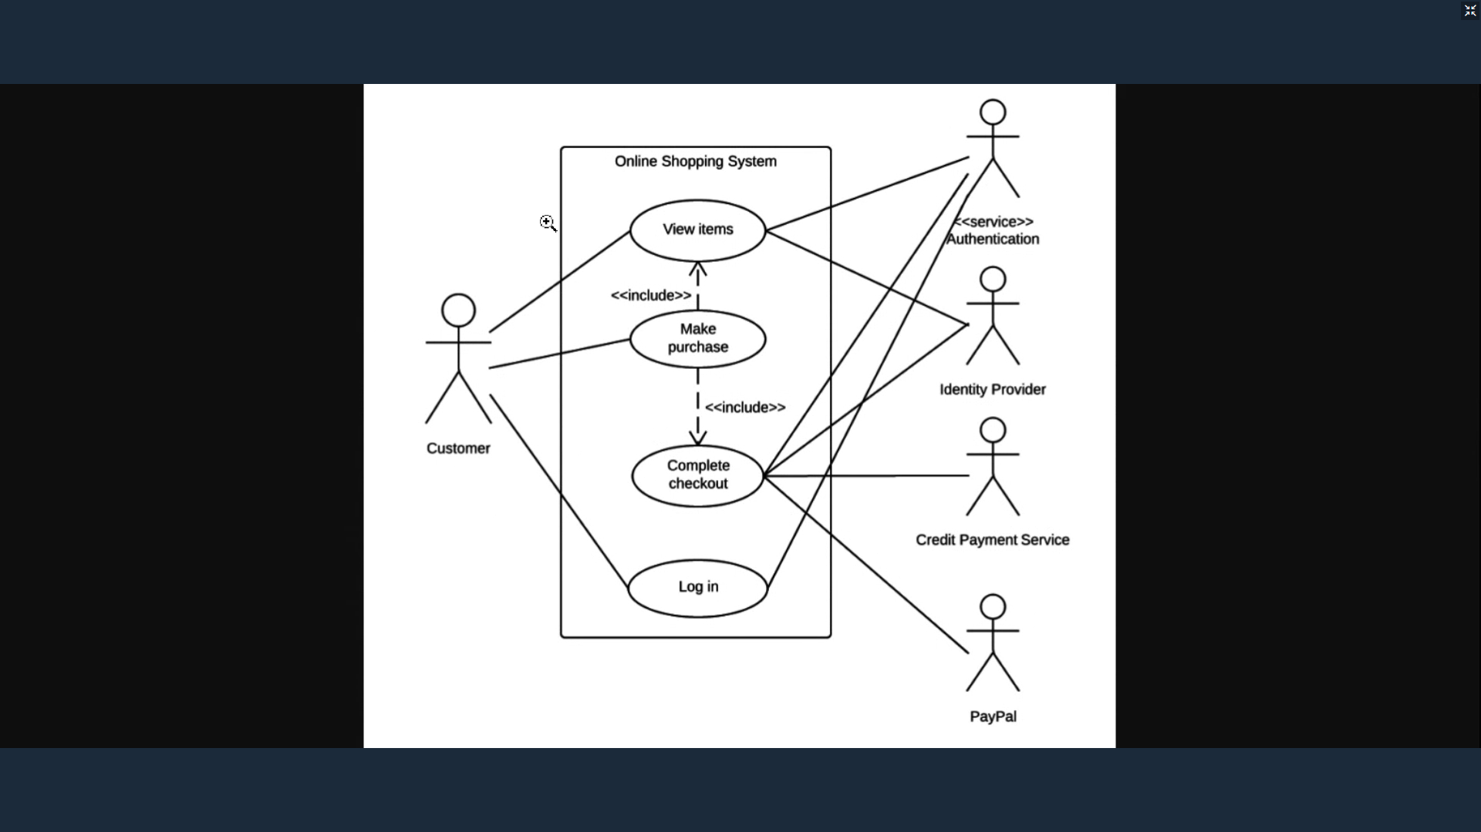

**Use Case Diagram for Bank transaction system:**

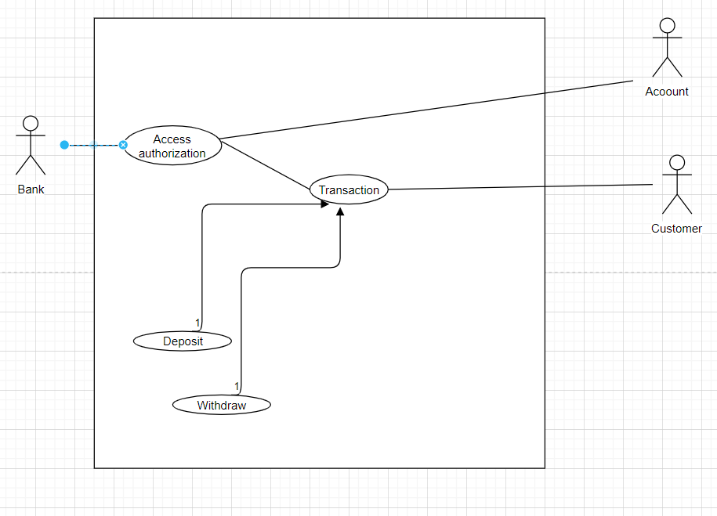

**Banking usecase diagram:**

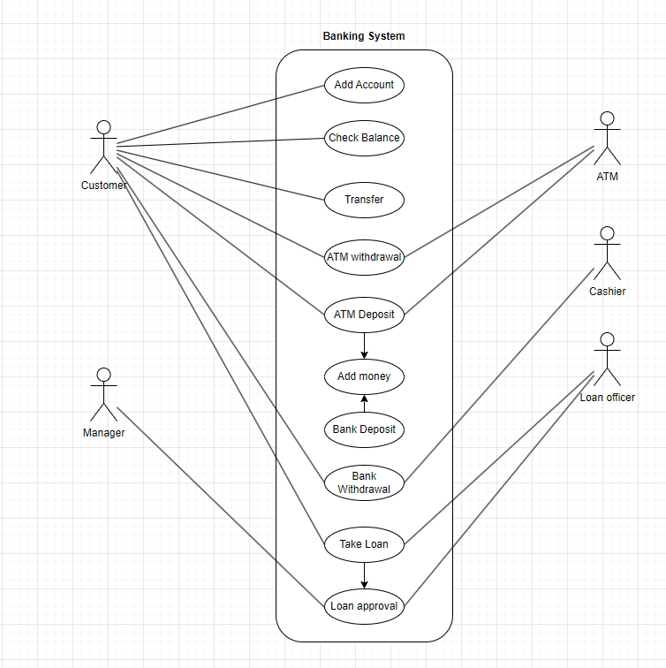

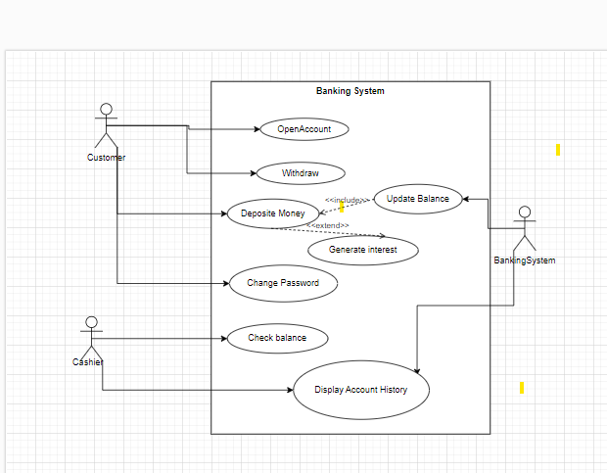

**Deployment Diagram:**

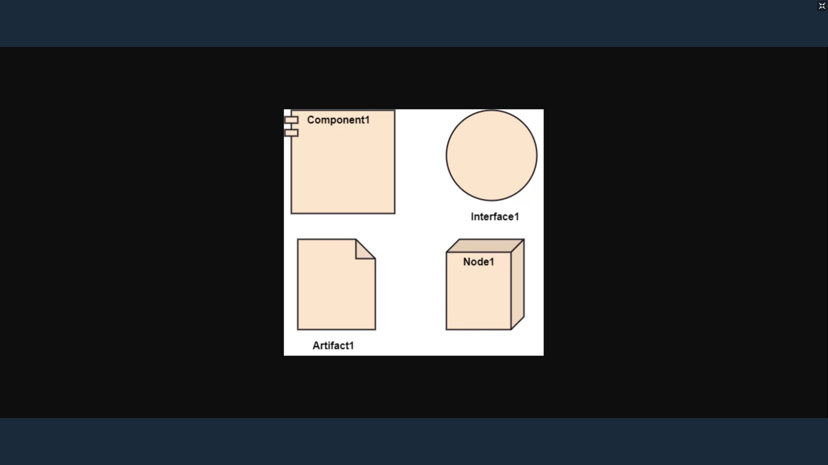

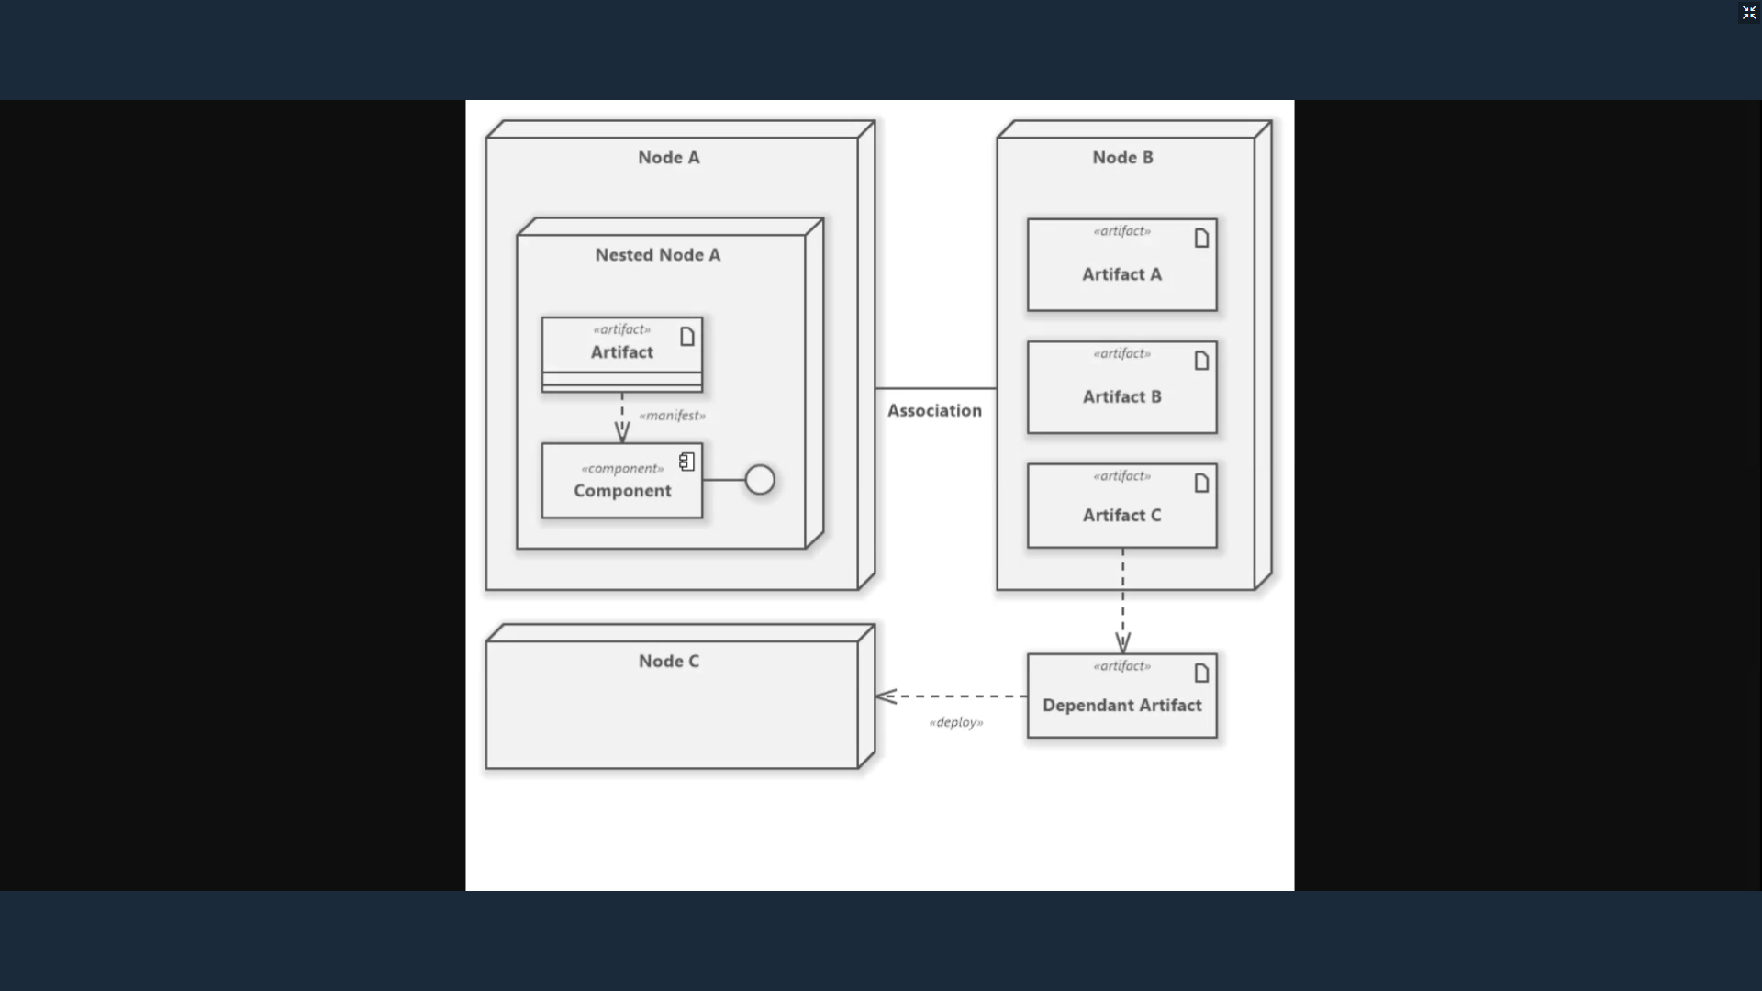

**RUP**

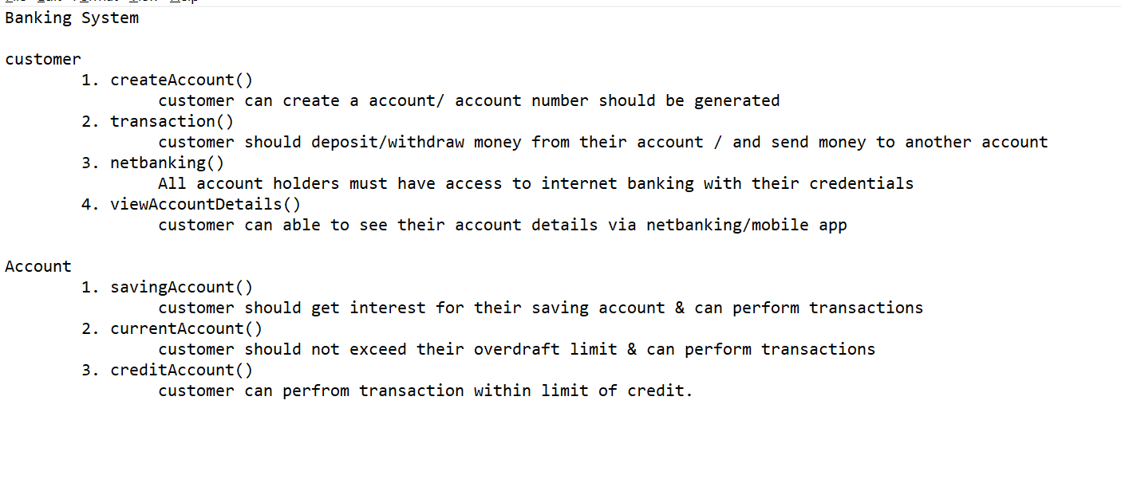

Banking System:  
Account

1. savingAccout

customer can perform transactions and he should get interest for his savings account

1. currentAccount

customer can deposited and withdrawn amount at any them without giving any notice. Customer can also make payments using cheques.

Customer

1. makeTransaction

customer can send the amount to recipient or customer can receive amount of sender.

1. ViewBalance

customer can view his/her current balance.

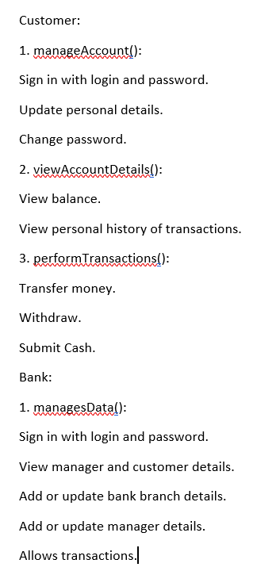

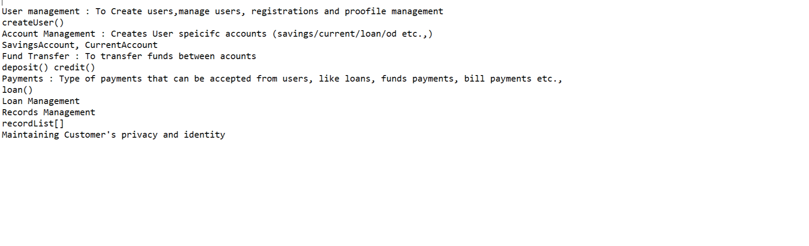

**Design work flow: -**

1 Analysis model (req in text)

2 Design model (classes, attributes, functions…)

3 Use case model (functionality flow)

4 Code

**E-Commers:**

**User Management:**

1) newUser()

Customer can create a new account.

2) existingUser()

Customer can login using Id and password.

**Product Management:**

1) viewProduct()

Customer can see all products present in E-Commers website.

2) searchProduct()

Customer can search for a particular product in E-Commers website.

**Cart Management:**

1) addToCart()

Customer can add one or more products into cart.

2) removeFromCart()

Customer can remove one or more products from cart.

**Billing Management:**

1) paymentMode()

Customer can choose payment method as Online or COD.

2) checkout()

Customer should get a invoice with item details and total amount.

