Create a use case diagram for a hotel reservation system. The system involves actors like "Guest," "Receptionist," and "Manager." Guests can search for rooms, make reservations, and cancel reservations. Receptionists handle check-ins, check-outs, and room assignments. Managers oversee room availability and staff assignments.

**USE CASE DIAGRAM:**

Note: Use Case diagram contains Actors and Use Case.

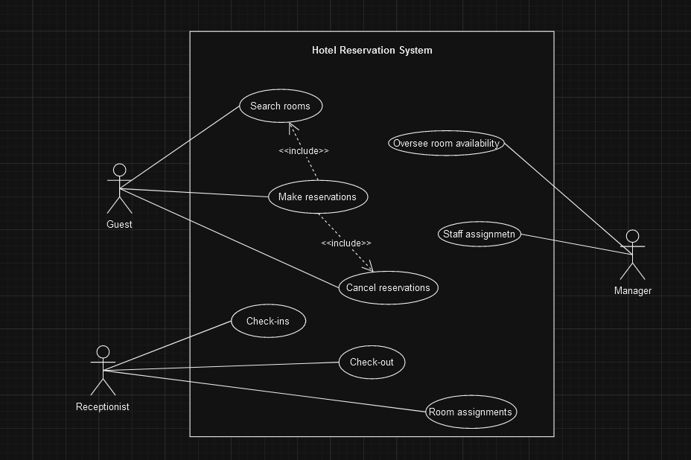

**CLASS DIAGRAM:**

Class Diagram represents static view of the application.

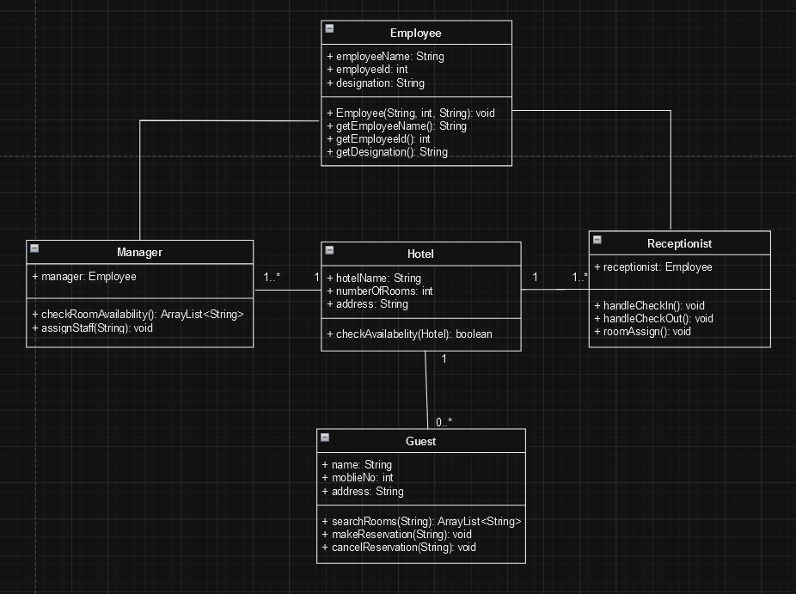

**STATE MACHINE DIAGRAM:**

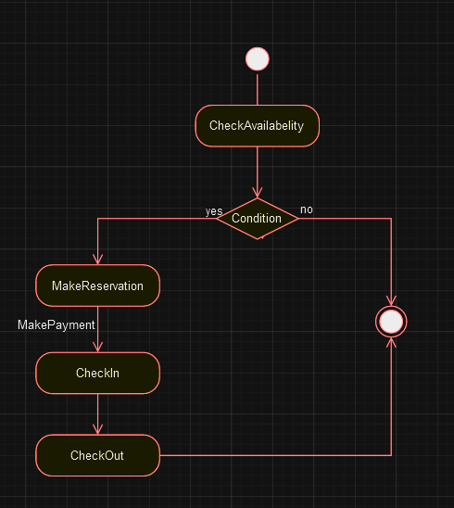

**IMP:**

Difference b/w realization and generalization

If we extend a class it is called generalization

If we implant an interface it is called realization

Generalization is the name of the relationship. Inheritance is the mechanism that the generalization relationship represents. Realization is the relationship between one class that serves as the contract that the other class agrees to carry out. (The interface and the class that implements the interface).