Query 0.1

aws dynamodb create-table \

--table-name Product \

--attribute-definitions \

AttributeName=ProductID,AttributeType=S \

AttributeName=Name,AttributeType=S \

--key-schema \

AttributeName=ProductID,KeyType=HASH \

AttributeName=Name,KeyType=RANGE \

--provisioned-throughput \

ReadCapacityUnits=5,WriteCapacityUnits=5 \

--table-class STANDARD

Query 0.2

aws dynamodb put-item \

--table-name Product \

--item \

'{"ProductID": {"S": "P001"}, "Name": {"S": "Laptop"}, "Brand": {"S": "Dell"}, "Quantity": {"N": "5"}, "Price": {"N": "32000"}}'

aws dynamodb put-item \

--table-name Product \

--item \

'{"ProductID": {"S": "P002"}, "Name": {"S": "Tablet"}, "Brand": {"S": "Lenovo"}, "Quantity": {"N": "7"}, "Price": {"N": "15000"}}'

aws dynamodb put-item \

--table-name Product \

--item \

'{"ProductID": {"S": "P003"}, "Name": {"S": "Camera"}, "Brand": {"S": "Nikon"}, "Quantity": {"N": "3"}, "Price": {"N": "22000"}}'

aws dynamodb put-item \

--table-name Product \

--item \

'{"ProductID": {"S": "P004"}, "Name": {"S": "Smartphone"}, "Brand": {"S": "Samsung"}, "Quantity": {"N": "8"}, "Price": {"N": "25000"}}'

aws dynamodb put-item \

--table-name Product \

--item \

'{"ProductID": {"S": "P005"}, "Name": {"S": "Speaker"}, "Brand": {"S": "Bose"}, "Quantity": {"N": "4"}, "Price": {"N": "12000"}}'

Query 1

aws dynamodb query \

--table-name Product \

--key-condition-expression "ProductID = :name" \

--expression-attribute-values '{":name":{"S":"P003"}}'

Query 2

aws dynamodb execute-statement --statement "SELECT * FROM Product WHERE Price BETWEEN 10000 AND 20000"

aws dynamodb execute-statement --statement "SELECT * FROM Music WHERE Artist='Acme Band' AND SongTitle='Happy Day'"

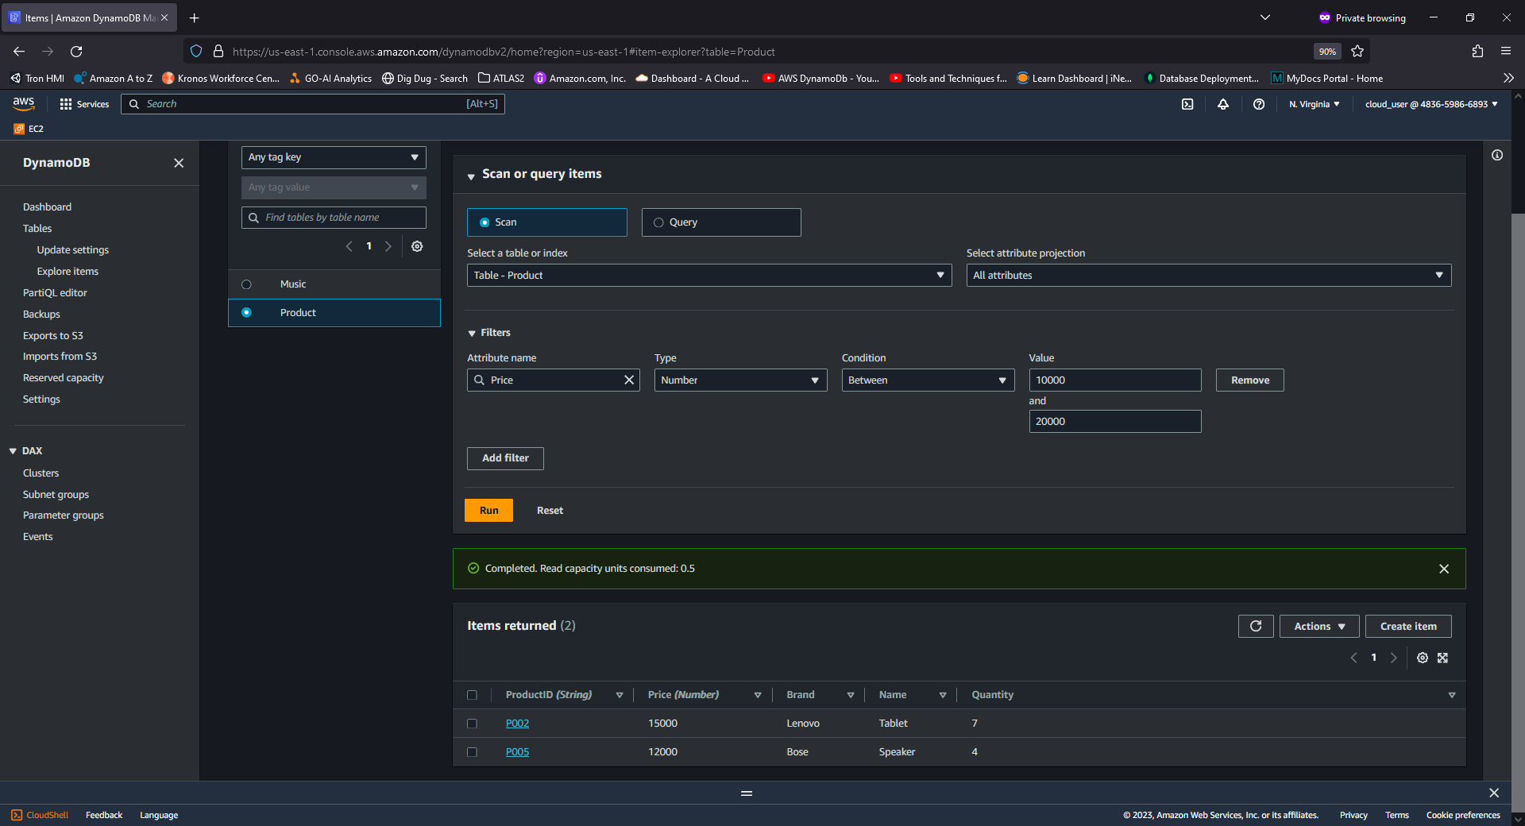

Query 3

aws dynamodb execute-statement --statement "SELECT * FROM Product WHERE Quantity>5"

Query 4

aws dynamodb execute-statement --statement "SELECT * FROM Product WHERE contains(Name, 'top')"

Query 5

aws dynamodb execute-statement --statement "SELECT * FROM Product WHERE NOT Price > 20000"

Query 6

Query 9

aws dynamodb update-item \

--table-name Product \

--key "{\"ProductID\": {\"S\": \"P002\"}, \"Price\": {\"N\": \"15000\"}}" \

--update-expression "SET Price = :newval" \

--expression-attribute-values "{\":newval\":{\"N\":\"20000\"}}" \

--return-values ALL_NEW