Matplotlib

Exploring how to visualize data, the library contains most important features that can be leveraged to visualize the data
Min preq Numpy
Goal arrays to visualize through plots and graphs
Very useful in data science projects and machine learning to see feature relationships, model performance…

Why
Raw data, its difficult to interpret
Visualization helps to see patterns, trends and generate insights quickly
Exploratory data analysis

Concepts
Facts and Dimensions
Facts numerical values – example like height, price, temperature…
Dimensions metadata – example like gender, category , location
Analyze the data D vs F like comparing height distributions across genders

Types of charts in matplotlib
Bar chart for comparing categories
- Number of fraud cases by region
- ML visualize feature importance from a model
Line graph for showing trends over time
- Stock prices over months
Scatter plot visualize relationships between variables
- Height vs weight
Histogram for understanding distributions
- Distribution of customer interests
Box plot* for spotting outliers and to know how the data got spread
- Salary distribution across department
- ML detect outliers

Data cleaning before visualization
- Before plotting, it’s imp to clean your data
- Missing values

Basic plotting methods
Method | Description | Example
plot() | Line plot | Loss over epochs
scatter() | Scatter plot | correlation
bar() | Vertical bar chart | Category comparison
barh() | Horizontal bar chart | Feature importance
hist() | Histogram | Feature distribution
boxplot() | Box plot | Outlier detection
pie() | Pie chart | Proportion visualization

Import matplotlib.pyplot as plt
epochs = [1,2,3,4,5]
train_loss = [0.9, 0.7, 0.5, 0.4, 0.3]
plt.plot(epochs, train_loss, marker=’0’) specific method
plt.title(“loss over epochs”)
plt.xlabel(“epochs”)
plt.ylabel(“loss”)
plt.grid(True)
plt.show()

how to modify the appearance of generated plots
Method | Description
title() | Add a title plot
xlabel | Label x – axis
ylabel | Label y – axis
grid | Add grid lines

Method | Description
figure() | Create a new figure | Multiple plots in one figure
subplot | Create subplots in a grid | Compare metrics
tight_layout | Adjust spacing between plots | Prevent overlap

How to save graph
savefig() save plot to a file reporting, dashboards

Summary
ML Context
Visualize training curves – plot(), grid(), legend()
Feature distribution – hist(), boxplot()
Feature relationships scatter()
Comparing categories bar(), barh()
Saving results savefig()

Box Plot

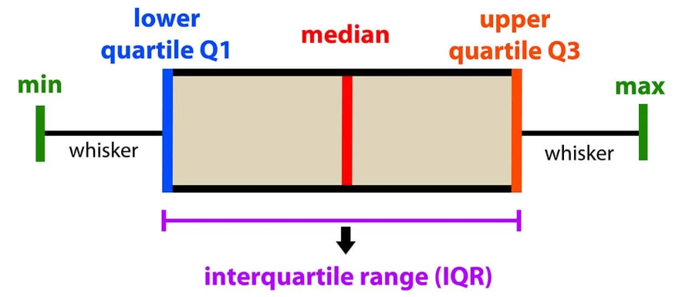

A box plot summarizes five key statistics

- Min
- First quartile (Q1) – 25th percentile
- Median (Q2) – 50th percentile
- Third quartile (Q3) – 75th percentile
- Maximum
It may highlight outliers beyond the whiskers
IQR the data spans from Q1 to Q3
Dots/data outside whiskers outliers (values beyond 1.5 X IQR)

Example
data= [7,15,13,18,21,22,23,24,25,30,35]
sorted data [7,13,15,18,21,22,23,24,25,30,35]
median (Q2) 22
Q1 (25th percentile) median of lower half 15
Q3 (75th percentile) median of upper half = 25
IQR = Q3-Q1 = 25-15 = 10

Whisker range
Lower whisker Q1 – 1.5 X IQR = 15 – 15 = 0
Upper whisker Q3 + 1.5 X IQR = 25 + 15 = 40
Whisker range is between 0 to 40
Min and max within whiskers
Min = 7 Max = 35

Outliers none in this case (no values < 0 or >40)

