PCA – Principal Component Analysis

Dimensional Reduction –
It’s the process of reducing no.of features in a dataset while retaining most imp info.

Too many features – high models become more complex
- Cost
- Redundant features /similar
- Irrelevant features – noise
Transforming original features into smaller set of new features
- PCA / linear method that corrects uncorrelated “principal components”
- LDA – linear discriminant analysis – find feature combinations that best separate classes
- t-SNE – for non-linear
- autoencoders neural network

PCA – dimensionality reduction technique

Ex
10 features having customer data – age, income, spending score, credit score, etc
From above ex – income, spending score might move together

Correlated uncorrelated

Ref
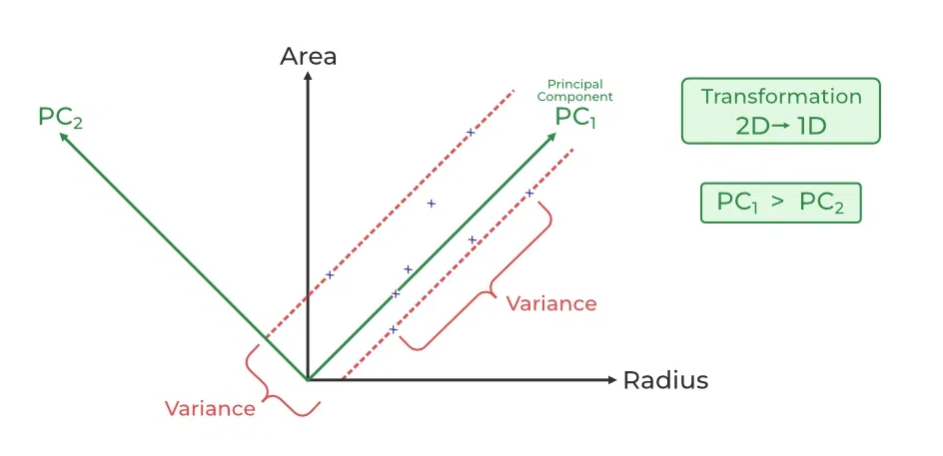

Linear regression, logistic regression
- features are independent

lets say have a dataset with 2 features
- x1 = height in cm
- x2 = weight in kg

the above 2 are positively correlated – taller people tend to weigh more
PCA
- PC1 – directions of maximum variation (approx. – along the height – weight diagonal)
- PC2 – orthogonal/ perpendicular direction, capturing remaining small variation

Each PC is a linear combination of original features
It’s not one of original feature – it’s a new feature made by combining original ones with certain weights

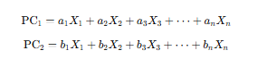

Like a1, a2, b2, b2…..an , bn……are coefficients (weights) determining by PCA
Coefficients are chosen such that
- PC1 captures maximum variance
- PC2 captures next max variance while being orthogonal (independent) to PC1 and so on

Example
PCA | Variance explained | Cumulative
PC1 | 60% | 60%
PC2 | 25% | 85%
PC3 | 10% | 95%
PC4 | 3% | 98%
PC5 | 2% | 100%

The above table tells that we can consider PC1 and PC2 & still preserve 85% of total information
5D to 2D

Uncorrelated PCs new independent axes rotating coordinates removes redundancy
PCs linear combination weighted mix of features captures data patterns
Ordered by variance PC1 > PC2 > PC3… enables dimensionality reduction

Step1 – center the data
- Subtract the mean from each variable

Step2-compute covariance matrix.


Step3 – eigen docomposition
- Finding eigen vectors and eigen value of covariance marix
  - Eigenvectors – direction of max variance (principal components)
  - Eigenvalues – amount of variance captured by each eigenvector

Step4 – project data – transform original data onto the principal components



Benefits
- Handling multicolinearity
- Noise reduction- eliminates with low variance
- Outlier detection
Cons
- Hard to interpret – new components which are combination of original variables
- Data scaling sensitivity – it requires proper scaling otherwise results may vary
- Info loss –
- Works well for variable that are linear and may struggle for non-linear data
- Risk of overfitting – model may not generalize well if using too many features or even with small dataset

PCA works focusing on two imp mathematical ideas –
- Variance and
- Basis vectors

Variance
- It measures how much the values in a dataset differ from the mean

Ex
Person | Height(cm) | Weight(kg)
A | 150 | 50
B | 160 | 55
C | 170 | 60
D | 180 | 65
E | 190 | 70

Mean height = 170 cm
Mean weight = 60 Kg
Variance approx.. tells how far each persons height/weight is from the average
- Height variance ~ 14
- Weight variance ~ 311
Weight shows much higher spread
PCA provides – keep features with higher variance, as these carry more information

Height (x-axis) vs weight (y-axis) for 5 people
- If everyone having same height, all points would line up vertically – low variance in height
- If weights are spread out more, points extend more along the direction of weight
PCA looks for directions(new axes) that capture maximum variance
- It finds the line/direction that captures most spread in the data – maximum variance – PC1
- Then it finds another line – perpendicular to PC1 PC2 – capturing the next highest variance
- This continues for all features

For ex –
A dataset with 3 columns, - height, weight and age
Step-1
- Ensure all features are on same scale (mean=0, variance=1)
Step-2
- Find covariance matrix
  - This steps tells how features vary together – ex: height and weight are positively correlated
Step-3
- Fine directions (eigenvectors)
  - These represent principal comonents – new axes that capture max variance
Step-4
- Project data onto new axes
  - Each datapoint is represented in new coordinate systems (basis)
Step-5
- Dimensionality reduction
  - Keep only top k components that explain 95% of total variance

Overall
Basis – directions(axes) used to represent data
Variance – measure spread or info
High variance – more info about feature
Principal components – new axes capturing max variance
PCA – change of basis choose new axes that explain most variance
Dimensionality reduction – keep only top PCs that explain most variance

Vectors
Matrices and their inverse
Basis vectors
Change of basis

Vector
- It’s an object with magnitude and direction
- Each row of a dataset be thought as a vector

Ex
Patient | Height | Weight
1 | 165 | 55
2 | 170 | 60
3 | 160 | 50

Vector for patient 1 : v1 = (165, 55)
- Represented as v1 = 165i+55j
- Where i and j are basis vectors (1,0) and(0,1)
PCA works on vectors in n-dimensional space

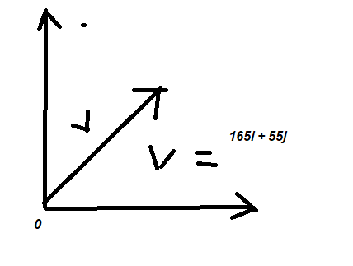

Vector operations
- Magnitude
  - ||v|| = sq root of x^2 + y^2 +……

Ex – v = (2,3) magnitude = sq root of 13

- Vector additions

V1 + v2 = (2,3) + (1,2) = (3,5)
In basis notation (2i+3j) + (i+2j) = 3i+5j

- Scalar multiplication
Multiply vector by a scalar changes magnitude, direction stays same if positive, oppo if negative

Matrix
- Matrix multiplication
  - Only possible if columns of A = rows of B
  - Multiply corresponding elements, sum results
- Inverse of matrix
  - Matrix B is inverse of A if AB=BA = I
In PCA, matrix operations are used for projections and change of basis calculations

Basis vectors
- These are fundamental units in which all vectors are expressed
- Any vector can be written as linear combination of basis vectors
  - PCA combines features as linear combinations – these are fundamental
- Lets say standard basis in 2D I =(1,0) j=(0,1)
  - Vector v (3,5) v = 3i+5j
- PCA finds new basis vectors (principal components) for data

